Guillain-Barré Syndrome and COVID-19 vaccination: a systematic review and meta-analysis

Stefano Censi¹, Giandomenico Bisaccia¹, Sabina Gallina¹,
Valentina Tomassini^{1,2}, Antonino Uncini¹*

- Department of Neuroscience, Imaging and Clinical Sciences, “G. d’Annunzio” University of Chieti-Pescara, 66100 Chieti, Italy; stefano.censi@unich.it; giandomenico.bisaccia@unich.it; uncini@unich.it, sabina.gallina@unich.it; valentina.tomassini@unich.it
- Clinical Neurology, SS. Annunziata University Hospital, Chieti, Italy

* Corresponding Author
Prof. Antonino Uncini
Department of Neuroscience, Imaging and Clinical Sciences - University “G. d’Annunzio”
Via Luigi Polacchi 11, 66100, Chieti, Italy
+39 0871 3556901
email: uncini@unich.it

Supplemental Material
Section 1: studies information (Page 1)
- Table S1 – PRISMA checklist (Page 2)
- Table S2 – Newcastle-Ottawa scale (Page 4)
- Table S3 – Information about included vaccines (Page 5)
- Table S4 – Expected GBS incidence source for Risk Analysis (Page 5)
- Table S5 – GBS Diagnosis criteria for each included cohort study (Page 6)
Section 2: data analysis (Page 7)

Section 1
Table S1 – Prisma Checklist
Section and Topic | Item # | Checklist item | Location where the item is reported?
TITLE
Title | 1 | Identify the report as a systematic review. | 1
ABSTRACT
Abstract | 2 | See the PRISMA 2020 for Abstracts checklist. | 2
INTRODUCTION
Rationale | 3 | Describe the rationale for the review in the context of existing knowledge. | 3
Objectives | 4 | Provide an explicit statement of the objective(s) or question(s) the review addresses. | 3
METHODS
Eligibility criteria | 5 | Specify the inclusion and exclusion criteria for the review and how studies were grouped for the syntheses. | 4
Information sources | 6 | Specify all databases, registers, websites, organisations, reference lists and other sources searched or consulted to identify studies. Specify the date when each source was last searched or consulted. | 4
Search strategy | 7 | Present the full search strategies for all databases, registers and websites, including any filters and limits used. | 4
Selection process | 8 | Specify the methods used to decide whether a study met the inclusion criteria of the review, including how many reviewers screened each record and each report retrieved, whether they worked independently, and if applicable, details of automation tools used in the process. | 4
Data collection process | 9 | Specify the methods used to collect data from reports, including how many reviewers collected data from each report, whether they worked independently, any processes for obtaining or confirming data from study investigators, and if applicable, details of automation tools used in the process. | 4
Data items | 10a | List and define all outcomes for which data were sought. Specify whether all results that were compatible with each outcome domain in each study were sought (e.g. for all measures, time points, analyses), and if not, the methods used to decide which results to collect. | 4
Data items | 10b | List and define all other variables for which data were sought (e.g. participant and intervention characteristics, funding sources). Describe any assumptions made about any missing or unclear information. | 4
Study risk of bias assessment | 11 | Specify the methods used to assess risk of bias in the included studies, including details of the tool(s) used, how many reviewers assessed each study and whether they worked independently, and if applicable, details of automation tools used in the process. | 4
Effect measures | 12 | Specify for each outcome the effect measure(s) (e.g. risk ratio, mean difference) used in the synthesis or presentation of results. | 4
Synthesis methods | 13a | Describe the processes used to decide which studies were eligible for each synthesis (e.g. tabulating the study intervention characteristics and comparing against the planned groups for each synthesis (item #5)). | NO
Synthesis methods | 13b | Describe any methods required to prepare the data for presentation or synthesis, such as handling of missing summary statistics, or data conversions. | 4
Synthesis methods | 13c | Describe any methods used to tabulate or visually display results of individual studies and syntheses. | 4
Synthesis methods | 13d | Describe any methods used to synthesize results and provide a rationale for the choice(s). If meta-analysis was performed, describe the model(s), method(s) to identify the presence and extent of statistical heterogeneity, and software package(s) used. | 4
Synthesis methods | 13e | Describe any methods used to explore possible causes of heterogeneity among study results (e.g. subgroup analysis, meta-regression). | 4
Synthesis methods | 13f | Describe any sensitivity analyses conducted to assess robustness of the synthesized results. | 4
Reporting bias assessment | 14 | Describe any methods used to assess risk of bias due to missing results in a synthesis (arising from reporting biases). | 4
Certainty assessment | 15 | Describe any methods used to assess certainty (or confidence) in the body of evidence for an outcome. | 4
RESULTS
Study selection | 16a | Describe the results of the search and selection process, from the number of records identified in the search to the number of studies included in the review, ideally using a flow diagram. | 5
Study selection | 16b | Cite studies that might appear to meet the inclusion criteria, but which were excluded, and explain why they were excluded. | NO
Study characteristics | 17 | Cite each included study and present its characteristics. | 5
Risk of bias in studies | 18 | Present assessments of risk of bias for each included study. | SupMat
Results of individual studies | 19 | For all outcomes, present, for each study: (a) summary statistics for each group (where appropriate) and (b) an effect estimate and its precision (e.g. confidence/credible interval), ideally using structured tables or plots. | 5-8
Results of syntheses | 20a | For each synthesis, briefly summarise the characteristics and risk of bias among contributing studies. | SupMat
Results of syntheses | 20b | Present results of all statistical syntheses conducted. If meta-analysis was done, present for each the summary estimate and its precision (e.g. confidence/credible interval) and measures of statistical heterogeneity. If comparing groups, describe the direction of the effect. | 5-8
Results of syntheses | 20c | Present results of all investigations of possible causes of heterogeneity among study results. | 5-8
Results of syntheses | 20d | Present results of all sensitivity analyses conducted to assess the robustness of the synthesized results. | 5-8
Reporting biases | 21 | Present assessments of risk of bias due to missing results (arising from reporting biases) for each synthesis assessed. | 5-8, SupMat
Certainty of evidence | 22 | Present assessments of certainty (or confidence) in the body of evidence for each outcome assessed. | 5-8
DISCUSSION
Discussion | 23a | Provide a general interpretation of the results in the context of other evidence. | 8-9
Discussion | 23b | Discuss any limitations of the evidence included in the review. | 8-9
Discussion | 23c | Discuss any limitations of the review processes used. | NO
Discussion | 23d | Discuss implications of the results for practice, policy, and future research. | 8-9
OTHER INFORMATION
Registration and protocol | 24a | Provide registration information for the review, including register name and registration number, or state that the review was not registered. | 4
Registration and protocol | 24b | Indicate where the review protocol can be accessed, or state that a protocol was not prepared. | 4
Registration and protocol | 24c | Describe and explain any amendments to information provided at registration or in the protocol. | NO
Support | 25 | Describe sources of financial or non-financial support for the review, and the role of the funders or sponsors in the review. | NO
Competing interests | 26 | Declare any competing interests of review authors. | 10
Availability of data, code and other materials | 27 | Report which of the following are publicly available and where they can be found: template data collection forms; data extracted from included studies; data used for all analyses; analytic code; any other materials used in the review. | 10
SI: Supplementary Information

PRISMA Abstract Checklist
Topic | No. | Item | Reported?
TITLE
Title | 1 | Identify the report as a systematic review. | Y
BACKGROUND
Objectives | 2 | Provide an explicit statement of the main objective(s) or question(s) the review addresses. | Y
METHODS
Eligibility criteria | 3 | Specify the inclusion and exclusion criteria for the review. | N
Information sources | 4 | Specify the information sources (e.g. databases, registers) used to identify studies and the date when each was last searched. | N
Risk of bias | 5 | Specify the methods used to assess risk of bias in the included studies. | N
Synthesis of results | 6 | Specify the methods used to present and synthesize results. | N
RESULTS
Included studies | 7 | Give the total number of included studies and participants and summarise relevant characteristics of studies. | N
Synthesis of results | 8 | Present results for main outcomes, preferably indicating the number of included studies and participants for each. If meta-analysis was done, report the summary estimate and confidence/credible interval. If comparing groups, indicate the direction of the effect (i.e. which group is favoured). | Y
DISCUSSION
Limitations of evidence | 9 | Provide a brief summary of the limitations of the evidence included in the review (e.g. study risk of bias, inconsistency and imprecision). | Y
Interpretation | 10 | Provide a general interpretation of the results and important implications. | Y
OTHER
Funding | 11 | Specify the primary source of funding for the review. | N
Registration | 12 | Provide the register name and registration number. | N

From: Page MJ, McKenzie JE, Bossuyt PM, Boutron I, Hoffmann TC, Mulrow CD, et al. The PRISMA 2020 statement: an updated guideline for reporting systematic reviews. BMJ 2021;372:n71. doi: 10.1136/bmj.n71
For more information, visit: http://www.prisma-statement.org/

Table S2 - NEWCASTLE - OTTAWA QUALITY ASSESSMENT SCALE FOR COHORT STUDIES
Study (First author et al., year of publication) | Selection | Comparability | Outcome | Overall
Shasha et al., 2021 | XXXX | XX | XXX | 9/9
Shao et al., 2021 | XXX | - | XXX | 6/7
Koh et al., 2021 | XXX | - | XXX | 6/7
Takuva et al., 2022 | XXX | - | XXX | 6/7
Garcia-Grimshaw et al., 2022 | XXX | - | XXX | 6/7
Abdel-Qader et al., 2022 | XXX | - | XXX | 6/7
Gupta et al., 2022 | XX | - | XXX | 5/7
Osowicki et al., 2022 | XXX | - | XX | 5/7
Atzenhoffer et al., 2022 | XXXX | XX | XXX | 9/9
Li et al., 2022 | XXX | X | XXX | 7/9
Keh et al., 2022 | XXX |  | XXX | 6/7
Otero-Losada et al., 2022 | XXX | - | XXX | 6/7
Tamborska et al., 2022 | XXX | - | XXX | 6/7
Abara et al., 2023 | XXXX | XX | XXX | 9/9
Ha et al., 2023 | XXX | - | XXX | 6/7
Overall score | 47/60 | 7/8 | 44/45 | 98/113 (87%)

Table S3 – Information about included vaccines
Manufacturer/WHO EUL holder | Trade name (or name used in papers) | Pre-trade or alternative name | Type/Technology
Pfizer - BioNTech | Comirnaty | BNT162b2; Tozinameran | mRNA
University of Oxford - AstraZenaca | Vaxzevria | AZD1222; ChAdOx1 nCoV-19 | Viral vector
Serum Institute of India | Covishield | AZD1222; ChAdOx1 nCoV-19 | Viral vector
Janssen | Jcovden | Ad26.COV2.S | Viral vector
Moderna Biotech | Spikevax | mRNA-1273; Elosameran | mRNA
Sinovac | Coronavac | Sinovac SARS-CoV-2 Vaccine (Vero Cell) | Inactivated
Sinopharm/BIBP | Sinopharm BIBP COVID-19 Vaccine | Sinopharm SARS-CoV-2 Vaccine (Vero Cell) | Inactivated
Russian Direct Investment Fund | Sputnik V |  | Viral vector
Biological E | Corbevax |  | Proteic

Table S4 - Expected GBS incidence source for Risk Analysis
First author | Source of expected GBS incidence
Osowicki et al. | ICD10 coded separations recorded in the state-wide hospital Victorian Admissions Episode Dataset during 2015–2019 (with a 12-month washout period applied), calculated as annual average per 100,000 population in adults. The annual rate was divided by 8.69 to adjust for a 42-day risk window period
Frontera et al. | published pre-COVID background incidence rates in the U.S. and incidence rates following acute SARS-CoV-2 infection
Atzenhoffer et al. | From published background rates for each country
Li et al. | Estimated from the general population cohort
Takuva et al. | pre-COVID-19 published GBS background rates
Abara | pre-COVID-19 published GBS background rates
Woo | Published background rates for the 42-day and 21-day risk windows

Table S5 – GBS Diagnosis criteria for each included cohort study
First author | GBS diagnosis criteria
Shasha et al., 2021 | Not specified – MHMO database
Shao et al., 2021 | Brighton criteria
Koh et al., 2021 | Brighton criteria
Takuva et al., 2022 | Not specified – EVDS database
Garcia-Grimshaw et al., 2022 | Asbury criteria
Abdel-Qader et al., 2022 | Not specified – PV register
Gupta et al., 2022 | Asbury criteria
Osowicki et al., 2022 | Not specified – SAEFVIC database
Atzenhoffer et al., 2022 | Not specified – VigiBase database
Li et al., 2022 | Not specified – AURUM database
Keh et al., 2022 | Report by a clinician reviewed by an authorized independent panel
Otero-Losada et al., 2022 | Not specified – UK regulatory agency database
Tamborska et al., 2022 | Brighton criteria
Abara et al., 2023 | Brighton criteria
Ha et al., 2023 | Brighton criteria
Figure S1 – Additional information on studies selection
Shasha et al.
Only reported vaccinated people, not doses. To obtain actual doses:
394.609 total vaccinated people
131.033 had the second shot
233.159 with first shot
233.159-131.033=102.126 are the people with just the first dose
(131.033x2) + 102.126 = 364.192 total doses for included people
Koh et al.
1.398.074 total vaccinated with mRNA vaccines
915.344 had two shots
1.398.074 - 915.344 = 482.730 with only one shot
1.830.688 + 482.730 = 2.313.418 total doses
Section2: Data analysis
- R Packages (Page 7)
- Cohorts analysis (Page 8)
R packages
Dmetar
Harrer, M., Cuijpers, P., Furukawa, T. & Ebert, D. D. (2019). dmetar: Companion R Package For The Guide 'Doing Meta-Analysis in R'. R package version 0.0.9000. URL http://dmetar.protectlab.org/.
Meta
Schwarzer, G., Carpenter, J. R., & Rücker, G. (2015). Meta-Analysis with R. Springer International Publishing. https://doi.org/10.1007/978-3-319-21416-0
Tidyverse
Wickham, Hadley, Mara Averick, Jennifer Bryan, Winston Chang, Lucy D’Agostino McGowan, Romain François, Garrett Grolemund, et al. 2019. “Welcome to the tidyverse.” Journal of Open Source Software 4 (43): 1686.
Readxl
Wickham H, Bryan J (2023). readxl: Read Excel Files. https://readxl.tidyverse.org, https://github.com/tidyverse/readxl.

Cohort Analysis
GBS incidence in COVID19 vaccinated people
- Freeman-Tukey Transform (FTT)
Number of studies: k = 17
Number of observations: o = 1058927070
Number of events: e = 1450
events 95%-CI
Random effects model 1.2451 [0.2129; 2.8341]
Prediction interval [0.0000; 9.6173]
Quantifying heterogeneity:
tau^2 < 0.0001 [0.0001; 0.0001]; tau = 0.0008 [0.0096; 0.0097]
I^2 = 97.9% [97.4%; 98.3%]; H = 6.89 [6.16; 7.72]
Test of heterogeneity:
Q d.f. p-value
760.45 16 < 0.0001
Details on meta-analytical method:
- Inverse variance method
- Restricted maximum-likelihood estimator for tau^2
- Q-Profile method for confidence interval of tau^2 and tau
- Hartung-Knapp adjustment for random effects model (df = 16)
- Prediction interval based on t-distribution (df = 15)
- Freeman-Tukey double arcsine transformation
- Clopper-Pearson confidence interval for individual studies
- Events per 1000000 observations
ASSESSMENT OF PUBLICATION BIAS
Linear regression test of funnel plot asymmetry
Egger et al. method
Test result: t = 2.43, df = 15, p-value = 0.0279
Sample estimates:
bias se.bias intercept se.intercept
5.1136 2.1007 0.0009 0.0001
Details:
- multiplicative residual heterogeneity variance (tau^2 = 36.3412)
- predictor: standard error
- weight: inverse variance
- reference: Egger et al. (1997), BMJ
Peters et al. method
Test result: t = 1.72, df = 15, p-value = 0.1066
Sample estimates:
bias se.bias intercept se.intercept
156.0803 90.9033 0.0014 0.0001
Details:
- multiplicative residual heterogeneity variance (tau^2 < 0.0001)
- predictor: inverse of total sample size
- weight: inverse variance of average event probability
- reference: Peters et al. (2006), JAMA
Identified outliers (random-effects model)
"Mexico - Garcia-Grimshaw et al. 2022", "India - Gupta et al. 2022", "Jordan - Abdel-Qader et al. 2022", "USA - Abara et al. 2023"
Results with outliers removed
Number of studies: k = 13
Number of observations: o = 1058927070
Number of events: e = 1450
events 95%-CI
Random effects model 0.8816 [0.1437; 2.0316]
Prediction interval [0.0000; 6.3530]
Quantifying heterogeneity:
tau^2 < 0.0001 [0.0001; 0.0001]; tau = 0.0006 [0.0091; 0.0096]
I^2 = 93.4% [90.5%; 95.5%]; H = 3.90 [3.24; 4.70]

Test of heterogeneity:
Q d.f. p-value
182.63 12 < 0.0001

INFLUENCE ANALYSIS

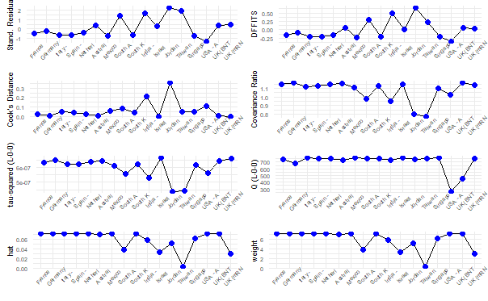
- General Linear Mixed Model (GLMM)
Number of studies: k = 17
Number of observations: o = 1058927070
Number of events: e = 1450
events 95%-CI
Random effects model 2.3268 [1.5338; 3.5298]
Prediction interval [0.3998; 13.5403]
Quantifying heterogeneity:
tau^2 = 0.6441; tau = 0.8026; I^2 = 97.9% [97.4%; 98.4%]; H = 6.97 [6.23; 7.80]
Test of heterogeneity:
Q d.f. p-value
Wald 777.22 16 < 0.0001
LRT 800.08 16 < 0.0001
Details on meta-analytical method:
- Random intercept logistic regression model
- Maximum-likelihood estimator for tau^2
- Random effects confidence interval based on t-distribution (df = 16)
- Prediction interval based on t-distribution (df = 15)
- Logit transformation
- Clopper-Pearson confidence interval for individual studies
- Events per 1000000 observations
Identified outliers (random-effects model)
"Garcia-Grimshaw et al. et al. 2022", "Gupta et al. et al. 2022", "Abdel-Qader et al. et al. 2022", "Shao et al. et al. 2021", "Abara et al. et al. 2023"
Results with outliers removed
Number of studies: k = 12
Number of observations: o = 1058927070
Number of events: e = 1450
events 95%-CI
Random effects model 2.0689 [1.5159; 2.8237]
Prediction interval [0.7850; 5.4528]
Quantifying heterogeneity:
tau^2 = 0.1692; tau = 0.4113; I^2 = 94.1% [91.4%; 96.0%]; H = 4.12 [3.42; 4.98]
Test of heterogeneity:
Q d.f. p-value
Wald 186.95 11 < 0.0001
LRT 184.27 11 < 0.0001
ASSESS FOR SMALL STUDIES BIAS
Linear regression test of funnel plot asymmetry
Egger’s method
Test result: t = 0.62, df = 15, p-value = 0.5459
Sample estimates:
bias se.bias intercept se.intercept
1.7655 2.8572 -13.3778 0.3094
Details:
- multiplicative residual heterogeneity variance (tau^2 = 50.5283)
- predictor: standard error
- weight: inverse variance
- reference: Egger et al. (1997), BMJ
Peters’ method
Test result: t = 0.62, df = 15, p-value = 0.5467
Sample estimates:
bias se.bias intercept se.intercept
81778.1692 132598.2871 -13.2314 0.1869
Details:
- multiplicative residual heterogeneity variance (tau^2 = 50.5331)
- predictor: inverse of total sample size
- weight: inverse variance of average event probability
- reference: Peters et al. (2006), JAMA
Funnel plots for FTT and GLMM
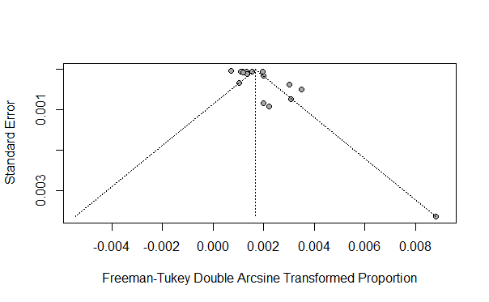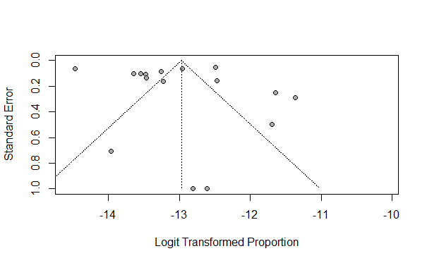

GBS incidence in COVID19 vaccinated people in Asian countries
FTT
Number of studies: k = 6
Number of observations: o = 44377532
Number of events: e = 87
events 95%-CI
Random effects model 1.5270 [0.0000; 11.0770]
Quantifying heterogeneity:
tau^2 < 0.0001 [0.0001; 0.0001]; tau = 0.0013 [0.0084; 0.0097]
I^2 = 89.6% [80.1%; 94.6%]; H = 3.10 [2.24; 4.30]
Test of heterogeneity:
Q d.f. p-value
48.10 5 < 0.0001
Details on meta-analytical method:
- Inverse variance method
- Restricted maximum-likelihood estimator for tau^2
- Q-Profile method for confidence interval of tau^2 and tau
- Hartung-Knapp adjustment for random effects model (df = 5)
- Freeman-Tukey double arcsine transformation
- Clopper-Pearson confidence interval for individual studies
- Events per 1000000 observations
Number of studies (k=6) too small to test for small study effects (k.min=10).
GLMM
Number of studies: k = 6
Number of observations: o = 44377532
Number of events: e = 87
events 95%-CI
Random effects model 3.9063 [1.1495; 13.2744]
Quantifying heterogeneity:
tau^2 = 1.0741; tau = 1.0364; I^2 = 93.9% [89.4%; 96.5%]; H = 4.05 [3.07; 5.36]
Test of heterogeneity:
Q d.f. p-value
Wald 82.20 5 < 0.0001
LRT 58.98 5 < 0.0001
Details on meta-analytical method:
- Random intercept logistic regression model
- Maximum-likelihood estimator for tau^2
- Random effects confidence interval based on t-distribution (df = 5)
- Logit transformation
- Clopper-Pearson confidence interval for individual studies
- Events per 1000000 observations
Number of studies (k=6) too small to test for small study effects (k.min=10).

GBS incidence in COVID19 vaccinated people in European countries
FTT
Number of studies: k = 7
Number of observations: o = 433964565
Number of events: e = 968
events 95%-CI
Random effects model 1.8108 [1.0786; 2.7082]
Quantifying heterogeneity:
tau^2 < 0.0001 [0.0001; 0.0001]; tau = 0.0003 [0.0093; 0.0097]
I^2 = 96.0% [93.7%; 97.4%]; H = 4.99 [3.98; 6.25]
Test of heterogeneity:
Q d.f. p-value
149.25 6 < 0.0001
Details on meta-analytical method:
- Inverse variance method
- Restricted maximum-likelihood estimator for tau^2
- Q-Profile method for confidence interval of tau^2 and tau
- Hartung-Knapp adjustment for random effects model (df = 6)
- Freeman-Tukey double arcsine transformation
- Clopper-Pearson confidence interval for individual studies
- Events per 1000000 observations
Number of studies (k=7) too small to test for small study effects (k.min=10).
Identified outliers (random-effects model)
"Otero-Losada et al. (BNT162b2, Chadox1ncov-19) 2023"
Results with outliers removed
Number of studies: k = 6
Number of observations: o = 433964565
Number of events: e = 968
events 95%-CI
Random effects model 1.4972 [1.0520; 2.0104]
Quantifying heterogeneity:
tau^2 < 0.0001 [0.0001; 0.0001]; tau = 0.0002 [0.0108; 0.0096]
I^2 = 84.7% [68.5%; 92.6%]; H = 2.56 [1.78; 3.67]
Test of heterogeneity:
Q d.f. p-value
32.71 5 < 0.0001
GLMM
Number of studies: k = 7
Number of observations: o = 433964565
Number of events: e = 968
events 95%-CI
Random effects model 1.9571 [1.3624; 2.8114]
Quantifying heterogeneity:
tau^2 = 0.1242; tau = 0.3525; I^2 = 96.1% [93.9%; 97.5%]; H = 5.07 [4.05; 6.33]
Test of heterogeneity:
Q d.f. p-value
Wald 153.97 6 < 0.0001
LRT 153.52 6 < 0.0001
Details on meta-analytical method:
- Random intercept logistic regression model
- Maximum-likelihood estimator for tau^2
- Random effects confidence interval based on t-distribution (df = 6)
- Logit transformation
- Clopper-Pearson confidence interval for individual studies
- Events per 1000000 observations
Number of studies (k=7) too small to test for small study effects (k.min=10).

GBS Prevalence in COVID19 mRNA vaccinated people
Number of studies: k = 14
Number of observations: o = 823793743
Number of events: e = 534
events 95%-CI
Random effects model 0.6855 [0.3795; 1.0612]
Prediction interval [0.0001; 2.1824]
Quantifying heterogeneity:
tau^2 < 0.0001 [0.0001; 0.0001]; tau = 0.0003 [0.0091; 0.0096]
I^2 = 92.7% [89.4%; 95.0%]; H = 3.70 [3.08; 4.45]
Test of heterogeneity:
Q d.f. p-value
178.00 13 < 0.0001
Details on meta-analytical method:
- Inverse variance method
- Restricted maximum-likelihood estimator for tau^2
- Q-Profile method for confidence interval of tau^2 and tau
- Hartung-Knapp adjustment for random effects model (df = 13)
- Prediction interval based on t-distribution (df = 12)
- Freeman-Tukey double arcsine transformation
- Clopper-Pearson confidence interval for individual studies
- Events per 1000000 observations
Identified outliers (random-effects model)
"Abara et al. (USA, mRNA-1273) 2023", "Abara et al. (USA, BNT162b2) 2023", "Garcia-Grimshaw et al. (Mexico) 2022"
Results with outliers removed
Number of studies: k = 11
Number of observations: o = 823793743
Number of events: e = 534
events 95%-CI
Random effects model 0.7443 [0.4276; 1.1294]
Prediction interval [0.0570; 1.9640]
Quantifying heterogeneity:
tau^2 < 0.0001 [0.0001; 0.0001]; tau = 0.0002 [0.0108; 0.0095]
I^2 = 81.3% [67.6%; 89.2%]; H = 2.31 [1.76; 3.04]
Test of heterogeneity:
Q d.f. p-value
53.41 10 < 0.0001
ASSESS FOR SMALL STUDIES BIAS
Linear regression test of funnel plot asymmetry
Egger’s method
Test result: t = 2.49, df = 12, p-value = 0.0287
Sample estimates:
bias se.bias intercept se.intercept
3.4386 1.3836 0.0006 0.0001
Details:
- multiplicative residual heterogeneity variance (tau^2 = 9.7927)
- predictor: standard error
- weight: inverse variance
- reference: Egger et al. (1997), BMJ
Peters’ method
Test result: t = 1.22, df = 12, p-value = 0.2451
Sample estimates:
bias se.bias intercept se.intercept
490.4676 401.2703 0.0009 0.0001
Details:
- multiplicative residual heterogeneity variance (tau^2 < 0.0001)
- predictor: inverse of total sample size
- weight: inverse variance of average event probability
- reference: Peters et al. (2006), JAMA

INFLUENCE ANALYSIS
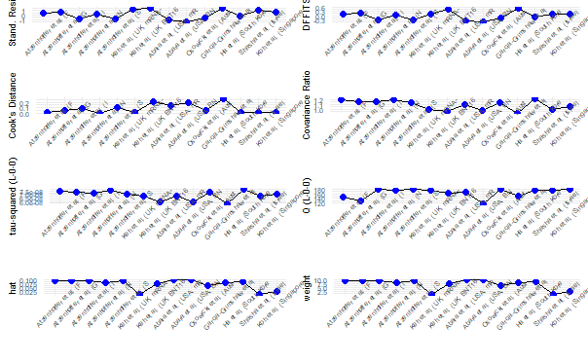
GLMM
Number of studies: k = 14
Number of observations: o = 823793743
Number of events: e = 534
events 95%-CI
Random effects model 0.8327 [0.5864; 1.1824]
Prediction interval [0.2420; 2.8655]
Quantifying heterogeneity:
tau^2 = 0.2954; tau = 0.5435; I^2 = 93.2% [90.2%; 95.3%]; H = 3.83 [3.20; 4.59]
Test of heterogeneity:
Q d.f. p-value
Wald 190.72 13 < 0.0001
LRT 185.14 13 < 0.0001
Details on meta-analytical method:
- Random intercept logistic regression model
- Maximum-likelihood estimator for tau^2
- Random effects confidence interval based on t-distribution (df = 13)
- Prediction interval based on t-distribution (df = 12)
- Logit transformation
- Clopper-Pearson confidence interval for individual studies
- Events per 1000000 observations
Identified outliers (random-effects model)
"Keh et al. (UK, BNT162b2) et al. 2022", "Abara et al. (USA, mRNA-1273) et al. 2023", "Abara et al. (USA, BNT162b2) et al. 2023", "Garcia-Grimshaw et al. (Mexico) et al. 2022"
Results with outli
Number of studies: k = 10
Number of observations: o = 823793743
Number of events: e = 534
events 95%-CI
Random effects model 0.8444 [0.6035; 1.1814]
Prediction interval [0.3576; 1.9939]
Quantifying heterogeneity:
tau^2 = 0.1168; tau = 0.3418; I^2 = 77.1% [58.0%; 87.6%]; H = 2.09 [1.54; 2.8]
Test of heterogeneity:
Q d.f. p-value
Wald 39.37 9 < 0.0001
LRT 43.55 9 < 0.0001

ASSESS SMALL STUDIES BIAS
Linear regression test of funnel plot asymmetry
Test result: t = 0.65, df = 12, p-value = 0.5276
Sample estimates:
bias se.bias intercept se.intercept
1.3217 2.0317 -14.2591 0.3290
Details:
- multiplicative residual heterogeneity variance (tau^2 = 15.3518)
- predictor: standard error
- weight: inverse variance
- reference: Egger et al. (1997), BMJ

Linear regression test of funnel plot asymmetry
Test result: t = 0.73, df = 12, p-value = 0.4774
Sample estimates:
bias se.bias intercept se.intercept
666066.4122 908138.3661 -14.0976 0.1714
Details:
- multiplicative residual heterogeneity variance (tau^2 = 15.2114)
- predictor: inverse of total sample size
- weight: inverse variance of average event probability
- reference: Peters et al. (2006), JAMA

Funnel plots for both FTT and GLMM
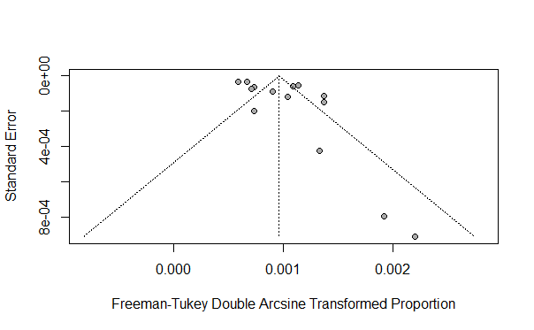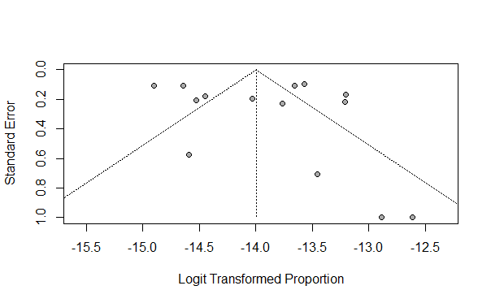

GBS Prevalence in Comirnaty vaccinated people
FTT
Number of studies: k = 5
Number of observations: o = 648450937
Number of events: e = 419
events 95%-CI
Random effects model 0.6207 [0.1189; 1.3943]
Quantifying heterogeneity:
tau^2 < 0.0001 [0.0001; 0.0001]; tau = 0.0003 [0.0092; 0.0097]
I^2 = 95.6% [92.3%; 97.5%]; H = 4.79 [3.61; 6.35]
Test of heterogeneity:
Q d.f. p-value
91.76 4 < 0.0001
Details on meta-analytical method:
- Inverse variance method
- Restricted maximum-likelihood estimator for tau^2
- Q-Profile method for confidence interval of tau^2 and tau
- Freeman-Tukey double arcsine transformation
- Clopper-Pearson confidence interval for individual studies
- Events per 1000000 observations

GLMM
Number of studies: k = 5
Number of observations: o = 648450937
Number of events: e = 419
events 95%-CI
Random effects model 0.7652 [0.4634; 1.2637]
Quantifying heterogeneity:
tau^2 = 0.4212; tau = 0.6490; I^2 = 95.5% [92.1%; 97.5%]; H = 4.74 [3.57; 6.29]
Test of heterogeneity:
Q d.f. p-value
Wald 89.81 4 < 0.0001
LRT 91.99 4 < 0.0001

Details on meta-analytical method:
- Random intercept logistic regression model
- Maximum-likelihood estimator for tau^2
- Logit transformation
- Clopper-Pearson confidence interval for individual studies
- Events per 1000000 observations

SPIKEVAX
FTT
Number of studies: k = 3
Number of observations: o = 253796319
Number of events: e = 136
events 95%-CI
Random effects model 0.6634 [0.2711; 1.2065]
Quantifying heterogeneity:
tau^2 < 0.0001 [0.0001; 0.0001]; tau = 0.0002 [0.0101; 0.0097]
I^2 = 87.3% [64.0%; 95.5%]; H = 2.81 [1.67; 4.73]
Test of heterogeneity:
Q d.f. p-value
15.75 2 0.0004
Details on meta-analytical method:
- Inverse variance method
- Restricted maximum-likelihood estimator for tau^2
- Q-Profile method for confidence interval of tau^2 and tau
- Freeman-Tukey double arcsine transformation
- Clopper-Pearson confidence interval for individual studies
- Events per 1000000 observations

GLMM
Number of studies: k = 3
Number of observations: o = 253796319
Number of events: e = 136
events 95%-CI
Random effects model 0.6651 [0.4148; 1.0663]
Prediction interval [0.0032; 139.0124]
Quantifying heterogeneity:
tau^2 = 0.1188; tau = 0.3447; I^2 = 88.6% [68.4%; 95.9%]; H = 2.96 [1.78; 4.92]
Test of heterogeneity:
Q d.f. p-value
Wald 17.50 2 0.0002
LRT 15.80 2 0.0004
Details on meta-analytical method:
- Random intercept logistic regression model
- Maximum-likelihood estimator for tau^2
- Prediction interval based on t-distribution (df = 1)
- Logit transformation
- Clopper-Pearson confidence interval for individual studies
- Events per 1000000 observations

ADENOVECTOR-BASED
Number of studies: k = 11
Number of observations: o = 127355745
Number of events: e = 806
events 95%-CI
Random effects model 3.9299 [2.5447; 5.5366]
Prediction interval [0.3926; 9.8430]
Quantifying heterogeneity:
tau^2 < 0.0001 [0.0001; 0.0001]; tau = 0.0004 [0.0108; 0.0095]
I^2 = 81.0% [67.0%; 89.1%]; H = 2.29 [1.74; 3.02]
Test of heterogeneity:
Q d.f. p-value
52.64 10 < 0.0001
Details on meta-analytical method:
- Inverse variance method
- Restricted maximum-likelihood estimator for tau^2
- Q-Profile method for confidence interval of tau^2 and tau
- Hartung-Knapp adjustment for random effects model (df = 10)
- Prediction interval based on t-distribution (df = 9)
- Freeman-Tukey double arcsine transformation
- Clopper-Pearson confidence interval for individual studies
- Events per 1000000 observations
No outliers detected (random-effects model).
ASSESSMENT FOR PUBLICATION BIAS
Linear regression test of funnel plot asymmetry
Egger’s method
Test result: t = 0.27, df = 9, p-value = 0.7916
Sample estimates:
bias se.bias intercept se.intercept
0.3862 1.4189 0.0025 0.0002
Details:
- multiplicative residual heterogeneity variance (tau^2 = 5.8009)
- predictor: standard error
- weight: inverse variance
- reference: Egger et al. (1997), BMJ
Peters’ method
Test result: t = 2.26, df = 9, p-value = 0.0502
Sample estimates:
bias se.bias intercept se.intercept
117.1134 51.8384 0.0026 0.0001
Details:
- multiplicative residual heterogeneity variance (tau^2 < 0.0001)
- predictor: inverse of total sample size
- weight: inverse variance of average event probability
- reference: Peters et al. (2006), JAMA
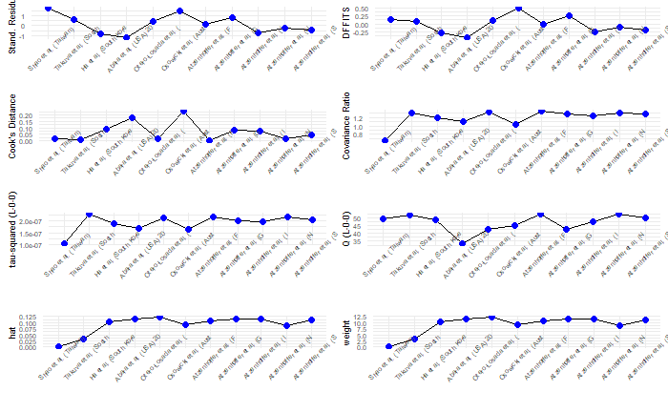

GLMM
Number of studies: k = 11
Number of observations: o = 127355745
Number of events: e = 806
events 95%-CI
Random effects model 6.0990 [4.9643; 7.4931]
Prediction interval [3.3678; 11.0450]
Quantifying heterogeneity:
tau^2 = 0.0604; tau = 0.2457; I^2 = 80.7% [66.5%; 88.9%]; H = 2.28 [1.73;3.01]
Test of heterogeneity:
Q d.f. p-value
Wald 51.91 10 < 0.0001
LRT 51.83 10 < 0.0001
Details on meta-analytical method:
- Random intercept logistic regression model
- Maximum-likelihood estimator for tau^2
- Random effects confidence interval based on t-distribution (df = 10)
- Prediction interval based on t-distribution (df = 9)
- Logit transformation
- Clopper-Pearson confidence interval for individual studies
- Events per 1000000 observations
Identified outliers (random-effects model)
"Shao et al. (Taiwan) et al.2021"
Results with outliers removed
Number of studies: k = 10
Number of observations: o = 127355745
Number of events: e = 806
events 95%-CI
Random effects model 6.0534 [4.9138; 7.4573]
Prediction interval [3.3116; 11.0650]
Quantifying heterogeneity:
tau^2 = 0.0599; tau = 0.2448; I^2 = 81.0% [66.1%; 89.4%]; H = 2.29 [1.72; 3.07]
Test of heterogeneity:
Q d.f. p-value
Wald 47.39 9 < 0.0001
LRT 49.28 9 < 0.0001
ASSESS SMALL STUDIES BIAS
Linear regression test of funnel plot asymmetry
Egger’s method
Test result: t = -0.29, df = 9, p-value = 0.7795
Sample estimates:
bias se.bias intercept se.intercept
-0.4000 1.3864 -11.8983 0.1620
Details:
- multiplicative residual heterogeneity variance (tau^2 = 5.7150)
- predictor: standard error
- weight: inverse variance
- reference: Egger et al. (1997), BMJ
Peters’ method
Test result: t = 0.94, df = 9, p-value = 0.3703
Sample estimates:
bias se.bias intercept se.intercept
39420.2167 41806.9794 -11.9441 0.0809
Details:
- multiplicative residual heterogeneity variance (tau^2 = 5.2493)
- predictor: inverse of total sample size
- weight: inverse variance of average event probability
- reference: Peters et al. (2006), JAMA
FUNNEL PLOTS (FTT and GLMM)
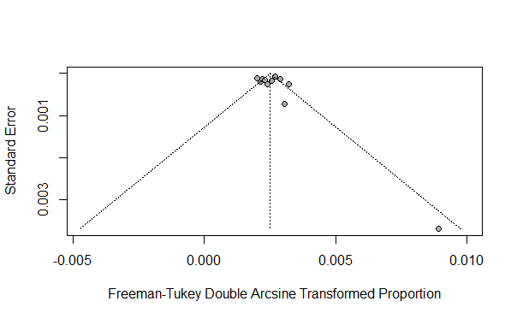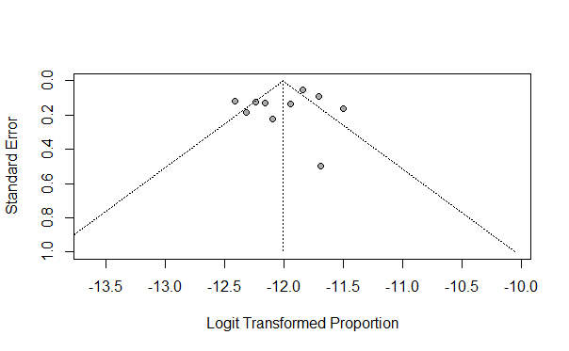

VAXZEVRIA
Number of studies: k = 8
Number of observations: o = 227858491
Number of events: e = 1440
events 95%-CI
Random effects model 2.2275 [0.0000; 7.8788]
Prediction interval [0.0000; 24.2104]
Quantifying heterogeneity:
tau^2 < 0.0001 [0.0001; 0.0001]; tau = 0.0011 [0.0097; 0.0098]
I^2 = 99.3% [99.1%; 99.4%]; H = 11.74 [10.42; 13.24]
Test of heterogeneity:
Q d.f. p-value
965.51 7 < 0.0001
Details on meta-analytical method:
- Inverse variance method
- Restricted maximum-likelihood estimator for tau^2
- Q-Profile method for confidence interval of tau^2 and tau
- Hartung-Knapp adjustment for random effects model (df = 7)
- Prediction interval based on t-distribution (df = 6)
- Freeman-Tukey double arcsine transformation
- Clopper-Pearson confidence interval for individual studies
- Events per 1000000 observations
Identified outliers (random-effects model)
"Garcia Grimshaw et al. 2022", "Atzenhoffer et al. 2022"
Results with outliers removed
Number of studies: k = 6
Number of observations: o = 227858491
Number of events: e = 1440
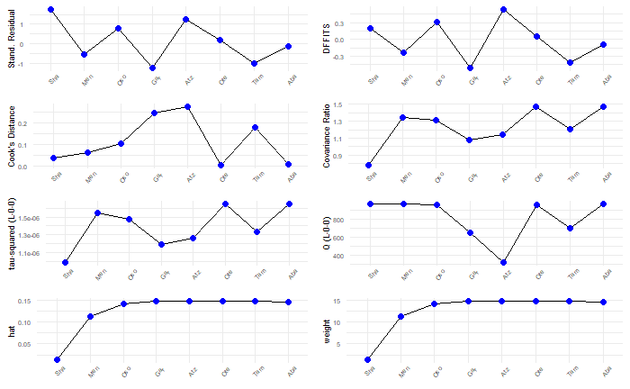
events 95%-CI
Random effects model 2.2037 [0.0000; 9.5253]
Prediction interval [0.0000; 29.4577]
Quantifying heterogeneity:
tau^2 < 0.0001 [0.0001; 0.0001]; tau = 0.0011 [0.0094; 0.0097]
I^2 = 97.5% [96.1%; 98.4%]; H = 6.30 [5.09; 7.80]
Test of heterogeneity:
Q d.f. p-value
198.43 5 < 0.0001

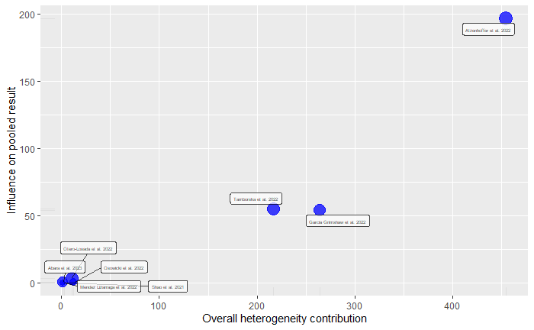

GLMM
Number of studies: k = 8
Number of observations: o = 227858491
Number of events: e = 1440
events 95%-CI
Random effects model 4.2351 [1.7904; 10.0179]
Prediction interval [0.3381; 53.0415]
Quantifying heterogeneity:
tau^2 = 0.9346; tau = 0.9667; I^2 = 98.8% [98.5%; 99.1%]; H = 9.27 [8.05; 10.66]
Test of heterogeneity:
Q d.f. p-value
Wald 600.96 7 < 0.0001
LRT 900.97 7 < 0.0001
Details on meta-analytical method:
- Random intercept logistic regression model
- Maximum-likelihood estimator for tau^2
- Random effects confidence interval based on t-distribution (df = 7)
- Prediction interval based on t-distribution (df = 6)
- Logit transformation
- Clopper-Pearson confidence interval for individual studies
- Events per 1000000 observations
Identified outliers (random-effects model)
"Garcia Grimshaw et al. 2022", "Atzenhoffer et al. 2022"
Results with outliers removed
Number of studies: k = 6
Number of observations: o = 227858491
Number of events: e = 1440
events 95%-CI
Random effects model 4.4615 [1.8353; 10.8455]
Prediction interval [0.4809; 41.3894]
Quantifying heterogeneity:
tau^2 = 0.5243; tau = 0.7241; I^2 = 96.6% [94.6%; 97.9%]; H = 5.42 [4.29; 6.85]
Test of heterogeneity:
Q d.f. p-value
Wald 146.86 5 < 0.0001
LRT 187.21 5 < 0.0001

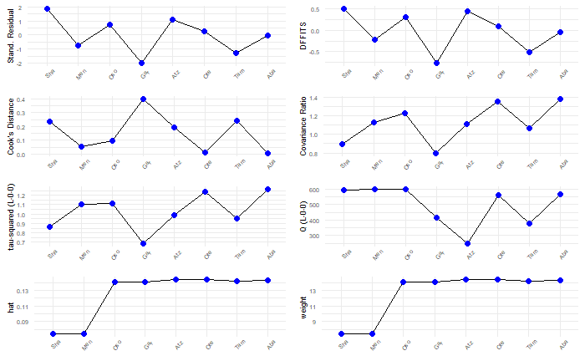

JCOVDEN
Number of studies: k = 4
Number of observations: o = 27979000
Number of events: e = 267
events 95%-CI
Random effects model 7.9174 [4.5939; 12.0880]
Quantifying heterogeneity:
tau^2 < 0.0001 [0.0001; 0.0001]; tau = 0.0006 [0.0106; 0.0097]
I^2 = 86.7% [68.0%; 94.5%]; H = 2.75 [1.77; 4.27]
Test of heterogeneity:
Q d.f. p-value
22.61 3 < 0.0001
Details on meta-analytical method:
- Inverse variance method
- Restricted maximum-likelihood estimator for tau^2
- Q-Profile method for confidence interval of tau^2 and tau
- Freeman-Tukey double arcsine transformation
- Clopper-Pearson confidence interval for individual studies
- Events per 1000000 observations
No outliers detected (random-effects model).
Number of studies (k=4) too small to test for small study effects (k.min=10)
GLMM
Number of studies: k = 4
Number of observations: o = 27979000
Number of events: e = 267
events 95%-CI
Random effects model 8.1434 [4.2508; 15.6004]
Prediction interval [1.7062; 38.8660]
Quantifying heterogeneity:
tau^2 = 0.0902; tau = 0.3004; I^2 = 85.9% [65.5%; 94.2%]; H = 2.66 [1.70; 4.17]
Test of heterogeneity:
Q d.f. p-value
Wald 21.30 3 < 0.0001
LRT 23.09 3 < 0.0001
Details on meta-analytical method:
- Random intercept logistic regression model
- Maximum-likelihood estimator for tau^2
- Random effects confidence interval based on t-distribution (df = 3)
- Prediction interval based on t-distribution (df = 2)
- Logit transformation
- Clopper-Pearson confidence interval for individual studies
- Events per 1000000 observations
No outliers detected (random-effects model).
Number of studies (k=4) too small to test for small study effects (k.min=10).

MORTALITY WITH RESPECT TO ADMINISTERED DOSES
FTT
Number of studies: k = 6
Number of observations: o = 696978860
Number of events: e = 28
events 95%-CI
Random effects model 0.0961 [0.0000; 0.7491]
Prediction interval [0.0000; 3.1646]
Quantifying heterogeneity:
tau^2 < 0.0001 [0.0000; 0.0001]; tau = 0.0001 [0.0000; 0.0096]
I^2 = 75.1% [43.6%; 89.0%]; H = 2.00 [1.33; 3.01]
Test of heterogeneity:
Q d.f. p-value
20.06 5 0.0012
Details on meta-analytical method:
- Inverse variance method
- Restricted maximum-likelihood estimator for tau^2
- Q-Profile method for confidence interval of tau^2 and tau
- Hartung-Knapp adjustment for random effects model (df = 5)
- Prediction interval based on t-distribution (df = 4)
- Freeman-Tukey double arcsine transformation
- Clopper-Pearson confidence interval for individual studies
- Events per 10000000 observations
No outliers detected (random-effects model).
Number of studies (k=6) too small to test for small study effects (k.min=10).
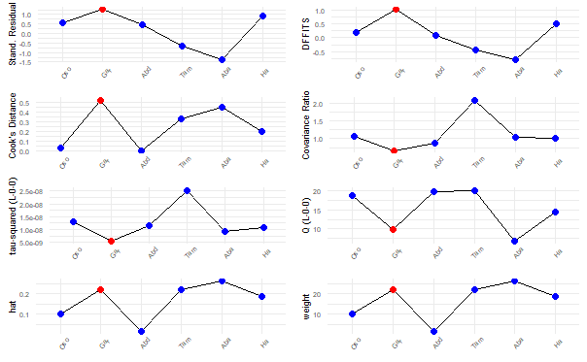
GLMM
Number of studies: k = 6
Number of observations: o = 696978860
Number of events: e = 28
events 95%-CI
Random effects model 0.5316 [0.1989; 1.4204]
Prediction interval [0.0555; 5.0948]
Quantifying heterogeneity:
tau^2 = 0.5165; tau = 0.7187; I^2 = 76.3% [46.8%; 89.4%]; H = 2.05 [1.37; 3.07]
Test of heterogeneity:
Q d.f. p-value
Wald 21.07 5 0.0008
LRT 20.40 5 0.0010
Details on meta-analytical method:
- Random intercept logistic regression model
- Maximum-likelihood estimator for tau^2
- Random effects confidence interval based on t-distribution (df = 5)
- Prediction interval based on t-distribution (df = 4)
- Logit transformation
- Clopper-Pearson confidence interval for individual studies
- Continuity correction of 0.5 in studies with zero cell frequencies
(only used to calculate individual study results)
- Events per 10000000 observations
No outliers detected (random-effects model).
Number of studies (k=6) too small to test for small study effects (k.min=10)
MORTALITY WITH RESPECT TO GBS CASES
Number of studies: k = 6
Number of observations: o = 524
Number of events: e = 28
events 95%-CI
Random effects model 4.6392 [1.6754; 8.6639]
Prediction interval [0.0405; 13.7462]
Quantifying heterogeneity:
tau^2 = 0.0020 [0.0000; 0.0296]; tau = 0.0448 [0.0000; 0.1720]
I^2 = 33.6% [0.0%; 73.3%]; H = 1.23 [1.00; 1.94]
Test of heterogeneity:
Q d.f. p-value
7.53 5 0.1840
Details on meta-analytical method:
- Inverse variance method
- Restricted maximum-likelihood estimator for tau^2
- Q-Profile method for confidence interval of tau^2 and tau
- Hartung-Knapp adjustment for random effects model (df = 5)
- Prediction interval based on t-distribution (df = 4)
- Freeman-Tukey double arcsine transformation
- Clopper-Pearson confidence interval for individual studies
- Events per 100 observations
No outliers detected (random-effects model).

GLMM
Number of studies: k = 6
Number of observations: o = 524
Number of events: e = 28

events 95%-CI
Random effects model 5.2632 [2.7220; 9.9347]
Prediction interval [1.6234; 15.7573]

Quantifying heterogeneity:
tau^2 = 0.1200; tau = 0.3464; I^2 = 35.0% [0.0%; 74.0%]; H = 1.24 [1.00; 1.96]

Test of heterogeneity:
Q d.f. p-value
Wald 7.69 5 0.1741
LRT 9.09 5 0.1055

Details on meta-analytical method:
- Random intercept logistic regression model
- Maximum-likelihood estimator for tau^2
- Random effects confidence interval based on t-distribution (df = 5)
- Prediction interval based on t-distribution (df = 4)
- Logit transformation
- Clopper-Pearson confidence interval for individual studies
- Continuity correction of 0.5 in studies with zero cell frequencies
(only used to calculate individual study results)
- Events per 100 observations
No outliers detected (random-effects model).

GBS risk with first vs second dose
Number of studies: k = 5
Number of observations: o = 106180721
Number of events: e = 125

RR 95%-CI z p-value
Random effects model 2.6011 [0.4249; 15.9211] 1.03 0.3011
Quantifying heterogeneity:
tau^2 = 2.9202 [0.3624; 36.3955]; tau = 1.7089 [0.6020; 6.0329]
I^2 = 78.7% [49.2%; 91.1%]; H = 2.17 [1.40; 3.35]
Test of heterogeneity:
Q d.f. p-value
18.80 4 0.0009
Details on meta-analytical method:
- Inverse variance method
- Paule-Mandel estimator for tau^2
- Q-Profile method for confidence interval of tau^2 and tau
- Continuity correction of 0.5 in studies with zero cell frequencies
No outliers detected (random-effects model).

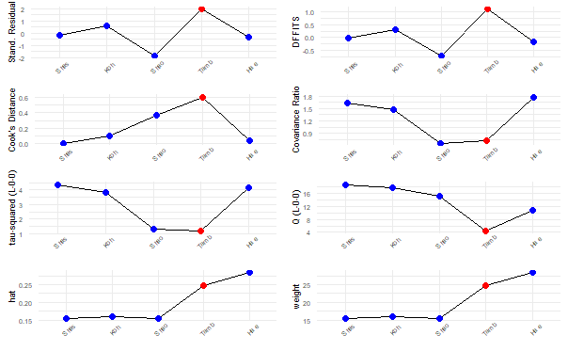

GBS risk between observed and expected GBS cases for all COVID-19 vaccines
Number of studies: k = 15
Number of observations: o = 1412468836
Number of events: e = 3879.69
RR 95%-CI t p-value
Random effects model 1.0894 [0.6156; 1.9279] 0.32 0.7525
Prediction interval [0.1215; 9.7647]
Quantifying heterogeneity:
tau^2 = 0.9598 [0.4743; 2.5745]; tau = 0.9797 [0.6887; 1.6045]
I^2 = 95.9% [94.5%; 97.0%]; H = 4.96 [4.27; 5.75]
Test of heterogeneity:
Q d.f. p-value
344.06 14 < 0.0001
Details on meta-analytical method:
- Inverse variance method
- Paule-Mandel estimator for tau^2
- Q-Profile method for confidence interval of tau^2 and tau
- Hartung-Knapp adjustment for random effects model (df = 14)
- Prediction interval based on t-distribution (df = 13)
Identified outliers (random-effects model)
"Atzenhoffer et al. (France - mRNA) 2022", "Atzenhoffer et al. (Germany - mRNA), "Atzenhoffer et al. (Italy - mRNA), "Atzenhoffer et al. (Spain - mRNA), "Atzenhoffer et al. (Germany - AdV)", "Atzenhoffer et al. (Spain - AdV)", "Atzenhoffer et al. (USA - AdV) 2022"
Results with outliers removed
Number of studies: k = 8
Number of observations: o = 1412468836
Number of events: e = 3879.69
RR 95%-CI t p-value
Random effects model 1.2521 [0.7153; 2.1917] 0.95 0.3740
Prediction interval [0.2763; 5.6748]
Quantifying heterogeneity:
tau^2 = 0.3254 [0.0755; 2.1419]; tau = 0.5704 [0.2747; 1.4635]
I^2 = 86.1% [74.6%; 92.4%]; H = 2.68 [1.99; 3.62]
Test of heterogeneity:
Q d.f. p-value
50.37 7 < 0.0001
ASSESSMENT OF SMALL STUDIES BIAS
Linear regression test of funnel plot asymmetry
Test result: t = 1.16, df = 13, p-value = 0.2668
Egger’s method
Sample estimates:
bias se.bias intercept se.intercept
2.2565 1.9449 -0.4940 0.2576
Details:
- multiplicative residual heterogeneity variance (tau^2 = 23.9828)
- predictor: standard error
- weight: inverse variance
- reference: Egger et al. (1997), BMJ
Peters’ method
Test result: t = 1.39, df = 13, p-value = 0.1866
Sample estimates:
bias se.bias intercept se.intercept
6282927.9502 4506544.7168 -0.3578 0.1982
Details:
- multiplicative residual heterogeneity variance (tau^2 = 137.9385)
- predictor: inverse of total sample size
- weight: inverse variance of average event probability
- reference: Peters et al. (2006), JAMA
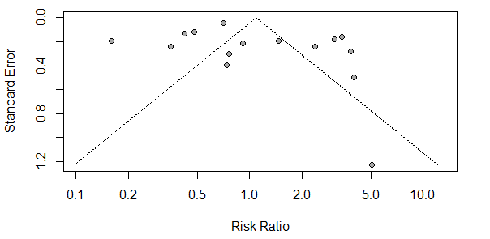

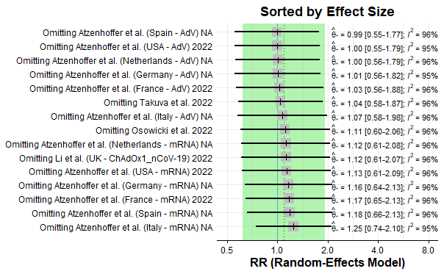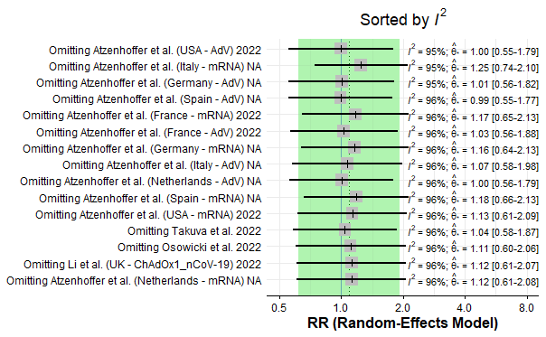

GBS risk between observed and expected GBS cases for mRNA COVID-19 vaccines
Number of studies: k = 9
Number of observations: o = 2202162122
Number of events: e = 3853.57
RR 95%-CI z p-value
Random effects model 0.3238 [0.2253; 0.4654] -6.09 < 0.0001
Prediction interval [0.0896; 1.1709]
Quantifying heterogeneity:
tau^2 = 0.2612 [0.0887; 1.2109]; tau = 0.5111 [0.2978; 1.1004]
I^2 = 92.7% [88.2%; 95.4%]; H = 3.69 [2.92; 4.67]
Test of heterogeneity:
Q d.f. p-value
108.89 8 < 0.0001
Details on meta-analytical method:
- Inverse variance method
- Paule-Mandel estimator for tau^2
- Q-Profile method for confidence interval of tau^2 and tau
- Prediction interval based on t-distribution (df = 7)
No outliers detected (random-effects model).
Funnel plot
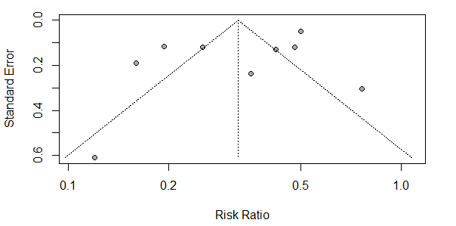

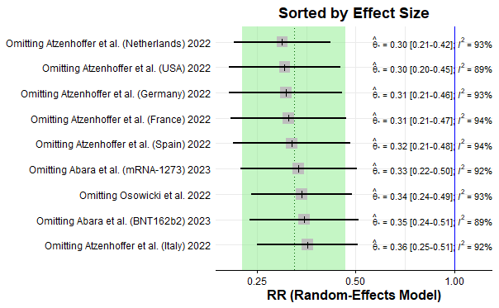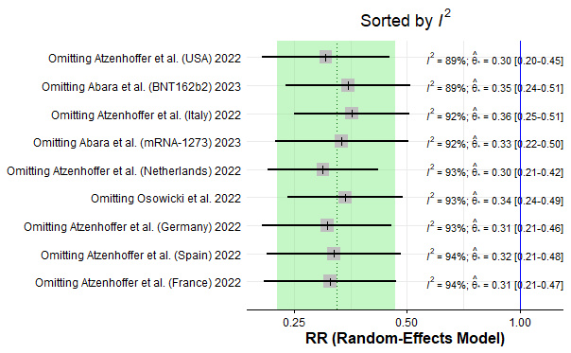
Influence Analysis

GBS risk between observed and expected GBS cases for vector-based COVID-19 vaccines
Number of studies: k = 10
Number of observations: o = 184886390
Number of events: e = 871.89
RR 95%-CI t p-value
Random effects model 2.3694 [1.6698; 3.3620] 5.58 0.0003
Prediction interval [0.9093; 6.1736]
Quantifying heterogeneity:
tau^2 = 0.1485 [0.0233; 0.8172]; tau = 0.3854 [0.1526; 0.9040]
I^2 = 65.7% [32.8%; 82.5%]; H = 1.71 [1.22; 2.39]
Test of heterogeneity:
Q d.f. p-value
26.23 9 0.0019
Details on meta-analytical method:
- Inverse variance method
- Paule-Mandel estimator for tau^2
- Q-Profile method for confidence interval of tau^2 and tau
- Hartung-Knapp adjustment for random effects model (df = 9)
- Prediction interval based on t-distribution (df = 8)
Identified outliers (random-effects model)
"Li et al. (UK) 2022"
Results with outliers removed
Number of studies: k = 9
Number of observations: o = 184886390
Number of events: e = 871.89
RR 95%-CI t p-value
Random effects model 2.5850 [1.9866; 3.3636] 8.32 < 0.0001
Prediction interval [1.4344; 4.6584]
Quantifying heterogeneity:
tau^2 = 0.0490 [0.0000; 0.3638]; tau = 0.2214 [0.0000; 0.6032]
I^2 = 51.8% [0.0%; 77.4%]; H = 1.44 [1.00; 2.10]
Test of heterogeneity:
Q d.f. p-value
16.59 8 0.0346
ASSESS FOR SMALL STUDIES BIAS
Linear regression test of funnel plot asymmetry
Eggers method

Test result: t = -0.40, df = 8, p-value = 0.6997
Sample estimates:
bias se.bias intercept se.intercept
-0.5882 1.4710 1.0388 0.3554
Details:
- multiplicative residual heterogeneity variance (tau^2 = 3.2148)
- predictor: standard error
- weight: inverse variance
- reference: Egger et al. (1997), BMJ
Peters methods
Test result: t = -0.06, df = 8, p-value = 0.9512
Sample estimates:
bias se.bias intercept se.intercept
-103379.9118 1635838.5901 0.9608 0.1599
Details:
- multiplicative residual heterogeneity variance (tau^2 = 15.2379)
- predictor: inverse of total sample size
- weight: inverse variance of average event probability
- reference: Peters et al. (2006), JAMA

Funnel plot
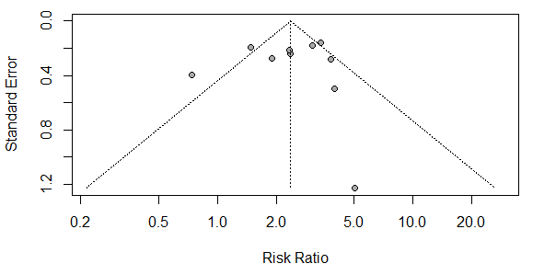

Influence analysis
