Supplemental Figure 1. The world maps report the native-country distribution of different ethnical groups included in the study population. Ethnicities were obtained from medical records as self-reported by patients at the first visit at MS Centre or obtained directly from patients.

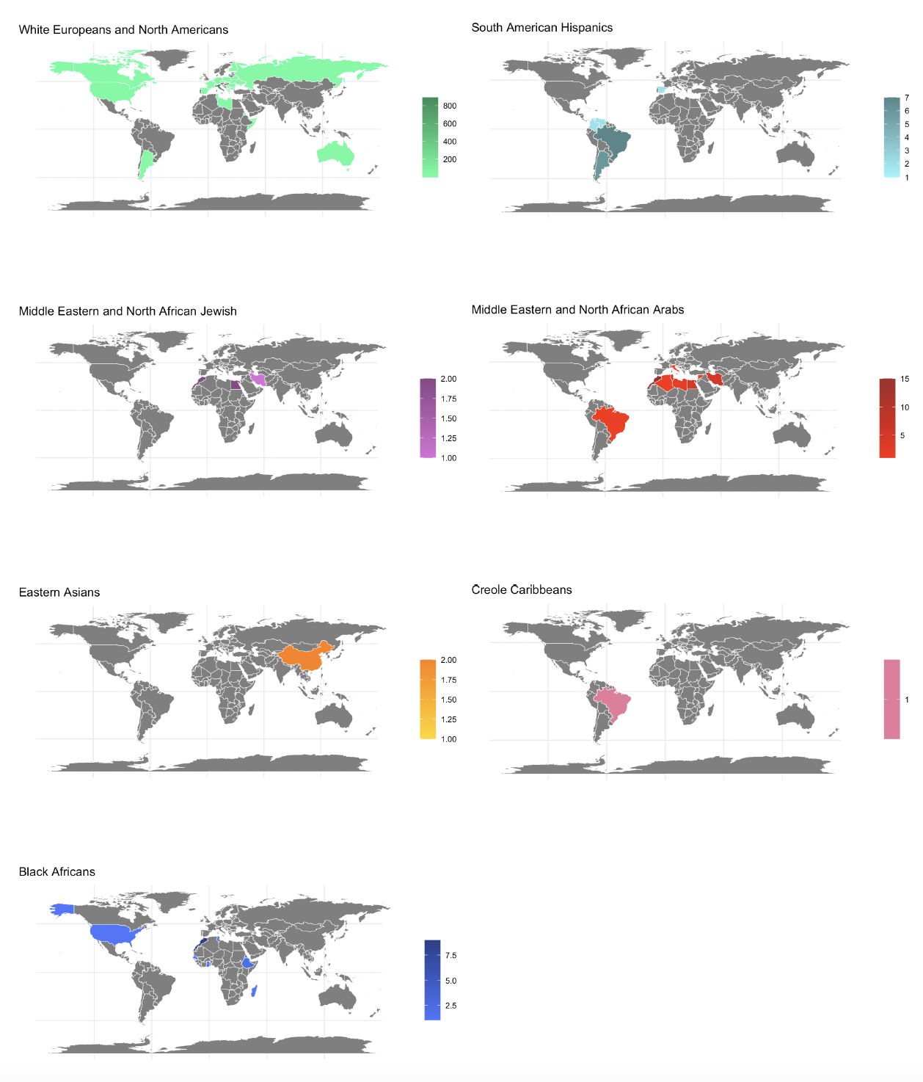

Supplemental Figure 2. The world map reports the income of different countries included in the study population according to the 2018 World Bank Atlas. Low- and middle-income (LMI) economies are defined as those with a GNI per capita of less than United States (US) $12,056, while high-income (HI) economies are those with a GNI per capita of US $12,056 or higher.
