Multicenter, randomized, double-blind, placebo-controlled phase 3 study of mogamulizumab with open-label extension study in a minimum number of patients with Human T-cell leukemia virus type-1-associated myelopathy
Journal of Neurology
Tomoo Sato^{1,2}, Masahiro Nagai³, Osamu Watanabe⁴, Tatsuro Misu⁵, Norihiro Takenouchi⁶, Ryuichi Ohkubo⁷, Satoshi Ishihara⁸, Yoshio Tsuboi⁹, Masahisa Katsuno¹⁰, Masanori Nakagawa¹¹, Takuya Matsushita¹², Yasuhiro Aso¹³, Eiji Matsuura¹⁴, Takashi Tokashiki¹⁵, Akihiro Mukaino¹⁶, Hiroaki Adachi¹⁷, Kaoru Nakanishi¹⁸, Yusuke Yamaguchi¹⁸, Saaya Yamaguchi¹⁸, Yoshihisa Yamano^{1,2}
Corresponding author:
Yoshihisa Yamano
Department of Rare Diseases Research, Institute of Medical Science, St. Marianna University School of Medicine, Kawasaki, Japan
Department of Neurology, St. Marianna University School of Medicine, Kawasaki, Japan
E-mail address: yyamano@marianna-u.ac.jp

This file contains the details of the Osame motor disability score.

Supplementary Table 1 Osame motor disability score
Grade | Motor disability
0 | No walking or running abnormalities
1 | Normal gait but runs slowly
2 | Abnormal gait (stumbling, stiffness)
3 | Unable to run
4 | Needs handrail to climb stairs
5 | Needs a cane (unilateral support) to walk
6 | Needs bilateral support to walk
7 | Can walk 5-10 m with bilateral support
8 | Can walk 1-5 m with bilateral support
9 | Cannot walk, but able to crawl
10 | Cannot crawl, but able to move using arms
11 | Cannot move around, but able to turn over in bed
12 | Cannot turn over in bed
13 | Cannot even move toes

Supplementary Table 2 Results of the secondary efficacy endpoints at Cycle 2-Week 12 (full analysis set)
 |  |  | Actual |  | Change from baseline |  | p value
 |  |  | Mogamulizumab  n = 33 | Placebo  n = 32 | Mogamulizumab  n = 33 | Placebo  n = 32 | p value
10-m timed walk test, seconds | n |  | 31 | 31 | 31 | 31
 | Mean ± SD |  | 18.95 ± 16.26 | 14.82 ± 9.20 | −0.88 ± 5.57 | −1.18 ± 4.19
 | Difference (95% CI) |  | – | – | – | 0.29 (−2.21 to 2.80) | 0.815
MAS, over Cycle 2-Week 4, 8, 12 | n |  | – | – | 31 | 31
 | Mean ± SD |  | – | – | −0.32 ± 0.69 | −0.52 ± 0.84
 | Difference (95% CI) |  | – | – | – | −0.20 (−0.59 to 0.19) | 0.317
CGI-I score | n |  | 31 | 31 | – | –
 | Mean ± SD |  | 3.6 ± 0.8 | 3.6 ± 0.8 | – | –
VAS score for HAM/TSP, mm | n |  | 31 | 31 | 31 | 31
 | Mean ± SD |  | 57.2 ± 28.5 | 60.5 ± 29.3 | −7.3 ± 22.9 | −2.5 ± 21.9
 | Difference (95% CI) |  |  |  |  | −4.8 (−16.2 to 6.5) | 0.398
OABSS | n |  | 23 | 24 | 23 | 24
 | Mean ± SD |  | 6.0 ± 3.6 | 5.8 ± 3.5 | −0.3 ± 2.3 | −0.4 ± 2.0
 | Difference (95% CI) |  | – | – | – | 0.1 (−1.1 to 1.4) | 0.855
I-PSS | n |  | 23 | 24 | 23 | 24
 | Mean ± SD |  | 12.7 ± 8.7 | 14.0 ± 9.3 | −2.7 ± 7.0 | 0.3 ± 5.6
 | Difference (95% CI) |  | – | – | – | −3.0 (−6.7 to 0.7) | 0.110
Lower extremity numbness (VAS score), mm | n |  | 31 | 31 | 31 | 31
 | Mean ± SD |  | 37.3 ± 35.2 | 39.4 ± 35.2 | −2.1 ± 20.2 | 0.3 ± 18.0
 | Difference (95% CI) |  | – | – | – | −2.4 (−12.1 to 7.4) | 0.629
Lower extremity pain (VAS score), mm | n |  | 31 | 31 | 31 | 31
 | Mean ± SD |  | 29.9 ± 34.6 | 30.3 ± 30.9 | 1.2 ± 24.6 | 1.5 ± 17.1
 | Difference (95% CI) |  | – | – | – | −0.3 (−11.0 to 10.5) | 0.961
CGI-I Clinical Global Impression-Improvement Scale, CI confidence interval, HAM/TSP human T-cell leukemia virus type 1-associated myelopathy/tropical spastic paraparesis, I-PSS International Prostate Symptom Score, MAS modified Ashworth scale, OABSS Overactive Bladder Symptom Score, SD standard deviation, VAS visual analogue scale

Supplementary Figure 1 Trends in the percent change in the peripheral HTLV-1 proviral load at each visit from baseline during the double-blind, open-label, and extension treatment periods

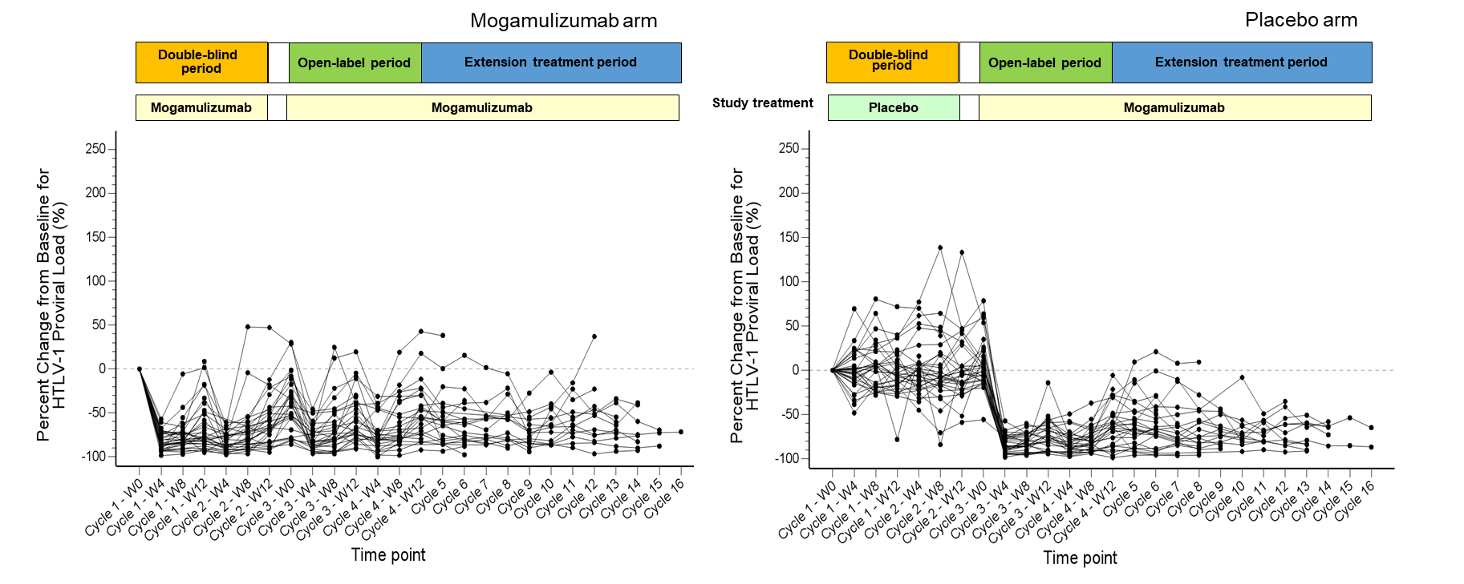
All patients in the placebo arm were treated with mogamulizumab in the open-label and extension treatment periods. HTLV-1 human T-cell leukemia virus type 1

