Supplementary materials
Supplementary Figures:1-11
Supplementary Figure 1: Traffic light plot Robins-I
Supplementary Figure 2: Prevalence of hypertension in the included MS population
Supplementary Figure 3: Prevalence of diabetes in the included MS population
Supplementary Figure 4: Prevalence of dyslipidemia in the included MS population
Supplementary Figure 5: Meta-regression bubble plot: association of age with risk ratio of acute ischemic stroke (AIS)
Supplementary Figure 6: Pooled prevalence of all-cause stroke in MS patients in sensitivity analysis after exclusion of low-quality studies
Supplementary Figure 7: Relative risk for all-cause stroke in the MS population compared to the general population in sensitivity analysis after exclusion of low-quality studies
Supplementary Figure 8: Pooled prevalence of all-cause stroke in MS patients in sensitivity analysis after exclusion of studies with duration shorter than 10 years
Supplementary Figure 9: Relative risk for all-cause stroke in the MS population compared to the general population in sensitivity analysis after exclusion of studies with duration shorter than 10 years
Supplementary Figure 10: Funnel Plot of all-cause stroke prevalence in the MS population
Supplementary Figure 11: Funnel Plot of the relative risk for all-cause stroke in the MS population compared to the general population

eMethods
Complete search algorithm used in MEDLINE search.
(multiple sclerosis) AND ((stroke) OR (intracranial hemorrhage) OR (small vessel disease) OR (vascular risk) OR (vascular comorbidities) OR (cardiovascular risk))

Complete search algorithm used in SCOPUS search.
TITLE-ABS-KEY ( multiple AND sclerosis AND ( intracranial AND hemorrhage ) OR ( stroke ) OR ( small AND vessel AND disease ) OR ( vascular AND risk ) OR ( vascular AND comorbidities ) OR ( cardiovascular AND risk ) )

Complete search algorithm used in Cochrane Library.
(multiple sclerosis) AND ((stroke) OR (intracranial hemorrhage) or (small vessel disease) OR (vascular risk) OR (vascular comorbidities) OR (cardiovascular risk))

Excluded studies, with reasons, can be found at the OSF registry : osf.io/7djhf

Supplementary Figure 1:Trafic Light Plot (Robins-I tool)
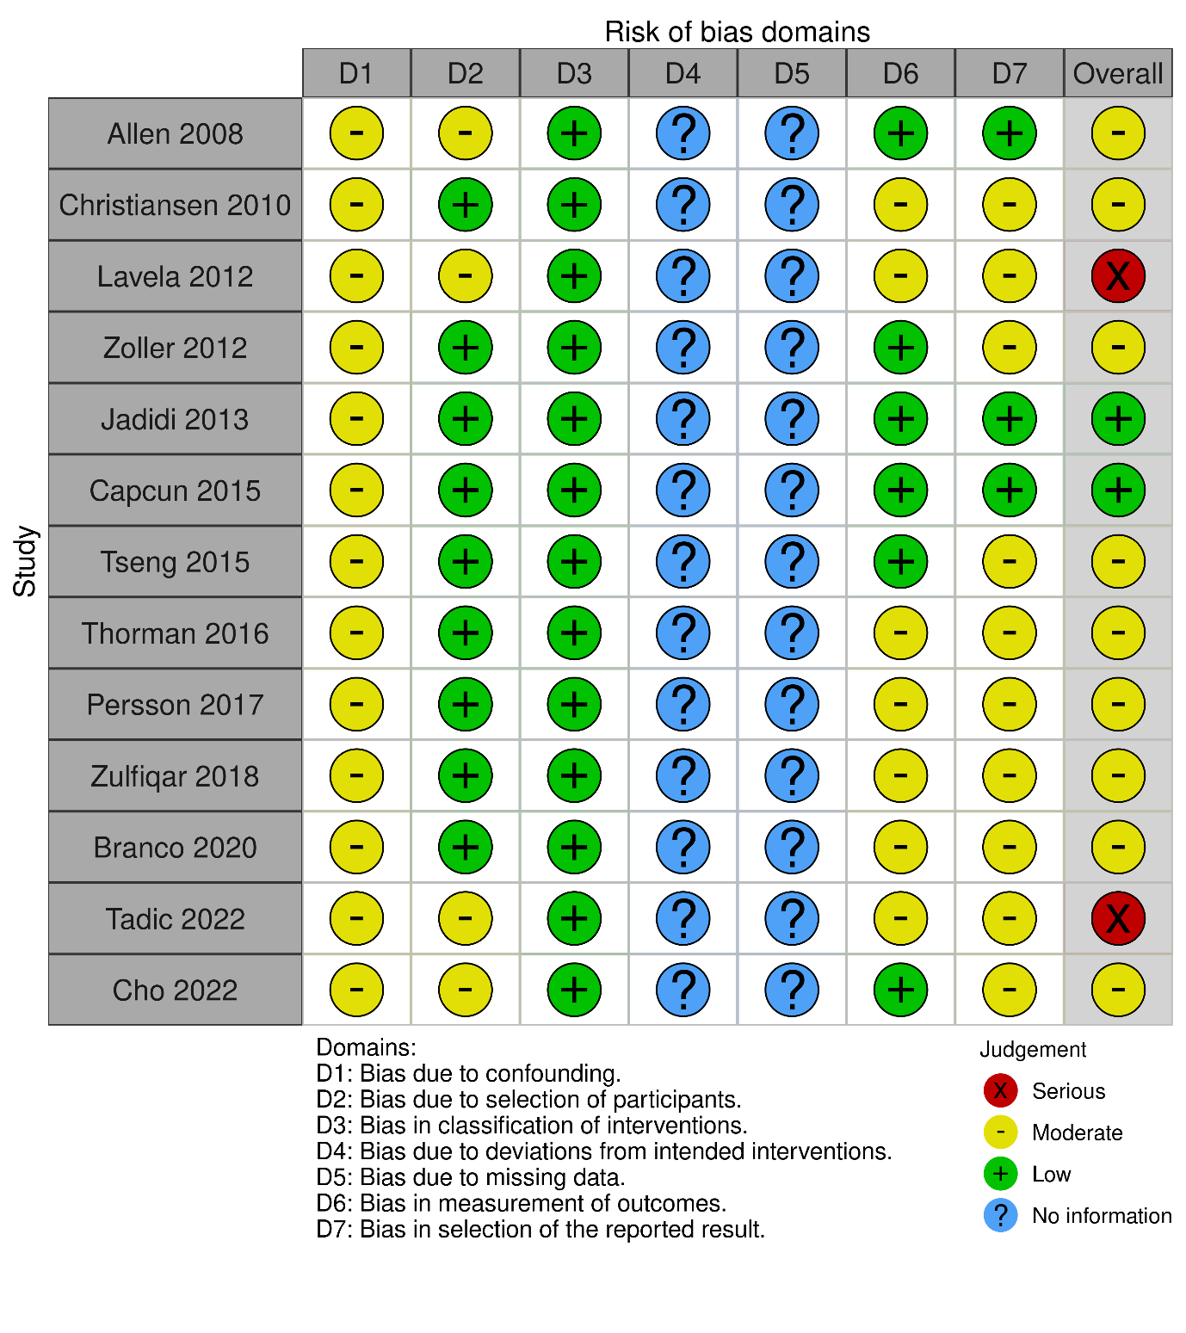

Supplementary Figure 2: Prevalence of hypertension in the included MS population
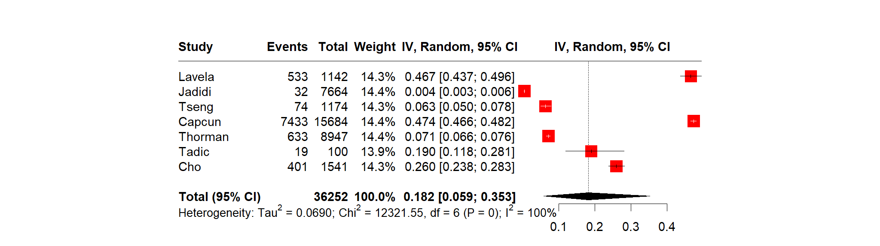
Supplementary Figure 3: Prevalence of diabetes in the included MS population
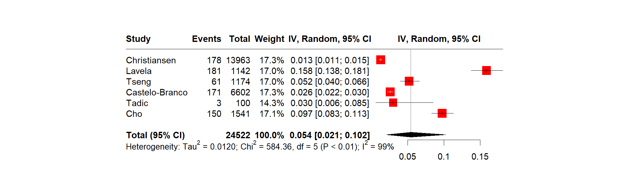

Supplementary Figure 4: Prevalence of dyslipidemia in the included MS population

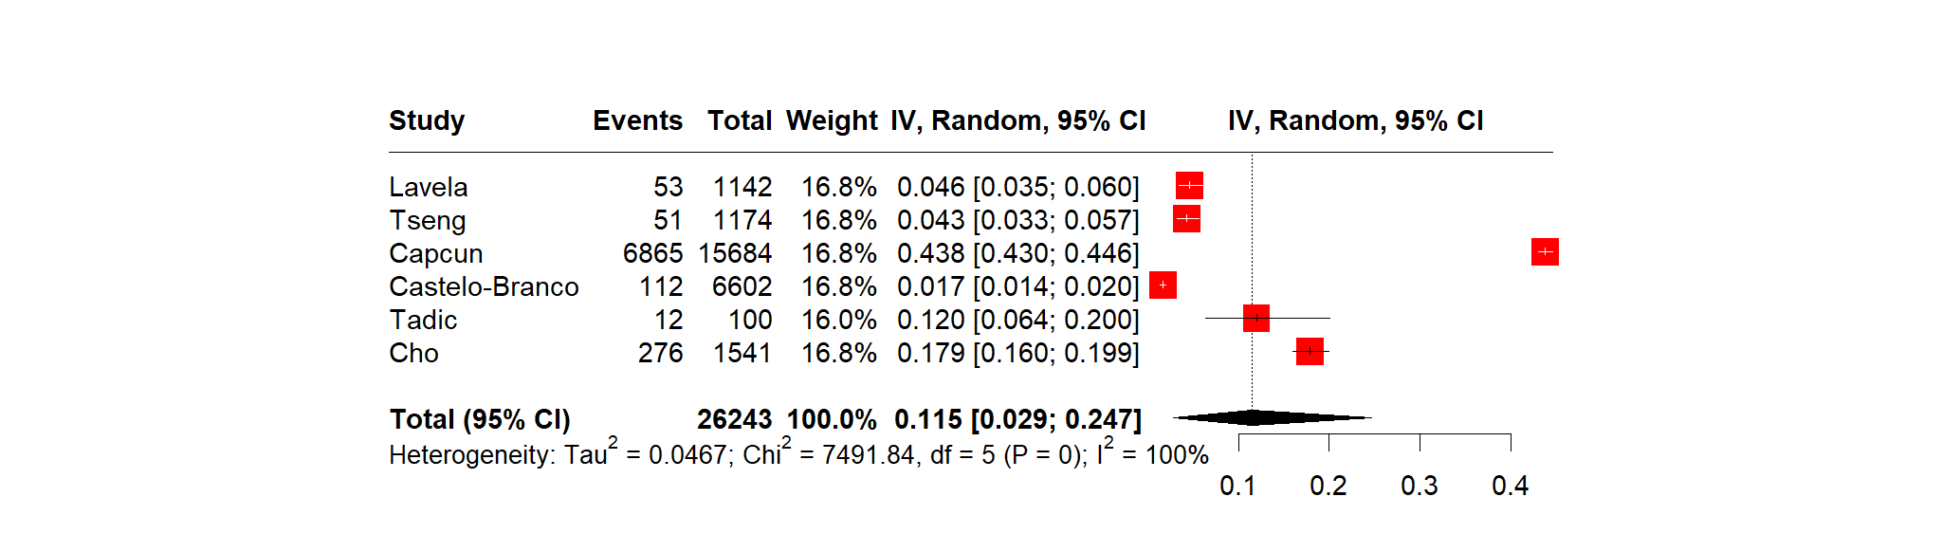
Supplementary Figure 5: Meta-regression bubble plot: association of age with risk ratio of acute ischemic stroke (AIS)
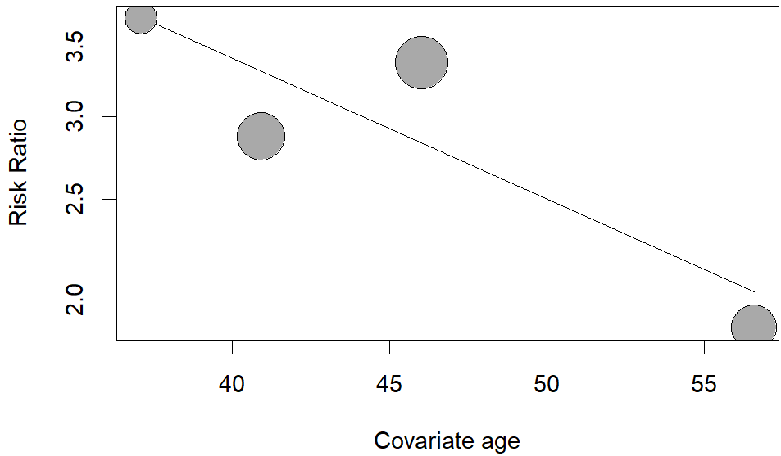

Supplementary Figure 6: Pooled prevalence of all-cause stroke in MS patients in sensitivity analysis after exclusion of low-quality studies

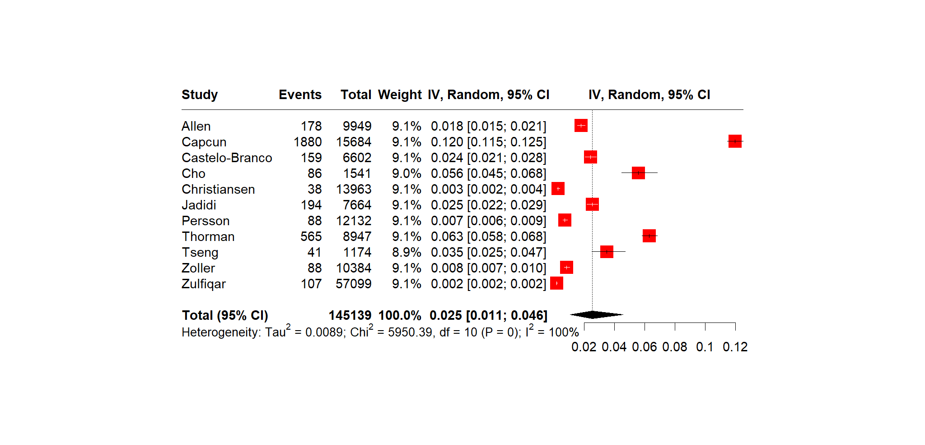

Supplementary Figure 7: Relative risk for all-cause stroke in the MS population compared to the general population in sensitivity analysis after exclusion of low-quality studies

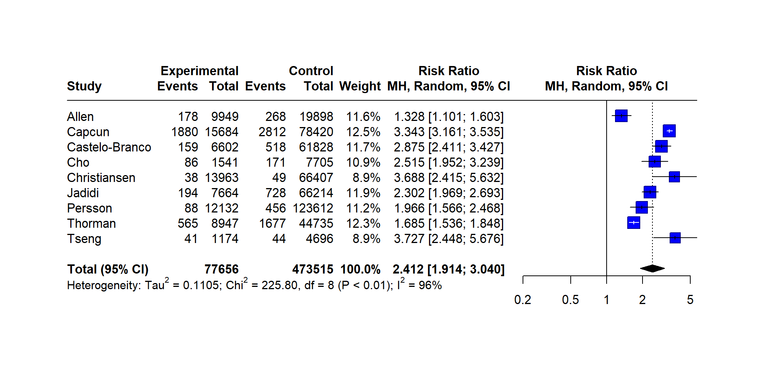
Supplementary Figure 8: Pooled prevalence of all-cause stroke in MS patients in sensitivity analysis after exclusion of studies with duration shorter than 10 years

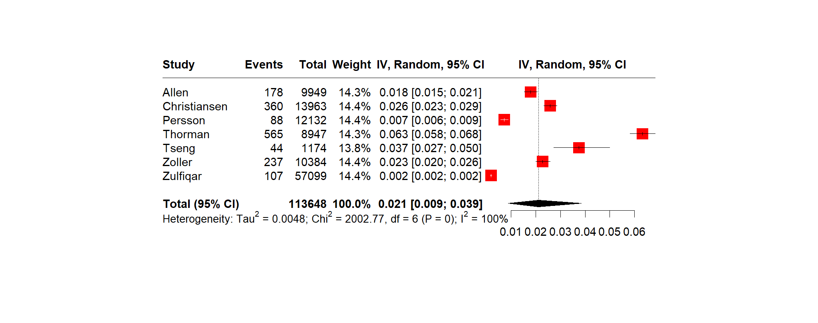
Supplementary Figure 9: Relative risk for all-cause stroke in the MS population compared to the general population in sensitivity analysis after exclusion of studies with duration shorter than 10 years

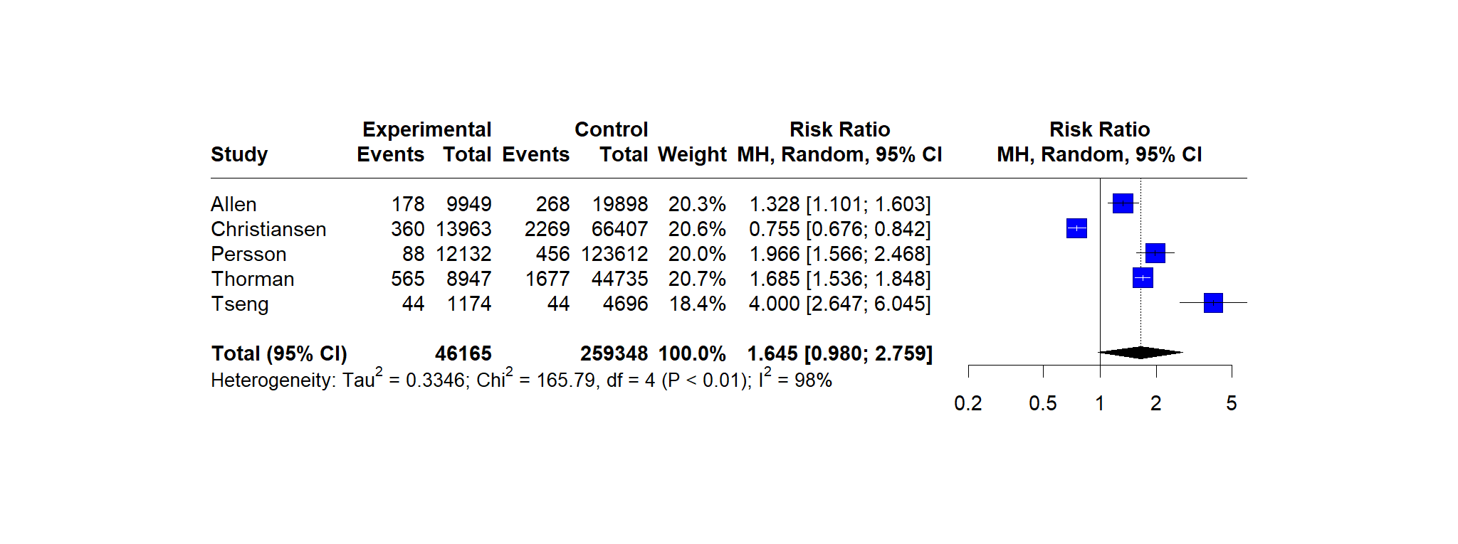
Supplementary Figure 10: Funnel Plot of all-cause stroke prevalence in the MS population
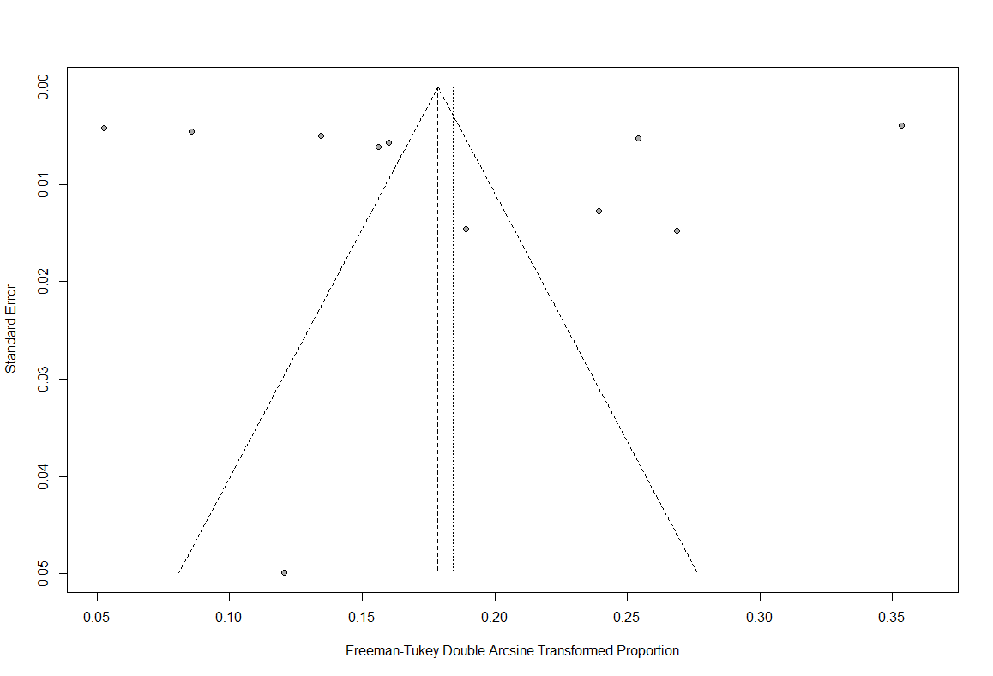
Supplementary Figure 11: Funnel Plot of the relative risk for all-cause stroke in the MS population compared to the general population
