Supplement
S1 Cortical thickness analysis: significant cluster
TFCE, FWE, p < 0.01
DM1 < HC
______________________________________________________
Desikan-Killiany DK40 Atlas: lh
______________________________________________________
P-value Cluster-Size Overlap of atlas region
0.00006 23675 10% superiorfrontal
8% precentral
8% postcentral
7% supramarginal
7% superiorparietal
7% rostralmiddlefrontal
6% inferiorparietal
5% lateraloccipital
4% superiortemporal
4% precuneus
3% caudalmiddlefrontal
3% lingual
3% fusiform
3% paracentral
2% parsopercularis
2% posteriorcingulate
2% isthmuscingulate
2% lateralorbitofrontal
2% pericalcarine
1% cuneus
1% parstriangularis
1% middletemporal
1% insula
1% bankssts
1% medialorbitofrontal
______________________________________________________
Desikan-Killiany DK40 Atlas: rh
____________________________________________________
P-value Cluster-Size Overlap of atlas region

0.00002 24395 9% superiorfrontal
8% precentral
8% superiorparietal
7% inferiorparietal
7% postcentral
7% supramarginal
6% rostralmiddlefrontal
6% precuneus
4% lateraloccipital
4% middletemporal
3% superiortemporal
3% lingual
3% paracentral
3% caudalmiddlefrontal
3% posteriorcingulate
2% fusiform
2% lateralorbitofrontal
2% bankssts
2% parsopercularis
1% pericalcarine
1% isthmuscingulate
1% cuneus
1% parstriangularis
1% medialorbitofrontal

DM2 < HC
______________________________________________________
Desikan-Killiany DK40 Atlas: lh
______________________________________________________
P-value Cluster-Size Overlap of atlas region
0.00004 18438 8% superiorfrontal
7% supramarginal
7% superiortemporal
7% rostralmiddlefrontal
6% postcentral
6% superiorparietal
6% lateraloccipital
5% precentral
5% inferiorparietal
5% precuneus
4% lingual
3% middletemporal
3% parsopercularis
3% posteriorcingulate
2% fusiform
2% isthmuscingulate
2% parstriangularis
2% paracentral
2% cuneus
2% bankssts
2% insula
2% pericalcarine
2% parahippocampal
1% caudalmiddlefrontal
1% caudalanteriorcingulate
1% lateralorbitofrontal
1% transversetemporal
______________________________________________________
Desikan-Killiany DK40 Atlas: rh
______________________________________________________
P-value Cluster-Size Overlap of atlas region
0.00001 20353 9% inferiorparietal
8% postcentral
8% superiorparietal
8% precentral
7% supramarginal
6% superiortemporal
6% superiorfrontal
5% rostralmiddlefrontal
5% precuneus
4% lateraloccipital
4% middletemporal
4% lingual
3% fusiform
3% posteriorcingulate
2% paracentral
2% bankssts
2% pericalcarine
2% cuneus
1% caudalmiddlefrontal
1% isthmuscingulate
1% lateralorbitofrontal
1% parstriangularis
1% parsorbitalis

DM1 < DM2
______________________________________________________
Desikan-Killiany DK40 Atlas: lh
______________________________________________________
P-value Cluster-Size Overlap of atlas region
0.00765 881 50% caudalmiddlefrontal
28% superiorfrontal
11% rostralmiddlefrontal
10% precentral
______________________________________________________
Desikan-Killiany DK40 Atlas: rh
______________________________________________________
P-value Cluster-Size Overlap of atlas region
0.00925 377 64% superiorfrontal
34% caudalmiddlefrontal
2% rostralmiddlefrontal

0.00981 149 60% precuneus
40% paracentral

S2 Average cortical thickness (in mm) of healthy controls.
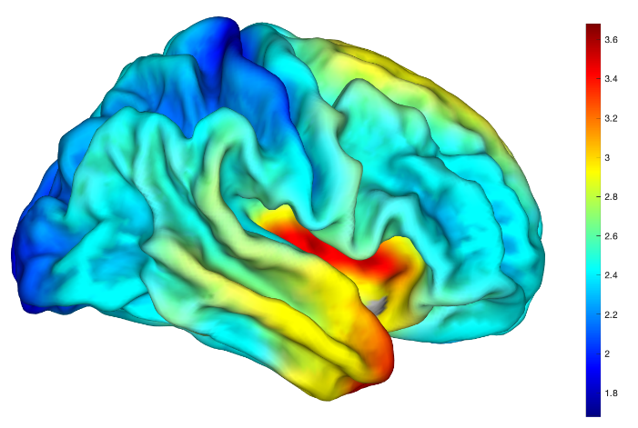
S3 Cortical thickness analysis for comparison between young (<33y) and old (>33y) healthy controls. Results were corrected by TFCE and FWE and thresholded at p<0.01 .
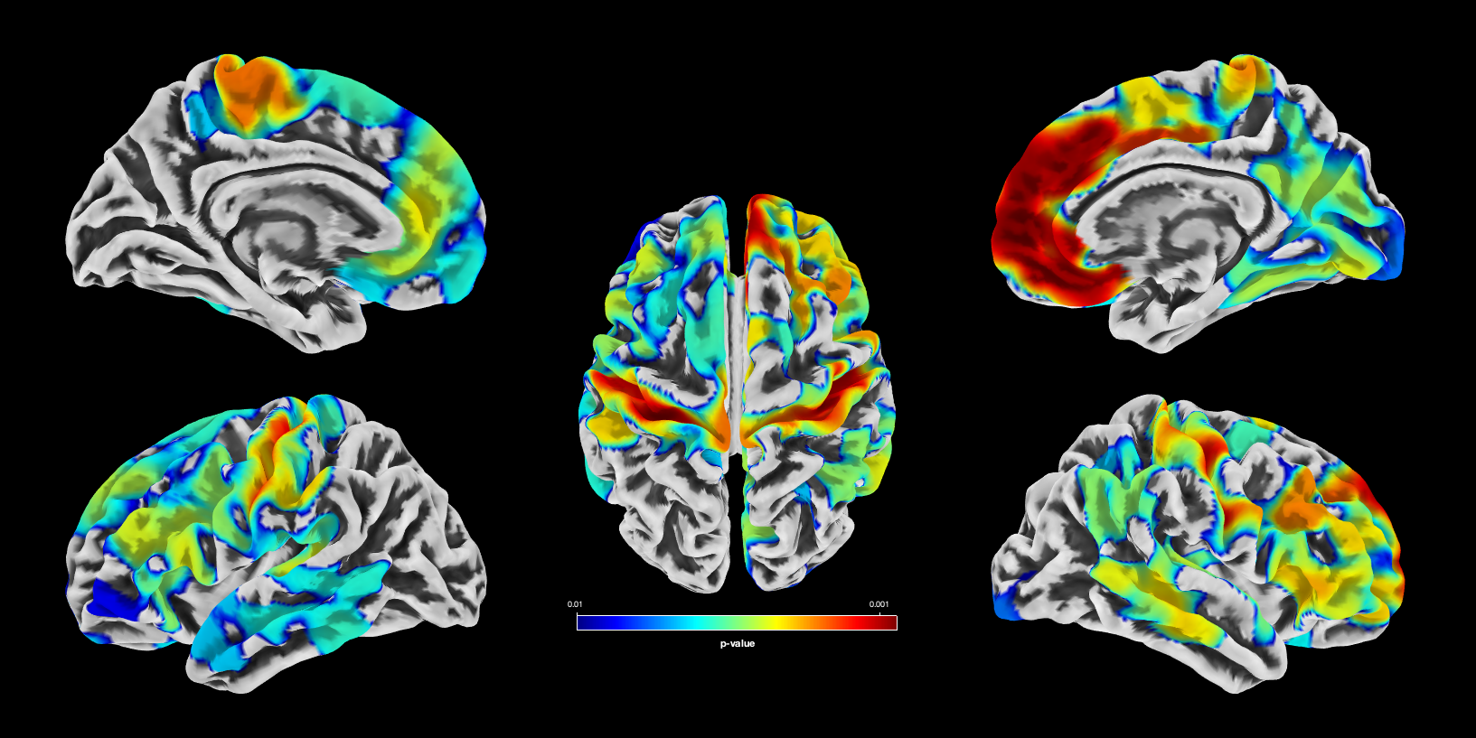
S4 TBSS
MD (red), RD (yellow) DM1 > HC
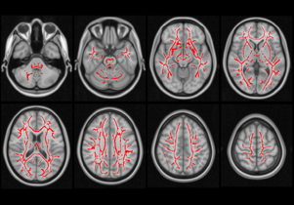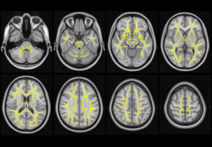

MD (red), RD (yellow) DM2 > HC
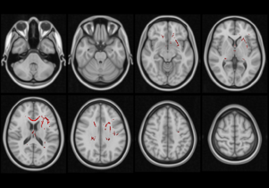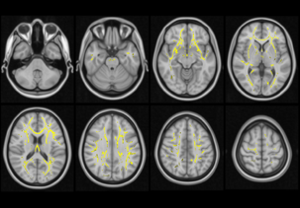

MD (red), RD (yellow), DM1 > DM2
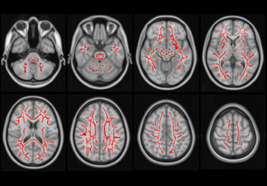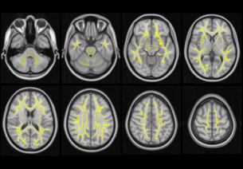

S5 Lesion distribution: (left: DM1, right: DM2)
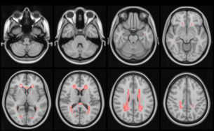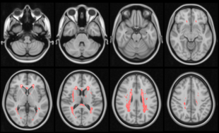

S6 Comparison of cortical thickness between childhood and adult onset DM1 patients with regard to CTG repeat length

