Supplementary information
The riluzole-treated ALS population
Figure S1 ALS incidence -and mortality rates stratified by gender and year of diagnosis
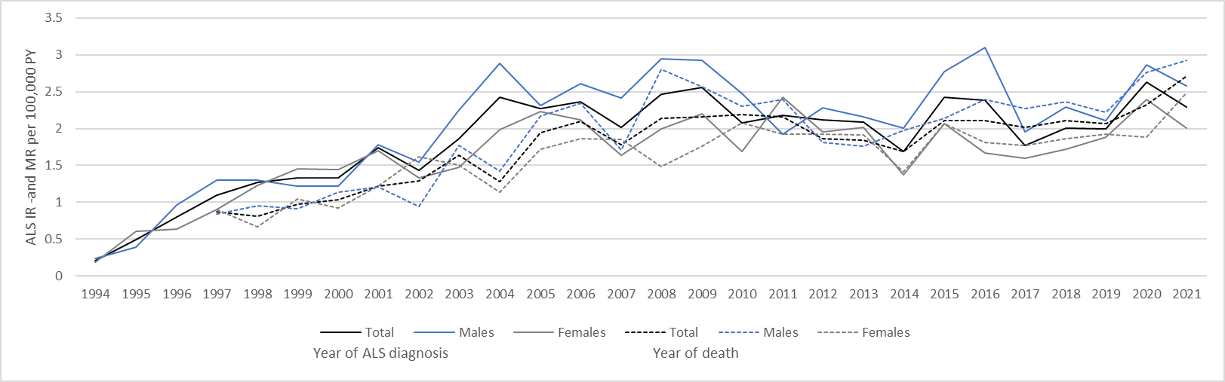
Abbreviations: ALS, amyotrophic lateral sclerosis; IR, incidence rate; MR, mortality rate; PY, person years

Figure S2 ALS incidence rate stratified by age and year of diagnosis
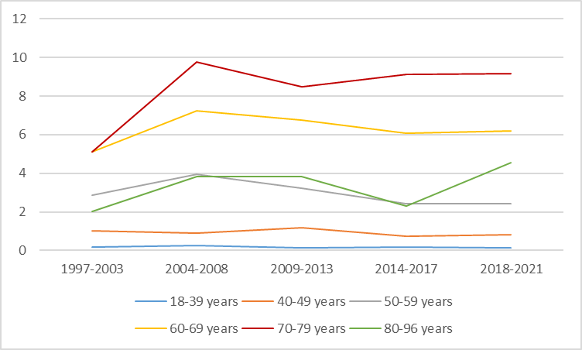

Figure S3 ALS incidence rate per 100,000 during the period from 1980 to 2021 stratified by gender and age
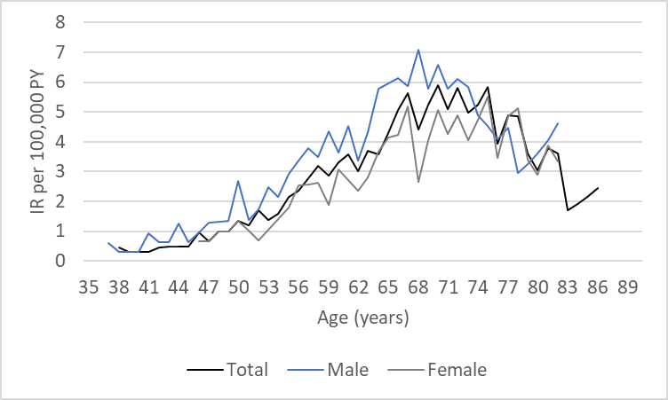
Abbreviations: ALS, amyotrophic lateral sclerosis; IR, incidence rate; PY, person years

Figure S4 Cumulative mortality
