Supplement

Supplementary Table 1. Distribution of SNPs at bp987 and bp1118 for control wildtype alleles, SCA3 mutation carrier wildtype and expanded alleles
base pair (bp) | Group1 | Group2 | sign. |  | p-value⁴
 | Controls | SCA3, wildtype
bp987 | G¹: 74.16 % C²: 25.84 % | G: 72.50 % C: 27.50 % |  |  | 0.52
bp1118 | C : 75.28 % A³: 24.72 % | C: 69.29 % A: 30.71 % |  |  | 0.07
 | Controls | SCA3, expanded
bp987 | G: 74.16 % C: 25.84 % | G: 27.14 % C: 72.86 % | ** |  | <0.001
bp1118 | C: 75.28 %. A: 24.72 % | C: 28.93 % A: 71.07 % | ** |  | <0.001
 | SCA3, wildtype | SCA3, expanded
bp987 | G: 72.50 % C: 27.50 % | G: 27.14 % C: 72.86 % | ** |  | <0.001
bp1118 | C: 69.29 % A: 30.71 % | C: 28.93 % A: 71.07 % | ** |  | <0.001
 | Ataxic SCA3, wildtype | Pre-ataxic SCA3, wildtype
bp987 | G: 71.7 %  C: 28.3 % | G: 75.9 %  C: 24.1 % |  |  | 0.61
bp1118 | C: 68.6 %. A: 31.4 % | C: 72.2 % A: 27.8 % |  |  | 0.74
 | Ataxic SCA3, expanded | Pre-ataxic SCA3,  expanded
bp987 | G: 28.3 %  C: 71.7 % | G: 22.2 %  C: 77.8 % |  |  | 0.40
bp1118 | C: 29.2 % A: 70.8 % | C: 27.8 % A: 72.2 % |  |  | 1.00
¹Guanine; ²Cytosine; ³Adenine; ⁴ Fisher-test; sign. = significance; ** p < 0.001

Supplementary Table 2. Clinical and demographic characteristics of pre-ataxic and ataxic SCA3 mutation carriers

 | Pre-ataxic SCA3 | Ataxic SCA3 | sign. | p-value
N | 54 | 226 |  | n.a.
N male / female (%) | 21 / 33 (38.9 / 61.1) | 117 / 109 (51.8 / 48.2) |  | 0.10¹
Age at baseline  mean [SD] | 34.10 [8.59] | 51.59 [11.47] | ** | < 0.001²
CAG repeats longer allele  median [IQR] | 68.50 [66.00, 70.00] | 69.00 [66.00, 71.00] |  | 0.20³
Age of onset  mean [SD] | 42.38 [8.46] | 39.86 [10.03] |  | 0.35²
SARA sum score  median [IQR] | 1.00 [0.00, 2.00] | 12.00 [8.00, 19.50] | ** | < 0.001³
SARA sum score  annual progression  median [IQR] | 0.00 [0.00, 0.49] | 1.07 [0.00, 2.38] | ** | < 0.001³
INAS count  median [IQR] | 1.00 [0.00, 2.00] | 5.00 [4.00, 7.00] | ** | < 0.001³
Disease duration at baseline, in years⁴  median [IQR] | -8.28 [-12.63, -5.71] | 10.89 [6.09, 17.22] | ** | < 0.001³
¹Fisher-Test; ²one-way Anova; ³Kruskal-Wallis-Test; ⁴disease duration is defined as the time from the age of onset (detailed description is given in the Methods section) until baseline visit, in years; n.a. = not applicable; sign. = significance; IQR = interquartile range; SD = standard deviation; ** p < 0.001
Supplementary Table 3. Clinical and demographic characteristics of ataxic SCA3 mutation carriers, divided per haplotype of the expanded allele
 | Haplotype, expanded allele bp987 – bp1118
 | Cytosine - Adenine | Guanine - Cytosine | Cytosine - Cytosine | Guanine - Adenine | sign. | p-value
N | 150 | 54 | 12 | 10 |  | n.a.
N male / female (%) | 81 / 69 (54 / 46) | 25 / 29 (46.6 / 53.7) | 7 / 5 (58.3 / 41.7) | 4 / 6 (40 / 60) |  | 0.66¹
Age at baseline  mean [SD] | 51.78 [10.52] | 51.32 [13.48] | 50.23 [10.00] | 51.87 [16.14] |  | 0.97²
CAG repeats longer allele  median [IQR] | 69.00 [66.00, 71.00] | 70.00 [65.25, 72.00] | 71.00 [68.50, 72.00] | 67.50 [66.25, 70.00] |  | 0.47³
Age of onset  mean [SD] | 40.32 [9.38] | 40.19 [11.53] | 35.60 [7.02] | 36.20 [13.16] |  | 0.28²
SARA sum score  median [IQR] | 11.00 [8.00, 17.00] | 10.25 [6.88, 21.25] | 15.00 [11.38, 25.88] | 20.00 [15.62, 22.25] | * | 0.01³
SARA sum score  annual progression  median [IQR] | 1.00 [0.00, 2.16] | 1.19 [-0.43, 2.57] | 3.35 [2.07, 4.30] | 0.66 [0.28, 1.67] |  | 0.06³
INAS count  median [IQR] | 5.00 [3.00, 7.00] | 5.00 [4.00, 8.00] | 4.00 [4.00, 6.00] | 8.00 [5.50, 9.00] |  | 0.20³
Disease duration at baseline, in years⁴  median [IQR] | 10.81 [5.88 , 16.21] | 9.79 [6.35 , 15.10] | 14.19 [8.36 , 19.44] | 17.50 [12.10 , 21.99] |  | 0.12³
¹Fisher-Test; ²one-way Anova; ³Kruskal-Wallis-Test; ⁴disease duration is defined as the time from the age of onset (detailed description is given in the Methods section) until baseline visit, in years; n.a. = non applicable; sign. = significance; IQR = interquartile range; SD = standard deviation; * p < 0.05

Supplementary Table 4. Distribution of each INAS item of the ataxic SCA3 mutation carrier, divided per haplotype of the expanded allele
 | Haplotype bp987 – bp1118, expanded allele ataxic SCA3 [N absent / present (%)] |  |  |  | sign. | p-value¹
INAS item | Cytosine - Adenine | Guanine - Cytosine | Cytosine - Cytosine | Guanine - Adenine
Hyperreflexia | 94 / 53 (63.9 / 36.1) | 26 / 25 (51.0 / 49.0) | 5 / 6 (45.5 / 54.5) | 7 / 3 (70.0 / 30.0) |  | 0.26
Areflexia | 58 / 89 (39.5 / 60.5) | 28 / 23 (54.9 / 45.1) | 9 / 2 (81.8 / 18.2) | 5 / 5 (50.0 / 50.0) | * | 0.02
Extensor plantar reflex | 109 / 36 (75.2 / 24.8) | 24 / 24 (50.0 / 50.0) | 5 / 6 (45.5 / 54.5) | 7 / 3 (70.0 / 30.0) | * | 0.01
Spasticity | 98 / 46 (68.1 / 31.9) | 23 / 27 (46.0 / 54.0) | 4 / 7 (36.4 / 63.6) | 2 / 5 (28.6 / 71.4) | * | 0.01
Paresis | 103 / 43 (70.5 / 29.5) | 31 / 20 (60.8 / 39.2) | 7 / 5 (58.3 / 41.7) | 4 / 6 (40.0 / 60.0) |  | 0.15
Muscle Atrophy | 114 / 33 (77.6 / 22.4) | 36 / 15 (70.6 / 29.4) | 11 / 1 (91.7 / 8.3) | 4 / 6 (40.0 / 60.0) | * | 0.03
Fasciculation | 123 / 24 (83.7 / 16.3) | 40 / 10 (80.0 / 20.0) | 9 / 3 (75.0 / 25.0) | 6 / 4 (60.0 / 40.0) |  | 0.23
Myoclonus | 128 / 19 (87.1 / 12.9) | 36 / 14 (72.0 / 28.0) | 7 / 5 (58.3 / 41.7) | 6 / 4 (60.0 / 40.0) | * | 0.01
Rigidity | 139 / 8 (94.6 / 5.4) | 47 / 3 (94.0 / 6.0) | 12 / 0 (100.0 / 0.0) | 9 / 1 (90.0 / 10.0) |  | 0.70
Chorea and Dyskinesia | 139 / 8 (94.6 / 5.4) | 48 / 3 (94.1 / 5.9) | 11 / 1 (91.7 / 8.3) | 9 / 1 (90.0 / 10.0) |  | 0.61
Dystonia | 119 / 28 (81.0 / 19.0) | 27 / 23 (54.0 / 46.0) | 11 / 1 (91.7 / 8.3) | 3 / 7 (30.0 / 70.0) | ** | < 0.001
Resting Tremor | 143 / 4 (97.3 / 2.7) | 51 / 0 (100.0 / 0.0) | 12 / 0 (100.0 / 0.0) | 9 / 1 (90.0 / 10.0) |  | 0.23
Sensory symptoms | 34 / 109 (23.8 / 76.2) | 18 / 32 (36.0 / 64.0) | 4 / 8 (33.3 / 66.7) | 3 / 7 (30.0 / 70.0) |  | 0.34
Urinary dysfunction | 69 / 78 (46.9 / 53.1) | 27 / 24 (52.9 / 47.1) | 8 / 4 (66.7 / 33.3) | 2 / 8 (20.0 / 80.0) |  | 0.15
Cognitive impairment | 111 / 36 (75.5 / 24.5) | 40 / 12 (76.9 / 23.1) | 6 / 6 (50.0 / 50.0) | 6 / 3 (66.7 / 33.3) |  | 0.25
Brainstem oculomotor signs | 31 / 118 (20.8 / 79.2) | 17 / 36 (32.1 / 67.9) | 7 / 5 (58.3 / 41.7) | 0 / 9 (0.0 / 100.0) | * | 0.01
¹Fisher-Test; sign. = significance; * p < 0.05; ** p < 0.001

Supplementary Table 5. Exact Fisher test of the INAS items which showed a significant relation in supplementary table 4, tested for each haplotype of the expanded allele
Haplotype bp987 – bp1118, expanded allele | Item | sign. | p-value¹
Cytosine - Adenine versus  Guanine - Cytosine | Areflexia |  | 0.07
Cytosine - Adenine versus  Guanine - Cytosine | Extensor plantar reflex | * | 0.00
Cytosine - Adenine versus  Guanine - Cytosine | Spasticity | * | 0.01
(N= 150)  (N= 54) | Muscle Atrophy |  | 0.35
(N= 150)  (N= 54) | Myoclonus |  | 0.03
(N= 150)  (N= 54) | Dystonia | * | 0.00
(N= 150)  (N= 54) | Brainstem oculomotor signs |  | 0.13

Haplotype, expanded allele | Item | sign. | p¹
Cytosine - Adenine  versus  Cytosine - Cytosine | Areflexia | * | 0.01
Cytosine - Adenine  versus  Cytosine - Cytosine | Extensor plantar reflex |  | 0.07
Cytosine - Adenine  versus  Cytosine - Cytosine | Spasticity |  | 0.05
(N= 150)  (N= 12) | Muscle Atrophy |  | 0.46
(N= 150)  (N= 12) | Myoclonus |  | 0.02
(N= 150)  (N= 12) | Dystonia |  | 0.70
(N= 150)  (N= 12) | Brainstem oculomotor signs | * | 0.01
Haplotype, expanded allele | Item | sign. | p¹
Cytosine - Adenine  versus  Guanine - Adenine | Areflexia |  | 0.52
Cytosine - Adenine  versus  Guanine - Adenine | Extensor plantar reflex |  | 0.71
Cytosine - Adenine  versus  Guanine - Adenine | Spasticity |  | 0.04
(N= 150)  (N= 10) | Muscle Atrophy | * | 0.02
(N= 150)  (N= 10) | Myoclonus |  | 0.04
(N= 150)  (N= 10) | Dystonia | * | 0.00
(N= 150)  (N= 10) | Brainstem oculomotor signs |  | 0.21
Haplotype, expanded allele | Item | sign. | p¹
Cytosine - Cytosine  versus  Guanine - Cytosine | Areflexia |  | 0.17
Cytosine - Cytosine  versus  Guanine - Cytosine | Extensor plantar reflex |  | 1.00
Cytosine - Cytosine  versus  Guanine - Cytosine | Spasticity |  | 0.74
(N= 12)  (N= 54) | Muscle Atrophy |  | 0.27
(N= 12)  (N= 54) | Myoclonus |  | 0.49
(N= 12)  (N= 54) | Dystonia |  | 0.02
(N= 12)  (N= 54) | Brainstem oculomotor signs |  | 0.11
Haplotype, expanded allele | Item | sign. | p¹
Cytosine - Cytosine  versus  Guanine - Adenine | Areflexia |  | 0.18
Cytosine - Cytosine  versus  Guanine - Adenine | Extensor plantar reflex |  | 0.39
Cytosine - Cytosine  versus  Guanine - Adenine | Spasticity |  | 1.00
(N= 12)  (N= 10) | Muscle Atrophy |  | 0.02
(N= 12)  (N= 10) | Myoclonus |  | 1.00
(N= 12)  (N= 10) | Dystonia | * | 0.01
(N= 12)  (N= 10) | Brainstem oculomotor signs | * | 0.01

Haplotype, expanded allele | Item | sign. | p¹
Guanine - Adenine  versus  Guanine - Cytosine | Areflexia |  | 1.00
Guanine - Adenine  versus  Guanine - Cytosine | Extensor plantar reflex |  | 0.31
Guanine - Adenine  versus  Guanine - Cytosine | Spasticity |  | 0.45
(N= 10)  (N= 54) | Muscle Atrophy |  | 0.08
(N= 10)  (N= 54) | Myoclonus |  | 0.47
(N= 10)  (N= 54) | Dystonia |  | 0.30
(N= 10)  (N= 54) | Brainstem oculomotor signs |  | 0.05
¹Significancy shown as * p < 0.0167 with corrected ¹alpha = 0.0167 for multiple comparisons; sign. = significance

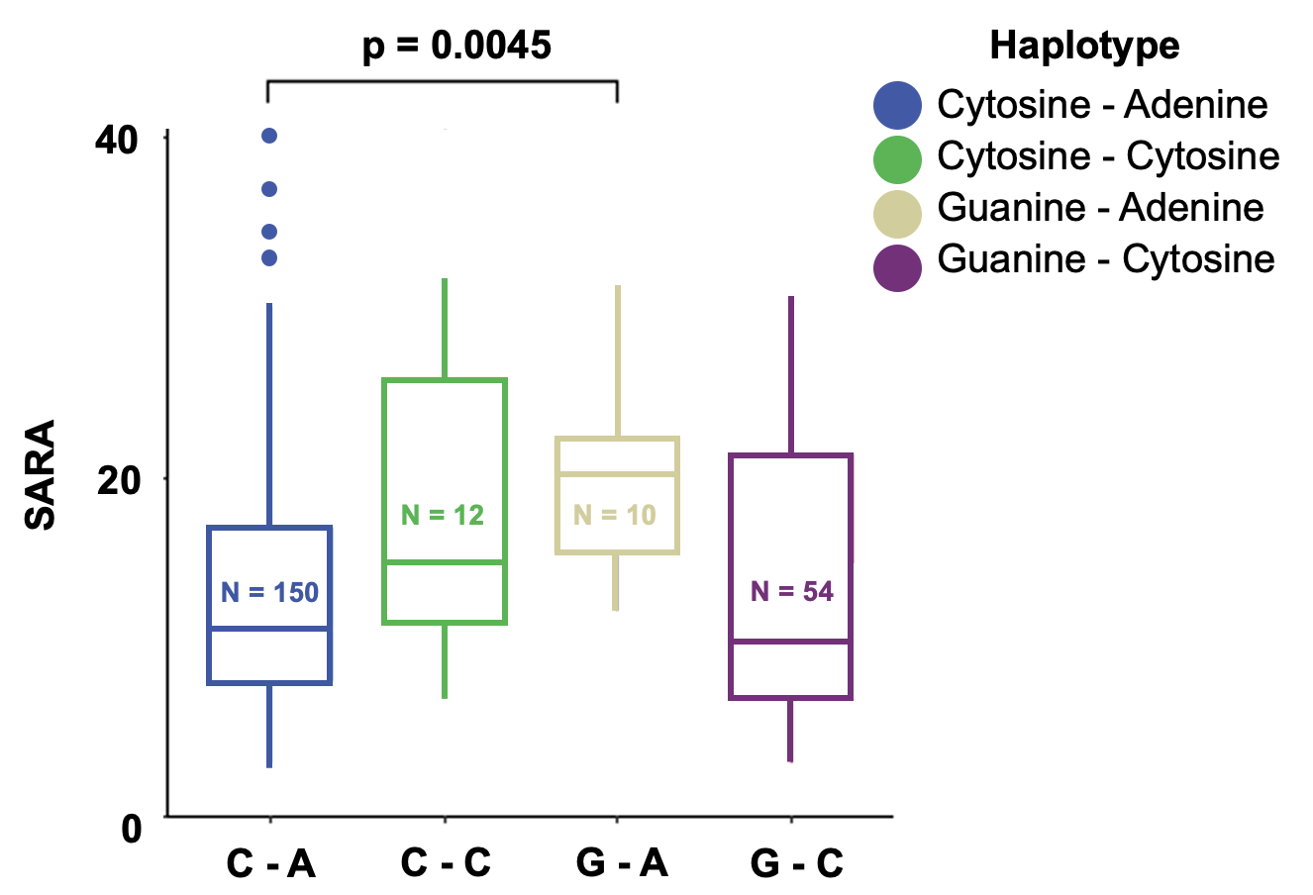
Supplementary Figure 1. Boxplots of ataxia severity assessed with the SARA sum score for each haplotype of the expanded allele at bp987 and bp1118 in ataxic SCA3 mutation carriers. Kruskal-Wallis-Test showed a statistically significant difference between the haplotypes Cytosine – Adenine (C – A) and Guanine – Adenine (G – A) (p < 0.01). The blue boxplot shows the distribution of Cytosine – Adenine (C – A) (N = 150), the green boxplot the distribution in Cytosine – Cytosine (C – C) (N = 12), the ochre boxplot the distribution in Guanine - Adenine (N = 10) and the purple boxplot the distribution in Guanine – Cytosine (G – C) (N = 54).

Supplementary Table 6. Number of participants with the different haplotypes of the expanded allele given for each research centers ranked by alphabetical order

 | N Haplotype bp987 - bp1118, expanded allele SCA3 |  |  |  | N total
Research center (in alphabetical order) | Cytosine - Adenine | Guanine - Cytosine | Cytosine - Cytosine | Guanine - Adenine
Aachen | 2 |  |  |  | 2
Azores | 31 | 25 | 8 | 1 | 65
Bonn | 37 | 2 | 1 |  | 40
Coimbra | 18 | 31 | 2 | 1 | 52
Essen | 6 |  | 1 | 1 | 8
Groningen | 13 |  |  |  | 13
Heidelberg | 7 |  |  |  | 7
London | 30 | 8 |  | 6 | 44
Nijmegen | 11 |  | 2 | 1 | 14
Santander | 7 |  |  |  | 7
Tübingen | 27 |  | 1 |  | 28

