Supplemental Material

Predicting Delirium In Acute Ischemic Stroke: The PREDELIS Score

Natalie Berger (MD)¹, Diether Kramer (PhD)², Michael Schrempf (MSc)³, Edith Hofer (PhD)^{1,4}, Alexander Pichler (MD, PhD)¹, Simon Fandler-Höfler (MD, PhD)¹, Melanie Haidegger (MD)¹, Isra Hatab (MD)¹, Martin Heine (MD)⁵, Jan Jagiello (MD)⁶, Herbert Koller (MD)⁷, Stefan Lilek (MD)⁸, Sai Veeranki (PhD)², Christian Enzinger (MD)¹, Thomas Gattringer (MD, PhD)¹, Markus Kneihsl (MD, PhD)^{1,9}

¹ Department of Neurology, Medical University of Graz, Graz, Austria
² Directorate Technology and IT, Steiermärkische Krankenanstaltengesellschaft m.b.H. (KAGes), Graz, Austria
³ Department of Internal Medicine, Division of Cardiolody, Medical University of Graz, Graz, Austria
⁴ Institute for Medical Informatics, Statistics and Documentation, Medical University of Graz, Graz, Austria
⁵ Department of Neurology, LKH Oststeiermark, Feldbach, Austria
⁶ Department of Neurology, LKH Murtal, Knittelfeld, Austria
⁷ Department of Neurology, LKH Graz II, Graz, Austria
⁸ Department of Neurology, LKH Hochsteiermark, Bruck/Mur, Austria
⁹ Division of Neuroradiology, Department of Radiology, Medical University of Graz, Graz, Austria

Supplemental Table 1: Overview of delirium risk factors as presented in previous studies.
Variables | Studies of hospitalized non-stroke patients |  |  | Studies of stroke patients
Demographics and medical history
Age | Vreeswijk et al.¹; Ormseth et al.²; van den Boogaard et al.³ |  | Oldenbeuving et al.⁴; Alvarez-Perez et al.⁵; Fleischmann et al.⁶; Gustafson et al.⁷; Kostalova et al.⁸; Miu et al.⁹, Shaw et al.¹⁰, Pasinska et al.¹¹, Zhang et al.¹²
Male sex | Ormseth et al.² |  | Gustafson et al.⁷, Shaw et al.¹⁰
Vascular risk factors
Arterial hypertension | Ormseth et al.² |  | -
Hyperlipidemia | - |  | Alvarez-Perez et al.⁵
Diabetes | Ormseth et al.² |  | Miu et al.⁹, Pasinska et al.¹¹
Smoking | Ormseth et al.² |  | Zhang et al.¹²
Chronic alcohol consumption | Ormseth et al.² |  | Shaw et al.¹⁰, Zhang et al.¹²
Artrial fibrillation | Ormseth et al.² |  | Alvarez-Perez et al.⁵, Gustafson et al.⁷, Pasinska et al.¹¹, Zhang et al.¹²
Laboratory parameters
Leucocytes | Ormseth et al.², van den Boogaard et al.³ |  | Alvarez-Perez et al.⁵, Kostalova et al.⁸, Pasinska et al.¹¹
Platelets | - |  | Kostalova et al.⁸
Blood urea | van den Boogaard et al.³ |  | Oldenbeuving et al.⁴, Kostalova et al.⁸
Creatinine | Ormseth et al.²; van den Boogaard et al.³ |  | Oldenbeuving et al.⁴, Kostalova et al.⁸, Pasinska et al.¹¹
Blood sodium | Ormseth et al.², van den Boogaard et al.³ |  | Oldenbeuving et al.⁴, Alvarez-Perez et al.⁵, Kostalova et al.⁸
Blood potassium | Ormseth et al.², van den Boogaard et al.³ |  | Pasinska et al.¹¹
Bilirubine | - |  | Kostalova et al.⁸
GGT | - |  | Kostalova et al.⁸
Glucose | Ormseth et al.² |  | Oldenbeuving et al.⁴, Pasinska et al.¹¹
CRP | - |  | Fleischmann et al.⁶, Pasinska et al.¹¹
Medical history
Cognitive impairment | Vreeswijk et al.¹; Ormseth et al.² |  | Oldenbeuving et al.⁴; Alvarez-Perez et al.⁵; Gustafson et al.⁷, Kostalova et al.⁸, Miu et al.⁹, Shaw et al.¹⁰, Pasinska et al.¹¹, Zhang et al.¹²
Previous stroke | Ormseth et al.² |  | Alvarez-Perez et al.⁵, Miu et al.⁹
Previous delirium | Vreeswijk et al.¹, Ormseth et al.² |  | Gustafson et al.⁷, Kostalova et al.⁸
Renal insufficiency | Ormseth et al.² |  | Miu et al.⁹
Chronic liver disease | - |  | Kostalova et al.⁸, Miu et al.⁹
Psychiatric disease | Ormseth et al.² |  | -
Previous heart disease | Ormseth et al.² |  | Gustafson et al.⁷, Miu et al.⁹
Malnutrition | Ormseth et al.² |  | -
Infection | Ormseth et al.²; van den Boogaard et al.³ |  | Oldenbeuving et al.⁴; Alvarez-Perez.et al.⁵; Fleischmann et al.⁶; Gustafson et al.⁷, Kostalova et al.⁸, Miu et al.⁹, Pasinska et al.¹¹, Zhang et al.¹²
Visual/hearing impairment | Vreeswijk et al.¹; Ormseth et al.² |  | Pasinska et al.¹¹
Epilepsy | Ormseth et al.² |  | -
Multimorbidity | Vreeswijk et al.¹, Ormseth et al.² |  | Miu et al.⁹, Pasinska et al.¹¹
Mobility problems | Vreeswijk et al.¹; Ormseth et al.² |  | Miu et al. ⁹, Shaw et al.¹⁰, Pasinska et al.¹¹ , Zhang et al.¹²
Medication
Sedative medication | Ormseth et al.² |  | Gustafson et al.⁷, Kostalova et al.⁸, Miu et al. ⁹
Number of medications | Vreeswijk et al.¹; Ormseth et al.³ |  | Kostalova et al.⁸, Shaw et al.¹⁰
Stroke specific factors
Infarct localization (anterior/posterior circulation) | - | Oldenbeuving et al.⁴; Alvarez-Perez et al.⁵; Fleischmann et al.⁶, Kostalova et al.⁸, Zhang et al.¹²
Lacunar stroke | - | Alvarez-Perez et al.⁵, Fleischmann et al.⁶
Infarct localization (infratentorial/supratentorial) | - | Alvarez-Perez et al.⁵, Pasinska et al.¹¹
Left/right hemispheric stroke | - | Oldenbeuving et al.⁴, Gustafson et al.¹³, Pasinska et al.¹¹
Severe stroke syndromes (based on NIHSS at admission) | - | Oldenbeuving et al.⁴, Alvarez-Perez et al.⁵, Kostalova et al.⁸, Shaw et al.¹⁰, Pasinska et al.¹¹
Aphasia | - | Pasinska et al.¹¹, Zhang et al.¹²
Neglect | - | Kostalova et al.⁸, Pasinska et al.¹¹
Dysphagia | Ormseth et al.² | -

CRP: c-reactive protein, GGT: gamma-glytamyl transferase, NIHSS: National Institutes of Health Stroke scale

Supplemental Table 2: Demographics, medical history and clinical/laboratory parameters of the development and the validation cohort.
Variables | Derivation-Cohort, n=6,151 |  | Validation-Cohort, n=8,324
Demographics
Age, median (Q1, Q3) | 76 (65, 83) |  | 76 (66, 83)
Age >70, n (%) | 4092 (66.5) |  | 5645 (67.8)
Male sex, n (%) | 3254 (52.9) |  | 3776 (45.3)
Delir, n (%) | 398 (6.5) |  | 568 (6.8)
Medical history, n (%)
Atrial fibrillation | 1784 (29) |  | 2513 (30.2)
Arterial hypertension | 5177 (84.2) |  | 7017 (84.3)
Diabetes | 1530 (24.9) |  | 2202 (26.5)
Smoking | 1136 (18.5) |  | 1418 (17.0)
Chronic alcohol consumption | 633 (10.3) |  | 825 (9.9)
Dementia | 457 (7.4) |  | 610 (7.3)
Previous delirium | 80 (1.3) |  | 106 (1.3)
Substance abuse | 519 (8.4) |  | 726 (8.7)
Renal insufficiency | 910 (14.8) |  | 1284 (15.4)
Chronic liver disease | 2381 (38.7) |  | 3265 (39.2)
Previous heart disease | 3753 (61) |  | 5326 (64)
Psychiatric disease | 1159 (18.8) |  | 1732 (20.8)
Malnutrition | 93 (1.5) |  | 157 (1.9)
Visual/hearing impairment | 2078 (33.8) |  | 2958 (35.5)
Multimorbidity (≥2 chronic diagnosis) | 4251 (69.1) |  | 5912 (71.0)
Clinical parameters
Infection, n (%) | 2556 (41.6) |  | 3505 (42.1)
Pre admission mRS, median (Q1, Q3) | 0 (0, 1) |  | 0 (0,1)
NIHSS>7 at admission, n (%) | 1728 (28.1) |  | 2373 (28.5)
Aphasia, n (%) | 1511 (24.6) |  | 2130 (25.6)
Neglect, n (%) | 713 (11.6) |  | 1034 (12.4)
Dysphagia, n (%) | 547 (8.9) |  | 803 (9.6)
Stroke syndrome, n (%)
Anterior circulation stroke | 3314 (53.9) |  | 4595 (55.2)
Posterior circulation stroke | 1066 (17.3) |  | 1419 (17.0)
Non-lacunar stroke | 4464 (72.6) |  | 6117 (73.5)
Left hemispheric stroke | 2798 (45.5) |  | 3701 (44.5)
Medication at admission, n (%)
Polypharmacy (≥5 drugs) | 1435 (23.3) |  | 2110 (25.3)
Sedative medication | 125 (2) |  | 189 (2.3)

mRS: modified Rankin scale, NIHSS: National Institutes of Health Stroke scale
Supplemental Table 3: Multicollinearity assessment based on variance inflation factor for predictors of delirium.

Variable | Variance inflation factor
Age (>70) | 1.334
Male sex | 1.115
NIHSS >7 on admission | 1.250
Atrial fibrillation | 1.162
Non-lacunar stroke | 1.071
Dementia/cognitive impairment | 1.074
Previous delirium | 1.032
Chronic alcohol consumption | 1.068
Visual/hearing impairment | 1.111
Infection at admission | 1.133
Abnormal hematocrit | 1.100
Dysphagia | 1.104

Supplemental Table 4: Variables included in preexisting delirium prediction scores^{1, 4}
Oldenbeuving et al. Model 1 (points) |  |  |  | Oldenbeuving et al. Model 2 (points) |  |  | Delirium risk assessment score (points)
Age |  |  | (0-6) | Age |  | (0-6) | Age | (1)
Stroke severity (NIHSS) |  |  | (0-13) | Stroke severity (NIHSS) |  | (0-10) | Chronic alcohol consumption | (3)
Stroke subtype (PACI/TACI; POCI; ICH) |  | (5; 2; -2) |  | Stroke subtype (PACI/TACI; POCI; ICH) | (3; 1; -1) |  | History of delirium | (1)
Infection |  |  | (6) | Infection |  | (4) | Pre-existing mobility problems | (2)
Right hemispheric stroke |  |  | (3) |  |  |  | Cognitive impairment | (3)
Cognitive impairment |  |  | (6) |  |  |  | Acute admission | (3)
 |  |  |  |  |  |  | Visual/hearing impairment | (1)
 |  |  |  |  |  |  | Polypharmacy (≥5 medications) | (1)
 | -2-39 |  |  | -1-13 |  |  | 0-5

c
PACI/TACI: partial/total anterior circulation infarct, POCI: posterior circulation infarct, ICH: intracerebral hemorrhage
NIHSS: National Institutes of Health Stroke scale

Supplemental Table 5: Additional laboratory parameters on admission of the derivation stroke, categorized by the presence of delirium.
Variables | All ischemic stroke patients (n=6,151) | Patients with delirium (n=398) | Patients without delirium (N=5,753) | OR (95% CI) | p-value
Laboratory Variables
Platelets <140/>440 *10^9/L | 482 (7.8) | 48 (12.1) | 434 (7.5) | 1.68 (1.22-2.3) | 0.003
Blood urea >45mg/dL | 1496 (24.3) | 108 (27.1) | 1388 (24.1) | 1.17 (0.93-1.47) | 0.184
MCV <80/>98 fL | 588 (9.6) | 40 (10.1) | 548 (9.5) | 1.06 (0.76-1.49) | 0.724
Sodium <135/>145 mmol/L | 630 (10.2) | 40 (10.1) | 590 (10.3) | 0.98 (0.7 - 1.37) | 1
Potassium <3.5/>5 mmol/L | 818 (13.3) | 67 (16.8) | 751 (13.1) | 1.35 (1.02-1.77) | 0.039
Bilirubine >1.2 mg/dL | 322 (5.2) | 39 (9.8) | 383 (6.7) | 1.52 (1.08-2.15) | 0.023
AST >35 U/L | 895 (14.6) | 75 (18.8) | 810 (14.1) | 1.42 (1.09-1.84) | 0.012
ALT >35 U/L | 415 (6.7) | 32 (8) | 383 (6.7) | 1.23 (0.84-1.79) | 0.300
Lipase >60 U/L | 28 (0.5) | 3 (0.8) | 25 (0.4) | 1.74 (0.52-5.79) | 0.424
Glucose <70/>100 mg/dL | 3779 (61.4) | 262 (65.8) | 3517 (61.1) | 1.23 (0.99-1.52) | 0.070
ALT: Alanine aminotransferase AST: Aspartate aminotransferase, CI: confidence interval; CRP: c-reactive protein; MCV: mean corpuscular volume, NIHSS: National Institutes of Health Stroke scale; OR: odds ratio
Supplemental Table 6: Diagnostic test evaluation of delirium risk scores at different cutoffs in acute ischemic stroke patients for their sensitivity, specificity, positive likelihood ratio and accuracy for delirium development.^{1, 4}

 | Low-Risk cutoff (≤5% risk) |  |  |  |  | High-Risk cutoff (≥20% risk)
Variable/ cutoffs | Sensitivity (%) | Specificity (%) |  | Likelihood ratio (+, %) | Accuracy | Sensitivity (%) | Specificity (%) |  | Likelihood ratio (+, %) | Accuracy
Delirium risk score (admission)
PREDELIS score (Derivation cohort, ≤5 points) | 63.4 | 70.1 | 1.91 |  | 62.4 | 22.1 | 94.8 | 4.25 |  | 90.1
PREDELIS score (Validation cohort, ≤5 points) | 61.8 | 70.0 | 1.83 |  | 62.4 | 23.2 | 94.4 | 4.22 |  | 89.6
Oldenbeuving et al. (Model 1; ≤17 points) | 49.8 | 74.1 | 1.48 |  | 51.4 | - | - | - |  | -
Oldenbeuving et al. (Model 2; ≤12 points) | 49.5 | 73.9 | 1.46 |  | 51.1 | - | - | - |  | -
DRAS (≤1 point) | 48.1 | 71.8 |  | 1.38 | 49.7 | - | - |  | - | -

DRAS: Delirium risk assessment score; PREDELIS: Predicting delirium in acute ischemic stroke

Supplemental Figure 1: Diagnostic criteria of delirium according to international classification of diseases (ICD)-10.¹⁴

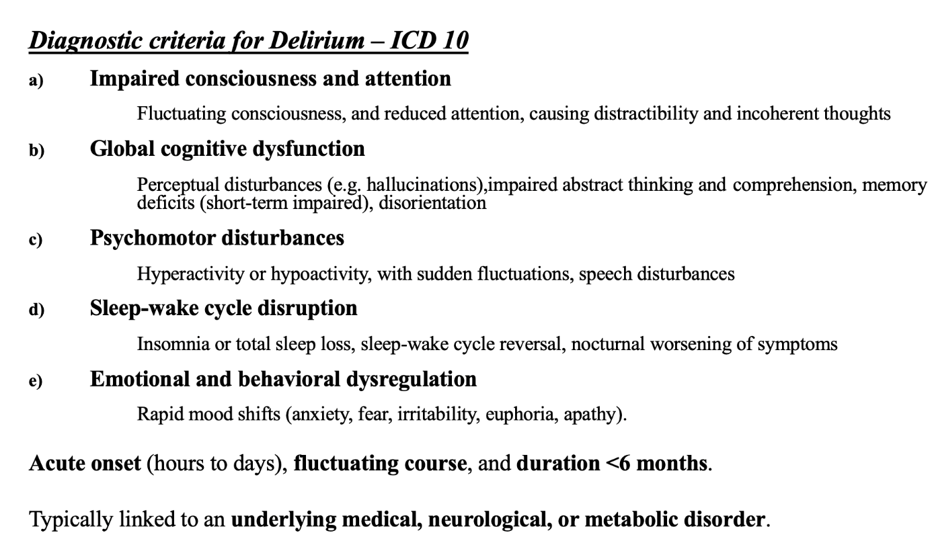

Supplemental Figure 2: Flowchart of patients who met inclusion/exclusion criteria in the study population.

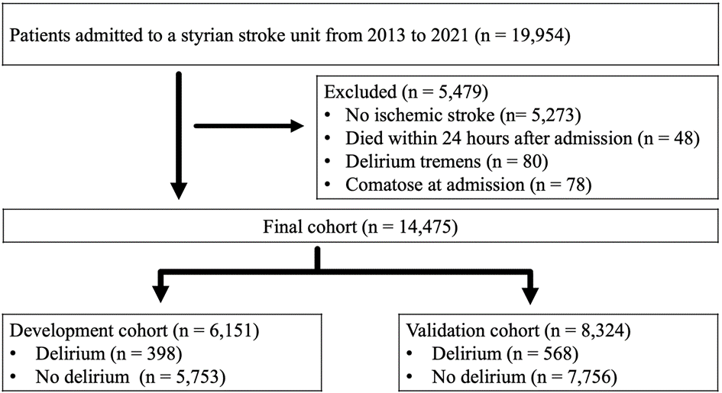
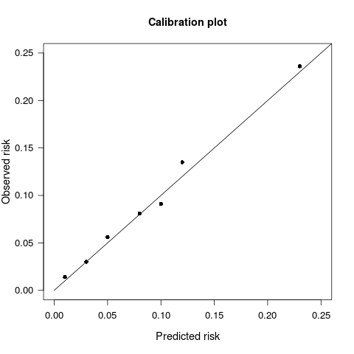
Supplemental Figure 3: Calibration plot of predicted versus observed probabilities of delirium risk according to the PREDELIS score (derivation versus validation cohort).*

*Data point 1 summarizes PREDELIS risk score points of 0-2. Data point 2 represents the risk for scores of 3-4 points, as the individual risks are very similar. Each subsequent point corresponds to one additional point in the PREDELIS risk score up to ≥9 score points.
Calibration Plot

Supplemental References
1. Vreeswijk, R.; Kalisvaart, I.; Maier, A. B.; Kalisvaart, K. J. Development and validation of the delirium risk assessment score (DRAS), Eur Geriatr Med. 2020, 11, 307-314.
2. Ormseth, C. H.; LaHue, S. C.; Oldham, M. A.; Josephson, S. A.; Whitaker, E.; Douglas, V. C. Predisposing and Precipitating Factors Associated With Delirium: A Systematic Review, JAMA Netw Open. 2023, 6, e2249950.
3. van den Boogaard, M.; Pickkers, P.; Slooter, A. J., et al. Development and validation of PRE-DELIRIC (PREdiction of DELIRium in ICu patients) delirium prediction model for intensive care patients: observational multicentre study, BMJ. 2012, 344, e420.
4. Oldenbeuving, A. W.; de Kort, P. L.; van Eck van der Sluijs, J. F.; Kappelle, L. J.; Roks, G. An early prediction of delirium in the acute phase after stroke, J Neurol Neurosurg Psychiatry. 2014, 85, 431-434.
5. Alvarez-Perez, F. J.; Paiva, F. Prevalence and Risk Factors for Delirium in Acute Stroke Patients. A Retrospective 5-Years Clinical Series, J Stroke Cerebrovasc Dis. 2017, 26, 567-573.
6. Fleischmann, R.; Andrasch, T.; Warwas, S., et al. Predictors of post-stroke delirium incidence and duration: Results of a prospective observational study using high-frequency delirium screening, Int J Stroke. 2023, 18, 278-284.
7. Gustafson, Y. O., T.; Eriksson, S.; Asplund, K.; Bucht, G. Acute Confusional States (Delirium) in Stroke Patients, Cerebrovasc Dis. 1991, 1:257-264.
8. Kostalova, M.; Bednarik, J.; Mitasova, A., et al. Towards a predictive model for post-stroke delirium, Brain Inj. 2012, 26, 962-971.
9. Miu, D. K.; Chan, C. W.; Kok, C. Delirium among elderly patients admitted to a post-acute care facility and 3-months outcome, Geriatr Gerontol Int. 2016, 16, 586-592.
10. Shaw, R. C.; Walker, G.; Elliott, E.; Quinn, T. J. Occurrence Rate of Delirium in Acute Stroke Settings: Systematic Review and Meta-Analysis, Stroke. 2019, 50, 3028-3036.
11. Pasinska, P., Kowalska, K.; Klimiec, E.; Szyper‐Maciejowska, A.; Wilk, A.; Klimkowicz‐Mrowiec, A. Frequency and predictors of post‐stroke delirium in PRospective Observational POLIsh Study (PROPOLIS), Journal of Neurology. 2018, 265(4):863-870.
12. Zhang, G. B.; Li, H. Y.; Yu, W. J., et al. Occurrence and risk factors for post-stroke delirium: A systematic review and meta-analysis, Asian J Psychiatr. 2024, 99, 104132.
13. Y. Gustafson, T. O., K. Asplund, and E. Hagg Acute confusional state (delirium) soon after stroke is associated with
hypercortisolism, Cerebrovascular Diseases. 1993, 3, 33-38.
14. (WHO), W. H. O. International Statistical Classification of Diseases and Health Related Problems—Tenth Revision.). Geneva: World Health Organization, 1993.

