Age at onset of epilepsy shapes neurocognitive profiles in focal cortical dysplasia

Anna-Laura Potthoff¹, Lukas Tennie², Juri-Alexander Witt², Attila Rácz², Valeri Borger¹, Hartmut Vatter¹, Albert Becker³, Rainer Surges², Matthias Schneider^{1*}, Christoph Helmstaedter^{2 *}

¹Department of Neurosurgery, University Hospital Bonn, Venusberg Campus 1, 53127 Bonn, Germany
²Department of Epileptology, University Hospital Bonn, Venusberg Campus 1, 53127 Bonn, Germany
³Department of Neuropathology, University Hospital Bonn, Venusberg Campus 1, 53127 Bonn, Germany

* Contributed equally

Supplementary Figure S1

Proportions of impaired patients per cognitive domain

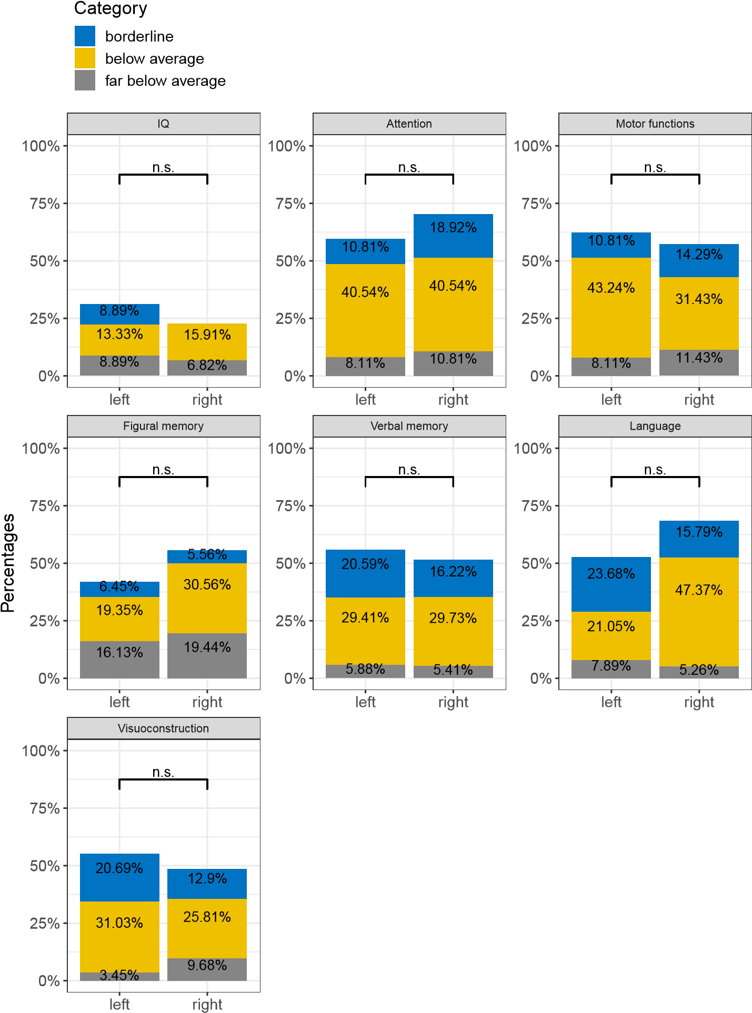

Supplementary Figure S1. Cognitive Performance across Cognitive Domains in Patients with FCD in Right versus Left Hemisphere.
Individual analysis results: Proportion of impaired patients categorized as borderline, below average, and far below average based on their performance in neurocognitive assessments. Abbreviations: n.s., not significant

Supplementary Figure S2

Proportions of impaired patients per cognitive domain

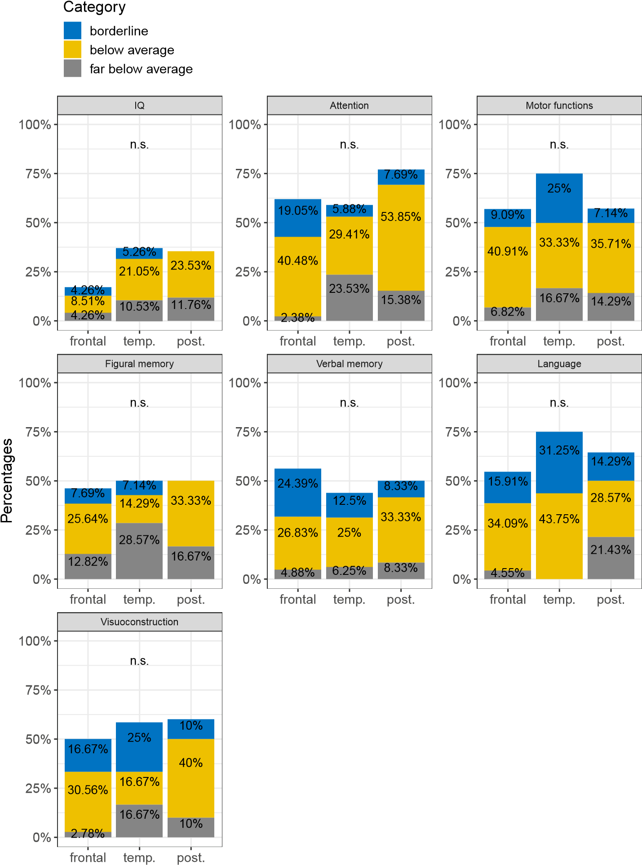

Supplementary Figure S2. Cognitive Performance Across Cognitive Domains in Patients with FCD in Frontal, Temporal, versus Posterior Localization.
Individual analysis results: Proportion of impaired patients categorized as borderline, below average, and far below average based on their performance in neurocognitive assessments. Abbreviations: n.s., not significant; temp, temporal; post, posterior

Supplementary Table S1. Patient Demographics and Clinical Characteristics

All patients
n = 98
Gender  Female  Male | 46 (47%)  52 (53%)
Age at seizure onset (yrs)* | 7.32 (7.48)
Age at surgery (yrs)* | 24.92 (14.79)
Duration of epilepsy (yrs)* | 17.44 (12.98)
Handedness  Right  Left  Ambidextrous | 80 (82%)  14 (14%)  4 (4%)
Mean IQ | 92.43 (14.79)
Seizures per month* | 37.51 (42.37)
ASM  Polytherapy  2 ASMs  3 ASMs  4 ASMs  Monotherapy  No ASM | 79 (81%)  43 (44%)  29 (30%)  7 (7%)  17 (17%)  2 (2%)
Lateralization  Right  Left | 48 (49%)  50 (51%)
Localization  Frontal  Temporal  Posterior  Others | 53 (54%)  21 (22%)  17 (17%)  7 (7%)
FCD Type  Ia  IIa  IIb  IIIa  Undefined Type | 2 (2%)  26 (27%)  59 (60%)  1 (1%)  10 (10%)
*Values presented as mean (SD)
Abbreviations: ASM, antiseizure medication; FCD, focal cortical dysplasia; IQ, intelligence quotient; yrs, years

Supplementary Table S1. Neuropsychological Test Used for Patients’ Assessment

Domain | Test | Reference
Intelligence  Adults | Hamburg Wechsler  Intelligence Scales for Adults - revised  (HAWIE-R) | Tewes (1991)
 | Mehrfachwahl-Wortschatz-Intelligenztest  (MWT-B) | Lehrl (2005)
 | Standard Progressive Matrices (SPM) | Raven and Horn (2009)
Children | Vineland Adaptive Behavior  Scales (VABS) | Sparrow (2011)
 | K-ABC: Kaufman  Assessment Battery for  Children | Rollett and Preckel (2012)
 | Wechsler Intelligence Scale for Children, third edition | Tewes (2002)
 | Coloured Progressive  Matrices (CPM) | Raven et al. (2006)
Motor functions | Luria Motor Sequences | Luria and Critchley (1970)
 | Purdue Pegboard Test (PPT)  Finger Tapping Test (FTT) | Ventola (2013)  Schmitt (2013)
Attention/executive fct. | d2-Letter cancellation Aufmerksamkeits-Belastungs-Test | Brickenkamp (2002)
 | Trail-Making Test  c.I.-Test | Reitan (1992)  Lehrl (1984)
 | Digit-span Task backward  Corsi-block-tapping Test backward | Tewes (1991)  Corsi (1973)
 | Maze Test (Chapuis) | Chapuis (1959)
Memory  Verbal memory | Digit-span Task forward  Verbaler Lern- und  Merkfähigkeitstest (VLMT) | Tewes (1991  Helmstaedter (2001)
Figural memory | Corsi-block-tapping Test forward  Diagnosticum für  Cerebralschädigung - revised (DCS-R) | Corsi (1973)  Helmstaedter (1991)
Language | Phonematic Fluency (LPS)  Token Test  Boston Naming Test | Horn (1983)  De Renzi (1962)  Busch (2005), Kaplan (2001)
Visuoconstruction | Block Design Test | Tewes (1991)
 | Mental Rotation Task LPS-7 | Horn (1983)

 | Patients’ characteristics | Sample (n=85) | FCD IIa (n=26) | FCD IIb (n=59) | Statistics
 | Gender  Male | 47 (55.3%) | 14 (53.8%) | 33 (55.9%) | χ²(1) = 0.32,
 | Female | 38 (44.7%) | 12 (46.2%) | 26 (44.1%) | p = 0.86
 | Age of onset  Mean (SD) | 6.79 (6.92) | 8.46 (8.53) | 6.03 (6.00) | F(1,83) = 2.24
 | Range | 0-43 | 1-43 | 0-41 | p = 0.14
 | Early vs. late AOE  Early | 48 (57.1%) | 10 (38.5%) | 38 (65.5%) | χ²(1) = 5.37,
 | Late | 36 (42.9%) | 16 (61.5%) | 20 (34.5%) | p = 0.021
Age at surgery  Mean |  | 23.65 (14.68) | 20.35 (11.84) | 25.10 (15.64) | F(1) = 2.37,
Range |  | 3-70 | 4-56 | 3-70 | p = 0.13 †
 | Duration of epilepsy  Mean | 16.68 (12.76) | 11.88 (9.09) | 18.80 (13.61) | F(1) = 7.56,
 | Range | 0-63 | 0-36 | 0-63 | p = 0.008 †
 | Lobe | n = 82 | n = 26 | n = 56
 | Frontal | 49 (59.8%) | 13 (50.0%) | 36 (64.3%) | χ²(2) = 3.12,
 | Temporal | 16 (19.5%) | 8 (30.8%) | 8 (13.3%) | p = 0.21
 | Posterior | 17 (20.7%) | 5 (19.2%) | 12 (21.4%)
 | Hemisphere  Right | 42 (49.4%) | 8 (30.8%) | 34 (57.6%) | χ² (1) = 5.21,
 | Left | 43 (50.6%) | 18 (69.2%) | 25 (42.2%) | p = 0.022
 | Seizures (per month)  Mean (SD) | 38.35 (42.22) | 35.64 (46.22) | 39.58 (40.82) | F(1) = 0.11,
 | Range | 0.16-4500 | 0.16-4500 | 0.25-300 | p = 0.74
 | Number of ASMs  Mean (SD) | 2.26 (0.89) | 2.50 (0.81) | 2.15 (0.91) | F(1) = 2.82
 | Range | 0-4 | 1-4 | 0-4 | p = 0.10
Supplementary Table S3. Comparison of Patients’ Demographics and Characteristics Between FCD Type IIa and IIb

Frequency distributions were analyzed using χ2-tests.
Abbreviations: ASM, antiseizure medication; FCD, focal cortical dysplasia; SD, standard deviations

Supplementary Table S4. Comparison of Patients’ Demographics and Characteristics Between Early and Late AOE

Patients’ characteristics | Total (n=97) | Early AOE  (n=52) | Late AOE (n=45) | Statistics
Gender  Male | 51 (52.6%) | 29 (56.9%) | 23 (50.0%) | χ²(1) = 0.46,
Female | 46 (47.4%) | 22 (43.1%) | 22 (50.0%) | p = 0.50
Duration of Epilepsy  Mean | 17.47 (13.04) | 16.73 (12.53) | 18.22 (13.69) | F(1) = 0.36,
Range | 0-63 | 0-52 | 0-63 | p = 0.55
Hemisphere  Right | 47 (48.5%) | 23 (48.9%) | 29 (58.0%) | χ² (1) = 0.80,
Left | 50 (51.5%) | 24 (51.1%) | 21 (42.0%) | p = 0.37
Lobe | n =91 | n = 48 | n = 43
Frontal | 53 (58.2%) | 28 (58.3%) | 25 (58.1%) | χ²(2) = 0.47,
Temporal | 21 (23.1%) | 10 (20.8%) | 11 (25.6%) | p = 0.79
Posterior | 17 (18.7%) | 10 (20.8%) | 7 (16.3%)
Seizures (per month)  Mean (SD) | 35.96 (39.10) | 45.13 (44.34) | 24.78 (28.43) | F(1) = 5.47,
Range | 0.16 -150 | 0.25-150 | 0.16-100 | p = 0.022 †
Number of ASMs  Mean (SD) | 2.22 (0.89) | 2.15 (1.0) | 2.29 (0.76) | F(1) = 0.55,
Range | 0-4 | 0-4 | 1-4 | p = 0.46

Frequency distributions were analyzed using χ2-tests.
Abbreviations: ASM, antiseizure medication; AOE, age at onset of epilepsy; SD, standard deviations

Test category |  | Right hemisphere  (n = 31-43) | Left hemisphere  (n=29-45) | Total | Test statistics
IQ (n = 89) | M/SD n/% ↓ | 2.54/1.07 10/22.7% | 2.42/1.08 14/31.1% | 2.48/1.07 24/27.0% | F(1,86) = 0.25, p = .62 χ²(1) = 0.79, p = .37
Attention (n = 74) | M/SD n/% ↓ | 1.68/1.03 26/70.3% | 1.86/1.11 22/59.5% | 1.77/1.07 48/64.9% | F(1,71) = 0.57, p = .45 χ²(1) = 0.95, p = .33
Motor functions (n = 72) | M/SD n/% ↓ | 1.89/1.11 20/57.1% | 1.78/1.06 23/62.2% | 1.83/1.07 43/59.7% | F(1,69) = 0.14, p = .71 χ²(1) = 0.19, p = .66
Figural memory (n = 67) | M/SD n/% ↓ | 1.81/1.31 20/55.6% | 2.16/1.32 13/41.9% | 1.97/1.31 33/49.3% | F(1,64) = 1.13, p = .29 χ²(1) = 1.24, p = .27
Verbal memory (n = 71) | M/SD n/% ↓ | 2.24/1.21 19/51.4% | 2.09/1.08 19/55.9% | 2.17/1.15 38/53.5% | F(1,68) = 0.31, p = .58 χ²(1) = 0.15, p = .70
Language (n = 76) | M/SD n/% ↓ | 1.76/1.03 26/68.4% | 2.13/1.04 20/52.6% | 1.95/1.04 46/60.5% | F(1,73) = 2.40, p = .13 χ²(1) = 1.98, p = .16
Visuo-  construction (n = 60) | M/SD n/% ↓ | 2.10/1.14 15/48.4% | 2.10/1.01 16/55.2% | 2.10/1.07 31/51.7% | F(1,57) = 0.00, p = .98 χ²(1) = 0.28, p = .60
Supplementary Table S5. Analyses of Cognitive Performances in Right versus Left Hemisphere

Frequency distributions were analyzed using χ2-tests.
Abbreviations: IQ, intelligence quotient; M, mean; n, number; SD, standard deviations; ↓, impaired patients

Test category |  | Frontal  (n = 45-54) | Temporal  (n = 17-19) | Posterior  (n = 13-17) | Total | Test statistics
IQ (n=83) | M/SD n/% ↓ | 2.72/0.87  8/17.0% | 2.26/1.19  7/36.8% | 2.23/1.25  6/35.3% | 2.52/1.05 21/25.3% | F(2,79) = 2.21, p = .12 χ²(2) = 3.94, p = .14
Attention (n=72) | M/SD n/% ↓ | 1.95/0.99 26/61.9% | 1.65/1.27 10/58.8% | 1.38/1.04 10/76.9% | 1.78/1.08 46/63.9% | F(2,68) = 1.54, p = .22 χ²(2) = 1.22, p = .54
Motor functions (n=70) | M/SD n/% ↓ | 1.89/1.06 25/56.8% | 1.58/1.08  9/75.0% | 1.79/1.19  8/57.1% | 1.81/1.08 42/60.0% | F(2,66) = 0.37, p = .69 χ²(2) = 1.36, p = .51
Figural memory (n= 65) | M/SD n/% ↓ | 2.10/1.25 18/46.2% | 1.93/1.54  7/50.0% | 1.83/1.27  6/50.0% | 2.02/1.31 31/48.4% | F(2,61) = 0.33, p = .72 χ²(2) = 0.09, p = .96
Verbal memory (n=69) | M/SD n/% ↓ | 2.12/1.03 23/56.1% | 2.44/1.32  7/43.8% | 2.17/1.34  6/50.0% | 2.20/1.15 36/52.2% | F(2,65) = 0.44, p = .64 χ²(2) = 0.73, p = .69
Language (n=74) | M/SD n/% ↓ | 2.05/1.03 24/54.5% | 1.88/0.96 12/75.0% | 1.64/1.22  9/64.3% | 1.93/1.05 45/60.8% | F(2,70) = 0.82, p = .44 χ²(2) = 2.15, p = .34
Visuo-  construction (n = 58) | M/SD n/% ↓ | 2.17/1.00 18/50.0% | 1.92/1.16  7/58.3% | 1.80/1.14  6/60.0% | 2.05/1.05 31/53.4% | F(2,54) = 0.59, p = .56 χ²(2) = 0.46, p = .80
Supplementary Table S6. Analyses of Cognitive Performances in Patients with FCD in Frontal, Temporal, versus Posterior Localization

Frequency distributions were analyzed using χ2-tests.
Abbreviations: IQ, intelligence quotient; M, mean; n, number; SD, standard deviations; ↓, impaired patients

