Supplement

Figure S1. Site outreach.


Figure S2. Saturation graph for the concepts of Parkinson’s disease (N=19). The following concepts arose during the interviews and were analyzed as they were mentioned: symptoms associated with advanced Parkinson’s disease, health-related quality of life impacts, care partner involvement, device and training experience, patient confidence in using the delivery system and satisfaction with LDp/CDp. The order in which these concepts were mentioned and the point during the interviews at which each concept was mentioned spontaneously is summarized. Each data point on the graph represents one participant, and the colors represent the different cohorts based on the order in which the interviews were conducted. These cohorts were established to calculate saturation. The y-axis is the percentage of saturation.

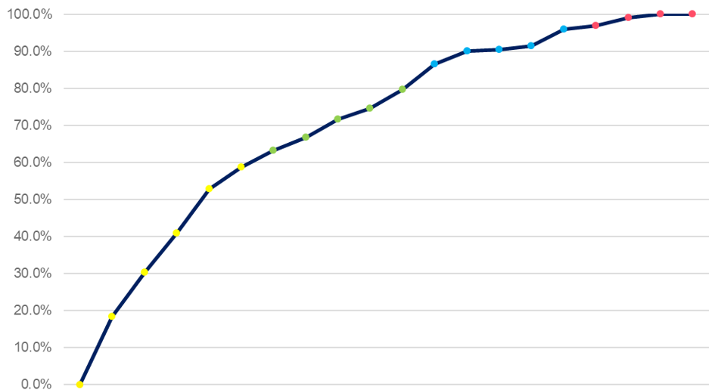

LDp/CDp, foslevodopa/foscarbidopa.

Table S1
Interview Guide
Thank you for taking the time to speak with me today. First I would like to quickly explain
why we are interviewing you. This interview is being conducted because we would like to
learn more about your experiences as someone with advanced Parkinson’s disease and
your treatment experience with the ABBV-951 delivery system.

This interview will last approximately 90 minutes. All of the information you (and, if present,
your caregiver) provide will be used for the purpose of this research study only. We may
publish the results of this study, but all the information you provide will be kept confidential.
This means that we will not mention you by name or include any information that would
identify you.

You do not have to answer any questions you do not feel comfortable answering. You may
stop the interview at any time or you may take a break if you need to, just let me know. We
are interested in your thoughts and opinions, and there are no right or wrong answers.
I will be audio-recording this interview to make sure we capture all of your comments and
feedback. Later, we’ll transcribe the interview, so that we can refer to it as we put together
our reports. We won’t use your name on the transcripts or on any documents or reports.
Instead, we will use an ID number to identify you to protect your confidentiality.

I have a number of questions for you, so please forgive me if I need to interrupt you at times
in order to move to the next question.

Do you have any questions before we get started?
Do I have your permission to audio-record the interview?
o Yes
o No
[If NO] As part of the study, we are required to audio-record the interviews so that we can
carefully review the responses at a later time. If you do not agree to be audio-recorded, you
will not be able to participate in this study. We will protect your confidentiality by not
associating your name with any responses. Do you agree to be audio-recorded? [If
participant declines to be audio-recorded, thank the participant for their time and terminate
interview]

[If YES] Thank you. First, I will say the name of the study, followed by the date and then your
study ID number. Then I will ask you to confirm that you are okay with being audio-recorded.

[Turn on recorder]
This is study 8001-0990; today’s date is [Insert date], and this is participant [Insert
Participant ID number]

• To confirm, do I have your permission to record the interview?
o Yes
o No

Do you provide consent to participate in this interview?
o Yes
o No
[Note to interviewer: Bolded questions and sections are priority. Cover others if time permits]
Section 1. Living with Parkinson’s Disease [<10 mins]
Before we talk about what your experience with the ABBV-951 delivery system during the
trial, I will ask some questions to understand your experience with Parkinson’s disease
before you started using ABBV-951.

1. When did you first experience symptoms of Parkinson’s Disease? What
symptoms were those?

2. Can you describe how Parkinson’s disease has impacted your daily activities?
a. What is a good day like with Parkinson’s disease?
b. What is a bad day like with Parkinson’s disease?
c. How has Parkinson’s disease affected your personal or social
relationships?

3. Do you have a care partner who helps you with your Parkinson’s disease? If
yes, is your care partner any of the following:
a. Family member support [indicate if spouse / child / sibling/ other family
member]
b. Home health aide
c. Nurse support
d. Support from a friend
e. Other [Ask patient to describe other support]
f. I do not have a care partner
g. I prefer not to answer

4. [If the participant has a care partner:] How does your care partner help you
throughout the day? [e.g. mobility, help with household chores, hours of care
partner support per day or per week on average]
a. Probe: What did your care partner do to help with your Parkinson’s disease
care?
i. Walking
ii. Household chores
iii. Daily activities (e.g. bathing or washing yourself, getting dressed)
b. Probe: Approximately how many hours of support does your care
partner provide on average per day or per week?

5. Prior to starting ABBV-951, can you describe your treatments used to treat
your Parkinson’s disease?
a. Probe: Can you describe your experience with that/those treatments? How
comfortable were you with that/those treatments?

6. What made you decide to seek new treatment?
a. What PD-related symptoms were most important for you to improve?
Why?
b. Why did you decide to try ABBV-951?

Section 2. Experiences with ABBV-951 [25-30 mins]
Now, I would like to ask about what your experiences with the ABBV-951 delivery system,
which includes the pump, solution vial, vial adapter, syringe, infusion set, carrying assessor,
rechargeable battery, and charger.
[Note for interviewer: Use the term the patient uses to refer to the ABBV-951 delivery
system.]

Onboarding experience with ABBV-951 delivery system
8. How was your experience starting/switching over to ABBV-951 from your
previous PD treatment?
a. Probe: What did you find most challenging, if any, to start on ABBV-951?
b. Probe: What did you find most helpful to get you started on ABBV-951?]
c. Probe on experience with device components, including: pump, cannula,
infusion set, medication vial, syringe, and carrying case (accessory)

9. What was your experience with the training and instructions from your
healthcare team on how to use and manage the delivery system?
a. Probe: Did you feel there was sufficient support from your healthcare team to
use the delivery system? Why?
b. Probe: What was missing or what worked well?
c. Probe: What aspect of the training did you find most useful?

10. Do you have a care partner to assist you with the use and management of the
delivery system?
a. If yes, how did your care partner assist you? How did you both define your
roles?
b. If yes, how many hours of assistance does your care partner provide
with the delivery system on average per day or per week?

11. After receiving the training and instructions, how confident were you [or your
care partner] with using the delivery system on your own? Why? [Note for
interviewer: if time permits, quickly review through steps with patient]
a. Probe: How long did it take for you to feel comfortable using the
delivery system? What has helped you and your care partner to feel
increasingly confident?
b. Probe: Do you feel confident refilling the syringe from the solution vial
and attached vial adapter on your own?
c. Probe: Do you feel confident changing the syringe/infusion set in the
pump alone?

12. Think back to when you first started using the ABBV-951 delivery system. What
additional training, instructions, tools, educational materials, or resources could have
been provided to support your use with the delivery system?

13. Thinking back, what would you like to have known about ABBV-951 before being
started on this treatment?

Experience living with the device
Now I would like to discuss your experience with the delivery system which
administers the medication.

14. Please describe your experience administrating your medication using the device,
including the pump, infusion set, cannula, vial adapter, medication vial, syringe, etc.

15. Where do you usually store the ABBV-951 delivery system materials used for
administering your medication?

16. Can you walk me through your process of setting-up the materials when you
are ready to set-up your delivery system and change your medication?
a. Probe: Where do you administer your medication, such as in the
bathroom or living room? Why did you choose this place?
b. How long does it take for you (or your care partner) to prepare the
infusion set and pump to start administering your medication?
i. When do you usually change out the infusion set?
1. Probe: How do you remember to change the infusion set?
2. Probe: How do you remember to rotate the infusion site?
ii. When do you usually change out the medication?
1. Probe: Do you change it when you fully run out of
medication or on a scheduled basis? If so, why?
i. Probe: if scheduled, what time and what made them
decide to change the medication at that time?
2. Probe: How does the countdown message on the pump
help you to decide when to refill your medication?
3. Probe: Do you pay attention to how much medication is
left before you go to bed?
4. Probe: The pump has an alarm that alerts you when it’s
time to change out your medication syringe. How would
you describe your experience with this notification?
i. Probe: Have you received an alert during the night?
How do you handle this?
c. What times during the day would you have to stop the infusion and/or
stop carrying the device?
i. Probe: bathing or hygiene-related activities? Hobbies or leisure
activities?
ii. Probe: Were there instances where you forgot to restart the
infusion and/or start carrying the device? Can you describe these
instances?

17. How do you go about your day while wearing the delivery system?
a. Can you walk us through a typical day in your life right now while using
the device?
i. How have you added this new therapy into your daily
routine/life?
a. Probe: How did you develop this routine? Do you have
something (e.g., reminders, rituals) that helps you perform
your routine? What is that?
b. Probe: How long did it take to establish this routine?
c. Probe: Any tips you’d like to share to help others build
their routine with the system?
ii. How do you perform your activities while wearing the device?
a. Probe: What tips or tricks [or best practices] do you use to
make it easy / comfortable for you?
iii. Has your need for assistance for everyday activities changed
since you started using the device? (If so, how?)
b. How would you describe your experience with carrying the device?
i. How do you carry the device?
a. Probe: Around your waist, over your shoulder?
a. Probe to see if patient is using the provided and
approved carrying case or if they utilized another
carrying case
b. Probe: What do you think about the size and weight of the
device?
a. [If too large/heavy] What size or weight would improve
your experience?
c. Probe: Is there anything you would suggest to improve your
experience of carrying the device?
ii. Does the carrying the device affect what clothing you can wear?
If yes, how?
iii. How do you feel about wearing the device around other people?
Why?
iv. What is your experience like traveling with the device outside of
your home (e.g. going to your medical appointments, shopping,
vacation)?
v. What is it like wearing the device when you sleep?
a. Probe: Where do you place the device when you sleep?
b. Probe: What tips or tricks [or best practice] do you use to
make it easy / comfortable for you to sleep while wearing
the device?

18. What did you find easiest about using the device to administer your medication?
a. What do you like about the ABBV-951 delivery system?
b. Is there anything you would like to change about the ABBV-951 delivery
system?
19. Overall, how has the device impacted your life?

Section 3. Satisfaction with ABBV-951 delivery system [5 mins]
20. Overall, how would you summarize your experience with the ABBV-951
delivery system so far?
a. Probe: How do you feel about using the device to administer your PD
medication?
b. Probe: How do you feel about the functionality of the delivery system
and its components like the pump?
c. Probe: Is the delivery system user-friendly? Why or why not?
d. Probe: Is the delivery system consistent and reliable? Why or why not?

21. How satisfied are you with the instructions and training provided to you on a scale of
1 to 5, where 1 is very dissatisfied and 5 is very satisfied? Why?
a. Probe: ability to self-administer or care partner administer dose, confidence
using device correctly, mitigates fear of injection/self-administration

22. How satisfied are you with the treatment administration overall on a scale of 1 to 5,
where 1 is very dissatisfied and 5 is very satisfied? Why?
a. Probe on convenience: use, storage, assembly, disposal, time to prepare/use,
fit in routine; ease of use: operation of device, comfort, troubleshooting,
instructions and training; confidence in dose accuracy

23. What motivates you to continue using the ABBV-951 delivery system for
management of your PD?
a. Probe: do the benefits of using ABBV-951 outweigh the negatives (note
to interviewer: refer to participant’s particular pain points with the
device) Please explain.
b. If your Parkinson’s disease progresses, what therapy do you see yourself on?
i. Probe: Can you explain why?
c. If you were not on ABBV-951, what therapy do you see yourself using?
i. Probe: Can you explain why?

24. Imagine ABBV-951 was available for use outside of clinical trials.
a. How likely are you to continue treatment with ABBV-951 after the
conclusion of the trial on a scale of 1 to 5, where 1 is Very unlikely and 5
is Very likely? Why?
b. If another patient with PD is considering using ABBV-951, how would
you talk to them about ABBV-951?
i. Probe: How likely would you recommend ABBV-951 to other
patients considering using ABBV-951?
c. If another patient with PD is starting to use ABBV-951, what advice
would you give to that patient?
i. Probe:
1. Using the device (e.g. administration or preparation of the
device for the medication)
2. Having care partner or healthcare professional support to
use the device
3. Resources or materials to understand how to use the
device

