MATERIAL
Supplement to “Global Burden of Motor Neuron Disease: Unraveling Socioeconomic Disparities, Aging Dynamics, and Divergent Future Trajectories (1990–2040)”

MATERIAL 1

Fig S1 2

Fig S2 3

Fig S3 4

Fig S4 5

Fig S5 5

Fig S6 6

Fig S7 6

Fig S8 7

Fig S9 7

Fig S10 8

Fig S11 8

Fig S12 9

Fig S13 9

Fig S14 10

Table S1 11

Table S2 12

Table S3 13

Table S4 20

Table S5 27

Table S6 34

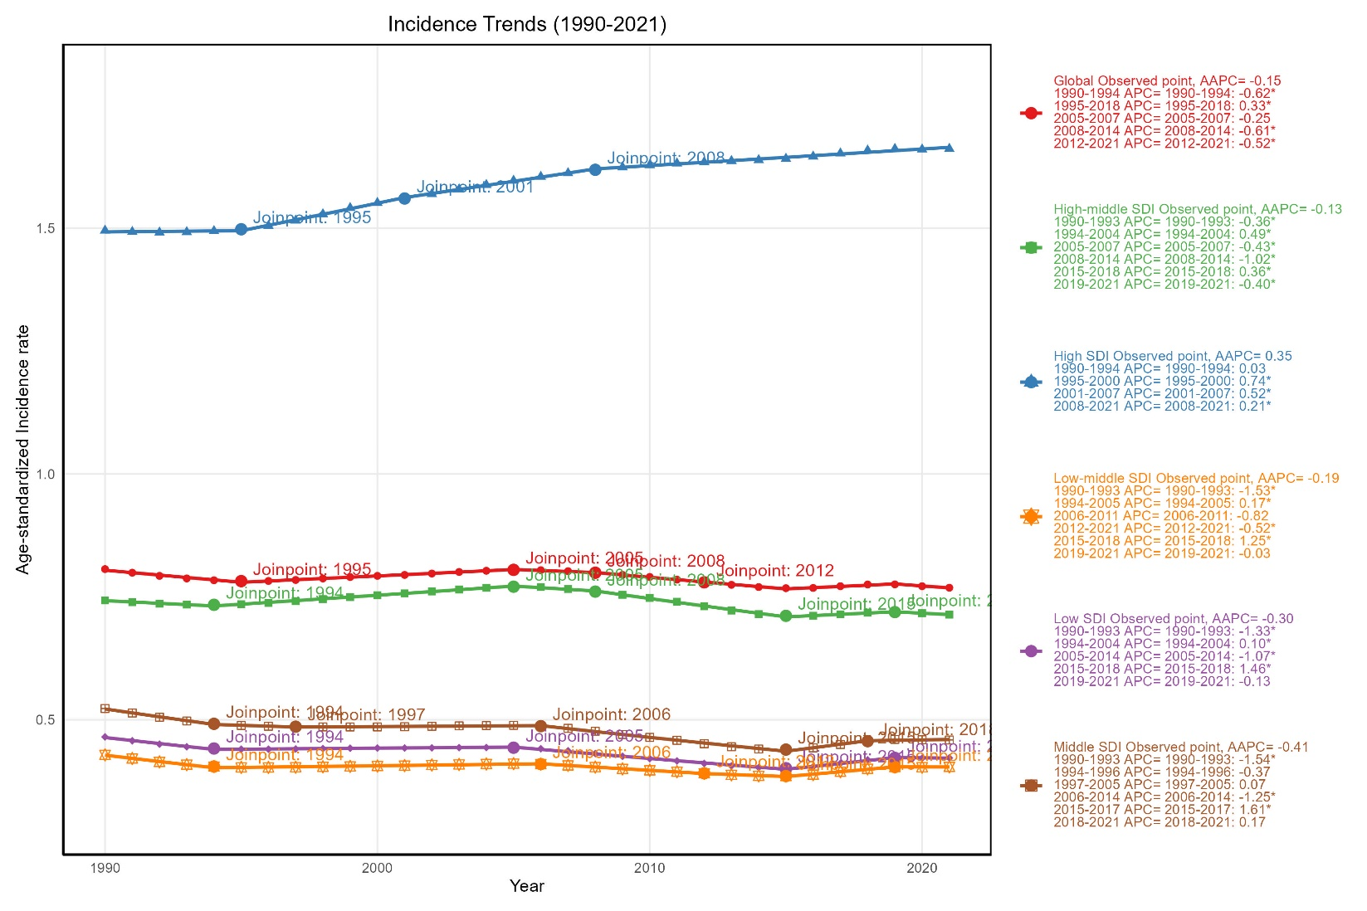
Figure S1: Temporal Trends in ASIR of MND by SDI Regions: A Joinpoint Regression Analysis, 1990-2021.
MND: Motor neuron disease; ASIR: age-standardized incidence rate; SDI, socio-demographic index;
APC, annual percent change; AAPC, average annual percent change. * p <0.05.

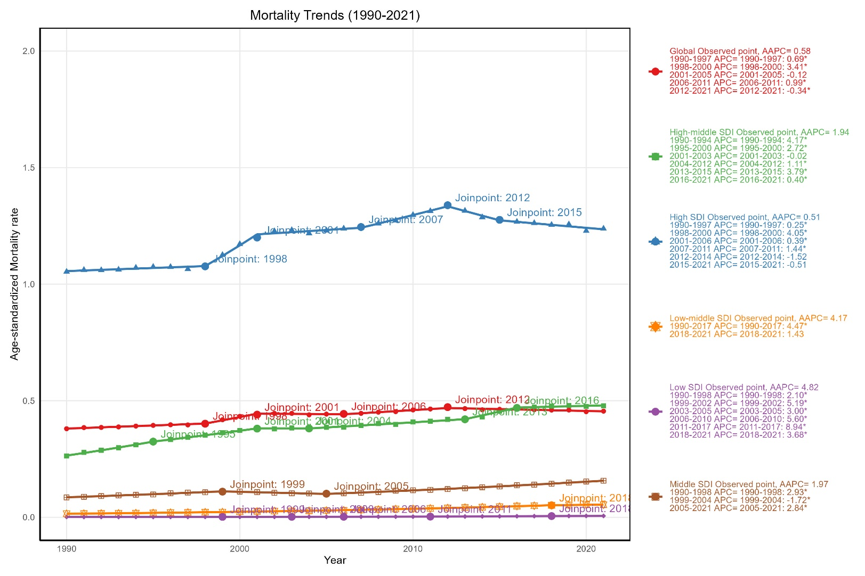
Fig S2: Temporal Trends in ASMR of MND by SDI Regions: A Joinpoint Regression Analysis, 1990-2021.
MND: Motor neuron disease; ASMR: age-standardized death rate; SDI, socio-demographic index;
APC, annual percent change; AAPC, average annual percent change. * p <0.05.

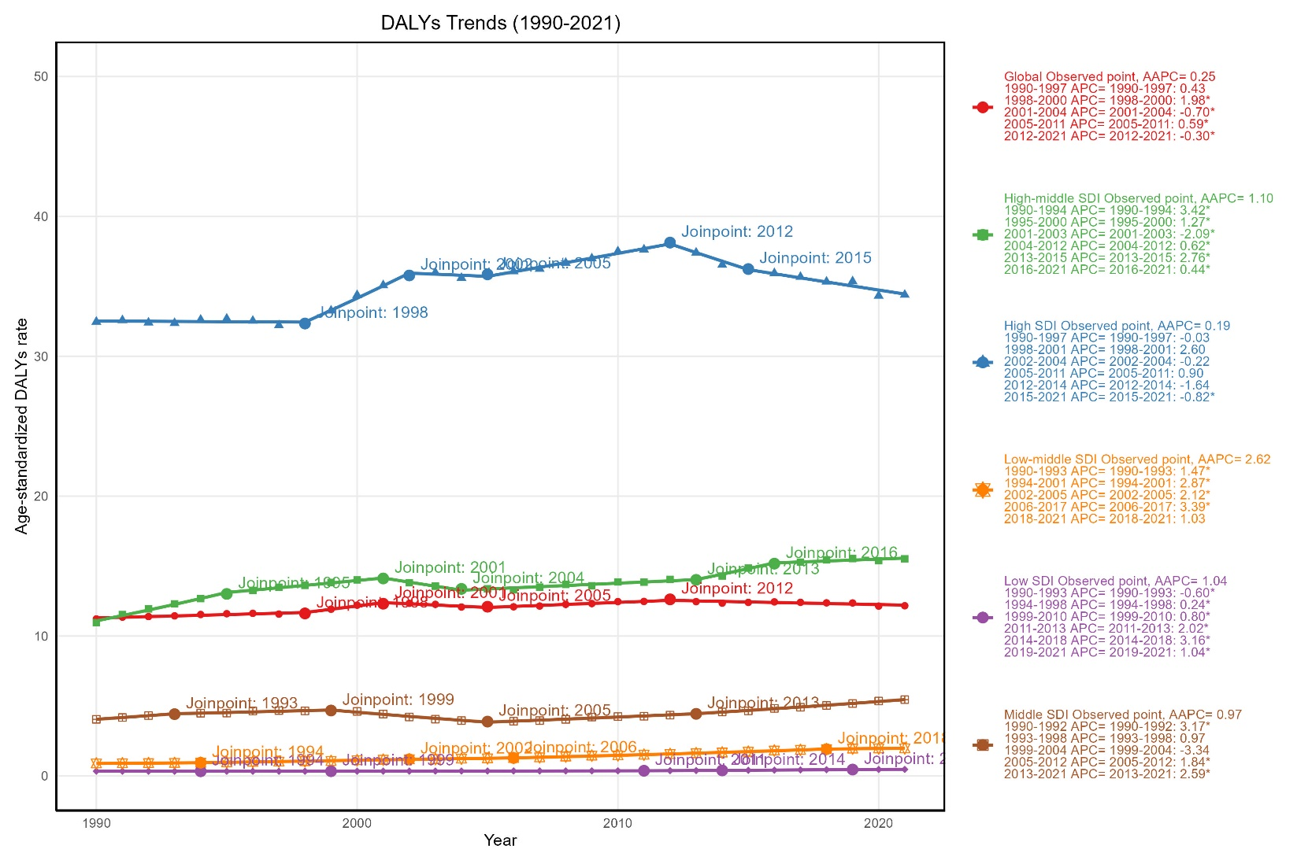
Fig S3: Temporal Trends in ASDR of MND by SDI Regions: A Joinpoint Regression Analysis, 1990-2021.
MND: Motor neuron disease; ASDR: age-standardized DALY rate; DALYs: disability-adjusted life years; SDI, socio-demographic index; APC, annual percent change; AAPC, average annual percent change. * p <0.05.
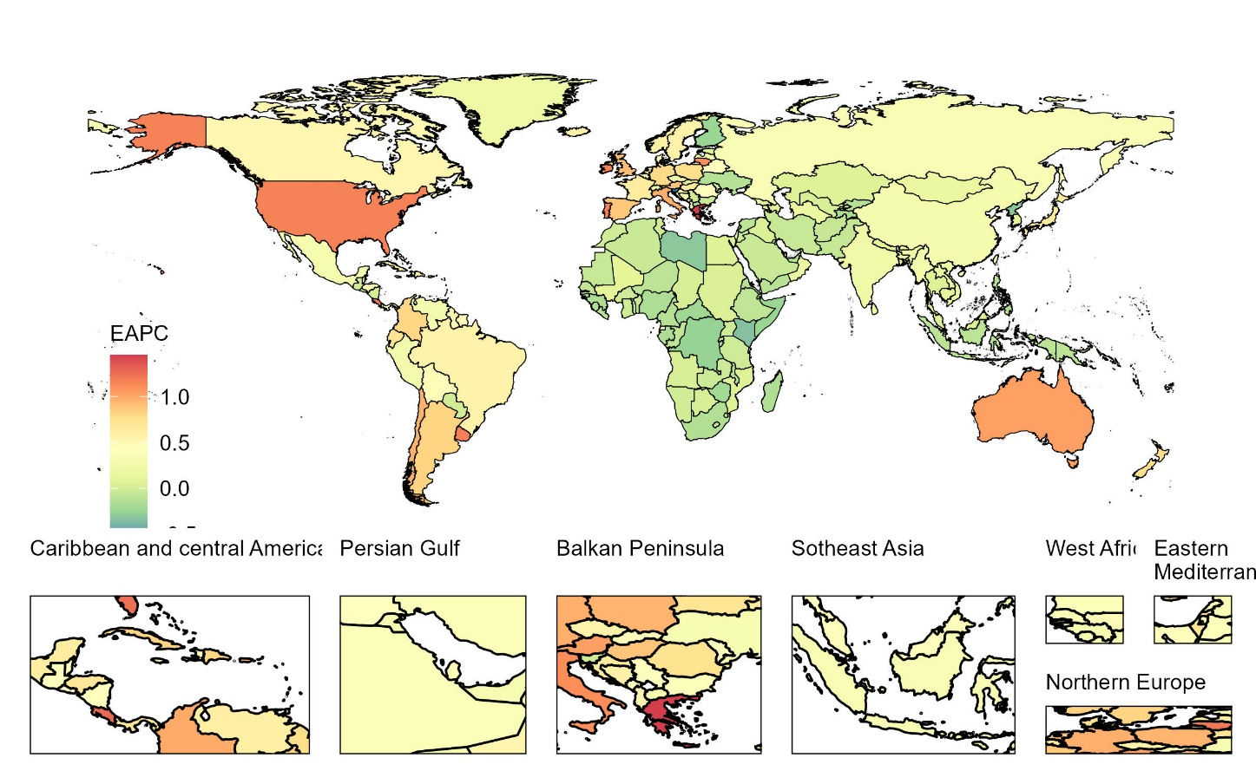
Fig S4: Estimated Annual Percentage Change (EAPC) and Age-Standardized Prevalence Rate (ASPR) of Motor Neuron Disease (MND) in 204 Countries/Territories from 1990 to 2021.
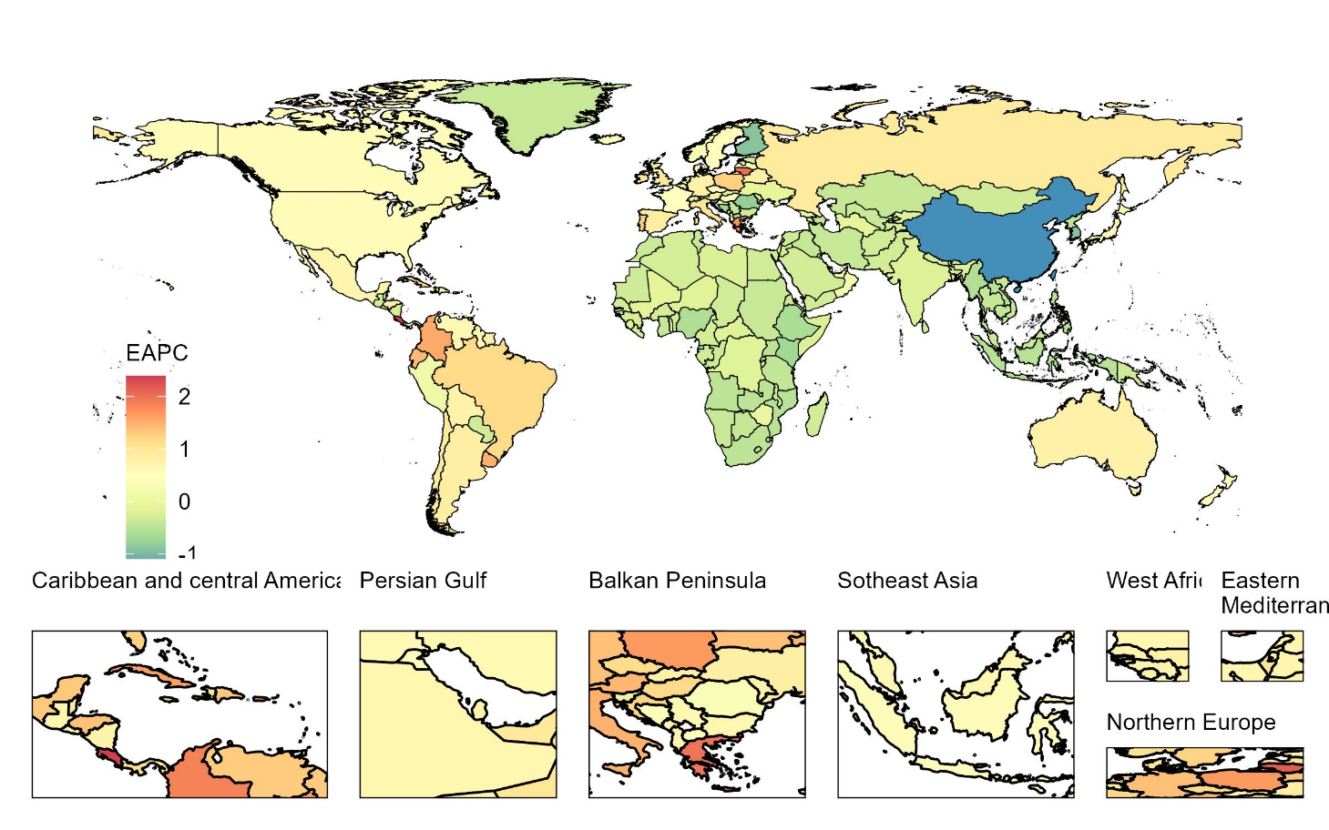
Fig S5: Estimated Annual Percentage Change (EAPC) and Age-Standardized Incidence Rate (ASIR) of Motor Neuron Disease (MND) in 204 Countries/Territories from 1990 to 2021.

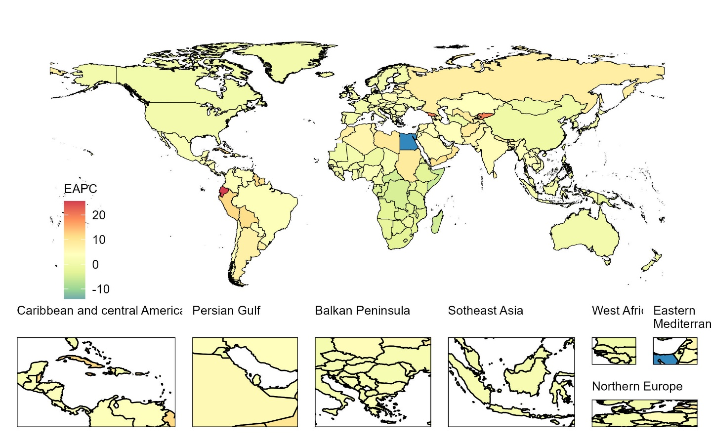
Fig S6: Estimated Annual Percentage Change (EAPC) and Age-Standardized deaths Rate (ASMR) of Motor Neuron Disease (MND) in 204 Countries/Territories from 1990 to 2021.

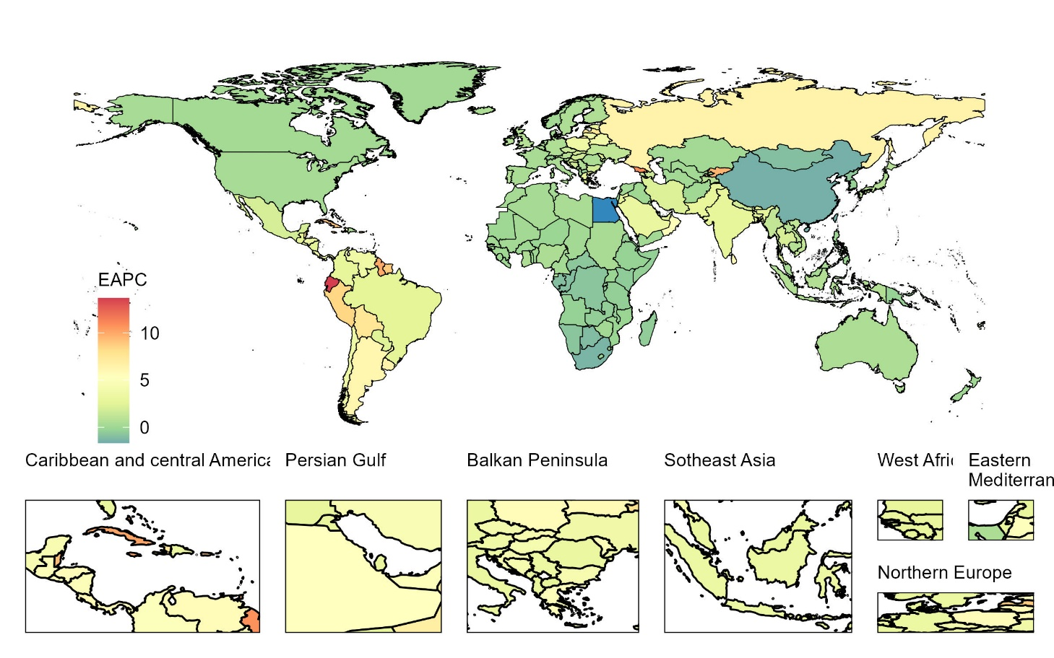
Fig S7: Estimated Annual Percentage Change (EAPC) and Age-Standardized DALYs Rate (ASDR) of Motor Neuron Disease (MND) in 204 Countries/Territories from 1990 to 2021. DALYs: disability-adjusted life years.

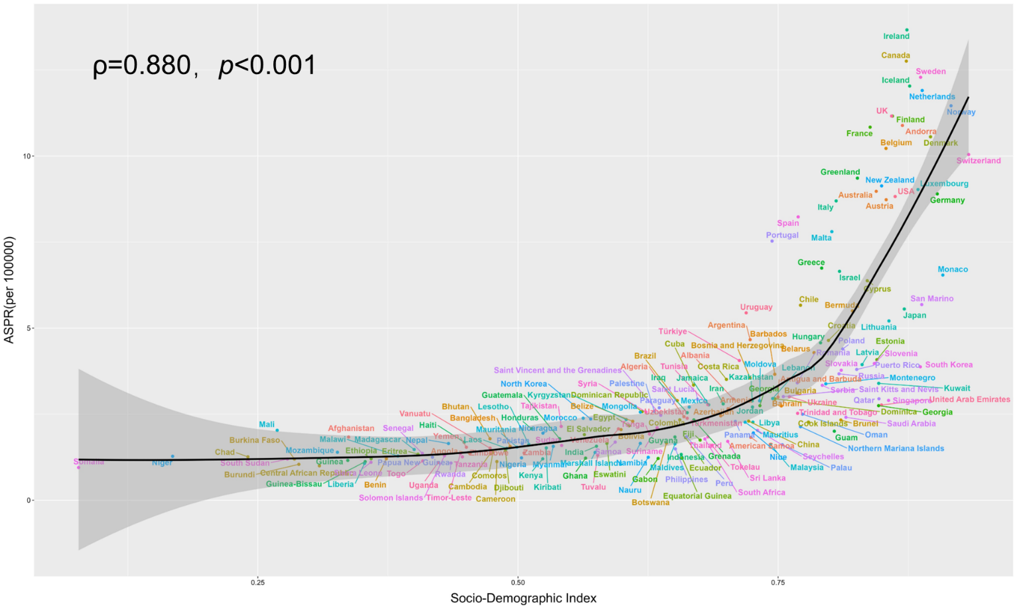
Figure S8: Association between Socio-Demographic Index (SDI) and Age-Standardized Prevalence Rate (ASPR) of Motor Neuron Disease (MND) Across Countries.
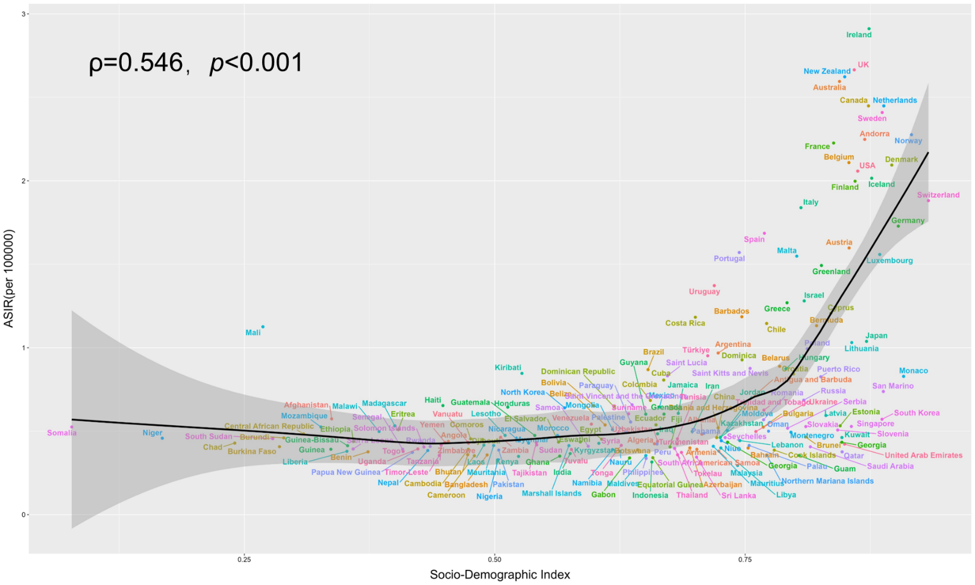
Fig S9: Association between Socio-Demographic Index (SDI) and Age-Standardized Incidence Rate (ASPR) of Motor Neuron Disease (MND) Across Countries.

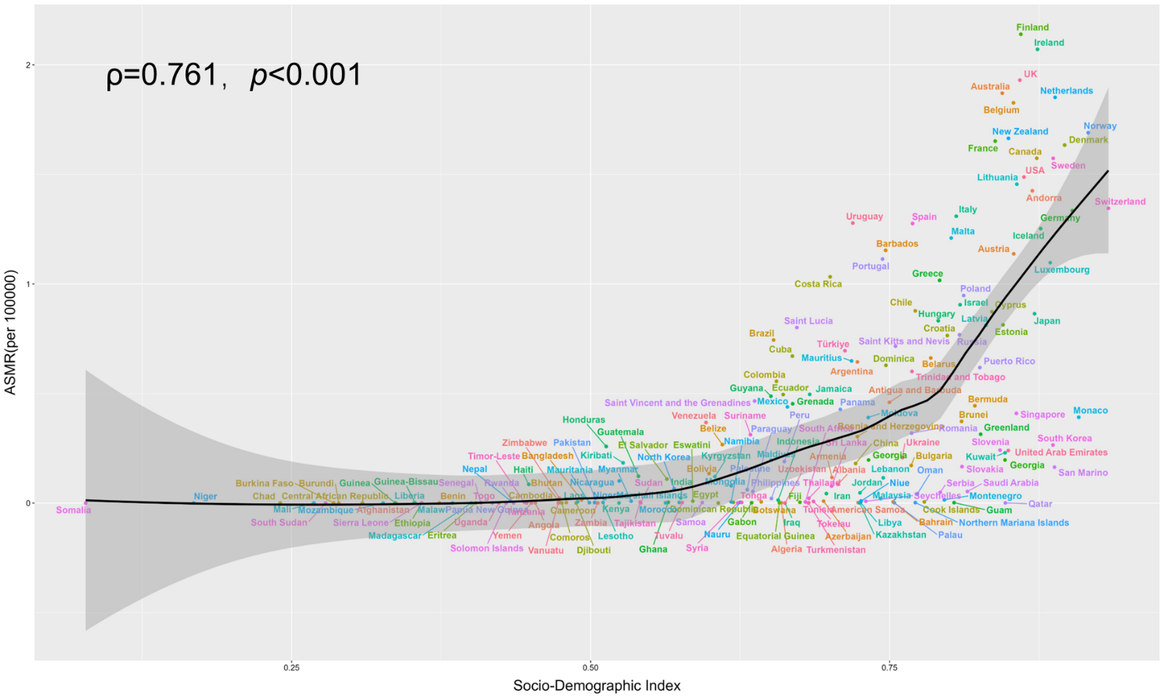
Figure S10: Association between Socio-Demographic Index (SDI) and Age-Standardized deaths Rate (ASMR) of Motor Neuron Disease (MND) Across Countries.

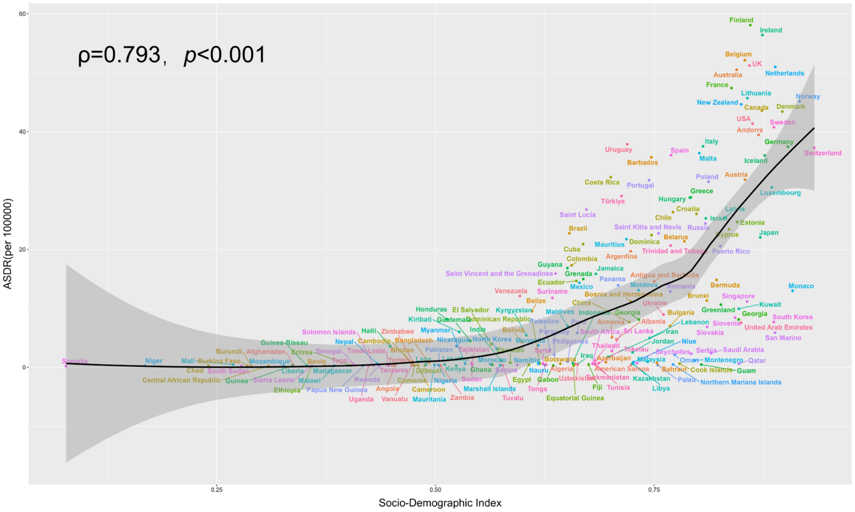
Figure S11: Association between Socio-Demographic Index (SDI) and Age-Standardized DALYs Rate (ASMR) of Motor Neuron Disease (MND) Across Countries. DALYs: disability-adjusted life years.

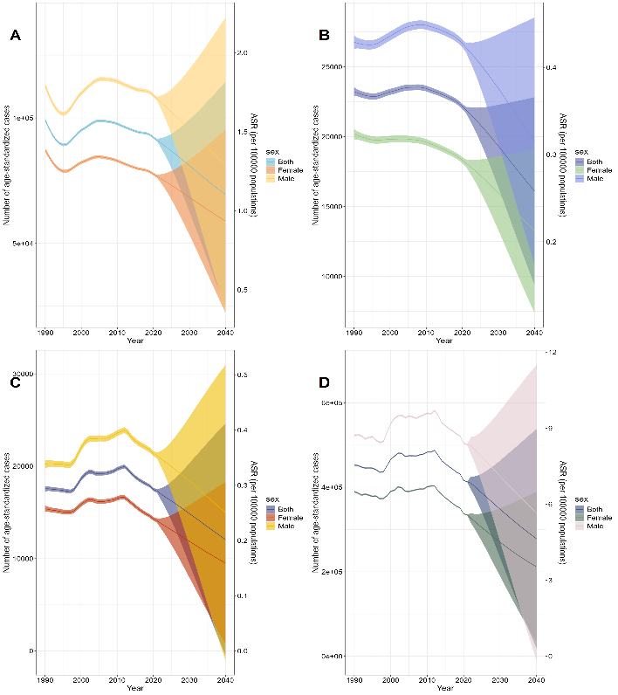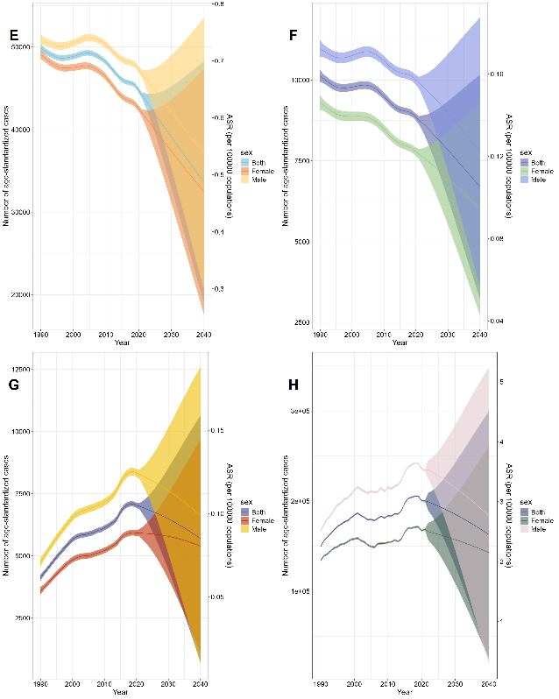
Figure S12: Future projections of the burden of Motor Neuron Disease (MND) in high Socio-Demographic Index (SDI) (A-D) and high-middle SDI (E-H) regions from 1990 to 2040.A/E: Age-Standardized Prevalence Rate (ASPR); B/F: Age-Standardized Incidence Rate (ASIR); C/G: Age-Standardized Mortality Rate (ASMR); D/H: Age-Standardized Disability-Adjusted Life Years (ASDR). The shaded areas represent the uncertainty intervals (95%) around the projections.
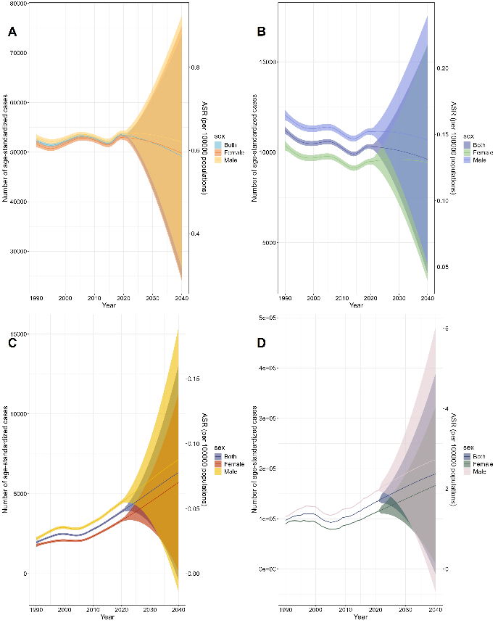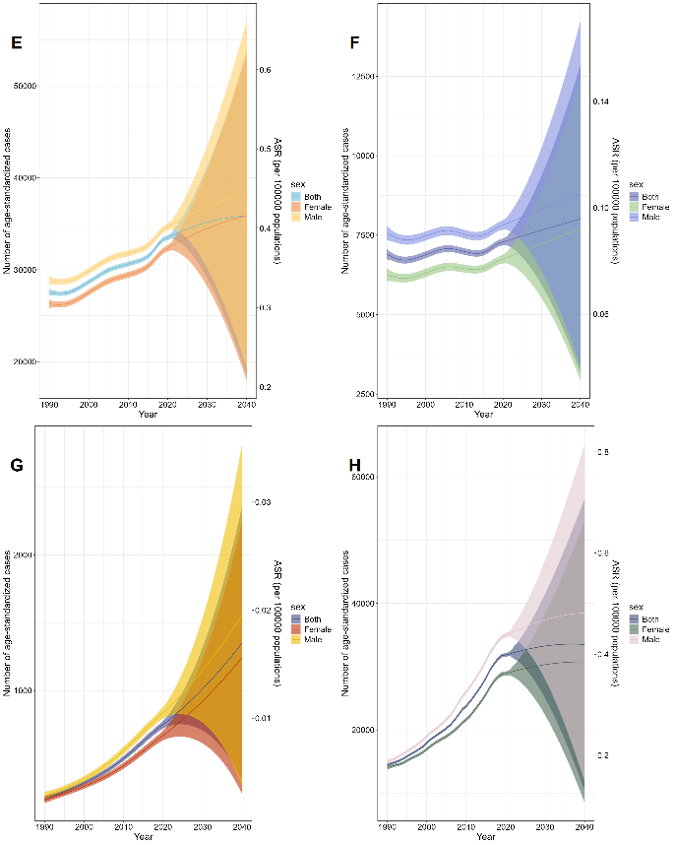
Figure S13: Future projections of the burden of Motor Neuron Disease (MND) in Middle Socio-Demographic Index (SDI) (A-D) and Low-middle SDI (E-H) regions from 1990 to 2040.A/E: Age-Standardized Prevalence Rate (ASPR); B/F: Age-Standardized Incidence Rate (ASIR); C/G: Age-Standardized Mortality Rate (ASMR); D/H: Age-Standardized Disability-Adjusted Life Years (ASDR). The shaded areas represent the uncertainty intervals (95%) around the projections.
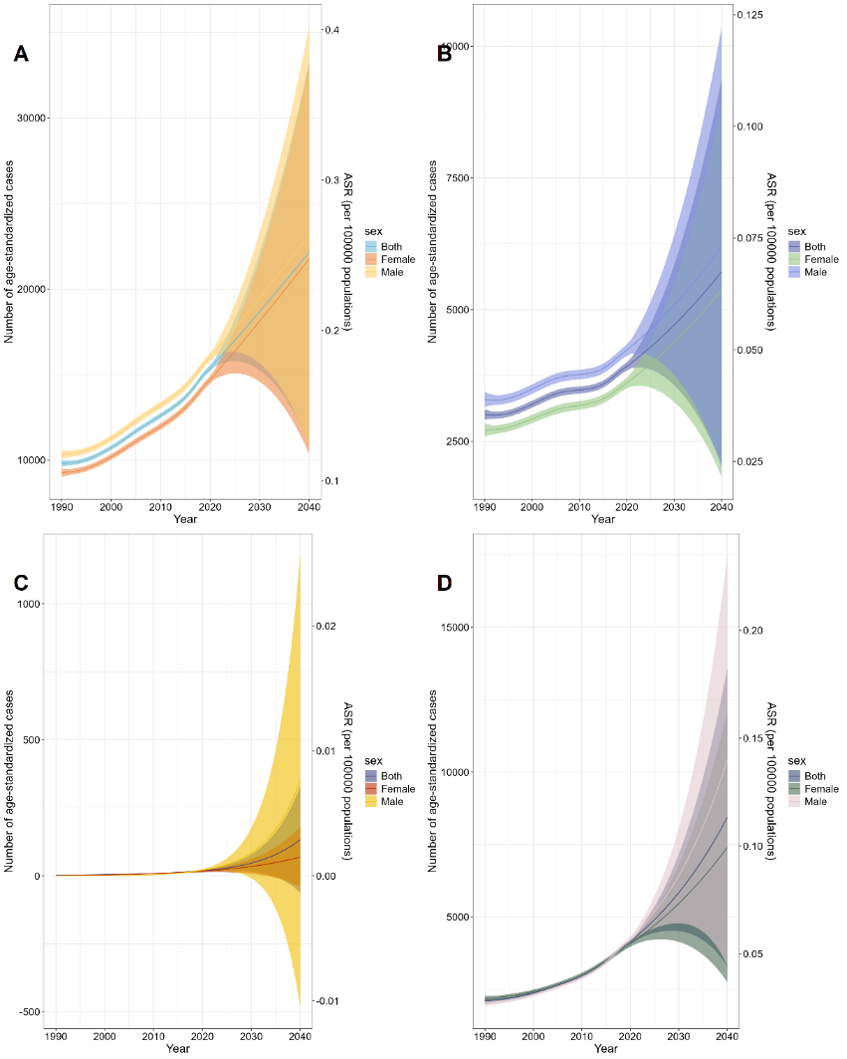
Figure S14：Future projections of the burden of Motor Neuron Disease (MND) in Low Socio-Demographic Index (SDI) (A-D) regions from 1990 to 2040.A: Age-Standardized Prevalence Rate (ASPR); B: Age-Standardized Incidence Rate (ASIR); C: Age-Standardized Mortality Rate (ASMR); D: Age-Standardized Disability-Adjusted Life Years (ASDR). The shaded areas represent the uncertainty intervals (95%) around the projections.

Table S1: Decomposition Analysis of the Impact of Aging, Population Growth, and Epidemiological Changes on Prevalence, Incidence, Mortality, and DALYs of Motor Neuron Disease across Different SDI Regions in 2021.
 |  | Prevalence |  | Incidence |  | Deaths |  | DALY
Location | Factor | OD | Value | OD | Value | OD | Value | OD | Value
Global | Aging | 104461.69 | 4274.498 | 25189.78 | 9924.931 | 21542.74 | 8169.206 | 501135.61 | 179716.431
Global | Population | 104461.69 | 95226.15 | 25189.78 | 18454.48 | 21542.74 | 9090.899 | 501135.61 | 275819.307
Global | EC | 104461.69 | 4961.048 | 25189.78 | -3189.63 | 21542.74 | 4282.637 | 501135.61 | 45599.875
Low SDI | Aging | 9323.3 | -373.703 | 2619.88 | -387.099 | 30.76 | -0.395 | 3233.86 | -127.565
Low SDI | Population | 9323.3 | 9710.371 | 2619.88 | 3322.754 | 30.76 | 12.718 | 3233.86 | 2649.412
Low SDI | EC | 9323.3 | -13.364 | 2619.88 | -315.778 | 30.76 | 18.439 | 3233.86 | 712.012
Low-middle SDI | Aging | 13468.36 | 1100.672 | 2762.92 | 365.543 | 874.09 | 138.447 | 28349.28 | 3545.242
Low-middle SDI | Population | 13468.36 | 11896.88 | 2762.92 | 2784.908 | 874.09 | 222.196 | 28349.28 | 9538.448
Low-middle SDI | EC | 13468.36 | 470.804 | 2762.92 | -387.534 | 874.09 | 513.451 | 28349.28 | 15265.587
Middle SDI | Aging | 17643.29 | 1167.88 | 3693.15 | 1684.089 | 4036.16 | 1244.053 | 113208.57 | 30856.129
Middle SDI | Population | 17643.29 | 14747.28 | 3693.15 | 3351.66 | 4036.16 | 916.015 | 113208.57 | 31912.355
Middle SDI | EC | 17643.29 | 1728.13 | 3693.15 | -1342.6 | 4036.16 | 1876.087 | 113208.57 | 50440.089
High-middle SDI | Aging | 21456.27 | 5825.018 | 6511.41 | 3370.777 | 9522.78 | 2544.828 | 217001.07 | 54277.711
High-middle SDI | Population | 21456.27 | 10327.75 | 6511.41 | 2248.021 | 9522.78 | 1599.014 | 217001.07 | 43631.915
High-middle SDI | EC | 21456.27 | 5303.505 | 6511.41 | 892.616 | 9522.78 | 5378.935 | 217001.07 | 119091.44
High SDI | Aging | 56011.55 | 17263.29 | 14715.22 | 4902.839 | 14382.59 | 4826.453 | 290327.47 | 91364.101
High SDI | Population | 56011.55 | 22743.34 | 14715.22 | 5717.388 | 14382.59 | 4785.653 | 290327.47 | 117419.737
High SDI | EC | 56011.55 | 16004.92 | 14715.22 | 4094.997 | 14382.59 | 4770.485 | 290327.47 | 81543.628
OD: Overall difference; EC: Epidemiological change.

Table S2: Forecasted Global and Regional Age-standardized Rates of Motor Neuron Disease by Sex from 2021 to 2040.
 | Both |  | Female |  | Male
 | ASR(2021) | ASR(2040) | ASR(2021) | ASR(2040) | ASR(2021) | ASR(2040)
Prevalence
Global | 3.29 | 2.75 | 3.00 | 2.54 | 3.62 | 3.03
High SDI | 1.45 | 1.10 | 1.22 | 0.93 | 1.71 | 1.29
High-middle SDI | 0.64 | 0.49 | 0.61 | 0.47 | 0.68 | 0.54
Middle SDI | 0.64 | 0.59 | 0.63 | 0.59 | 0.64 | 0.62
Low-middle SDI | 0.39 | 0.42 | 0.38 | 0.42 | 0.40 | 0.44
Low SDI | 0.18 | 0.25 | 0.17 | 0.25 | 0.19 | 0.26
Incidence
Global | 0.76 | 0.65 | 0.66 | 0.58 | 0.87 | 0.74
High SDI | 0.35 | 0.26 | 0.29 | 0.21 | 0.42 | 0.32
High-middle SDI | 0.14 | 0.11 | 0.12 | 0.09 | 0.16 | 0.12
Middle SDI | 0.14 | 0.13 | 0.13 | 0.13 | 0.15 | 0.15
Low-middle SDI | 0.09 | 0.10 | 0.08 | 0.09 | 0.09 | 0.11
Low SDI | 0.05 | 0.07 | 0.04 | 0.06 | 0.05 | 0.07
Deaths
Global | 0.45 | 0.37 | 0.38 | 0.31 | 0.54 | 0.44
High SDI | 0.29 | 0.20 | 0.24 | 0.16 | 0.35 | 0.25
High-middle SDI | 0.10 | 0.09 | 0.09 | 0.08 | 0.12 | 0.10
Middle SDI | 0.05 | 0.08 | 0.04 | 0.07 | 0.06 | 0.09
Low-middle SDI | 0.01 | 0.02 | 0.01 | 0.02 | 0.01 | 0.02
Low SDI | 0.00 | 0.00 | 0.00 | 0.00 | 0.00 | 0.01
DALYs
Global | 12.07 | 10.82 | 9.99 | 8.96 | 14.33 | 12.62
High SDI | 6.88 | 4.64 | 5.58 | 3.53 | 8.35 | 5.66
High-middle SDI | 3.01 | 2.45 | 2.54 | 2.15 | 3.52 | 2.77
Middle SDI | 1.70 | 2.37 | 1.45 | 2.09 | 1.96 | 2.73
Low-middle SDI | 0.40 | 0.42 | 0.36 | 0.38 | 0.44 | 0.48
Low SDI | 0.06 | 0.11 | 0.06 | 0.10 | 0.06 | 0.14

Table S3: Global and Regional Trends in Motor Neuron Disease Prevalence across 204 Countries from 1990 to 2021.
Location | Number(1990) | ASR(1990) | Number(2021) | ASR(2021) | EAPC(95%CI)
Afghanistan | 178.3 (145.1-218.9) | 1.9 (1.6-2.4) | 553.2 (441.7-687.8) | 1.8 (1.5-2.2) | -0.06 (-0.12 to 0)
Albania | 93.2 (75.3-113) | 2.9 (2.3-3.4) | 81.7 (67.6-97.8) | 2.9 (2.4-3.5) | 0.17 (0.12 to 0.21)
Algeria | 608 (480.6-746.6) | 2.5 (2-3) | 1071.8 (854.8-1307.9) | 2.4 (1.9-3) | -0.04 (-0.08 to -0.01)
American Samoa | 1 (0.7-1.2) | 2.1 (1.7-2.5) | 0.9 (0.7-1.1) | 1.8 (1.5-2.2) | -0.43 (-0.48 to -0.39)
Andorra | 5.4 (4.6-6.3) | 9.2 (7.9-10.8) | 14.2 (12.2-16.7) | 10.9 (9.5-12.7) | 0.63 (0.59 to 0.67)
Angola | 121.4 (94.8-152.7) | 1.4 (1.1-1.7) | 387.8 (298.4-495.5) | 1.4 (1.1-1.7) | 0.03 (-0.01 to 0.06)
Antigua and Barbuda | 1.6 (1.3-2) | 2.7 (2.1-3.2) | 2.8 (2.3-3.3) | 3 (2.5-3.5) | 0.42 (0.4 to 0.44)
Argentina | 1214 (1008.1-1433.3) | 3.7 (3.1-4.4) | 2275.2 (1931.3-2637.1) | 4.7 (4-5.4) | 0.82 (0.77 to 0.86)
Armenia | 91.8 (72.6-112.6) | 2.7 (2.1-3.3) | 80.4 (64.7-97.8) | 2.7 (2.1-3.2) | 0.07 (0.01 to 0.13)
Australia | 1243.7 (1077.6-1430.3) | 6.7 (5.9-7.7) | 3285.3 (2822.2-3792.7) | 9 (7.8-10.2) | 1.04 (0.96 to 1.13)
Austria | 630.6 (541-728.9) | 6.8 (5.8-7.8) | 1150.6 (975.6-1341.8) | 8.7 (7.5-10) | 0.88 (0.79 to 0.98)
Azerbaijan | 180.6 (143.6-222.4) | 2.5 (2-3) | 262.2 (208.5-320.3) | 2.5 (2-3) | 0.08 (-0.01 to 0.17)
Bahamas | 7.7 (6.1-9.5) | 3 (2.4-3.6) | 12.6 (10.6-14.8) | 3.2 (2.7-3.8) | 0.28 (0.25 to 0.32)
Bahrain | 14.5 (11.4-17.9) | 2.8 (2.2-3.3) | 44.3 (34.7-54.9) | 2.7 (2.2-3.3) | 0.02 (-0.02 to 0.05)
Bangladesh | 1531.8 (1185.4-1940.4) | 1.5 (1.2-1.8) | 2608.1 (2045.2-3248.4) | 1.6 (1.2-1.9) | 0.14 (0.1 to 0.18)
Barbados | 7.3 (5.9-8.7) | 2.8 (2.3-3.3) | 13.3 (11.3-15.4) | 3.7 (3.1-4.3) | 0.87 (0.77 to 0.97)
Belarus | 410.6 (339.2-487.5) | 3.9 (3.2-4.6) | 443.4 (374.8-516.1) | 4.3 (3.6-5) | 0.43 (0.39 to 0.46)
Belgium | 1231.6 (1049.3-1429.5) | 9.3 (8-10.6) | 1835.5 (1556.7-2129.7) | 10.2 (8.8-11.8) | 0.31 (0.28 to 0.35)
Belize | 4 (3.2-4.9) | 2.2 (1.8-2.7) | 9.8 (7.8-11.9) | 2.3 (1.9-2.7) | 0.09 (0.06 to 0.12)
Benin | 51.8 (39.6-66.1) | 1.2 (1-1.5) | 147.4 (111.7-188.1) | 1.2 (0.9-1.5) | -0.04 (-0.08 to 0)
Bermuda | 3.2 (2.7-3.7) | 5.3 (4.5-6.1) | 4.3 (3.7-5) | 5.5 (4.7-6.3) | 0.16 (0.14 to 0.17)
Bhutan | 10.2 (7.8-12.9) | 1.7 (1.3-2.1) | 14 (11-17.5) | 1.8 (1.4-2.2) | 0.21 (0.18 to 0.24)
Bolivia (Plurinational State of) | 106.3 (84-130) | 1.8 (1.5-2.2) | 234.2 (191.9-280.4) | 2.1 (1.7-2.4) | 0.46 (0.43 to 0.5)
Bosnia and Herzegovina | 153.3 (125.2-181.9) | 3.3 (2.8-4) | 117.3 (96-141.8) | 3.6 (2.9-4.3) | 0.24 (0.14 to 0.34)
Botswana | 20.3 (15.7-25.8) | 1.6 (1.3-2) | 39.7 (31.2-49.7) | 1.7 (1.3-2) | 0.02 (-0.01 to 0.06)
Brazil | 3685.6 (2916.1-4523.2) | 2.5 (2-3) | 6627.7 (5532.3-7769) | 2.9 (2.4-3.4) | 0.57 (0.54 to 0.6)
Brunei Darussalam | 4.8 (3.9-6) | 2.2 (1.8-2.7) | 10.4 (8.4-12.6) | 2.3 (1.9-2.8) | 0.26 (0.22 to 0.3)
Bulgaria | 271.2 (222.3-327.7) | 3.2 (2.6-3.8) | 209.4 (171.7-252.4) | 3.1 (2.5-3.7) | -0.03 (-0.07 to 0.02)
Burkina Faso | 99.9 (77.8-125.9) | 1.2 (0.9-1.5) | 244.4 (188.3-314) | 1.2 (0.9-1.5) | -0.02 (-0.06 to 0.02)
Burundi | 53 (40.8-67.6) | 1.1 (0.9-1.4) | 123.2 (93.6-157.6) | 1 (0.8-1.3) | -0.19 (-0.23 to -0.15)
Cabo Verde | 5.3 (4.1-6.6) | 1.6 (1.3-2) | 9.4 (7.4-11.6) | 1.6 (1.3-2) | 0.03 (0 to 0.07)
Cambodia | 128.7 (100-161.4) | 1.3 (1.1-1.6) | 232.8 (182.6-289.6) | 1.4 (1.1-1.7) | 0.13 (0.09 to 0.17)
Cameroon | 108.3 (82.9-137.2) | 1.2 (0.9-1.5) | 331.7 (252.5-425.8) | 1.1 (0.9-1.4) | -0.12 (-0.16 to -0.08)
Canada | 3277.5 (2882.7-3765.1) | 11.1 (9.8-12.6) | 6928.7 (5945.5-7932.7) | 12.8 (11.1-14.4) | 0.52 (0.48 to 0.57)
Central African Republic | 25.8 (19.6-33) | 1.1 (0.8-1.3) | 50.2 (37.7-64.7) | 1 (0.8-1.3) | -0.22 (-0.26 to -0.18)
Chad | 66.4 (52.1-83.8) | 1.3 (1-1.6) | 193.7 (148.9-248.7) | 1.3 (1-1.6) | 0.02 (-0.02 to 0.05)
Chile | 549 (456.2-643.6) | 4.3 (3.6-5) | 1204 (1027.3-1395.6) | 5.7 (4.8-6.5) | 0.96 (0.9 to 1.01)
China | 25691.6 (20344.8-31960.5) | 2.1 (1.7-2.6) | 33342.5 (27028.1-40366.4) | 2.3 (1.8-2.8) | 0.28 (0.22 to 0.35)
Colombia | 594.4 (469.8-735.4) | 1.9 (1.5-2.3) | 1190.8 (989.7-1393.6) | 2.3 (1.9-2.7) | 0.81 (0.76 to 0.85)
Comoros | 5.9 (4.6-7.5) | 1.5 (1.2-1.8) | 10 (7.8-12.7) | 1.4 (1.1-1.7) | -0.17 (-0.21 to -0.13)
Congo | 24.6 (18.9-31.4) | 1.1 (0.9-1.4) | 56.8 (43.9-73.3) | 1.1 (0.9-1.4) | -0.07 (-0.1 to -0.03)
Cook Islands | 0.4 (0.4-0.5) | 2.4 (1.9-2.8) | 0.4 (0.3-0.5) | 2.3 (1.8-2.7) | -0.19 (-0.23 to -0.15)
Costa Rica | 71.3 (56.5-87.5) | 2.5 (2-2.9) | 179 (152.2-208.4) | 3.5 (3-4.1) | 1.2 (1.13 to 1.26)
Croatia | 211.8 (179.1-247) | 4.3 (3.7-5) | 216.7 (183.9-250.4) | 4.6 (3.9-5.5) | 0.34 (0.3 to 0.38)
Cuba | 317.4 (255.7-379.2) | 2.9 (2.3-3.4) | 413.8 (352.6-477.7) | 3.3 (2.9-3.9) | 0.57 (0.54 to 0.59)
Cyprus | 45.9 (39.4-53.7) | 5.6 (4.8-6.5) | 112.1 (95.7-131.4) | 6.4 (5.5-7.4) | 0.49 (0.43 to 0.55)
Czechia | 469.7 (389.8-551.1) | 4.5 (3.7-5.3) | 546.3 (463.3-637.8) | 4.7 (4-5.5) | 0.21 (0.18 to 0.24)
Côte d’Ivoire | 132.9 (101.4-169.7) | 1.2 (1-1.5) | 308.3 (234.7-393.7) | 1.2 (0.9-1.5) | -0.11 (-0.16 to -0.07)
Democratic People's Republic of Korea | 521.4 (428-628) | 2.6 (2.1-3.1) | 632.4 (517.9-766.8) | 2.4 (1.9-2.9) | -0.31 (-0.37 to -0.26)
Democratic Republic of the Congo | 370.2 (283.2-470.4) | 1.1 (0.9-1.4) | 847.5 (645.1-1093.8) | 1 (0.8-1.3) | -0.26 (-0.33 to -0.2)
Denmark | 621.9 (530-720.1) | 9.3 (7.8-10.7) | 966.3 (825.2-1124.8) | 10.6 (9.1-12.2) | 0.45 (0.38 to 0.51)
Djibouti | 5.5 (4.2-7) | 1.5 (1.2-1.8) | 17.4 (13.5-22.1) | 1.4 (1.1-1.8) | -0.16 (-0.21 to -0.11)
Dominica | 1.7 (1.3-2) | 2.3 (1.9-2.8) | 2.1 (1.8-2.4) | 2.9 (2.5-3.4) | 0.82 (0.77 to 0.87)
Dominican Republic | 154.5 (121.4-188.9) | 2.3 (1.8-2.7) | 282.4 (232.3-334.6) | 2.6 (2.1-3) | 0.55 (0.5 to 0.6)
Ecuador | 145.4 (113.4-181.8) | 1.5 (1.2-1.9) | 324.1 (262.9-387) | 1.8 (1.5-2.2) | 0.72 (0.66 to 0.78)
Egypt | 1153.4 (919-1413.9) | 2.1 (1.7-2.6) | 2268.3 (1799.7-2761.9) | 2.2 (1.7-2.6) | 0.06 (0.03 to 0.09)
El Salvador | 97.2 (75.9-119.1) | 1.9 (1.5-2.3) | 123.7 (98.9-150) | 1.9 (1.5-2.3) | 0.02 (-0.01 to 0.06)
Equatorial Guinea | 4.1 (3.1-5.2) | 1.1 (0.9-1.4) | 17.3 (13.2-22.5) | 1.2 (1-1.5) | 0.47 (0.36 to 0.58)
Eritrea | 40.8 (31.4-52.2) | 1.4 (1.1-1.7) | 82.9 (63.4-106.1) | 1.3 (1-1.7) | -0.11 (-0.16 to -0.05)
Estonia | 62.6 (51.6-74.7) | 4 (3.3-4.8) | 54 (45-63.1) | 4.1 (3.3-4.8) | 0.09 (0.05 to 0.13)
Eswatini | 12.5 (9.6-15.6) | 1.7 (1.3-2) | 18.8 (14.6-23.6) | 1.7 (1.3-2) | -0.06 (-0.09 to -0.02)
Ethiopia | 549.4 (407.6-714.2) | 1.2 (0.9-1.6) | 1238.1 (909.9-1630.3) | 1.2 (0.9-1.5) | -0.08 (-0.17 to 0)
Fiji | 13.4 (10.5-16.7) | 1.8 (1.4-2.1) | 16 (12.7-19.5) | 1.7 (1.4-2.1) | -0.03 (-0.07 to 0.01)
Finland | 740.7 (633.5-859.4) | 11.8 (10.2-13.5) | 990.2 (833.1-1154.4) | 11.2 (9.5-12.8) | -0.24 (-0.39 to -0.09)
France | 6331.5 (5453-7243.2) | 9 (7.8-10.2) | 11407.6 (9997.1-13107) | 10.8 (9.5-12.4) | 0.64 (0.59 to 0.68)
Gabon | 11.4 (9-14.4) | 1.3 (1-1.6) | 21 (16.2-26.4) | 1.2 (0.9-1.5) | -0.16 (-0.19 to -0.12)
Gambia | 12.1 (9.4-15.4) | 1.4 (1.1-1.7) | 29.5 (22.3-37.6) | 1.3 (1-1.6) | -0.16 (-0.2 to -0.12)
Georgia | 151.5 (123.4-182.5) | 2.7 (2.2-3.3) | 98.4 (80.9-117) | 2.7 (2.2-3.3) | 0.14 (0.05 to 0.24)
Germany | 7225.6 (6175-8442.8) | 7.1 (6.1-8.3) | 12378.9 (10700.2-14386.5) | 8.9 (7.8-10.2) | 0.79 (0.74 to 0.84)
Ghana | 166.3 (126.7-209) | 1.2 (1-1.5) | 399.9 (309.1-513.4) | 1.2 (1-1.5) | -0.01 (-0.05 to 0.03)
Greece | 565.7 (479.1-667.7) | 4.6 (3.9-5.4) | 1032.2 (892.5-1195.3) | 6.7 (5.8-7.7) | 1.45 (1.32 to 1.57)
Greenland | 4.3 (3.7-5.1) | 8.9 (7.7-10.4) | 5.7 (4.8-6.7) | 9.4 (8-10.9) | 0.21 (0.15 to 0.26)
Grenada | 1.8 (1.5-2.3) | 2.1 (1.7-2.6) | 2.5 (2-2.9) | 2.3 (1.9-2.8) | 0.24 (0.18 to 0.3)
Guam | 3.4 (2.8-4.1) | 2.8 (2.3-3.3) | 3.2 (2.6-3.9) | 2 (1.6-2.4) | -1.39 (-1.54 to -1.23)
Guatemala | 139.1 (108.6-169.9) | 1.8 (1.5-2.2) | 280.4 (223.3-345.1) | 1.8 (1.5-2.2) | 0 (-0.04 to 0.04)
Guinea | 63.7 (49.8-80) | 1.2 (0.9-1.5) | 141.5 (107.6-181.1) | 1.2 (0.9-1.5) | -0.15 (-0.19 to -0.1)
Guinea-Bissau | 10.5 (8.1-13.5) | 1.2 (0.9-1.4) | 21.6 (16.5-27.9) | 1.1 (0.9-1.4) | -0.15 (-0.19 to -0.11)
Guyana | 12.2 (9.4-15.2) | 1.6 (1.3-1.9) | 13.9 (11.3-16.8) | 1.8 (1.5-2.2) | 0.51 (0.48 to 0.53)
Haiti | 103 (82-127.9) | 1.7 (1.4-2.1) | 208.7 (168-255) | 1.7 (1.4-2) | -0.03 (-0.07 to 0)
Honduras | 83.6 (65.6-102.3) | 1.9 (1.5-2.3) | 200.1 (160.1-242.9) | 2.1 (1.7-2.5) | 0.38 (0.35 to 0.41)
Hungary | 407.5 (341.7-478.2) | 3.9 (3.2-4.5) | 465.5 (401.1-537) | 4.6 (3.9-5.3) | 0.66 (0.59 to 0.73)
Iceland | 27.7 (23.9-31.7) | 10.3 (8.8-11.8) | 56.7 (48.9-65.7) | 12 (10.5-13.8) | 0.57 (0.53 to 0.61)
India | 12433.7 (9448.2-15840.3) | 1.5 (1.1-1.8) | 22869.7 (17755.5-28955.3) | 1.6 (1.2-2) | 0.23 (0.17 to 0.29)
Indonesia | 2518.4 (1895.2-3220.9) | 1.4 (1-1.7) | 3770.5 (2898.6-4776.6) | 1.3 (1-1.7) | -0.1 (-0.16 to -0.03)
Iran (Islamic Republic of) | 1553.5 (1230.6-1907.2) | 2.9 (2.3-3.5) | 2478.4 (1935.9-3045.4) | 2.8 (2.2-3.4) | -0.05 (-0.1 to 0)
Iraq | 460.2 (363.9-570.7) | 2.6 (2.1-3.2) | 1056.9 (850.7-1286.6) | 2.5 (2.1-3.1) | 0.04 (-0.01 to 0.09)
Ireland | 387.1 (335.3-445.8) | 9.9 (8.6-11.3) | 927.2 (780.3-1077.7) | 13.7 (11.7-15.5) | 1.16 (1.12 to 1.2)
Israel | 286.1 (244.6-331.3) | 5.9 (5-6.8) | 713.4 (612.6-814.3) | 6.6 (5.8-7.6) | 0.42 (0.39 to 0.46)
Italy | 4720.7 (4050.1-5474) | 6.5 (5.6-7.5) | 8959.9 (7624.1-10458.5) | 8.7 (7.5-10) | 0.97 (0.82 to 1.12)
Jamaica | 62.4 (50.3-76.2) | 2.6 (2.2-3.2) | 79.9 (66.2-94.8) | 2.8 (2.3-3.3) | 0.18 (0.16 to 0.21)
Japan | 6720.4 (5656.3-7823.3) | 4.6 (3.9-5.4) | 11752.7 (10062.9-13647.2) | 5.6 (4.8-6.4) | 0.63 (0.54 to 0.73)
Jordan | 102.3 (79.7-128.6) | 2.8 (2.2-3.4) | 341.2 (275-417.3) | 2.7 (2.2-3.3) | -0.03 (-0.07 to 0)
Kazakhstan | 475.3 (389-569.8) | 2.9 (2.4-3.5) | 537.6 (431.6-651.6) | 2.9 (2.3-3.5) | 0.06 (0 to 0.12)
Kenya | 270.6 (199-348.6) | 1.3 (1-1.7) | 591 (439-767.6) | 1.2 (0.9-1.5) | -0.34 (-0.42 to -0.26)
Kiribati | 0.9 (0.7-1.2) | 1.4 (1.2-1.7) | 1.6 (1.3-2) | 1.5 (1.3-1.8) | 0.23 (0.21 to 0.24)
Kuwait | 61.5 (49.3-75) | 3.5 (2.9-4.2) | 164.2 (131.2-197.4) | 3.4 (2.8-4) | -0.12 (-0.14 to -0.1)
Kyrgyzstan | 108.7 (86.2-132.9) | 2.5 (2-2.9) | 160.7 (127.9-195.3) | 2.3 (1.9-2.8) | -0.12 (-0.19 to -0.04)
Lao People's Democratic Republic | 56.3 (44.5-70.4) | 1.4 (1.1-1.8) | 110.4 (87.1-137.5) | 1.5 (1.2-1.8) | 0.17 (0.13 to 0.21)
Latvia | 99.7 (81.4-118.6) | 3.8 (3.1-4.5) | 76.3 (64.1-89.1) | 3.9 (3.2-4.7) | 0.24 (0.18 to 0.3)
Lebanon | 88.8 (71.7-107.2) | 3 (2.5-3.6) | 168.2 (135.7-202.6) | 3 (2.4-3.5) | -0.01 (-0.05 to 0.02)
Lesotho | 23.6 (18.8-29.4) | 1.6 (1.3-2) | 30.4 (23.9-38.2) | 1.6 (1.3-2) | -0.05 (-0.09 to 0)
Liberia | 24.8 (19-31.6) | 1.1 (0.9-1.4) | 54.9 (41.3-70.5) | 1.1 (0.8-1.3) | -0.1 (-0.15 to -0.04)
Libya | 102.3 (80.4-126.7) | 2.5 (2-3.1) | 161 (127.7-197.1) | 2.3 (1.8-2.7) | -0.31 (-0.34 to -0.27)
Lithuania | 142.7 (116.7-168.7) | 3.9 (3.2-4.6) | 167.5 (143.4-194.9) | 5.2 (4.4-6.1) | 1.11 (1.05 to 1.17)
Luxembourg | 38.3 (32.9-44.5) | 8.1 (7-9.4) | 77.6 (66.1-89.9) | 9 (7.8-10.3) | 0.32 (0.24 to 0.4)
Madagascar | 159.6 (125.1-199.7) | 1.5 (1.2-1.9) | 383 (298.4-484.2) | 1.5 (1.2-1.8) | -0.15 (-0.19 to -0.1)
Malawi | 112.9 (87.1-144.7) | 1.3 (1-1.7) | 228.3 (174.7-291) | 1.3 (1-1.6) | -0.13 (-0.17 to -0.09)
Malaysia | 277.8 (213.7-353.7) | 1.6 (1.3-2) | 524.4 (417.4-648.9) | 1.6 (1.3-2) | 0.06 (0.03 to 0.09)
Maldives | 3.2 (2.4-4) | 1.5 (1.2-1.9) | 8.8 (6.7-11) | 1.6 (1.3-2) | 0.26 (0.23 to 0.3)
Mali | 132.4 (106.3-160.4) | 2 (1.6-2.3) | 364 (293.7-442.9) | 2 (1.7-2.4) | 0.1 (0.08 to 0.13)
Malta | 25.4 (21.9-29.5) | 6.2 (5.4-7.2) | 55.1 (46.6-64.8) | 7.8 (6.7-9) | 0.77 (0.73 to 0.81)
Marshall Islands | 0.7 (0.5-0.8) | 1.5 (1.2-1.8) | 0.8 (0.6-1) | 1.4 (1.1-1.7) | -0.17 (-0.2 to -0.14)
Mauritania | 29.4 (23-36.9) | 1.6 (1.2-2) | 63.4 (49.4-79.3) | 1.5 (1.2-1.9) | -0.05 (-0.09 to -0.02)
Mauritius | 24.6 (19.5-30.2) | 2.2 (1.8-2.7) | 29 (23.7-34.8) | 2.3 (1.8-2.7) | 0.09 (0.05 to 0.13)
Mexico | 2142.8 (1672-2636.1) | 2.5 (2-3.1) | 3543.1 (2866.1-4255.1) | 2.7 (2.2-3.2) | 0.29 (0.25 to 0.33)
Micronesia (Federated States of) | 1.4 (1.1-1.8) | 1.4 (1.1-1.7) | 1.4 (1.1-1.7) | 1.3 (1.1-1.7) | -0.13 (-0.17 to -0.1)
Monaco | 2.5 (2.1-3.1) | 5.9 (5-7) | 3.8 (3.2-4.6) | 6.5 (5.6-7.6) | 0.34 (0.29 to 0.39)
Mongolia | 53.3 (42.2-65.1) | 2.5 (2-3) | 83.8 (67.3-101) | 2.6 (2.1-3.1) | 0.17 (0.12 to 0.21)
Montenegro | 21.8 (17.7-26.2) | 3.5 (2.8-4.1) | 20.7 (17.1-25.1) | 3.4 (2.8-4.1) | -0.01 (-0.06 to 0.04)
Morocco | 598.3 (477.6-735.2) | 2.4 (1.9-2.9) | 892.6 (721.6-1085.7) | 2.4 (1.9-2.9) | -0.01 (-0.05 to 0.02)
Mozambique | 160.1 (126-202.6) | 1.4 (1.1-1.7) | 382.3 (292-483.2) | 1.4 (1.1-1.7) | 0.06 (0.02 to 0.1)
Myanmar | 577.2 (451.2-726.3) | 1.5 (1.2-1.8) | 880.4 (702.1-1089.8) | 1.6 (1.3-1.9) | 0.27 (0.22 to 0.32)
Namibia | 22 (17-27.6) | 1.7 (1.3-2.1) | 39.5 (30.7-49.8) | 1.7 (1.3-2) | -0.01 (-0.05 to 0.02)
Nauru | 0.1 (0.1-0.2) | 1.4 (1.1-1.7) | 0.1 (0.1-0.2) | 1.2 (1-1.5) | -0.32 (-0.42 to -0.23)
Nepal | 294.6 (231.3-371.5) | 1.6 (1.3-2) | 519.1 (407.3-646) | 1.6 (1.3-2) | 0.09 (0.04 to 0.13)
Netherlands | 1757.3 (1502.9-2024.2) | 9.9 (8.5-11.3) | 3315.3 (2803.5-3831.4) | 11.9 (10.2-13.5) | 0.67 (0.61 to 0.73)
New Zealand | 276.3 (236.1-320.1) | 7.4 (6.3-8.5) | 647.9 (554.6-750.5) | 9.1 (7.9-10.4) | 0.76 (0.68 to 0.83)
Nicaragua | 70.4 (55-87) | 2 (1.6-2.4) | 129 (102.9-157.5) | 1.9 (1.6-2.4) | 0.02 (-0.02 to 0.06)
Niger | 89.6 (69.7-113.1) | 1.3 (1-1.6) | 272.7 (209-345.4) | 1.3 (1-1.6) | -0.1 (-0.14 to -0.05)
Nigeria | 1081.5 (807.3-1388.9) | 1.3 (1-1.7) | 2640.4 (1940.6-3420.7) | 1.2 (0.9-1.6) | -0.16 (-0.23 to -0.09)
Niue | 0 (0-0.1) | 2 (1.6-2.4) | 0 (0-0) | 2 (1.6-2.3) | -0.08 (-0.11 to -0.05)
North Macedonia | 66.8 (55.3-80) | 3.3 (2.8-3.9) | 69.4 (56.6-84.2) | 3.2 (2.6-3.8) | -0.13 (-0.17 to -0.1)
Northern Mariana Islands | 1 (0.8-1.3) | 2.3 (1.8-2.8) | 1 (0.8-1.2) | 2.1 (1.7-2.6) | -0.23 (-0.29 to -0.17)
Norway | 551.2 (471.4-644) | 9.8 (8.4-11.3) | 936.6 (800.2-1100.2) | 11.5 (9.8-13.3) | 0.59 (0.53 to 0.66)
Oman | 46.4 (36.6-57.8) | 2.4 (1.9-2.9) | 118.8 (93.7-149) | 2.5 (2-3) | 0.18 (0.14 to 0.22)
Pakistan | 1763.3 (1347.9-2242.2) | 1.7 (1.3-2.1) | 3884.8 (2947.3-4931.5) | 1.6 (1.3-2) | -0.06 (-0.12 to 0)
Palau | 0.3 (0.2-0.3) | 1.7 (1.4-2.1) | 0.3 (0.2-0.4) | 1.6 (1.3-2) | -0.26 (-0.3 to -0.22)
Palestine | 50.5 (39.9-61.8) | 2.6 (2.1-3.1) | 133.7 (106.9-164.9) | 2.6 (2.1-3.1) | -0.02 (-0.05 to 0.01)
Panama | 47.5 (37.2-58.5) | 2.1 (1.7-2.5) | 99.3 (81.9-118.3) | 2.3 (1.9-2.7) | 0.38 (0.37 to 0.4)
Papua New Guinea | 50.2 (39.2-63.4) | 1.3 (1-1.6) | 126.9 (98.6-159.9) | 1.3 (1-1.6) | -0.09 (-0.13 to -0.05)
Paraguay | 101.8 (82.9-123.1) | 2.7 (2.2-3.2) | 191.8 (153.4-231) | 2.7 (2.2-3.2) | 0 (-0.04 to 0.04)
Peru | 353.4 (277.3-438.5) | 1.7 (1.4-2.1) | 670.3 (535.9-816.9) | 1.8 (1.5-2.2) | 0.27 (0.23 to 0.3)
Philippines | 953.8 (725.8-1215.1) | 1.5 (1.2-1.9) | 1711.9 (1305.9-2180.4) | 1.5 (1.2-1.9) | -0.13 (-0.2 to -0.06)
Poland | 1403.1 (1150-1695.7) | 3.6 (2.9-4.3) | 2025 (1716.3-2364.3) | 4.4 (3.7-5.1) | 0.76 (0.72 to 0.8)
Portugal | 633.8 (538.9-738.4) | 5.4 (4.6-6.3) | 1263.9 (1083.9-1494.6) | 7.5 (6.5-8.8) | 1.16 (1.04 to 1.27)
Puerto Rico | 113.5 (93.2-135.4) | 3.1 (2.6-3.7) | 151.3 (130-174.8) | 3.8 (3.2-4.5) | 0.78 (0.73 to 0.83)
Qatar | 13.8 (10.8-17.4) | 2.9 (2.4-3.6) | 96.9 (75.5-123) | 2.9 (2.4-3.6) | 0.09 (0.05 to 0.13)
Republic of Korea | 1555.6 (1286.4-1845.8) | 3.6 (3-4.3) | 2394.9 (1959.7-2926) | 3.9 (3.2-4.6) | 0.12 (0.07 to 0.18)
Republic of Moldova | 131 (106.5-157.3) | 3 (2.4-3.5) | 101.9 (83.7-122.2) | 2.9 (2.4-3.5) | -0.01 (-0.08 to 0.06)
Romania | 721.4 (606.3-867.7) | 3.1 (2.6-3.7) | 644.5 (536.9-767.6) | 3.4 (2.8-4.1) | 0.45 (0.38 to 0.52)
Russian Federation | 5213.9 (4187.6-6329.1) | 3.5 (2.8-4.2) | 5490.8 (4574.7-6490.6) | 3.7 (3-4.3) | 0.34 (0.25 to 0.43)
Rwanda | 68.1 (51.6-87.6) | 1.1 (0.8-1.4) | 134.6 (102.3-173.3) | 1.1 (0.8-1.4) | 0.01 (-0.04 to 0.07)
Saint Kitts and Nevis | 1 (0.8-1.2) | 2.4 (2-2.9) | 1.9 (1.6-2.2) | 3 (2.5-3.5) | 0.75 (0.72 to 0.78)
Saint Lucia | 3.2 (2.5-3.9) | 2.4 (1.9-2.9) | 5.6 (4.7-6.5) | 2.9 (2.5-3.4) | 0.77 (0.74 to 0.79)
Saint Vincent and the Grenadines | 2.4 (1.9-2.9) | 2.2 (1.8-2.6) | 2.9 (2.4-3.5) | 2.5 (2-2.9) | 0.51 (0.48 to 0.54)
Samoa | 2.9 (2.2-3.6) | 1.7 (1.4-2.1) | 3.6 (2.8-4.4) | 1.7 (1.4-2) | -0.1 (-0.14 to -0.06)
San Marino | 1.7 (1.4-2) | 5.9 (4.9-7.1) | 2.6 (2.1-3.2) | 5.7 (4.8-6.8) | -0.15 (-0.25 to -0.04)
Sao Tome and Principe | 1.3 (1-1.7) | 1.2 (1-1.5) | 2.8 (2.2-3.4) | 1.4 (1.1-1.7) | 0.61 (0.56 to 0.67)
Saudi Arabia | 387.2 (300.8-480) | 2.5 (2-3) | 952.4 (749.7-1184.2) | 2.4 (1.9-2.9) | -0.04 (-0.07 to -0.01)
Senegal | 93.9 (73-118.3) | 1.4 (1.1-1.7) | 203.5 (157.9-256.9) | 1.4 (1.1-1.7) | -0.07 (-0.11 to -0.03)
Serbia | 328 (269.5-393.9) | 3.4 (2.8-4.1) | 302.4 (249.6-363.3) | 3.3 (2.7-4) | 0 (-0.05 to 0.05)
Seychelles | 1.4 (1.1-1.7) | 1.9 (1.5-2.2) | 2.1 (1.8-2.6) | 2 (1.6-2.5) | 0.29 (0.26 to 0.32)
Sierra Leone | 42.8 (32.9-54.9) | 1.1 (0.9-1.4) | 91.1 (68.9-116.6) | 1.1 (0.9-1.4) | -0.14 (-0.18 to -0.1)
Singapore | 71.6 (59-86.3) | 2.5 (2.1-2.9) | 203.1 (168.6-239.1) | 2.9 (2.4-3.4) | 0.57 (0.53 to 0.62)
Slovakia | 200.1 (164.5-239) | 3.7 (3.1-4.5) | 206.9 (170.3-243.6) | 3.8 (3.1-4.5) | 0.07 (0.03 to 0.11)
Slovenia | 91.7 (77-107.8) | 4.6 (3.9-5.4) | 83.7 (68.7-101) | 4 (3.2-4.7) | -0.59 (-0.69 to -0.49)
Solomon Islands | 4.5 (3.4-5.8) | 1.3 (1.1-1.6) | 8.8 (6.9-11.1) | 1.3 (1-1.6) | -0.17 (-0.2 to -0.13)
Somalia | 70.2 (52.9-90.2) | 1 (0.8-1.3) | 179.8 (133.5-233.9) | 0.9 (0.7-1.2) | -0.24 (-0.29 to -0.2)
South Africa | 680.8 (521.5-857.2) | 1.9 (1.5-2.3) | 1028 (790-1301.1) | 1.8 (1.4-2.2) | -0.14 (-0.2 to -0.07)
South Sudan | 67.1 (51.7-85.4) | 1.3 (1-1.6) | 101.6 (76.7-130.5) | 1.2 (0.9-1.5) | -0.28 (-0.32 to -0.24)
Spain | 2991.3 (2575.1-3451) | 6.3 (5.5-7.3) | 5937.1 (5089.6-6962.4) | 8.2 (7.1-9.5) | 0.87 (0.76 to 0.97)
Sri Lanka | 279 (215.6-345.5) | 1.6 (1.3-2) | 383.7 (307.1-472.5) | 1.7 (1.4-2.1) | 0.17 (0.15 to 0.19)
Sudan | 301.3 (235.2-372.3) | 1.6 (1.3-1.9) | 681.9 (534.4-850.6) | 1.6 (1.3-2) | 0.04 (0 to 0.07)
Suriname | 7.1 (5.6-8.8) | 1.9 (1.5-2.3) | 12.4 (10.3-14.7) | 2.1 (1.7-2.5) | 0.48 (0.46 to 0.51)
Sweden | 1303 (1118.6-1517.8) | 10.6 (9.2-12.4) | 2051.1 (1735.9-2397.5) | 12.3 (10.6-14.2) | 0.57 (0.4 to 0.74)
Switzerland | 838.1 (721-968.8) | 9.4 (8.1-10.8) | 1396.4 (1193.3-1631.2) | 10 (8.5-11.6) | 0.22 (0.19 to 0.26)
Syrian Arab Republic | 325.5 (258.8-400.3) | 2.7 (2.2-3.2) | 357.7 (288.9-438.6) | 2.6 (2.1-3.1) | -0.09 (-0.12 to -0.05)
Taiwan (Province of China) | 565.2 (456.7-677.5) | 2.8 (2.3-3.3) | 834 (702.6-973.7) | 3.2 (2.6-3.7) | 0.16 (0 to 0.32)
Tajikistan | 117 (92.8-144.1) | 2.3 (1.8-2.8) | 216 (172-266.1) | 2.1 (1.7-2.6) | -0.15 (-0.24 to -0.06)
Thailand | 1015 (799-1265.5) | 1.8 (1.4-2.2) | 1254.9 (1008.8-1547.6) | 1.8 (1.5-2.3) | 0.06 (0.02 to 0.09)
Timor-Leste | 9.8 (7.6-12.3) | 1.3 (1.1-1.7) | 18.5 (14.3-23.2) | 1.4 (1.1-1.7) | 0.09 (0.07 to 0.11)
Togo | 38.4 (29.3-49.3) | 1.2 (0.9-1.5) | 90.5 (69.8-115.8) | 1.1 (0.9-1.4) | -0.13 (-0.17 to -0.09)
Tokelau | 0 (0-0) | 1.6 (1.3-2) | 0 (0-0) | 1.6 (1.3-2) | -0.04 (-0.08 to -0.01)
Tonga | 1.9 (1.5-2.4) | 2 (1.6-2.4) | 2 (1.6-2.5) | 1.9 (1.5-2.3) | -0.1 (-0.14 to -0.06)
Trinidad and Tobago | 26.3 (20.8-32.4) | 2.2 (1.8-2.6) | 37.3 (31.1-44.1) | 2.5 (2.1-3) | 0.53 (0.48 to 0.57)
Tunisia | 229.7 (183.1-278.4) | 2.8 (2.3-3.4) | 332.7 (271.4-401.7) | 2.8 (2.2-3.3) | -0.01 (-0.05 to 0.03)
Turkmenistan | 84 (66.1-103.8) | 2.3 (1.9-2.8) | 122.7 (98.3-148.9) | 2.4 (1.9-2.9) | 0.18 (0.11 to 0.26)
Tuvalu | 0.1 (0.1-0.2) | 1.3 (1.1-1.6) | 0.2 (0.1-0.2) | 1.3 (1-1.6) | -0.14 (-0.18 to -0.09)
Turkey | 2001.6 (1672.4-2364.1) | 3.6 (3.1-4.3) | 3548.2 (3010.3-4136.8) | 4.1 (3.5-4.7) | 0.42 (0.38 to 0.46)
Uganda | 161.7 (120.9-206) | 1.1 (0.9-1.4) | 418.9 (314.4-544.8) | 1.1 (0.8-1.4) | -0.02 (-0.05 to 0.02)
Ukraine | 1652.3 (1324.9-2005.3) | 3.2 (2.6-3.8) | 1253.7 (1020.1-1488.2) | 3 (2.4-3.6) | -0.12 (-0.2 to -0.04)
United Arab Emirates | 55.8 (43.9-69.7) | 2.9 (2.3-3.5) | 280.8 (216.5-358.5) | 2.8 (2.2-3.3) | -0.13 (-0.17 to -0.09)
United Kingdom | 6577.6 (5683.6-7603.7) | 8.7 (7.5-10) | 11918.9 (10168.5-13931.6) | 11.2 (9.7-12.8) | 0.91 (0.83 to 0.99)
United Republic of Tanzania | 283.2 (220.6-356.7) | 1.3 (1-1.6) | 667 (511.7-850.2) | 1.3 (1-1.6) | -0.02 (-0.07 to 0.03)
United States Virgin Islands | 3.2 (2.7-3.9) | 3.2 (2.6-3.7) | 4.6 (4-5.4) | 4 (3.4-4.6) | 0.83 (0.72 to 0.94)
United States of America | 22197.5 (19256.5-25429.7) | 7.8 (6.8-8.9) | 40495.4 (37645.4-43576.3) | 8.8 (8.3-9.5) | 1.16 (0.87 to 1.44)
Uruguay | 125.6 (105.8-147.3) | 3.8 (3.2-4.5) | 227.1 (195.1-261.4) | 5.4 (4.6-6.2) | 1.17 (1.1 to 1.24)
Uzbekistan | 493.3 (390.9-607.7) | 2.4 (1.9-2.9) | 813.3 (651-1000.5) | 2.4 (1.9-2.9) | 0.03 (-0.03 to 0.09)
Vanuatu | 2.4 (1.9-2.9) | 1.6 (1.3-1.9) | 4.7 (3.7-5.9) | 1.5 (1.2-1.9) | -0.15 (-0.18 to -0.11)
Venezuela (Bolivarian Republic of) | 357.6 (278.6-440.4) | 2 (1.6-2.4) | 566.4 (467.5-669.4) | 2.1 (1.7-2.5) | 0.27 (0.24 to 0.3)
Viet Nam | 1157.1 (903.5-1433.3) | 1.7 (1.4-2.1) | 1822.6 (1456.9-2241.6) | 1.8 (1.4-2.2) | 0.19 (0.16 to 0.23)
Yemen | 204.3 (159.9-256.8) | 1.6 (1.3-2) | 511.6 (400.8-635.6) | 1.5 (1.2-1.9) | -0.11 (-0.15 to -0.07)
Zambia | 96 (74.1-122.1) | 1.4 (1.1-1.7) | 244.8 (186.8-313.3) | 1.4 (1.1-1.7) | -0.03 (-0.08 to 0.02)
Zimbabwe | 143.4 (110.3-181.6) | 1.5 (1.2-1.8) | 211.7 (165.3-268.8) | 1.4 (1.1-1.7) | -0.21 (-0.26 to -0.16)

Table S4: Global and Regional Trends in Motor Neuron Disease incidence across 204 Countries from 1990 to 2021.
Location | Number(1990) | ASR(1990) | Number(2021) | ASR(2021) | EAPC(95%CI)
Afghanistan | 61.6 (51.4-73) | 0.6 (0.5-0.8) | 158.2 (129.4-189.5) | 0.6 (0.5-0.7) | -0.31 (-0.4 to -0.22)
Albania | 15.6 (13.2-18.1) | 0.5 (0.4-0.6) | 14.6 (12.3-17.1) | 0.5 (0.4-0.6) | -0.29 (-0.35 to -0.22)
Algeria | 100.3 (83.8-118.1) | 0.5 (0.4-0.6) | 184 (150.2-222) | 0.4 (0.4-0.5) | -0.28 (-0.34 to -0.21)
American Samoa | 0.2 (0.2-0.2) | 0.5 (0.4-0.6) | 0.2 (0.2-0.2) | 0.4 (0.3-0.4) | -0.98 (-1.08 to -0.88)
Andorra | 1.1 (1-1.2) | 1.9 (1.7-2.1) | 3.1 (2.9-3.4) | 2.2 (2.1-2.4) | 0.61 (0.58 to 0.64)
Angola | 36 (29.4-43.5) | 0.5 (0.4-0.6) | 100.9 (82.5-123.4) | 0.4 (0.4-0.5) | -0.48 (-0.56 to -0.4)
Antigua and Barbuda | 0.3 (0.2-0.3) | 0.5 (0.4-0.6) | 0.7 (0.6-0.7) | 0.7 (0.6-0.7) | 0.91 (0.87 to 0.95)
Argentina | 247.3 (212-283.1) | 0.8 (0.6-0.9) | 486.6 (446.2-529.6) | 1 (0.9-1.1) | 0.83 (0.77 to 0.89)
Armenia | 13.7 (11.2-16.6) | 0.4 (0.4-0.5) | 13.1 (10.6-15.9) | 0.4 (0.3-0.5) | -0.34 (-0.4 to -0.29)
Australia | 391.3 (370.6-412.1) | 2.1 (2-2.2) | 1070.4 (1027.5-1116.3) | 2.6 (2.5-2.7) | 0.78 (0.71 to 0.85)
Austria | 119.1 (109-129.6) | 1.2 (1.1-1.4) | 231.9 (219-245.6) | 1.6 (1.5-1.7) | 0.9 (0.81 to 1)
Azerbaijan | 28.9 (24-34.6) | 0.4 (0.4-0.5) | 41.7 (33.7-51.4) | 0.4 (0.3-0.5) | -0.4 (-0.48 to -0.33)
Bahamas | 1.2 (1-1.4) | 0.6 (0.5-0.7) | 2.7 (2.4-3) | 0.7 (0.6-0.8) | 0.68 (0.64 to 0.72)
Bahrain | 1.8 (1.4-2.1) | 0.4 (0.4-0.5) | 5.6 (4.4-7.1) | 0.4 (0.3-0.5) | -0.2 (-0.26 to -0.14)
Bangladesh | 348.1 (285.6-422.5) | 0.4 (0.3-0.5) | 549.1 (449.6-668) | 0.4 (0.3-0.4) | -0.27 (-0.33 to -0.22)
Barbados | 1.6 (1.4-1.8) | 0.6 (0.5-0.7) | 5.4 (5.1-5.8) | 1.2 (1.1-1.3) | 1.99 (1.79 to 2.18)
Belarus | 80.6 (69.9-91.1) | 0.7 (0.6-0.8) | 117.8 (107.5-128.1) | 0.9 (0.8-1) | 0.8 (0.71 to 0.9)
Belgium | 298.3 (279.5-316) | 2.1 (2-2.2) | 417.2 (395.5-436.9) | 2.1 (2-2.2) | -0.02 (-0.12 to 0.08)
Belize | 0.8 (0.7-0.9) | 0.5 (0.5-0.6) | 1.9 (1.7-2.2) | 0.5 (0.5-0.6) | -0.01 (-0.06 to 0.04)
Benin | 15 (12.4-18.1) | 0.4 (0.3-0.5) | 38 (31-45.8) | 0.4 (0.3-0.5) | -0.29 (-0.35 to -0.22)
Bermuda | 0.6 (0.6-0.7) | 1.1 (1-1.2) | 1.2 (1.2-1.3) | 1.1 (1.1-1.2) | 0.14 (0.12 to 0.17)
Bhutan | 1.9 (1.6-2.3) | 0.4 (0.3-0.5) | 2.5 (2-3) | 0.4 (0.3-0.4) | -0.32 (-0.37 to -0.26)
Bolivia (Plurinational State of) | 26.8 (23-31.2) | 0.5 (0.5-0.6) | 67.1 (59.6-74.9) | 0.7 (0.6-0.7) | 0.75 (0.69 to 0.81)
Bosnia and Herzegovina | 26.3 (22.4-30.6) | 0.6 (0.5-0.7) | 21.5 (17.1-26.5) | 0.5 (0.4-0.6) | -0.73 (-0.83 to -0.64)
Botswana | 4.2 (3.5-5) | 0.4 (0.4-0.5) | 8 (6.3-9.9) | 0.4 (0.3-0.5) | -0.41 (-0.47 to -0.34)
Brazil | 783.6 (674.8-893.1) | 0.7 (0.6-0.7) | 2078 (1891.5-2252.9) | 0.9 (0.8-0.9) | 1.16 (1.09 to 1.23)
Brunei Darussalam | 0.8 (0.7-1) | 0.5 (0.4-0.6) | 1.8 (1.5-2.1) | 0.5 (0.4-0.5) | -0.01 (-0.07 to 0.06)
Bulgaria | 53.7 (44.1-64.3) | 0.6 (0.5-0.7) | 44 (35.7-52.8) | 0.5 (0.4-0.6) | -0.3 (-0.36 to -0.23)
Burkina Faso | 32.7 (27-39) | 0.4 (0.4-0.5) | 70.7 (58-85.2) | 0.4 (0.3-0.5) | -0.28 (-0.35 to -0.21)
Burundi | 18.3 (15-22.2) | 0.5 (0.4-0.6) | 41.2 (33.5-50.5) | 0.5 (0.4-0.6) | -0.1 (-0.16 to -0.03)
Cabo Verde | 1.2 (1-1.4) | 0.4 (0.3-0.5) | 1.9 (1.5-2.3) | 0.4 (0.3-0.4) | -0.49 (-0.56 to -0.42)
Cambodia | 37.9 (31.5-44.7) | 0.4 (0.4-0.5) | 60.1 (49.5-72) | 0.4 (0.3-0.5) | -0.43 (-0.5 to -0.35)
Cameroon | 30.5 (25.1-36.2) | 0.4 (0.3-0.5) | 83.3 (68.9-100.2) | 0.4 (0.3-0.4) | -0.29 (-0.35 to -0.23)
Canada | 644.5 (606.1-686.9) | 2.1 (2-2.2) | 1566.4 (1486.9-1643.3) | 2.4 (2.3-2.6) | 0.57 (0.52 to 0.62)
Central African Republic | 9.9 (8.1-12.2) | 0.5 (0.4-0.6) | 18.9 (15.2-23.4) | 0.5 (0.4-0.6) | -0.19 (-0.26 to -0.12)
Chad | 22 (18.3-26.5) | 0.5 (0.4-0.6) | 55.6 (45.7-67.2) | 0.4 (0.3-0.5) | -0.31 (-0.39 to -0.24)
Chile | 103.2 (91-115) | 0.9 (0.8-1) | 263.7 (245.3-283.5) | 1.1 (1.1-1.2) | 0.9 (0.85 to 0.95)
China | 6854.4 (5928.8-7956.9) | 0.7 (0.6-0.8) | 7324.8 (5993.2-8709.1) | 0.5 (0.4-0.5) | -1.33 (-1.51 to -1.16)
Colombia | 123.6 (104.4-143.3) | 0.5 (0.4-0.5) | 350.5 (315.3-383.2) | 0.7 (0.6-0.7) | 1.55 (1.46 to 1.64)
Comoros | 1.6 (1.3-1.9) | 0.5 (0.4-0.6) | 2.8 (2.3-3.5) | 0.5 (0.4-0.6) | -0.25 (-0.31 to -0.18)
Congo | 6.8 (5.5-8.3) | 0.4 (0.3-0.5) | 15.7 (12.4-19.7) | 0.4 (0.3-0.5) | -0.33 (-0.4 to -0.26)
Cook Islands | 0.1 (0.1-0.1) | 0.5 (0.4-0.6) | 0.1 (0.1-0.1) | 0.4 (0.3-0.4) | -0.89 (-0.96 to -0.81)
Costa Rica | 12.9 (11-14.7) | 0.5 (0.5-0.6) | 62.3 (58.4-66.1) | 1.2 (1.1-1.3) | 2.39 (2.12 to 2.66)
Croatia | 37.7 (32.9-42.4) | 0.7 (0.7-0.8) | 51.5 (47-55.8) | 0.8 (0.8-0.9) | 0.53 (0.48 to 0.58)
Cuba | 58.1 (49.6-66.9) | 0.6 (0.5-0.7) | 127.8 (116-139) | 0.8 (0.7-0.9) | 1.17 (1.08 to 1.25)
Cyprus | 9.3 (8.4-10.2) | 1.1 (1-1.2) | 22.5 (20.9-24.3) | 1.2 (1.1-1.3) | 0.26 (0.23 to 0.3)
Czechia | 74 (64.7-83.4) | 0.7 (0.6-0.8) | 113 (102.2-124) | 0.7 (0.7-0.8) | 0.43 (0.39 to 0.46)
Côte d’Ivoire | 34.4 (28.1-41.7) | 0.4 (0.3-0.5) | 77.3 (63.2-94.1) | 0.4 (0.3-0.4) | -0.26 (-0.31 to -0.2)
Democratic People's Republic of Korea | 141.7 (120.6-164.6) | 0.7 (0.6-0.8) | 177.1 (148.2-208.1) | 0.6 (0.5-0.7) | -0.46 (-0.55 to -0.37)
Democratic Republic of the Congo | 118.3 (97.1-142.2) | 0.4 (0.4-0.5) | 268.8 (219.6-324) | 0.4 (0.3-0.5) | -0.17 (-0.25 to -0.09)
Denmark | 139.5 (131.1-147.7) | 2 (1.8-2.1) | 213.1 (201.5-224.3) | 2.1 (2-2.2) | 0.21 (0.16 to 0.26)
Djibouti | 1.3 (1.1-1.6) | 0.5 (0.4-0.6) | 4.5 (3.6-5.6) | 0.4 (0.4-0.6) | -0.28 (-0.35 to -0.21)
Dominica | 0.4 (0.3-0.4) | 0.6 (0.5-0.7) | 0.7 (0.6-0.8) | 0.9 (0.9-1) | 1.7 (1.58 to 1.82)
Dominican Republic | 32.2 (27-37.1) | 0.6 (0.5-0.6) | 67.4 (59.3-75) | 0.6 (0.6-0.7) | 0.72 (0.62 to 0.83)
Ecuador | 29.8 (24.7-34.9) | 0.4 (0.3-0.5) | 90.8 (79.9-101.1) | 0.5 (0.5-0.6) | 1.42 (1.31 to 1.52)
Egypt | 246.9 (204.6-293.6) | 0.5 (0.4-0.6) | 438.2 (362.5-514.8) | 0.5 (0.4-0.5) | -0.31 (-0.37 to -0.25)
El Salvador | 21.3 (17.9-24.7) | 0.5 (0.4-0.6) | 26.7 (22.4-31.2) | 0.4 (0.4-0.5) | -0.38 (-0.45 to -0.32)
Equatorial Guinea | 1.3 (1.1-1.6) | 0.4 (0.3-0.5) | 3.5 (2.8-4.2) | 0.3 (0.3-0.4) | -0.88 (-1 to -0.76)
Eritrea | 12.7 (10.4-15.7) | 0.6 (0.4-0.7) | 24.4 (19.9-30.2) | 0.5 (0.4-0.6) | -0.32 (-0.4 to -0.24)
Estonia | 9.8 (8.1-11.7) | 0.6 (0.5-0.7) | 8.7 (7.4-10.2) | 0.5 (0.5-0.6) | -0.26 (-0.32 to -0.21)
Eswatini | 2.8 (2.3-3.4) | 0.5 (0.4-0.6) | 3.9 (3.2-4.8) | 0.4 (0.4-0.5) | -0.36 (-0.43 to -0.29)
Ethiopia | 184.8 (149.9-229.5) | 0.5 (0.4-0.7) | 343.4 (276.5-433.4) | 0.4 (0.3-0.6) | -0.61 (-0.75 to -0.47)
Fiji | 2.7 (2.2-3.1) | 0.4 (0.4-0.5) | 3.6 (2.9-4.3) | 0.4 (0.3-0.5) | -0.29 (-0.35 to -0.23)
Finland | 166 (158-175.1) | 2.5 (2.4-2.7) | 195.4 (185.4-206.8) | 2 (1.9-2.1) | -0.9 (-1.08 to -0.72)
France | 1406.7 (1327.7-1490.6) | 1.9 (1.8-2) | 2543.9 (2428.3-2664.4) | 2.2 (2.1-2.4) | 0.49 (0.46 to 0.52)
Gabon | 2.8 (2.3-3.4) | 0.4 (0.3-0.5) | 4.9 (3.9-6) | 0.3 (0.3-0.4) | -0.31 (-0.37 to -0.24)
Gambia | 3 (2.5-3.6) | 0.4 (0.3-0.5) | 7 (5.7-8.5) | 0.4 (0.3-0.5) | -0.27 (-0.33 to -0.2)
Georgia | 24.2 (19.8-29.3) | 0.4 (0.4-0.5) | 18.5 (15.4-22) | 0.4 (0.4-0.5) | 0.06 (0.03 to 0.1)
Germany | 1510.6 (1401-1618.1) | 1.4 (1.3-1.5) | 2674.8 (2520.2-2813.4) | 1.7 (1.6-1.8) | 0.79 (0.74 to 0.83)
Ghana | 44 (36.3-52.7) | 0.4 (0.3-0.5) | 94.7 (78.2-114.7) | 0.4 (0.3-0.4) | -0.4 (-0.46 to -0.34)
Greece | 101 (88.3-114.3) | 0.8 (0.7-0.9) | 218 (203.9-231.7) | 1.3 (1.2-1.4) | 1.72 (1.6 to 1.84)
Greenland | 0.7 (0.6-0.8) | 1.7 (1.4-2) | 1 (0.8-1.2) | 1.5 (1.3-1.7) | -0.39 (-0.48 to -0.29)
Grenada | 0.4 (0.4-0.5) | 0.5 (0.5-0.6) | 0.7 (0.6-0.7) | 0.6 (0.5-0.7) | 0.15 (0.04 to 0.27)
Guam | 0.8 (0.7-0.9) | 0.8 (0.7-0.9) | 0.6 (0.5-0.7) | 0.4 (0.3-0.4) | -3.57 (-3.96 to -3.17)
Guatemala | 35.6 (29.9-41.8) | 0.5 (0.4-0.6) | 63.4 (53.3-74.1) | 0.5 (0.4-0.6) | -0.29 (-0.36 to -0.23)
Guinea | 21.1 (17.4-25.3) | 0.4 (0.3-0.5) | 39.7 (32.8-47.8) | 0.4 (0.3-0.5) | -0.26 (-0.33 to -0.2)
Guinea-Bissau | 3.3 (2.7-4) | 0.4 (0.4-0.5) | 6.2 (5.1-7.6) | 0.4 (0.3-0.5) | -0.28 (-0.35 to -0.22)
Guyana | 3.1 (2.6-3.6) | 0.5 (0.4-0.6) | 4.3 (3.8-4.8) | 0.6 (0.5-0.7) | 0.67 (0.62 to 0.72)
Haiti | 36.8 (31.3-42.3) | 0.6 (0.6-0.7) | 71 (61.7-80.6) | 0.7 (0.6-0.7) | 0.08 (0.04 to 0.12)
Honduras | 20.2 (17.1-23.9) | 0.5 (0.5-0.6) | 51.5 (45-58.2) | 0.6 (0.6-0.7) | 0.77 (0.71 to 0.82)
Hungary | 85.8 (74.8-96) | 0.8 (0.7-0.9) | 112.4 (102.2-123.6) | 0.9 (0.8-0.9) | 0.47 (0.42 to 0.52)
Iceland | 4.9 (4.5-5.2) | 1.8 (1.7-2) | 10.1 (9.5-10.7) | 2 (1.9-2.1) | 0.38 (0.35 to 0.4)
India | 2925.6 (2401.8-3604.4) | 0.4 (0.3-0.5) | 4858 (3978.4-5902.2) | 0.4 (0.3-0.4) | -0.2 (-0.28 to -0.13)
Indonesia | 567.5 (461.6-691.6) | 0.4 (0.3-0.4) | 852.5 (693.7-1049.6) | 0.3 (0.3-0.4) | -0.51 (-0.61 to -0.42)
Iran (Islamic Republic of) | 273.8 (230.1-322.9) | 0.6 (0.5-0.7) | 414.9 (339.4-502.8) | 0.5 (0.4-0.6) | -0.39 (-0.46 to -0.32)
Iraq | 86.2 (71.3-103.6) | 0.5 (0.4-0.7) | 174.4 (144.5-211.3) | 0.5 (0.4-0.6) | -0.4 (-0.47 to -0.33)
Ireland | 87 (82.5-91.5) | 2.2 (2.1-2.4) | 211.9 (200.5-223.6) | 2.9 (2.8-3.1) | 1.03 (0.98 to 1.07)
Israel | 58.4 (53.7-63.4) | 1.2 (1.1-1.3) | 143.3 (133.4-152.8) | 1.3 (1.2-1.4) | 0.22 (0.2 to 0.24)
Italy | 1019.8 (946.5-1097.5) | 1.4 (1.3-1.5) | 2109.5 (1992.3-2222.7) | 1.8 (1.7-2) | 0.97 (0.88 to 1.06)
Jamaica | 11.4 (9.7-13.1) | 0.6 (0.5-0.7) | 17 (14.9-19.1) | 0.6 (0.5-0.7) | 0.35 (0.29 to 0.4)
Japan | 1381.1 (1249.8-1516.6) | 0.9 (0.8-1) | 2831.1 (2661.5-2997.7) | 1 (1-1.1) | 0.59 (0.56 to 0.62)
Jordan | 15.9 (13.3-18.8) | 0.5 (0.4-0.6) | 49.3 (40.9-59.2) | 0.5 (0.4-0.6) | -0.26 (-0.33 to -0.2)
Kazakhstan | 78.1 (63.7-95.5) | 0.5 (0.4-0.6) | 88.5 (72.1-108.4) | 0.5 (0.4-0.6) | -0.4 (-0.46 to -0.34)
Kenya | 65.8 (53.9-81.3) | 0.4 (0.3-0.5) | 131.8 (104.3-166.1) | 0.3 (0.3-0.4) | -0.7 (-0.82 to -0.57)
Kiribati | 0.4 (0.3-0.4) | 0.8 (0.7-0.8) | 0.8 (0.7-0.8) | 0.8 (0.8-0.9) | 0.44 (0.42 to 0.47)
Kuwait | 7.3 (6.1-8.6) | 0.5 (0.4-0.6) | 18.5 (14.5-23) | 0.5 (0.4-0.5) | -0.51 (-0.55 to -0.48)
Kyrgyzstan | 18.4 (15.1-21.7) | 0.5 (0.4-0.6) | 27.3 (22.5-32.4) | 0.4 (0.4-0.5) | -0.19 (-0.25 to -0.13)
Lao People's Democratic Republic | 17.1 (14.4-20.1) | 0.5 (0.4-0.6) | 27 (22.1-32.4) | 0.4 (0.3-0.5) | -0.48 (-0.55 to -0.41)
Latvia | 16.6 (13.5-20.2) | 0.6 (0.5-0.7) | 15 (12.9-17) | 0.6 (0.5-0.7) | 0.28 (0.21 to 0.36)
Lebanon | 13.7 (11.4-16.1) | 0.5 (0.4-0.6) | 24.2 (19.9-29.3) | 0.4 (0.4-0.5) | -0.3 (-0.36 to -0.24)
Lesotho | 6.6 (5.5-8) | 0.5 (0.4-0.7) | 7.1 (5.8-8.6) | 0.5 (0.4-0.6) | -0.47 (-0.54 to -0.39)
Liberia | 7.7 (6.4-9.2) | 0.4 (0.3-0.5) | 15.6 (12.7-19) | 0.4 (0.3-0.5) | -0.26 (-0.33 to -0.19)
Libya | 15.2 (12.8-18.2) | 0.4 (0.4-0.5) | 25.2 (20.5-30.5) | 0.4 (0.3-0.5) | -0.22 (-0.3 to -0.14)
Lithuania | 22.9 (19.3-26.6) | 0.6 (0.5-0.7) | 43.9 (40.7-47) | 1 (0.9-1.1) | 2.03 (1.85 to 2.2)
Luxembourg | 7.8 (7.2-8.4) | 1.6 (1.5-1.7) | 14.3 (13.3-15.2) | 1.6 (1.5-1.7) | -0.09 (-0.16 to -0.02)
Madagascar | 48 (39.6-58.4) | 0.6 (0.5-0.7) | 106.2 (87.1-130.5) | 0.5 (0.4-0.7) | -0.31 (-0.38 to -0.24)
Malawi | 36.7 (30.2-45.1) | 0.5 (0.4-0.7) | 64.8 (52.3-79.6) | 0.5 (0.4-0.6) | -0.34 (-0.41 to -0.27)
Malaysia | 46.6 (38-56.9) | 0.3 (0.3-0.4) | 87.9 (71.1-108.4) | 0.3 (0.2-0.4) | -0.34 (-0.4 to -0.28)
Maldives | 0.7 (0.6-0.9) | 0.4 (0.3-0.4) | 1.5 (1.2-1.8) | 0.4 (0.3-0.4) | -0.09 (-0.16 to -0.02)
Mali | 67.7 (60.4-75.2) | 1.2 (1-1.3) | 157 (142.1-172.7) | 1.1 (1-1.2) | -0.14 (-0.19 to -0.09)
Malta | 5.6 (5.2-6.1) | 1.4 (1.3-1.5) | 12.4 (11.7-13.2) | 1.5 (1.4-1.7) | 0.46 (0.44 to 0.48)
Marshall Islands | 0.2 (0.1-0.2) | 0.5 (0.4-0.5) | 0.2 (0.2-0.2) | 0.4 (0.3-0.5) | -0.49 (-0.54 to -0.43)
Mauritania | 7.3 (6.1-8.6) | 0.5 (0.4-0.6) | 14.1 (11.7-17.1) | 0.4 (0.3-0.5) | -0.32 (-0.38 to -0.25)
Mauritius | 4 (3.4-4.7) | 0.4 (0.4-0.5) | 6.1 (5.1-7.1) | 0.4 (0.3-0.5) | -0.17 (-0.24 to -0.1)
Mexico | 394.4 (335.3-456.2) | 0.5 (0.5-0.6) | 815.2 (716.7-909.2) | 0.6 (0.6-0.7) | 0.7 (0.64 to 0.77)
Micronesia (Federated States of) | 0.4 (0.3-0.4) | 0.5 (0.4-0.5) | 0.4 (0.3-0.4) | 0.4 (0.3-0.5) | -0.36 (-0.42 to -0.31)
Monaco | 0.4 (0.3-0.4) | 0.8 (0.7-0.9) | 0.6 (0.5-0.6) | 0.8 (0.7-0.9) | 0.07 (0.02 to 0.12)
Mongolia | 10.5 (8.8-12.3) | 0.6 (0.5-0.7) | 16.3 (13.7-19.4) | 0.5 (0.4-0.6) | -0.32 (-0.36 to -0.27)
Montenegro | 3.3 (2.7-4) | 0.5 (0.4-0.6) | 3.5 (2.8-4.3) | 0.5 (0.4-0.6) | -0.3 (-0.37 to -0.23)
Morocco | 118.5 (98.3-141.9) | 0.5 (0.4-0.6) | 172 (141.4-207.2) | 0.5 (0.4-0.6) | -0.36 (-0.43 to -0.29)
Mozambique | 57.6 (47.5-70.1) | 0.6 (0.5-0.8) | 109.8 (90.7-132.8) | 0.5 (0.4-0.7) | -0.5 (-0.57 to -0.43)
Myanmar | 166.8 (138.9-198.4) | 0.5 (0.4-0.6) | 230.3 (189.7-281) | 0.4 (0.4-0.5) | -0.56 (-0.64 to -0.48)
Namibia | 4.5 (3.7-5.5) | 0.4 (0.3-0.5) | 7.7 (6.2-9.4) | 0.4 (0.3-0.5) | -0.38 (-0.45 to -0.31)
Nauru | 0 (0-0) | 0.4 (0.4-0.5) | 0 (0-0) | 0.4 (0.3-0.4) | -0.49 (-0.55 to -0.43)
Nepal | 69.5 (57.9-84.1) | 0.4 (0.3-0.5) | 107.6 (88.4-131.7) | 0.4 (0.3-0.5) | -0.29 (-0.35 to -0.22)
Netherlands | 383.3 (363.1-404.9) | 2.1 (2-2.2) | 758.6 (719.7-799.6) | 2.4 (2.3-2.6) | 0.54 (0.51 to 0.58)
New Zealand | 86.4 (82-91.1) | 2.3 (2.1-2.4) | 204 (194.9-215) | 2.6 (2.5-2.8) | 0.55 (0.51 to 0.59)
Nicaragua | 14.1 (11.8-16.5) | 0.5 (0.4-0.6) | 25.7 (21.4-30.2) | 0.4 (0.4-0.5) | -0.22 (-0.28 to -0.17)
Niger | 28.9 (23.7-34.7) | 0.5 (0.4-0.6) | 82.7 (68.7-98.9) | 0.5 (0.4-0.6) | -0.17 (-0.24 to -0.1)
Nigeria | 282 (230.9-344.4) | 0.4 (0.3-0.5) | 600.1 (489-735.9) | 0.3 (0.3-0.4) | -0.58 (-0.7 to -0.47)
Niue | 0 (0-0) | 0.5 (0.4-0.6) | 0 (0-0) | 0.4 (0.4-0.5) | -0.57 (-0.63 to -0.51)
North Macedonia | 11.4 (9.8-13.3) | 0.6 (0.5-0.7) | 12.3 (9.8-15.1) | 0.5 (0.4-0.6) | -0.66 (-0.73 to -0.59)
Northern Mariana Islands | 0.1 (0.1-0.2) | 0.4 (0.3-0.5) | 0.2 (0.1-0.2) | 0.4 (0.3-0.4) | -0.16 (-0.22 to -0.11)
Norway | 122.3 (115.1-129.8) | 2.1 (2-2.2) | 197.6 (186.3-209.1) | 2.3 (2.1-2.4) | 0.31 (0.29 to 0.34)
Oman | 7.6 (6.3-9) | 0.5 (0.4-0.6) | 18.4 (15.1-22.5) | 0.5 (0.4-0.6) | 0.18 (0.12 to 0.23)
Pakistan | 409.3 (337.3-494.2) | 0.4 (0.3-0.5) | 793.5 (651.9-958.2) | 0.4 (0.3-0.5) | -0.3 (-0.38 to -0.22)
Palau | 0.1 (0.1-0.1) | 0.5 (0.4-0.6) | 0.1 (0.1-0.1) | 0.4 (0.3-0.5) | -0.79 (-0.85 to -0.72)
Palestine | 9.8 (8.2-11.6) | 0.5 (0.4-0.7) | 21.4 (17.7-25.3) | 0.5 (0.4-0.6) | -0.28 (-0.35 to -0.22)
Panama | 8.7 (7.3-10) | 0.4 (0.4-0.5) | 20.9 (18-23.5) | 0.5 (0.4-0.5) | 0.3 (0.27 to 0.33)
Papua New Guinea | 13.9 (11.5-16.5) | 0.4 (0.3-0.5) | 33.9 (27.8-40.3) | 0.4 (0.3-0.4) | -0.32 (-0.38 to -0.26)
Paraguay | 19.9 (16.8-22.9) | 0.6 (0.5-0.7) | 35.5 (29.7-41.1) | 0.6 (0.5-0.6) | -0.32 (-0.41 to -0.24)
Peru | 71.2 (59.7-82.5) | 0.4 (0.3-0.5) | 147.3 (125.2-168.4) | 0.4 (0.4-0.5) | 0.13 (0.09 to 0.16)
Philippines | 206.8 (169.5-249.8) | 0.4 (0.3-0.5) | 348.7 (288.8-424.3) | 0.3 (0.3-0.4) | -0.51 (-0.61 to -0.41)
Poland | 273.2 (234.7-315) | 0.7 (0.6-0.8) | 545.4 (503.9-588.7) | 1 (0.9-1.1) | 1.25 (1.16 to 1.35)
Portugal | 128.5 (116-141.5) | 1.1 (1-1.2) | 290.9 (275.4-306.6) | 1.6 (1.5-1.7) | 1.28 (1.17 to 1.38)
Puerto Rico | 20.3 (17.5-23) | 0.6 (0.5-0.6) | 43.9 (40.3-47.2) | 0.8 (0.8-0.9) | 1.44 (1.36 to 1.53)
Qatar | 1.5 (1.2-1.9) | 0.4 (0.3-0.5) | 9.9 (7.5-12.9) | 0.4 (0.3-0.5) | -0.21 (-0.26 to -0.16)
Republic of Korea | 249.7 (210.3-290.7) | 0.7 (0.6-0.8) | 395.9 (322.9-471.1) | 0.6 (0.5-0.7) | -0.91 (-1 to -0.81)
Republic of Moldova | 23.6 (19.8-28) | 0.5 (0.4-0.6) | 20.8 (17-24.9) | 0.5 (0.4-0.6) | -0.16 (-0.22 to -0.1)
Romania | 157.6 (135-182) | 0.7 (0.6-0.8) | 125.8 (106.4-145.9) | 0.6 (0.5-0.6) | -0.8 (-0.91 to -0.7)
Russian Federation | 872.5 (723.6-1051) | 0.6 (0.5-0.7) | 1267.1 (1124-1412) | 0.7 (0.6-0.8) | 0.91 (0.82 to 1.01)
Rwanda | 22 (18-26.7) | 0.4 (0.4-0.6) | 40.1 (32.4-50) | 0.4 (0.3-0.5) | -0.37 (-0.44 to -0.3)
Saint Kitts and Nevis | 0.2 (0.2-0.3) | 0.6 (0.5-0.7) | 0.6 (0.6-0.7) | 0.9 (0.8-0.9) | 1.45 (1.38 to 1.52)
Saint Lucia | 0.6 (0.5-0.7) | 0.6 (0.5-0.6) | 1.8 (1.6-1.9) | 0.8 (0.8-0.9) | 1.55 (1.47 to 1.63)
Saint Vincent and the Grenadines | 0.5 (0.4-0.5) | 0.5 (0.5-0.6) | 0.8 (0.8-0.9) | 0.7 (0.6-0.7) | 0.83 (0.77 to 0.89)
Samoa | 0.6 (0.5-0.7) | 0.5 (0.4-0.5) | 0.8 (0.7-0.9) | 0.4 (0.3-0.5) | -0.53 (-0.59 to -0.47)
San Marino | 0.3 (0.2-0.3) | 0.9 (0.7-1.1) | 0.4 (0.3-0.4) | 0.7 (0.6-0.9) | -0.71 (-0.84 to -0.58)
Sao Tome and Principe | 0.4 (0.3-0.4) | 0.4 (0.3-0.5) | 0.8 (0.7-1) | 0.5 (0.5-0.6) | 1.14 (1.07 to 1.21)
Saudi Arabia | 58.1 (47.4-70.3) | 0.4 (0.4-0.5) | 136.4 (107.5-171.2) | 0.4 (0.3-0.5) | -0.3 (-0.37 to -0.23)
Senegal | 24.4 (20.2-29.2) | 0.4 (0.3-0.5) | 48.1 (39.3-58) | 0.4 (0.3-0.5) | -0.28 (-0.35 to -0.21)
Serbia | 58.1 (47.5-69.7) | 0.6 (0.5-0.7) | 54.9 (44.5-66.9) | 0.5 (0.4-0.6) | -0.39 (-0.47 to -0.31)
Seychelles | 0.3 (0.2-0.3) | 0.4 (0.4-0.5) | 0.5 (0.5-0.6) | 0.5 (0.4-0.5) | 0.38 (0.33 to 0.43)
Sierra Leone | 13.8 (11.4-16.6) | 0.4 (0.3-0.5) | 26.3 (21.6-31.9) | 0.4 (0.3-0.5) | -0.21 (-0.29 to -0.14)
Singapore | 13.1 (11.3-14.8) | 0.5 (0.5-0.6) | 39.5 (34.9-44.3) | 0.5 (0.5-0.6) | -0.03 (-0.05 to -0.01)
Slovakia | 29.6 (24.7-35.5) | 0.6 (0.5-0.7) | 34.5 (28.8-40.1) | 0.5 (0.4-0.6) | -0.16 (-0.23 to -0.1)
Slovenia | 14.1 (12.2-16) | 0.7 (0.6-0.8) | 13.7 (11.1-16.9) | 0.5 (0.4-0.6) | -1.39 (-1.59 to -1.18)
Solomon Islands | 1.2 (1-1.4) | 0.5 (0.4-0.5) | 2.3 (1.9-2.8) | 0.4 (0.3-0.5) | -0.37 (-0.44 to -0.31)
Somalia | 28.7 (23.4-35.4) | 0.6 (0.4-0.7) | 72.5 (59.1-89.7) | 0.5 (0.4-0.7) | -0.21 (-0.28 to -0.14)
South Africa | 138.3 (113.4-169.7) | 0.5 (0.4-0.6) | 212.8 (169.5-269.9) | 0.4 (0.3-0.5) | -0.47 (-0.58 to -0.36)
South Sudan | 19.2 (15.7-22.9) | 0.5 (0.4-0.6) | 31.3 (25.6-38.4) | 0.5 (0.4-0.6) | -0.17 (-0.24 to -0.09)
Spain | 621.5 (579.3-668.8) | 1.3 (1.2-1.4) | 1333.1 (1262.9-1408.4) | 1.7 (1.6-1.8) | 0.86 (0.76 to 0.97)
Sri Lanka | 53.9 (44.5-64.9) | 0.4 (0.3-0.5) | 81.7 (68-96.7) | 0.3 (0.3-0.4) | -0.32 (-0.35 to -0.28)
Sudan | 85.2 (70.1-101.6) | 0.5 (0.4-0.6) | 154.9 (127.2-184.7) | 0.4 (0.3-0.5) | -0.38 (-0.45 to -0.31)
Suriname | 1.6 (1.3-1.8) | 0.5 (0.4-0.6) | 3.6 (3.2-4) | 0.6 (0.5-0.7) | 0.78 (0.74 to 0.83)
Sweden | 271.2 (255.8-287.8) | 2.1 (1.9-2.2) | 448.8 (425.6-472) | 2.4 (2.3-2.5) | 0.55 (0.48 to 0.63)
Switzerland | 179.4 (168.6-190.9) | 1.9 (1.8-2.1) | 286.9 (269.9-303.4) | 1.9 (1.8-2) | -0.08 (-0.11 to -0.05)
Syrian Arab Republic | 59 (49.7-71) | 0.5 (0.4-0.7) | 65.6 (53.7-80.3) | 0.5 (0.4-0.6) | -0.33 (-0.4 to -0.26)
Taiwan (Province of China) | 92.5 (78.9-105.7) | 0.5 (0.5-0.6) | 198.2 (176-220.1) | 0.6 (0.5-0.7) | -0.3 (-0.67 to 0.06)
Tajikistan | 21.7 (18-25.7) | 0.5 (0.4-0.6) | 39.7 (32.3-48) | 0.4 (0.4-0.5) | -0.25 (-0.32 to -0.19)
Thailand | 186.4 (152-228.7) | 0.4 (0.3-0.5) | 292 (231.6-365.5) | 0.4 (0.3-0.4) | -0.39 (-0.46 to -0.32)
Timor-Leste | 2.6 (2.1-3.1) | 0.4 (0.3-0.5) | 4.3 (3.5-5) | 0.4 (0.3-0.4) | -0.45 (-0.53 to -0.36)
Togo | 10.6 (8.6-12.8) | 0.4 (0.3-0.5) | 24.7 (20.1-30.3) | 0.4 (0.3-0.5) | -0.25 (-0.32 to -0.19)
Tokelau | 0 (0-0) | 0.4 (0.4-0.5) | 0 (0-0) | 0.4 (0.3-0.4) | -0.53 (-0.59 to -0.47)
Tonga | 0.4 (0.3-0.4) | 0.5 (0.4-0.5) | 0.4 (0.3-0.5) | 0.4 (0.3-0.5) | -0.4 (-0.47 to -0.34)
Trinidad and Tobago | 5.1 (4.3-5.9) | 0.5 (0.4-0.6) | 10.6 (9.3-11.7) | 0.6 (0.6-0.7) | 0.73 (0.64 to 0.82)
Tunisia | 37.1 (31.1-43.6) | 0.5 (0.4-0.6) | 55.5 (45.4-67.2) | 0.5 (0.4-0.5) | -0.37 (-0.43 to -0.3)
Turkmenistan | 14.1 (11.8-16.7) | 0.4 (0.4-0.5) | 20.9 (17.5-24.7) | 0.4 (0.4-0.5) | -0.12 (-0.16 to -0.08)
Tuvalu | 0 (0-0) | 0.5 (0.4-0.5) | 0 (0-0.1) | 0.4 (0.3-0.5) | -0.56 (-0.62 to -0.5)
Turkey | 422.3 (384.4-462) | 0.8 (0.8-0.9) | 814.9 (747.2-887.9) | 1 (0.9-1) | 0.48 (0.46 to 0.51)
Uganda | 52.4 (43.2-62.5) | 0.4 (0.4-0.6) | 113.2 (93.5-135.3) | 0.4 (0.3-0.5) | -0.47 (-0.54 to -0.4)
Ukraine | 292.6 (241.9-353.6) | 0.5 (0.4-0.6) | 253.3 (210.7-298.4) | 0.5 (0.4-0.6) | -0.09 (-0.15 to -0.02)
United Arab Emirates | 6.3 (5-7.7) | 0.4 (0.3-0.5) | 41.4 (31.8-53.2) | 0.4 (0.4-0.5) | 0.08 (0.05 to 0.12)
United Kingdom | 1650.1 (1561.1-1746) | 2.1 (2-2.2) | 3120.1 (2948.8-3297.4) | 2.7 (2.5-2.8) | 0.94 (0.89 to 0.99)
United Republic of Tanzania | 82.8 (67.8-99.9) | 0.5 (0.4-0.6) | 174.9 (142.1-211.4) | 0.4 (0.3-0.5) | -0.42 (-0.49 to -0.34)
United States Virgin Islands | 0.7 (0.6-0.8) | 0.7 (0.7-0.8) | 1.9 (1.7-2) | 1.2 (1.1-1.3) | 1.64 (1.49 to 1.78)
United States of America | 5280.9 (5003.5-5603.9) | 1.8 (1.7-1.9) | 11089 (10634-11559.1) | 2.1 (2-2.1) | 0.57 (0.52 to 0.61)
Uruguay | 30.4 (26.6-33.9) | 0.9 (0.7-1) | 64.7 (61-68.7) | 1.4 (1.3-1.5) | 1.49 (1.34 to 1.63)
Uzbekistan | 89.2 (74.4-106.2) | 0.5 (0.4-0.6) | 145 (119.8-178.4) | 0.4 (0.4-0.5) | -0.37 (-0.43 to -0.32)
Vanuatu | 0.6 (0.5-0.7) | 0.5 (0.4-0.6) | 1.2 (1-1.4) | 0.4 (0.4-0.5) | -0.38 (-0.44 to -0.31)
Venezuela (Bolivarian Republic of) | 66.7 (56-77.1) | 0.5 (0.4-0.5) | 159 (140.2-176.7) | 0.5 (0.5-0.6) | 0.66 (0.63 to 0.69)
Viet Nam | 239.1 (198.3-279.2) | 0.4 (0.3-0.5) | 384.6 (319.2-455.4) | 0.4 (0.3-0.4) | -0.36 (-0.42 to -0.3)
Yemen | 58.3 (47.6-70.3) | 0.5 (0.4-0.6) | 124.7 (103.7-150.5) | 0.4 (0.4-0.5) | -0.3 (-0.37 to -0.22)
Zambia | 27.4 (22.6-33.1) | 0.5 (0.4-0.7) | 61.8 (50.5-75.3) | 0.5 (0.4-0.6) | -0.47 (-0.55 to -0.4)
Zimbabwe | 32.3 (26.9-38.7) | 0.4 (0.4-0.5) | 50.2 (41.8-59.6) | 0.4 (0.4-0.5) | 0 (-0.04 to 0.04)

Table S5: Global and Regional Trends in Motor Neuron Disease mortality across 204 Countries from 1990 to 2021.
Location | Number(1990) | ASR(1990) | Number(2021) | ASR(2021) | EAPC(95%CI)
Afghanistan | 0 (0-0) | 0 (0-0) | 0.1 (0.1-0.2) | 0 (0-0) | 8.49 (7.47 to 9.53)
Albania | 2.1 (1.4-3.1) | 0.1 (0-0.1) | 2.9 (1.7-4.6) | 0.1 (0.1-0.1) | 1.14 (0.97 to 1.31)
Algeria | 0.1 (0-0.3) | 0 (0-0) | 0.7 (0.4-2) | 0 (0-0) | 6.34 (5.92 to 6.77)
American Samoa | 0 (0-0) | 0 (0-0) | 0 (0-0) | 0 (0-0) | -6.72 (-7.73 to -5.69)
Andorra | 0.7 (0.3-1.1) | 1.3 (0.6-2) | 2.1 (1.3-3.1) | 1.4 (0.8-2.1) | 0.97 (0.74 to 1.19)
Angola | 0.1 (0.1-0.1) | 0 (0-0) | 0.1 (0.1-0.3) | 0 (0-0) | -3.22 (-4.05 to -2.39)
Antigua and Barbuda | 0 (0-0) | 0 (0-0) | 0.5 (0.4-0.5) | 0.5 (0.4-0.5) | 10.97 (7.56 to 14.49)
Argentina | 16 (15.2-16.8) | 0 (0-0.1) | 351.4 (317.6-391.3) | 0.6 (0.6-0.7) | 7.44 (5.45 to 9.47)
Armenia | 1.6 (1.1-2.8) | 0.1 (0-0.1) | 4.7 (3.7-5.8) | 0.1 (0.1-0.1) | 2.61 (1.88 to 3.35)
Australia | 307.7 (289.7-322.3) | 1.6 (1.5-1.7) | 821.7 (721.5-914.8) | 1.9 (1.7-2.1) | 0.7 (0.41 to 0.99)
Austria | 90.7 (85.3-95.8) | 0.8 (0.8-0.9) | 194.4 (177.2-210.6) | 1.1 (1-1.2) | 1.49 (1.3 to 1.67)
Azerbaijan | 0.1 (0.1-0.3) | 0 (0-0) | 1 (0.4-1.8) | 0 (0-0) | 6.16 (5.51 to 6.81)
Bahamas | 0 (0-0) | 0 (0-0) | 2.5 (1.9-3.2) | 0.6 (0.4-0.8) | 12.24 (8.57 to 16.03)
Bahrain | 0 (0-0) | 0 (0-0) | 0.1 (0-0.1) | 0 (0-0) | 1.02 (0.56 to 1.48)
Bangladesh | 1.5 (0.7-3.2) | 0 (0-0) | 20.7 (6.1-40.1) | 0 (0-0) | 6.23 (6.09 to 6.37)
Barbados | 0.1 (0.1-0.1) | 0 (0-0) | 5.7 (3.9-8.2) | 1.2 (0.8-1.7) | 12.39 (8.86 to 16.04)
Belarus | 17 (10.2-36.6) | 0.1 (0.1-0.3) | 101.8 (82.3-124.5) | 0.7 (0.5-0.8) | 4.82 (4.28 to 5.37)
Belgium | 394.3 (362.7-425.2) | 2.5 (2.3-2.7) | 395 (344.6-449.6) | 1.8 (1.6-2.1) | 0.78 (-0.02 to 1.58)
Belize | 0 (0-0) | 0 (0-0) | 0.9 (0.7-1) | 0.3 (0.2-0.3) | 11.49 (7.79 to 15.31)
Benin | 0 (0-0.1) | 0 (0-0) | 0.1 (0.1-0.2) | 0 (0-0) | 0.38 (0.08 to 0.69)
Bermuda | 0 (0-0) | 0 (0-0.1) | 0.5 (0.4-0.7) | 0.4 (0.3-0.6) | 7.89 (5.44 to 10.4)
Bhutan | 0 (0-0) | 0 (0-0) | 0.1 (0-0.1) | 0 (0-0) | 7.67 (7.45 to 7.89)
Bolivia (Plurinational State of) | 0.2 (0.1-0.4) | 0 (0-0) | 12.9 (7.2-19) | 0.1 (0.1-0.2) | 11.16 (10.01 to 12.31)
Bosnia and Herzegovina | 7.3 (3.8-9.7) | 0.2 (0.1-0.2) | 16.9 (10-23.1) | 0.3 (0.2-0.4) | 2.36 (2.18 to 2.54)
Botswana | 0.1 (0-0.2) | 0 (0-0) | 0.1 (0-0.3) | 0 (0-0) | -2.87 (-3.16 to -2.58)
Brazil | 313.3 (303.1-324.3) | 0.3 (0.3-0.3) | 1873.4 (1745.1-2006.4) | 0.7 (0.7-0.8) | 3.17 (3.06 to 3.28)
Brunei Darussalam | 0.3 (0.1-0.5) | 0.2 (0.1-0.4) | 1.3 (0.6-1.9) | 0.4 (0.2-0.5) | 2.05 (1.92 to 2.18)
Bulgaria | 8.1 (7.3-9) | 0.1 (0.1-0.1) | 20.2 (16.6-24.7) | 0.2 (0.1-0.2) | 2.95 (2.68 to 3.21)
Burkina Faso | 0 (0-0.1) | 0 (0-0) | 0.1 (0.1-0.2) | 0 (0-0) | 0.34 (0.08 to 0.6)
Burundi | 0 (0-0.1) | 0 (0-0) | 0 (0-0) | 0 (0-0) | -5.8 (-6.76 to -4.83)
Cabo Verde | 0 (0-0) | 0 (0-0) | 0 (0-0) | 0 (0-0) | 2.1 (2 to 2.2)
Cambodia | 0.2 (0.1-0.4) | 0 (0-0) | 0.8 (0.3-1.6) | 0 (0-0) | 2.37 (2.22 to 2.52)
Cameroon | 0.2 (0.1-0.2) | 0 (0-0) | 0.7 (0.4-1) | 0 (0-0) | 1.01 (0.75 to 1.28)
Canada | 437.4 (415.4-455.3) | 1.4 (1.3-1.4) | 1104.9 (1010.1-1188.5) | 1.6 (1.5-1.7) | 0.44 (0.18 to 0.69)
Central African Republic | 0 (0-0) | 0 (0-0) | 0 (0-0) | 0 (0-0) | -4.88 (-5.59 to -4.17)
Chad | 0 (0-0) | 0 (0-0) | 0.1 (0.1-0.1) | 0 (0-0) | 1.55 (1.31 to 1.8)
Chile | 16 (15.1-16.7) | 0.2 (0.1-0.2) | 220.4 (198.4-245.4) | 0.9 (0.8-1) | 3.97 (2.97 to 4.98)
China | 1528.2 (845.3-1953.3) | 0.2 (0.1-0.2) | 3450.4 (2220.4-4790.9) | 0.2 (0.1-0.2) | -0.6 (-1.14 to -0.04)
Colombia | 48.7 (46.5-50.8) | 0.2 (0.2-0.2) | 303.2 (247.7-363.8) | 0.6 (0.5-0.7) | 3.09 (2.84 to 3.35)
Comoros | 0 (0-0) | 0 (0-0) | 0 (0-0) | 0 (0-0) | -4.06 (-4.81 to -3.3)
Congo | 0.1 (0-0.1) | 0 (0-0) | 0.1 (0-0.1) | 0 (0-0) | -3.69 (-4.51 to -2.86)
Cook Islands | 0 (0-0) | 0 (0-0) | 0 (0-0) | 0 (0-0) | -1.39 (-1.62 to -1.16)
Costa Rica | 6.1 (5.8-6.4) | 0.3 (0.3-0.3) | 56.4 (48.6-64.8) | 1 (0.9-1.2) | 3.86 (3.46 to 4.27)
Croatia | 25.6 (23.6-27.7) | 0.4 (0.4-0.5) | 59.2 (49.5-73.4) | 0.8 (0.6-0.9) | 2.48 (2.2 to 2.76)
Cuba | 1.2 (1.2-1.3) | 0 (0-0) | 123.6 (103.1-146.6) | 0.7 (0.6-0.8) | 11.91 (8.27 to 15.68)
Cyprus | 5.6 (2.3-9.6) | 0.7 (0.3-1.3) | 18 (11.4-24.8) | 0.9 (0.6-1.2) | 0.4 (0.16 to 0.64)
Czechia | 51.4 (46.7-56.7) | 0.4 (0.4-0.4) | 119.7 (102.4-140.1) | 0.6 (0.5-0.7) | 2.21 (1.82 to 2.6)
Côte d’Ivoire | 0.1 (0.1-0.2) | 0 (0-0) | 0.4 (0.2-0.6) | 0 (0-0) | 0.41 (0.2 to 0.62)
Democratic People's Republic of Korea | 15 (7.4-26.5) | 0.1 (0-0.1) | 21 (10.7-43.9) | 0.1 (0-0.1) | -0.35 (-0.59 to -0.11)
Democratic Republic of the Congo | 0.4 (0.3-0.6) | 0 (0-0) | 0.3 (0.1-0.7) | 0 (0-0) | -4.36 (-5.81 to -2.89)
Denmark | 97.2 (88.5-106.3) | 1.3 (1.2-1.4) | 192 (173.1-214.7) | 1.6 (1.5-1.8) | 0.71 (0.54 to 0.88)
Djibouti | 0 (0-0) | 0 (0-0) | 0 (0-0) | 0 (0-0) | -4.46 (-5.08 to -3.84)
Dominica | 0 (0-0) | 0 (0-0) | 0.5 (0.3-0.7) | 0.6 (0.4-0.8) | 11.87 (9.28 to 14.52)
Dominican Republic | 0.1 (0.1-0.5) | 0 (0-0) | 0.4 (0.1-1.4) | 0 (0-0) | 1.13 (-0.38 to 2.67)
Ecuador | 0 (0-0) | 0 (0-0) | 82.4 (63.4-104) | 0.5 (0.4-0.6) | 25.61 (18.24 to 33.43)
Egypt | 4.4 (2.6-6.2) | 0 (0-0) | 0.1 (0.1-0.5) | 0 (0-0) | -17.47 (-20.14 to -14.72)
El Salvador | 1.4 (0.8-1.6) | 0 (0-0) | 6.7 (4.5-8.9) | 0.1 (0.1-0.1) | 3.59 (3.45 to 3.73)
Equatorial Guinea | 0 (0-0) | 0 (0-0) | 0 (0-0) | 0 (0-0) | -0.04 (-0.46 to 0.38)
Eritrea | 0 (0-0) | 0 (0-0) | 0 (0-0.1) | 0 (0-0) | -3.02 (-3.56 to -2.49)
Estonia | 6.9 (5.7-8.7) | 0.3 (0.3-0.4) | 19.3 (16.5-22.3) | 0.8 (0.7-0.9) | 4.06 (1.27 to 6.93)
Eswatini | 0.1 (0-0.1) | 0 (0-0) | 0.1 (0-0.3) | 0 (0-0) | -0.97 (-1.17 to -0.77)
Ethiopia | 0.2 (0.2-0.4) | 0 (0-0) | 0.2 (0.1-0.5) | 0 (0-0) | -3.27 (-4.25 to -2.27)
Fiji | 0 (0-0) | 0 (0-0) | 0 (0-0) | 0 (0-0) | 4.65 (3.75 to 5.56)
Finland | 121.7 (114.7-128.7) | 1.7 (1.7-1.8) | 257.4 (208.3-316.4) | 2.1 (1.8-2.6) | 0.84 (0.73 to 0.95)
France | 1107 (1042.8-1160.3) | 1.4 (1.4-1.5) | 2138.4 (1815-2510.9) | 1.7 (1.4-1.9) | 0.68 (0.6 to 0.76)
Gabon | 0 (0-0) | 0 (0-0) | 0 (0-0) | 0 (0-0) | -3.75 (-4.43 to -3.07)
Gambia | 0 (0-0) | 0 (0-0) | 0 (0-0) | 0 (0-0) | 1.31 (1 to 1.61)
Georgia | 0.1 (0.1-0.2) | 0 (0-0) | 10 (8.3-12.1) | 0.2 (0.2-0.2) | 19.83 (16.69 to 23.06)
Germany | 1270.4 (1207.9-1331.7) | 1.1 (1-1.1) | 2395.1 (2173.1-2581.5) | 1.3 (1.2-1.4) | 1.08 (0.85 to 1.31)
Ghana | 0.3 (0.2-0.4) | 0 (0-0) | 1.1 (0.6-1.7) | 0 (0-0) | 1.68 (1.43 to 1.93)
Greece | 58.4 (55.1-61.6) | 0.4 (0.4-0.4) | 219.1 (194.9-246.7) | 1 (0.9-1.1) | 3.11 (3 to 3.23)
Greenland | 0.1 (0-0.1) | 0.3 (0.1-0.4) | 0.2 (0.1-0.3) | 0.3 (0.1-0.4) | 0.56 (0.41 to 0.71)
Grenada | 0 (0-0) | 0 (0-0) | 0.5 (0.4-0.6) | 0.5 (0.4-0.5) | 11.4 (8.16 to 14.73)
Guam | 0.1 (0-0.1) | 0.1 (0.1-0.1) | 0 (0-0) | 0 (0-0) | -13.28 (-14.52 to -12.03)
Guatemala | 2.5 (2.4-2.7) | 0.1 (0-0.1) | 14.5 (12.1-17) | 0.1 (0.1-0.1) | 2.98 (2.72 to 3.23)
Guinea | 0 (0-0.1) | 0 (0-0) | 0.1 (0.1-0.2) | 0 (0-0) | 1.32 (1.14 to 1.5)
Guinea-Bissau | 0 (0-0) | 0 (0-0) | 0 (0-0) | 0 (0-0) | 0.71 (0.55 to 0.87)
Guyana | 0 (0-0.1) | 0 (0-0) | 3.4 (2.5-4.4) | 0.5 (0.4-0.6) | 11.81 (8.5 to 15.22)
Haiti | 0.5 (0.2-0.9) | 0 (0-0) | 7.8 (3.4-15) | 0.1 (0-0.2) | 7.77 (6.92 to 8.62)
Honduras | 2 (1.5-2.5) | 0.1 (0.1-0.1) | 17.7 (10.8-26.5) | 0.3 (0.2-0.4) | 4.39 (4.26 to 4.52)
Hungary | 58.7 (53.4-64.4) | 0.5 (0.4-0.5) | 140 (120-162.4) | 0.8 (0.7-1) | 2.57 (2.26 to 2.88)
Iceland | 3 (2.8-3.2) | 1.1 (1-1.1) | 7 (6.1-7.9) | 1.3 (1.1-1.4) | 0.82 (0.61 to 1.03)
India | 27.7 (13.5-60.4) | 0 (0-0) | 291.7 (146.8-440) | 0 (0-0) | 5.1 (4.89 to 5.31)
Indonesia | 8.6 (4.5-14.5) | 0 (0-0) | 35.1 (20-61.8) | 0 (0-0) | 1.66 (1.43 to 1.89)
Iran (Islamic Republic of) | 4.2 (2.8-6.3) | 0 (0-0) | 33.7 (24.5-46) | 0 (0-0.1) | 4.3 (4.1 to 4.5)
Iraq | 0 (0-0) | 0 (0-0) | 0 (0-0.1) | 0 (0-0) | 4.54 (4.41 to 4.68)
Ireland | 68.2 (63.6-72.3) | 1.7 (1.6-1.8) | 161.2 (132.7-190.7) | 2.1 (1.7-2.4) | 1.01 (0.88 to 1.14)
Israel | 38.3 (36.2-40.2) | 0.8 (0.7-0.8) | 109.5 (96.4-121.4) | 0.9 (0.8-1) | 0.6 (0.46 to 0.73)
Italy | 693.1 (662.7-714.3) | 0.9 (0.8-0.9) | 1749.4 (1529.5-1970.1) | 1.3 (1.2-1.5) | 1.4 (1.12 to 1.68)
Jamaica | 0.2 (0.1-0.2) | 0 (0-0) | 15 (10.7-20) | 0.5 (0.4-0.7) | 12.47 (8.66 to 16.41)
Japan | 1008.5 (963.6-1037.7) | 0.6 (0.6-0.6) | 3007.7 (2592.8-3327.5) | 0.9 (0.8-0.9) | 1.25 (1.11 to 1.4)
Jordan | 0.5 (0.3-0.8) | 0 (0-0) | 4.3 (2.7-6) | 0 (0-0.1) | 4.33 (3.81 to 4.85)
Kazakhstan | 0 (0-0.1) | 0 (0-0) | 0.2 (0.1-0.2) | 0 (0-0) | 4.18 (0.88 to 7.6)
Kenya | 0.2 (0.1-0.2) | 0 (0-0) | 0.2 (0.2-0.4) | 0 (0-0) | -2.35 (-3.07 to -1.61)
Kiribati | 0 (0-0.1) | 0.1 (0.1-0.1) | 0.2 (0.1-0.2) | 0.2 (0.1-0.3) | 2.08 (1.89 to 2.26)
Kuwait | 3.6 (3.1-4) | 0.3 (0.3-0.4) | 7.8 (5.7-9.8) | 0.2 (0.2-0.3) | 0.29 (-1.71 to 2.33)
Kyrgyzstan | 0.1 (0-0.1) | 0 (0-0) | 7.3 (5.9-8.8) | 0.1 (0.1-0.1) | 19.48 (16.26 to 22.8)
Lao People's Democratic Republic | 0.1 (0-0.1) | 0 (0-0) | 0.3 (0.1-0.7) | 0 (0-0) | 3.54 (3.39 to 3.68)
Latvia | 2.4 (1.9-3.3) | 0.1 (0.1-0.1) | 27.8 (23.5-32) | 0.8 (0.7-0.9) | 9.31 (7.4 to 11.27)
Lebanon | 1.1 (0.5-2.3) | 0 (0-0.1) | 6.5 (3.9-8.6) | 0.1 (0.1-0.2) | 4.22 (3.93 to 4.51)
Lesotho | 0.1 (0-0.1) | 0 (0-0) | 0 (0-0.1) | 0 (0-0) | -1.39 (-1.64 to -1.15)
Liberia | 0 (0-0) | 0 (0-0) | 0.1 (0-0.1) | 0 (0-0) | 0.5 (-0.05 to 1.06)
Libya | 0 (0-0) | 0 (0-0) | 0.2 (0.1-0.4) | 0 (0-0) | 9.02 (8.53 to 9.51)
Lithuania | 17.6 (14.5-21.9) | 0.4 (0.3-0.5) | 72.5 (61.6-83.2) | 1.5 (1.2-1.6) | 4.38 (2.96 to 5.81)
Luxembourg | 5.7 (5.3-6) | 1.1 (1-1.1) | 11.2 (9.9-12.9) | 1.1 (1-1.3) | 0.48 (0.29 to 0.67)
Madagascar | 0.1 (0.1-0.2) | 0 (0-0) | 0.1 (0-0.1) | 0 (0-0) | -5 (-5.94 to -4.04)
Malawi | 0.1 (0-0.1) | 0 (0-0) | 0 (0-0.1) | 0 (0-0) | -3.49 (-4.31 to -2.66)
Malaysia | 1.5 (0.6-2.7) | 0 (0-0) | 6 (3.2-10.9) | 0 (0-0) | 0.75 (0.53 to 0.98)
Maldives | 0.1 (0-0.1) | 0 (0-0.1) | 0.7 (0.4-1.1) | 0.2 (0.1-0.3) | 4.94 (4.5 to 5.39)
Mali | 0.1 (0-0.1) | 0 (0-0) | 0.2 (0.1-0.3) | 0 (0-0) | 0.97 (0.65 to 1.28)
Malta | 4.1 (3.8-4.3) | 1 (0.9-1) | 11 (9.3-12.8) | 1.2 (1-1.4) | 0.81 (0.63 to 1)
Marshall Islands | 0 (0-0) | 0 (0-0) | 0 (0-0) | 0 (0-0) | -0.48 (-0.81 to -0.15)
Mauritania | 0 (0-0) | 0 (0-0) | 0.1 (0-0.1) | 0 (0-0) | 0.36 (0.05 to 0.68)
Mauritius | 0.5 (0.5-0.5) | 0.1 (0.1-0.1) | 11.9 (10.6-13.1) | 0.6 (0.6-0.7) | 8.75 (6.02 to 11.54)
Mexico | 108.6 (105.8-111.4) | 0.2 (0.2-0.2) | 574.6 (500.4-661) | 0.4 (0.4-0.5) | 2.32 (2.14 to 2.49)
Micronesia (Federated States of) | 0 (0-0) | 0 (0-0) | 0 (0-0) | 0 (0-0) | -1.69 (-1.94 to -1.44)
Monaco | 0.1 (0.1-0.2) | 0.2 (0.1-0.3) | 0.3 (0.2-0.5) | 0.4 (0.3-0.5) | 2.19 (1.82 to 2.56)
Mongolia | 1.3 (0.4-2.8) | 0.1 (0-0.1) | 2.3 (1.5-3.6) | 0.1 (0.1-0.1) | -0.24 (-0.54 to 0.05)
Montenegro | 0.1 (0-0.1) | 0 (0-0) | 0.1 (0.1-0.2) | 0 (0-0) | 1.93 (1.8 to 2.07)
Morocco | 0 (0-0.1) | 0 (0-0) | 0.5 (0.2-1.6) | 0 (0-0) | 7.94 (7.37 to 8.51)
Mozambique | 0.1 (0-0.1) | 0 (0-0) | 0.1 (0-0.2) | 0 (0-0) | -2.89 (-3.76 to -2.01)
Myanmar | 1 (0.4-2.2) | 0 (0-0) | 4.5 (2.1-8.4) | 0 (0-0) | 3.06 (3 to 3.11)
Namibia | 0.1 (0-0.2) | 0 (0-0) | 0.1 (0-0.3) | 0 (0-0) | -2.23 (-2.61 to -1.86)
Nauru | 0 (0-0) | 0 (0-0) | 0 (0-0) | 0 (0-0) | -2.75 (-3.38 to -2.12)
Nepal | 0.2 (0.1-0.3) | 0 (0-0) | 2.5 (0.7-5.3) | 0 (0-0) | 7.6 (7.24 to 7.95)
Netherlands | 289.7 (273.5-303.4) | 1.5 (1.4-1.6) | 634.1 (567.9-697.5) | 1.9 (1.7-2) | 0.8 (0.63 to 0.97)
New Zealand | 67.2 (63.5-70.9) | 1.7 (1.6-1.8) | 138.2 (122.1-153.8) | 1.7 (1.5-1.9) | 0.11 (-0.26 to 0.48)
Nicaragua | 0.9 (0.5-1.2) | 0 (0-0.1) | 5.3 (3-7.1) | 0.1 (0.1-0.1) | 3.59 (3.28 to 3.9)
Niger | 0 (0-0.1) | 0 (0-0) | 0 (0-0.1) | 0 (0-0) | -0.78 (-1.14 to -0.42)
Nigeria | 1 (0.6-1.3) | 0 (0-0) | 4.5 (3-6.8) | 0 (0-0) | 2.72 (2.29 to 3.15)
Niue | 0 (0-0) | 0 (0-0) | 0 (0-0) | 0 (0-0) | -1.02 (-1.51 to -0.51)
North Macedonia | 3 (1.7-3.9) | 0.2 (0.1-0.2) | 6.3 (3.9-8.9) | 0.2 (0.1-0.3) | 1.18 (0.99 to 1.37)
Northern Mariana Islands | 0 (0-0) | 0 (0-0) | 0 (0-0) | 0 (0-0) | -2.16 (-3.55 to -0.76)
Norway | 94 (89.6-97) | 1.5 (1.4-1.5) | 164.5 (150.4-177.9) | 1.7 (1.6-1.8) | 0.45 (0.27 to 0.64)
Oman | 0 (0-0.1) | 0 (0-0) | 1.1 (0.8-1.4) | 0 (0-0.1) | 9.93 (9.37 to 10.49)
Pakistan | 2.7 (1.3-5.5) | 0 (0-0) | 32.7 (14.5-52.8) | 0 (0-0) | 5.88 (5.55 to 6.2)
Palau | 0 (0-0) | 0 (0-0) | 0 (0-0) | 0 (0-0) | 1.02 (0.9 to 1.13)
Palestine | 0.4 (0.3-0.6) | 0 (0-0) | 2.1 (1.6-2.7) | 0.1 (0-0.1) | 3.92 (3.61 to 4.23)
Panama | 2.2 (2.1-2.3) | 0.1 (0.1-0.1) | 18.7 (14.4-22.7) | 0.4 (0.3-0.5) | 3.82 (3.6 to 4.03)
Papua New Guinea | 0 (0-0) | 0 (0-0) | 0 (0-0.1) | 0 (0-0) | -2.58 (-3.15 to -2.01)
Paraguay | 0.4 (0.2-0.5) | 0 (0-0) | 3.1 (2-4.2) | 0.1 (0-0.1) | 4.15 (4.07 to 4.23)
Peru | 0.7 (0.4-1.3) | 0 (0-0) | 64.4 (37.3-91.1) | 0.2 (0.1-0.3) | 11.77 (10.1 to 13.47)
Philippines | 7.1 (3.2-9.8) | 0 (0-0) | 19 (13.4-23.5) | 0 (0-0) | 0.2 (-0.39 to 0.79)
Poland | 87.4 (85-90.1) | 0.2 (0.2-0.2) | 616.4 (556.6-682.9) | 0.9 (0.9-1) | 4.78 (4.05 to 5.51)
Portugal | 89.5 (85-94.8) | 0.7 (0.7-0.7) | 253 (224.5-285.5) | 1.1 (1-1.3) | 1.63 (1.49 to 1.76)
Puerto Rico | 0.6 (0.6-0.7) | 0 (0-0) | 37 (30.4-44.6) | 0.6 (0.5-0.7) | 9.96 (6.42 to 13.62)
Qatar | 0 (0-0) | 0 (0-0) | 0 (0-0) | 0 (0-0) | 2.35 (1.62 to 3.08)
Republic of Korea | 76.3 (39.3-88.4) | 0.2 (0.1-0.3) | 246.2 (156.2-303.5) | 0.3 (0.2-0.3) | 0.32 (-0.36 to 1)
Republic of Moldova | 13.7 (12.8-14.9) | 0.3 (0.3-0.3) | 22.4 (19.5-25.5) | 0.4 (0.3-0.4) | 3.78 (0.42 to 7.25)
Romania | 49.3 (46.6-51.5) | 0.2 (0.2-0.2) | 96.4 (82.8-111) | 0.3 (0.3-0.4) | 1.77 (1.44 to 2.1)
Russian Federation | 107.8 (81-166.6) | 0.1 (0-0.1) | 1798.4 (1644.4-1952.2) | 0.8 (0.7-0.8) | 7.88 (7.09 to 8.67)
Rwanda | 0.1 (0-0.1) | 0 (0-0) | 0 (0-0) | 0 (0-0) | -4.94 (-5.94 to -3.94)
Saint Kitts and Nevis | 0 (0-0) | 0 (0-0) | 0.5 (0.4-0.6) | 0.7 (0.6-0.9) | 11.73 (8.36 to 15.2)
Saint Lucia | 0 (0-0) | 0 (0-0) | 1.9 (1.4-2.3) | 0.8 (0.6-1) | 10.85 (7.52 to 14.29)
Saint Vincent and the Grenadines | 0 (0-0) | 0 (0-0) | 0.7 (0.6-0.8) | 0.5 (0.4-0.5) | 8.47 (6.24 to 10.76)
Samoa | 0 (0-0) | 0 (0-0) | 0 (0-0) | 0 (0-0) | -1.73 (-2.06 to -1.41)
San Marino | 0.1 (0-0.1) | 0.2 (0.1-0.3) | 0.1 (0.1-0.2) | 0.2 (0.1-0.3) | 0.11 (-0.26 to 0.48)
Sao Tome and Principe | 0 (0-0) | 0 (0-0) | 0 (0-0) | 0 (0-0) | 3.11 (2.99 to 3.23)
Saudi Arabia | 1.1 (0.5-2.4) | 0 (0-0) | 15.2 (8.4-22.8) | 0.1 (0-0.1) | 5.36 (4.72 to 5.99)
Senegal | 0.1 (0-0.1) | 0 (0-0) | 0.2 (0.1-0.4) | 0 (0-0) | 1.2 (0.94 to 1.47)
Serbia | 3.1 (1.5-4.1) | 0 (0-0) | 7.3 (4.6-9.5) | 0 (0-0.1) | 1.89 (1.74 to 2.05)
Seychelles | 0 (0-0) | 0 (0-0) | 0 (0-0) | 0 (0-0) | 2.86 (2.4 to 3.32)
Sierra Leone | 0 (0-0.1) | 0 (0-0) | 0.1 (0-0.1) | 0 (0-0) | 1.08 (0.64 to 1.52)
Singapore | 10.2 (9.7-10.7) | 0.5 (0.4-0.5) | 34.6 (30.6-39.1) | 0.4 (0.4-0.5) | -0.2 (-0.47 to 0.07)
Slovakia | 5.2 (3.1-6.4) | 0.1 (0.1-0.1) | 14.1 (9.7-17.5) | 0.2 (0.1-0.2) | 2.41 (2.15 to 2.68)
Slovenia | 4 (3.7-4.2) | 0.2 (0.2-0.2) | 9.3 (7.9-11) | 0.2 (0.2-0.3) | 1.37 (1.05 to 1.69)
Solomon Islands | 0 (0-0) | 0 (0-0) | 0 (0-0) | 0 (0-0) | -1.77 (-2.47 to -1.06)
Somalia | 0 (0-0) | 0 (0-0) | 0 (0-0) | 0 (0-0) | -5.69 (-6.43 to -4.94)
South Africa | 3.5 (0.9-7.8) | 0 (0-0) | 3 (0.7-6.5) | 0 (0-0) | -3.05 (-3.21 to -2.89)
South Sudan | 0 (0-0.1) | 0 (0-0) | 0 (0-0) | 0 (0-0) | -5.02 (-5.96 to -4.08)
Spain | 461.7 (435.2-486) | 0.9 (0.9-1) | 1153.6 (979.4-1359.8) | 1.3 (1.1-1.5) | 1.1 (0.91 to 1.3)
Sri Lanka | 1.4 (0.7-3.1) | 0 (0-0) | 21.2 (11.4-31.7) | 0.1 (0-0.1) | 8.16 (7.26 to 9.07)
Sudan | 0 (0-0) | 0 (0-0) | 0.2 (0.1-0.6) | 0 (0-0) | 8.66 (7.96 to 9.37)
Suriname | 0 (0-0.1) | 0 (0-0) | 2 (1.3-2.7) | 0.3 (0.2-0.4) | 10.76 (8.13 to 13.46)
Sweden | 187.9 (176.2-198.5) | 1.3 (1.2-1.4) | 334 (291.5-374.4) | 1.6 (1.4-1.8) | 0.8 (0.54 to 1.06)
Switzerland | 146.4 (135-157.1) | 1.5 (1.4-1.6) | 233.1 (205.5-257.8) | 1.3 (1.2-1.5) | 0.15 (-0.07 to 0.37)
Syrian Arab Republic | 0 (0-0.1) | 0 (0-0) | 0.2 (0.1-0.6) | 0 (0-0) | 5.97 (5.48 to 6.46)
Taiwan (Province of China) | 45.4 (43.7-47.3) | 0.3 (0.2-0.3) | 159.6 (130.1-193.1) | 0.4 (0.3-0.5) | 1.11 (0.62 to 1.6)
Tajikistan | 0.1 (0-0.1) | 0 (0-0) | 0.4 (0.1-1.1) | 0 (0-0) | 5.54 (4.95 to 6.14)
Thailand | 2.4 (1.1-4.3) | 0 (0-0) | 22.7 (12.2-33.9) | 0 (0-0) | 3.94 (3.62 to 4.26)
Timor-Leste | 0 (0-0) | 0 (0-0) | 0 (0-0.1) | 0 (0-0) | 2.78 (2.56 to 3)
Togo | 0 (0-0) | 0 (0-0) | 0.1 (0.1-0.2) | 0 (0-0) | 0.44 (0.16 to 0.73)
Tokelau | 0 (0-0) | 0 (0-0) | 0 (0-0) | 0 (0-0) | -0.83 (-1.39 to -0.28)
Tonga | 0 (0-0) | 0 (0-0) | 0 (0-0) | 0 (0-0) | -1.29 (-1.7 to -0.89)
Trinidad and Tobago | 0.1 (0.1-0.1) | 0 (0-0) | 11.3 (8.1-15.2) | 0.6 (0.4-0.8) | 11.16 (7.6 to 14.83)
Tunisia | 0 (0-0.1) | 0 (0-0) | 0.2 (0.1-0.7) | 0 (0-0) | 6.04 (5.67 to 6.41)
Turkmenistan | 0 (0-0) | 0 (0-0) | 0 (0-0) | 0 (0-0) | -0.54 (-2.83 to 1.81)
Tuvalu | 0 (0-0) | 0 (0-0) | 0 (0-0) | 0 (0-0) | -0.58 (-0.84 to -0.31)
Turkey | 162.9 (92.8-282.6) | 0.3 (0.2-0.6) | 616.4 (411.6-891.8) | 0.7 (0.5-1) | 3.01 (2.74 to 3.27)
Uganda | 0.1 (0-0.2) | 0 (0-0) | 0.1 (0-0.4) | 0 (0-0) | -1.75 (-2.38 to -1.11)
Ukraine | 61 (35.4-95.3) | 0.1 (0.1-0.2) | 132.5 (95-173.3) | 0.2 (0.1-0.3) | 1.72 (1.13 to 2.31)
United Arab Emirates | 0.9 (0.4-1.5) | 0.1 (0.1-0.2) | 8.8 (6.3-12.2) | 0.2 (0.2-0.3) | 4.01 (3.28 to 4.75)
United Kingdom | 1315.6 (1271.1-1340.4) | 1.5 (1.5-1.5) | 2455.1 (2242.5-2638.2) | 1.9 (1.8-2.1) | 1.21 (0.87 to 1.55)
United Republic of Tanzania | 0.2 (0.1-0.4) | 0 (0-0) | 0.2 (0.1-0.4) | 0 (0-0) | -3.74 (-4.55 to -2.93)
United States Virgin Islands | 0.2 (0.1-0.2) | 0.2 (0.1-0.3) | 0.9 (0.7-1.3) | 0.6 (0.4-0.8) | 3.81 (2.82 to 4.81)
United States of America | 3890.2 (3686.9-4008.2) | 1.3 (1.2-1.3) | 8465.6 (7799.9-8899) | 1.5 (1.4-1.6) | 0.66 (0.33 to 0.99)
Uruguay | 3.1 (3-3.3) | 0.1 (0.1-0.1) | 64.9 (57.5-72.3) | 1.3 (1.1-1.4) | 7.22 (5.39 to 9.08)
Uzbekistan | 0 (0-0) | 0 (0-0) | 0.1 (0.1-0.1) | 0 (0-0) | 8.71 (7.84 to 9.58)
Vanuatu | 0 (0-0) | 0 (0-0) | 0 (0-0) | 0 (0-0) | -1.55 (-2.1 to -1)
Venezuela (Bolivarian Republic of) | 13.3 (12.7-13.9) | 0.1 (0.1-0.1) | 112.3 (73.9-154.6) | 0.4 (0.2-0.5) | 3.77 (3.22 to 4.32)
Viet Nam | 2.8 (1-6.1) | 0 (0-0) | 14.7 (7-27.5) | 0 (0-0) | 2.71 (2.58 to 2.84)
Yemen | 0 (0-0) | 0 (0-0) | 0.1 (0.1-0.3) | 0 (0-0) | 10.11 (9.37 to 10.86)
Zambia | 0.1 (0.1-0.1) | 0 (0-0) | 0.1 (0-0.1) | 0 (0-0) | -3.52 (-4.46 to -2.57)
Zimbabwe | 1 (0.4-1.6) | 0 (0-0) | 2 (1.1-3.3) | 0 (0-0) | -0.12 (-0.57 to 0.32)

Table S6: Global and Regional Trends in Motor Neuron Disease DALY rate across 204 Countries from 1990 to 2021.
Location | Number(1990) | ASR(1990) | Number(2021) | ASR(2021) | EAPC(95%CI)
Afghanistan | 38.3 (26.1-54) | 0.4 (0.3-0.6) | 122.6 (82.5-177.4) | 0.4 (0.3-0.6) | 0.07 (0 to 0.15)
Albania | 167.4 (112-237.6) | 4.7 (3.3-6.6) | 118.6 (76.9-185.3) | 4.7 (3-8.1) | 0.21 (0.07 to 0.36)
Algeria | 133.3 (90.4-191.1) | 0.5 (0.4-0.8) | 255.1 (175.2-359.2) | 0.6 (0.4-0.8) | 0.29 (0.25 to 0.34)
American Samoa | 0.3 (0.2-0.4) | 0.7 (0.5-1) | 0.2 (0.2-0.3) | 0.4 (0.3-0.6) | -2.29 (-2.67 to -1.91)
Andorra | 21.6 (11.6-33.3) | 41.4 (23-63.5) | 53.7 (33-79.3) | 39.4 (24.5-57.5) | 0.44 (0.23 to 0.65)
Angola | 31.3 (22.6-43.9) | 0.3 (0.2-0.5) | 88.8 (59.8-129.1) | 0.3 (0.2-0.4) | -0.32 (-0.42 to -0.22)
Antigua and Barbuda | 0.5 (0.4-0.7) | 0.9 (0.8-1.2) | 15.1 (13.5-16.8) | 14.6 (13-16.1) | 8.47 (6.07 to 10.93)
Argentina | 790.5 (702.6-890.2) | 2.4 (2.1-2.7) | 10139 (9241.5-11117.7) | 19.7 (17.9-21.6) | 6.18 (4.52 to 7.87)
Armenia | 106.1 (76.7-167.8) | 3.1 (2.2-4.9) | 172.3 (139.5-209) | 5.1 (4.1-6.2) | 1.56 (0.94 to 2.18)
Australia | 8499.8 (8135-8879.7) | 46.8 (44.8-48.9) | 19399.9 (17504.5-21306) | 50.5 (46-55.2) | 0.52 (0.23 to 0.8)
Austria | 2558.2 (2439.6-2680.6) | 27.6 (26.4-28.8) | 4689.4 (4360.2-5010.5) | 31.9 (29.9-34.1) | 0.89 (0.7 to 1.08)
Azerbaijan | 45.9 (33-63) | 0.6 (0.5-0.9) | 94.4 (64.4-132.8) | 0.9 (0.6-1.3) | 1.68 (1.45 to 1.91)
Bahamas | 2 (1.5-2.6) | 0.8 (0.6-1.1) | 85.7 (65.7-109.8) | 20.4 (15.7-26.5) | 9.24 (6.78 to 11.77)
Bahrain | 3.8 (2.7-5.1) | 0.8 (0.6-1) | 11.7 (8.4-16) | 0.8 (0.6-1) | 0.23 (0.13 to 0.33)
Bangladesh | 404.7 (291.1-551.3) | 0.4 (0.3-0.5) | 1279.6 (747.2-1939.5) | 0.8 (0.5-1.3) | 2.33 (2.14 to 2.52)
Barbados | 3.4 (2.9-4) | 1.3 (1.1-1.6) | 153.6 (106.6-220) | 35.6 (25-51.1) | 10.5 (7.6 to 13.48)
Belarus | 701.5 (488.8-1331) | 6.3 (4.6-11.4) | 3022.7 (2448.2-3690.6) | 21.4 (17.3-25.8) | 3.73 (3.25 to 4.22)
Belgium | 8365.1 (7895.2-8837.6) | 61.6 (58.7-64.5) | 9535.7 (8533.2-10636.2) | 52.1 (47-57.9) | 0.6 (0.05 to 1.16)
Belize | 1.2 (1-1.6) | 0.7 (0.5-0.9) | 34.8 (28.9-40.6) | 9.5 (7.9-11.2) | 8.04 (5.65 to 10.48)
Benin | 13.6 (9.6-19) | 0.3 (0.2-0.4) | 38.8 (27-54) | 0.3 (0.2-0.4) | 0.02 (-0.04 to 0.08)
Bermuda | 1.3 (1-1.8) | 2.1 (1.6-3) | 15.2 (11.9-19.5) | 14.8 (11.5-19.1) | 5.86 (4.16 to 7.58)
Bhutan | 2.4 (1.7-3.4) | 0.4 (0.3-0.6) | 5.6 (3.2-8.3) | 0.8 (0.4-1.2) | 2.31 (2.19 to 2.42)
Bolivia (Plurinational State of) | 30.4 (21.6-41.5) | 0.6 (0.4-0.8) | 439.7 (256.1-606.4) | 4.3 (2.5-6) | 7.51 (6.96 to 8.06)
Bosnia and Herzegovina | 324.1 (179.7-429.9) | 7.3 (4.1-9.9) | 505.4 (306.1-688.7) | 11.2 (6.9-16.2) | 1.7 (1.53 to 1.87)
Botswana | 9.9 (6.7-14.3) | 0.8 (0.5-1.2) | 15.8 (9.4-26.8) | 0.6 (0.4-1) | -1.08 (-1.21 to -0.96)
Brazil | 13138 (12654-13790.9) | 11.1 (10.8-11.6) | 56677.9 (53149.6-60580.1) | 22.8 (21.3-24.3) | 2.6 (2.47 to 2.73)
Brunei Darussalam | 10.6 (4.1-19.2) | 6.8 (2.6-12.4) | 45.1 (21.5-61.7) | 11.3 (5.5-15.1) | 1.98 (1.86 to 2.09)
Bulgaria | 371.1 (336.4-407.1) | 4.3 (3.9-4.8) | 626.4 (522.2-747.6) | 7 (5.9-8.3) | 1.81 (1.56 to 2.05)
Burkina Faso | 24.2 (16.8-33.9) | 0.3 (0.2-0.4) | 59 (40.9-83) | 0.3 (0.2-0.4) | 0.01 (-0.03 to 0.06)
Burundi | 13.2 (9.3-18.5) | 0.3 (0.2-0.4) | 27 (17.9-39.5) | 0.2 (0.2-0.3) | -0.57 (-0.66 to -0.48)
Cabo Verde | 1.3 (0.9-1.8) | 0.4 (0.3-0.5) | 2.5 (1.8-3.4) | 0.4 (0.3-0.6) | 0.33 (0.31 to 0.35)
Cambodia | 35.6 (25.1-50.2) | 0.4 (0.3-0.6) | 79.2 (53.2-115.5) | 0.5 (0.3-0.7) | 0.81 (0.73 to 0.88)
Cameroon | 33 (24.5-44.1) | 0.3 (0.3-0.4) | 108.9 (79.9-148.3) | 0.4 (0.3-0.5) | 0.22 (0.13 to 0.32)
Canada | 12214.3 (11645.8-12705.2) | 40.9 (39-42.5) | 26640.8 (24703.5-28501.9) | 43.6 (40.4-46.5) | 0.22 (0.02 to 0.43)
Central African Republic | 6.7 (4.8-9.4) | 0.3 (0.2-0.4) | 11.2 (7.3-16.2) | 0.2 (0.2-0.3) | -0.69 (-0.77 to -0.6)
Chad | 15.5 (10.6-21.4) | 0.3 (0.2-0.4) | 46.8 (32-66.2) | 0.3 (0.2-0.4) | 0.15 (0.11 to 0.19)
Chile | 632.1 (592.3-681) | 5.5 (5.2-6) | 6283.9 (5686.7-6944.2) | 26.4 (23.9-29) | 3.59 (2.67 to 4.52)
China | 87564.8 (50251.3-111668.1) | 8 (4.7-10.2) | 122661.8 (81013.8-167333) | 7.7 (4.9-10.1) | -1.51 (-2.11 to -0.91)
Colombia | 2045.8 (1943.3-2147) | 8.3 (7.9-8.6) | 9255 (7582.4-11024.2) | 17.3 (14.1-20.6) | 2.75 (2.52 to 2.99)
Comoros | 1.5 (1-2.1) | 0.4 (0.3-0.5) | 2.2 (1.5-3.2) | 0.3 (0.2-0.4) | -0.49 (-0.57 to -0.41)
Congo | 7.8 (5.4-10.6) | 0.4 (0.3-0.5) | 14.3 (9.8-20.2) | 0.3 (0.2-0.4) | -0.97 (-1.18 to -0.76)
Cook Islands | 0.1 (0.1-0.2) | 0.7 (0.5-1) | 0.1 (0.1-0.2) | 0.6 (0.4-0.9) | -0.73 (-0.86 to -0.61)
Costa Rica | 226.7 (215.3-238.5) | 10.4 (9.9-10.9) | 1734.3 (1508.9-1977) | 32.3 (28.1-36.8) | 3.74 (3.38 to 4.1)
Croatia | 918.9 (859-989.3) | 17.8 (16.7-18.9) | 1619.9 (1362.3-1970.6) | 26 (22.1-31.3) | 1.88 (1.61 to 2.16)
Cuba | 107.7 (86.4-134.9) | 1 (0.8-1.2) | 3455.6 (2889.1-4066.3) | 20.9 (17.6-24.6) | 9.19 (6.56 to 11.88)
Cyprus | 155.3 (71.4-254.2) | 19.8 (9.1-32.1) | 446 (293.1-610.9) | 23.4 (15.5-32) | 0.41 (0.11 to 0.7)
Czechia | 1845.9 (1702.5-2010) | 16.8 (15.6-18.1) | 3342.7 (2879.9-3878.4) | 21.6 (18.7-25.1) | 1.52 (1.16 to 1.89)
Côte d’Ivoire | 36.3 (26.1-49.3) | 0.3 (0.2-0.4) | 86 (61.9-119) | 0.3 (0.2-0.4) | -0.01 (-0.08 to 0.06)
Democratic People's Republic of Korea | 858.9 (477.6-1456.9) | 4 (2.2-6.7) | 913.3 (503.3-1808) | 3.2 (1.7-6.2) | -0.65 (-0.87 to -0.43)
Democratic Republic of the Congo | 103 (74.2-143.6) | 0.3 (0.2-0.4) | 192.2 (127.9-276.8) | 0.2 (0.2-0.3) | -0.76 (-0.96 to -0.56)
Denmark | 2660.7 (2446.4-2883) | 40.9 (37.7-44.3) | 4400.4 (3976.5-4855.3) | 43.4 (39.3-47.6) | 0.25 (0.1 to 0.39)
Djibouti | 1.4 (1-1.9) | 0.4 (0.3-0.5) | 3.9 (2.6-5.6) | 0.3 (0.2-0.5) | -0.54 (-0.63 to -0.44)
Dominica | 0.6 (0.5-1) | 0.9 (0.7-1.5) | 15.5 (10.6-20.8) | 22.4 (15.7-30.3) | 10.58 (8.63 to 12.56)
Dominican Republic | 39.9 (27.7-57) | 0.6 (0.4-0.8) | 74 (50.9-117.4) | 0.7 (0.5-1.1) | 0.5 (0.09 to 0.92)
Ecuador | 31.4 (21.3-45.4) | 0.3 (0.2-0.5) | 2489.2 (1925.8-3154.8) | 14.7 (11.4-18.6) | 13.69 (10.69 to 16.78)
Egypt | 550.3 (414.5-739.6) | 0.9 (0.7-1.2) | 488.4 (322-698.8) | 0.5 (0.3-0.7) | -2.99 (-3.54 to -2.44)
El Salvador | 79.9 (55.5-95.4) | 1.8 (1.2-2.1) | 239 (165.1-308.4) | 3.9 (2.7-5.1) | 2.76 (2.67 to 2.86)
Equatorial Guinea | 1.1 (0.8-1.5) | 0.3 (0.2-0.4) | 4.3 (2.9-6.1) | 0.3 (0.2-0.5) | 0.37 (0.33 to 0.41)
Eritrea | 9.6 (6.7-13.7) | 0.3 (0.2-0.4) | 18.6 (12.2-26.5) | 0.3 (0.2-0.4) | -0.34 (-0.39 to -0.28)
Estonia | 237.3 (200.9-297.4) | 13.1 (11.2-16.2) | 509.7 (440.6-584.8) | 24.7 (21.4-28.3) | 2.96 (0.7 to 5.27)
Eswatini | 6.1 (4.3-9) | 0.8 (0.5-1.3) | 9.4 (5.4-19.4) | 0.8 (0.5-1.6) | -0.23 (-0.32 to -0.14)
Ethiopia | 130.6 (87.9-187.2) | 0.3 (0.2-0.4) | 272.5 (171.2-400.2) | 0.3 (0.2-0.4) | -0.28 (-0.39 to -0.16)
Fiji | 3 (2.1-4.3) | 0.4 (0.3-0.6) | 4.3 (3.1-5.8) | 0.5 (0.3-0.6) | 0.63 (0.45 to 0.81)
Finland | 3269.5 (3127.8-3438.9) | 51.7 (49.5-54.1) | 5874.9 (4860.9-7071.1) | 58.1 (48.9-68.4) | 0.58 (0.45 to 0.71)
France | 30745.3 (29363.1-32019.8) | 45.8 (44.2-47.6) | 50543.2 (43537.5-58162.6) | 47.4 (41.5-54) | 0.34 (0.26 to 0.41)
Gabon | 3.5 (2.5-4.8) | 0.4 (0.3-0.5) | 5.3 (3.7-7.6) | 0.3 (0.2-0.4) | -0.97 (-1.14 to -0.81)
Gambia | 3 (2.1-4.2) | 0.3 (0.2-0.5) | 7.9 (5.6-11) | 0.4 (0.3-0.5) | 0.08 (0 to 0.16)
Georgia | 39.1 (28.6-52.5) | 0.7 (0.5-1) | 351.9 (296.8-418.2) | 8.1 (6.9-9.6) | 10.87 (9.18 to 12.58)
Germany | 35385 (33959.7-36792.5) | 35.1 (33.7-36.5) | 56597.1 (52429.5-60390.2) | 37.4 (35.1-39.8) | 0.6 (0.41 to 0.78)
Ghana | 51.5 (38.5-68.4) | 0.4 (0.3-0.5) | 142.1 (104.2-189.7) | 0.4 (0.3-0.6) | 0.53 (0.42 to 0.64)
Greece | 1643.9 (1559.9-1725.9) | 13.3 (12.7-13.9) | 5123.1 (4587.4-5728.6) | 28.8 (25.9-32.1) | 2.73 (2.61 to 2.84)
Greenland | 5 (2.1-6.3) | 11.3 (4.7-14.3) | 7.6 (3.1-10.1) | 10.6 (4.6-14) | 0.16 (0.05 to 0.27)
Grenada | 0.7 (0.6-0.9) | 0.9 (0.7-1.1) | 17.3 (14.4-19.7) | 15 (12.5-17) | 9.35 (6.95 to 11.8)
Guam | 3.5 (2.3-4.6) | 3.5 (2.2-4.5) | 0.8 (0.6-1.1) | 0.5 (0.3-0.7) | -7.38 (-8.31 to -6.44)
Guatemala | 156.9 (144.7-171.3) | 2.2 (2.1-2.4) | 581.1 (495.3-669.8) | 4.5 (3.8-5.2) | 2.52 (2.31 to 2.74)
Guinea | 16.6 (12-22.5) | 0.3 (0.2-0.4) | 37.8 (26.9-52.5) | 0.3 (0.2-0.4) | 0.07 (0 to 0.14)
Guinea-Bissau | 2.8 (2.1-3.9) | 0.3 (0.2-0.4) | 6 (4.4-8.4) | 0.3 (0.2-0.4) | 0.02 (-0.03 to 0.08)
Guyana | 4.6 (3.7-5.8) | 0.7 (0.6-0.8) | 123.5 (89.8-160.9) | 16.8 (12.3-21.9) | 9.98 (7.39 to 12.63)
Haiti | 46.9 (31.7-70.1) | 0.7 (0.5-1.2) | 408.5 (220.3-688.4) | 3.6 (1.8-6.3) | 5.75 (5.25 to 6.26)
Honduras | 110.9 (88.5-138.2) | 3 (2.4-3.7) | 618.9 (412.6-886.4) | 8.2 (5.3-11.9) | 3.48 (3.4 to 3.56)
Hungary | 2188.5 (2039-2356.7) | 20 (18.9-21.4) | 4011 (3455.8-4631.2) | 28.8 (25-32.9) | 1.74 (1.42 to 2.06)
Iceland | 87.1 (81.6-92.5) | 32.8 (30.7-34.8) | 178.3 (160.1-197.8) | 36 (32.4-39.8) | 0.53 (0.36 to 0.7)
India | 3809.4 (2729.1-5224.6) | 0.5 (0.3-0.7) | 14693.3 (9550.1-19885.1) | 1.1 (0.7-1.5) | 2.75 (2.55 to 2.94)
Indonesia | 903.7 (667.4-1193.6) | 0.5 (0.4-0.7) | 2008 (1394.1-2878.6) | 0.7 (0.5-1) | 0.68 (0.56 to 0.8)
Iran (Islamic Republic of) | 535.8 (403-688) | 1.1 (0.8-1.4) | 1508.9 (1193.7-1897.9) | 1.8 (1.4-2.2) | 2.2 (2.02 to 2.38)
Iraq | 98.3 (66.3-140.5) | 0.6 (0.4-0.8) | 226.7 (150.5-322.7) | 0.5 (0.4-0.8) | 0.06 (0.01 to 0.12)
Ireland | 1895.2 (1796.9-1993.1) | 50.1 (47.6-52.5) | 3976.2 (3288.7-4648.4) | 56.4 (46.5-65.9) | 0.68 (0.55 to 0.81)
Israel | 1267.3 (1209.3-1325.6) | 25.9 (24.8-27.1) | 2835.9 (2562.9-3114.3) | 25.3 (22.9-27.7) | 0.17 (0.03 to 0.31)
Italy | 21337.6 (20620.6-21960.9) | 33.1 (32.2-34.1) | 39783.5 (35726.2-44492.7) | 37.5 (34-41.7) | 0.48 (0.25 to 0.71)
Jamaica | 19.3 (15.1-24.4) | 0.9 (0.7-1.1) | 463 (332.9-622.8) | 15.9 (11.4-21.3) | 9.12 (6.48 to 11.84)
Japan | 28490.3 (27547.9-29382.7) | 17.7 (17.1-18.2) | 60948.7 (54462.2-66333.6) | 22.1 (20.4-23.7) | 0.76 (0.61 to 0.9)
Jordan | 51.5 (37.1-69.3) | 1.4 (1-1.8) | 278.1 (195.4-361.5) | 2.6 (1.8-3.4) | 2.89 (2.5 to 3.28)
Kazakhstan | 103.4 (71.2-144.2) | 0.6 (0.4-0.9) | 120.8 (82.7-165.7) | 0.6 (0.4-0.9) | 0.13 (0.02 to 0.24)
Kenya | 66.9 (46.3-96.5) | 0.3 (0.2-0.4) | 134.7 (88.1-194.6) | 0.3 (0.2-0.4) | -0.56 (-0.67 to -0.44)
Kiribati | 1.8 (1.3-2.3) | 3.4 (2.5-4.7) | 5.9 (4.1-8) | 6 (4.3-8.4) | 1.96 (1.79 to 2.13)
Kuwait | 220.7 (190.4-248.8) | 15.6 (13.4-17.5) | 370 (283.6-461.7) | 9.9 (7.6-12.5) | 0.16 (-1.63 to 1.98)
Kyrgyzstan | 26.8 (18.9-36.2) | 0.6 (0.4-0.8) | 357.2 (301.4-419.4) | 5.4 (4.6-6.4) | 9.56 (8.08 to 11.07)
Lao People's Democratic Republic | 14.7 (10.3-20.5) | 0.4 (0.3-0.5) | 36 (24.2-57.4) | 0.5 (0.3-0.8) | 1.06 (0.98 to 1.15)
Latvia | 98.8 (82.4-130.3) | 3.3 (2.8-4.3) | 768.4 (658.5-881.9) | 25.4 (21.9-29) | 7.54 (6.2 to 8.89)
Lebanon | 72.3 (42-126.5) | 2.4 (1.4-4.1) | 264.2 (175.2-341.5) | 5 (3.3-6.6) | 3.08 (2.88 to 3.28)
Lesotho | 7.6 (5.5-10.7) | 0.5 (0.4-0.7) | 9.2 (6.1-13.5) | 0.5 (0.3-0.7) | -0.25 (-0.32 to -0.18)
Liberia | 7 (5.1-9.5) | 0.3 (0.2-0.4) | 14.7 (10.3-20) | 0.3 (0.2-0.4) | -0.04 (-0.17 to 0.1)
Libya | 22.3 (15.2-31.5) | 0.5 (0.4-0.8) | 41.1 (29.1-56.9) | 0.6 (0.4-0.8) | 0.43 (0.36 to 0.49)
Lithuania | 620.4 (527.1-766.8) | 15.3 (13.2-18.8) | 2010.9 (1726.3-2261) | 45.7 (39.4-51.3) | 3.69 (2.31 to 5.09)
Luxembourg | 159.2 (150.5-168.5) | 34.2 (32.3-36.2) | 281.8 (249.6-321.8) | 30.5 (27-34.9) | -0.01 (-0.18 to 0.16)
Madagascar | 40 (28.4-55.1) | 0.4 (0.3-0.5) | 84.3 (55.1-120.7) | 0.3 (0.2-0.5) | -0.48 (-0.57 to -0.38)
Malawi | 28.3 (20.2-39.3) | 0.3 (0.2-0.4) | 50.5 (32.7-73.1) | 0.3 (0.2-0.4) | -0.39 (-0.46 to -0.31)
Malaysia | 118.2 (73.8-170.5) | 0.8 (0.5-1.2) | 303 (204.3-446.9) | 1 (0.7-1.4) | 0.37 (0.24 to 0.51)
Maldives | 3.4 (2.1-5.8) | 1.8 (1-3.3) | 29.9 (17.2-46.8) | 7 (4.1-10.4) | 4.63 (4.25 to 5.01)
Mali | 31.4 (22.6-42.4) | 0.5 (0.3-0.6) | 87.1 (61-118) | 0.5 (0.3-0.6) | 0.16 (0.12 to 0.21)
Malta | 115.9 (108.3-123.4) | 28.8 (26.9-30.7) | 266.3 (230.8-309) | 36.3 (31.4-42.1) | 0.89 (0.73 to 1.06)
Marshall Islands | 0.2 (0.1-0.2) | 0.4 (0.3-0.5) | 0.2 (0.1-0.3) | 0.4 (0.3-0.5) | -0.41 (-0.49 to -0.34)
Mauritania | 7.8 (5.7-10.9) | 0.4 (0.3-0.6) | 17.3 (12.4-23.8) | 0.4 (0.3-0.6) | 0.01 (-0.06 to 0.09)
Mauritius | 23.1 (21.3-25.5) | 2.5 (2.3-2.7) | 365.4 (327.8-403.2) | 21.8 (19.4-23.9) | 7.66 (5.48 to 9.87)
Mexico | 5131.4 (4891.6-5387.3) | 7.7 (7.5-8) | 19103.6 (16634.3-21760.3) | 14.4 (12.5-16.3) | 1.95 (1.79 to 2.12)
Micronesia (Federated States of) | 0.4 (0.3-0.6) | 0.4 (0.3-0.6) | 0.4 (0.2-0.5) | 0.4 (0.3-0.5) | -0.7 (-0.78 to -0.62)
Monaco | 3.5 (2.6-4.7) | 7.8 (5.9-10.3) | 8.5 (6.3-11.5) | 13 (9.5-17.9) | 1.52 (1.25 to 1.79)
Mongolia | 98.1 (36.9-200.4) | 4.1 (1.6-8) | 121.2 (81.6-188.6) | 3.7 (2.5-5.7) | -0.97 (-1.27 to -0.67)
Montenegro | 7.2 (5.7-9.3) | 1.2 (0.9-1.5) | 8.4 (6.8-10.4) | 1.2 (1-1.5) | 0.3 (0.23 to 0.37)
Morocco | 129.3 (87.3-186.6) | 0.5 (0.3-0.7) | 206.8 (141.4-292.2) | 0.6 (0.4-0.8) | 0.25 (0.2 to 0.29)
Mozambique | 39.2 (27.8-55.2) | 0.3 (0.2-0.5) | 84.7 (55-122.7) | 0.3 (0.2-0.4) | -0.14 (-0.2 to -0.07)
Myanmar | 166.1 (116.4-233.2) | 0.4 (0.3-0.6) | 349 (246.2-488.9) | 0.6 (0.4-0.9) | 1.26 (1.21 to 1.31)
Namibia | 10.1 (7.1-13.9) | 0.8 (0.5-1) | 15.1 (9.4-25.9) | 0.6 (0.4-1.1) | -0.78 (-0.95 to -0.61)
Nauru | 0 (0-0.1) | 0.5 (0.4-0.7) | 0 (0-0.1) | 0.4 (0.3-0.5) | -1.24 (-1.5 to -0.98)
Nepal | 71.4 (49.4-98.6) | 0.4 (0.3-0.5) | 196.4 (116.2-290.9) | 0.7 (0.4-1) | 1.92 (1.74 to 2.1)
Netherlands | 8028.2 (7669.4-8347.9) | 47 (45.1-48.8) | 14812.3 (13466.2-16267.7) | 51 (46.7-55.8) | 0.5 (0.33 to 0.66)
New Zealand | 1781.1 (1691-1876.9) | 47.3 (45.1-49.8) | 3357.8 (3002.2-3724.2) | 44.6 (40-49.5) | 0.02 (-0.34 to 0.38)
Nicaragua | 60.2 (40.3-76.7) | 1.8 (1.2-2.3) | 205.9 (132.7-269) | 3.6 (2.3-4.8) | 2.59 (2.39 to 2.79)
Niger | 20.9 (14.1-29.1) | 0.3 (0.2-0.4) | 60.9 (40.1-86.3) | 0.3 (0.2-0.4) | -0.15 (-0.2 to -0.11)
Nigeria | 292.3 (210.2-402.4) | 0.3 (0.2-0.5) | 813.1 (587.6-1102.6) | 0.4 (0.3-0.5) | 0.47 (0.34 to 0.6)
Niue | 0 (0-0) | 0.7 (0.5-0.9) | 0 (0-0) | 0.9 (0.7-1.2) | -0.3 (-0.69 to 0.09)
North Macedonia | 170.1 (106.8-226.9) | 9.4 (5.8-12.8) | 200.6 (127.6-283.2) | 7.5 (4.6-10.9) | -0.07 (-0.27 to 0.13)
Northern Mariana Islands | 0.2 (0.2-0.3) | 0.6 (0.4-0.8) | 0.2 (0.2-0.3) | 0.5 (0.3-0.7) | -0.67 (-0.92 to -0.43)
Norway | 2425.3 (2339.7-2502) | 43.5 (42.1-44.9) | 3918.8 (3660.5-4190.5) | 45.1 (42.3-48.1) | 0.14 (-0.03 to 0.3)
Oman | 12.8 (9.4-17.4) | 0.7 (0.5-0.9) | 77.6 (62.3-97.6) | 2.1 (1.7-2.7) | 5 (4.5 to 5.51)
Pakistan | 512.6 (358.6-705.2) | 0.5 (0.3-0.7) | 2274.7 (1439.4-3128.6) | 1.1 (0.7-1.6) | 2.88 (2.83 to 2.93)
Palau | 0.1 (0-0.1) | 0.4 (0.3-0.5) | 0.1 (0.1-0.1) | 0.4 (0.3-0.5) | -0.16 (-0.19 to -0.12)
Palestine | 38.6 (26.9-54.9) | 1.6 (1.2-2.3) | 134.6 (102.6-179.6) | 3 (2.3-3.7) | 2.59 (2.34 to 2.84)
Panama | 91.4 (85.3-98) | 4.8 (4.5-5.1) | 601.7 (470.9-733.3) | 13.9 (10.9-17) | 3.54 (3.36 to 3.73)
Papua New Guinea | 12 (8.3-17.3) | 0.3 (0.2-0.4) | 28.7 (19.1-40.3) | 0.3 (0.2-0.4) | -0.31 (-0.37 to -0.25)
Paraguay | 37.8 (29.7-48.5) | 1.1 (0.9-1.4) | 138.4 (98.6-173.2) | 2.1 (1.5-2.7) | 2.36 (2.31 to 2.41)
Peru | 99.7 (69.3-135.9) | 0.5 (0.4-0.7) | 2034.1 (1205.8-2816.6) | 5.8 (3.5-8.1) | 8.45 (7.51 to 9.4)
Philippines | 493.4 (320.8-633.9) | 1 (0.6-1.3) | 1009.8 (761.8-1238.5) | 1 (0.7-1.2) | -0.05 (-0.47 to 0.36)
Poland | 3913.4 (3764-4070) | 10.8 (10.3-11.2) | 17210.3 (15596.4-18880.5) | 31.5 (28.7-34.5) | 3.52 (2.93 to 4.12)
Portugal | 2788.8 (2667.8-2937.8) | 25.7 (24.6-26.9) | 5998.6 (5375.3-6709.2) | 31.8 (28.5-35.4) | 0.75 (0.65 to 0.84)
Puerto Rico | 44.9 (37.2-54.9) | 1.2 (1-1.5) | 1002.6 (833.7-1204.6) | 20.6 (17.3-24.5) | 8.1 (5.39 to 10.88)
Qatar | 3 (2-4.3) | 0.6 (0.4-0.9) | 21.1 (14-30.1) | 0.7 (0.4-0.9) | 0.16 (0.12 to 0.2)
Republic of Korea | 3105.9 (1729.7-3630.5) | 8.9 (5-10.3) | 6404.2 (4308.8-7845.6) | 7.7 (5.2-9.5) | -0.31 (-0.93 to 0.3)
Republic of Moldova | 535.8 (501.1-577.2) | 11.9 (11.1-12.8) | 674.4 (588.6-761.6) | 13.1 (11.3-14.8) | 2.59 (-0.03 to 5.28)
Romania | 2690.3 (2523.3-2856.1) | 13.6 (12.7-14.6) | 3046.7 (2654.4-3455.3) | 12.9 (11.4-14.5) | 0.47 (0.11 to 0.83)
Russian Federation | 4915.3 (3861.2-7011.6) | 3.1 (2.4-4.3) | 52302 (48059-56522.6) | 24.4 (22.5-26.3) | 6.44 (5.76 to 7.13)
Rwanda | 17.5 (12.3-24.6) | 0.3 (0.2-0.4) | 29.7 (19.7-42.7) | 0.2 (0.2-0.3) | -0.43 (-0.56 to -0.3)
Saint Kitts and Nevis | 0.4 (0.3-0.5) | 1 (0.9-1.2) | 16.2 (12.6-20) | 22.8 (17.8-28) | 9.41 (6.89 to 11.98)
Saint Lucia | 1.3 (1.1-1.6) | 1.1 (0.9-1.3) | 58 (45.1-73.3) | 26.8 (20.7-34.1) | 9.34 (6.66 to 12.08)
Saint Vincent and the Grenadines | 1.1 (1-1.3) | 1.2 (1-1.4) | 21.1 (17.9-24.7) | 15.9 (13.4-18.7) | 7.33 (5.44 to 9.25)
Samoa | 0.8 (0.6-1.1) | 0.5 (0.3-0.7) | 0.9 (0.6-1.2) | 0.4 (0.3-0.6) | -0.57 (-0.65 to -0.49)
San Marino | 2.1 (1.4-2.7) | 7.8 (5-10.2) | 3 (1.9-4.5) | 5.9 (3.6-8.8) | -0.24 (-0.52 to 0.03)
Sao Tome and Principe | 0.4 (0.3-0.5) | 0.3 (0.2-0.4) | 0.9 (0.7-1.2) | 0.5 (0.3-0.6) | 1.2 (1.12 to 1.28)
Saudi Arabia | 156.1 (106.4-237.8) | 1 (0.7-1.5) | 836.6 (530.5-1159.3) | 2.4 (1.5-3.4) | 3.12 (2.74 to 3.51)
Senegal | 24.6 (17.4-34) | 0.4 (0.3-0.5) | 55.4 (39-77.6) | 0.4 (0.3-0.5) | 0.14 (0.08 to 0.21)
Serbia | 193.1 (133-248.8) | 2 (1.4-2.7) | 264.4 (192.9-335.9) | 2.3 (1.7-2.9) | 0.59 (0.46 to 0.73)
Seychelles | 0.4 (0.3-0.5) | 0.5 (0.4-0.7) | 0.8 (0.6-1) | 0.7 (0.5-0.9) | 1.1 (0.99 to 1.22)
Sierra Leone | 11.5 (8.4-15.7) | 0.3 (0.2-0.4) | 24.3 (17.3-33.7) | 0.3 (0.2-0.4) | 0.02 (-0.09 to 0.12)
Singapore | 329.5 (314.3-344.7) | 13.6 (13-14.3) | 896.7 (798.3-1007.2) | 11.2 (10-12.5) | -0.45 (-0.72 to -0.19)
Slovakia | 238 (154.1-286.4) | 4.5 (3-5.5) | 464.3 (329-582.3) | 6.9 (4.8-8.7) | 1.83 (1.61 to 2.06)
Slovenia | 155.6 (145.3-166.4) | 7.7 (7.1-8.2) | 261.9 (222.6-304.7) | 8.4 (7.2-9.7) | 0.59 (0.32 to 0.87)
Solomon Islands | 1 (0.7-1.5) | 0.3 (0.2-0.4) | 2 (1.3-2.8) | 0.3 (0.2-0.4) | -0.31 (-0.38 to -0.24)
Somalia | 15.8 (10.3-22.7) | 0.2 (0.2-0.3) | 38.6 (24.7-56) | 0.2 (0.1-0.3) | -0.38 (-0.44 to -0.32)
South Africa | 318.9 (181.5-565) | 0.9 (0.5-1.6) | 377.2 (211.5-571.6) | 0.6 (0.4-0.9) | -1.34 (-1.47 to -1.21)
South Sudan | 16.1 (11.3-22.8) | 0.3 (0.2-0.4) | 22.4 (14.6-32.8) | 0.3 (0.2-0.4) | -0.54 (-0.58 to -0.5)
Spain | 13919.6 (13274.6-14585.5) | 31.8 (30.4-33.4) | 27442.2 (23641.8-32065.2) | 36 (31.4-41.6) | 0.41 (0.26 to 0.55)
Sri Lanka | 113.2 (79.1-177.1) | 0.7 (0.5-1.2) | 712.5 (407-1049.9) | 2.8 (1.6-4.1) | 5.78 (5.13 to 6.44)
Sudan | 65.4 (43.3-93.8) | 0.3 (0.2-0.5) | 158.6 (106.1-222.6) | 0.4 (0.3-0.5) | 0.33 (0.28 to 0.37)
Suriname | 2.4 (1.8-4) | 0.7 (0.5-1.2) | 71.2 (46.7-92.9) | 11.8 (7.8-15.4) | 8.83 (6.84 to 10.86)
Sweden | 4723.3 (4464.8-4971.3) | 37.6 (35.8-39.5) | 7404 (6526.4-8313.2) | 40.7 (36.4-45.7) | 0.53 (0.28 to 0.79)
Switzerland | 3863.2 (3550.5-4124.8) | 45.9 (41.8-49.2) | 5416.3 (4894.9-5933.1) | 37.3 (33.9-40.7) | -0.23 (-0.44 to -0.02)
Syrian Arab Republic | 70.9 (47.6-100.7) | 0.6 (0.4-0.8) | 82.3 (56.2-116.5) | 0.6 (0.4-0.8) | 0.16 (0.13 to 0.2)
Taiwan (Province of China) | 1993.9 (1906.5-2080.3) | 10.5 (10.1-11) | 5114 (4234.2-6112.7) | 15.7 (13.3-18.5) | 0.71 (0.22 to 1.19)
Tajikistan | 28.2 (19.3-39.9) | 0.5 (0.4-0.7) | 69.1 (45.6-108.8) | 0.7 (0.5-1) | 0.9 (0.71 to 1.1)
Thailand | 309.8 (217.3-413.3) | 0.6 (0.4-0.8) | 969.9 (636.9-1277.5) | 1.2 (0.8-1.5) | 2 (1.78 to 2.22)
Timor-Leste | 2.5 (1.7-3.5) | 0.3 (0.2-0.5) | 5.4 (3.8-8) | 0.4 (0.3-0.6) | 0.69 (0.63 to 0.75)
Togo | 10.3 (7.4-14.3) | 0.3 (0.2-0.4) | 24.8 (17.7-33.5) | 0.3 (0.2-0.4) | -0.03 (-0.11 to 0.05)
Tokelau | 0 (0-0) | 0.5 (0.4-0.7) | 0 (0-0) | 0.7 (0.5-1.1) | -0.23 (-0.67 to 0.21)
Tonga | 0.5 (0.3-0.7) | 0.5 (0.4-0.7) | 0.5 (0.4-0.7) | 0.5 (0.4-0.7) | -0.43 (-0.54 to -0.31)
Trinidad and Tobago | 9.8 (8-12.1) | 0.9 (0.7-1.1) | 355.9 (255.5-476.9) | 20.7 (15-27.7) | 9.27 (6.49 to 12.13)
Tunisia | 50.2 (33.7-71.4) | 0.6 (0.4-0.9) | 78 (53.8-110.4) | 0.6 (0.5-0.9) | 0.26 (0.22 to 0.29)
Turkmenistan | 19.3 (13.3-26.8) | 0.5 (0.4-0.7) | 26.2 (17.5-37.1) | 0.5 (0.3-0.7) | 0.12 (0.01 to 0.24)
Tuvalu | 0 (0-0) | 0.4 (0.3-0.5) | 0 (0-0.1) | 0.3 (0.2-0.5) | -0.4 (-0.49 to -0.31)
Turkey | 10744.8 (6198.9-19508.1) | 18 (10.6-31.4) | 23198.3 (16443.8-32617.3) | 29.1 (20.5-40.4) | 2.07 (1.8 to 2.35)
Uganda | 39.3 (26.8-56.4) | 0.3 (0.2-0.4) | 94.9 (62.5-139) | 0.3 (0.2-0.4) | -0.15 (-0.21 to -0.09)
Ukraine | 2929.9 (1877-4329.4) | 5.2 (3.4-7.6) | 4987.6 (3652.8-6402.8) | 8.9 (6.7-11.3) | 1.16 (0.68 to 1.63)
United Arab Emirates | 62.9 (36.1-102.9) | 4.7 (2.8-7.6) | 413.1 (315.6-559.8) | 7.6 (5.8-10.3) | 2.7 (2.08 to 3.32)
United Kingdom | 34186.4 (33322.8-34910) | 45.6 (44.6-46.6) | 55541.7 (51909.6-59018.8) | 51.2 (48.4-54.2) | 0.8 (0.46 to 1.14)
United Republic of Tanzania | 75.3 (54.8-105.5) | 0.3 (0.2-0.4) | 150.3 (98-218.9) | 0.3 (0.2-0.4) | -0.4 (-0.5 to -0.29)
United States Virgin Islands | 6.3 (5-8.3) | 6.4 (5-8.3) | 25.5 (18.6-34.6) | 19.8 (14.5-27.3) | 3.93 (3.02 to 4.86)
United States of America | 111651.9 (107615.6-114636.3) | 39.7 (38.5-40.7) | 210559.4 (199250.1-218996.6) | 41.4 (39.5-42.9) | 0.31 (0.04 to 0.58)
Uruguay | 120.1 (111.2-130.4) | 3.5 (3.2-3.8) | 1730.4 (1545.5-1905.5) | 37.9 (33.9-41.7) | 6.38 (4.75 to 8.02)
Uzbekistan | 105.4 (70.8-149.4) | 0.5 (0.3-0.7) | 178.4 (120-251.9) | 0.5 (0.4-0.7) | 0.13 (0.05 to 0.2)
Vanuatu | 0.5 (0.4-0.8) | 0.4 (0.3-0.5) | 1.1 (0.7-1.5) | 0.3 (0.2-0.5) | -0.29 (-0.35 to -0.24)
Venezuela (Bolivarian Republic of) | 601.1 (569.2-639.6) | 4.3 (4.1-4.5) | 3655.8 (2426-4964.6) | 12.1 (8-16.4) | 3.55 (3.09 to 4.02)
Viet Nam | 355.7 (240-521.9) | 0.6 (0.4-0.9) | 860.5 (551.2-1329.8) | 0.8 (0.5-1.3) | 1.23 (1.19 to 1.26)
Yemen | 43.9 (29.1-62.9) | 0.3 (0.2-0.5) | 115.6 (77-163.5) | 0.4 (0.2-0.5) | 0.12 (0.09 to 0.15)
Zambia | 26.5 (18.7-36.7) | 0.4 (0.3-0.5) | 55.7 (37.4-80.8) | 0.3 (0.2-0.4) | -0.46 (-0.6 to -0.32)
Zimbabwe | 70.4 (45.8-93.2) | 0.9 (0.5-1.2) | 130.4 (93-192) | 1 (0.7-1.5) | 0.12 (-0.16 to 0.4)

