Supplementary Table1. ACMG/AMP evidence-based classification and supporting data for GAN variants identified in this study
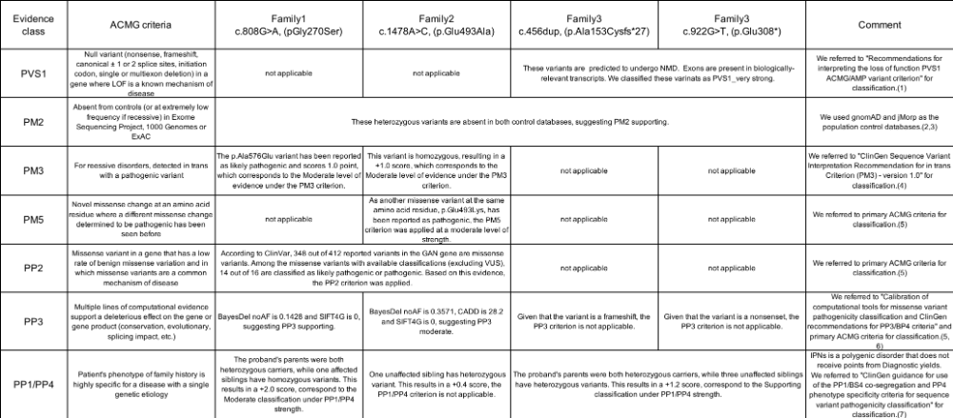
(1) Abou Tayoun AN, Pesaran T, DiStefano MT, et al. Recommendations for interpreting the loss of function PVS1 ACMG/AMP variant criterion. Hum Mutat. 2018;39(11):1517-1524. doi:10.1002/humu.23626
(2) Karczewski KJ, Francioli LC, Tiao G, et al. The mutational constraint spectrum quantified from variation in 141,456 humans. Nature. 2020;581(7809):434-443. doi:10.1038/s41586-020-2308-7
(3) Tadaka S, Kawashima J, Hishinuma E, et al. jMorp: Japanese Multi-Omics Reference Panel update report 2023. Nucleic Acids Res. 2024;52(D1):D622-D632. doi:10.1093/nar/gkad978
(4) https://clinicalgenome.org/working-groups/sequence-variant-interpretation/
(5) Richards S, Aziz N, Bale S, et al. Standards and guidelines for the interpretation of sequence variants: A joint consensus recommendation of the American College of Medical Genetics and Genomics and the Association for Molecular Pathology. Genetics in Medicine. 2015;17(5):405-424. doi:10.1038/gim.2015.30
(6) Pejaver V, Byrne AB, Feng BJ, et al. Calibration of computational tools for missense variant pathogenicity classification and ClinGen recommendations for PP3/BP4 criteria. Am J Hum Genet. 2022;109(12):2163-2177. doi:10.1016/j.ajhg.2022.10.013
(7) Biesecker LG, Byrne AB, Harrison SM, et al. ClinGen guidance for use of the PP1/BS4 co-segregation and PP4 phenotype specificity criteria for sequence variant pathogenicity classification. Am J Hum Genet. 2024;111(1):24-38. doi:10.1016/j.ajhg.2023.11.009

Supplementary Fig 1. Flowchart of genetic diagnosis
In total, 3315 patients with IPNs, including 865 cases with disease onset before 10 years of age, were genetically analyzed. From 2007 to 2012, DNA microarray analysis targeted 28 IPN-related genes, excluding the GAN gene. Whole-exome sequencing was subsequently performed in 273 patients in whom no causative gene was identified, leading to the detection of biallelic GAN variants in two patients. Since 2012, genetic screening has been conducted using an in-house IPN-related gene panel, which includes the GAN gene, via next-generation sequencing. This approach identified two additional patients with biallelic GAN variants.

