SUPPLEMENTARY INFORMATION
Efficacy and Safety of Avalglucosidase Alfa in Patients with Late-Onset Pompe Disease after 145 Weeks of Treatment during the COMET Trial
Journal of Neurology

Priya S. Kishnani, MD,¹ Jordi Díaz-Manera² Sergey Illarioshkin³, et al. on behalf of the COMET Investigator Group

Corresponding author:
Priya S. Kishnani, MD
Division of Medical Genetics, Department of Pediatrics
Duke University Medical Center, Durham, NC, USA
Phone: 919-681-1939; Email: priya.kishnani@duke.edu

Contents
Online Resource 1. Disposition of participants in the COMET trial. 2
Online Resource 2. Individual participant results for FVC, MIP and MEP percent predicted in the upright position from baseline to week 145. 3
Online Resource 3. Least squares (LS) mean change in 6MWT percent predicted from baseline to week 145. 6MWT: six-minute walk test; SE: standard error. 4
Online Resource 4. Individual participant results for 6MWT distance from baseline to week 145. 5
Online Resource 5. Least squares (LS) mean change in SF-12 Mental Component Summary (MCS) score from baseline to week 145. SF-12: short-form 12-item; SE: standard error. 6
Online Resource 6. Mean change from baseline to week 145. (A) GMFM-88 standing and walking total score. (B) GCSC total score. GSGC: gait, stairs, Gower, chair; GMFM: Gross Motor Function Measure; SD: standard deviation. 7
Online Resource 7. Biomarker absolute values from baseline to week 145. (A) Urinary hexose tetrasaccharide (HEX₄) and (B) creatine kinase (CK). SD: standard deviation. 8
Collaborators on the Avalglucosidase Alfa Phase 3 COMET Clinical Trial 9

Online Resource 1. Disposition of participants in the COMET trial.

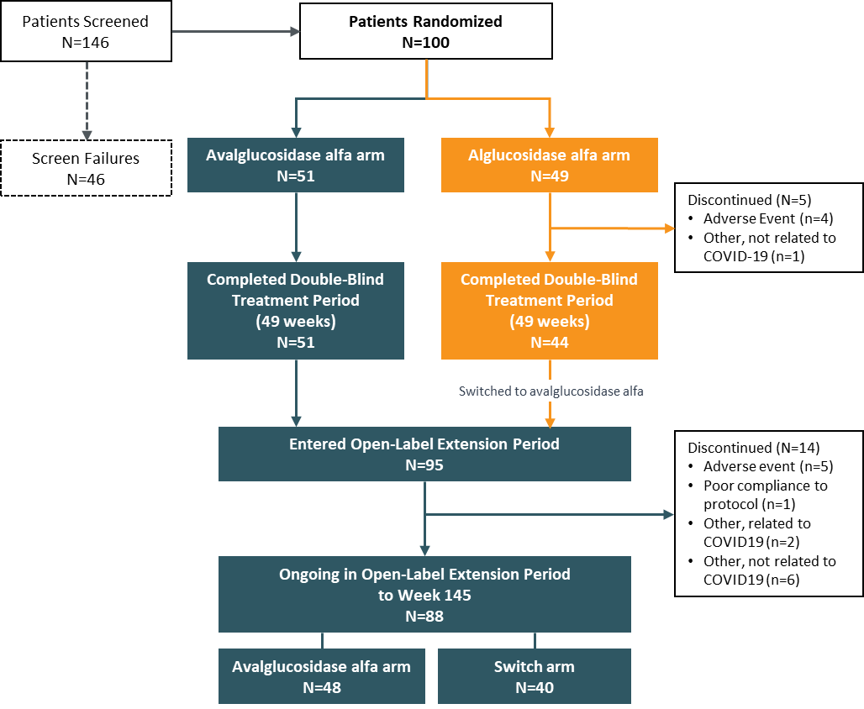

Online Resource 2. Individual participant results for FVC, MIP and MEP percent predicted in the upright position from baseline to week 145.
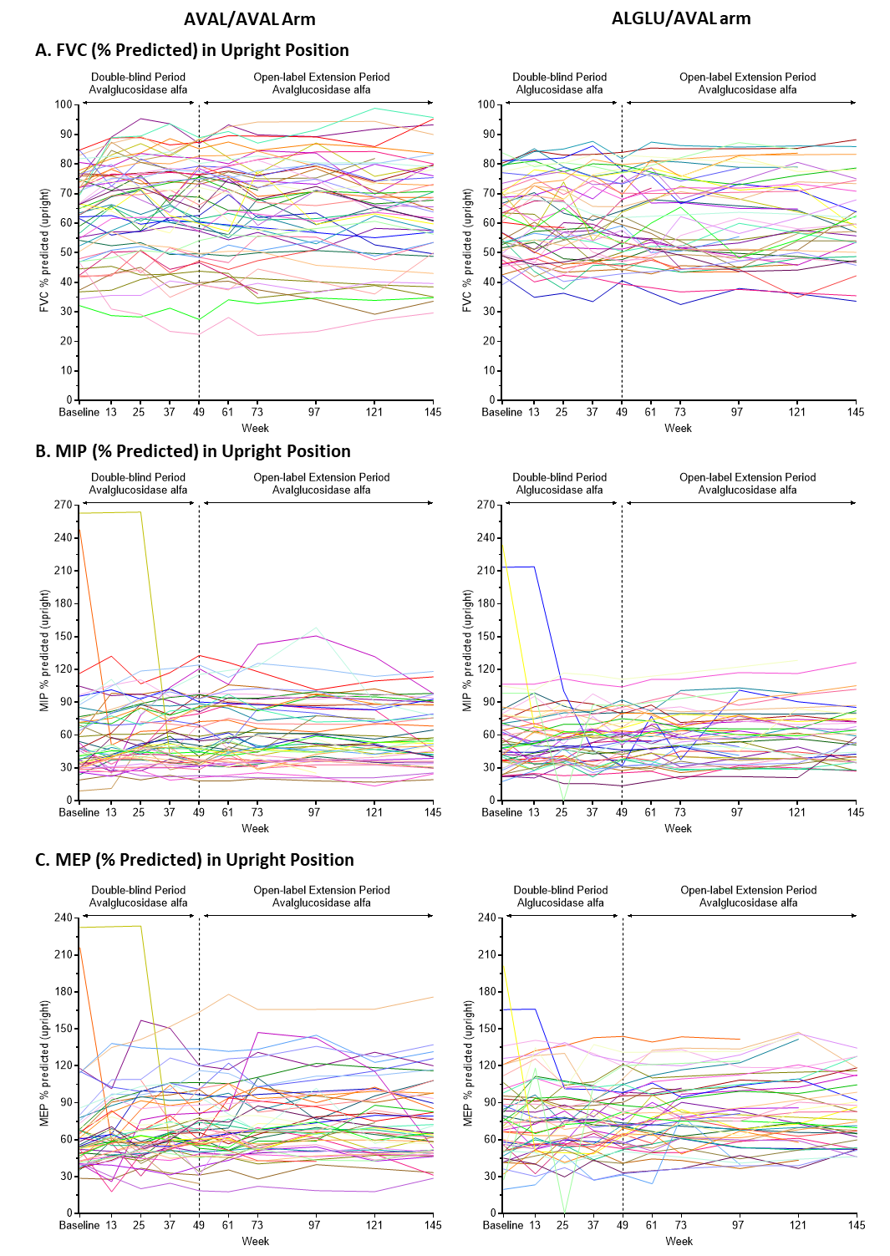

Online Resource 3. Least squares (LS) mean change in 6MWT percent predicted from baseline to week 145. 6MWT: six-minute walk test; SE: standard error.

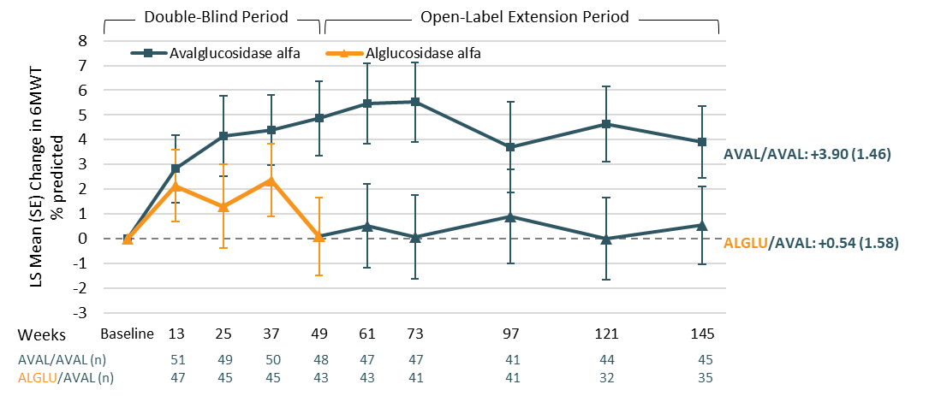

Online Resource 4. Individual participant results for 6MWT distance from baseline to week 145.

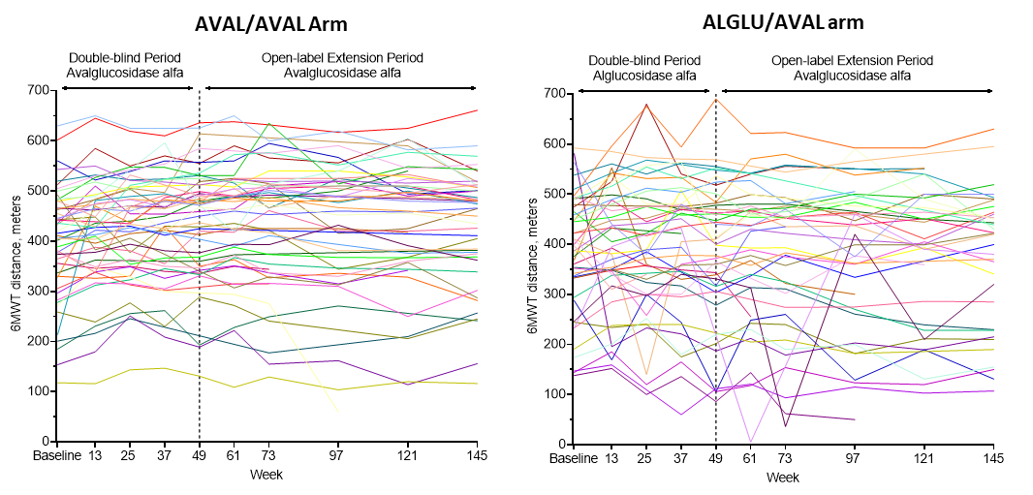

Online Resource 5. Least squares (LS) mean change in SF-12 Mental Component Summary (MCS) score from baseline to week 145. SF-12: short-form 12-item; SE: standard error.

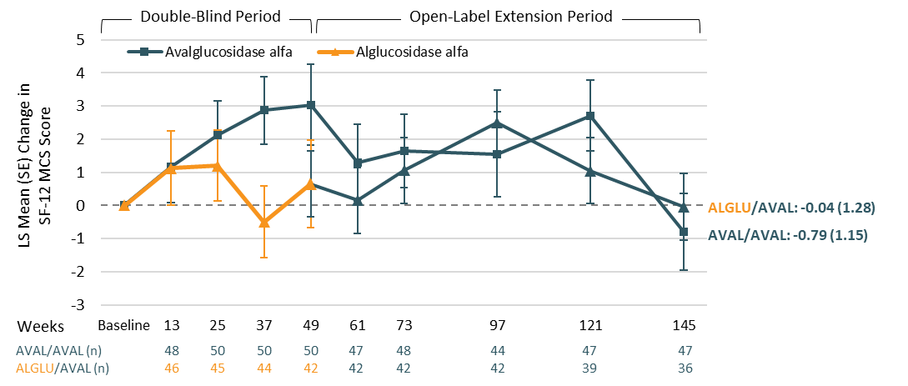

Online Resource 6. Mean change from baseline to week 145. (A) GMFM-88 standing and walking total score. (B) GCSC total score. GSGC: gait, stairs, Gower, chair; GMFM: Gross Motor Function Measure; SD: standard deviation.

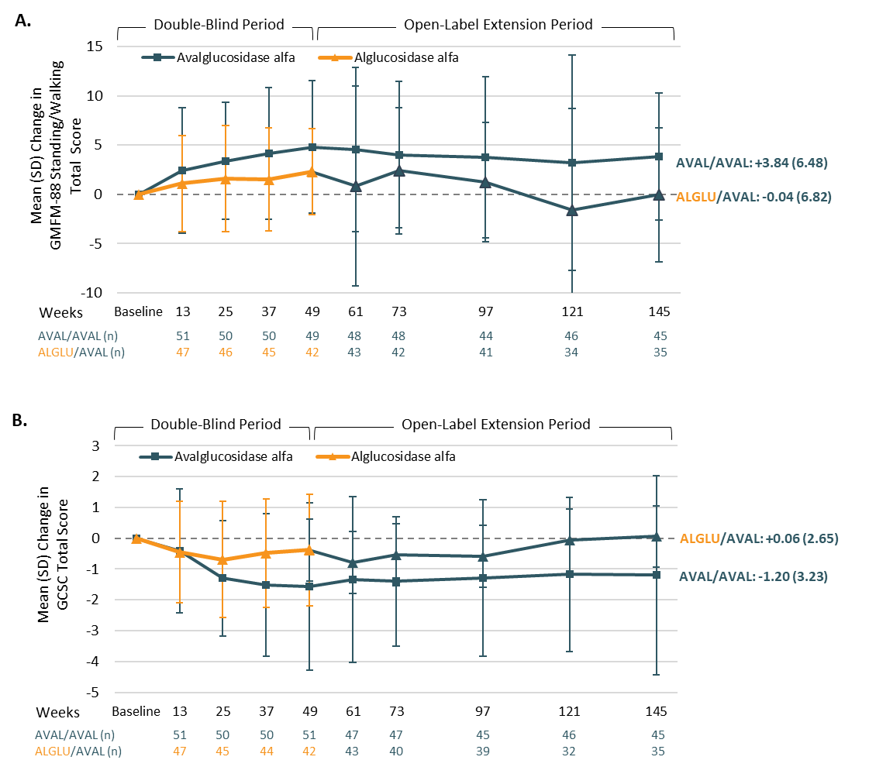

Online Resource 7. Biomarker absolute values from baseline to week 145. (A) Urinary hexose tetrasaccharide (HEX₄) and (B) creatine kinase (CK). SD: standard deviation.
Normal ranges (shaded): urinary HEX₄ (mmol/mol cre): 0‒3 (males and females, ages 13‒18 years), 0‒1 (males and females, ages ˃18 years). CK (IU/L): 18-169 (females, ages 16‒17), 26‒192 (females, ages ≥18 years), 18‒408 (males, ages 16‒17 years), 39‒308 (males, ages ≥18 years).

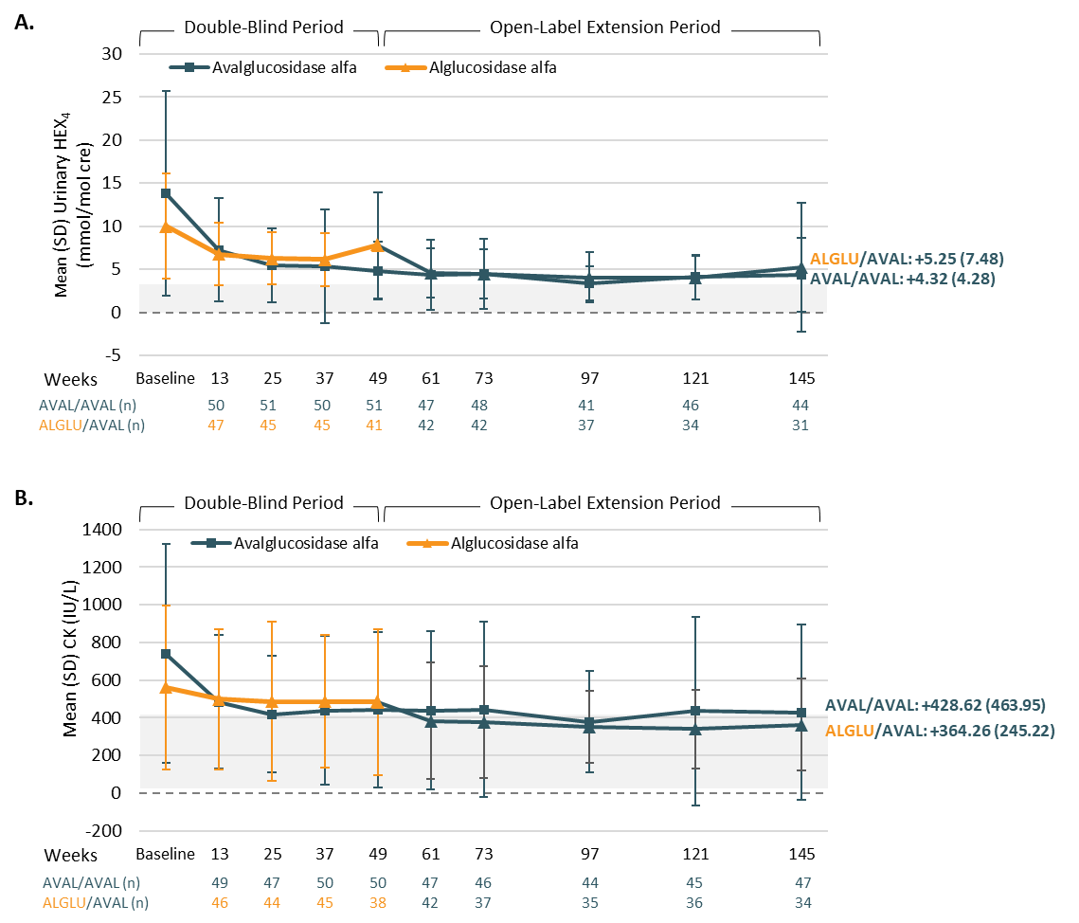

Collaborators on the Avalglucosidase Alfa Phase 3 COMET Clinical Trial

Principal Investigators
Anthony | Behin
Matthias | Boentert
Gerson | Carvalho
Nizar | Chahin
Joel | Charrow
Patrick | Deegan
Hacer | Durmus Tekce
Fanny | Duval
Angela | Genge
Ludwig | Gutmann
Robert D. | Henderson
Julia B. | Hennermann
Tarekegn | Hiwot
Derralynn | Hughes
Amel | Karaa
Chafic | Karam
Alexandra | Kautzky-Willer
Hirofumi | Komaki
Pascal | Laforet
Nicola | Longo
Vera | Malinova
Ricardo | Maré
Clarisa | Maxit
Eugen | Mengel
Maurizio Gualtiero | Moggio
Mária Judit | Molnár
Tiziana Enrica | Mongini
Aleksandra | Nadaj-Pakleza
Andres | Nascimento Osorio
Jean-Baptiste | Noury
Acary Souza Bulle | Oliveira
Yesim | Parman
Loren | Pena
Gauthier | Remiche
Monica | Sciacco
Perry B. Shieh | Shieh
Cheryl | Smith
Thomas | Stulnig
Frederic | Taithe
Céline | Tard
Mark | Tarnopolsky
Matthias | Vorgerd
Chester | Whitley
Peter | Young

Co-Investigators/Study Coordinators
Jorge | Alonso-Pérez
Patricia | Altemus
Anne-Catherine | Aubé-Nathier
Jennifer B. | Avelar
Carrie | Bailey
Can Ebru | Bekircan-Kurt
Jenny | Billy
Silvia | Boschi
Kathryn E. | Brown
Laura | Carrera Garcia
Lauren | Chase
Hamilton | Cirne
Loïc | Danjoux
Jean-Baptiste | Davion
Stephanie | DeArmey
Ekaterina | Fedotova
Eve | Gandolfo
Zoltan | Grosz
Dewi | Guellec
Anne-Katrin | Guettsches
Michela | Guglieri
Erin | Hatcher
Sina | Helms
Miriam | Hufgard-Leitner
Sergey A. | Klyushnikov
Jacqui | Langton
Lenka | Linková
Nicolas | Mavroudakis
Stella | Mazurová
Madoka | Mori
Louisa | Müller-Miny
Olimpia | Musumeci
Christopher S. | Nance
Daniel | Natera-de Benito
Robert | Neel
Gabriela A. | Niizawa
Lauren | Noll
Erik | Ortega
Mamatha | Pasnoor
Vivien | Pautot
Anna | Potulska-Chromik
Alessia | Pugliese
Claire | Questienne
Margarida | Ramos Lopes
David | Reyes-Leiva
Michaela | Riedl
Marcelo Francisco | Rugiero
Emmanuelle | Salort-Campana
Paulo Victor | Sgobbi Souza
Guilhem | Sole
Luca | Solera
Suzara | Souto Lopes
Sabine | Specht
Jeffrey | Statland
Andrea | Swenson
Chong Yew | Tan
Sónia | Tizon
N.A.M.E. | van der Beek
Harmke A. | van Kooten
Marie | Wencel
Stephan | Wenninger
Fabien | Zagnoli

