Supplementary information
Abbreviation List (alphabetically listed)
- α-syn - α-synuclein;
- CTR - Controls;
- MC - Motor Complications;
- noMC - patients without Motor Complications;
- NPV - Negative Predictive Value;
- p-tau - Phosphorylated-181-tau;
- PD - Parkinson’s Disease;
- PPV - Positive Predictive Value;
- t-tau - Total-tau;
- wMC - patients with Motor Complications.

1. Group analysis between PD and CTR
Supplemental Fig.1 Scatter plots of CSF total α-synuclein (total α-syn) and total-tau (t-tau) values in patients with Parkinson’s disease (PD) and controls (CTR), with median and 25th-75th interquartile range. *p < 0.05. (a) CSF total α-syn values comparison. Black dots represent CTR cohort; red dots represent PD cohort. (b) CSF t-tau values. Black dots represent CTR cohort; red dots represent PD cohort.

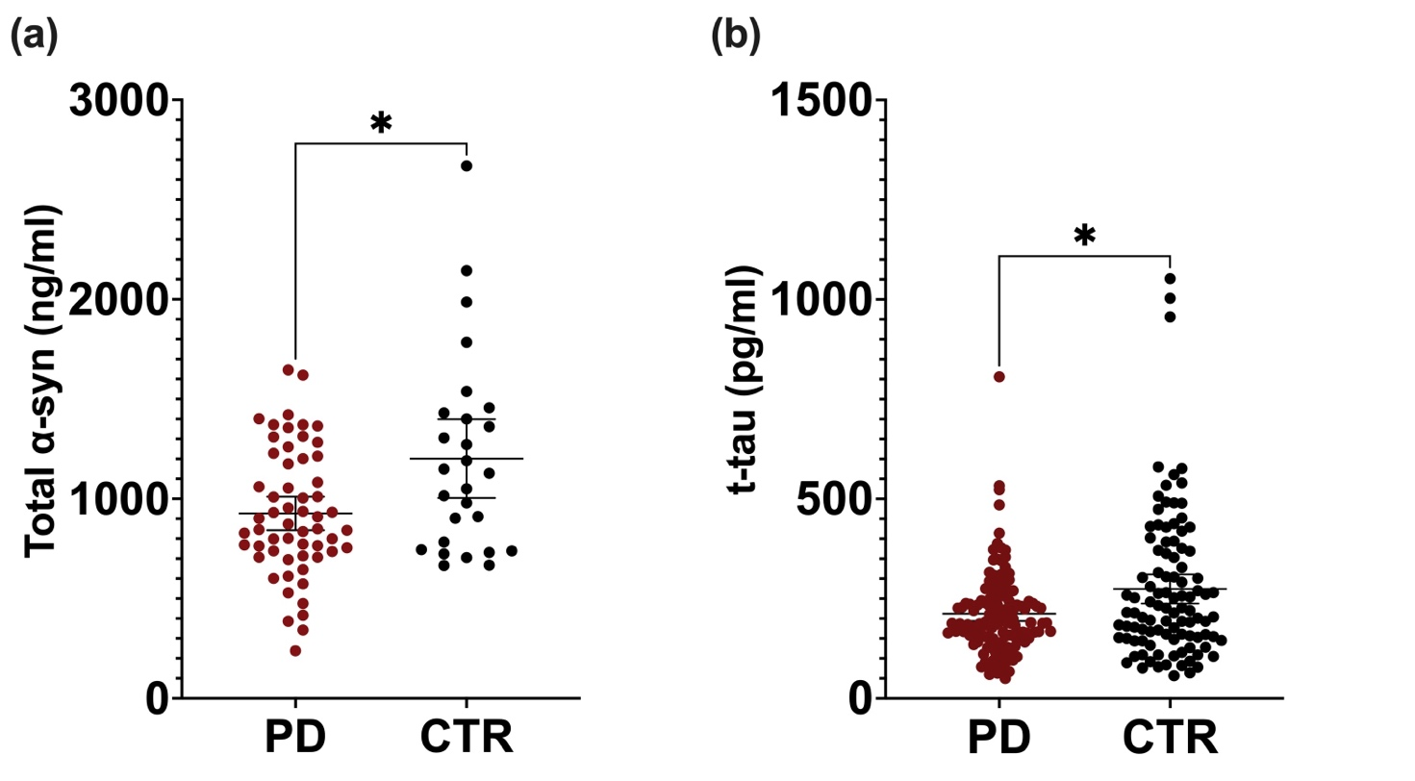

2. Calculation of PPV
Supplemental Table1. presents the distribution of patients according to the p-tau/t-tau ratio threshold of 0.148, stratified by the presence (wMC) or absence (noMC) of MC. This cut-off was derived from the ROC curve of the p-tau/t-tau ratio using the Youden index.
 | wMC patients | noMC patients
p-tau/t-tau ratio < 0.148 | 12 | 62
p-tau/t-tau ratio ≥ 0.148 | 26 | 31

PPV = 45.6%
NPV = 83.7%
Accuracy = 67.1%

