Chronic Vertigo and Dizziness Signal Unmet Needs in Stroke Recovery
Lino Braadt¹, Markus Naumann¹, Dennis Freuer², Christa Meisinger², Jakob Linseisen², Michael Ertl^{1,3}
¹Department of Neurology and Clinical Neurophysiology, University Hospital Augsburg, Augsburg, Germany, ²Epidemiology, Faculty of Medicine, University of Augsburg, Augsburg, Germany, ³Department of Neurology and Neurological Rehabilitation, District Hospital Guenzburg, Guenzburg, Germany
Correspondence: Lino Braadt, lino-dominic.braadt@uk-augsburg.de; Tel.: +49 821/400-2991

Supplementary Material
This supplementary material contains two additional figures:
Supplementary Figure 1 presents health-related quality of life outcomes in patients with vertigo or dizziness of unspecified duration.
Supplementary Figure 2 shows sensitivity analysis comparing linear, median, and robust regression models for all SIS domain scores across the three patient groups.
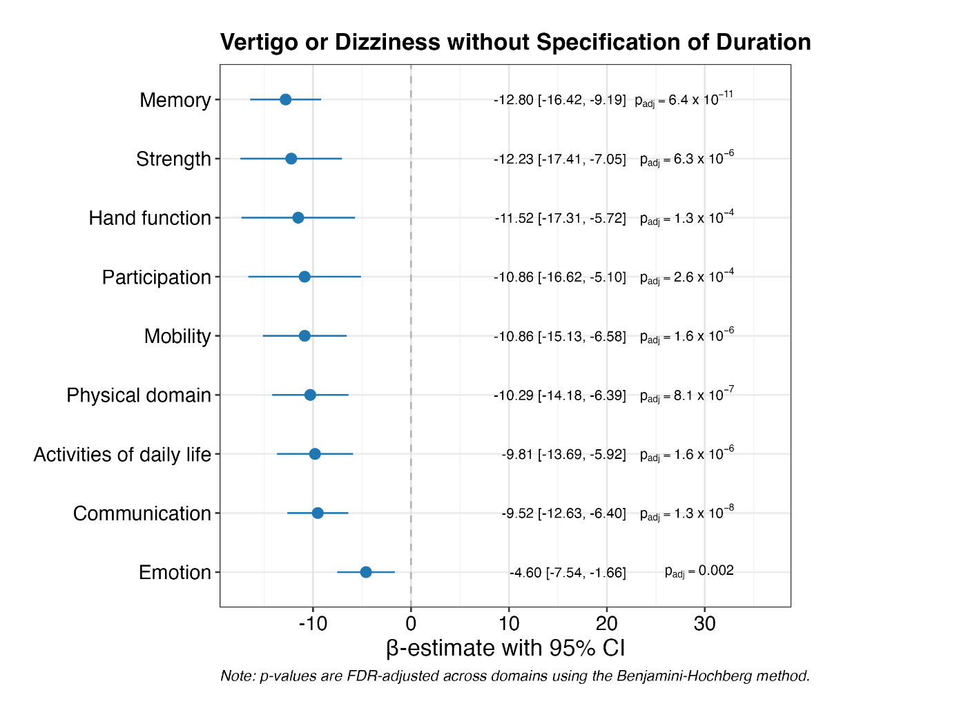
Supplementary Figure 1 | Health-related Quality of Life in Patients with Vertigo or Dizziness, without Specification of Duration
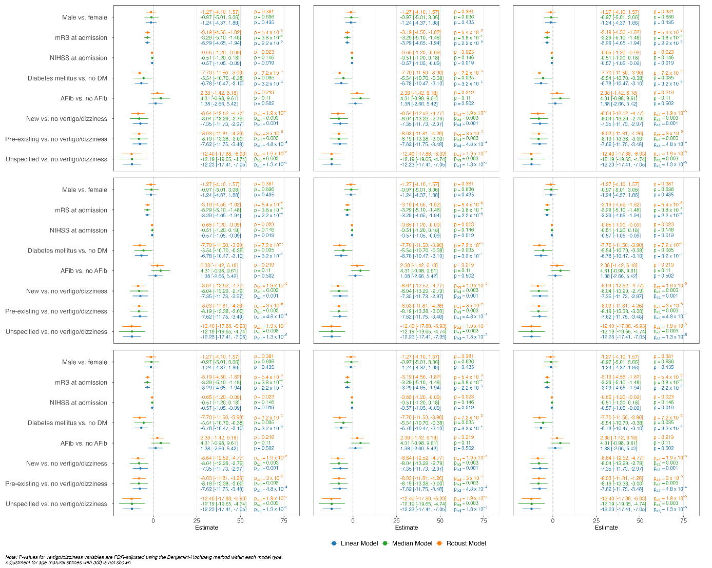
Supplementary Figure 2 | Comparison of Regression Models for Health-Related Quality of Life Outcomes in Patients with Vertigo and Dizziness

