Supplementary Tables and Figures
Supplementary Table 1: Definitions of the measurement properties according to COSMIN [33].
 | Measurement property | Definition of the measurement properties
 | Content validity | The degree to which the content of a PROM is an adequate reflection of the construct to be measured. It refers to the relevance, comprehensiveness, and comprehensibility of the instrument
Structural validity |  | The degree to which the scores of an instrument are adequate  reflections of the dimensionality of the construct to be measured
Internal consistency |  | The degree of the interrelatedness among the items
Cross-cultural validity |  | The degree to which the performance of the items on a translated or  culturally adapted instrument is an adequate reflection of the  performance of the items of the original version of the instrument
Construct validity |  | The degree to which the scores of an instrument are consistent with hypotheses (for instance with regard to internal relationships, relationships to scores of other instruments, or differences between relevant groups) based on the assumption that the instrument validly measures the construct to be measured
Floor and ceiling effects |  | The percentage of patients with the highest or lowest possible score, respectively
Abbreviations: COSMIN = COnsensus-based Standards for the selection of health Measurement INstruments

Supplementary Table 2: Individual item fit for subsample (n=600)
Item | Statement | Location | SE | FitResid | Prob
I0001 | RODS_bend_pick_up | 0.121 | 0.096 | -1.837 | 0.338557
I0002 | RODS_standing_long | 1.837 | 0.097 | 0.155 | 0.075961
I0003 | RODS_walk_up_stairs | 1.33 | 0.097 | -1.963 | 0.005701
I0004 | RODS_run | 3.594 | 0.112 | -0.895 | 0.405165
I0005 | RODS_outdoors_max_1km | 1.552 | 0.096 | -0.445 | 0.347771
I0006 | RODS_walk_avoid_obstacles | 0.399 | 0.094 | -2.072 | 0.48974
I0007 | RODS_dance | 2.802 | 0.121 | -1.018 | 0.593175
I0008 | RODS_public_transport | 1.117 | 0.101 | -0.964 | 0.044096
I0009 | RODS_turn_key_in_lock | -0.795 | 0.099 | 1.972 | 0.027319
I0010 | RODS_carry_put_down_heavy_object | 1.476 | 0.096 | -0.76 | 0.957435
I0011 | RODS_move_chair | -0.482 | 0.098 | -1.61 | 0.354452
I0012 | RODS_catch_object | -0.911 | 0.101 | 3.204 | 0.000217
I0013 | RODS_wash_upper_body | -1.563 | 0.105 | -1.714 | 0.677723
I0014 | RODS_wash_lower_body | -0.646 | 0.098 | -2.917 | 0.092387
I0015 | RODS_shower | -0.487 | 0.097 | -3.19 | 0.020668
I0016 | RODS_brush_teeth | -2.419 | 0.115 | 2.679 | 0.002376
I0017 | RODS_toilet | -1.234 | 0.101 | -0.605 | 0.139434
I0018 | RODS_dress_upper_body | -1.523 | 0.104 | -1.217 | 0.01321
I0019 | RODS_eat | -3.063 | 0.124 | 1.484 | 0.132499
I0020 | RODS_dishes | 0.072 | 0.109 | -0.154 | 0.004714
I0021 | RODS_sandwich | -0.779 | 0.111 | 0.691 | 0.266525
I0022 | RODS_shopping | 1.136 | 0.102 | -3.006 | 0.017181
I0023 | RODS_general_practitioner | 0.049 | 0.102 | -2.075 | 0.179399
I0024 | RODS_read | -1.586 | 0.104 | 6.461 | 0
 |  | Bonf | 0.05 | 24 | 0.002083

Supplementary Table 3: local dependency subsample (n=600)
Statement | Item | I0001 | I0002 | I0003 | I0004 | I0005 | I0006 | I0007 | I0008 | I0009 | I0010 | I0011 | I0012 | I0013 | I0014 | I0015 | I0016 | I0017 | I0018 | I0019 | I0020 | I0021 | I0022 | I0023 | I0024
RODS_bend_pick_up | I0001
RODS_standing_long | I0002 | 0.014
RODS_walk_up_stairs | I0003 | 0.072 | 0.078
RODS_run | I0004 | 0.074 | 0.111 | 0.114
RODS_outdoors_max_1km | I0005 | -0.01 | 0.12 | 0.172 | 0.119
RODS_walk_avoid_obstacles | I0006 | 0.059 | 0.136 | 0.221 | 0.011 | 0.261
RODS_dance | I0007 | 0.013 | 0.043 | 0.111 | 0.447 | 0.161 | 0.066
RODS_public_transport | I0008 | -0.04 | 0.015 | 0.08 | 0.122 | 0.207 | 0.088 | 0.223
RODS_turn_key_in_lock | I0009 | -0.01 | -0.091 | -0.083 | -0.178 | -0.2 | -0.17 | -0.241 | -0.169
RODS_carry_put_down_heavy_object | I0010 | 0.056 | -0.042 | -0.169 | 0.02 | -0.032 | -0.151 | 0.019 | -0.043 | -0.019
RODS_move_chair | I0011 | 0.021 | -0.112 | -0.056 | -0.079 | -0.156 | -0.135 | -0.089 | -0.099 | 0.038 | 0.053
RODS_catch_object | I0012 | -0.07 | -0.141 | -0.103 | -0.159 | -0.088 | 0 | -0.15 | -0.102 | 0.051 | -0.069 | -0.039
RODS_wash_upper_body | I0013 | -0.15 | -0.276 | -0.126 | -0.3 | -0.26 | -0.244 | -0.274 | -0.266 | 0.081 | -0.074 | 0.035 | 0.05
RODS_wash_lower_body | I0014 | 0.023 | -0.153 | -0.062 | -0.18 | -0.248 | -0.137 | -0.193 | -0.188 | -0.004 | -0.021 | 0.001 | -0.122 | 0.448
RODS_shower | I0015 | -0.01 | -0.071 | 0.013 | -0.114 | -0.05 | 0.002 | -0.122 | -0.059 | -0.167 | -0.108 | 0.014 | -0.132 | 0.259 | 0.325
RODS_brush_teeth | I0016 | -0.09 | -0.177 | -0.143 | -0.236 | -0.176 | -0.069 | -0.182 | -0.114 | 0.187 | -0.051 | 0.008 | 0.087 | 0.206 | 0.036 | -0.01
RODS_toilet | I0017 | 0.081 | -0.033 | 0.05 | -0.052 | -0.06 | 0.07 | -0.065 | -0.019 | -0.11 | -0.078 | 0.032 | -0.167 | -0.033 | 0.055 | 0.284 | -0.038
RODS_dress_upper_body | I0018 | -0.16 | -0.198 | -0.113 | -0.234 | -0.215 | -0.111 | -0.228 | -0.189 | -0.007 | -0.069 | 0.033 | -0.059 | 0.377 | 0.217 | 0.332 | 0.094 | 0.193
RODS_eat | I0019 | -0.13 | -0.078 | -0.13 | -0.174 | -0.141 | -0.088 | -0.181 | -0.128 | 0.036 | 0.05 | -0.075 | -0.04 | 0.022 | -0.04 | -0.112 | 0.047 | -0.06 | 0.098
RODS_dishes | I0020 | -0.08 | -0.085 | -0.119 | -0.26 | -0.156 | -0.147 | -0.149 | -0.075 | 0.161 | -0.005 | 0.001 | -0.005 | 0.062 | 0.094 | -0.072 | 0.034 | -0.064 | 0.069 | 0.164
RODS_sandwich | I0021 | -0.18 | -0.217 | -0.172 | -0.189 | -0.117 | -0.157 | -0.107 | -0.085 | 0.067 | -0.004 | -0.003 | 0.111 | 0.159 | -0.003 | -0.109 | 0.075 | -0.06 | 0.018 | 0.012 | 0.287
RODS_shopping | I0022 | -0.01 | 0.151 | -0.014 | 0.073 | 0.168 | 0.039 | 0.002 | 0.201 | -0.148 | -0.053 | -0.055 | -0.111 | -0.251 | -0.147 | -0.006 | -0.139 | -0.045 | -0.118 | -0.093 | -0.011 | -0.093
RODS_general_practitioner | I0023 | -0.05 | 0.066 | 0.064 | 0.009 | 0.127 | 0.087 | 0.095 | 0.235 | -0.168 | -0.048 | -0.1 | -0.111 | -0.269 | -0.072 | -0.006 | -0.138 | -0.03 | -0.193 | -0.067 | -0.07 | -0.085 | 0.381
RODS_read | I0024 | -0.09 | -0.061 | -0.194 | -0.173 | -0.127 | -0.065 | -0.196 | -0.063 | 0.078 | -0.093 | -0.019 | 0.093 | -0.063 | -0.111 | -0.138 | 0.041 | -0.075 | -0.063 | 0.13 | -0.014 | -0.036 | -0.086 | -0.071
 | ave | -0.03
Criterion cut point | ave + 0.2 | 0.168

Supplementary Table 4: Local dependency full sample (n=1226)
Statement | Item | I0001 | I0002 | I0003 | I0004 | I0005 | I0006 | I0007 | I0008 | I0009 | I0010 | I0011 | I0012 | I0013 | I0014 | I0015 | I0016 | I0017 | I0018 | I0019 | I0020 | I0021 | I0022 | I0023 | I0024
RODS_bend_pick_up | I0001
RODS_standing_long | I0002 | 0.003
RODS_walk_up_stairs | I0003 | 0.079 | 0.031
RODS_run | I0004 | 0.038 | 0.044 | 0.095
RODS_outdoors_max_1km | I0005 | -0.031 | 0.126 | 0.151 | 0.095
RODS_walk_avoid_obstacles | I0006 | 0.052 | 0.082 | 0.231 | 0.008 | 0.211
RODS_dance | I0007 | -0.028 | -0.011 | 0.07 | 0.252 | 0.099 | 0.039
RODS_public_transport | I0008 | 0.003 | 0.051 | 0.086 | 0.104 | 0.158 | 0.12 | 0.12
RODS_turn_key_in_lock | I0009 | -0.015 | -0.105 | -0.12 | -0.146 | -0.176 | -0.151 | -0.169 | -0.148
RODS_carry_put_down_heavy_object | I0010 | 0.032 | -0.042 | -0.133 | -0.066 | -0.052 | -0.129 | -0.025 | -0.052 | -0.038
RODS_move_chair | I0011 | 0.016 | -0.105 | -0.024 | -0.107 | -0.148 | -0.053 | -0.061 | -0.065 | 0.007 | 0.05
RODS_catch_object | I0012 | -0.059 | -0.085 | -0.117 | -0.149 | -0.079 | -0.028 | -0.137 | -0.097 | 0.005 | -0.006 | -0.033
RODS_wash_upper_body | I0013 | -0.148 | -0.236 | -0.16 | -0.222 | -0.211 | -0.232 | -0.174 | -0.257 | 0.073 | -0.04 | 0.049 | 0.006
RODS_wash_lower_body | I0014 | -0.004 | -0.162 | -0.045 | -0.147 | -0.225 | -0.138 | -0.096 | -0.215 | -0.022 | -0.037 | 0.016 | -0.107 | 0.391
RODS_shower | I0015 | -0.034 | -0.085 | 0.002 | -0.102 | -0.025 | -0.034 | -0.092 | -0.089 | -0.129 | -0.081 | 0.028 | -0.135 | 0.254 | 0.306
RODS_brush_teeth | I0016 | -0.118 | -0.153 | -0.122 | -0.202 | -0.139 | -0.085 | -0.131 | -0.114 | 0.176 | -0.025 | -0.007 | 0.078 | 0.195 | 0.02 | -0.002
RODS_toilet | I0017 | 0.066 | -0.034 | 0.057 | 0.003 | -0.052 | 0.045 | -0.071 | -0.062 | -0.07 | -0.078 | 0.036 | -0.164 | -0.03 | 0.063 | 0.19 | -0.044
RODS_dress_upper_body | I0018 | -0.162 | -0.17 | -0.124 | -0.17 | -0.183 | -0.126 | -0.138 | -0.16 | 0.03 | -0.076 | -0.009 | -0.058 | 0.315 | 0.166 | 0.261 | 0.111 | 0.117
RODS_eat | I0019 | -0.095 | -0.061 | -0.153 | -0.156 | -0.104 | -0.106 | -0.114 | -0.115 | 0.009 | 0.052 | -0.073 | -0.055 | 0.036 | -0.037 | -0.089 | 0.053 | -0.033 | 0.148
RODS_dishes | I0020 | -0.061 | -0.089 | -0.102 | -0.197 | -0.139 | -0.123 | -0.078 | -0.104 | 0.132 | -0.005 | 0.019 | -0.014 | 0.036 | 0.09 | -0.027 | 0.07 | -0.031 | 0.075 | 0.115
RODS_sandwich | I0021 | -0.164 | -0.202 | -0.176 | -0.144 | -0.141 | -0.168 | -0.056 | -0.097 | 0.07 | 0.024 | 0.02 | 0.064 | 0.142 | 0.005 | -0.128 | 0.09 | -0.071 | 0.02 | 0.026 | 0.309
RODS_shopping | I0022 | -0.065 | 0.06 | -0.054 | 0.048 | 0.125 | 0.03 | 0.007 | 0.187 | -0.134 | -0.093 | -0.045 | -0.084 | -0.168 | -0.088 | -0.001 | -0.1 | -0.089 | -0.097 | -0.072 | -0.004 | -0.029
RODS_general_practitioner | I0023 | -0.012 | 0.005 | 0.029 | 0.022 | 0.098 | 0.083 | 0.033 | 0.218 | -0.106 | -0.084 | -0.073 | -0.105 | -0.242 | -0.095 | -0.023 | -0.131 | -0.015 | -0.136 | -0.086 | -0.079 | -0.085 | 0.273
RODS_read | I0024 | -0.081 | -0.04 | -0.188 | -0.201 | -0.142 | -0.084 | -0.151 | -0.057 | 0.098 | -0.093 | -0.054 | 0.111 | -0.057 | -0.082 | -0.113 | 0.01 | -0.079 | -0.045 | 0.102 | -0.042 | -0.034 | -0.04 | -0.058
 | ave | -0.031
Criterion cut point | ave + 0.2 | 0.169

Supplementary Table 5: DIF summary full sample (n=1226)
 |  | Country | Country | Sex | Sex | Agegroup | Agegroup
 |  | Uniform | Non-uniform | Uniform | Non-uniform | Uniform | Non-uniform
Item | Statement | Probability | Probability | Probability | Probability | Probability | Probability
1 | RODS_bend_pick_up | 0.051 | 0.362 | 0.465 | 0.793 | 0.816 | 0.026
2 | RODS_standing_long | 0.000 | 0.000 | 0.198 | 0.480 | 0.941 | 0.033
3 | RODS_walk_up_stairs | 0.000 | 0.003 | 0.364 | 0.210 | 0.524 | 0.925
4 | RODS_run | 0.000 | 0.000 | 0.651 | 0.939 | 0.213 | 0.057
5 | RODS_outdoors_max_1km | 0.000 | 0.000 | 0.156 | 0.983 | 0.042 | 0.623
6 | RODS_walk_avoid_obstacles | 0.000 | 0.006 | 0.888 | 0.147 | 0.170 | 0.975
7 | RODS_dance | 0.090 | 0.384 | 0.982 | 0.140 | 0.990 | 0.091
8 | RODS_public_transport | 0.000 | 0.046 | 0.004 | 0.992 | 0.000 | 0.311
9 | RODS_turn_key_in_lock | 0.007 | 0.020 | 0.266 | 0.781 | 0.195 | 0.681
10 | RODS_carry_put_down_heavy_object | 0.000 | 0.478 | 0.850 | 0.419 | 0.836 | 0.000
11 | RODS_move_chair | 0.006 | 0.002 | 0.452 | 0.547 | 0.396 | 0.988
12 | RODS_catch_object | 0.000 | 0.023 | 0.807 | 0.029 | 0.006 | 0.000
13 | RODS_wash_upper_body | 0.000 | 0.001 | 0.333 | 0.195 | 0.008 | 0.180
14 | RODS_wash_lower_body | 0.000 | 0.371 | 0.097 | 0.125 | 0.009 | 0.700
15 | RODS_shower | 0.000 | 0.005 | 0.541 | 0.342 | 0.683 | 0.537
16 | RODS_brush_teeth | 0.000 | 0.884 | 0.094 | 0.928 | 0.521 | 0.444
17 | RODS_toilet | 0.000 | 0.111 | 0.027 | 0.689 | 0.334 | 0.610
18 | RODS_dress_upper_body | 0.520 | 0.048 | 0.022 | 0.917 | 0.583 | 0.224
19 | RODS_eat | 0.618 | 0.599 | 0.517 | 0.916 | 0.647 | 0.295
20 | RODS_dishes | 0.124 | 0.156 | 0.673 | 0.829 | 0.816 | 0.133
21 | RODS_sandwich | 0.000 | 0.302 | 0.620 | 0.927 | 0.450 | 0.663
22 | RODS_shopping | 0.007 | 0.004 | 0.033 | 0.930 | 0.045 | 0.975
23 | RODS_general_practitioner | 0.000 | 0.144 | 0.032 | 0.998 | 0.037 | 0.164
24 | RODS_read | 0.308 | 0.128 | 0.242 | 1.000 | 0.077 | 0.881

Supplementary Table 6: Expected values for each item by country/region
 |  | Level | Bangladesh | NorthEUR | SouthEUR | NorthAmerica | Asia | Other | Overall
Item | Statement | [N] | [189] | [397] | [259] | [125] | [189] | [65]
1 | RODS_bend_pick_up | Mean | 0.70 | 1.02 | 1.29 | 1.28 | 1.20 | 1.23 | 1.09
2 | RODS_standing_long | Mean | 0.48 | 0.43 | 0.87 | 0.66 | 1.17 | 0.86 | 0.67
3 | RODS_walk_up_stairs | Mean | 0.46 | 0.82 | 0.89 | 1.01 | 1.03 | 0.82 | 0.83
4 | RODS_run | Mean | 0.15 | 0.24 | 0.38 | 0.45 | 0.53 | 0.52 | 0.33
5 | RODS_outdoors_max_1km | Mean | 0.73 | 0.66 | 0.85 | 0.91 | 0.93 | 0.82 | 0.78
6 | RODS_walk_avoid_obstacles | Mean | 0.77 | 1.04 | 1.01 | 1.27 | 1.27 | 1.05 | 1.05
7 | RODS_dance | Mean | 0.36 | 0.41 | 0.54 | 0.61 | 0.61 | 0.78 | 0.52
8 | RODS_public_transport | Mean | 0.65 | 0.69 | 1.00 | 1.15 | 1.06 | 0.91 | 0.86
9 | RODS_turn_key_in_lock | Mean | 0.86 | 1.41 | 1.53 | 1.58 | 1.35 | 1.60 | 1.38
10 | RODS_carry_put_down_heavy_object | Mean | 0.47 | 0.76 | 1.06 | 0.85 | 0.83 | 0.91 | 0.80
11 | RODS_move_chair | Mean | 0.80 | 1.27 | 1.46 | 1.38 | 1.28 | 1.42 | 1.27
12 | RODS_catch_object | Mean | 1.43 | 1.33 | 1.48 | 1.38 | 1.19 | 1.53 | 1.38
13 | RODS_wash_upper_body | Mean | 0.95 | 1.60 | 1.56 | 1.67 | 1.44 | 1.67 | 1.50
14 | RODS_wash_lower_body | Mean | 0.80 | 1.34 | 1.44 | 1.45 | 1.34 | 1.49 | 1.31
15 | RODS_shower | Mean | 0.89 | 1.28 | 1.34 | 1.47 | 1.43 | 1.25 | 1.28
16 | RODS_brush_teeth | Mean | 1.41 | 1.70 | 1.66 | 1.80 | 1.47 | 1.77 | 1.64
17 | RODS_toilet | Mean | 0.91 | 1.43 | 1.48 | 1.61 | 1.52 | 1.49 | 1.41
18 | RODS_dress_upper_body | Mean | 1.13 | 1.51 | 1.59 | 1.63 | 1.53 | 1.67 | 1.50
19 | RODS_eat | Mean | 1.41 | 1.69 | 1.76 | 1.72 | 1.75 | 1.86 | 1.69
20 | RODS_dishes | Mean | 0.42 | 1.23 | 1.38 | 1.40 | 1.24 | 1.36 | 1.26
21 | RODS_sandwich | Mean | 0.67 | 1.49 | 1.49 | 1.55 | 1.09 | 1.64 | 1.45
22 | RODS_shopping | Mean | 0.63 | 0.82 | 1.08 | 1.12 | 1.13 | 1.02 | 0.93
23 | RODS_general_practitioner | Mean | 0.84 | 1.04 | 1.34 | 1.41 | 1.27 | 1.23 | 1.16
24 | RODS_read | Mean | 1.22 | 1.60 | 1.73 | 1.61 | 1.60 | 1.74 | 1.58

Supplementary Figure 1: DIF-by-Geographic region plot for item 1 Bend forward and pick something up
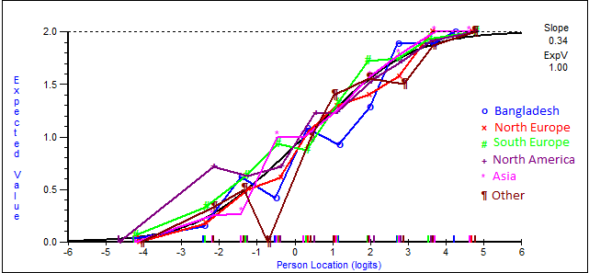

Supplementary Figure 2: DIF-by-Geographic region plot for item 2 Remain standing for a long time period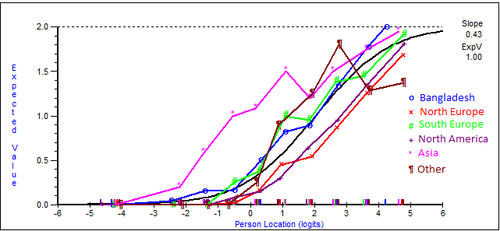

Supplementary Figure 3: DIF-by-Geographic region plot for item 3 Walk up a flight of stairs
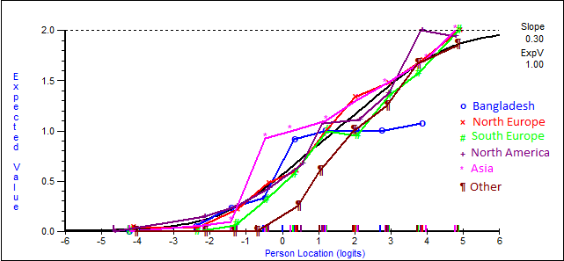

Supplementary Figure 4: DIF-by-Geographic region plot for item 4 Run
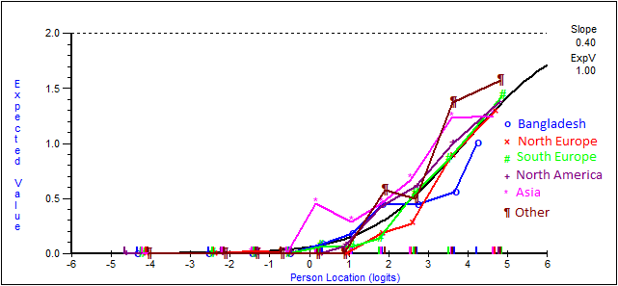

Supplementary Figure 5: DIF-by-Geographic region plot for item 5 Walk outdoors, up to max 1 kilometre
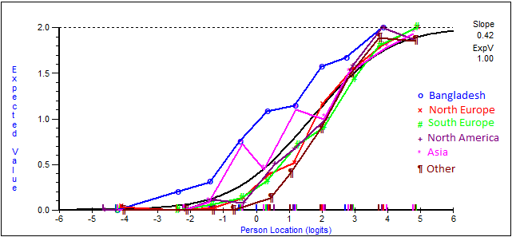

Supplementary Figure 6: DIF-by-Geographic region plot for item 6 Walk while avoiding obstacles
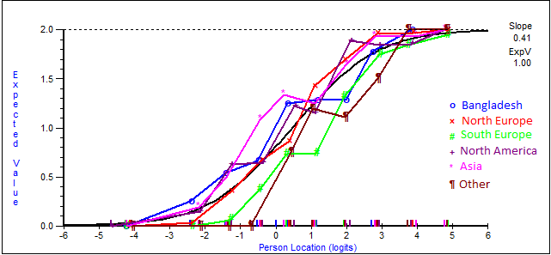

Supplementary Figure 7: DIF-by-Geographic region plot for item 7 Dance
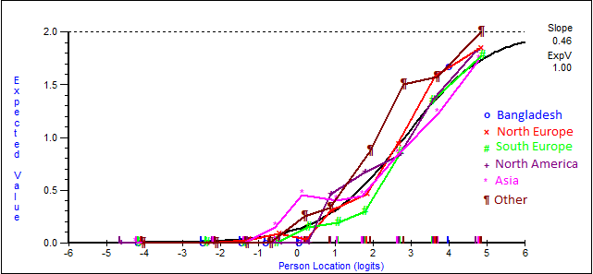

Supplementary Figure 8: DIF-by-Geographic region plot for item 8 Travel by public transport
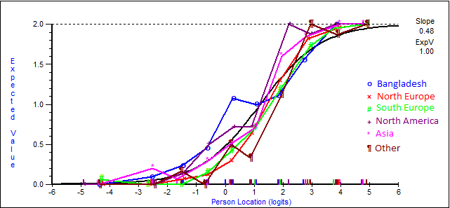

Supplementary Figure 9: DIF-by-Geographic region plot for item 9 Turn a key in a lock
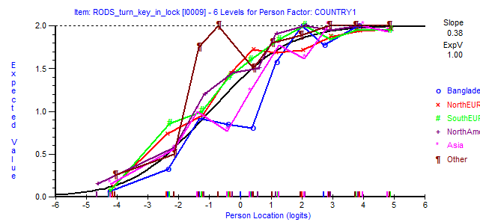

Supplementary Figure 10: DIF-by-Geographic region plot for item 10 Carry and put down a heavy object
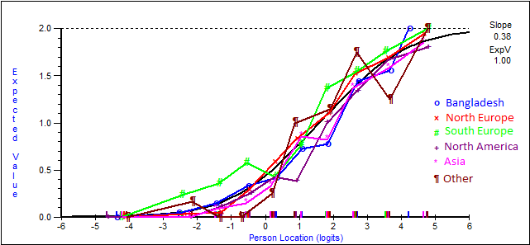

Supplementary Figure 11: DIF-by-Geographic region plot for item 11 Move a chair
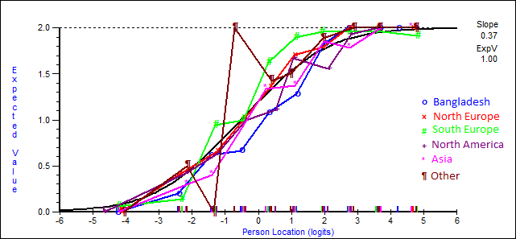

Supplementary Figure 12: DIF-by-Geographic region plot for item 12 Catch an object (e.g. a ball)
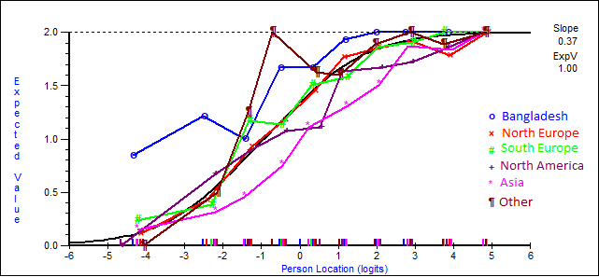

Supplementary Figure 13: DIF-by-Geographic region plot for item 13 Wash your upper body
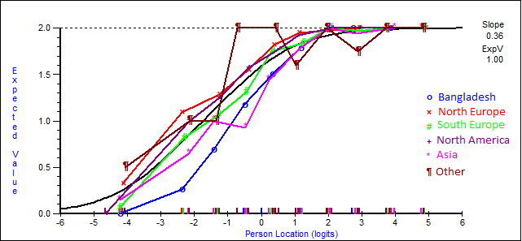

Supplementary Figure 14: DIF-by-Geographic region plot for item 14 Wash your lower body
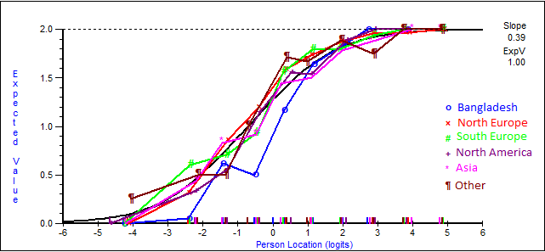

Supplementary Figure 15: DIF-by-Geographic region plot for item 15 Take a shower
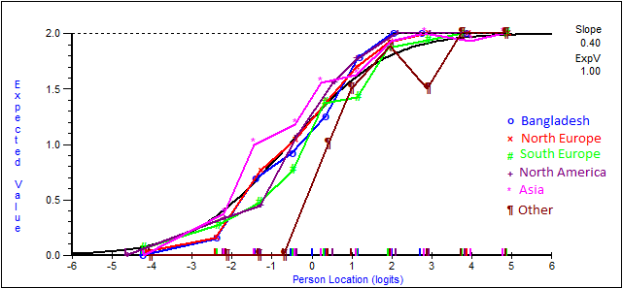

Supplementary Figure 16: DIF-by-Geographic region plot for item 16 Brush your teeth
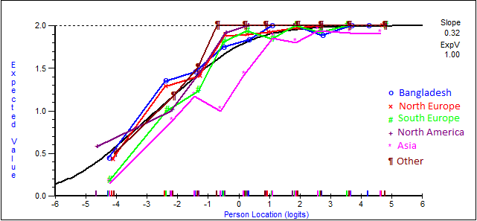

Supplementary Figure 17: DIF-by-Geographic region plot for item 17 Sit on/go to a toilet
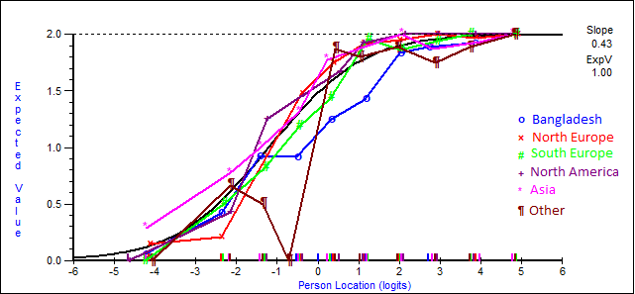

Supplementary Figure 18: DIF-by-Geographic region plot for item 18 Dress your upper body
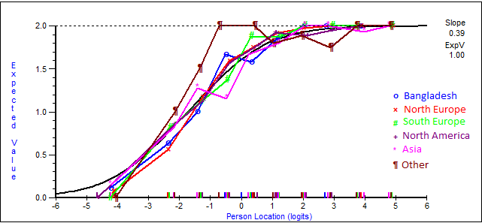

Supplementary Figure 19: DIF-by-Geographic region plot for item 19 Eat
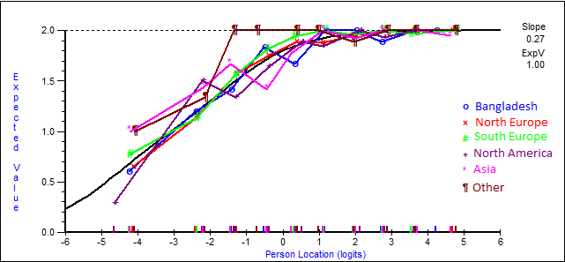

Supplementary Figure 20: DIF-by-Geographic region plot for item 20 Do the dishes
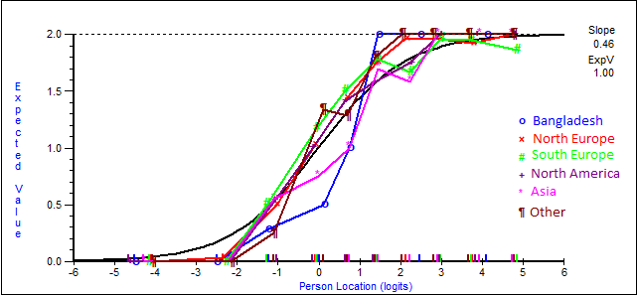

Supplementary Figure 21: DIF-by-Geographic region plot for item 21 Make a sandwich
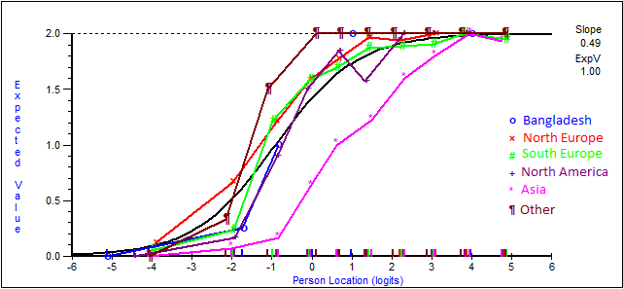

Supplementary Figure 22: DIF-by-Geographic region plot for item 22 Do the shopping
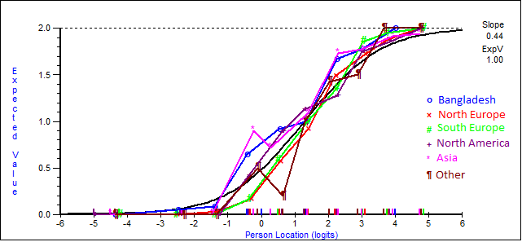

Supplementary Figure 23: DIF-by-Geographic region plot for item 23 Go to the general practitioner
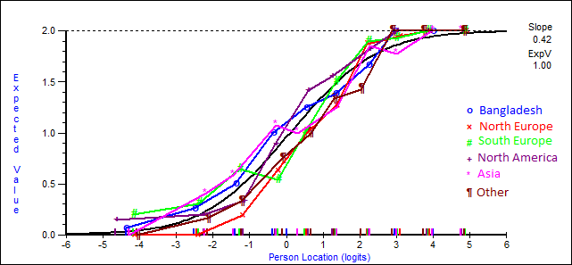

Supplementary Figure 24: DIF-by-Geographic region plot for item 24 Read a book/newspaper
