Supplementary material for:
Personality Change After Traumatic Brain Injury:
A Systematic Review and Meta-analysis

Figure S1. Variable importance for MetaForest analysis identifying contributors to heterogeneity
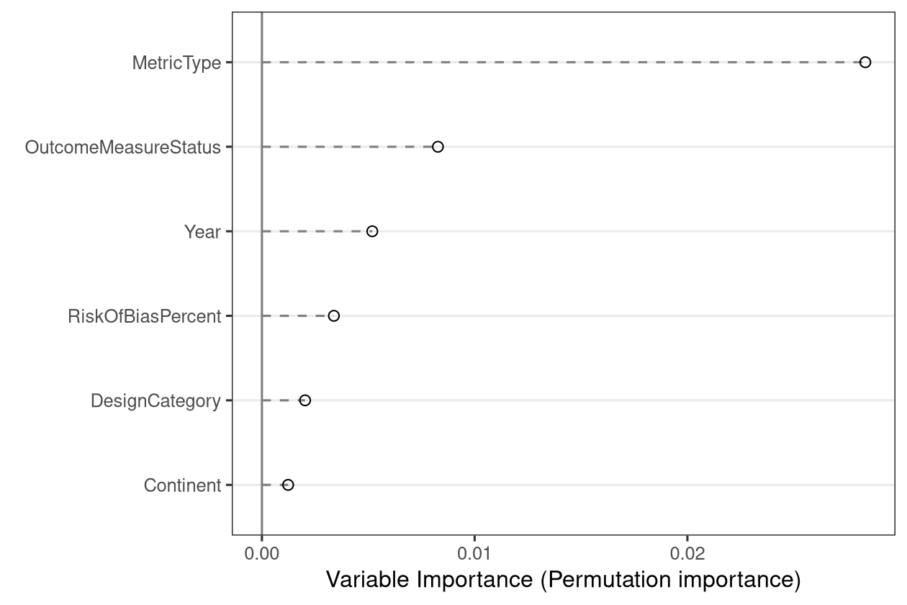

Figure S2a. Doi plot for broad personality change studies
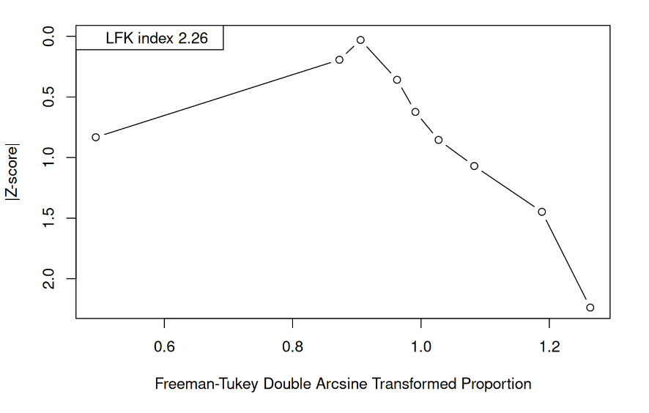

Figure S2b. Doi plot for secondary personality disorder studies
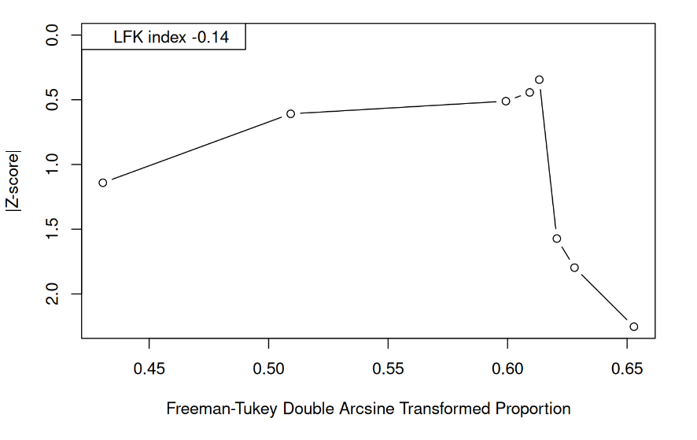

Figures S3a. Risk of bias ratings and risk of bias summary for cross-sectional studies
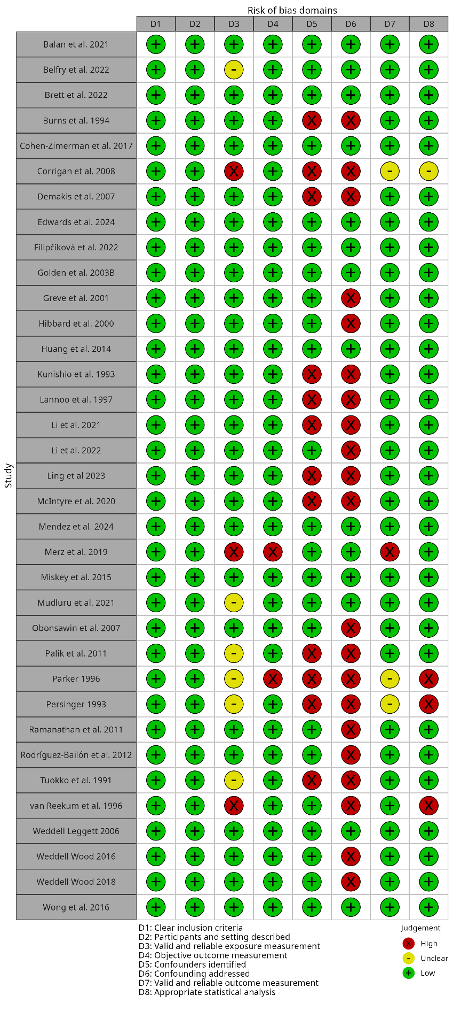

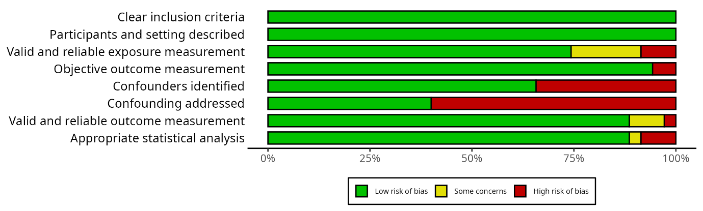

Figures S3b. Risk of bias ratings and risk of bias summary for cross-sectional studies
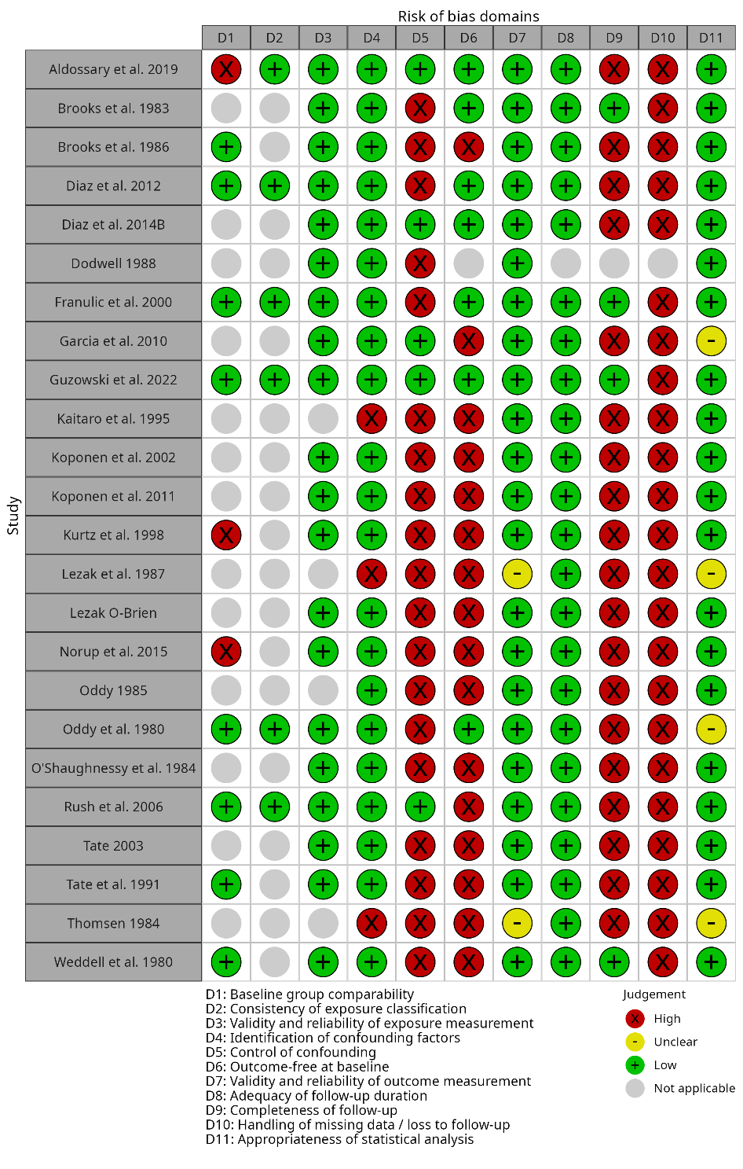
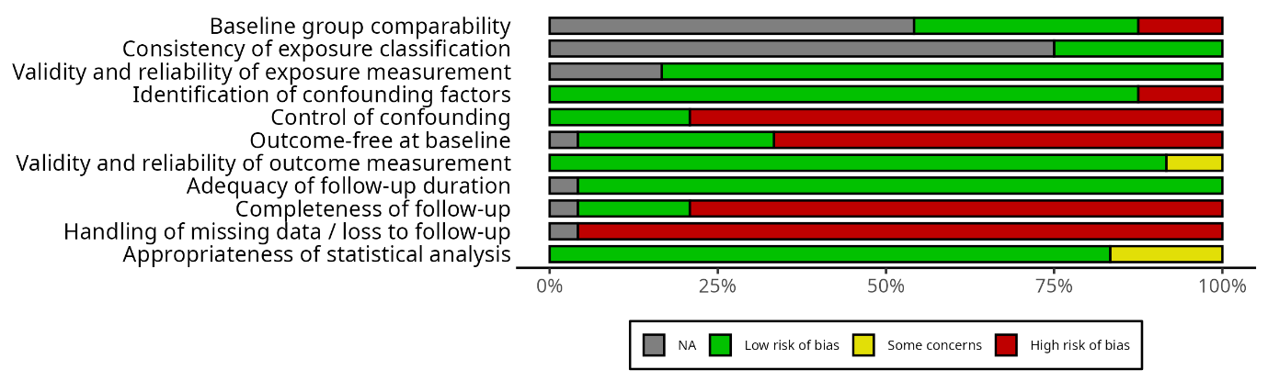

Figure S3c. Risk of bias ratings and risk of bias summary for retrospective observational studies
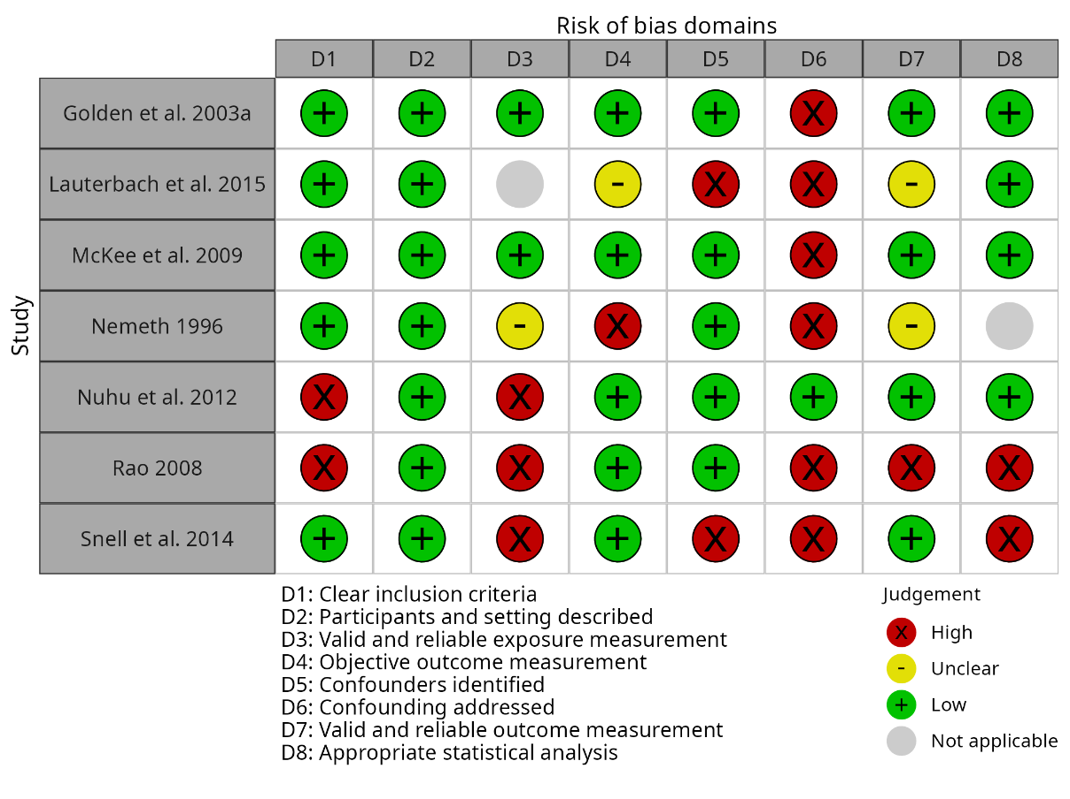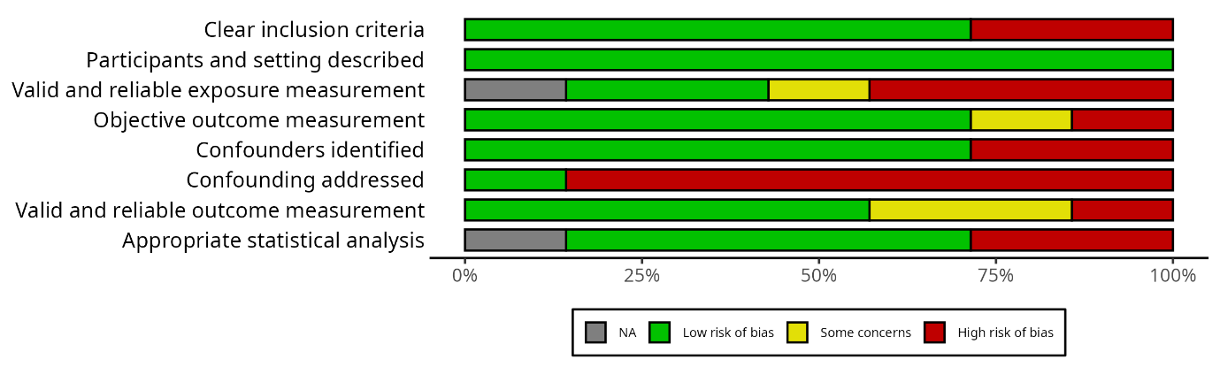

Figure S3d. Risk of bias ratings and risk of bias summary for case control studies
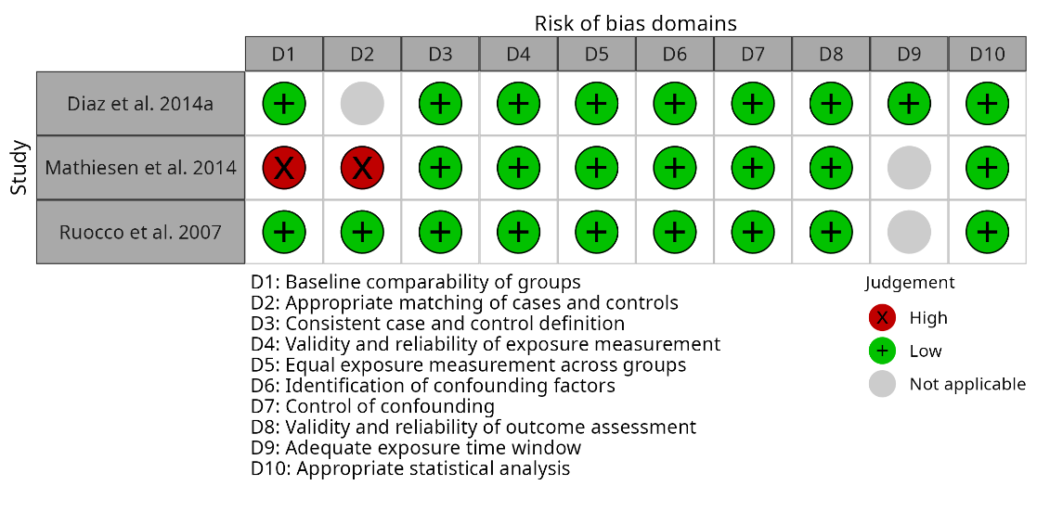
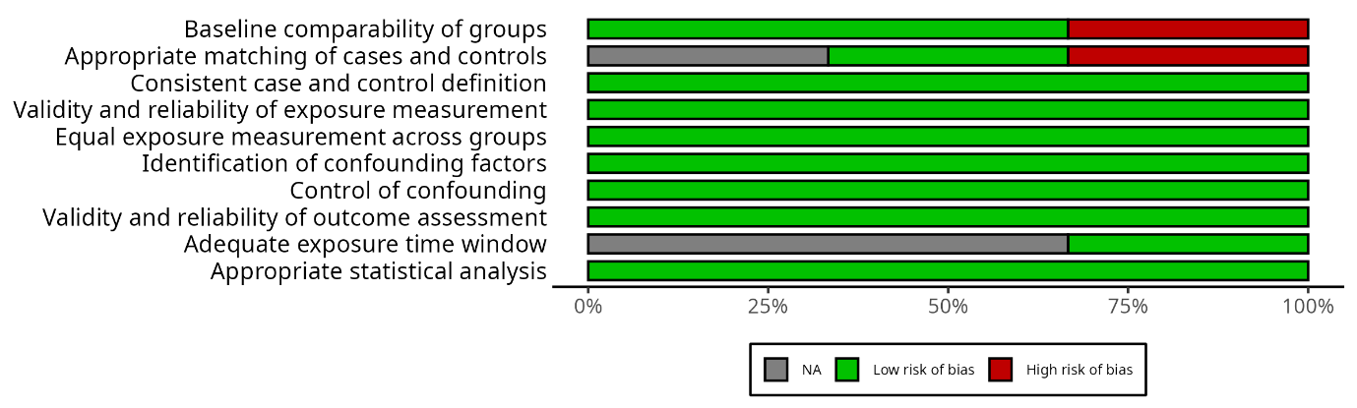

Table S1. Search strategy for the systematic review
S1 – Search Strategy
("traumatic brain injury" OR "TBI" or "craniocerebral trauma") AND ("personality" OR "personality change" OR "personality disorder" OR "personality syndrome" OR "frontal lobe syndrome" OR "prefrontal syndrome" OR "comportmental learning disabilities" OR "comportmental learning disability" OR "behavior disorder" OR "behaviour disorder" OR "behavioral disorder" OR "behavioural disorder" OR neurobehavi* OR antisocial OR dissocial* OR borderline OR histrionic OR narcissis* OR psychopath* OR sociopath* OR anankast* OR schizoid OR paranoid OR schizotyp* OR disinhibit*)

MeSH Terms: Brain Injuries OR Craniocerebral Trauma AND Personality

Table S2. Studies included in the systematic review

No. | Author | Year | Study Type | Participants | Country | TBI details | Personality outcomes | Instrument / Measures | Brain Injury Location
1 | Oddy & Humphrey | 1980 | Cohort study | TBIinitial=54, 6m=49, 12m=44, 2yr=39; CInitial=35, 6m=30, 12m=26, 2y=17 | UK | Closed head injury | Qualitative/Questionnaires | Kats Adjustment Scale | Not specified
2 | Weddell et al. | 1980 | Cohort study | n=44, m=31, age=24.4, time between accident and admission = 6.4m | UK | Severe head injury | Post-injury: irritability {N = 17), increased affection (n=8), increased talkativeness (N = 4), increased disinhibition (TV = 3) and childishness (N = 4). | Oddy's interview; Bond Neurophysical Scale; Standard Progressive Matrices | Not specified
3 | Thomsen | 1981 | Case study | Male, 44yo, edu=12y | Denmark | RTA | Partner gave pre-and post information | Neuropsych testing, but not specified | An X-ray revealed multiple fractures in the posterior left part of the skull
4 | Goldberg & Buongiorno | 1982 | Case study | Male, 44 | USA | RTA | OPD | WAIS; Halsted Reitan battery | open skull fracture over the right frontal bone; prefrontal and frontal damage
5 | Brooks & McKinlay | 1983 | Cohort study | TBI=55, M=46; age=m35.7 | UK | RTA=26; work-related injury=4; assault=11; other =14. | Personality adjective checklist: Present 3m=27, 6m=33, 12m=33; Absent 3m=28, 6m=22, 12m=22 | GCS | Not specified
6 | O’Shaughnessy et al. | 1984 | Cohort study | N=39, M=29, age=28.2, edu=12.46, PTA=5.65days | USA | Closed head injury | EPI | WAIS; EMS; PASAT; TMT; EPI; Social Leisure Form | Not specified
7 | Prigatano et al. | 1984 | Non-RCT intervention study | TBI=18, m=15, Age=26.1; C=17, m=15, age=23.5 | USA | Serious brain injury | KATS | WAIS; WMS; TMT; FTT; RN AIR; KATS | Severe Cerebral Contusion, Brain Stem Contusion
8 | Thomsen | 1984 | Cohort study | n=40; m=28 age=21.5; f=12, age = 27.3 | Denmark | RTA=37; Falls =3; Closed head inj=9; Closed head inj + brainstem damage = 15; Closed head inj+verified focal lesion =16 | Changes in personality and emotion 2-5yrs=80%, 10-15yrs=65%: Childishness 2-15yrs=60% 10-15yrs=25%, Emotional lability = 40% 35%, Irritability 2-5yrs=38%, 10-15yrs=48%, Restlessness 2-5yrs=25%, 10-15yrs=38%, Disturbed behaviour 2-5yrs=23%, 10-15yrs=20%, Loss of social contact 2-5yrs=60%, 10-15yrs=68%, Aspontaneity 2-5yrs=43%, 10-15yrs=53%, Sensitivity distress 2-5yrs=23%, 10-15yrs=68%, Lack of interests 2-5yrs=20%, 10-15yrs=55% | WAIS | The worse overall outcome was seen in cases with severe brainstem involvement or anterior lesions or both.
9 | Oddy et al. | 1985 | Cohort study | n=44, m=31 | UK | Closed head injury | Qualitative/Questionnaire | Bond Neuropsychological scale; ravens progressive matrices & mill hill vocab scale; Wimbledon self-report scale | Not specified
10 | Brooks et al. | 1986 | Cohort study | TBI=55, M=46; age=m35.7. Relatives=42 | UK | RTA=26; work-related injury=4; assault=11; other =14. | Personality change 1year=60%, 5years=74% | GCS | Not specified
11 | Nemeth | 1986 | Retrospective observational | n=21, m=10, 17to47age varying levels of education | USA | mTBI refers to a condition where cell loss or damage is assumed to have occurred as a result of a relatively mild cerebral concussion ; RTA=26, Falls=2, assaults=2, falling object=1 | Categorised as: 1. Impaired impulse control: Impatience, irritability, low frustration tolerance [n=18] 2. Inappropriate intensity of affect; mood swings [n=17] 3. Impaired motivation; loss of interest; social withdrawal; apathy. [n=17]. 4. Ability to relate [n=8]. 5. Diminished libido [n=6]. 6. Sleep disturbance [n=8] | GCS | Not specified
12 | Lezak | 1987 | Cohort study | n=42, white, male, 27.8 | USA | RTA=28, Assault=7, falls=5, gunshot=1, airplane=1 | PAI | WAIS; PAI | Not specified
13 | Dodwell | 1988 | Cohort study | n=56, M=46, age=26, O-levels=25, a-Levels=5, graduates=4 | UK | Blunt head injury | EPI | EPI; MNTS; MPI; PSE | Not specified
14 | Lezak & O’Brien | 1988 | Cohort study | 42 white males with TBI (39 analyzed in some analyses). Mean age at injury: 27.1 years (SD=7.4), mean education: 12.4 years (SD=2.2). 17 unconscious <2 weeks, 25 unconscious >2 weeks. No prior psychiatric history. | USA | Unselected TBI sample. Etiology: 67% motor vehicle accidents, 17% blow to head, 12% fall, 5% other. Duration of unconsciousness: 8 patients <1 day, 9 patients <2 weeks, 23 patients >2 weeks, 2 patients >1 month. All examined within first year post-injury, followed for 5 years with 6 assessment periods. | 1) Persistent difficulties: anger (39% at year 5), anxiety, significant relationships (22-36%), social contacts, work/school, driving, appropriate social interaction; (2) Rapid improvement: initiative, residence, self-care, leisure, ambulation, aphasia; (3) Variable improvement: anxiety, depression. At 5 years, 45% displayed delusions/hallucinations or paranoia at some point. Emotional/social disturbances more handicapping than cognitive/physical disabilities. | Portland Adaptability Inventory (PAI) - developed for this study with 3 subscales: Temperament and Emotionality (7 items: anger, anxiety, indifference, depression, delusions/hallucinations, paranoia, initiative); Activities of Social Behavior (8 items analyzed: relationships, residence, social contacts, self-care, work/school, leisure, driving, appropriate social interaction); Physical Capabilities (6 items: ambulation, hands, auditory, vision, dysarthria, aphasia). 4-point scale (0-3). | Not specified
15 | Tate et al. | 1991 | Cohort study | n=100; TBI=87, m=66, ageInj = 23.9, ageStudy=30, edu=9.3; C=40, m=28, ageStudy=29.2, edu=9.9 | Australia | Closed head injury = 58; Closed head injury with neurosurgery = 19; Open head injury = 20; RTA = 87% | In appendix A: PC TBI = 34 (40%), compliance =10, flexibility = 11, C+F =13; PC C = 3 (7.5%), compliance = 2, flexibility = 1 | Glasgow Outcome Scale | Not specified
16 | Tuokko et al. | 1991 | Cross-sectional | N=79; age=33.9; time since inj=0.25 to 148 months mean = 16.27 months. | Canada | Not specified | MCMI | MCMI; GCS; WAIS | Not specified
17 | Kunishio et al | 1993 | Cross-sectional | TBI=123, age=35.5, m=96; C=8 | USA | Focal or Diffuse injuries | Yatabe-Guilford personality test | WAIS; YGPT; GCS | Focal Injuries = acute epidural hematoma (EDH), acute subdural hematoma (SDH), in tracerebral hematoma (ICH), and low-density lesion.; Diffuse injuries= head injury accompanied by coma persisting for longer than 6 hours, but no CT evidence of a mass lesion, subdivided into diffuse axonal injury (DAI),') diffuse brain swelling (DBS), and hemispheric swelling (HS).
18 | Persinger | 1993 | Cross-sectional | 56 neuro cases; TBI=39, m=23, C=17, m=10 | Canada | 90% RTA | Generalized activity, hedonism, arousal, and memory, were reported by all CHI patients but by none of the reference patients. | WAIS | frontal, temporal, temporofrontal and superior parietal lobes
19 | Burns et al. | 1994 | Cross-sectional | n=85; m=71%, edu=13.1y, age at inj =34 y; age_test=36 y; time between inj and test = 2 y 9 m.; TBI=57, M=43, edu=13.; nTBI=28, M=17, edu=13. | USA | Traumatic brain injury (TBI) = 57 (inc assault i.e. gunshot wounds, blows; falls; RTAs) | Cattell's 16PF Personality test | LNNB; QAB; Cattell's 16PF Personality test | Not specified
20 | Damasio et al. | 1994 | Case study | Phineas Gage - 25yo | USA | Work-related accident | Pre-injury: responsible, efficient, capable, intelligent, and socially well-adapted individual. Post injury: irreverent and capricious, lack of respect for social conventions, used profanities, lack of sense of responsibility. Unable to honour his commitments. | X-Ray | Left hemisphere: the anterior orbital frontal cortex, the polar and anterior mesial frontal cortices, and the anterior-most sector of the anterior cingulate gyrus. Right hemisphere: the anterior and mesial orbital region, the mesial and polar frontal cortices, and the anterior segment of the anterior cingulate gyrus.
21 | Kaitaro et al. | 1995 | Cohort study | n=19, male=15, age inj=28, PTA=175days | Finland | Not specified | Not specified | WAIS, WMS, BVRT, | Not specified
22 | Marshall et al. | 1995 | Case study | Male, 69yo | UK | RTA; work-related accident | his wife described her husband as a very gentle, calm man before the accident | MMSE | CT-scan showed bilateral frontal haemorrhages with additional right frontal lobe contusion.
23 | Stratton & Gregory | 1995 | Case series | Case 1 = 31, ageinj=23, female; Case 2 = 18, ageinj=16, female; Case 3 = 31, ageinj=29, female; Case 4 = 19, female | New Zealand | RTA = 1, 2,3,4 (pedestrian/passenger) | Case 1 = no ref to personality change; Case 2 = no longer had any sense of humor and jokes went over her head. Pre-injury: good sense of humour.; Case 3 = Severe depression, loss of confidence, irritability and impatience. Pre-injury: optimistic person with a feeling of well-being and happiness.; Case 4 = Reported no personality changes. | Not specified | Case 1 = left frontal temporal and occipital areas; Case 2 = Frontal lobe; Case 3= Occipital areas; Case 4= posterior temporal region, right hemisphere
24 | Parker | 1996 | Cross-sectional | Total = 33; edu = 14.2 years; time since inj=20 months, age=38.5 | USA | RTA | A wide spectrum of disorders was observed: cerebral personality disorder, persistent altered consciousness, post-traumatic stress, psychodynamic reactions to impairment, and complex reactions expressing neurological, somatic, and psychological dysfunctions (sexuality and somatization). | WAIS; Inkblots; Figure drawings | Not specified
25 | Van Reekum et al. | 1996 | Cross-sectional | n=18; m=8; post-inj=4.9y; 19-49y | Canada. | sevTBI=10, modTBI=8; | DSM-IV | SIDP-R; SADS-L | Not specified
26 | Harrington et al. | 1997 | Case study | Male, 59yo, Israeli born | USA | Fall | Post-injury: disinhibited behavior, mood swings, delusional jealousy, temper outbursts, impulsivity, foul language, decreased hygiene and self-care and decreased interest in his usual activities. He was easily fatigued and very impatient. | Not specified | bifrontal hemorrhagic contusions right > left, with subfalcine herniation from right to left and downward mass effect with blood in the right lateral ventricle. A right frontal subdural hematorna. Small, old lacunar infarction in the left caudate nucleus/ anterior limb of the internal capsule.
27 | Labbate et al. | 1997 | Case series | A=Male, 20yo; B=Male, 34yo; C=Female, 29yo | USA | A= Work-related accident; B=RTA; C=RTA | A= Before was very anxious socially and urinating. Now, he longer felt uncomfortable with groups and felt more confident, able to speak his thoughts. He rarely blushed and was able to urinate without difficulty for the military mandatory urine drug tests. Seven months after the injury much of his irritability and emotional lability had resolved. He, however, continued to feel confident and noticed the absence of anxiety persisted in all social situations.; B= His former wife states that around September 1976 he had personality change. Prior to the injury, he had antisocial personality disorder. He no longer has sociopathv interests since the motorcycle trauma.; C= Following the injury she reported mild memory deficits, but noticed a marked change; she was no longer always angry. Two months after the injury, coworkers and friends in the Navy also noticed that she was much more calm and friendly, she was able calmly to complain about concerns with ward nurses, whereas formerly she commonly became extremely angry in such instances. She was not apathetic, and her mood was euthymic. | A=WAIS, WCST, DSM-V ("personality") | A=No abnormality; B= a right hemothorax, an acute subdural hematoma in the right cerebral hemisphere, and cerebral edema, and he underwent a bifrontal craniotomy.
28 | Lannoo et al. | 1997 | Cross-sectional | TBI=68, m=54, age=35, edu=11; Trauma=28 m=20, age=37, edu=12 | Belgium | Moderate-Severe head injury | NEO-FFI | NEO-FFI; GCS | Not specified
29 | Kurtz et al. | 1998 | Cohort study | TBI=21, m=18, black=13, age=32.71; C=25, m=18, black=11, age=35.48 | USA | RTA=12, assault=6, bicycle=2, fall=1 | NEO-PR-IV | NEO-PR-IV; REC | Not specified
30 | Cantagallo et al. | 1999 | Case study | Male, 32yo | UK | RTA | Acquired DID post TBI | Not specified | CT Scan did not disclose any abnormality. EEG saw patchy dyshomogeneous uptake with left temporal and biparietal hypo- perfusion, worse in the left hemisphere.
31 | Dimitrov et al. | 1999 | Case study | Male, 50yo (injury sustained at 20yo) | USA | War (Shrapnel) | Post-injury: Unusual moodiness, mood swings, sarcasm, lack of tact with others, bluntness of affect, remoteness of rapport, social withdrawal, no ability to make and keep friends, and, especially, questionable competency in handling large sums of money, unable to plan daily activities…. He “possessed the experience and ethics of a 14 year old”, increased pornography use. | WAIS, WMS, BADS, WCST, BDI | right frontal ventromedial lesion
32 | Neylan | 1999 | Case study | Phineas Gage | USA | Work-related accident | Pre-injury: efficient, capable.; Post-injury: fitful, irreverent, profane, unempathetic, impatient, obstinate, capricious and vacillating. | Not specified | Right prefrontal cortex
33 | Tsai et al. | 1999 | Case series | n=10, TBI=6/10, age=37.6 | Taiwan | Head trauma | Affective liability =5; aggression =4; impulsivity =2; grandiosity =1; impulsivity =3; paranoia=3; apathy=2 | DSM-IV | Not specified
34 | Franulic et al. | 2000 | Cohort study | w/OPD n=9, m=0, age=41av; w/o OPD n=21, m=3, age=33av | Chile | TBI | ICD-10 defined organic personality disorder | ICD-10; WAIS, Benton TestROT, WCST, PS, NRS-27. | OPD = 6 x disturbed cerebral TC, specifically frontal and temporal secondary type. The most frequent lesion was of the haemorrhagic contusive type.
35 | Glover | 2000 | Case study | Male, 34yo | UK | Fall | Pre-injury: vibrant, energetic physical man.; Post-injury: “a shell of himself”, angry, frustrated, short tempered, unable to reason, argumentative, stubborn. | Not specified | Not specified
36 | Hibbard et al. | 2000 | Cross-sectional | n=100, TBIw/oPD=76, TBIw/PD=24, m=53, age=38, White=73, Black=14, Hispanic=9, Other=4 | USA | Motor vehicle accident 62%; Assault 8%; Pedestrian accident 8%; Fall 6%; Sport related 6%; Hit by falling or flying object 5%; Gunshot wound 2%; 41% Other means 3% | DSM-IV Criteria | DSM-5 ("personality change"); | Not specified
37 | Greve et al. | 2001 | Cross-sectional | IA n=26, m=24, age=33.9, education=11.4, injuryage=23.3, comalength=44.85; C=19, m=17, age=38.9, education = 12.9, injuryage=26.8, comalength=42.9 | USA | TBI | Eysenck Personality Questionnaire (EPQ) | LHA, BPAQ (aggression); EPQ (personality); BIS (impulsivity); PPVT, TMT, COWAT, WCST | Not specified
38 | Mataró et al. | 2001 | Case study | Male, 81 (inj=21) | Spain | Fell onto an iron stake | Post-injury: dependent on others, cheerful, problems establishing realistic goals, lack of drive, difficulties initiating, continuing and finishing activities. Lack of drive and concern, apathy, poor planning. | Not specified | Bilateral damage affecting the orbital and dorsolateral frontal regions
40 | Koponen et al. | 2002 | Cohort study | n=60; male=41, age=60.8, ageinj=29.4, | Finland | Not specified | DSM-IV Criteria | DSM-5; MMSE | Not specified
41 | Tate | 2003 | Cohort study | Relatives Initial = 45, 6m=30, 12m=28; TBI; m=24 (85.7%), age=26.82, edu = 10.29 | Australia | RTA =21 (75%), assault = 5, fall =1, sport (soccer) = 1. | EPQ-R | EPQ-R; CBS | structural lesions in frontal lobes = 17
42 | Golden & Golden | 2003.1 | Retrospective observational | 320 TBI pts; Ethnicity - Caucasian (82.2%), Black (14.1%), Hispanic (3.8%). M=234 (73.1 %), age 45.4 (SD = 12.69), education 12.02 (SD = 2.012) | USA | TBI | MMPI | MMPI-2; HRNB | Not specified
43 | Golden & Golden | 2003.2 | Cross-sectional | Stroke n= 124. HI = 290. Dementia n= 66 ; Av 58.04yo, education = 12.67, mostly Caucasian but 80 African-Americans, Hispanics, or others. Av chronicity = 77.55 months | USA | TBI | MMPI | MMPI-2 | Not specified
44 | Heinrich & Junig | 2004 | Case study | Male, 69yo | USA | RTA | Post-injury: irritable, slightly elevated. Noted changes. Thought process was tangential and difficult to redirect at times. | Folstein Mini-Mental Status Examination | left-sided frontal bacute on chronic SDH with mild left frontal mass effect. A left frontal SDH and gliosis in the left orbitofrontal and left posterior basotemporal lobes along with the right occipital lobe (contra-coup injury).
45 | Wood & Rutterford | 2004 | Case study | Male, 40yo, age inj=22 | UK | RTA | Pre-injury: quiet, mild mannered person. Post-injury: disorientated, restless, and agitated. Post-operatively, more outspoken, less agitation, bright, cheerful and articulate. 9months: Irritability, agitation, poor concentration, difficulty with memory, inordinate fatigue, lethargy, and a poor sleep pattern. 15 months: extraverted, tiredness. lacked inhibition and social judgement, told socially inappropriate jokes or comments. | WCST | Bifrontal damage. Walls of the frontal sinuses were extensively fractured, with damage to the ethmoidal complex and right orbital wall. Breach in the dura near the midline on the left side. Cerebrospinal fluid rhinorrhoea was present.
46 | Chang et al. | 2006 | Case study | Male, 77yo | Taiwan | Fall | Change in personality characterized by bad temper, disturbed sleep patterns, easily fatigue ability and poor appetite | Glasgow Coma Scale | mild subdural effusion in bilateral frontotemporal areas. Cerebrospinal fluid was normal. Biochemistry studies showed only mild hyponatremia and mild hypokalemia
47 | O’Gorman | 2006 | Case study | Male | UK | RTA | Pre-injury: laid back, easy–going, creative.; Post-injury: Frightening dreams, angry outbursts, out of control emotionally. | Not specified | cerebral contusions – in both frontal lobes and brainstem areas of the brain
48 | Rush et al. | 2006 | Cohort study | n=90, mTBI=20; Mod-SevTBI= 39; C=3. Ax Data= 38-56 days post-inj, 1-2yr follow up= 391-442 days post-inj | USA | GCS | NEO-PI-R | NEO-PI-R (personality), GCS; GOAT; MPAI; ILS; VIS. | Not specified
49 | Weddell & Leggett | 2006 | Cross-sectional | n= 87; M=71; age=? | UK | Severe TBI=72; Mild TBI=15 | noPC (n = 24), PC? (n = 9) and yesPC (n = 54) | GCS; WAIS; WMS; UPSIT; STA; ZDS; GHQ-28 | orbitofrontal and/or medial temporal damage
50 | Demakis et al. | 2007 | Cross-sectional | Combined= 95, age=33.4, edu=12.5, m=82.1%, w=72%; Rehab =60, age=36.8, edu=12.4y, m=73.3%, w=80%; Military= 35, age=27.5, edu=12.5, m=97.1%, w=57% | USA | Rehab: RTA=73%, falls=15%, other=12%. Military: blast=57%, other =43% | PAI | PAI | Not specified
51 | Handel et al. | 2007 | Case study | Male, 58yo | USA | RTA | Post-injury: Withdrawn, excessively worried about money, nihilistic delusions about his lack of resources and convictions about impoverishment. Decline in mood, sleep, appetite, interest in self-care, and participation in daily activities. Stopped working. | WAIS | subarachnoid hemorrhage, primarily involving the left fronto-parietal regions
52 | Obonsawin et al. | 2007 | Cross-sectional | TBI=184, m=152, age=35.2, age inj=28.8; C=87, m=57, age=35.8 | UK | Not specified | 123 personality characteristics gathered from (1) literature on TBI, (2) personality assessment scales, (3) rehabilitation staff (4) clients (5) the Scale for the Assessment of Negative Symptoms14 and the Scale for the Assessment of Positive Symptoms,15 and (6) literature on personality disorder. | GCS; SANS; SPNS | Not specified
53 | Ruocco et al. | 2007 | Case control | Total=462; TBI=231, age=40.6, edu=13.6yrs, m=128; Psychiatric=231, age=40.9, m=128, W=87, AA=29, H=11, A=3, edu=13.6 | USA | RTA =74.8%, falls =11%, blows to the head =10.6%, physical assault =2.2%, aircraft crash =1.3%. mildTBI=84%, moderateTBI=16% | MCMI | MCMI | Not specified
54 | Corrigan & Deutschle | 2008 | Cross-sectional | n=50; m=31, w=92%, age=37.5; less than high school diploma=44%, 42% = diploma or GED; 14% = college or advanced training. | USA | COFD item = ‘Have you ever hurt your head or had a head injury that resulted in being knocked out or being taken to the hospital?’ | Axis II Personality disorder diagnoses. Borderline personality disorder TBI=4 (11%), nonTBI=0 (0%); Antisocial personality disorder TBI=2 (6%), nonTBI=0 (0%); Personality disorder. NOS TBI=3 (8%), nonTBI=0 (0%); Any personality disorder TBI=9 (25%), nonTBI=0 (0%) | COFD
55 | Namiki et al. | 2008 | Case study | Male, 54yo (inj @53) | Japan | RTA | Post-injury: disinhibition relating to impulsivity and sexual matters. Easily angered or irritated, emotional outbursts, makes inappropriate sexual comments and advances, is too flirtatious, is hyperactive and unable to sit still. | FrSBS, WAIS, WMS, BFRT, WCST, BADS | Ambiguous findings in the orbitofrontal cortex area were found when using the MRI, EEG or SPECT with N-isopropyl-p-[123I] iodoamphetamine (IMP).
56 | Rao et al. | 2008 | Retrospective observational | Total=54; age=41.1 years; male=37; w=81.5%; edu=13.4years. | USA | Closed Head-Injury; 44%=mTBI, 20.4%= moderate, 35.2% sTBI. | DSM-IV Criteria | GCS; MMSE | Not specified
57 | Dasarathy et al. | 2009 | Case study | Female, 82yo | UK | RTA | Pre-injury: pleasant and polite. Post-injury: agitation, verbal aggression and expression of obscene gestures. | MMSE | Contra-coup bilateral frontal contusions and small sub-arachnoid, subdural and extradural haemorrhages
58 | McKee et al. | 2009 | Retrospective observational | n=51, m=49, SymptomAge=42.8, age starting=15.4; Case A=45yo, white male; Case B = 80yo, african american man; Case C=73yo, male | USA | Sport-related injury; boxing=39, american football=5, wrestler=1, soccer=1. | Case A = NFL linebacker, became angry, verbally aggressive, more emotionally labile.; Case B = boxing for 5 yrs, wife referred to him as "punch-drunk" in mid-30s, and at age 78 became paranoid; Case C=boxing, late 50s became forgetful, mood swings, restless, apathetic, socially withdrawn, paranoid, irritable, and sometimes violently agitated. Previously happy, easy-going self. | Not specified | Case C: Computed tomographic scan and magnetic resonance imaging (MRI) showed generalized cortical atrophy, enlargement of the cerebral ventricles, cavumseptum pellucidum, and a right globus pallidus lacuna.
59 | Gracia-Garcia et al. | 2010 | Cohort study | 41 pts | USA | TBI | personality profiles were captured with the 60-item NEO Five-Factor Inventory (NEO-FFI) | NEO-FFI | Not specified
60 | Koponen et al. | 2011 | Cohort study | n=38, m=27 (71.1%), ageinj=41.6, edu=10.7 | Finland | Fall n=26 (68.4%); RTA=10 (26.3%); Assault =1 (2.6%); Other cause =1 (2.6%); Mild = 27 (71.1%); Moderate = 6 (15.8%); Severe = 3 (7.9%); Very severe = 2 (5.3%) | SCID | SCAN; SCID | Not specified
61 | Paik et al. | 2011 | Cross-sectional | Total = 237; Contol = 150, BT=54, BD=33, male=100%, 19yo, brain trauma = 2 weeks to 12 years ago | Korea | Not specified | KMPI | KMPI | Not specified
62 | Ramanathan et al. | 2011 | Cross-sectional | Total =45; M=25; W=40, B=4, A=1; age=34.1;edu=13; | USA | Not specified | Not specified | SCL-90-R; TICKS; CHARTS; LOT-R | Not specified
63 | Colantonio & Comper | 2012 | Case series | Male = 75%, > 44 yo = 69%, married = 70%, less than high school education (47%). | Canada | Work-related accident | Not specified | RPQ | Not specified
64 | Diaz et al. | 2012 | Cohort study | Total n =48; male = 42, mean age = 32.33.; No Psych Dis = 15; male = 13, mean age = 34.45; Psych Dis = 33; male = 29, mean age = 31.36 | Brazil | Severe TBI | Thus, for this study, ‘‘personality changes’’ is considered to be personality changes in general, more specifically due to a severe head trauma, reported by family. | Glasgow Coma Scale; DSM-IV (Personality Change); HADS | n=11 (33.3%) experienced personality changes
65 | Nuhu & Yusuf | 2012 | Retrospective observational | n=75, m=68, age=32.2, PTA=5.45 days | Nigeria | RTA=69.3%; Other=30.7% | Premorbid personality n=71, maladjusted=5 | Not specified | Not specified
66 | Rodriguez-Bailon et al. | 2012 | Cross-sectional | TBI=9, M=7, age=29.4, edu=13yrs; C=9, M=6, age=30.89, edu=14 yrs | Spain | The inclusion criterion for the frontal group was the presence of damage in the prefrontal lobe confirmed by neuroimaging and the neuropsychological assessment performed. | DSM-IV Criteria | MCMI; DSM | All the patients had impairment in the dorsolateral prefrontal cortex, the orbital prefrontal cortex or the anterior cingulate cortex.
67 | Huang et al. | 2014 | Cross-sectional | B-TBI n=84, PostInj=8.7m, m=84, age=28.3.; NonB-TBI n=48; m=34; age=30.2.; Control n=79; civ=68; m=27; age=28.4 | USA | War: Blast injury (B-TBI); RTA, Sport, Falls (nonB-TBI) | HISC | GCS; HISC (Personality Change) | Not specified
68 | Mathiesen et al. | 2014 | Case-control study | BPD=20, m=3, 18-50; OPD=24, m=15, 20-60 | Denmark | Not specified | OPD | DSM-IV; KAPP | Not specified
69 | Pachalska et al | 2014 | Case study | Male, 27yo | Poland | Work-related accident | Post-injury: aggressiveness, anxiety, impulsiveness, inappropriateness and lack of good manners, unreasonable behaviour, hypersensitivity, and irritability. | FBInv | Frontal Lobe
70 | Snell et al. | 2014 | Retrospective observational | n=14, m=12, age=41 years; follow-up= 5.8 yrs post-inj. | Australia | RTA= 9; sport-related injury = 2; fall= 2; firecracker explosion=1 | EBIQ | EBIQ | Complex fracture; 3 of the 4 axial facial levels (upper and lower maxillae, naso-orbito-zygomatic, and cranial vault) were impacted
71 | Diaz et al. | 2014.1 | Case control | Total=41, m=35, age=31; PChange=14, m=13, age=33.9; nPChange=29, m= 22, age=29.8 | Brazil | nonmissile traumatic brain injury | DSM-IV | DSM-IV | Not specified
72 | Diaz et al. | 2014.2 | Cohort study | N=43, m=36, age=31.6, | Brazil | Two pts trauma were not mentioned. 69.7% =RTA, 7%= assault,16.3%= falls, 2.3%= a bicycle accident. | SCID | GCS; DSM-IV; SCAT | Not specified
73 | Bodley-Scott & Riley | 2015 | Qualitative | Small group n= 5; 29-42yo; 9months-7years post injury | UK | Sporting accident n=1; fall n=3; assault n=1 | "Personality changes" not defined | Interview Schedule | Not specified
74 | Lauterbach et al. | 2015 | Retrospective observational | n=60; m=47, age=46, | USA | RTA; Falls | Not specified | GCS | Not specified
75 | Manjila et al. | 2015 | Case study | Male, 30yo, | USA | RTA | Post-injury: emotional instability, aggressiveness, possessiveness, impulsivity. Rechristened himself. Grandiose thoughts, obsessive-compulsive traits. Took risky decisions. | Not specified | Frontal Lobe
76 | Menger et al. | 2015 | Case study | Male, 41yo (inj) | USA | Work-related accident: Assassination Attempt | Not specified | Not specified | Left frontal lobe, corpus callosum, right frontal and temporal lobes. There was also a bullet fragment with an associated intraparenchymal haemorrhage in right temporal lobe.
77 | Miskey et al. | 2015 | Cross-sectional | n=144, m=89.6%, age=35.29, edu=13.92. C=40; mTBI=31; H=25; mTBI/PTSD=23; mTBI/PTSD=25. | USA | Not specified | PAI | PAI | Not specified
78 | Norup & Mortensen | 2015 | Cohort study | TBI=22, TBI-SO=22; C=22, C-SO=22. | Denmark | Not specified | NEO-FFI; EPQ | NEO-FFI; HRQOL; EPQ | Not specified
80 | Ikram et al. | 2016 | Case study | Henry VIII |  | Multiple Sport-Related Incidents | Impulse control, irritability, anger outbursts, depression, sleeplessness, forgetfulness. | Not specified | Not specified
81 | Weddell & Wood | 2016 | Cross-sectional | NHS = 40; m=30; Age=39.8; MSinceInj=64.5; ML = 31; M=22; age=33.8; MSinceInj=49.3 | UK | NHS: RTA=45%, Fall=30%, Assault=17.5%, other = 7.5%; ML: RTA=87.1%, Fall=9.6%, Assault=3.2%, other = 0.0% | Self-reported personality changes | GCS; DEX; BIS-11; WAIS; WMS; BADS; BSIT; SIT; HADS; BDI-FS; STAXI-II; Family questionnaire | Not specified
82 | Wong et al. | 2016 | Cross-sectional | TBI=81, m=61, age=44.6, edu=12, AA=60 W=17 H=1; SO= 76, m=23, age=49.9, edu=12.7, AA=57 W=18 | USA | medically documented complicated-mild, moderate, or severe TBI |  | BIS/BAS; PNAS; AQ; GCS; WTAR | Not specified
79 | Achinivu | 2017 | Case study | Female, 58yo, inj at 54 | UK | RTA | OPD | GCS | bilateral small acute subdural hematomas and multiple contusions especially in both temporal lobes
83 | Cohen-Zimerman et al. | 2017 | Cross-sectional | HC = 62.23yo; education = 15.06; N= 39. PC = 63.70yo; education = 15.45; N=33. R dlPFC = 63.27yo; education = 13.64; N=11. L dlPFC = 62.31yo; education = 13.56; N=15 | USA | Not specified | Machiavellianism | AFQT; WAIS; Mississippi PTSD scale; BDI; STAI; BNT; Faux Pas story/Control; BEES; MSCEIT; D-KEFS | Left dorsolateral prefrontal cortex
84 | Margetic & Margetic | 2018 | Case study | Male, 52yo | Croatia | Work-related accident | OPD | GCS; ICD-10 (personality); WBI; WMS | a fracture of the skull base and the right temporal bone, along with temporal epidural hemorrhage
85 | Weddell & Wood | 2018 | Cross-sectional | N=71, M=52, age=37.2, mntssinceinj=57.9 | UK | RTA = 60.6%, Fall = 14.1%, assault=7%, other=18.3% | Self-reported personality changes | GCS; BSIT; FSBQ; HADS, BDI-FS, STAXI-II; Family Questionnaire; WAIS, WMS; DKEFS; DEX | Not specified
86 | Aldossary et al. | 2019 | Cohort study | Pts with (n=70[m=52]; 39.4 +- 9.2) vs without diffuse axonal injury (n=181[m=141]; 40.3 +- 8.4) | Saudi Arabia | Traffic (w/oDAI n=52; w/DAI n=134); Fall (w/oDAI n=10; w/DAI n=33); Pupillary Abnormality (w/oDAI n=8; w/DAI n=23); Other (w/oDAI n=8; w/DAI n=14) | "Personality changes" not defined | GOSE; SCAN (perhaps used for personality?); MMSE | Not specified
87 | Merz et al. | 2019 | Cross-sectional | Total=612, m=201, age = 35.63, w=74.8%; TBI =110, time since inj=427.3 weeks | USA | Not specified | NEO-FFI | IPIP-NEO-FFI; PCSS | Not specified
88 | Durcan et al. | 2020 | Case study | 46yo male | Ireland | Work-related accident | Pre-injury: affable and gregarious. Post-injury: paranoid, irritable, short-tempered; difficulties socialising, withdrew from society. Poor concentration, memory, and lost his job. Readily insults people, showing no remorse or empathy | Not specified | left fronto-parietal and temporal lobe damage.
89 | McIntyre et al. | 2020 | Cross-sectional | N=89; M=39, Age=46.6 | Canada | Not specified | BFI | PHQ-9; AAQ; ASI; ADHS; BFI; BCOPE; RSES; GCS | Not specified
90 | Balan et al. | 2021 | Cross-sectional | Total n=41 [m=34]; 32 avg. No R2W = n=21 [m=18]; 35 avg. R2W = 20 [m=16]; 29.5 avg. | Brazil | TBI | "Personality changes" not defined | DSM-5 ("personality change"); Overt Aggression Scale; Neuropsychiatric Inventory-Questionnaire; Starkstein Apathy Scale | Not specified
91 | Banerjee et al. | 2021 | Case study | 25yo female (RTA age 23) | India | RTA | Post-injury changes included: Increased irritability, anger outbursts, stubbornness and rigidity, an inability to experience her sense of ‘self’, uncomfortable in social situations, inability to engage in conversations, or social interactions, unable to comprehend humour, sarcasm, pun, metaphors. Premorbid Personality; fun-loving extrovert, good at extra-curricular activities. K.S. found it difficult to relate to this change. | NIMHANS neuropsychological battery; Beck’s Depression Inventory | K.S often reported how ‘she is not the same following the injury’.
92 | Li et al. | 2021 | Cross-sectional | TBI=234, m=166, age=44.43; C=277, male = 183, age = 46.03 | China | Not specified | ICD-10 criterion F07 and Z87.820 | ADL scale, SDSS scale, and scale of personality change following a traumatic brain injury | Not specified
93 | Mundluru et al. | 2021 | Cross-sectional | Total = 1774, m=612 (age=68.7 edu=16.4), f=1162 (age=69.8 edu=16.3); TBI=266 (M=118, age=68.7, edu=16.4); C=1508 (m=494, age=69.8, edu=16.3) | Canada | Not specified | NPI-Q | NPI-Q | Not specified
94 | Brett et al. | 2022 | Cross-sectional | Total = 106; m=73, age=21.37, ethnicity B=8, W=97, O=1 | USA | Sport-Related Incident | Big Five Inventory | BFI; BSI-GSI; MPQ; PSQI; SCAT; WTAR | Not specified
96 | Guzowski et al. | 2022 | Cohort study | Athlete n=100: Male n=100, Age=18, Race white=75, black=23, other=2; CTBI n=75: Male=35, age=49.7, Race white=50, black=18, other=7; Control n=79: Male=56, age=48, Race white=57, black=18, other=5 | USA | Sport-Related Incident | positive and negative emotionality; negative affect, detachment, antagonism, disinhibition, and psychoticism | MPQ; DSM-5; DIS-11 | Not specified
97 | Li et al. | 2022 | Cross-sectional | OPD=340, m=198, age=41.4, edu=8.8; nOPD=687, m=363, age=37.9, edu=11.3 | China |  | Neuroticism Extraversion Openness Five-Factor Inventory | NEO-FFI; ICD-10 | Not specified
39 | Belfry et al. | 2023 | Cross-sectional | n=637, m=100%, age=m35 | Canada | ABI based on several coded variables regarding events consistent with the potential to cause brain injury documented in the medical file | Personality disorder TBI=36 (28%) C=73 (14%); Antisocial personality disorder TBI= 22 (17%), C=51 (10%) | non-standardised; VRAG; CATS | Not specified
98 | Ling et al. | 2023 | Cross-sectional | TBI n=31, Controls n=24; TBI: M age=36.90 (SD=10.81), 14 male/17 female, edu=12.81y (SD=2.50); Controls: M age=32.96 (SD=12.10), 15 male/9 female, edu=14.77y (SD=3.66) | China | Neurocognitive disorder after TBI diagnosed per ICD-10; Patients recovered for at least 6 months after TBI; Received clinical care | Scale of personality change following  TBI | EEG contingent negative variation correlated with personality change | Not specified
95 | Filipčíková et al. | 2024 | Cross-sectional | 25 TBI (19M, 6F); 25 controls (18M, 7F). TBI group: mean age 46.76 (SD=15.78), mean education 12.76 years (SD=2.31), average time since injury 14.67 years (SD=11.67) | Australia | Severe TBI: PTA > 7 days, or ≥1 day altered consciousness, or GCS 3-8. Median PTA: 52 days (IQR=53, range 9-180). Average age at injury: 31.54 years (SD=15.55, range 13-59). At least 1 year post-injury. | Social disinhibition and aggression components (physical aggression, verbal aggression, anger, hostility). Higher self-reported anger associated with higher self-reported social disinhibition, controlling for age and mood. | Frontal Systems Behaviour Scale (FrSBe) - Disinhibition subscale; Social Disinhibition Interview (SDI); Buss-Perry Aggression Questionnaire (BPAQ) - Physical, Verbal, Anger, Hostility subscales | Not specified
99 | Edwards et al. | 2024 | Cross-sectional | 328 US service members and veterans: Uncomplicated mild TBI (MTBI, n=155), Complicated mild/moderate/severe TBI (STBI, n=97), Non-injured controls (NIC, n=76). Three cohorts by time since injury: ≤12 months (MTBI n=46, STBI n=41), 3-5 years (MTBI n=57, STBI n=30), 8-10 years (MTBI n=52, STBI n=26). Predominantly male (87-100% in TBI groups). Mean age at assessment ranged 29.5-40.3 years across cohorts. | USA | TBI severity classified: (1) Uncomplicated mild: GCS 13-15, PTA <24h, LOC <30min, no intracranial abnormality; (2) Complicated mild: same criteria but with intracranial abnormality on CT/MRI; (3) Moderate: LOC >30min-24h, PTA 1-7 days; (4) Severe: LOC >24h, PTA >7 days. Combat or non-combat related. Part of DVBIC-TBICoE 15-Year Longitudinal TBI Study. Cross-sectional assessment at three time points post-injury. | Higher MMPI-2-RF scores associated with lower biomarker concentrations (GFAP, NfL, tau) in subacute/chronic phase up to 5 years post-injury, with reverse trend at 8-10 years. proneness (STBI ≤12mo), head pain (STBI 8-10yr). Lower NfL related to demoralization, somatic/neurological/cognitive complaints (MTBI ≤12mo), demoralization (STBI ≤12mo, 3-5yr), head pain, stress/worry (STBI 3-5yr). At 8-10 years, increased tau associated with worse demoralization and anxiety (STBI). Findings suggest biomarkers may relate to neurobehavioral outcomes throughout recovery trajectory. | Minnesota Multiphasic Personality Inventory-2-Restructured Format (MMPI-2-RF) - 11 scales: | Not specified
100 | Hanna et al. | 2024 | Case study | 1 case: 63-year-old male with history of hypertension, chronic kidney disease on dialysis, and TBI. Injured at age 18. No family history of schizophrenia or psychosis. Lives alone, able to perform activities of daily living. Adherent to medications. | USA | Severe TBI from gunshot wound through right frontal bone at age 18. Pre-injury: patient was very social, smart, had many friends. Injury resulted in cognitive dysfunction and seizures. History of inpatient psychiatric admissions | Personality changes included: impulsivity, excessive spending (gambling, buying unnecessary things), development of short temper. At presentation: depressed mood, aggressive behaviors, suicidal ideation, internally preoccupied with disorganized thoughts. Developed schizophrenia over several years following trauma. | Not specified | Encephalomalacia in right frontal convexity region. Deformity in calvarium just above right frontal convexity region.
101 | Riccitelli et al. | 2024 | Case study | 1 case: 34-year-old right-handed woman. Sustained severe head trauma at age 18. 16 years post-injury | Switzerland | Severe brain injury from road traffic accident at age 18. Cranial trauma induced coma due to bilateral subdural hematomas requiring emergency craniotomy. Widespread axonal damage in subcortical white matter. | Complex psychopathology including: impulsivity leading to destructive behavior and self-harm, delusions, mood instability with depressive episodes, emotional suppression, obsessive-compulsive behaviors. Severity often required emergency psychiatric interventions and compulsory hospital admissions. Treatment: 20 daily sessions of dual-site sequential rTMS (inhibitory 1Hz right DLPFC, excitatory 10Hz left DLPFC). Results - 2 weeks: decreased impulsivity (6.4%), significant reduction in OCD symptoms (52.4%, compulsions 91.7%), improvements in attention and processing speed (18.7%), improved inhibitory control (34.6%). 4 weeks: further impulsivity decline (17.7%), attentive impulsiveness improved (26.3%). 8 weeks follow-up: persistent positive effects including enhanced positive emotions. Daily emotions diary showed qualitative increase in positive emotions (baseline 3.9 to 6.5 at 8 weeks) and decrease in negative emotions (baseline 3.9 to 1.9 at 8 weeks). CGI severity improved from severe (6) at baseline to moderate (4) at 4 weeks. | Barratt Impulsiveness Scale (BIS-11) for impulsivity with subscales (attentional, motor, non-planning). | Bilateral subdural hematomas (requiring craniotomy). Widespread axonal damage at subcortical level primarily in: frontotemporal regions (predominantly left), temporobasal regions (predominantly left), trunk of corpus callosum, right upper paravermial region. MRI showed hemorrhagic contusions at: left forceps minor, left dorsolateral prefrontal cortex, right inferior frontal gyrus, splenium of corpus callosum, periaqueductal mesencephalon tegmental region. Follow-up MRI showed severe lateral ventricular and aqueductal enlargement related to parenchymal volume loss.

Table S3. Meta-regression results

Moderator | k | Estimate |  | CI |  | p
Broad personality change
Mean age | 8 | -0.004 |  | [-0.025, 0.017] |  | 0.724
% Female | 8 | 0.002 |  | [-0.007, 0.01] |  | 0.714
Follow-up (months) | 8 | 0.003 |  | [0, 0.005] |  | 0.044*
% mild TBI | 6 | NA |  | [NA, NA] |  | NA
% moderate TBI | 6 | 0.007 |  | [-0.002, 0.017] |  | 0.104
% severe TBI | 6 | -0.007 |  | [-0.017, 0.002] |  | 0.104
Year of publication | 9 | -0.006 |  | [-0.016, 0.003] |  | 0.186
Risk of bias (%) | 9 | -0.004 |  | [-0.009, 0.001] |  | 0.116
Secondary personality disorder diagnosis
Mean age | 8 | -0.004 |  | [-0.011, 0.003] |  | 0.293
% Female | 8 | -0.001 |  | [-0.005, 0.002] |  | 0.441
Follow-up (months) | 7 | 0 |  | [-0.001, 0] |  | 0.205
% mild TBI | 8 | -0.002 |  | [-0.005, 0.001] |  | 0.196
% moderate TBI | 8 | -0.007 |  | [-0.013, -0.001] |  | 0.018*
% severe TBI | 8 | 0.002 |  | [0, 0.004] |  | 0.093
Year of publication | 8 | 0.007 |  | [0.004, 0.011] |  | <0.0001*
Risk of bias (%) | 8 | 0 |  | [-0.003, 0.003] |  | 0.813
Entire sample
Mean age | 16 | -0.008 |  | [-0.022, 0.005] |  | 0.219
% Female | 16 | 0 |  | [-0.006, 0.006] |  | 0.976
Follow-up (months) | 15 | 0 |  | [-0.002, 0.001] |  | 0.79
% mild TBI | 14 | -0.007 |  | [-0.013, -0.001] |  | 0.023*
% moderate TBI | 14 | 0.003 |  | [-0.005, 0.012] |  | 0.445
% severe TBI | 14 | 0.002 |  | [-0.003, 0.007] |  | 0.378
Year of publication | 17 | -0.008 |  | [-0.017, 0.001] |  | 0.093
Risk of bias (%) | 17 | -0.005 |  | [-0.009, 0] |  | 0.037*

References
Achinivu, K. (2017). Case Vignette. Brain Injury Can Make One Better! In Neuropsychiatry Case Studies (pp. 207–210). Springer.
Aldossary, N. M., Kotb, M. A., & Kamal, A. M. (2019). Predictive value of early MRI findings on neurocognitive and psychiatric outcomes in patients with severe traumatic brain injury. Journal of Affective Disorders, 243, 1–7. https://doi.org/10.1016/j.jad.2018.09.001
Balan, A. B., Walz, R., Diaz, A. P., & Schwarzbold, M. L. (2021). Return to work after severe traumatic brain injury: Further investigation of the role of personality changes. Brazilian Journal of Psychiatry, 43(3), 340–342. https://doi.org/10.1590/1516-4446-2020-1660
Banerjee, M., Hegde, S., Thippeswamy, H., Kulkarni, G. B., & Rao, N. (2021). In search of the “self”: Holistic rehabilitation in restoring cognition and recovering the “self” following traumatic brain injury: A case report. NeuroRehabilitation, 48(2), 231–242. https://doi.org/10.3233/NRE-208017
Belfry, K. D., Ham, E., Kolla, N. J., & Hilton, N. Z. (2023). Adverse Childhood Experiences and Offending as a Function of Acquired Brain Injury Among Men in a High Secure Forensic Psychiatric Hospital. Canadian Journal of Psychiatry, 68(6), 453–460. https://doi.org/10.1177/07067437221144629
Bodley-Scott, S. E. M., & Riley, G. A. (2015). How Partners Experience Personality Change after Traumatic Brain Injury-Its Impact on Their Emotions and their Relationship. Brain Impairment, 16(3), 205–220. https://doi.org/10.1017/BrImp.2015.22
Brett, B. L., Nelson, L. D., & Meier, T. B. (2022). The Association Between Concussion History and Increased Symptom Severity Reporting Is Independent of Common Medical Comorbidities, Personality Factors, and Sleep Quality in Collegiate Athletes. Journal of Head Trauma Rehabilitation, 37(4), 258–267. https://doi.org/10.1097/HTR.0000000000000724
Brooks, N., Campsie, L., Symington, C., Beattie, A., & McKinlay, W. (1986). The five year outcome of severe blunt head injury: A relative’s view. Journal of Neurology, Neurosurgery & Psychiatry, 49(7), 764–770.
Brooks, N., & McKinlay, W. (1983). Personality and behavioural change after severe blunt head injury—A relative’s view. Journal of Neurology, Neurosurgery & Psychiatry, 46(4), 336–344. https://doi.org/10.1136/jnnp.46.4.336
Burns, S., Kappenberg, R., McKenna, A., & Wood, C. (1994). Brain injury: Personality, psychopathology and neuropsychology. Brain Injury, 8(5), 413–427.
Cantagallo, A., Grassi, L., & Della Sala, S. (1999). Dissociative disorder after traumatic brain injury. Brain Injury, 13(4), 219–228.
Chang, Y. C., Tsai, J. C., & Tseng, F. Y. (2006). Neuropsychiatric disturbances and hypopituitarism after traumatic brain injury in an elderly man. Journal of the Formosan Medical Association, 105(2), 172–176. https://doi.org/10.1016/S0929-6646(09)60341-7
Colantonio, A., & Comper, P. (2012). Post-injury symptoms after work related traumatic brain injury in Canadian population. Work, 43(2), 195–201. https://doi.org/10.3233/wor-2012-1377
Corrigan, J. D., & and Deutschle Jr, J. J. (2008). The presence and impact of traumatic brain injury among clients in treatment for co-occurring mental illness and substance abuse. Brain Injury, 22(3), 223–231. https://doi.org/10.1080/02699050801938967
Damasio, H., Grabowski, T., Frank, R., Galaburda, A. M., & Damasio, A. R. (1994). The return of Phineas Gage: Clues about the brain from the skull of a famous patient. Science, 264(5162), 1102–1105.
Dasarathy, S., Huntley, J. D., & Howard, R. J. (2009). A rare subtype of delusional misidentification: Reduplicative paramnesia of the self-A case report. International Journal of Geriatric Psychiatry, 24(12), 1479–1480.
Demakis, G. J., Hammond, F., Knotts, A., Cooper, D. B., Clement, P., Kennedy, J., & Sawyer, T. (2007). The Personality Assessment Inventory in individuals with Traumatic Brain Injury. Archives of Clinical Neuropsychology, 22(1), 123–130. https://doi.org/10.1016/j.acn.2006.09.004
Diaz, A. P., Schwarzbold, M. L., Guarnieri, R., Oliveira Thais, M. E. R., Hohl, A., Nunes, J. C., & Walz, R. (2014). Posttraumatic Amnesia and Personality Changes after Severe Traumatic Brain Injury: Preliminary Findings. CNS Neuroscience and Therapeutics, 20(5), 479–482. https://doi.org/10.1111/cns.12256
Diaz, A. P., Schwarzbold, M. L., Thais, M. E., Cavallazzi, G. G., Schmoeller, R., Nunes, J. C., & Walz, R. (2014). Personality changes and return to work after severe traumatic brain injury: A prospective study. Revista Brasileira de Psiquiatria, 36(3), 213–219. https://doi.org/10.1590/1516-4446-2013-1303
Diaz, A. P., Schwarzbold, M. L., Thais, M. E., Hohl, A., Bertotti, M. M., Schmoeller, R., & Walz, R. (2012). Psychiatric disorders and health-related quality of life after severe traumatic brain injury: A prospective study. Journal of Neurotrauma, 29(6), 1029–1037. https://doi.org/10.1089/neu.2011.2089
Dimitrov, M., Phipps, M., Zahn, T. P., & Grafman, J. (1999). A thoroughly modern gage. Neurocase, 5(4), 345–354. https://doi.org/10.1093/neucas/5.4.345
Dodwell, D. (1988). Comparison of self-ratings with informant-ratings of pre-morbid personality on two personality rating scales. Psychol Med, 18(2), 495–501. https://doi.org/10.1017/s0033291700008035
Durcan, R., Mulroy, E., Kavanagh, E., & Lynch, T. (2020). The irish phineas gage: Frontal lobe traumatic brain injury. Irish Medical Journal, 113(9), 1–4.
Edwards, K. A., Lange, R. T., Lippa, S. M., Brickell, T. A., Gill, J. M., & French, L. M. (2024). Serum GFAP, NfL, and tau concentrations are associated with worse neurobehavioral functioning following mild, moderate, and severe TBI: A cross-sectional multiple-cohort study. Frontiers in Neurology, 14. https://doi.org/10.3389/fneur.2023.1223960
Filipčíková, M., Wearne, T., & McDonald, S. (2024). Disinhibited and angry: Investigating the relationship between social disinhibition and the components of aggression following severe TBI. Neuropsychological Rehabilitation, 34(1), 23–44.
Franulic, A., Horta, E., Maturana, R., Scherpenisse, J., & Carbonell, C. (2000). Organic personality disorder after traumatic brain injury: Cognitive, anatomic and psychosocial factors. A 6 month follow-up. Brain Injury, 14(5), 431–439. https://doi.org/10.1080/026990500120538
Glover, A. (2000). Is this what life is going to be like?” The story of a 34 year old man (T) who suffered a severe head injury after a fall. Disabil Rehabil, 22(10), 471–477. https://doi.org/10.1080/09638280050045956
Goldberg, R. L., & Buongiorno, P. A. (1983). The use of carbamazepine for the treatment of paraphilias in a brain damaged patient. International Journal of Psychiatry in Medicine, 12(4), 275–279. https://doi.org/10.2190/5uku-njkt-75jv-pkab
Golden, Z., & Golden, C. J. (2003a). Impact of brain injury severity on personality dysfunction. International Journal of Neuroscience, 113(5), 733–745. https://doi.org/10.1080/00207450390200044
Golden, Z., & Golden, C. J. (2003b). The differential impacts of Alzheimer’s dementia, head injury, and stroke on personality dysfunction. International Journal of Neuroscience, 113(6), 869–878. https://doi.org/10.1080/00207450390200927
Gracia-Garcia, P., Mielke, M. M., Rosenberg, P., Bergey, A., & Rao, V. (2011). Personality changes in brain injury. The Journal of Neuropsychiatry and Clinical Neurosciences, 23(2), E14–E14.
Greve, K. W., Sherwin, E., Stanford, M. S., Mathias, C., Love, J., & Ramzinski, P. (2001). Personality and neurocognitive correlates of impulsive aggression in long-term survivors of severe traumatic brain injury. Brain Injury, 15(3), 255–262. https://doi.org/10.1080/026990501300005695
Guzowski, N. S., Hoelzle, J. B., McCrea, M. A., & Nelson, L. D. (2022). Differing associations between measures of somatic symptom reporting, personality, and mild traumatic brain injury (mTBI). The Clinical Neuropsychologist, 36(8), 2135–2152.
Handel, S. F., Ovitt, L., Spiro, J. R., & Rao, V. (2007). Affective disorder and personality change in a patient with traumatic brain injury. Psychosomatics, 48(1), 67–70. https://doi.org/10.1176/appi.psy.48.1.67
Hanna, D., Priven, S., Carroll, N., Ekladios, H., Fitzsimmons, A., Hanna, D., Priven, S., Carroll, N. A., Ekladios, H., & Fitzsimmons, A. (2024). Psychosis and Personality Changes Following Traumatic Brain Injury. Cureus, 16(11). https://doi.org/10.7759/cureus.72849
Harrington, C., Salloway, S., & Malloy, P. (1997). Dramatic neurobehavioral disorder in two cases following bilateral anteromedial frontal lobe injury: Delayed psychosis and marked change in personality. Neurocase, 3(2), 137–149. https://doi.org/10.1093/neucas/3.2.137
Heinrich, T. W., & Junig, J. T. (2004). Recurrent mania associated with repeated brain injury. General Hospital Psychiatry, 26(6), 490–492.
Hibbard, M. R., Bogdany, J., Uysal, S., Kepler, K., Silver, J. M., Gordon, W. A., & Haddad, L. (2000). Axis II psychopathology in individuals with traumatic brain injury. Brain Injury, 14(1), 45–61. https://doi.org/10.1080/0269905001209161
Huang, M. X., Nichols, S., Baker, D. G., Robb, A., Angeles, A., Yurgil, K. A., & Lee, R. R. (2014). Single-subject-based whole-brain MEG slow-wave imaging approach for detecting abnormality in patients with mild traumatic brain injury. NeuroImage: Clinical, 5, 109–119. https://doi.org/10.1016/j.nicl.2014.06.004
Ikram, M. Q., Sajjad, F. H., & Salardini, A. (2016). The head that wears the crown: Henry VIII and traumatic brain injury. Journal of Clinical Neuroscience, 28, 16–19. https://doi.org/10.1016/j.jocn.2015.10.035
Kaitaro, T., Koskinen, S., & Kaipio, M. L. (1995). Neuropsychological problems in everyday life: A 5-year follow-up study of young severely closed-head-injured patients. Brain Injury, 9(7), 713–727.
Koponen, S., Taiminen, T., Hiekkanen, H., & Tenovuo, O. (2011). Axis I and II psychiatric disorders in patients with traumatic brain injury: A 12-month follow-up study. Brain Injury, 25(11), 1029–1034. https://doi.org/10.3109/02699052.2011.607783
Koponen, S., Taiminen, T., Portin, R., Himanen, L., Isoniemi, H., Heinonen, H., Hinkka, S., & Tenovuo, O. (2002). Axis I and II psychiatric disorders after traumatic brain injury: A 30-year follow-up study. American Journal of Psychiatry, 159(8), 1315–1321.
Kunishio, K., Matsumoto, Y., Kawada, S., Miyoshi, Y., Matsuhisa, T., Moriyama, E., & Tanaka, R. (1993). Neuropsychological outcome and social recovery of head-injured patients. Neurol Med Chir (Tokyo, 33(12), 824–829. https://doi.org/10.2176/nmc.33.824
Kurtz, J. E., Putnam, S. H., & Stone, C. (1998). Stability of normal personality traits after traumatic brain injury. Journal of Head Trauma Rehabilitation, 13(3), 1–14.
Labbate, L. A., Warden, D., & Murray, G. B. (1997). Salutary change after frontal brain trauma. Annals of Clinical Psychiatry, 9(1), 27–30. https://doi.org/10.1023/A:1026278224598
Lannoo, E., Deyne, C., Colardyn, F., Soete, G., & Jannes, C. (1997). Personality change following head injury: Assessment with the NEO Five-Factor Inventory. J Psychosom Res, 43(5), 505–511. https://doi.org/10.1016/s0022-3999(97)00152-9
Lauterbach, M. D., Notarangelo, P. L., Nichols, S. J., Lane, K. S., & Koliatsos, V. E. (2015). Diagnostic and treatment challenges in traumatic brain injury patients with severe neuropsychiatric symptoms: Insights into psychiatric practice. Neuropsychiatric Disease and Treatment, 1601–1607.
Lezak, M. D. (1987). Relationships between personality disorders, social disturbances, and physical disability following traumatic brain injury. Journal of Head Trauma Rehabilitation, 2(1), 57–69.
Lezak, M. D., & O’Brien, K. P. (1988). Longitudinal study of emotional, social, and physical changes after traumatic brain injury. Journal of Learning Disabilities, 21(8), 456–462.
Li, B., Fang, Y., Lin, J., Chen, X., Li, C., & He, M. (2022). Forensic psychiatric analysis of organic personality disorders after craniocerebral injury in Shanghai, China. Frontiers in Psychiatry, 13, 944888. https://doi.org/10.3389/fpsyt.2022.944888
Li, H., Li, N., Xing, Y., Zhang, S., Liu, C., Cai, W., & Zhang, Q. (2021). P300 as a Potential Indicator in the Evaluation of Neurocognitive Disorders After Traumatic Brain Injury. Frontiers in Neurology, 12, 690792. https://doi.org/10.3389/fneur.2021.690792
Ling, X., Wang, S., Zhang, S., Li, W., Zhang, Q., Cai, W., & Li, H. (2023). Contingent negative variation as an evaluation indicator of neurocognitive disorder after traumatic brain injury. Frontiers in Psychiatry, 14. https://doi.org/10.3389/fpsyt.2023.1255608
Manjila, S., Singh, G., Alkhachroum, A. M., & Ramos-Estebanez, C. (2015). Understanding Edward Muybridge: Historical review of behavioral alterations after a 19th-century head injury and their multifactorial influence on human life and culture. Neurosurgical Focus, 39(1), 4. https://doi.org/10.3171/2015.4.FOCUS15121
Margetic, B., & Margetic, B. A. (2018). Improvement of depression and cognitive dysfunction 6 years after severe traumatic brain injury. Psychiatric Annals, 48(11), 528–530.
Marshall, J. C., Halligan, P. W., & Wade, D. T. (1995). Reduplication of an event after head injury? A cautionary case report. Cortex, 31(1), 183–190. https://doi.org/10.1016/s0010-9452(13)80116-5
Mataró, M., Jurado, M. A., García-Sánchez, C., Barraquer, L., Costa-Jussà, F. R., & Junqué, C. (2001). Long-term effects of bilateral frontal brain lesion: 60 years after injury with an iron bar. Arch Neurol, 58(7), 1139–1142. https://doi.org/10.1001/archneur.58.7.1139
Mathiesen, B. B., Simonsen, E., Soegaard, U., & Kvist, K. (2014). Similarities and differences in borderline and organic personality disorder. Cognitive Neuropsychiatry, 19(1), 1–16. https://doi.org/10.1080/13546805.2013.776494
McIntyre, A., Mehta, S., Janzen, S., Rice, D., Harnett, A., MacKenzie, H. M., & Kamen, L. (2020). Coping strategies and personality traits among individuals with brain injury and depressive symptoms. NeuroRehabilitation, 47(1), 25–34. https://doi.org/10.3233/NRE-203081
McKee, A. C., Cantu, R. C., Nowinski, C. J., Hedley-Whyte, T., Gavett, B. E., Budson, A. E., & Stern, R. A. (2009). Chronic traumatic encephalography in athletes: Progressive tauopathy after repetitive head injury. Journal of Neuropathology and Experimental Neurology, 68(7), 709–735.
Menger, R., Kalakoti, P., Hanif, R., Ahmed, O., Nanda, A., & Guthikonda, B. (2017). A political case of penetrating cranial trauma: The injury of James Scott Brady. Neurosurgery, 81(3), 545–551. https://doi.org/10.1093/neuros/nyx152
Merz, Z. C., Zane, K., Emmert, N. A., Lace, J., & Grant, A. (2019). Examining the relationship between neuroticism and post-concussion syndrome in mild traumatic brain injury. Brain Injury, 33(8), 1003–1011. https://doi.org/10.1080/02699052.2019.1581949
Miskey, H., Shura, R., Yoash-Gantz, R., Rowland, J., Miskey, H. M., Shura, R. D., & Rowland, J. A. (2015). Personality Assessment Inventory profiles of veterans: Differential effects of mild traumatic brain injury and psychopathology. Brain Imaging & Behavior, 9(3), 461–471. https://doi.org/10.1007/s11682-015-9391-7
Mundluru, J., Subhan, A., Lo, T. W. B., Churchill, N., Fornazzari, L., Munoz, D. G., & Fischer, C. E. (2021). Neuropsychiatric Presentations due to Traumatic Brain Injury in Cognitively Normal Older Adults. Journal of Neurotrauma, 38(5), 566–572. https://doi.org/10.1089/neu.2020.7282
Namiki, C., Yamada, M., Yoshida, H., Hanakawa, T., Fukuyama, H., & Murai, T. (2008). Small orbitofrontal traumatic lesions detected by high resolution MRI in a patient with major behavioural changes. Neurocase (Taylor & Francis Ltd, 14(6), 474–479. https://doi.org/10.1080/13554790802459494
Nemeth, A. J. (1996). Behavior-descriptive data on cognitive, personality, and somatic residua after relatively mild brain trauma: Studying the syndrome as a whole. Archives of Clinical Neuropsychology, 11(8), 677–695. https://doi.org/10.1016/S0887-6177
Neylan, T. C. (1999). Frontal lobe function: Mr. Phineas Gage’s famous injury. Journal of Neuropsychiatry and Clinical Neurosciences, 11(2), 280–281. https://doi.org/10.1176/jnp.11.2.280
Norup, A., & Mortensen, E. L. (2015). Prevalence and Predictors of Personality Change After Severe Brain Injury. Archives of Physical Medicine & Rehabilitation, 96(1), 56–62. https://doi.org/10.1016/j.apmr.2014.08.009
Nuhu, F. T., & Yusuf, A. J. (2012). Psychiatric sequelae of traumatic brain injury: Retrospective analysis of 75 subjects from Kaduna, Nigeria. Nigerian Journal of Clinical Practice, 15(4), 397–399. https://doi.org/10.4103/1119-3077.104510
Obonsawin, M. C., Jefferis, S., Lowe, R., Crawford, J. R., Fernandes, J., Holland, L., & Bowie, G. (2007). A model of personality change after traumatic brain injury and the development of the Brain Injury Personality Scales. Journal of Neurology, Neurosurgery & Psychiatry, 78(11), 1239–1247. https://doi.org/10.1136/jnnp.2004.052654
Oddy, M., Coughlan, T., Tyerman, A., & Jenkins, D. (1985). Social adjustment after closed head injury: A further follow-up seven years after injury. J Neurol Neurosurg Psychiatry, 48(6), 564–568. https://doi.org/10.1136/jnnp.48.6.564
Oddy, M., & Humphrey, M. (1980). Social recovery during the year following severe head injury. J Neurol Neurosurg Psychiatry, 43(9), 798–802. https://doi.org/10.1136/jnnp.43.9.798
O’Gorman, M. P. (2006). Two accidents—One survivor: Neurological and narcissistic damage following traumatic brain injury. Psychodynamic Practice, 12(2), 133–148. https://doi.org/10.1080/14753630600644516
O’Shaughnessy, E., Fowler, R., & Reid, V. (1984). Sequelae of mild closed head injuries. The Journal of Family Practice, 18(3). https://pubmed.ncbi.nlm.nih.gov/6699578/
Pachalska, M., Bulinski, L., Jauer-Niworowska, O., Rasmus, A., Daniluk, B., Mirski, A., & Kropotov, J. D. (2014). Neuropsychological functioning after traumatic injury to the orbito-frontal area: A Polish Phineas Gage. Acta Neuropsychologica, 12(4), 503–516. https://doi.org/10.5604/17307503.1138851
Paik, H. K., Oh, C. H., Choi, K., Kim, C. E., Yoon, S. H., & Chung, J. (2011). Influence of history of brain disease or brain trauma on psychopathological abnormality in young male in Korea: Analysis of multiphasic personal inventory test. Journal of Korean Neurosurgical Society, 50(2), 114–118. https://doi.org/10.3340/jkns.2011.50.2.114
Parker, R. S. (1996). The spectrum of emotional distress and personality changes after minor head injury incurred in a motor vehicle accident. Brain Injury, 10(4), 287–302.
Persinger, M. A. (1993). Personality changes following brain injury as a grief response to the loss of sense of self: Phenomenological themes as indices of local lability and neurocognitive structuring as psychotherapy. Psychological Reports, 72(3 Pt 2), 1059–1068.
Prigatano, G. P., Fordyce, D. J., Zeiner, H. K., Roueche, J. R., Pepping, M., & Wood, B. C. (1984). Neuropsychological rehabilitation after closed head injury in young adults. Journal of Neurology, Neurosurgery & Psychiatry, 47(5), 505–513.
Ramanathan, D. M., Wardecker, B. M., Slocomb, J. E., & Hillary, F. G. (2011). Dispositional optimism and outcome following traumatic brain injury. Brain Injury, 25(4), 328–337. https://doi.org/10.3109/02699052.2011.554336
Rao, V., Spiro, J. R., Handel, S., & Onyike, C. U. (2008). Clinical correlates of personality changes associated with traumatic brain injury. Journal of Neuropsychiatry and Clinical Neurosciences, 20(1), 118–119. https://doi.org/10.1176/jnp.2008.20.1.118
Riccitelli, G. C., Borgonovo, R., Villa, M., Pravatà, E., & Kaelin-Lang, A. (2024). Efficacy of transcranial magnetic stimulation treatment in reducing neuropsychiatric symptomatology after traumatic brain injury. Frontiers in Neurology, 15. https://doi.org/10.3389/fneur.2024.1412304
Rodriguez-Bailon, M., Trivino, M., & Lupianez, J. (2012). Executive attention and personality variables in patients with frontal lobe damage. Spanish Journal of Psychology, 15(3), 967–977. https://doi.org/10.5209/rev-SJOP.2012.v15.n3.39388
Ruocco, A. C., Swirsky-Sacchetti, T., & Choca, J. P. (2007). Assessing personality and psychopathology after traumatic brain injury with the Millon Clinical Multiaxial Inventory-III. Brain Injury, 21(12), 1233–1244. https://doi.org/10.1080/02699050701716919
Rush, B. K., Malec, J. F., Brown, A. W., & Moessne, A. M. (2006). Personality and functional outcome following traumatic brain injury. Rehabilitation Psychology, 51(3), 257–264. https://doi.org/10.1037/0090-5550.51.3.257
Snell, B. J., Roberts, R. M., Anderson, P., & David, D. J. (2014). Neuropsychologic outcomes in patients treated for complex maxillofacial trauma. The Journal of Craniofacial Surgery, 25(4), 1164–1167. https://doi.org/10.1097/SCS.0000000000000779
Stratton, M. C., & Gregory, R. J. (1995). What happens after a traumatic brain injury?: Four case studies. Rehabilitation Nursing : The Official Journal of the Association of Rehabilitation Nurses, 20(6), 323–327.
Tate, R. L. (2003). Impact of pre-injury factors on outcome after severe traumatic brain injury: Does post-traumatic personality change represent an exacerbation of premorbid traits? Neuropsychological Rehabilitation, 13(1–2), 43–64. https://doi.org/10.1080/09602010244000372
Tate, R. L., Fenelon, B., Manning, M. L., & Hunter, M. (1991). Patterns of neuropsychological impairment after severe blunt head injury. The Journal of Nervous and Mental Disease, 179(3), 117–126.
Thomsen, I. V. (1981). Neuropsychological treatment and longtime follow-up in an aphasic patient with very severe head trauma. Journal of Clinical Neuropsychology, 3(1), 43–51.
Thomsen, I. V. (1984). Late outcome of very severe blunt head trauma: A 10-15 year second follow-up. J Neurol Neurosurg Psychiatry, 47(3), 260–268. https://doi.org/10.1136/jnnp.47.3.260
Tsai, Y.-C., Liu, C.-J., Huang, H.-C., Lin, J.-H., Chen, P.-Y., Su, Y.-K., Chen, C.-T., & Chiu, H.-Y. (2021). A Meta-analysis of Dynamic Prevalence of Cognitive Deficits in the Acute, Subacute, and Chronic Phases After Traumatic Brain Injury. Journal of Neuroscience Nursing, 53(2), 63. https://doi.org/10.1097/JNN.0000000000000570
Tuokko, H., Vernon-Wilkinson, R., & Robinson, E. (1991). The use of the MCMI in the personality assessment of head-injured adults. Brain Inj, 5(3), 287–293. https://doi.org/10.3109/02699059109008098
Van Reekum, R., Bolago, I., Finlayson, M. A. J., Garner, S., & Links, P. S. (1996). Psychiatric disorders after traumatic brain injury. Brain Injury, 10(5), 319–328.
Weddell, R. A., & Leggett, J. A. (2006). Factors triggering relatives’ judgements of personality change after traumatic brain injury. Brain Injury, 20(12), 1221–1234. https://doi.org/10.1080/02699050601049783
Weddell, R. A., & Wood, R. L. (2016). Exploration of correlates of self-reported personality change after moderate–severe traumatic brain injury. Brain Injury, 30(11), 1362–1371. https://doi.org/10.1080/02699052.2016.1195921
Weddell, R. A., & Wood, R. L. (2018). Perceived personality change after traumatic brain injury II: comparing participant and informant perspectives. Brain Injury, 32(4), 442–452. https://doi.org/10.1080/02699052.2018.1429657
Weddell, R., Oddy, M., & Jenkins, D. (1980). Social adjustment after rehabilitation: A two year follow-up of patients with severe head injury. Psychological Medicine, 10(2), 257–263. https://doi.org/10.1017/S0033291700044019
Wong, C. G., Rapport, L. J., Meachen, S.-J., Hanks, R. A., & Lumley, M. A. (2016). Behavioral inhibition and activation systems in traumatic brain injury. Rehabilitation Psychology, 61(4), 397–407. https://doi.org/10.1037/rep0000109
Wood, R. L., & Rutterford, N. A. (2004). Relationships between measured cognitive ability and reported psychosocial activity after bilateral frontal lobe injury: An 18‐year follow‐up. Neuropsychological Rehabilitation, 14(3), 329–350.

