Supplementary Material 1. Flow-cytometry panel and representative gating strategy

For the immunophenotypic characterization, fluorochrome-conjugated monoclonal antibodies were used. Each fluorochrome has specific excitation and emission spectra and was selected according to its compatibility with the lasers and optical filters of the flow-cytometry system. The immunophenotyping panel is presented below with antigen target followed by the conjugated fluorochrome and detection channels.

Fluorochrome | FITC | PE | PeCy5 | PE-Cy7 | APC | APC CY7 | HV450 | HV500
Antigen target | CD20 | CD4 | CD45 | CD56 | CD19 | CD8 | CD3 | CD27
Excitation laser | 488 nm (blue) | 488 nm (blue) | 488 nm (blue) | 488 nm (blue) | 638 nm (red) | 638 nm (red) | 405 nm (violet) | 405 nm (violet)
Peak emission (nm) | ~519 nm | ~578 nm | ~670 nm | ~780 nm | ~660 nm | ~780 nm | ~448 nm | ~510 nm
Emission colour | Green | Yellow–orange | Violet–red | Dark red | Red | Far red | Blue–violet | Cyan–green

Gating strategy
Initial gate based on physical parameters (FSC versus SSC). This step focuses the analysis on the main leukocyte region and excludes obvious debris and extreme events. | 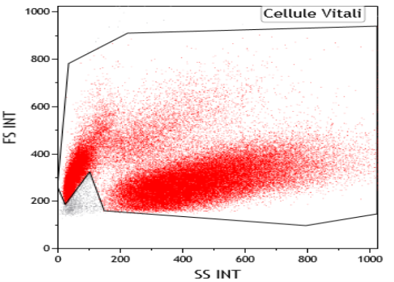
Lymphocyte gate (CD45 versus SSC). Lymphocytes are identified by bright CD45 expression and low side scatter, reflecting low internal complexity; this separates them from other circulating cells.
Total T cells (CD3+ lymphocytes).
Major T-cell subsets (CD3+CD4+ cells).
Major T-cell subsets (CD3+CD8+ cells).
B cells (CD19+CD20+ lymphocytes). Plot shows a patient with a detectable circulating B-cell population.
B cells: CD19+CD20+ lymphocytes. Plot shows treatment-associated peripheral B-cell depletion in a patient receiving ofatumumab therapy.
NK cells (CD56+CD3− lymphocytes).
CD27+CD45+ lymphocytes. This gate measures total CD27-expressing leukocytes within the lymphocyte region.
CD27+CD3+ cells. CD27 is found on naïve and central-memory T cells and on other subsets.
CD27+CD19+ B cells. Plot shows detectable CD19+ B cells, including a CD27-expressing B-cell fraction.
CD27+CD19+ B cells. Plot shows treatment-associated peripheral CD27+CD19+ cell depletion in a patient receiving ofatumumab therapy.

Figure 1. Box-and-whisker plots of peripheral lymphocyte subsets at baseline and during treatment with ofatumumab. Box-and-whisker plots represent distribution of different laboratory variables at baseline and follow-up. Statistical estimates are derived from mixed-effects models.

