DELPHI expert consensus-derived factors influencing the early use of monoclonal high-efficacy therapies in treatment-naïve patients with relapsing-remitting multiple sclerosis
Journal : Journal of Neurology
Bertrand Bourre¹, Olivier Guerrier², Xavier Ayrignac³, Laurent Suchet⁴, Jérôme de Seze⁵, Ines Masmoudi⁶, Vito AG Ricigliano⁷, Patrick Vermersch⁸, Jonathan Ciron⁹ on behalf of the CAReSEP working group.
¹ CHU Rouen, Department of Neurology and Inserm CIC-CRB 1404, F-76000, Rouen, France
² Department of Neurology and Neurovascular Unit, Valence Hospital, Valence, France
³ Univ Montpellier, INM, INSERM, Département de Neurologie, CRC sclérose en plaques, CRMR LEUKOFRANCE & Centre d’investigation clinique U1411, CHU de Montpellier, Montpellier, France
⁴ Department of Neurology, European Hospital of Marseille, Marseille, France
⁵ Department of Neurology and Clinical Investigation Center, Strasbourg University Hospital, Strasbourg, France
⁶ Department of Neurology, Amiens University Hospital, Amiens, France
⁷ Neurology Unit, GHNE Paris Saclay Hospital, Orsay, France; Université Paris-Saclay, UNIACT, Neurospin – INSERM UMR 1129, CEA, Gif-sur-Yvette, France
⁸ University of Lille, INSERM U1172 LilNCog, Lille University Hospital, FHU Precise, Lille, France
⁹ Department of Neurology, CRC-SEP, Toulouse University Hospital, Toulouse, France; INSERM UMR1291 – CNRS UMR5051, INFINITY, University Toulouse III, Toulouse, France

Corresponding author:
Jonathan Ciron
ciron.j@chu-toulouse.fr

Online Resource 1 MRI scans used to classify low, moderate and high brain lesion load in the Delphi study to explore expert consensus & identify key factors driving the initiation of monoclonal high-efficacy therapies among treatment-naive relapsing-remitting multiple sclerosis patients, France
Low brain lesion load (<10 lesions) |  |  |  |  |  |  |  | Moderate brain lesion load (10-20 lesions) |  |  |  |  |  |  |  |  |  | High brain lesion load (>20 lesions)
Example 1 |  |  |  |  |  |  |  | Example 1 |  |  |  |  |  |  |  |  |  | Example 1
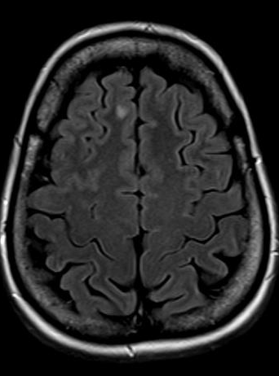 |  | 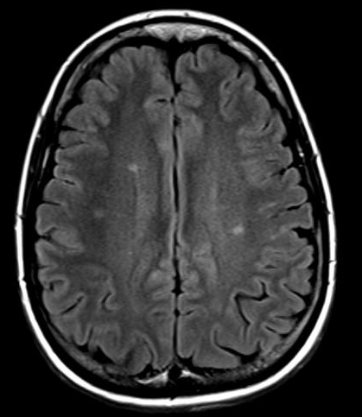 |  | 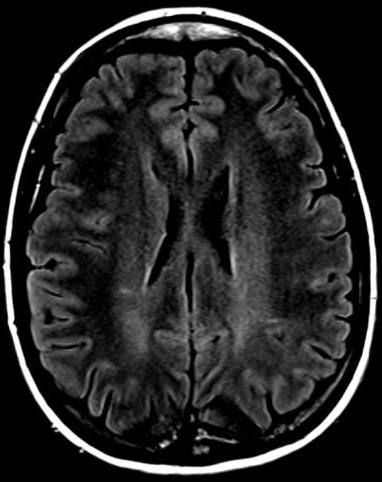 |  | 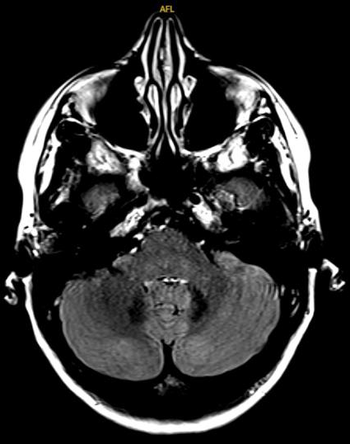 |  | 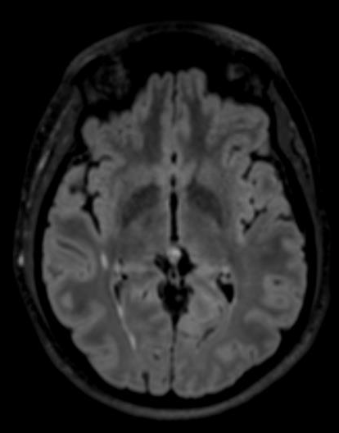 |  |  |  |  | 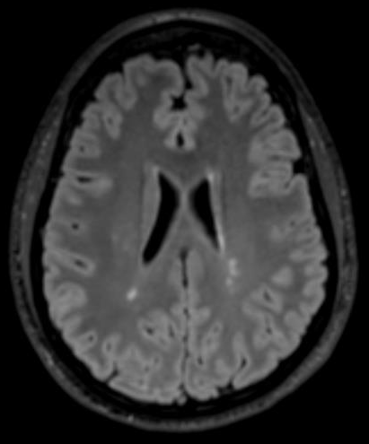 |  |  | 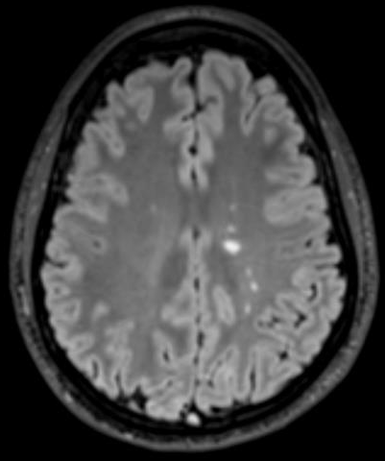 |  | 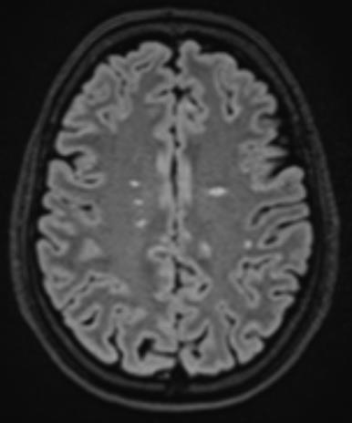 | 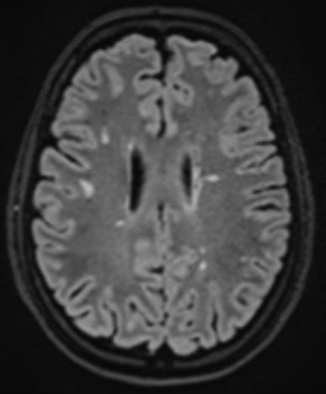 |  |  | 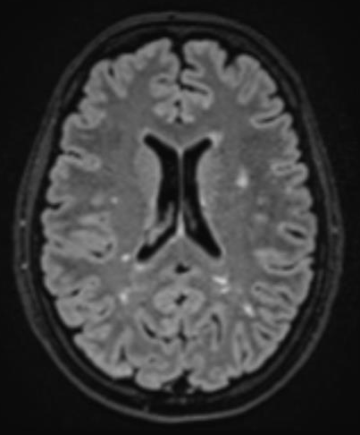 |  |  | 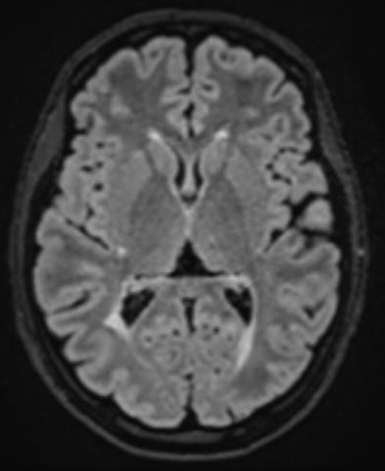
Exemple 2 |  |  |  |  |  |  |  | Exemple 2 |  |  |  |  |  |  |  |  |  | Exemple 2
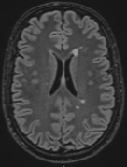 |  |  |  | 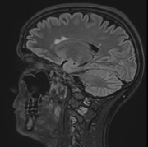 |  |  |  | 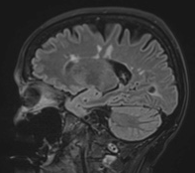 |  |  | 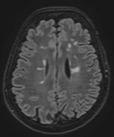 |  |  |  | 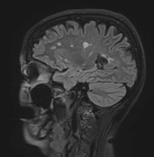 |  |  | 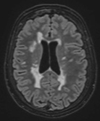 | 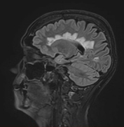 |  |  | 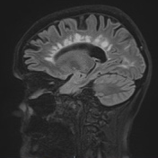 |  |  | 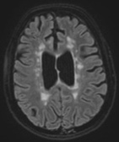
Exemple 3 |  |  |  |  |  |  |  | Exemple 3 |  |  |  |  |  |  |  |  |  | Exemple 3
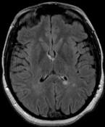 |  |  |  |  |  |  |  | 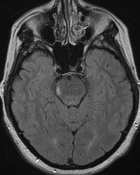 |  | 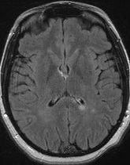 |  |  | 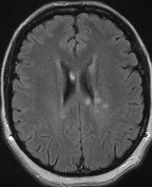 |  |  | 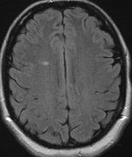 |  | 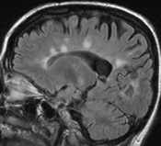 |  |  | 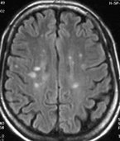 |  |  | 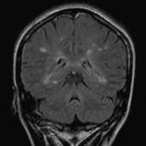
Exemple 4 |  |  |  |  |  |  |  | Exemple 4 |  |  |  |  |  |  |  |  |  | Exemple 4
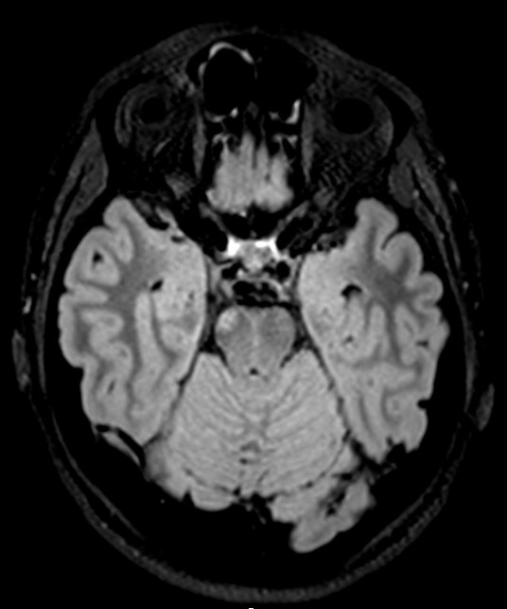 | 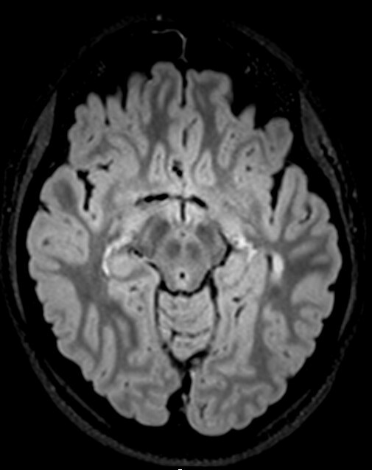 |  | 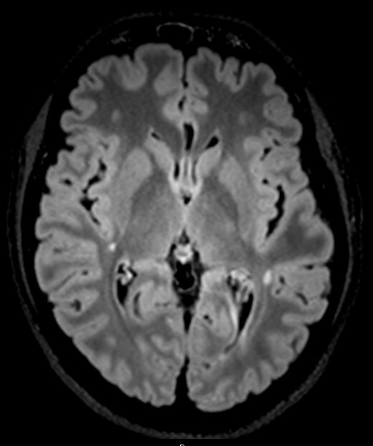 |  |  |  | 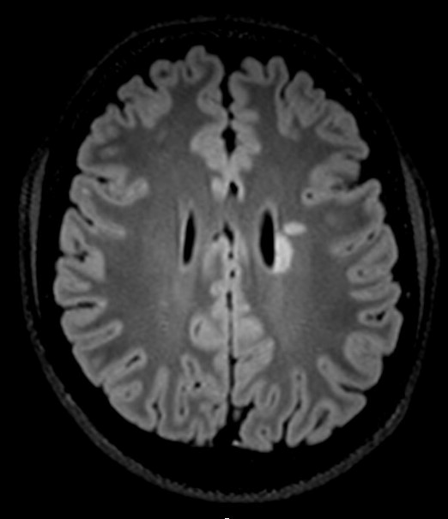 | 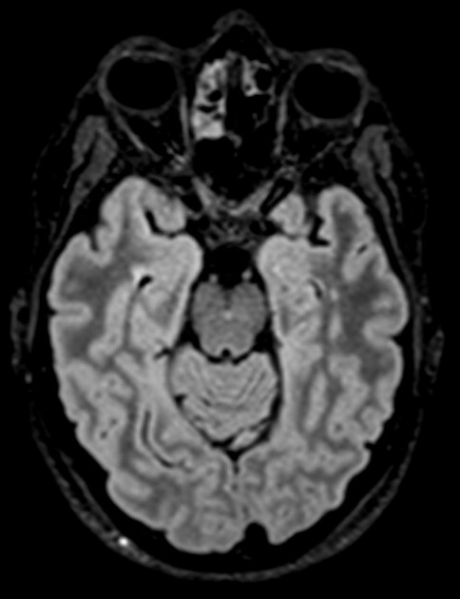 | 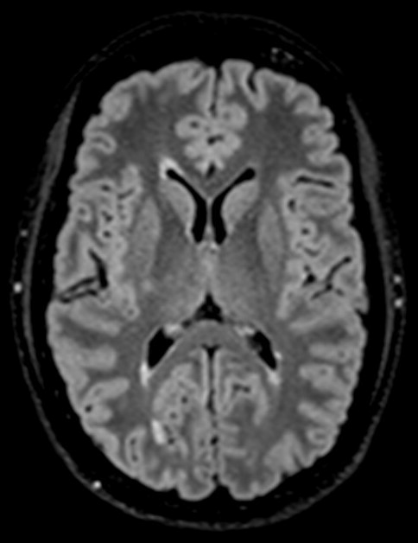 |  |  | 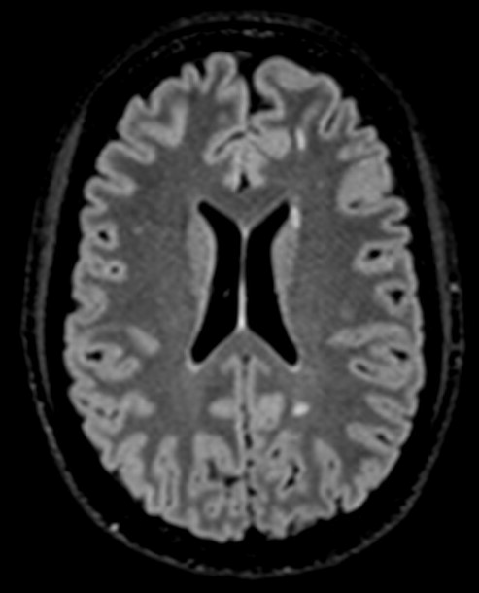 |  | 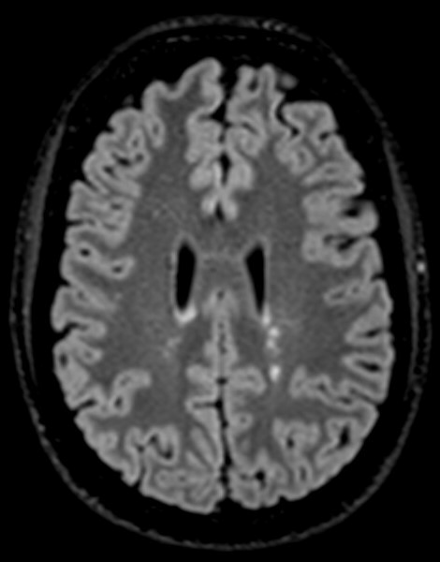 |  |  | 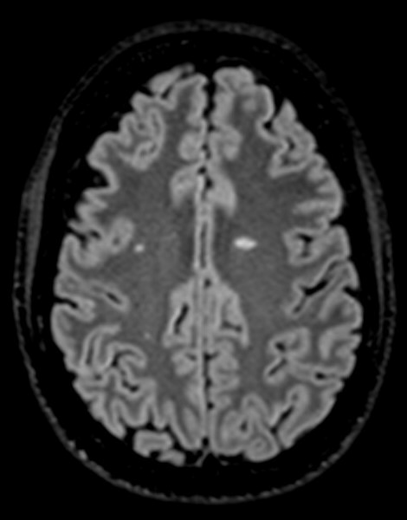 | 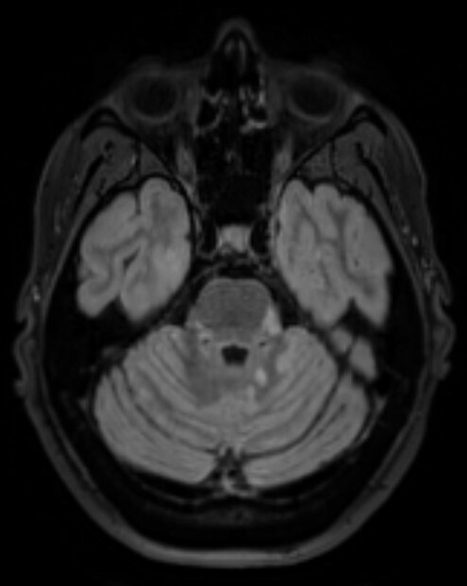 |  | 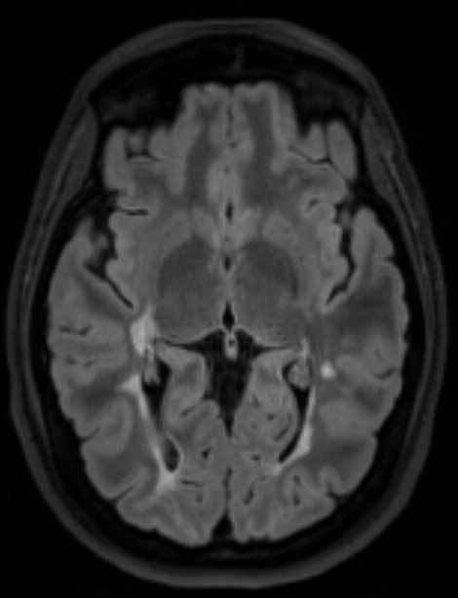 |  |  | 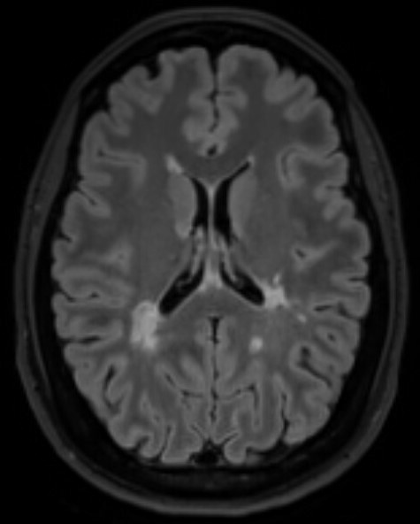 |  |  | 