Long-term intraocular pressure-lowering efficacy and safety of ripasudil-brimonidine fixed-dose combination for glaucoma and ocular hypertension: a multicentre, open-label, phase 3 study
Graefe's Archive for Clinical and Experimental Ophthalmology
Online Resource 1
Authors: Hidenobu Tanihara, Tetsuya Yamamoto, Makoto Aihara, Noriko Koizumi, Atsuki Fukushima, Koji Kawakita, Satoshi Kojima, Toka Nakamura, Hideki Suganami, K-232 Clinical Study Group*
*K-232 Clinical Study Group members are listed in Appendix 1
Corresponding author: Hidenobu Tanihara
Department of Ophthalmology, Biei Municipal Hospital
3-8-35 Naka-machi, Biei Town, Kamikawa-gun, Hokkaido 071-0207, Japan
Email: tanihara@pearl.ocn.ne.jp

Supplementary Table S1 Study inclusion and exclusion criteria
Inclusion criteria
- Patients with POAG, OHT, EXG or pigmentary glaucoma
- Aged ≥ 20 years at the time of providing consent
- IOP at 9:00 on day 1 of the treatment periodª met the following conditions:
  - IOP ≥ 15 mmHg in one eye diagnosed with POAG, OHT, EXG or pigmentary glaucoma
  - IOP < 35 mmHg in both eyes
Exclusion criteria
- Patients who have difficulty measuring the IOP with a Goldmann applanation tonometer
- Patients with narrow angle closure in either eye (Shaffer classification grade 0–2) at the start of the screening period
- BCVA 20/70 or worse in either eye at the start of the screening and treatment periods
- Patients with severe visual field impairment in either eye and judged by the investigator to be unsuitable for study participation
- Patients with retinal disease that may cause worsening of symptoms in any eye during the study
- Previous ophthalmic surgery or laser treatment in any eye before the start of the screening period, except for:
  - Retinal photocoagulation or YAG laser posterior capsulotomy ≥ 90 days before the start of the screening period
  - Surgery on the eyelid ≥ 120 days before the start of the screening period
  - Cataract surgery ≥ 1 year before the start of the screening period
- Patients for whom the following prohibited use or treatments is planned during the screening and treatment periods:
  - Use of drugs to treat glaucoma or ocular hypertension (except for permitted concomitant agents specified for each cohort)
  - Any ophthalmic surgery or laser treatment
  - Use of contact lenses
- Patients who have received intravitreal, Tenon's capsule or subconjunctival steroids in any eye ≤ 180 days before the start of the treatment period
- Patients with contraindications to concomitant agent(s) specified for their assigned cohort
- Patients with circulatory insufficiency such as cerebrovascular disorder, orthostatic hypotension or cardiovascular disease, and judged unsuitable to participate by the investigator
- Patients with a history of hypersensitivity to ingredients of ripasudil 0.4% or brimonidine 0.1% ophthalmic solutions
- Patients with a history of shock or anaphylaxis as drug hypersensitivity
- Patients who are pregnant, lactating or currently seeking pregnancy
- Patients who have participated in another clinical study or clinical study ≤ 30 days before the start of the screening period, or who participate in another trial at the same time as the present study
- Patients who have previously received RBFC eye drops at any time
- Patients deemed otherwise unsuitable for study participation by the investigator

BCVA Best-corrected visual acuity, EXG Exfoliative glaucoma, IOP Intraocular pressure, OHT Ocular hypertension, POAG Primary open-angle glaucoma, RBFC Ripasudil-brimonidine fixed-dose combination, YAG Yttrium aluminium garnet.
ªIOP used to determine eligibility was measured before the initiation of RBFC and based on the median of 2–3 readings for each eye.

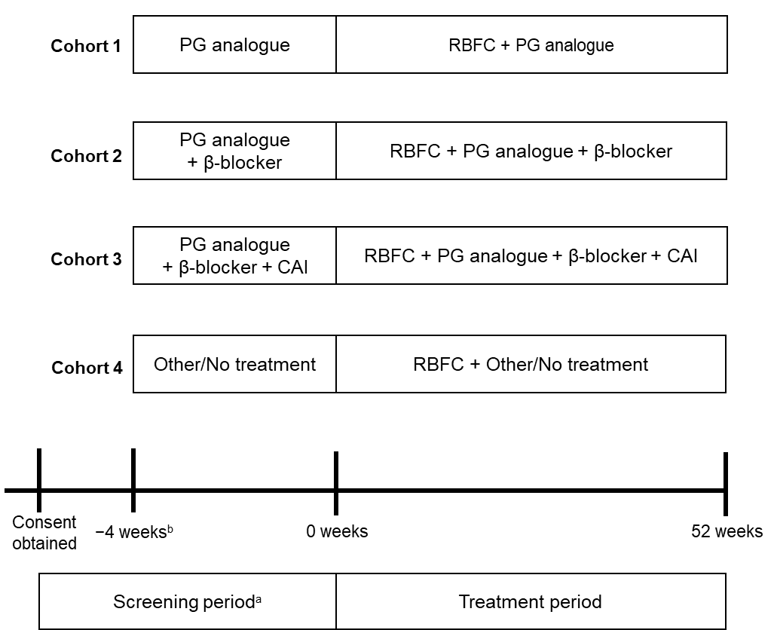
Supplementary Fig. S1 Study design
β-blocker Beta-adrenoceptor blocker, CAI Carbonic anhydrase inhibitor, PG Prostaglandin, RBFC Ripasudil-brimonidine fixed-dose combination
ªDuring the screening period, patients in all cohorts could receive ripasudil 0.4% or brimonidine 0.1% per the investigator’s discretion; these agents were to be administered for ≥ 4 weeks, up to a maximum of 6 weeks
^{b}In Cohorts 1–3, the duration of the screening period was ≥ 4 weeks, up to a maximum of 6 weeks. For patients in Cohort 4 who did not receive any combination therapy, including ripasudil 0.4% or brimonidine 0.1%, during the screening period, the treatment period could start ≥ 1 day after the start of the screening period, provided that any applicable washout criteria were met
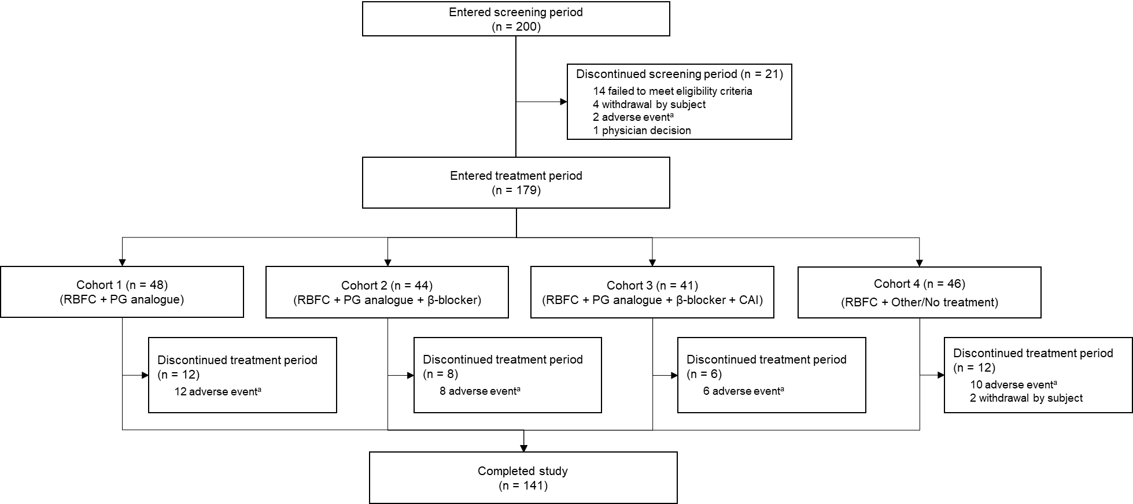
Supplementary Fig. S2 Patient flow diagram
β-blocker Beta-adrenoceptor blocker, CAI Carbonic anhydrase inhibitor, PG Prostaglandin, RBFC Ripasudil-brimonidine fixed-dose combination

