Supplemental File
Table S1: CME treatments and optical coherence tomography at most recent visit; years of follow-up prior to recent visit and progression within that time.
ID | Eye | CME | Fovea-involving | Epiretinal membrane | Foveal EZ integrity | Perifoveal EZ integrity | Current CME treatment | Previous CME treatments | Years of OCT follow-up | Progression
P1 | OD | Yes | Yes | No | Indiscernible | Continuous | Brinzolamide  1 drop 2x/day | None | 10 | Yes, loss of foveal EZ integrity
P1 | OS | Yes | Yes | No | Indiscernible | Continuous
P2 | OD | No | NA | No | Indiscernible | Indiscernible | None | Unknown | 6 | No
P2 | OS | No | NA | Yes | Indiscernible | Indiscernible
P3 | OD | Yes | Yes | Yes | Indiscernible | Indiscernible | None | Acetazolamide 125 mg 2x/day  Octreotide 30 mg 1x/4 weeks  Dorzolamide 1 drop 3x/day | NA* | NA
P3 | OS | Yes | Yes | Yes | Indiscernible | Indiscernible
P4 | OD | Yes | No | No | Continuous | Continuous | Dorzolamide  1 drop 3x/day | Brinzolamide 1 drop 2x/day | 5 | Yes, development of epiretinal membrane OS
P4 | OS | Yes | No | Yes | Continuous | Continuous
P5 | OD | No | NA | No | Continuous | Continuous | None | Brinzolamide  1 drop 3x/day | 3 | Yes, recurrence of CME ODS
P5 | OS | Yes | Yes | no | Discontinuous | Continuous
P6 | OD | No | NA | No | Continuous | Continuous | None | None | NA | NA
P6 | OS | No | NA | No | Continuous | Continuous
P7 | OD | No | No | No | Indiscernible | Indiscernible | None | Brinzolamide 1 drop 2x/day  Timolol/latanoprost 1 drop 1x/day | 5 | No
P7 | OS | Yes | Yes | No | Indiscernible | Indiscernible
P8 | OD | Yes | Yes | No | Indiscernible | Indiscernible | Acetazolamide  125 mg 2x/day | Acetazolamide 250 mg 2x/day  Acetazolamide 250 mg 1x/day | NA | NA
P8 | OS | Yes | Yes | No | Indiscernible | Indiscernible
P9 | OD | Yes | No | No | Continuous | Continuous | None | Acetazolamide | NA | NA
P9 | OS | Yes | Yes | No | Continuous | Continuous
P10 | OD | Yes | No | No | Continuous | Continuous | None | None | NA | NA
P10 | OS | Yes | Yes | No | Continuous | Continuous
P11 | OD | Yes | No | Yes | Discontinuous | Discontinuous | Acetazolamide  125 mg 2x/day | Acetazolamide 250 mg 2x/day  Octreotide 20 mg 1x/4 weeks  Vitrectomy ODS | 7 | Yes, loss of (peri)foveal EZ integrity, remission and recurrence of CME
P11 | OS | Yes | Yes | Yes | Discontinuous | Discontinuous
P12 | OD | No | NA | No | Discontinuous | Discontinuous | None | None | NA | NA
P12 | OS | No | NA | No | Discontinuous | Discontinuous
P13 | OD | No | NA | No | Continuous | Continuous | None | None | NA | NA
P13 | OS | No | NA | No | Continuous | Continuous
P14 | OD | Yes | Yes | No | Discontinuous | Discontinuous | Dorzolamide/timolol  1 drop 2x/day | Acetazolamide 250 mg 2x/day  Dorzolamide 1 drop 2x/day  Brimonidine 1 drop 2x/day | 7 | Yes, loss of (peri)foveal EZ integrity
P14 | OS | Yes | Yes | No | Discontinuous | Discontinuous
P15 | OD | Yes | Yes | No | Discontinuous | Discontinuous | None | None | NA | NA
P15 | OS | No | NA | No | Continuous | Continuous
P16 | OD | Yes | No | No | Continuous | Continuous | None | None | NA | NA
P16 | OS | No | NA | No | Continuous | Continuous
P17 | OD | No | NA | No | Discontinuous | Discontinuous | None | None | 12 | Yes, loss of (peri)foveal EZ integrity OD
P17 | OS | No | NA | No | Indiscernible | Indiscernible
P18 | OD | Yes | Yes | No | Indiscernible | Indiscernible | None | None | 2 | No
P18 | OS | Yes | Yes | No | Discontinuous | Discontinuous
P19 | OD | No | NA | No | Indiscernible | Indiscernible | None | None | 6 | No
P19 | OS | No | NA | No | Indiscernible | Indiscernible
*OCT imaging was excluded from analyses due to the presence of posterior uveitis ODS.

Table S2: Pathogenic variants identified including ACMG classifications and novelty of variants
Variant | ACMG classification | Reported previously*
c.1A>G; p.(1M) | Class 4 (likely pathogenic) | Yes
c.1058G>A; p.(Gly353Asp) | Class 5 (pathogenic) | Yes
c.1276C>T; p.(Arg426Ter) | Class 5 (pathogenic) | Yes
c.460C>T; p.(Arg154Cys) | Class 3 (uncertain significance) | Yes
c.539G>C; p.(Arg180Thr) | Class 4/5 (likely pathogenic/pathogenic) | Yes
c.1034T>C; p.(Leu345Pro) | Class 4 (likely pathogenic) | No
c.1112dup; p.(Arg372Lysfs*12) | Class 4 (likely pathogenic) | Yes
c.1172delT; p.(Trp391Glyfs*29) | Class 4/5 (likely pathogenic/pathogenic) | Yes
c.1235T>C; p.(Ile412Thr) | Class 4 (likely pathogenic) | No
c.1173G>A; p.(Trp391Ter) | Class 4/5 (likely pathogenic/pathogenic) | Yes
c.1192C>T; p.(Arg398*) | Class 5 (pathogenic) | Yes
*Reported in the GnomAD database.

Figure S1: Optical coherence tomography (OCT) of several different patients with GACR depicting the ellipsoid zone (EZ) as continuous, discontinuous, or indiscernible.
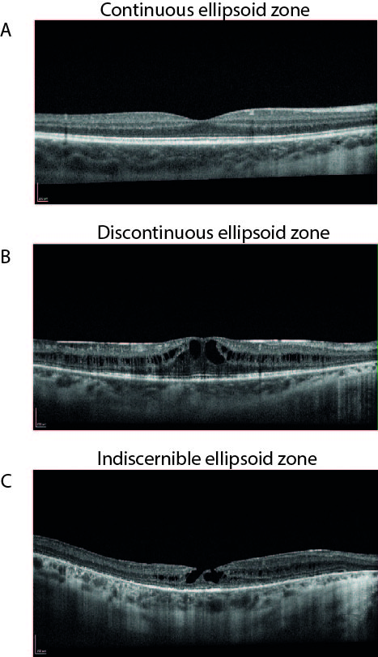
A) OCT of an 11-year-old patient with GACR with a continuous EZ. B) OCT of a 28-year-old patient with GACR with a discontinuous (foveal) EZ. C) OCT of a 49-year-old patient with GACR with an indiscernible EZ.

