Supplementary Material 3

Figure 1: Risk of bias of the risk of bias in the case report and series included using the Hassan Murad tool
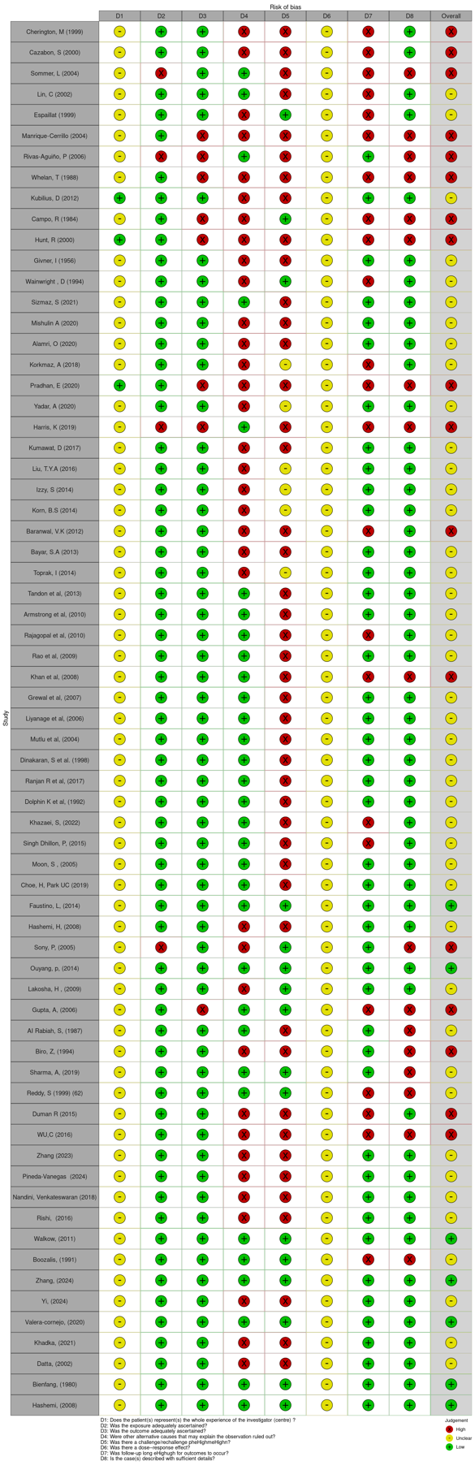
Figure 2: Risk of bias of the risk of bias in the cross-sectional study included using the Hoy et al. tool.

