Cataract Surgery in Eyes with Adult-Onset Foveomacular-Vitelliform Dystrophy (Unilateral Sub-group Analysis; Supplementary material)

Or Shmueli, MD (1), Tomer Batash, MD (1), Itay Nitzan, MD (1), Itay Chowers, MD (1), Liran Tiosano, MD (1)

Correspondence:
Or Shmueli, MD, Ophthalmology Department, Hadassah Medical Center, Faculty of Medicine, Hebrew University, Jerusalem 91120, POB 12000, Israel.
Tel.: ‏+972547631035.
E-mail address: Orchuk86@gmail.com

Table S1. Baseline Patients Characteristics for Unilateral Sub-group Analysis
NVAMD | None-Neovascular AMD | AVFD | Group
29 | 21 | 11 | Number of eyes
1M= 100%  3M= 100%  6M= 100%  12M= 96.5%  Last Follow-up= 100% | 1M= 100%  3M= 57.1%  6M= 47.6%  12M= 47.6%  Last Follow-up= 71.4% | 1M= 100%  3M= 81.8%  6M= 81.8%  12M= 72.7%  Last Follow-up= 54.5% | Follow up rate (months and percent of eyes):
78.6±7.4 (79; 59-90) | 77.9±10.0 (79; 61-92) | 78.4±5.7 (78; 70-87) | Age (years)
58.6%/41.4% | 61.9%/38.1% | 36.4%/63.6% | Males/Females (%)
- | - | Vitelliform=7 (63.6%)  Pseudohypopyon=3 (27.2%)  Vitellieruptive=1 (9.1%)  Atrophic=0 (0%) | AVFD stage (%)
1.14±0.60 (0.9; 0.4-2.3)* | 0.59±0.49 (0.49; 0.05-1.95) | 0.64±0.40 (0.5; 0.30-1.60) | Baseline VA

Continuous variables are presented by Mean±standard deviation (median; minimum-maximum values).
AVFD=Adult vitelliform foveal dystrophy; AMD= Age related macular degeneration; NVAMD= Neovascular AMD; VA= Visual acuity, reported as LogMAR of best-corrected visual acuity; *P<0.05

Table 2S: Demographic characteristics, laterality, visual acuity, and disease stage before and following cataract surgery in AFVD for unilateral cases
AFVD Stage at Last Follow-up | AFVD Stage 12 Months  Post-Op | AFVD Stage Pre-Op | BCVA LogMAR at Last Follow-up | BCVA LogMAR 12 Months  Post-Op | BCVA LogMAR 1 Month  Post-Op | BCVA LogMAR Pre-Op | Follow- up (Months) | Laterality | Gender | Age at Surgery (years) | Patient no.
atrophic | atrophic | Vittelieruptive | 0.4 | 0.3 | 0.3 | 0.3 | 24 | RE | M | 78 | 1
Vitteliform | Vitteliform | Vitteliform | 0.3 | 0.3 | 0.3 | 0.5 | 34 | RE | M | 80 | 2
NA | NA | Vitteliform | NA | NA | 0.3 | 1.6 | 1 | RE | F | 87 | 3
NA | Vitteliform | Vitteliform | 0.3 | 0.3 | 0.3 | 1 | 76 | RE | F | 74 | 4
NA | Vitteliform | Vitteliform | NA | NA | 0 | 0.7 | 1 | RE | M | 79 | 5
NA | Vitteliform | Vitteliform | NA | 0.16 | 0.16 | 0.3 | 12 | LE | F | 85 | 6
NA | Pseudohypopion | Pseudohypopion | 0.4 | 0.1 | 0.1 | 0.48 | 130 | RE | F | 71 | 7
NA | Vitteliform | Vitteliform | 0.4 | 0.3 | 0.4 | 0.5 | 18 | RE | M | 86 | 8
atrophic | Vittelieruptive | Pseudohypopion | 1 | 0.4 | 0.16 | 0.4 | 36 | RE | F | 75 | 9
Vitteliform | NA | Vitteliform | NA | 0.2 | 0.2 | 1 | 3 | RE | F | 78 | 10
Pseudohypopion | Pseudohypopion | Pseudohypopion | NA | NA | 0.3 | 0.3 | 9 | RE | F | 70 | 11

M: male, F: female, LE: left eye, RE: right eye, NA: not available, AFVD: Adult Foveal Vitteliform Dystrophy

Figure S3. Visual acuity changes following cataract surgery in AFVD (N=11), None-NV AMD (N=21), and NVAMD (N=29) patients
(one eye per patient).

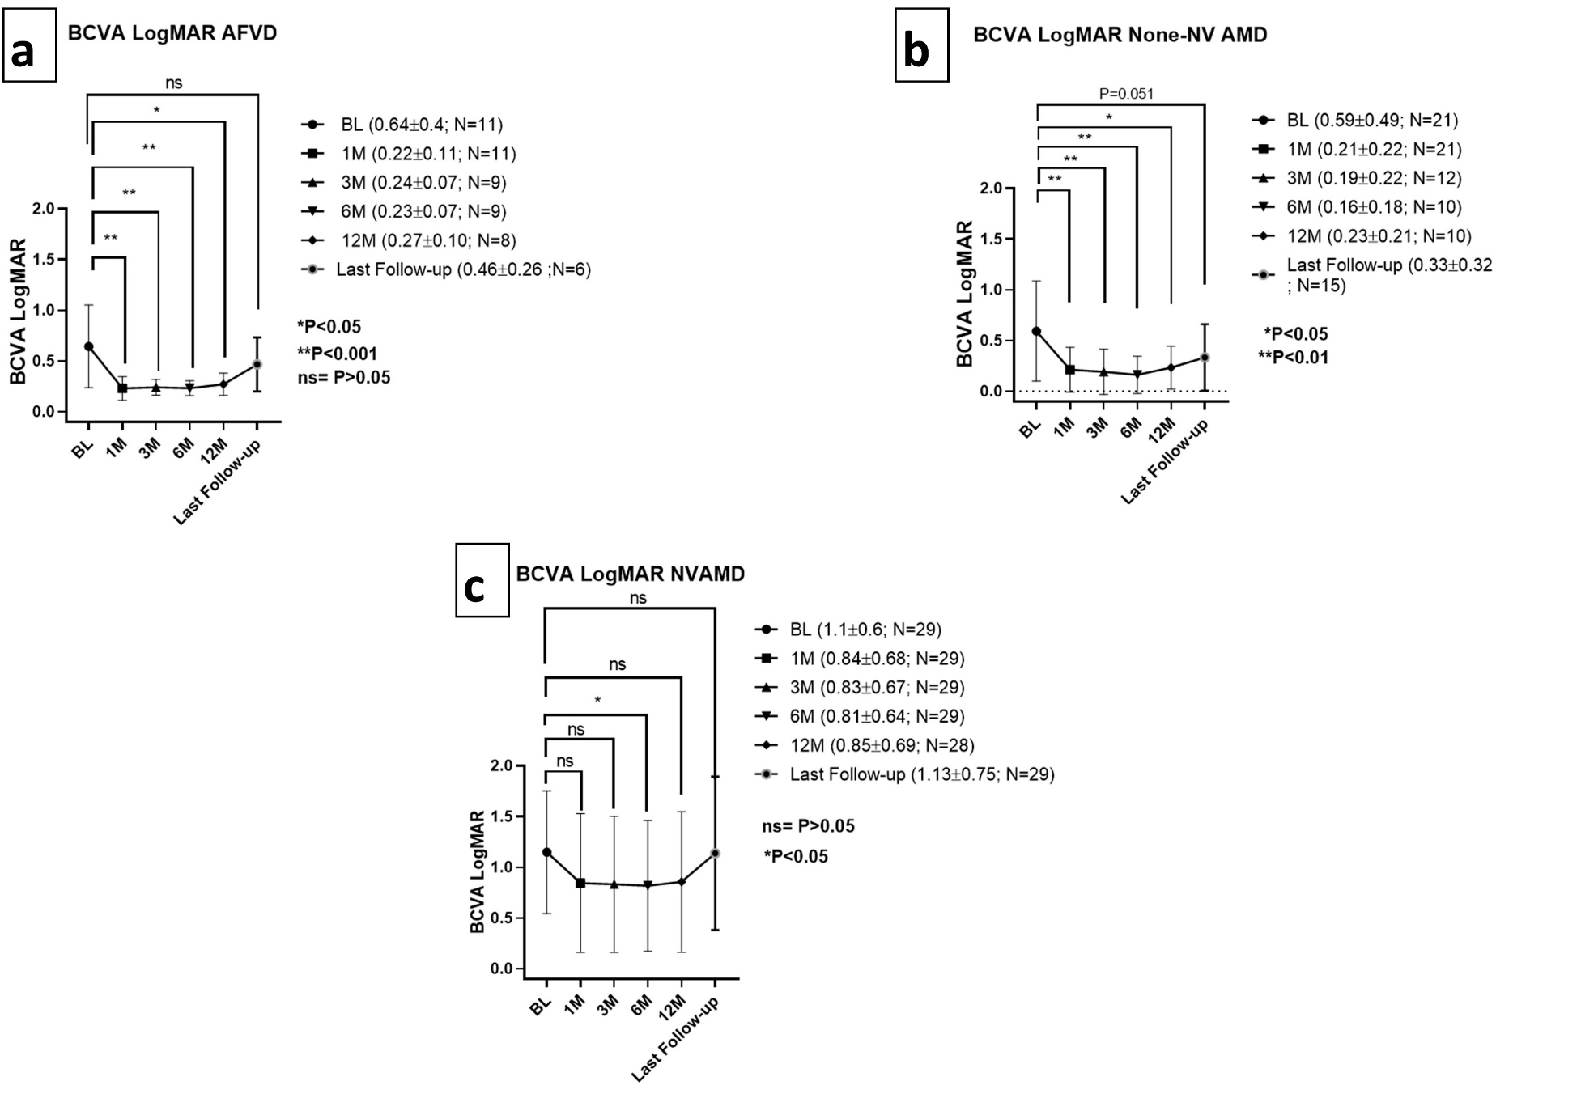
N=number of eyes; M=months following surgery; BCVA LogMAR= LogMAR of best-corrected visual acuity; AFVD =Adult foveo-macular vitelliform dystrophy; AMD= Age related macular degeneration; None-NV AMD= None-neovascular age related macular degeneration; NVAMD= Neovascular age related macular degeneration *P-value<0.05; **P-value<0.01; ns=non-significant

Figure S4. Comparison of visual acuity improvement 1 month, 12 months and at last extended follow-up post-cataract surgery in the different study groups (one eye per patient).
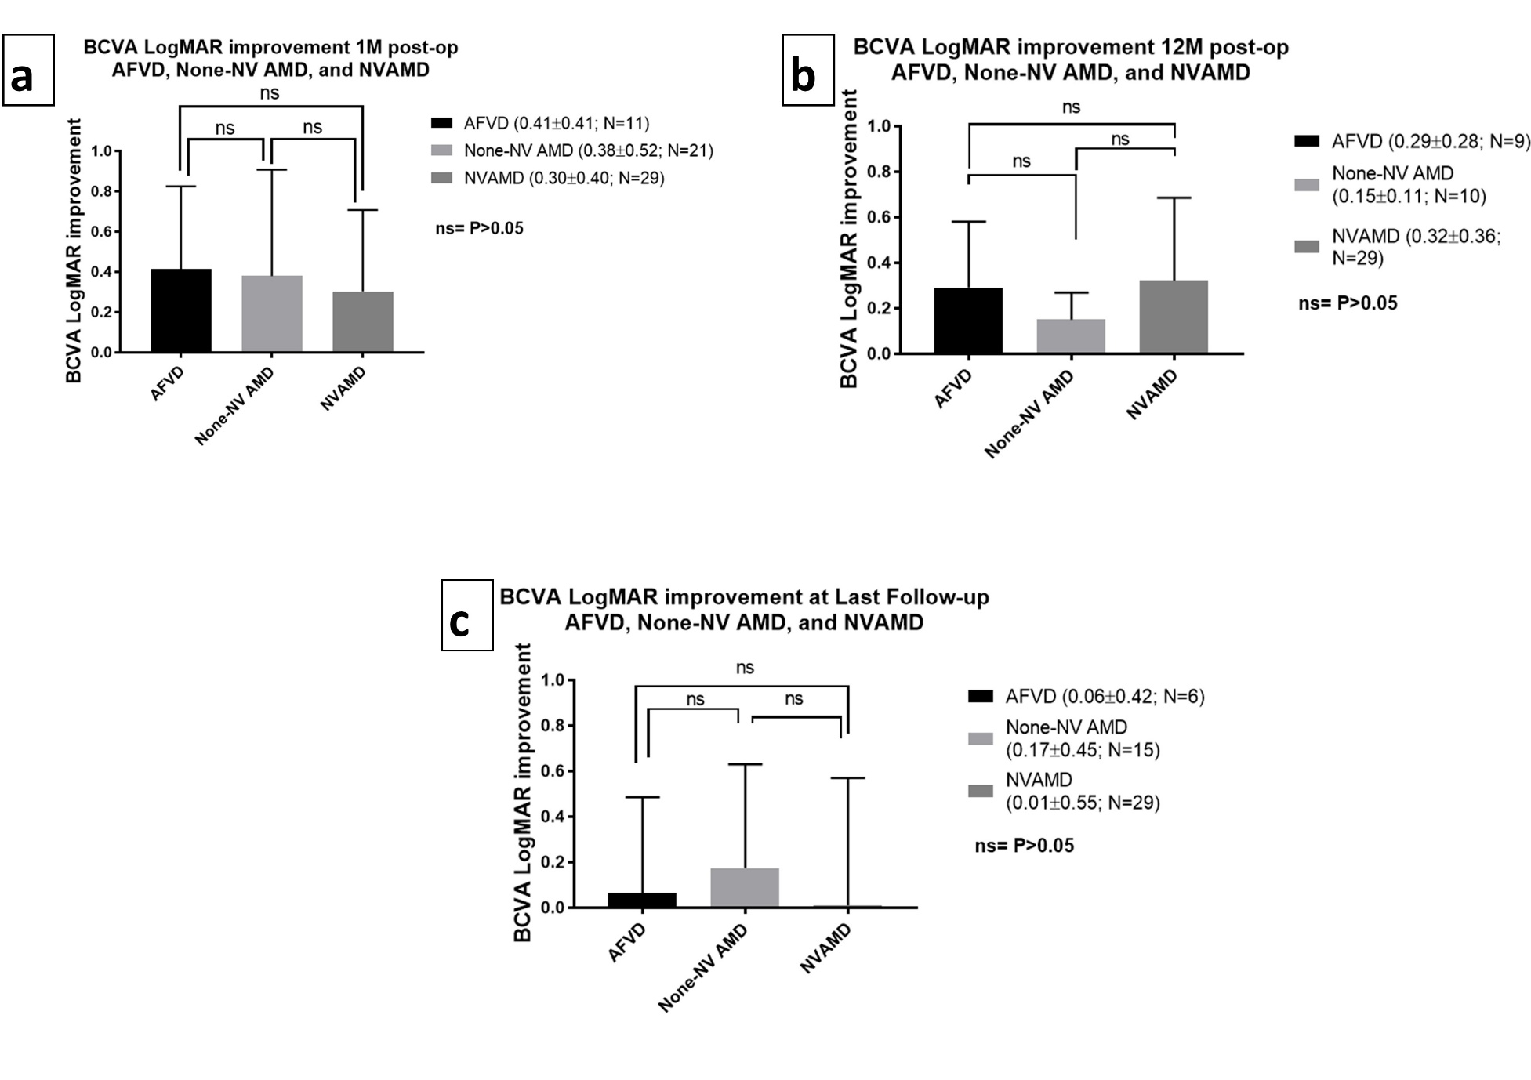
N=number of eyes; M=months following surgery; BCVA LogMAR= LogMAR of best-corrected visual acuity; AFVD =Adult foveo-macular vitelliform dystrophy; AMD= Age related macular degeneration; None-NV AMD= None-neovascular age related macular degeneration; NVAMD= Neovascular age related macular degeneration; ns=non-significant

Figure S5. Comparison of AVFD stage before, 12 months and at last extended follow-up post-cataract surgery (one eye per patient).

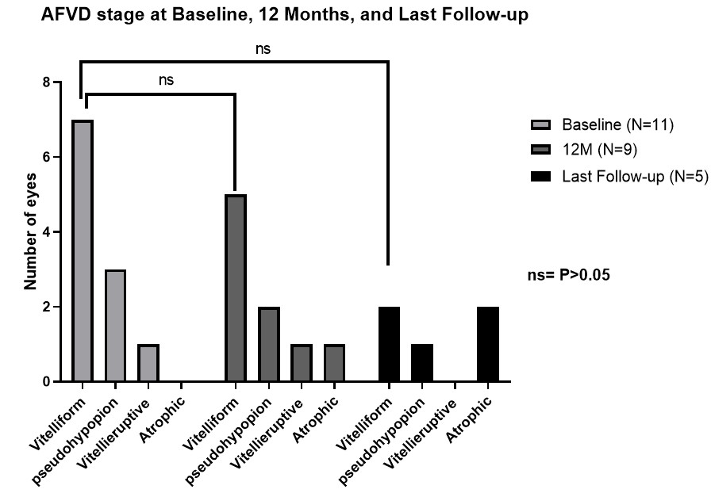

N=number of eyes; M=months following surgery; AFVD =Adult foveo-macular vitelliform dystrophy

