Longitudinal Trends of Linear Mixed-Effects Models (LMEM)

Outcome | Time (Pap) | p | Time×Uveitic | p | ICC | cond.R²
GCL+IPL Vol (Mac) | −9.19 | 0.007** | −15.48 | 0.002** | 0.80 | 0.84
RNFL Vol (Mac) | −13.71 | <0.001*** | −15.06 | 0.007** | 0.65 | —
RNFL Vol (ONH) | −128.0 | <0.001*** | −13.9 | 0.621 | 0.47 | 0.61
Visual Acuity (logMAR) | −0.005 | 0.302 | −0.002 | 0.788 | 0.44 | 0.49

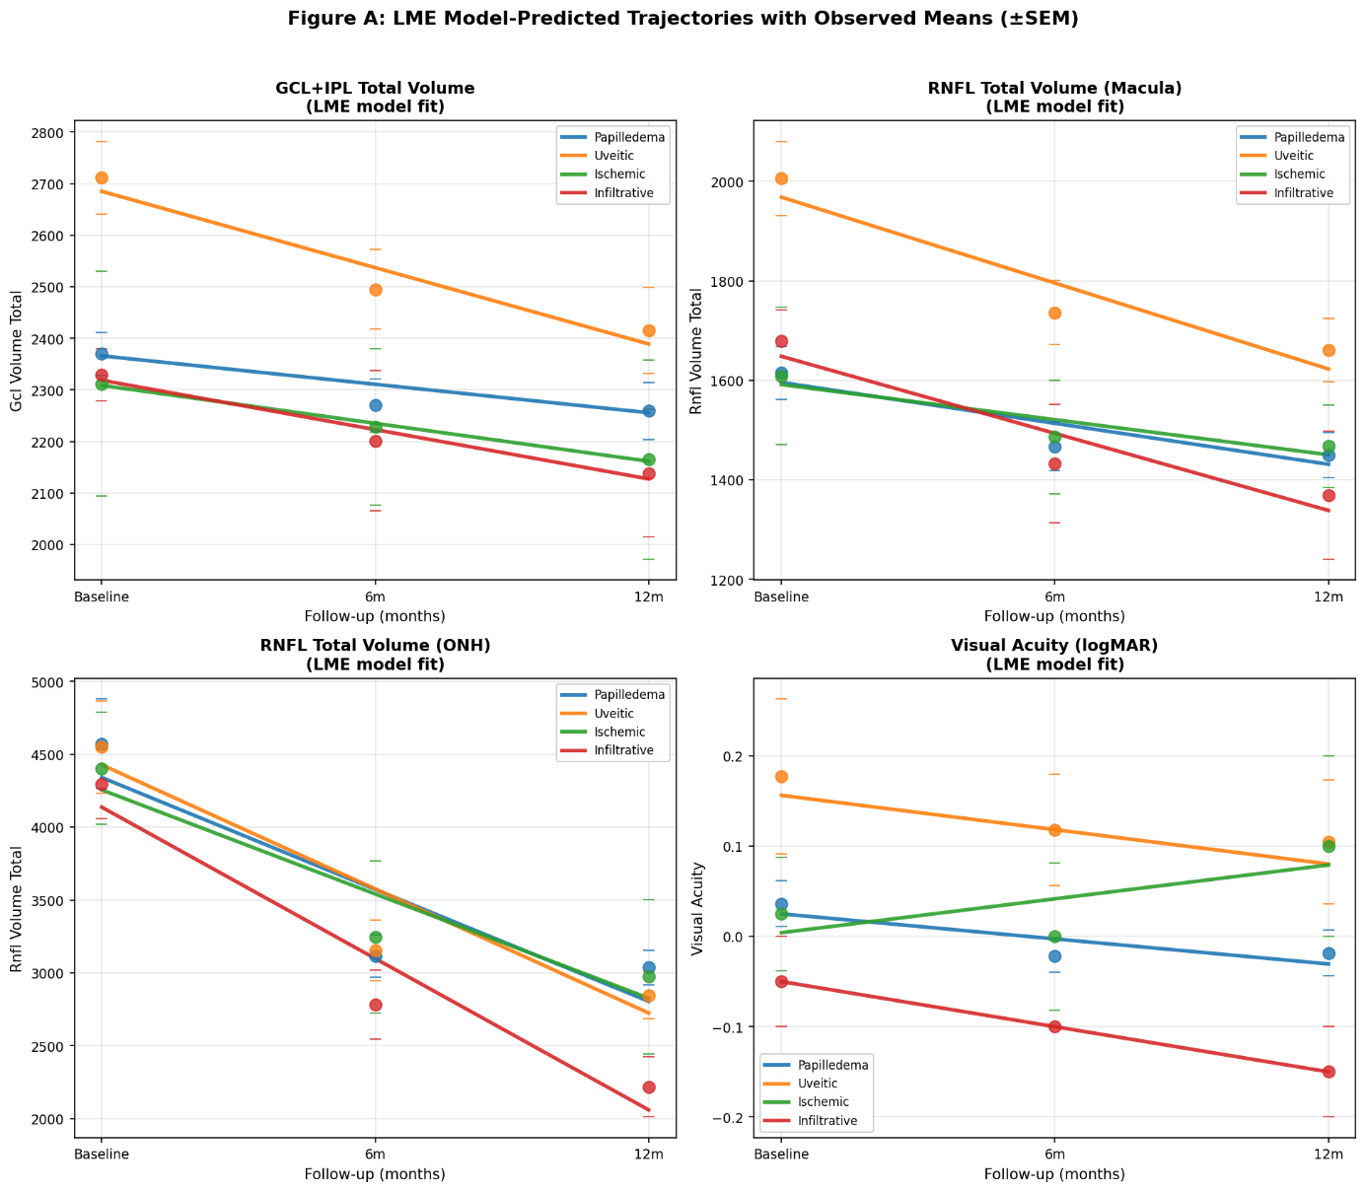

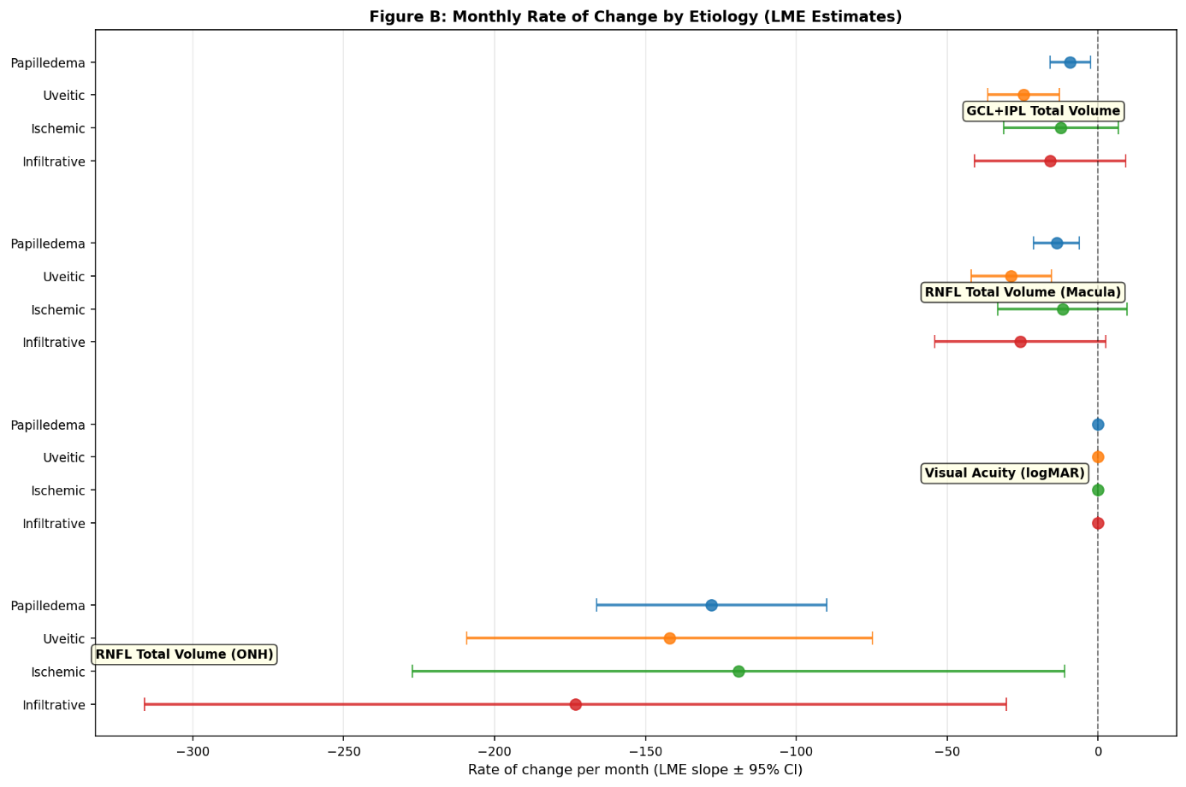

GCL+IPL Total Volume - Full Model

N=156 obs, 32 patients. ICC=0.80, marginal R²=0.18, conditional R²=0.84.
Parameter | Coef | SE | z | p
Intercept | 2366.08 | 82.84 | 28.56 | <0.001***
Time (months) | −9.19 | 3.42 | −2.69 | 0.007**
Uveitic | 319.00 | 115.62 | 2.76 | 0.006**
Ischemic | −57.31 | 176.18 | −0.33 | 0.745
Infiltrative | −47.34 | 308.48 | −0.15 | 0.878
Time × Uveitic | −15.48 | 4.94 | −3.13 | 0.002**
Time × Ischemic | −3.07 | 9.04 | −0.34 | 0.734
Time × Infiltrative | −6.75 | 12.32 | −0.55 | 0.584
The papilloedema group lost an estimated 9.2 units/month (p=0.007). The uveitic disc oedema group lost an additional 15.5 units/month beyond this rate (p=0.002), for a total decline of ~24.7 units/month — roughly 2.7× the papilledema rate. The high ICC (0.80) confirms that between-patient variation dominates, validating the random-effects approach.

Sectoral GCL+IPL Analysis

Sector | Time-Pap (p) | Time×Uveitic (p) | ICC | cond.R²
GCL+IPL BG | −0.19 (0.005**) | −0.34 (<0.001***) | 0.72 | 0.76
GCL+IPL S3 | −0.30 (0.079) | −0.76 (0.002**) | 0.74 | 0.77
GCL+IPL N3 | −0.22 (0.227) | −0.98 (<0.001***) | 0.78 | 0.81
GCL+IPL I3 | −0.30 (0.128) | −0.86 (0.002**) | 0.65 | 0.70
GCL+IPL T3 | −0.23 (0.199) | −0.91 (<0.001***) | 0.71 | 0.74
GCL+IPL C1 | −0.11 (0.317) | −0.52 (<0.001***) | 0.88 | 0.88
The Time × Uveitic interaction was significant across all six GCL+IPL sectors analyzed (all p≤0.002), indicating diffuse (not localized) accelerated ganglion cell loss in uveitic optic neuropathy. Notably, no individual sector showed significant decline in the papilloedema group alone (all p>0.05).

ONH RNFL Total Volume – Full Model

N=156 obs, 32 patients. ICC=0.47, marginal R²=0.27, conditional R²=0.61.
Parameter | Coef | SE | z | p
Intercept | 4341.16 | 259.86 | 16.71 | <0.001***
Time (months) | −128.04 | 19.49 | −6.57 | <0.001***
Uveitic | 87.26 | 366.68 | 0.24 | 0.812
Ischemic | −84.80 | 590.09 | −0.14 | 0.886
Infiltrative | −203.47 | 957.53 | −0.21 | 0.832
Time × Uveitic | −13.94 | 28.18 | −0.49 | 0.621
Time × Ischemic | 8.89 | 51.55 | 0.17 | 0.863
Time × Infiltrative | −45.13 | 70.25 | −0.64 | 0.521
ONH RNFL volume declined steeply in the papilloedema group (−128 units/month, p<0.001), consistent with resolution of disc oedema, but with no significant Time × Aetiology interactions.

