Online Resource 1 Potentially invasion relevant human proteases which cleave decidual ECM components (collagens I, III, IV, V and VI; laminin; fibronectin; fibrillin 1, 2; vitronectin) and trophoblast integrins (α6β4; α5β1; αvβ3) and their substrates. The list was obtained from MEROPS database. Proteases in grey were not covered by the microarray analysis. Proteases in bold were expressed in isolated primary first trimester trophoblasts.
Gene name | Gene symbol | Substrate
ADAM8 peptidase | ADAM8 | FN1
ADAM12 peptidase | ADAM12 | COL IV, FN1
procollagen I N-peptidase | ADAMTS2 | COL I
ADAMTS4 peptidase | ADAMTS4 | COL I
ADAMTS5 peptidase | ADAMTS5 | COL III, FN1
procollagen C-peptidase | BMP1 | COL I, LAMG2
calpain 1 | CAPN1 | ITGB1, ITGB3
calpain 2 | CAPN2 | ITGB1, ITGB3
caspase 3 | CASP3 | ITGB4
caspase 7 | CASP7 | ITGB4
chymase | CMA1 | COL I , FN1
cathepsin B | CTSB | COL III
cathepsin D | CTSD | COL I, IV
cathepsin K | CTSK | COL I
cathepsin L | CTSL | COL I
elastase 2 | ELANE | COL III, FN1, LAMA1, LAMB1, LAMG1, LAMG2
furin | FURIN | ITGA5, ITGA6, FBN1, VTN
granzyme B | GZMB | VTN
hepsin | HPN | LAMB3
kallikrein-related peptidase 2 | KLK2 | FN1
kallikrein-related peptidase 3 | KLK3 | FN1
kallikrein-related peptidase 4 | KLK4 | FN1
kallikrein-related peptidase 5 | KLK5 | VTN
kallikrein-related peptidase 8 | KLK8 | FN1
kallikrein-related peptidase 13 | KLK13 | FN1, LAMA5
kallikrein-related peptidase 14 | KLK14 | COL IV, FN1, LAMA5, VTN
legumain | LGMN | COL IV, FN1
meprin alpha subunit | MEP1A | FN1, LAMA1
meprin beta subunit | MEP1B | FN1, LAMA3
matrix metallopeptidase 1 | MMP1 | COL I
matrix metallopeptidase 2 | MMP2 | COL I, III, IV, V, VI, FBN2, FN1, LAMA1
matrix metallopeptidase 3 | MMP3 | COL IV, FN1, LAMG2
matrix metallopeptidase 7 | MMP7 | COL I, LAMB3, ITGB4
matrix metallopeptidase 8 | MMP8 | COL I, III, FN1, LAMG2
matrix metallopeptidase 9 | MMP9 | COL IV, FBN1, FBN2, FN1, LAMA1, LAMB1
matrix metallopeptidase 12 | MMP12 | COL I, III, FBN1, FBN2, FN1, LAMG2
matrix metallopeptidase 13 | MMP13 | COL I, III, FBN1, FBN2, LAMG2
membrane-type matrix metallopeptidase 1 | MMP14 | COL I, ITGAV, LAMA5
membrane-type matrix metallopeptidase 1 | MMP15 | FN1, LAM
membrane-type matrix metallopeptidase 3 | MMP16 | COL III
matrix metallopeptidase 20 | MMP20 | LAMG2
matrix metallopeptidase 26 | MMP26 | FN1, VTN
PCSK2 peptidase | PCSK2 | FBN1, ITGA5, ITGA6
PCSK4 peptidase | PCSK4 | FBN1, ITGA5, ITGA6
PCSK5 peptidase | PCSK5 | FBN1, ITGA5, ITGA6
PCSK6 peptidase | PCSK6 | FBN1, ITGA5, ITGA6
PCSK7 peptidase | PCSK7 | FBN1, ITGA5, ITGA6
pepsin A | PGA3 | COL I
urokinase-type plasminogen activator | PLAU | ITGA6
plasmin | PLG | VTN
trypsin 1 | PRSS1 | COL IV , V, VI, FN1, LAMB2
matriptase | ST14 | FN1, LAMA1
tolloid-like 1 protein | TLL1 | COL I,III, IV, LAMG2

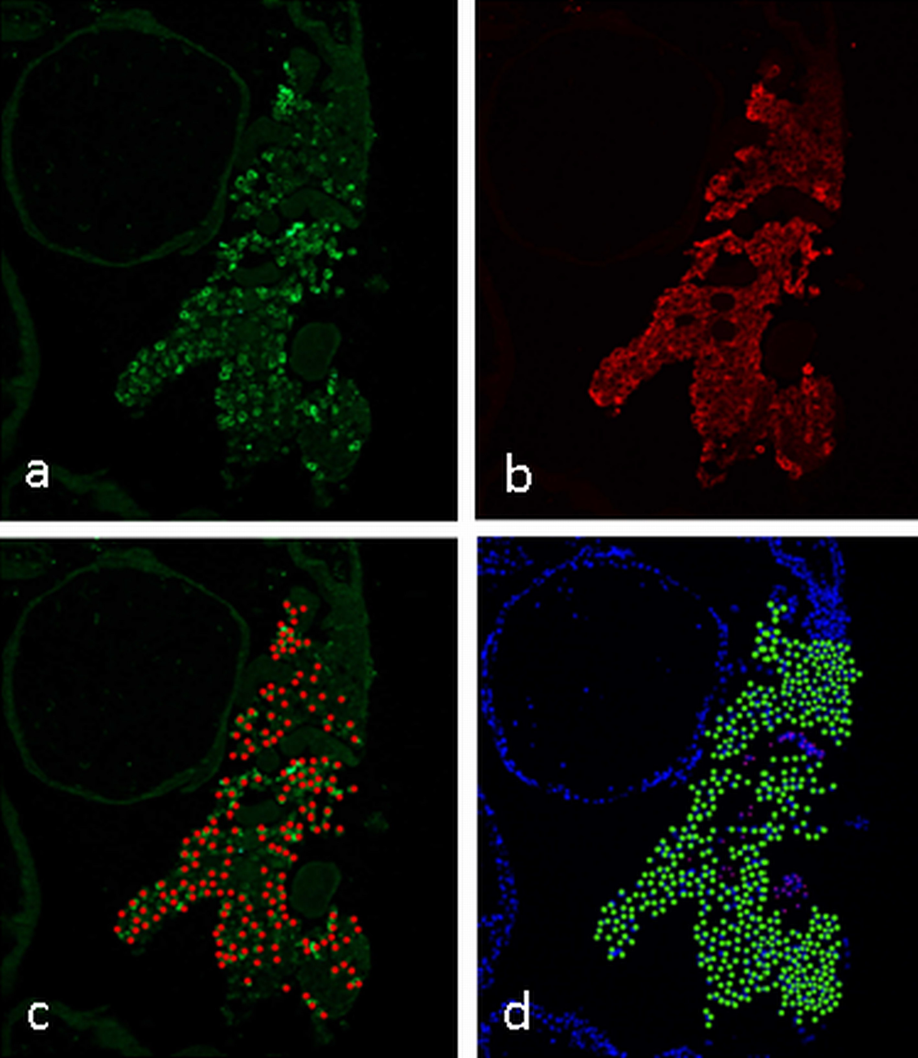

Online Resource 2 Quantification of MMP12 positive cells (a, green fluorescence) within the extravillous trophoblasts of the cell column (HLA-G positive cells, b, red fluorescence). MMP12 positive cells were marked with red dots (c), and HLA-G positive cells with green dots (d) using GIMP software, and automatically counted using Matic Images Advanced 3.2 software.

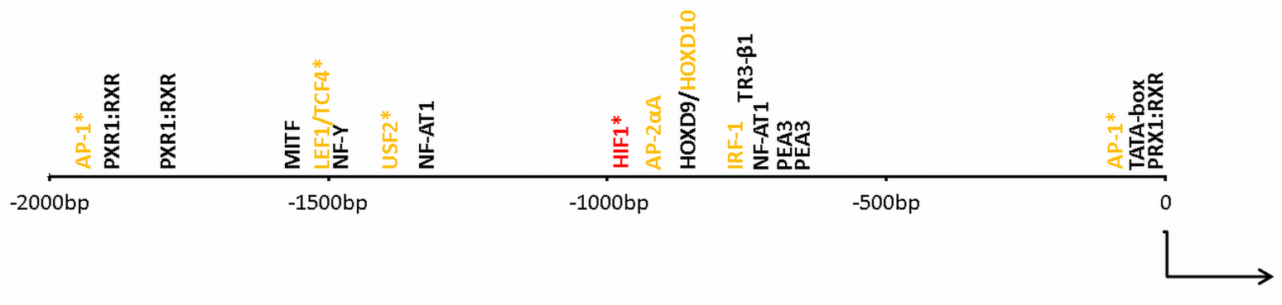

Online Resource 3 Potential transcription factor binding sites (TFBS) in the MMP12 promoter. Data were obtained using PROMO 3.0.2 bioinformatics tool (maximum matrix dissimilation = 2, random expectation query value < 0.2). TFBS that were shown to transactivate other MMPs or genes involved in trophoblast invasion are shown in orange (AP-1: activator protein 1, is responsive to cytokines and growth factors and regulates the invasive and endocrine phenotype of trophoblasts (Kubota et al. 2015); LEF1/TCF4: lymphoid enhancer binding factor 1/transcription factor 4, target of wnt signalling with TCF4 almost exclusively expressed in non-proliferating invasive trophoblasts (Pollheimer et al. 2006); USF2: upstream transcription factor 2, induces hypoxia responsive genes in trophoblast (James et al. 2006); HIF-1: hypoxia inducible factor 1, promotes trophoblast invasion (Highet et al. 2015); AP-2αA: transcription factor AP-2 alpha, promotes invasion and upregulates MMP2 (Biadasiewicz et al. 2011); HOXD9/HOXD10: Homeobox D9/D10: HOXD10 suppresses MMP14, 2 and 9 (Liao et al. 2014; Sun et al. 2011), IRF-1: interferon regulatory factor 1, transactivates HLA-G in trophoblasts (Lefebvre et al. 2001)). PXR1:RXR-α: steroid and xenobiotic sensing nuclear receptor; MITF: melanogenesis associated transcription factor; NF-Y: nuclear transcription factor Y; NF-AT1: nuclear factor of activated T-cells; TR3-β1: thyroid hormone receptor. The HIF-1 binding site with the consensus sequence ACGTGCACC is highlighted in red. TFBS of transcription factors that may be either induced directly by hypoxia or via HIF-1, are marked with an asterisk.

References for Online Resource 3

Biadasiewicz K, Sonderegger S, Haslinger P, et al. (2011) Transcription factor AP-2alpha promotes EGF-dependent invasion of human trophoblast. Endocrinology 152:1458-69. doi: 10.1210/en.2010-0936
Highet AR, Khoda SM, Buckberry S, et al. (2015) Hypoxia induced HIF-1/HIF-2 activity alters trophoblast transcriptional regulation and promotes invasion. Eur J Cell Biol 94:589-602. doi: 10.1016/j.ejcb.2015.10.004
James JL, Stone PR, Chamley LW (2006) The regulation of trophoblast differentiation by oxygen in the first trimester of pregnancy. Hum Reprod Update 12:137-44. doi: 10.1093/humupd/dmi043
Kubota K, Kent LN, Rumi MA, Roby KF, Soares MJ (2015) Dynamic Regulation of AP-1 Transcriptional Complexes Directs Trophoblast Differentiation. Mol Cell Biol 35:3163-77. doi: 10.1128/MCB.00118-15
Lefebvre S, Berrih-Aknin S, Adrian F, et al. (2001) A specific interferon (IFN)-stimulated response element of the distal HLA-G promoter binds IFN-regulatory factor 1 and mediates enhancement of this nonclassical class I gene by IFN-beta. J Biol Chem 276:6133-9. doi: 10.1074/jbc.M008496200
Liao CG, Kong LM, Zhou P, et al. (2014) miR-10b is overexpressed in hepatocellular carcinoma and promotes cell proliferation, migration and invasion through RhoC, uPAR and MMPs. Journal of translational medicine 12:234. doi: 10.1186/s12967-014-0234-x
Pollheimer J, Loregger T, Sonderegger S, et al. (2006) Activation of the canonical wingless/T-cell factor signaling pathway promotes invasive differentiation of human trophoblast. Am J Pathol 168:1134-47. doi: 10.2353/ajpath.2006.050686
Sun L, Yan W, Wang Y, et al. (2011) MicroRNA-10b induces glioma cell invasion by modulating MMP-14 and uPAR expression via HOXD10. Brain Res 1389:9-18. doi: 10.1016/j.brainres.2011.03.013

