Table S2. H&E Slide Scoring analysed by site and tissue type.

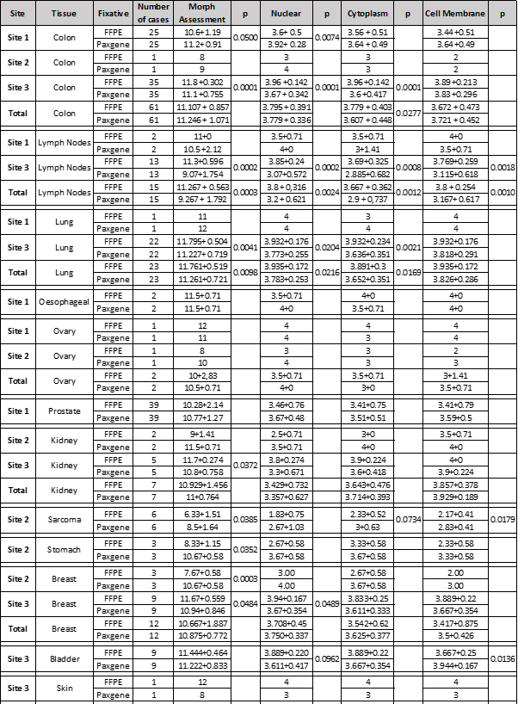
Table shows comparison of blinded scoring of H&amp;E sections across the 3 sites where samples were collected, and also scoring by tissue type. Data represents the mean + SD for each tissue group, for membrane, nuclear and cytoplasmic staining. A paired Student <Emphasis Type="Italic">t</Emphasis> test was performed to determine significance.

