Online Resources
Table 1 Exposure to hand/arm vibrations daily or weekly for seafarers
 |  | Number | Percentage (%)
 | Total | 1681 | 24
Category | Deck | 1036 | 16
Category | Engine | 531 | 43
Category | Service | 114 | 16
Age | 18-30 yrs | 335 | 36
Age | 31-40 yrs | 421 | 24
Age | 41-50 yrs | 338 | 20
Age | >50 yrs | 471 | 17
Position | Officer – deck | 789 | 7
Position | Rating – deck | 173 | 50
Position | Officer - engine | 456 | 38
Position | Rating - engine | 48 | 75
Type of ship | Ro/Ro, or similar | 240 | 25
Type of ship | Ro/pax, Passenger ship | 642 | 25
Type of ship | Container, Cargo, Bulk | 31 | 35
Type of ship | Tank | 246 | 15
Type of ship | Supply, Service or Research vessels | 379 | 26
Trade | Sheltered | 223 | 12
Trade | Near coastal | 573 | 30
Trade | European | 489 | 24
Trade | Worldwide | 370 | 22
Years as a seafarer | 0-5 yrs | 370 | 36
Years as a seafarer | 6-15 yrs | 533 | 25
Years as a seafarer | >15 yrs | 762 | 18

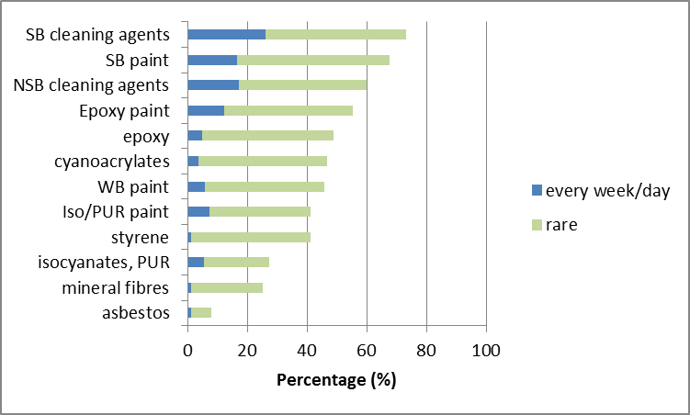
Fig 1 Selection of potentially hazardous chemicals with rare, every week or daily exposures on deck. SB = solvent based; NSB = non solvent based; WB = water based
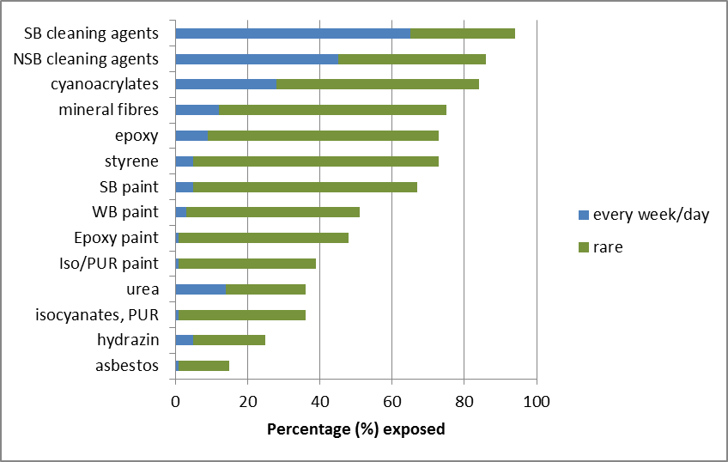
Fig 2 Selection of potentially hazardous chemicals showing rare, exposures in the engine room. SB = solvent based; NSB = non solvent based; WB = water based
Table 2 Associations between air way exposures and symptoms from the lower airways. Statistical significant associations were found for lower airway symptoms and exposures to soot*, exhausts† or dust^
 | Lower airway symptoms
 | Exposed |  |  | Non-exposed
 | Obs  (N) | Cases  (N) | Percentage (%) | Obs  (N) | Cases  (N) | Percentage  (%) | PR | 95% CI
Soot* | 300 | 28 | 9.3 | 202 | 8 | 4.0 | 2.4 | 1.1 | 5.1
Oil mist* | 340 | 28 | 8.2 | 165 | 8 | 4.9 | 1.7 | 0.8 | 3.6
Exhausts† | 854 | 54 | 6.3 | 619 | 4 | 32.0 | 1.6 | 1.0 | 2.5
Dust^ | 432 | 32 | 7.4 | 655 | 24 | 3.7 | 2.0 | 1.2 | 3.4
*) engine; †) deck & engine; ^) deck & service
Table 3 Number (N) of seafarers for each subgroup and respective percentage (%), that reported vibrations from the hull as a work problem
 |  | N seafarers | Percentage (%)
Trade | Sheltered | 268 | 40
Trade | Near coastal | 624 | 52
Trade | European | 523 | 59
Trade | Worldwide | 393 | 53
Position | Officer - deck | 810 | 54
Position | Rating - deck | 176 | 41
Position | Officer - engine | 466 | 67
Position | Rating - engine | 48 | 52
Years as a seafarer | 0-5 yrs | 489 | 33
Years as a seafarer | 6-15 yrs | 582 | 53
Years as a seafarer | >15 yrs | 824 | 58
Type of ship | Ro/Ro, or similar | 245 | 64
Type of ship | Ro/pax, Pass. | 695 | 51
Type of ship | Container, Cargo, Bulk | 34 | 50
Type of ship | Tank | 252 | 62
Type of ship | Supply, Service or Research vessels | 411 | 53
Type of ship | Other | 133 | 36
Type of ship | Ice breakers | 46 | 72

Table 4 Presence of symptoms if exposed to hand/arm vibrations (HAV) or not (non-HAV), and if having reported vibrations from the hull as a work problem (whole body vibrations, WBV) or not (non-WBV). Prevalence ratios and 95% confidence intervals
 | N | (%) | N | (%)
 | HAV |  | non-HAV |  | PR | 95% CI
White fingers | 370 | 21 | 1199 | 15 | 1.43 | 1.12 | 1.82
Numbness/pricking | 370 | 19 | 1195 | 10 | 1.91 | 1.45 | 2.50
 | WBV |  | non-WBV |  | PR | 95% CI
Back – pain | 295 | 41 | 1312 | 32 | 1.27 | 1.08 | 1.48
Hips - pain | 292 | 20 | 1303 | 9 | 2.19 | 1.65 | 2.92
Knees - pain | 295 | 39 | 1305 | 23 | 1.70 | 1.43 | 2.03
Sleep disturbance | 302 | 52 | 1332 | 42 | 1.25 | 1.10 | 1.41
Unusual tiredness | 302 | 38 | 1330 | 25 | 1.52 | 1.28 | 1.81

Table 5 Conception of risk of an accident as a work problem, having experienced offensive (off.) actions or harassments at work, and perception of health and symptoms divided by experiencing strain at work without social support (Iso-strain) or not (No iso-strain). Number (N) of answers with prevalence ratios (PR) and 95% confidence intervals (CI), controlling for sex
 | Answers (total) | Iso-strain | No iso-strain
 | N | N | N | PR | CI
Risk of an accident | 1583 | 85 (31%) | 191 (15%) | 2.01 | 1.60-2.51
Off. Action/harassment | 1589 | 128 (46%) | 261 (20%) | 2.59 | 2.08-3.21
Good or excellent health | 1585 | 175 (63%) | 1050 (80%) | 0.50 | 0.41-0.63
Headache | 1576 | 19 (7%) | 32 (2%) | 2.19 | 1.51-3.18
Tiredness | 1572 | 42 (15%) | 52 (4%) | 2.68 | 2.06-3.48
Sleep disorder | 1576 | 44 (16%) | 63 (5%) | 2.37 | 1.82-3.10
Anxiety | 1574 | 21 (8%) | 33 (3%) | 2.05 | 1.41-2.98
Unusual tiredness | 1574 | 126 (45%) | 308 (24%) | 2.18 | 1.77-2.70
Poor or moderate work ability | 1565 | 32 (12%) | 61 (5%) | 1.99 | 1.46-2.71
Women | 1542 | 39 (14%) | 108 (9%) | 1.60^ | 1.19-2.14
^) not controlling for gender

Table 6 Point estimates of safety climate in seafarers sailing under a Swedish flag, illustrating the seafarers view on their leaders views on safety (Management Safety Priority), and their own views (General Security Climate).
 |  |  | Management Safety Priority |  | General Security Climate
 |  | N | Mean | p | Mean | p
Work category | deck* | 938 | 3.36 |  | 3.32
Work category | engine | 480 | 3.36 | ns | 3.32 | ns
Work category | service | 116 | 3.51 | 0.0187 | 3.44 | 0.0165
Sex | men* | 1374 | 3.38 |  | 3.33
Sex | women | 147 | 3.30 | ns | 3.26 | 0.0803
Management | Manager* | 1157 | 3.40 |  | 3.35
Management | Non manager | 374 | 3.29 | 0.0049 | 3.24 | 0.0002
Unusual tiredness | no* | 1114 | 3.42 |  | 3.38
Unusual tiredness | yes | 426 | 3.22 | <0.0001 | 3.19 | <0.0001
Age | <30 | 327 | 3.29 | <0.0001 | 3.21 | <0.0001
Age | 31-40 | 402 | 3.30 | <0.0001 | 3.26 | <0.0001
Age | 41-50 | 348 | 3.37 | 0.0097 | 3.36 | 0.0115
Age | >50* | 459 | 3.49 |  | 3.45
Trade | Sheltered* | 220 | 3.24 |  | 3.29
Trade | Near coastal | 552 | 3.31 | ns | 3.26 | ns
Trade | European | 437 | 3.37 | 0.0169 | 3.34 | ns
Trade | Worldwide | 346 | 3.56 | <0.0001 | 3.45 | <0.0001
Type of ship | Ro/Ro. or similar* | 230 | 3.46 |  | 3.40
Type of ship | Ro/pax. Pass. | 604 | 3.30 | 0.0014 | 3.28 | 0.0007
Type of ship | Container. Cargo. Bulk | 24 | 3.48 | ns | 3.36 | ns
Type of ship | Tank | 239 | 3.38 | ns | 3.35 | ns
Type of ship | Supply. Service or Research vessels | 353 | 3.43 | ns | 3.38 | ns
Type of ship | other | 83 | 3.34 | ns | 3.27 | 0.0287
*)Referent; ns=non significant

