Supplementary Files S1. The search string in three databases: PubMed. EMBASE, and PsycINFO
The search string in PubMed
("Burnout, Professional"[Mesh] OR "professional exhaustion"[tiab] OR ("Burnout, Psychological"[Mesh:NoExp] OR burnout[tiab] OR "burn-out"[tiab] OR "emotional exhaust*"[tiab] OR "emotionally exhaust*"[tiab]) AND (job[tiab] OR jobs[tiab] OR occupation*[tiab] OR profession*[tiab] OR staff*[tiab] OR work*[tiab] OR employ*[tiab] OR colleague*[tiab])) AND ("Organizational Innovation"[Mesh] OR "Organization and Administration"[Mesh:NoExp] OR organisation* [tiab] OR organization* [tiab]) AND (intervention* [tiab] OR prevent*[tiab])

The search string in EMBASE
('professional burnout'/de OR 'professional exhaustion':ti,ab
OR 'burnout'/de OR burnout:ti,ab OR 'burn-out':ti,ab OR (emotion* NEAR/2 exhaust*):ti,ab)
AND
(job*:ti,ab OR occupation*:ti,ab OR profession*:ti,ab OR staff*:ti,ab OR work*:ti,ab OR employ*:ti,ab OR colleague*:ti,ab)
AND
organi?ation*:ti,ab
AND
(prevention*:ti,ab OR intervent*:ti,ab)
The search string in PsycINFO
((MeSH: burnout OR burnout OR burn-out OR (emotion* adj2 exhaust*)) AND (job* OR occupation* OR profession* OR staff* OR work* OR employ* OR colleagu*) AND (organisation OR organization) AND (intervent* OR prevent*))
AND Publication Type: Peer Reviewed Journal

Keywords used for Cochrane database: Burnout; professional burnout

Supplementary Files S2. Formula to compute the varaince of the effect size (d_{ppc2})

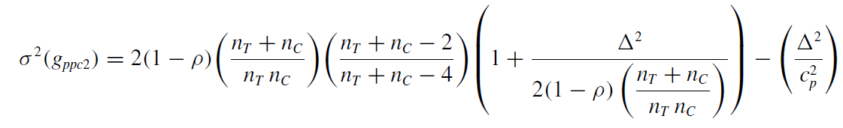
Note: P: correlation coefficient, n T: number of participants in the treatment (here intervention) group, n C: number of participants in the control group, cp: correction factor corresponding to the formula: 1-(3/4(n T +n.C -2)-1), and Δ: the difference between the standardized mean change for the treatment and control groups

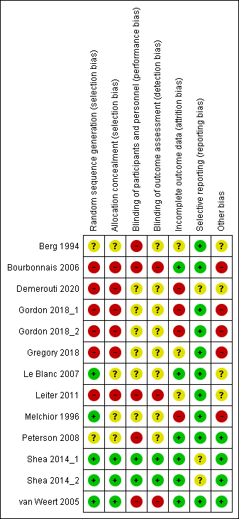
Supplementary Figure S1. Results of risk of bias assessment
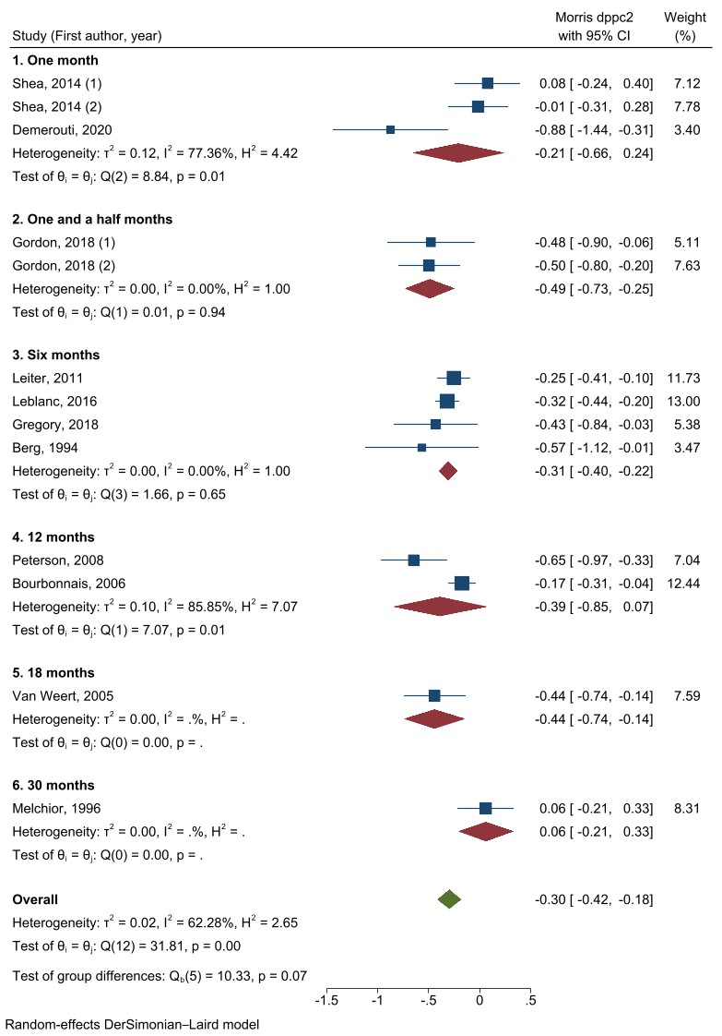
Supplementary Figure S2. Meta-analysis of effect sizes from pretest-posttest-control design (dppc2) of organizational directed interventions to reduce or prevent occupational burnout, results of subgroup analysis by the follow-up duration
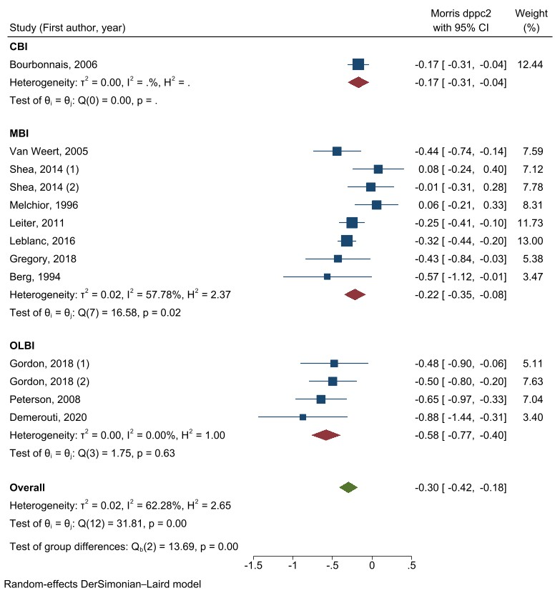
Supplementary Figure S3. Meta-analysis of effect sizes from pre-test - post-test control design (d_{ppc2}) of organizational directed interventions to reduce or prevent occupational burnout, results of subgroup analysis by the scale used to measure burnout

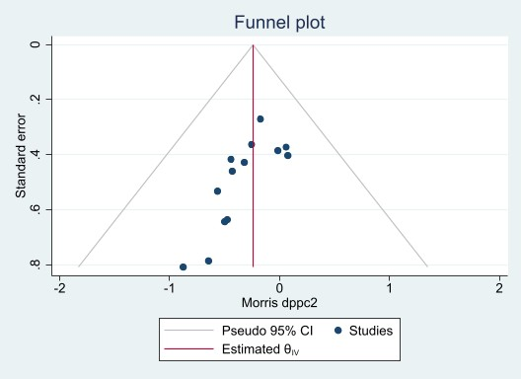
Supplementary Figure S4. Funnel plot

