Supplementary Information

Article: Health inequalities among young workers: The mediating role of working conditions and company characteristics

Journal: International Archives of Occupational and Environmental Health

Authors: Marvin Reuter, Claudia R Pischke, Mariann Rigo, Katharina Diehl, Jacob Spallek, Matthias Richter, Claudia Hövener, Nico Dragano

Corresponding author: Marvin Reuter, Junior Professorship for Sociology, esp. Work and Health, University of Bamberg, Feldkirchenstraße 21, 96045 Bamberg, Germany, Mail: marvin.reuter@uni-bamberg.de

e-Table 1: Assessment of health problems at work during the last 12 months.
No | Symptoms of musculoskeletal disorders | No | Symptoms of mental health problems
1 | Lower back pain | 1 | Sleep disturbances at night
2 | Pain in the neck, shoulder area | 2 | General tiredness, faintness or fatigue
3 | Pain in the arms | 3 | Nervousness or irritability
4 | Pain in the hands | 4 | Low mood
5 | Pain in the hips | 5 | Emotional exhaustion
6 | Pain in the knees
7 | Pain in the legs, feet
Original question: “Please tell me if you have experienced the following health complaints during the last 12 months at work. We are interested in the complaints that occurred frequently.”

e-Table 2: Indicators of physical and psychosocial job demands (α=Cronbach’s alpha)
 |  | α | Mean | SD | n
Physical demands (Ergo + Env) |  | 0.81 | 3.22 | 2.92 | 3,142
Ergonomic demands (Ergo) |  | 0.66 | 1.56 | 1.28 | 3,142
 | (1) Working while standing
 | (2) Lifting and carrying heavy loads (Men ≥20 kg, women ≥10 kg)
 | (3) Manual work requiring great dexterity, fast sequences of movements or greater strength
 | (4) Working in forced postures
Environmental demands (Env) |  | 0.73 | 1.67 | 1.96 | 3,142
 | (1) Work in fumes, dust, gases or vapours
 | (2) Work in cold, heat, wet, damp or windy conditions
 | (3) Working with oil, grease, dirt, grime
 | (4) Working with strong vibrations, shocks and oscillations that are felt in the body
 | (5) Work in bright light or in poor or too dim lighting
 | (6) Working under noise
 | (7) Handling hazardous substances
 | (8) Wearing protective clothing or equipment
 | (9) Dealing with microorganisms such as pathogens, bacteria, moulds or viruses
 | (10) Do you work in a place where people smoke?
Psychosocial demands (Sup + Dec + Psy + Time) |  | 0.64 | 4.35 | 2.88 | 3,142
Low social support (Sup) |  | 0.36 | 0.28 | 0.60 | 3,142
 | (1) Frequently not informed in time about important developments in the company
 | (2) Frequently not receiving necessary information
 | (3) Never experiencing a sense of community at work
 | (4) Never experiencing good cooperation with colleagues
 | (5) Never experiencing support from colleagues when necessary
 | (6) Never experiencing support from direct supervisor
Low decision latitude (Dec) |  | 0.43 | 0.51 | 0.75 | 3,142
 | (1) Never possibility to organise work oneself
 | (2) Never having influence on the assigned amount of work
 | (3) Never having influence on when to take a break
Psychological demands (Psy) |  | 0.62 | 3.03 | 2.14 | 3,142
 | (1) Frequently working under time or performance pressure
 | (2) Frequently faced with new tasks
 | (3) Frequently improving procedures or trying new things
 | (4) Frequently being disturbed/interrupted at work
 | (5) Frequently have to meet minimum performance
 | (6) Frequently doing things that have not been learned
 | (7) Frequently doing different jobs at the same time
 | (8) Frequently small mistakes often have big consequences
 | (9) Frequently having to push the limits of ability to perform
 | (10) Frequently have to work very quickly
 | (11) Work is often emotionally exhausting
Working time demands (Time) |  | 0.44 | 0.54 | 0.89 | 3,142
 | (1) Usual working hours ≥48h per week (including overwork)
 | (2) On-call duty
 | (3) Working every Saturday
 | (4) Working every Sunday
 | (5) Working night shifts
 | (6) Working morning or evening shifts
 | (7) Frequently not able to match family/private interests
Total score: Working demands (Physical + Psychosocial) |  | 0.78 | 7.58 | 4.74 | 3,142

e-Table 3: Missing information before imputation
Variable |  | Missing (n) | Valid (n) | Categories | Min | Max
sex | Sex |  | 3,214 | 2 | 1 | 2
age | Age |  | 3,214 | 10 | 15 | 24
nation | Nationality |  | 3,214 | 2 | 1 | 2
region | Region |  | 3,214 | 2 | 1 | 2
mscdis | Symptoms of musculoskeletal disorders |  | 3,214 | 10 | 7 | 63
mentdis | Symptoms of mental disorders |  | 3,214 | 9 | 5 | 31
physical | Physical job demands |  | 3,214 | 15 | 0 | 14
psychosocial | Psychosocial job demands |  | 3,214 | 21 | 0 | 21
wrkh | Weekly working hours | 2 | 3,212 | 103 | 1 | 84
jobten | Job tenure | 18 | 3,196 | 11 | 0 | 11
edu | Education | 39 | 3,175 | 4 | 9 | 13
empst | Employment status | 5 | 3,209 | 4 | 1 | 4
compsize | Company size | 224 | 2,990 | 11 | 1 | 1000
wrksec | Working sector | 138 | 3,076 | 10 | 1 | 10
econ | Company economic situation | 188 | 3,026 | 2 | 0 | 1
whp | Company health promotion | 390 | 2,824 | 2 | 0 | 1
downsizing | Company downsizing | 84 | 3,130 | 2 | 0 | 1
srhlth | Self-rated health | 2 | 3,212 | 5 | 1 | 5
absent_days | Absenteeism days | 26 | 3,188 | 56 | 0 | 365
present_days | Presenteeism days | 68 | 3,146 | 40 | 0 | 200
parocc | Parental occupational class | 185 | 3,029 | 4 | 1 | 4
eseg | European socio-economic group | 58 | 3,156 | 7 | 1 | 7
income | Job income | 288 | 2,926 | 432 | 1 | 21000
Variables marked in italics were used as auxiliary variables in the imputation model.

e-Table 4: Original versus imputed data set
 | Original |  |  |  |  |  | Imputed
 | n | Mean | SD | Min | Max |  | n | Mean | SD | Min | Max
wrkh | 3,209 | 35.9 | 11.3 | 10 | 84 |  | 3,214 | 35.9 | 11.3 | 10 | 84
jobten | 3,196 | 2.0 | 1.7 | 0 | 11 |  | 3,214 | 2.0 | 1.7 | 0 | 11
edu | 3,175 | 11.0 | 1.5 | 9 | 13 |  | 3,214 | 11.0 | 1.5 | 9 | 13
empst | 3,209 | 2.4 | 1.2 | 1 | 4 |  | 3,214 | 2.4 | 1.2 | 1 | 4
compsize | 2,990 | 256.9 | 354.6 | 1 | 1000 |  | 3,214 | 252.4 | 352.4 | 1 | 1000
wrksec | 3,076 | 5.7 | 2.7 | 1 | 10 |  | 3,214 | 5.7 | 2.7 | 1 | 10
econ | 3,026 | 0.1 | 0.2 | 0 | 1 |  | 3,214 | 0.1 | 0.2 | 0 | 1
whp | 2,824 | 0.5 | 0.5 | 0 | 1 |  | 3,214 | 0.4 | 0.5 | 0 | 1
downsizing | 3,130 | 0.3 | 0.5 | 0 | 1 |  | 3,214 | 0.3 | 0.5 | 0 | 1
srhlth | 3,212 | 3.6 | 0.8 | 1 | 5 |  | 3,214 | 3.6 | 0.8 | 1 | 5
absent_days | 3,188 | 6.4 | 15.0 | 0 | 365 |  | 3,214 | 6.4 | 15.0 | 0 | 365
present_days | 3,146 | 4.9 | 10.7 | 0 | 200 |  | 3,214 | 5.0 | 10.7 | 0 | 200

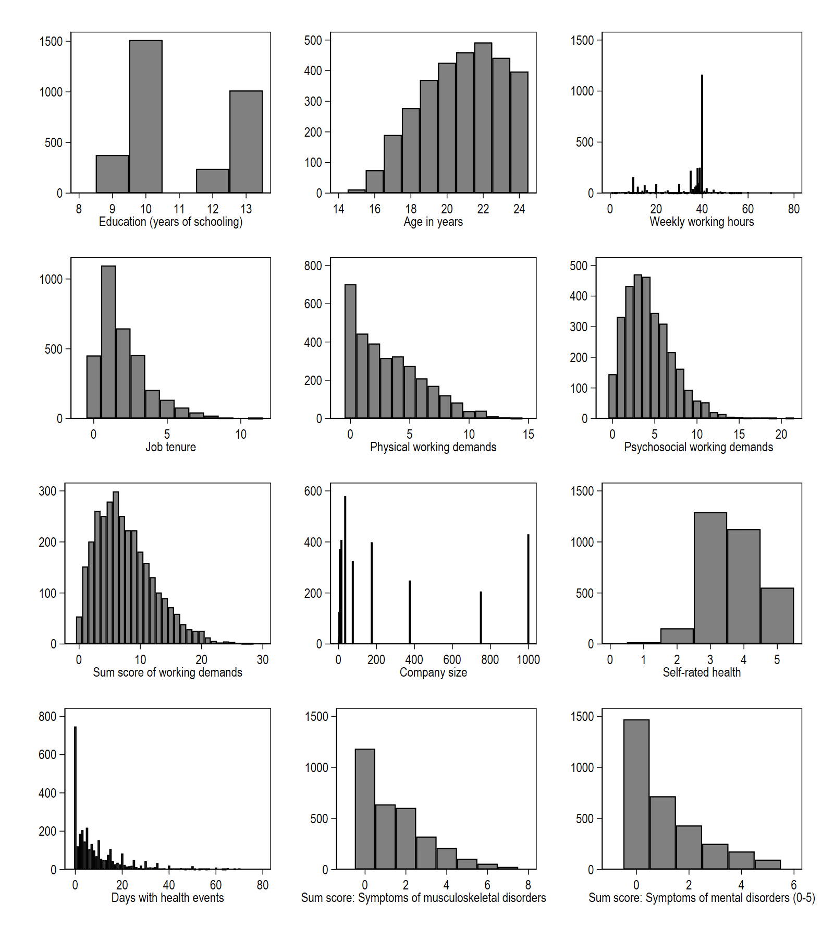
eFig 1 Histogram illustrating the distribution of continuous variables. n=3,142.
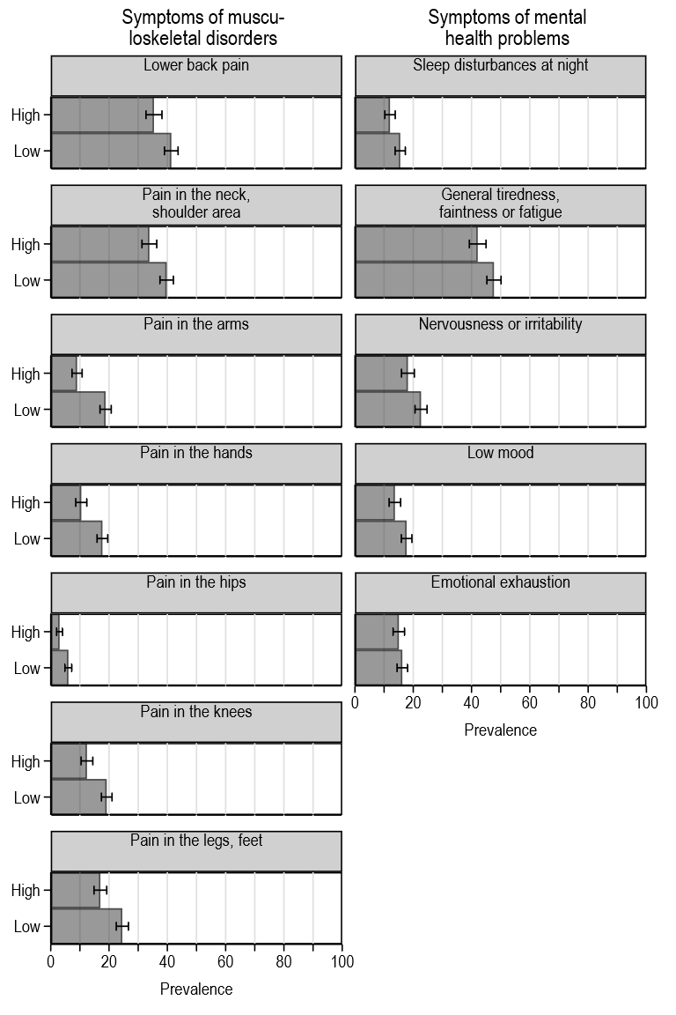
eFig 2 Prevalence (%) of musculoskeletal symptoms and mental health problems by low (<12 years) and high (≥12 years) levels of school education
Data: BIBB/BAuA Youth Employment Survey 2012. n=3,142. Relative frequencies with 95% confidence intervals. Estimates were adjusted for age, sex, nationality, region, employment relation, weekly working hours, job tenure, and working sector.

