Supplementary Table 1 – Frequency distribution of the characteristics of the three cohorts, CVD cumulative incidence and person-days of follow-up, by gender, after exclusion of CVD prevalent cases.
Variables | ILS 2005 |  | TLS 2001 |  | TLS 2011
Variables | Men | Women | Men | Women | Men | Women
Age at baseline (mean - sd) | 40.9 (9.1) | 40.9 (9.0) | 39.2 (8.6) | 39.0 (8.5) | 39.6 (9.6) | 39.5 (9.4)
Charlson index (% subjects >0) |  |  | 2.4 | 2.2 | 1.9 | 2.1
Deprivation index. (mean - sd) |  |  | 0.11¹ (2.0) | -0.08¹ (1.8) | 1.64² (2.1) | 1.48² (2.0)
CVD cumulative incidence (%) | 9.3 | 5.8 | 12.3 | 8.3 | 4.3 | 2.6
N. subjects | 15,307 | 15,423 | 75,994 | 76,322 | 70,970 | 77,287
Person-days of follow-up (mean - sd) | 3,354.9 (621.4) | 3,414.5 (524.8) | 4,908.1 (1,990.8) | 5,174.3 (1,869.2) | 2,245.2 (95.0) | 2,272.8 (87.1)
Physical Component Summary (mean - sd) | 53.3 (6.3) | 52.4 (7.1)
Educational level (%)
University | 11.6 | 14.8 | 17.9 | 22.1 | 20.2 | 24.0
High school | 30.8 | 34.8 | 32.7 | 35.6 | 30.1 | 32.9
Low secondary/elementary | 57.6 | 50.4 | 49.3 | 42.3 | 49.7 | 43.1
Household typology (%)
Single | 12.6 | 9.8 | 18.1 | 16.0 | 26.6 | 24.3
Couple without children | 11.0 | 12.8 | 16.9 | 18.2 | 16.0 | 16.6
Couple with children | 69.5 | 65.3 | 58.0 | 52.5 | 49.1 | 42.7
Single parent | 6.9 | 12.0 | 6.9 | 13.3 | 8.3 | 16.4
Body Mass Index (%)
Normal or underweight | 48.4 | 73.2
Overweight | 41.8 | 20.0
Obese | 9.8 | 6.8
Pack-years smoking (%)
0 | 40.4 | 58.9
0.1 - 10 | 17.1 | 16.5
10.1 - 20 | 16.5 | 9.6
20.1 - 30 | 9.7 | 4.7
> 30 | 9.4 | 2.5
Missing | 6.8 | 7.8
Leisure time physical activity (%)
None | 46.4 | 48.2
Light | 18.3 | 25.9
Regular | 20.3 | 19.5
Intense | 15.0 | 6.4
Diabetes (%) | 2.0 | 1.4
Hypertension (%) | 8.8 | 8.3
Household economic resources (%)
Excellent or adequate | 70.3 | 72.7
Scarce or absolutely insufficient | 26.7 | 27.3
Geographical area of residence (%)
North-West | 22.1 | 24.6
North-East | 21.0 | 24.7
Center | 17.2 | 19.1
South | 39.6 | 31.6
¹ Range: from -5.76 to 16.38
² Range: from -5.04 to 27.89

Supplementary Table 2 – Incidence rate ratio (IRR 95% CI) of cardiovascular diseases (CVD) by quartile of Occupational Physical Activity (OPA), stratified by Leisure Time Physical Activity (LTPA).
 | Mortality |  | CVD
 | LTPA no¹ | LTPA yes² | LTPA no¹ | LTPA yes²
Men | IRR (95% CI) | IRR (95% CI) | IRR (95% CI) | IRR (95% CI)
Ergo index (ref: 1° quartile) | 1 | 1 | 1 | 1
2° quartile | 1.12  (0.61 – 2.05) | 0.98  (0.55 - 1.77) | 1.24  (0.94 – 1.64) | 1.11  (0.87 – 1.43)
3° quartile | 1.39  (0.78 – 2.47) | 1.40  (0.81 – 2.43) | 1.28  (0.97 – 1.68) | 1.17  (0.92 – 1.50)
4° quartile | 1.20  (0.69 – 2.09) | 1.52  (0.91 – 2.54) | 1.07  (0.83 – 1.38) | 1.06  (0.84 – 1.33)
Women | IRR (95% CI) | IRR (95% CI) | IRR (95% CI) | IRR (95% CI)
Ergo index (ref: 1° quartile) | 1 | 1 | 1 | 1
2° quartile | 0.43  (0.18 – 0.99) | 0.82  (0.35 - 1.88) | 1.04  (0.73 – 1.47) | 0.91  (0.62 – 1.32)
3° quartile | 0.81  (0.46 – 1.42) | 0.66  (0.31 – 1.39) | 1.34  (1.02 – 1.77) | 1.24  (0.94 – 1.62)
4° quartile | 0.68  (0.37 – 1.23) | 0.89  (0.42 – 1.90) | 1.11  (0.83 – 1.50) | 1.31  (0.97 – 1.76)
* p<0.05, ** p<0.01.
¹ No physical activity.
² Light + regular + intense physical activity.
³ Adjusted for age, household typology, household economic resources, Physical Component Summary, geographical area of residence, educational level, BMI, pack-years smoking, diabetes, hypertension.

Supplementary Table 3 – Incidence rate ratio (IRR 95% CI) of mortality and cardiovascular diseases (CVD) by quartile of Occupational Physical Activity (OPA) and gender in the TLS 2001 cohort after exclusion of subjects present also in the TSL 2011 cohort.
 | Mortality |  | CVD
 | MEN | WOMEN | MEN | WOMEN
Men | IRR (95% CI) | IRR (95% CI) | IRR (95% CI) | IRR (95% CI)
Ergo index (ref: 1° quartile) | 1 | 1 | 1 | 1
2° quartile | 1.11  (0.99 – 1.25) | 1.01  (0.86 - 1.18) | 1.02  (0.95 – 1.10) | 1.31  (1.20 – 1.42)
3° quartile | 1.04  (0.92 – 1.17) | 0.98  (0.85 – 1.13) | 1.01  (0.94 – 1.09) | 1.16  (1.07 – 1.26)
4° quartile | 1.14  (1.02 – 1.27) | 1.23  (1.05 – 1.44) | 0.98  (0.91 – 1.06) | 1.34  (1.22 – 1.47)
³ Adjusted for age, household typology, Charlson Index, educational level, are deprivation index.

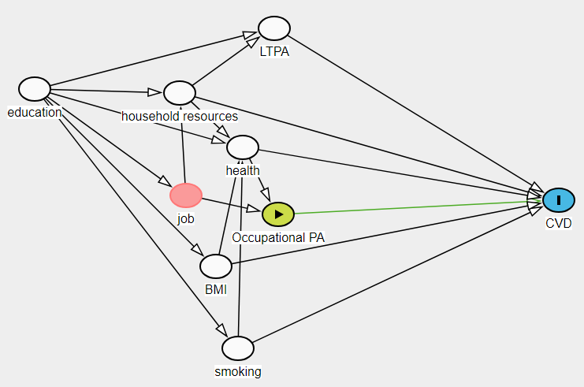
Supplementary Figure 1. Simplified DAG of the total effect of occupational physical activity on cardiovascular diseases (CVD). Nodes: Green (with ►) = exposure, Blue (with I) = outcome, Red = ancestor of exposure and outcome (confounder), White = adjusted variable. Arrows: Green = causal path, black = blocked path. Abbreviation: Occupational PA=Occupational physical activity. LTPA=leisure time physical activity. BMI=body mass index.

