Table S1. VOCs metabolites
Variable Name | Abbreviation | Parent Compound | VOCs Metabolite | LLOD (ng/mL)
URX2MH | 2MHA | Xylene | 2-Methylhippuric acid | 5.00
URX34M | 34MHA | Xylene | 3- and 4-Methylhippuric acid | 8.00
URXAAM | AAMA | Acrylamide | N-Acetyl-S-(2-carbamoylethyl)-L-cysteine | 2.20
URXAMC | AMCA | N, N-Dimethylformamide | N-Acetyl-S-(N-methylcarbamoyl)-L-cysteine | 6.26
URXATC | ATCA | Cyanide | 2-Aminothiazoline-4-carboxylic acid | 15.0
URXBMA | BMA | Toluene | N-Acetyl-S-(benzyl)-L-cysteine | 0.500
URXBPM | BPMA | 1-Bromopropane | N-Acetyl-S-(n-propyl)-L-cysteine | 1.20
URXCEM | CEMA | Acrolein | N-Acetyl-S-(2-carboxyethyl)-L-cysteine | 6.96
URXCYM | CYMA | Acrylonitrile | N-Acetyl-S-(2-cyanoethyl)-L-cysteine | 0.500
URXDHB | DHBMA | 1,3-Butadiene | N-Acetyl-S-(3,4-dihydroxybutyl)-L-cysteine | 5.25
URXGAM | GAMA | Acrylamide | N-Acetyl-S-(2-carbamoyl-2-hydroxyethyl)-L-cysteine | 9.40
URXHEM | HEMA | Ethylene oxide | N-Acetyl-S-(2-hydroxyethyl)-L-cysteine | 0.791
URXHP2 | HPM2 | Propylene oxide | N-Acetyl-S-(2-hydroxypropyl)-L-cysteine | 5.30
URXHPM | HPMA | Acrolein | N-Acetyl-S-(3-hydroxypropyl)-L-cysteine | 13.0
URXMAD | MADA | Ethylbenzene, Styrene | Mandelic acid | 12.0
URXMB3 | MHB3 | 1,3-Butadiene | N-Acetyl-S-(4-hydroxy-2-butenyl)-L-cysteine | 0.600
URXPHE | PHEM | Styrene | N-Acetyl-S-(1-phenyl-2-hydroxyethyl)-L-cysteine N-Acetyl-S-(2-phenyl-2-hydroxyethyl)-L-cysteine | 0.700
URXPHG | PHGA | Ethylbenzene, Styrene | Phenylglyoxylic acid | 12.0
URXPMM | HPMM | Crotonaldehyde | N-Acetyl-S-(3-hydroxypropyl-1-methyl)-L-cysteine | 1.70
mVOCs, metabolites of volatile organic compounds; LLOD, lower limit of detection

Table S2. Baseline characteristics of participants stratified by quartile of LDH in NHANES 2011-2018
Characteristic | Overall  N = 4907 | LDH group
Characteristic | Overall  N = 4907 | Q1, N = 1281 | Q2, N = 1173 | Q3, N = 1265 | Q3, N = 1265
Gender
Male | 2,433 (48.6) | 616 (49.1) | 601 (49.9) | 615 (47.7) | 601 (47.7)
Female | 2,474 (51.4) | 665 (50.9) | 572 (50.1) | 650 (52.3) | 587 (52.3)
Age (years) | 47.4 (16.7) | 42.4 (15.5) | 45.8 (16.2) | 49.7 (17.0) | 52.4 (16.6)
Race
Mexican American | 601 (7.8) | 177 (8.0) | 142 (7.7) | 161 (8.3) | 121 (7.2)
Other Hispanic | 513 (6.3) | 147 (7.0) | 133 (6.2) | 131 (6.4) | 102 (5.3)
Non-Hispanic White | 1,860 (66.3) | 509 (67.3) | 461 (68.4) | 461 (66.3) | 429 (63.0)
Non-Hispanic Black | 1,098 (10.9) | 220 (8.9) | 241 (9.8) | 298 (11.1) | 339 (14.2)
Other Race | 835 (8.7) | 228 (8.8) | 196 (7.8) | 214 (7.9) | 197 (10.2)
Education
Above High School | 2,814 (64.5) | 811 (72.0) | 674 (65.1) | 677 (59.9) | 652 (60.2)
Below High School | 1,002 (13.0) | 226 (10.6) | 251 (14.2) | 285 (14.6) | 240 (12.9)
Completed High School | 1,091 (22.5) | 244 (17.4) | 248 (20.7) | 303 (25.5) | 296 (26.9)
PIR
<1.30 | 1,565 (22.2) | 417 (23.1) | 374 (20.9) | 406 (22.4) | 368 (22.1)
1.30-3.50 | 1,825 (34.8) | 445 (32.6) | 410 (31.2) | 473 (35.2) | 497 (40.7)
>3.50 | 1,517 (43.0) | 419 (44.2) | 389 (47.9) | 386 (42.4) | 323 (37.2)
BMI (kg/m^2)
<25.0 | 1,451 (29.0) | 457 (36.5) | 364 (30.2) | 378 (29.2) | 252 (18.7)
25.0-29.9 | 1,542 (31.9) | 425 (33.4) | 370 (31.6) | 388 (30.6) | 359 (32.1)
≥30 | 1,914 (39.1) | 399 (30.0) | 439 (38.2) | 499 (40.2) | 577 (49.2)
Cotinine (ng/ml) | 55.3 (129.7) | 58.1 (129.6) | 56.4 (129.0) | 50.5 (127.9) | 56.2 (132.8)
Smoking status
Current Smoker | 938 (18.2) | 287 (21.0) | 238 (18.4) | 211 (15.8) | 202 (17.5)
Former Smoker | 1,172 (25.3) | 267 (24.4) | 261 (22.2) | 320 (26.9) | 324 (28.0)
Never Smoker | 2,797 (56.5) | 727 (54.6) | 674 (59.5) | 734 (57.3) | 662 (54.4)
Drinking status
Heavy drinking | 2,693 (61.7) | 732 (63.5) | 673 (62.6) | 666 (59.5) | 622 (60.9)
No heavy drinking | 2,214 (38.3) | 549 (36.5) | 500 (37.4) | 599 (40.5) | 566 (39.1)
DM
No | 4,090 (87.0) | 1,095 (88.2) | 1,006 (88.7) | 1,046 (87.1) | 943 (83.6)
Yes | 817 (13.0) | 186 (11.8) | 167 (11.3) | 219 (12.9) | 245 (16.4)
Hypertension
No | 3,160 (68.5) | 984 (79.7) | 805 (72.7) | 778 (66.7) | 593 (53.1)
Yes | 1,747 (31.5) | 297 (20.3) | 368 (27.3) | 487 (33.3) | 595 (46.9)
Data are presented as mean ± SD or n %;

LDH: Lactate Dehydrogenase; BMI: Body Mass Index; DM: Diabetes Mellitus; PIR: Poverty Income Ratio

Table S3. Association between urinary mVOCs and serum LDH by exposure quartiles in adjusted linear regression models
Variable | Q1 |  | Q2 |  |  | Q3 |  |  | Q4 |  |  | P for trend
Variable |  |  | β (95% CI) | P value |  | β (95% CI) | P value |  | β (95% CI) | P value |  | P for trend
2MHA | Ref |  | -0.001 (-0.008, 0.007) | 0.835 |  | -0.011 (-0.019, -0.004) | 0.004 |  | -0.016 (-0.023, -0.008) | <0.001 |  | <0.001
34MHA | Ref |  | 0.002 (-0.006, 0.009) | 0.667 |  | -0.019 (-0.027, -0.012) | <0.001 |  | -0.021 (-0.028, -0.013) | <0.001 |  | <0.001
AAMA | Ref |  | 0.003 (-0.005, 0.010) | 0.489 |  | -0.000 (-0.008, 0.007) | 0.948 |  | -0.006 (-0.014, 0.002) | 0.123 |  | 0.965
AMCA | Ref |  | -0.001 (-0.008, 0.007) | 0.871 |  | -0.006 (-0.014, 0.002) | 0.117 |  | -0.006 (-0.014, 0.002) | 0.117 |  | 0.023
ATCA | Ref |  | -0.002 (-0.009, 0.006) | 0.665 |  | -0.017 (-0.024, -0.009) | <0.001 |  | -0.017 (-0.025, -0.009) | <0.001 |  | <0.001
BMA | Ref |  | -0.003 (-0.011, 0.004) | 0.394 |  | 0.002 (-0.006, 0.009) | 0.650 |  | 0.007 (-0.001, 0.015) | 0.071 |  | 0.905
BPMA | Ref |  | -0.007 (-0.014, 0.001) | 0.090 |  | -0.005 (-0.012, 0.003) | 0.236 |  | -0.009 (-0.017, -0.002) | 0.015 |  | 0.088
CEMA | Ref |  | -0.001 (-0.009, 0.006) | 0.714 |  | 0.004 (-0.004, 0.011) | 0.356 |  | 0.006 (-0.002, 0.014) | 0.117 |  | 0.789
CYMA | Ref |  | -0.006 (-0.013, 0.002) | 0.140 |  | -0.009 (-0.016, -0.001) | 0.023 |  | -0.020 (-0.028, -0.013) | <0.001 |  | <0.001
DHBMA | Ref |  | -0.000 (-0.008, 0.008) | 0.999 |  | 0.008 (0.000, 0.015) | 0.046 |  | 0.013 (0.005, 0.020) | 0.001 |  | 0.099
HPM2 | Ref |  | -0.004 (-0.011, 0.004) | 0.348 |  | -0.008 (-0.016, -0.001) | 0.032 |  | -0.011 (-0.018, -0.003) | 0.006 |  | 0.035
HPMA | Ref |  | -0.000 (-0.008, 0.007) | 0.926 |  | -0.006 (-0.014, 0.001) | 0.097 |  | -0.007 (-0.015, 0.000) | 0.065 |  | 0.265
MADA | Ref |  | -0.002 (-0.010, 0.006) | 0.593 |  | -0.000 (-0.008, 0.008) | 1.000 |  | -0.004 (-0.012, 0.003) | 0.261 |  | 0.568
MHB3 | Ref |  | 0.004 (-0.004, 0.012) | 0.301 |  | -0.003 (-0.011, 0.005) | 0.429 |  | -0.008 (-0.016, -0.001) | 0.036 |  | 0.012
PHEM | Ref |  | 0.100 (0.093, 0.107) | <0.001 |  | 0.012 (0.004, 0.019) | 0.002 |  | 0.029 (0.022, 0.035) | <0.001 |  | <0.001
PHGA | Ref |  | 0.003 (-0.005, 0.010) | 0.459 |  | 0.008 (0.001, 0.016) | 0.032 |  | 0.005 (-0.002, 0.013) | 0.158 |  | 0.368
HPMM | Ref |  | 0.006 (-0.002, 0.013) | 0.150 |  | 0.002 (-0.006, 0.009) | 0.634 |  | -0.007 (-0.015, 0.000) | 0.056 |  | 0.014
Model was adjusted for age, sex, race, educational level, cotinine, smoking status, drinking status, Poverty Income Ratio (PIR), body mass index (BMI) and history of hypertension or diabetes.
P for trend was calculated by treating quartile categories as a continuous variable.

Table S4. Association between urinary creatinine-corrected mVOCs and serum LDH by exposure quartiles in fully adjusted linear regression models
Variable | Q1 |  | Q2 |  |  | Q3 |  |  | Q4 |  |  | P for trend
Variable |  |  | β (95% CI) | P value |  | β (95% CI) | P value |  | β (95% CI) | P value |  | P for trend
2MHA | Ref |  | -0.004 (-0.011, 0.004) | 0.319 |  | -0.011 (-0.018, -0.003) | 0.005 |  | -0.020 (-0.028, -0.013) | <0.001 |  | <0.001
34MHA | Ref |  | -0.018 (-0.025, -0.010) | <0.001 |  | -0.021 (-0.029, -0.014) | <0.001 |  | -0.035 (-0.043, -0.028) | <0.001 |  | <0.001
AAMA | Ref |  | 0.002 (-0.005, 0.010) | 0.569 |  | 0.003 (-0.004, 0.011) | 0.400 |  | -0.006 (-0.014, 0.001) | 0.097 |  | 0.971
AMCA | Ref |  | -0.002 (-0.010, 0.006) | 0.614 |  | -0.006 (-0.013, 0.002) | 0.150 |  | -0.010 (-0.018, -0.002) | 0.011 |  | 0.023
ATCA | Ref |  | -0.007 (-0.015, 0.001) | 0.068 |  | -0.016 (-0.024, -0.009) | <0.001 |  | -0.020 (-0.028, -0.013) | <0.001 |  | <0.001
BMA | Ref |  | -0.001 (-0.009, 0.006) | 0.732 |  | 0.006 (-0.001, 0.014) | 0.097 |  | 0.010 (0.002, 0.017) | 0.011 |  | 0.909
BPMA | Ref |  | -0.002 (-0.009, 0.006) | 0.659 |  | -0.006 (-0.014, 0.002) | 0.116 |  | -0.008 (-0.015, -0.000) | 0.046 |  | 0.093
CEMA | Ref |  | -0.001 (-0.008, 0.007) | 0.843 |  | 0.001 (-0.006, 0.009) | 0.730 |  | 0.006 (-0.002, 0.013) | 0.149 |  | 0.809
CYMA | Ref |  | -0.003 (-0.010, 0.005) | 0.489 |  | -0.012 (-0.020, -0.004) | 0.002 |  | -0.021 (-0.028, -0.013) | <0.001 |  | <0.001
DHBMA | Ref |  | 0.011 (0.003, 0.019) | 0.005 |  | 0.021 (0.014, 0.029) | <0.001 |  | 0.031 (0.023, 0.039) | <0.001 |  | 0.095
HPM2 | Ref |  | 0.002 (-0.006, 0.009) | 0.640 |  | -0.008 (-0.015, -0.000) | 0.043 |  | -0.013 (-0.020, -0.005) | <0.001 |  | 0.036
HPMA | Ref |  | 0.002 (-0.005, 0.010) | 0.521 |  | 0.001 (-0.007, 0.009) | 0.779 |  | -0.011 (-0.019, -0.004) | 0.004 |  | 0.278
MADA | Ref |  | -0.004 (-0.012, 0.003) | 0.269 |  | -0.004 (-0.011, 0.004) | 0.338 |  | -0.008 (-0.016, -0.000) | 0.041 |  | 0.558
MHB3 | Ref |  | 0.006 (-0.002, 0.013) | 0.152 |  | 0.002 (-0.006, 0.010) | 0.621 |  | -0.010 (-0.018, -0.003) | 0.008 |  | 0.012
PHEM | Ref |  | 0.012 (0.004, 0.019) | 0.002 |  | 0.012 (0.004, 0.020) | 0.002 |  | 0.017 (0.010, 0.025) | <0.001 |  | <0.001
PHGA | Ref |  | 0.005 (-0.002, 0.013) | 0.181 |  | 0.007 (-0.000, 0.015) | 0.058 |  | 0.010 (0.003, 0.018) | 0.008 |  | 0.371
HPMM | Ref |  | 0.007 (-0.000, 0.015) | 0.067 |  | 0.006 (-0.002, 0.013) | 0.141 |  | -0.010 (-0.017, -0.002) | 0.013 |  | 0.015
Model was adjusted for age, sex, race, educational level, cotinine, smoking status, drinking status, Poverty Income Ratio (PIR), Body Mass Index (BMI) and history of hypertension or diabetes.
P for trend was calculated by treating quartile categories as a continuous variable.

Table S5. RCS results for association between serum LDH and mVOCs
mVOCs | UCr-uncorrected |  |  |  | UCr-corrected
mVOCs | knots | P-overall | P-nonlinear |  | knots | P-overall | P-nonlinear
2MHA | 3 | 0.002 | 0.042 |  | 3 | 0.087 | 0.307
34MHA | 4 | <0.001 | 0.003 |  | 4 | <0.001 | <0.001
AAMA | 3 | 0.712 | 0.412 |  | 3 | 0.712 | 0.412
AMCA | 3 | 0.002 | 0.074 |  | 3 | 0.006 | 0.035
ATCA | 4 | <0.001 | 0.080 |  | 4 | <0.001 | 0.007
BMA | 3 | 0.238 | 0.100 |  | 3 | 0.094 | 0.285
BPMA | 3 | 0.026 | 0.207 |  | 3 | 0.324 | 0.861
CEMA | 4 | 0.057 | 0.054 |  | 4 | 0.187 | 0.091
CYMA | 3 | <0.001 | 0.001 |  | 3 | <0.001 | 0.002
DHBMA | 3 | 0.030 | 0.049 |  | 3 | <0.001 | 0.299
HPM2 | 3 | 0.109 | 0.255 |  | 3 | 0.738 | 0.851
HPMA | 4 | 0.019 | 0.008 |  | 4 | 0.009 | 0.005
MADA | 3 | 0.272 | 0.263 |  | 3 | 0.942 | 0.990
MHB3 | 3 | 0.010 | 0.036 |  | 3 | 0.165 | 0.139
PHEM | 3 | <0.001 | <0.001 |  | 3 | 0.000 | 0.444
PHGA | 3 | 0.692 | 0.544 |  | 3 | 0.740 | 0.662
HPMM | 3 | 0.051 | 0.189 |  | 3 | 0.061 | 0.040
UCr-corrected models: lg(mVOCs/UCr) as exposure; UCr-uncorrected models: lg(mVOCs) as exposure. All models were additionally adjusted for age, sex, race, educational level, cotinine, smoking status, drinking status, Poverty Income Ratio (PIR), Body Mass Index (BMI, kg/m2) and history of hypertension or diabetes.
Knots were selected based on the smallest Akaike Information Criterion (AIC).
RCS: Restricted cubic splines; mVOCs: metabolites of volatile organic compounds; UCr: urinary creatinine.

Table S6. Associations between urinary creatinine-corrected VOC metabolites and serum LDH levels in Generalized Linear Models
Variable | Model 1 |  |  | Model 2 |  |  | Model 3
Variable | β (95% CI) | P value |  | β (95% CI) | P value |  | β (95% CI) | P value
2MHA | -0.013 (-0.019, -0.008) | 0.000 |  | -0.011 (-0.016, -0.006) | 0.000 |  | -0.006 (-0.012, 0.000) | 0.050
34MHA | -0.023 (-0.028, -0.017) | 0.000 |  | -0.023 (-0.029, -0.018) | 0.000 |  | -0.022 (-0.029, -0.016) | 0.000
AAMA | -0.008 (-0.016, 0.000) | 0.064 |  | -0.001 (-0.009, 0.006) | 0.733 |  | 0.009 (-0.000, 0.018) | 0.062
AMCA | -0.011 (-0.018, -0.004) | 0.003 |  | -0.016 (-0.023, -0.009) | 0.000 |  | -0.011 (-0.020, -0.002) | 0.015
ATCA | -0.017 (-0.023, -0.010) | 0.000 |  | -0.018 (-0.025, -0.011) | 0.000 |  | -0.016 (-0.022, -0.009) | 0.000
BMA | 0.012 (0.005, 0.019) | 0.001 |  | 0.004 (-0.003, 0.011) | 0.254 |  | 0.007 (-0.000, 0.014) | 0.059
BPMA | -0.007 (-0.011, -0.002) | 0.005 |  | -0.004 (-0.009, 0.001) | 0.081 |  | -0.004 (-0.008, 0.001) | 0.136
CEMA | 0.009 (0.000, 0.017) | 0.038 |  | -0.005 (-0.013, 0.003) | 0.224 |  | 0.000 (-0.009, 0.009) | 0.971
CYMA | -0.008 (-0.011, -0.005) | 0.000 |  | -0.007 (-0.010, -0.004) | 0.000 |  | -0.006 (-0.011, -0.001) | 0.019
DHBMA | 0.059 (0.045, 0.073) | 0.000 |  | 0.039 (0.024, 0.054) | 0.000 |  | 0.051 (0.035, 0.066) | 0.000
HPM2 | -0.010 (-0.017, -0.004) | 0.003 |  | -0.009 (-0.015, -0.002) | 0.008 |  | -0.003 (-0.009, 0.004) | 0.449
HPMA | -0.007 (-0.014, -0.000) | 0.044 |  | -0.006 (-0.012, 0.001) | 0.099 |  | 0.004 (-0.004, 0.012) | 0.330
MADA | -0.008 (-0.018, 0.002) | 0.098 |  | -0.008 (-0.018, 0.001) | 0.081 |  | 0.002 (-0.009, 0.012) | 0.730
MHB3 | -0.009 (-0.015, -0.003) | 0.005 |  | -0.010 (-0.016, -0.005) | 0.000 |  | -0.005 (-0.013, 0.003) | 0.234
PHEM | 0.017 (0.010, 0.025) | 0.000 |  | 0.015 (0.007, 0.022) | 0.000 |  | 0.023 (0.015, 0.031) | 0.000
PHGA | 0.015 (0.004, 0.025) | 0.006 |  | 0.006 (-0.004, 0.016) | 0.267 |  | 0.018 (0.007, 0.029) | 0.002
HPMM | -0.008 (-0.015, -0.001) | 0.023 |  | -0.012 (-0.018, -0.005) | 0.001 |  | -0.004 (-0.013, 0.005) | 0.366
Values are presented as β coefficients with 95% confidence intervals (CIs) and corresponding P values.
Model 1: Crude model (unadjusted).
Model 2: Adjusted for age, sex, race.
Model 3: Further adjusted for education level, Poverty Income Ratio (PIR), cotinine, smoking status, drinking status, Body Mass Index (BMI), and history of hypertension or diabetes.

Table S7. Association between urinary mVOCs and serum LDH in fully adjusted linear regression models with FDR correction
Variable | β (95% CI) | P value | FDR-adjusted q value
2MHA | -0.008 (-0.013, -0.002) | 0.005 | 0.014
34MHA | -0.018 (-0.024, -0.013) | <0.001 | <0.001
AAMA | 0.000 (-0.006, 0.007) | 0.952 | 0.952
AMCA | -0.010 (-0.017, -0.004) | 0.002 | 0.007
ATCA | -0.015 (-0.021, -0.009) | <0.001 | <0.001
BMA | 0.001 (-0.005, 0.007) | 0.690 | 0.733
BPMA | -0.005 (-0.010, -0.001) | 0.017 | 0.041
CEMA | -0.004 (-0.011, 0.002) | 0.191 | 0.271
CYMA | -0.007 (-0.012, -0.003) | 0.002 | 0.007
DHBMA | 0.007 (-0.001, 0.015) | 0.076 | 0.118
HPM2 | -0.005 (-0.011, 0.001) | 0.076 | 0.118
HPMA | -0.002 (-0.008, 0.005) | 0.590 | 0.669
MADA | -0.004 (-0.011, 0.003) | 0.245 | 0.320
MHB3 | -0.007 (-0.014, -0.001) | 0.027 | 0.057
PHEM | 0.021 (0.012, 0.030) | <0.001 | <0.001
PHGA | 0.002 (-0.005, 0.009) | 0.544 | 0.661
HPMM | -0.007 (-0.014, -0.000) | 0.040 | 0.076
Values are presented as β coefficients with 95% confidence intervals (CIs) and corresponding P values.
False discovery rate (FDR) correction was performed using the Benjamini–Hochberg procedure across the 17 metabolites in model 3.
P values were ranked in ascending order and adjusted using the formula q = P × m / i (where m = 17 and i represents the rank of each P value). Monotonicity of q values was ensured using the standard step-down procedure. Statistical significance after FDR correction was defined as q < 0.10.

Fig. S1 Restricted cubic spline plots for the association between serum LDH and the first 9 mVOCs
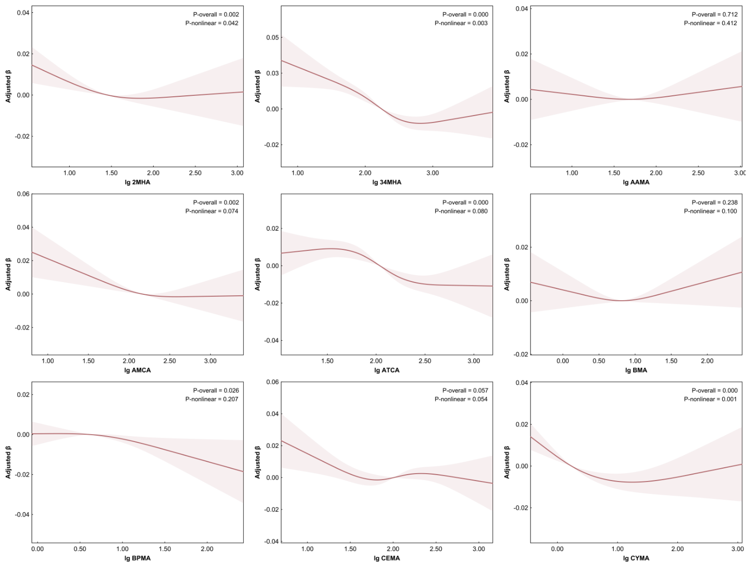

Fig. S2 Restricted cubic spline plots for the association between serum LDH and the remaining 8 mVOCs
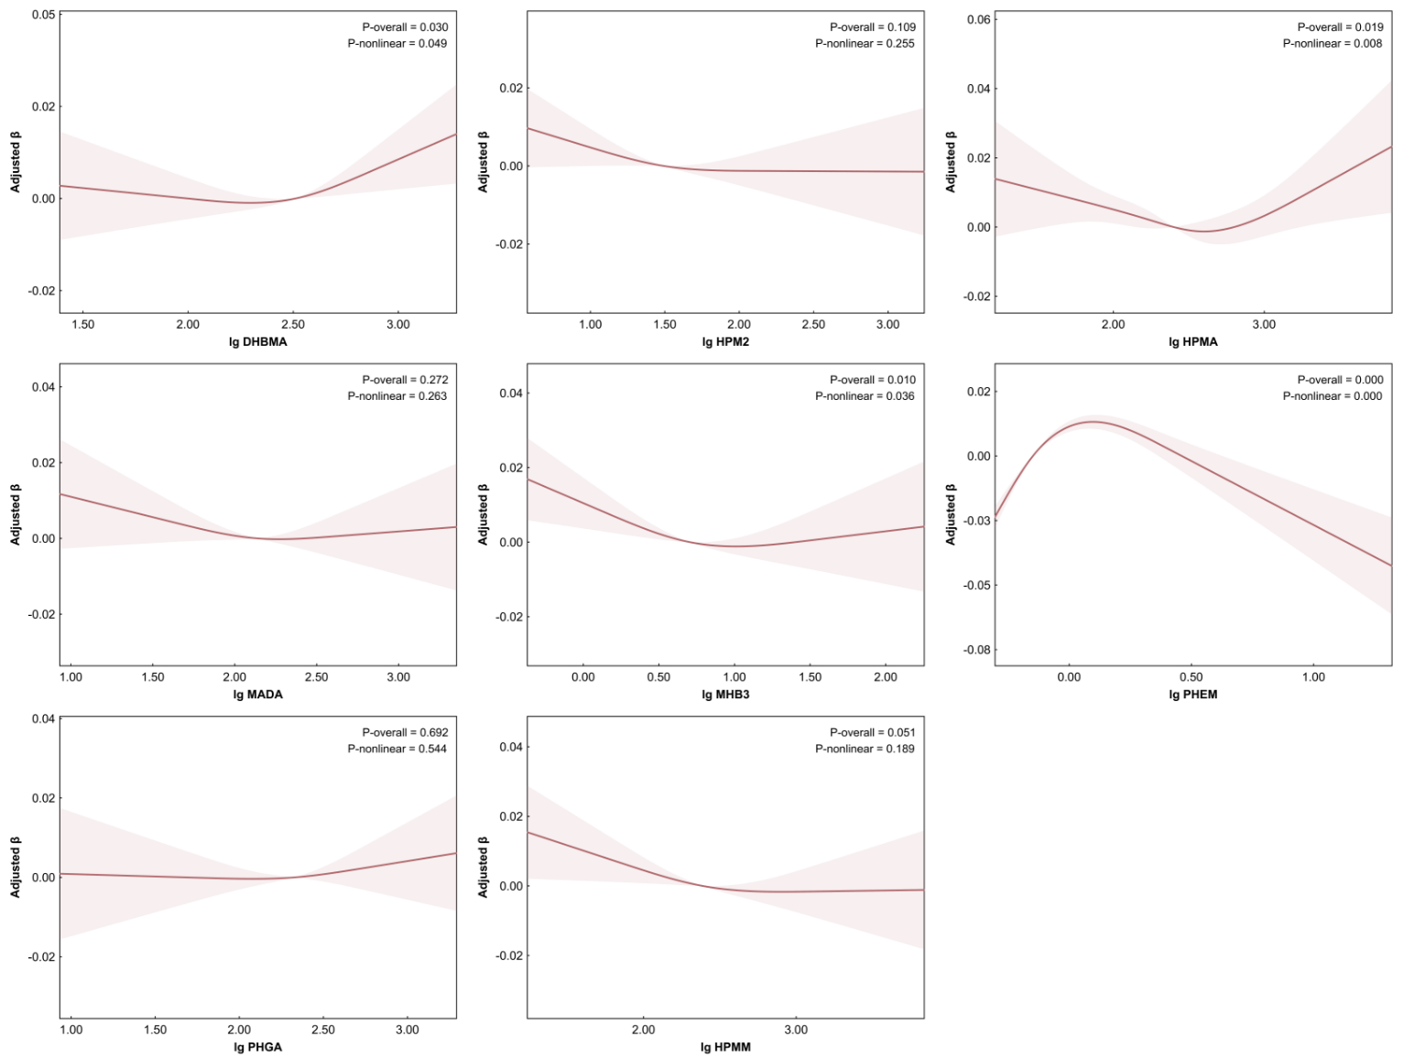
Fig. S3 Restricted cubic spline plots for the association between creatinine-corrected mVOCs and serum LDH (first 9 mVOCs)
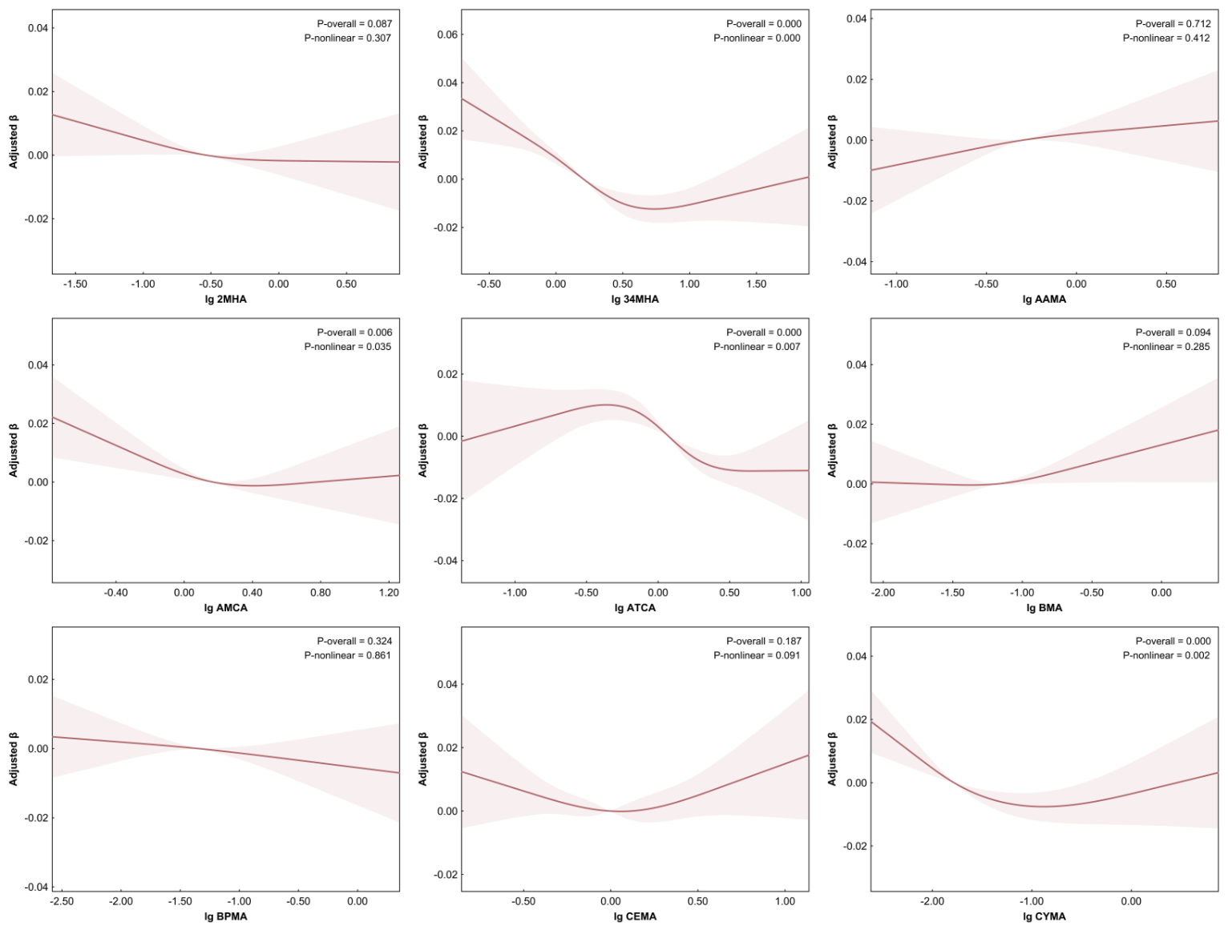
Fig. S4 Restricted cubic spline plots for the association between creatinine-corrected mVOCs and serum LDH (remaining 8 mVOCs)
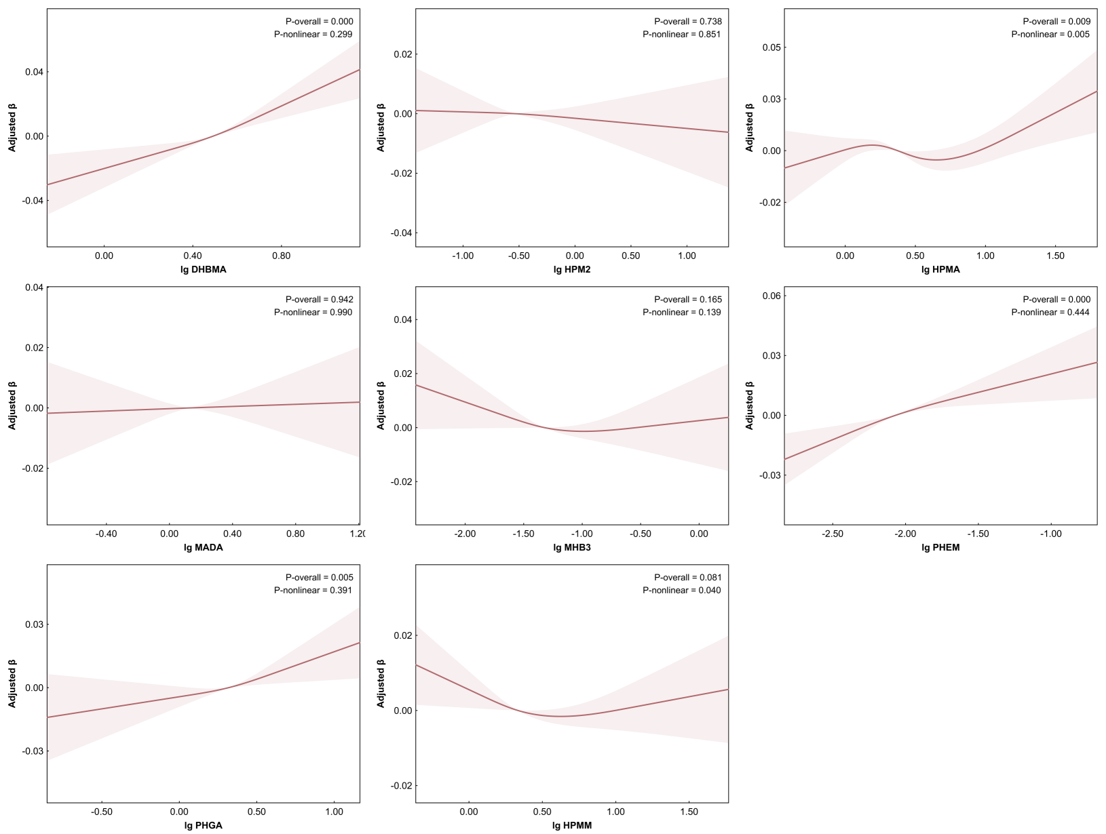
Fig. S5 Weighted quantile sum regression results for the mixture effects of creatinine-corrected mVOCs on serum LDH

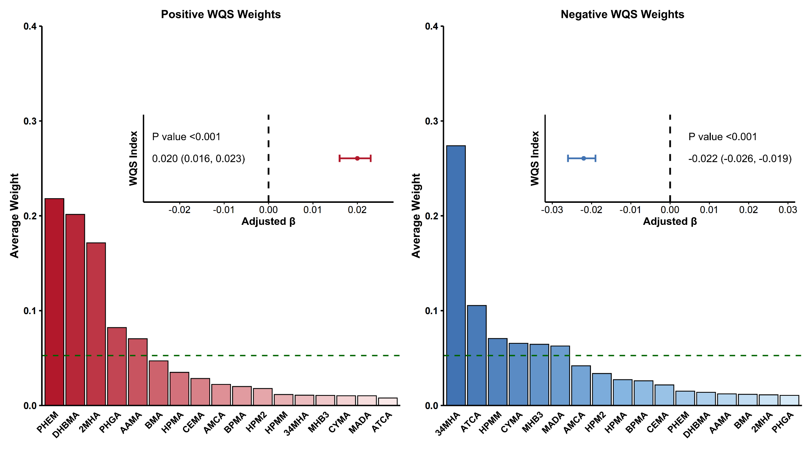
Fig. S6 The quantile g-computation result for the mixture effects of mVOCs on serum LDH
