Supplementary material
Table S1. CONSORT 2010 checklist of information to include when reporting a randomized trial

CONSORT 2010 checklist of information to include when reporting a randomised trial*

Section/Topic | Item No | Checklist item | Reported on page No
Title and abstract
 | 1a | Identification as a randomised trial in the title | 1
 | 1b | Structured summary of trial design, methods, results, and conclusions (for specific guidance see CONSORT for abstracts) | 2
Introduction
Background and objectives | 2a | Scientific background and explanation of rationale | 4-5
Background and objectives | 2b | Specific objectives or hypotheses | 5
Methods
Trial design | 3a | Description of trial design (such as parallel, factorial) including allocation ratio | 6
Trial design | 3b | Important changes to methods after trial commencement (such as eligibility criteria), with reasons | 6-8
Participants | 4a | Eligibility criteria for participants | 6
Participants | 4b | Settings and locations where the data were collected | 7-9
Interventions | 5 | The interventions for each group with sufficient details to allow replication, including how and when they were actually administered | 5-6
Outcomes | 6a | Completely defined pre-specified primary and secondary outcome measures, including how and when they were assessed | 7-9
Outcomes | 6b | Any changes to trial outcomes after the trial commenced, with reasons | Not applicable
Sample size | 7a | How sample size was determined | 6
Sample size | 7b | When applicable, explanation of any interim analyses and stopping guidelines | 6,12
Randomisation:
Sequence generation | 8a | Method used to generate the random allocation sequence | 6
Sequence generation | 8b | Type of randomisation; details of any restriction (such as blocking and block size) | 6
Allocation concealment mechanism | 9 | Mechanism used to implement the random allocation sequence (such as sequentially numbered containers), describing any steps taken to conceal the sequence until interventions were assigned | 6
Implementation | 10 | Who generated the random allocation sequence, who enrolled participants, and who assigned participants to interventions | 6-8
Blinding | 11a | If done, who was blinded after assignment to interventions (for example, participants, care providers, those assessing outcomes) and how | 6-8
Blinding | 11b | If relevant, description of the similarity of interventions
Statistical methods | 12a | Statistical methods used to compare groups for primary and secondary outcomes | 9-10
Statistical methods | 12b | Methods for additional analyses, such as subgroup analyses and adjusted analyses | 9-10
Results
Participant flow (a diagram is strongly recommended) | 13a | For each group, the numbers of participants who were randomly assigned, received intended treatment, and were analysed for the primary outcome | 12
Participant flow (a diagram is strongly recommended) | 13b | For each group, losses and exclusions after randomisation, together with reasons | 12
Recruitment | 14a | Dates defining the periods of recruitment and follow-up | 6
Recruitment | 14b | Why the trial ended or was stopped | Not applicable
Baseline data | 15 | A table showing baseline demographic and clinical characteristics for each group | 12
Numbers analysed | 16 | For each group, number of participants (denominator) included in each analysis and whether the analysis was by original assigned groups | 12
Outcomes and estimation | 17a | For each primary and secondary outcome, results for each group, and the estimated effect size and its precision (such as 95% confidence interval) | 12
Outcomes and estimation | 17b | For binary outcomes, presentation of both absolute and relative effect sizes is recommended | 11-12
Ancillary analyses | 18 | Results of any other analyses performed, including subgroup analyses and adjusted analyses, distinguishing pre-specified from exploratory | 11-12
Harms | 19 | All important harms or unintended effects in each group (for specific guidance see CONSORT for harms) | 11-12
Discussion
Limitations | 20 | Trial limitations, addressing sources of potential bias, imprecision, and, if relevant, multiplicity of analyses | 13-15
Generalisability | 21 | Generalisability (external validity, applicability) of the trial findings | 13-15
Interpretation | 22 | Interpretation consistent with results, balancing benefits and harms, and considering other relevant evidence | 13-15
Other information
Registration | 23 | Registration number and name of trial registry | 6
Protocol | 24 | Where the full trial protocol can be accessed, if available | 6
Funding | 25 | Sources of funding and other support (such as supply of drugs), role of funders | 15

*We strongly recommend reading this statement in conjunction with the CONSORT 2010 Explanation and Elaboration for important clarifications on all the items. If relevant, we also recommend reading CONSORT extensions for cluster randomised trials, non-inferiority and equivalence trials, non-pharmacological treatments, herbal interventions, and pragmatic trials. Additional extensions are forthcoming: for those and for up to date references relevant to this checklist, see www.consort-statement.org.

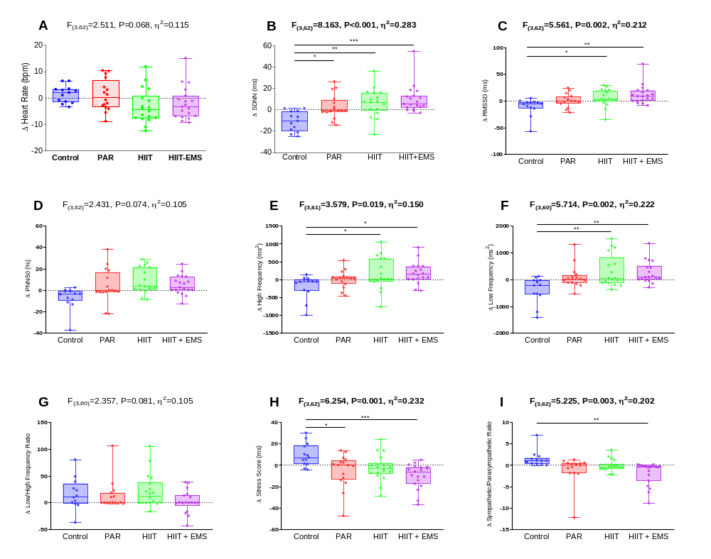Fig. S1. Raw changes in heart rate and heart rate variability parameters after the intervention study in the four groups. Analysis of covariance adjusting for baseline values, with post hoc Bonferroni-corrected t-test. F, p and η² of analysis of variance, * p < 0.05, ** p<0.01, *** p < 0.001. Abbreviations: ∆ Differences between post and pretest, %; percentage, bpm; beats per minute, HIIT; High-Intensity Interval Training group; HIIT+EMS; HIIT plus whole-body electromyostimulation group, Ln; Napierian logarithm, ms; milliseconds, ms²; milliseconds square, PAR; physical activity recommendation from the World Health Organization group, PNN50; percentage of successive RR interval pairs that differ more than 50 ms, RMSSD; Square root of the mean squared differences between successive RR intervals, SDNN; Standard Deviation of RR intervals.
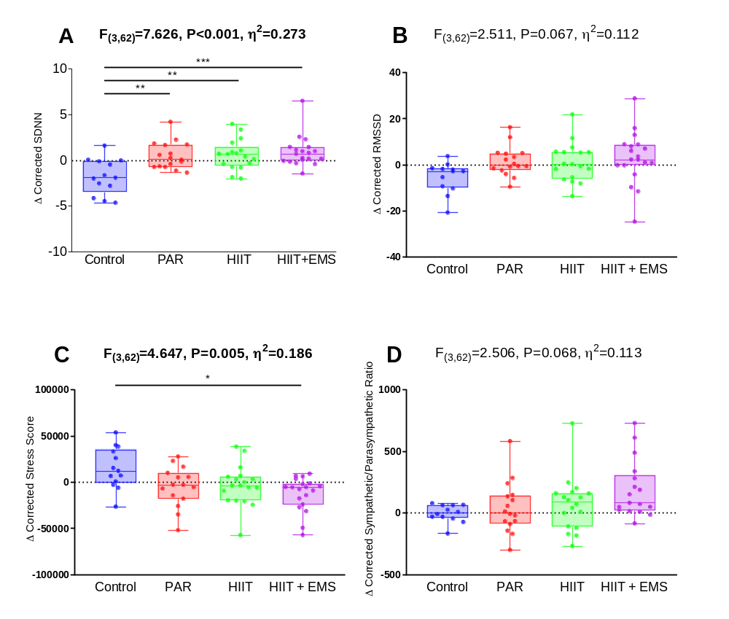
Fig. S2. Raw changes in heart rate variability parameters corrected by medium R-R interval after the intervention study in the four groups. Analysis of covariance adjusting for baseline values, with post hoc Bonferroni-corrected t-test. F, p and η² of analysis of variance, * p < 0.05, ** p<0.01, *** p < 0.001. Abbreviations: ∆ Differences between post and pretest, %; percentage, bpm; beats per minute, HIIT; High-Intensity Interval Training group; HIIT+EMS; HIIT plus whole-body electromyostimulation group, ms; milliseconds, PAR; physical activity recommendation from the World Health Organization group, PNN50; percentage of successive RR interval pairs that differ more than 50 ms, RMSSD; Square root of the mean squared differences between successive RR intervals, SDNN; Standard Deviation of RR intervals

