Supplementary Material

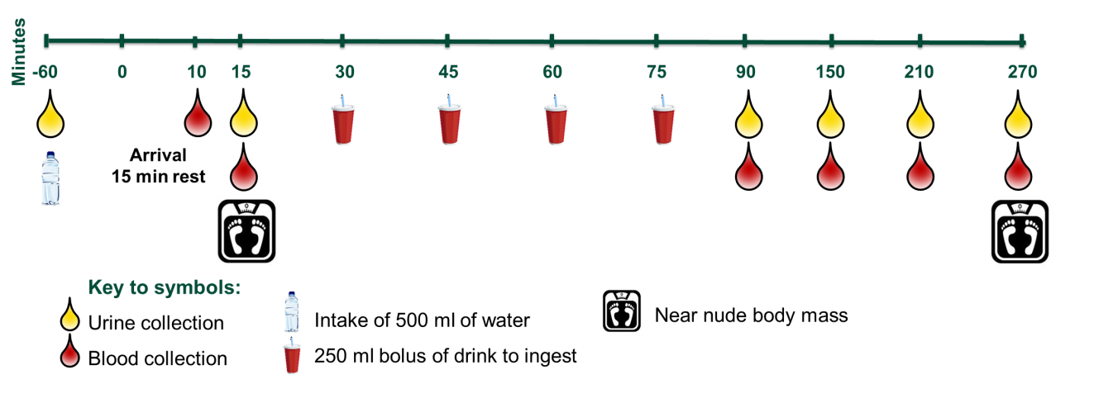
-90 -60 -25 -10 0 15 30 45 60 120 180 240

Appendix 1. Schematic of experimental trial days. All trials were conducted first thing in the morning after an overnight fast.

