Title
Intensity- and time-matched acute interval and continuous endurance exercise similarly induce an anti-inflammatory environment in recreationally active runners: focus on T_{regs} and the IL-6/IL-10 axis

Journal
European Journal of Applied Physiology

Authors and affiliations
Sebastian Proschinger¹, Alexander Schenk¹, Inga Weßels², Lars Donath³, Ludwig Rappelt³, Alan J. Metcalfe⁴, Philipp Zimmer¹

¹TU Dortmund University, Institute for Sport and Sport Science, Division of Performance and Health (Sports Medicine), 44227 Dortmund, Germany
²RWTH Aachen University, Institute of Immunology, Faculty of Medicine, 52074 Aachen, Germany
³Department of Intervention Research in Exercise Training, German Sport University Cologne, Cologne, Germany
⁴Department for Molecular and Cellular Sports Medicine, Institute of Cardiovascular Research and Sports Medicine, German Sport University Cologne, Cologne, Germany

Corresponding author: Prof. Philipp Zimmer, philipp.zimmer@tu-dortmund.de

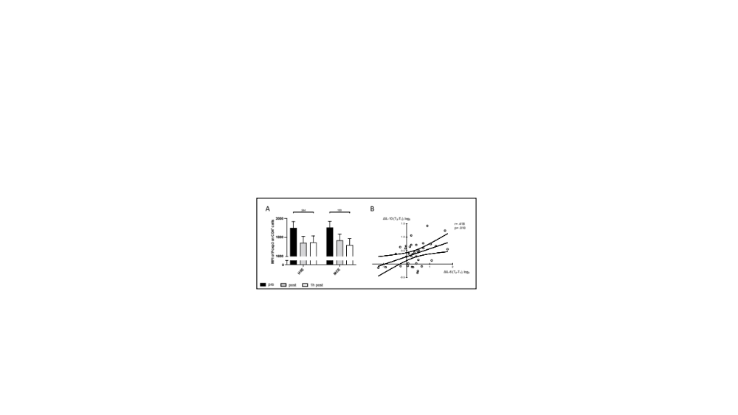
Fig. S1 Changes in levels of Foxp3 (within CD4⁺ cells) (A) are presented for high-intensity interval exercise (HIIE) and moderate continuous exercise (MCE), respectively. Correlation analysis are presented between delta changes of IL-6 (ΔT2-T1) and IL-10 (ΔT3-T1) (B). Data is presented as mean ± SEM. HIIE: high-intensity interval exercise, MCE: moderate continuous exercise, MFI: median fluorescense intesity, T₁: pre exercise, T₂: immediately post exercise, T₃: one hour post exercise

Tab. S1 Detailed Mixed Model or Repeated Measures results separated by group and main effects for reported outcome measures.
 |  | Group |  |  | Main effects
Outcome |  | MCE | HIIE |  |  | Time | Group | Time x  Group
MFI PD-1 on T_{regs}
 | Pre | 2576.9 ± 55.3 | 2579.7 ± 56.5
 | Post | 2502.6 ± 55.3 | 2579.2 ± 56.5 |  | F-value: | 31.109 | 0.00003 | 1.292
 | 1h post | 2932.3 ± 56.4*** | 2851.9 ± 56.5*** |  | p-value: | <0.001 | 0.996 | 0.280
MFI Foxp3 on CD4⁺
 | Pre | 1903.106 ± 66.1 | 1898.218 ± 67.5
 | Post | 1768.28 ± 66 | 1742.968 ± 67.5 |  | F-value: | 4.573 | 0.0002 | 0.098
 | 1h post | 1719.579 ± 67.4 | 1747.127 ± 67.5 |  | p-value: | 0.013 | 0.989 | 0.907
MFI Foxp3 on CD4⁺
pooled | Pre | 1900662 ± 47.2
 | Post | 1755.624 ± 47.2
 | 1h post | 1733.353 ± 47.7*
T_{regs} [*10⁶/μl]
 | Pre | 9.464 ± 0.654 | 9.114 ± 0.682
 | Post | 9.342 ± 0.666 | 8.446± 0.682 |  | F-value: | 7.882 | 0.606 | 0.174
 | 1h post | 7.039 ± 0.666* | 6.856± 0.682* |  | p-value: | <0.001 | 0.441 | 0.841
T_{regs} [% CD4⁺]
 | Pre | 3.027 ± 0.196 | 2.963 ± 0.196
 | Post | 2.410 ± 0.196 | 1.919 ± 0.196* |  | F-value: | 9.017 | 1.573 | 0.829
 | 1h post | 2.507 ± 0.200 | 2.468 ± 0.196 |  | p-value: | <0.001 | 0.217 | 0.440
PD1⁺ eT_{regs} [*10⁶/μl]
 | Pre | 2.785 ± 0.204 | 2.739 ± 0.208
 | Post | 2.738 ± 0.204 | 2.519 ± 0.208* |  | F-value: | 6,618 | 1,245 | 0,470
 | 1h post | 2.211 ± 0.208 | 2.090 ± 0.208 |  | p-value: | 0,002 | 0,271 | 0,626
PD1⁺ eT_{regs} [% CD4⁺]
 | Pre | 0.806 ± 0.057 | 0.782 ± 0.058
 | Post | 0.611 ± 0.058 | 0.523 ± 0.058* |  | F-value: | 8.677 | 0.529 | 0.350
 | 1h post | 0.749 ± 0.058 | 0.758 ± 0.058 |  | p-value: | <0.001 | 0.471 | 0.705
nT_{regs} [*10⁶/μl]
 | Pre | 0.993 ± 0.100 | 0.962 ± 0.105
 | Post | 0.959 ± 0.102 | 0.723 ± 0.105* |  | F-value: | 20.660 | 2.077 | 1.254
 | 1h post | 0.583 ± 0.105* | 0.496 ± 0.105* |  | p-value: | <0.001 | 0.157 | 0.290
nT_{regs} [% CD4⁺]
 | Pre | 0.387 ± 0.043 | 0.409 ± 0.038
 | Post | 0.292 ± 0.039 | 0.214 ± 0.035*** |  | F-value: | 12.915 | 2.545 | 0.927
 | 1h post | 0.315 ± 0.040 | 0.164 ± 0.032*** |  | p-value: | <0.001 | 0.119 | 0.400
IL-10 (pg/ml), log₂
 | Pre | 4.454 ± 0.0763 | 4.454 ± 0.0763
 | Post | 4.646 ± 0.0763 | 4.734 ± 0.0763* |  | F-value: | 16.399 | 1.965 | 1.414
 | 1h post | 4.725 ± 0.0778* | 4.951 ± 0.0764*** |  | p-value: | <0.001 | 0.168 | 0.248
IL-6 (pg/ml), log₂
 | Pre | 3.389 ± 0.1275 | 3.376 ± 0.1245
 | Post | 3.859 ± 0.1304* | 3.813 ± 0.1273* |  | F-value: | 7.837 | 0.016 | 0.031
 | 1h post | 3.709 ± 0.1337 | 3.722 ± 0.1273 |  | p-value: | 0.001 | 0.900 | 0.970
Data is presented as mean ± SEM. eT_{regs}: effector T_{regs}. HIIE: high-intensity interval exercise. MCE: moderate continuous exercise. MFI: median fluorescence intensity. nT_{regs}: naive T_{regs}. PD-1: programmed cell death protein 1. T_{regs}: CD4⁺ regulatory T cells; *different from baseline .005 < p ≤ .05. **different from baseline .001 < p ≤ .005. ***different from baseline p ≤ .001

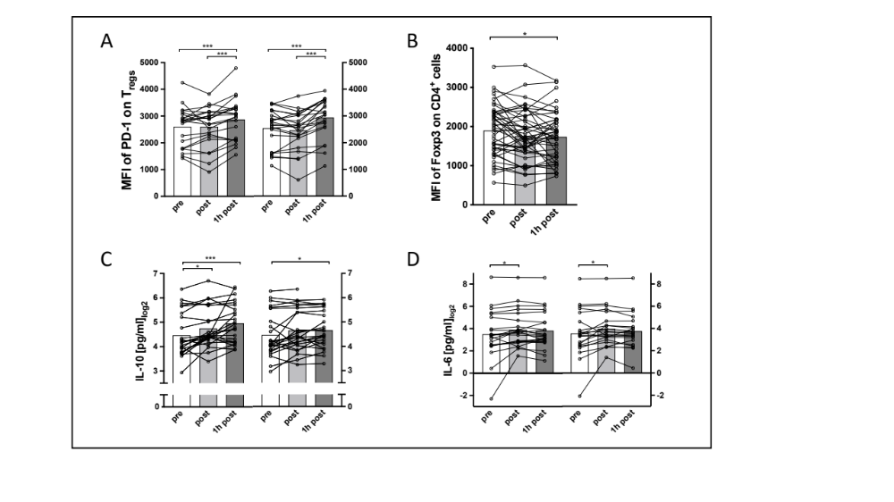
Fig. S2 Connected individual data points of respective outcomes. The left part of A, C, and D represents the HIIE condition, whereas the right part represents the MCE condition. In C, pooled HIIE and MCE data are shown, since only main effects were detected.

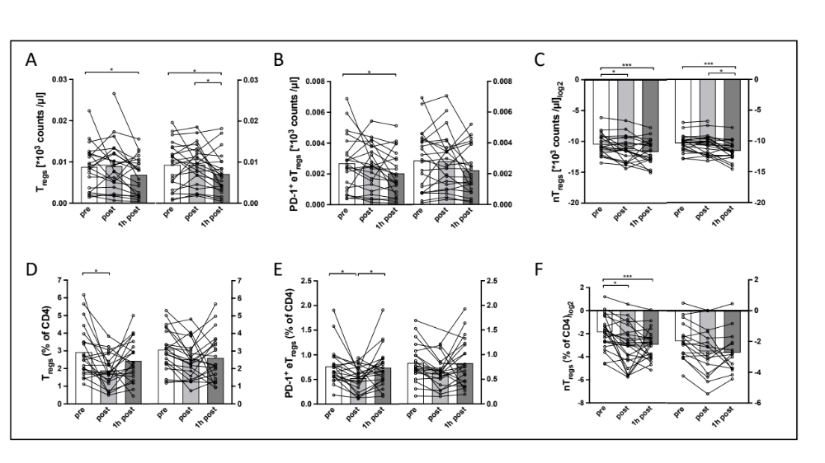
Fig. S3 Connected individual data points of respective outcomes. The left part of each figure represents the HIIE condition, whereas the right part represents the MCE condition.

