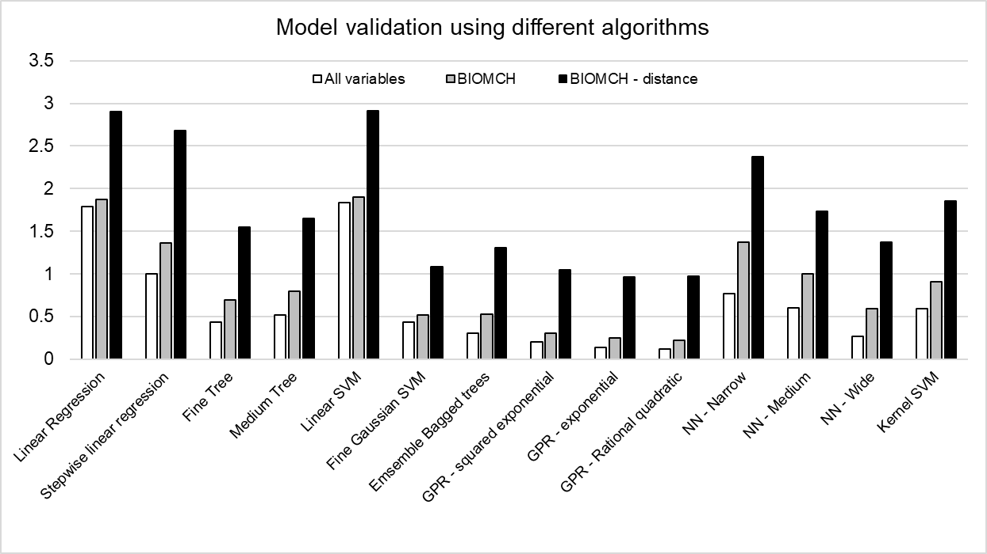

Supplementary Figure 1. Prediction error (in RPE points) when applying different machine learning algorithms to predict RPE using age, body mass and body height combined with running biomechanical data (All variables, white bars), only biomechanical data (BIOMCH, gray bars) and only biomechanical data except running distance (BIOMCH – distance, black bars).SVM = support vector machine; GPR: gaussian process regression; NN = 2-layer neural network.

