Supplementary Material A of:
Eight weeks of high-intensity interval training versus stretching do not change the psychoneuroendocrine response to a social stress test in emotionally impulsive humans
Running title: HIIT and the psychoneuroendocrine stress response

F. Javelle^{1*}, W. Bloch¹, U. Borges^{2,3}, T. Burberg⁴, B. Collins¹, N. Gunasekara¹, T. Hosang⁵, T. Jacobsen⁵, S. Laborde², A. Löw⁵, A. Schenk⁶, M.L. Schlagheck⁶, D. Schoser⁷, A. Vogel⁸, D. Walzik⁶, P. Zimmer⁶

As described in the article, the Positive and Negative Affect Schedule (Watson & Clark, 1999) and the Pittsburgh Sleep Quality Index (Buysse et al., 1989)(T0, T8) were presented to each participant before the TSST for explorative control over potential chronic covariates. For the same reasons, four additional visual analogue scales (i.e., sleep, nutrition, cigarette consumption [only for smokers], and alcohol consumption) and one question about adverse events were presented to each participant after the TSST at T8. The description and the results of these additional questionnaires are given below and not in the main article due to a lack of focus in the manuscript.
2. Methods
2.1 Pittsburgh Sleep Quality Index (PSQI) (Buysse et al., 1989)
The PSQI is the most widely used index of insomnia and sleep problems, with seven subscales covering subjective sleep quality, sleep latency, sleep duration, habitual sleep efficiency, sleep disturbances, use of sleep medication, and daytime dysfunction. Participants were asked to consider their past four weeks. The German-validated version was used (Backhaus & Riemann, 1996).
2.2 Positive and Negative Affect Schedule (PANAS) (Watson & Clark, 1999)
The PANAS is a widely used 20-item self-report measure (Watson and Clark 1999) that assesses the specific distinguishable states that emerge from the general dimension of positive and negative emotional experiences. Each adjective used in this test is answered on a Likert scale (from 1 “I strongly disagree” to 5 “I strongly agree”) to indicate the extent to which one feels at the moment of completion. The German-validated version was used (Breyer & Bluemke, 2016).
2.3 Visual analogue scales
Some brief additional questions were gathered in a subjective perception questionnaire to evaluate how participants perceived the effects of the intervention. These questions were visual analogue scales from 1 to 10 (1: “Yes, negative”; 5: “No change”; 10: “Yes, positive”), asking to rate the changes in their sleep quality, nutrition quality (in terms of health), cigarettes consumption (only for smokers) and alcohol consumption.
3. Results
3.1 Sleep quality
When adjusted for baseline level and controlled for gender, the PSQI had a significant time effect (n=45, p<.050, ƞ_{p}²=.149). No group and interaction effects were detected (n=45, p=.228, ƞ_{p}²=.035).
3.2 PANAS
When adjusted for baseline level and controlled for gender, the Positive Affects had a significant time effect (n=45, p<.010, ƞ_{p}²=.183). No group and interaction effects were detected (n=45, p=.086, ƞ_{p}²=.070). When adjusted for baseline level and controlled for gender, the Negative Affects had a significant time effect (n=45, p<.010, ƞ_{p}²=.161). No group and interaction effects were detected (n=45 p=.100, ƞ_{p}²=.065).
3.3 Visual Analogue Scales
Sleep: When controlled for gender, no group difference in the perceived sleep quality was detected (n=45, p=.082, ƞ_{p}²=.070).
Nutrition: When controlled for gender, no group difference in the nutrition quality was detected (n=45, p=.264, ƞ_{p}²=.030).
Cigarettes: The four smokers in the stretching group and the one in the HITT group reported decreased cigarette consumption.
Alcohol: When controlled for gender, no group difference in the perceived alcohol consumption was detected (n=45, p=.885, ƞ_{p}²=.001).
3.4 Additional Figures and Tables
Table 1
Participants’ not adjusted results with skewness and kurtosis per timepoint.
 | Timepoint | raw mean ±SD | Skewness | Kurtosis
Stress reactivity (ng/mL) | T0 | 3.786 ±4.112 | 2.429 | 6.855
Stress reactivity (ng/mL) | T8 | 2.748 ±3.124 | 1.627 | 1.810
_{log} ₍₂ ₊ Stress reactivity₎ | T0 | 0.691 ±.232 | 1.001 | 0.657
_{log} ₍₂ ₊ Stress reactivity₎ | T8 | 0.606 ±.237 | 0.801 | -0.292
Cortisol max (ng/mL) | T0 | 5.616 ±5.075 | 2.990 | 11.704
Cortisol max (ng/mL) | T8 | 4.281 ±3.765 | 1.841 | 2.842
_{log} Cortisol max | T0 | 0.636 ±.304 | 0.445 | 0.289
_{log} Cortisol max | T8 | 0.507 ±.318 | 0.566 | -0.284
AUC_{G} | T0 | 378.659 ±355.865 | 3.834 | 18.327
AUC_{G} | T8 | 308.148 ±274.129 | 2.333 | 5.895
_{log} AUC_{G} | T0 | 2.477 ±.276 | 0.705 | 1.493
_{log} AUC_{G} | T8 | 2.365 ±.328 | 0.026 | 0.775
SE | T0 | 2.812 ±.325 | -0.706 | 0.637
SE | T8 | 3.055 ±.417 | -0.381 | 0.294
Worries | T0 | 2.233 ±.507 | -0.017 | 0.237
Worries | T8 | 1.900 ±.617 | 0.648 | 0.246
Tension | T0 | 2.710 ±.590 | -0.083 | -0.339
Tension | T8 | 2.238 ±.620 | 0.395 | -0.613
Joy | T0 | 2.476 ±.634 | -0.039 | -0.590
Joy | T8 | 2.805 ±.577 | -0.608 | 0.235
Δ _{log}Theta/_{log}Beta-2 _{close} | T0 | 0.042 ±.066 | 1.423 | 1.662
Δ _{log}Theta/_{log}Beta-2 _{close} | T8 | -0.036 ±.080 | -0.081 | 0.199
Δ_{log}Theta/_{log}Beta-2 _{open} | T0 | -0.033 ±.069 | -0.250 | -0.377
Δ_{log}Theta/_{log}Beta-2 _{open} | T8 | -0.030 x10⁻¹⁵ ±0.076 x10⁻¹⁵ | 0.016 | -0.144
Δ_{log}Theta _{close} | T0 | -0.076 x10⁻¹⁵ ±0.172 x10⁻¹⁵ | -1.475 | 2.763
Δ_{log}Theta _{close} | T8 | 0.041 x10⁻¹⁵ ±0.104 x10⁻¹⁵ | -1.166 | 2.662
Δ_{log}Theta _{open} | T0 | -0.044 x10⁻¹⁵ ±0.188 x10⁻¹⁵ | -0.651 | 0.551
Δ_{log}Theta _{open} | T8 | -0.036 x10⁻¹⁵ ±0.098 x10⁻¹⁵ | -0.288 | -0.286
Δ_{log}Beta-2 _{close} | T0 | 0.058 x10⁻¹⁵ ±0.150 x10⁻¹⁵ | 0.639 | -0.056
Δ_{log}Beta-2 _{close} | T8 | 0.034 x10⁻¹⁵ ±0.121 x10⁻¹⁵ | 0.332 | 0.500
Δ_{log}Beta-2 _{open} | T0 | 0.044 x10⁻¹⁵ ±0.154 x10⁻¹⁵ | 0.988 | 2.134
Δ_{log}Beta-2 _{open} | T8 | 0.035 x10⁻¹⁵ ±0.166 x10⁻¹⁵ | 0.038 | -0.882
Δ_{log}RMSSD _{close} | T0 | 0.006 ±.133 | -0.759 | 0.937
Δ_{log}RMSSD _{close} | T8 | 0.041 ±.121 | 0.489 | 0.223
Δ_{log}RMSSD _{open} | T0 | 0.000 ±.132 | -0.645 | 0.813
Δ_{log}RMSSD _{open} | T8 | 0.034 ±.124 | 0.583 | 0.198
AUC_{G}: Area Under the Curve with respect to the ground; SE: Self-Efficacy; Δ: delta; SD: standard deviation

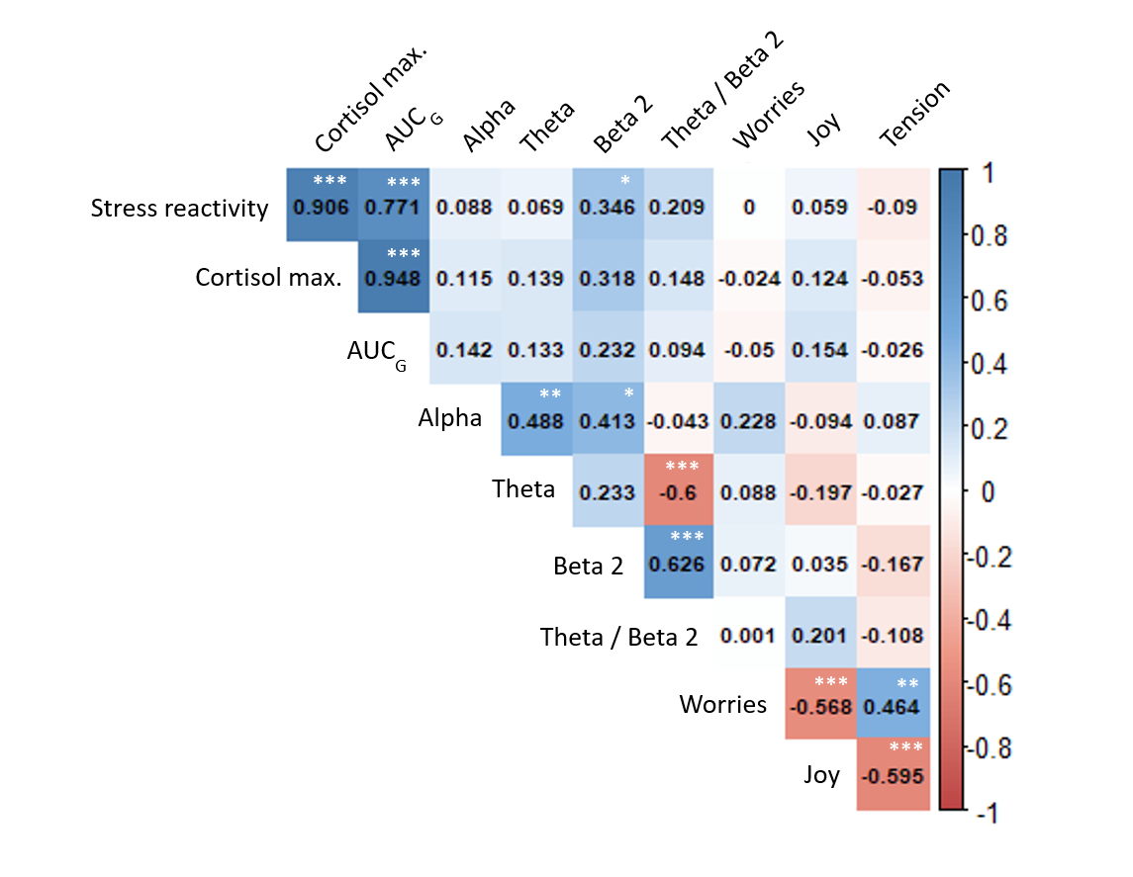

Figure 1: Pearson’s correlation between stress markers at T0 (n=42). EEG activity markers are delta (post-pre) and with eyes closed (n=36). SE: self-efficacy. AUC_{G}: area under the curve with respect to the ground. *: p<.050, **:p<.010, ***:p<.001.
Figure 1 reports the correlation coefficients between stress markers at T0. To avoid overloading the figure, only the EEG with eyes closed (standard set-up and the most direct measurements post-TSST) was included in Figure 1. One can still note that the correlation between stress reactivity and beta-2 with eyes closed disappears with eyes opened (n=36, r=.186, p=.279).
4. References
Backhaus J & Riemann D (1996). Schlafstörungen bewältigen : Informationen und Anleitung zur Selbsthilfe. Available at: https://www.abebooks.co.uk/Schlafstörungen-bewältigen-Informationen-Anleitung-Selbsthilfe-Backhaus/30666959189/bd [Accessed August 31, 2021].
Breyer B & Bluemke M (2016). Deutsche Version der Positive and Negative Affect Schedule PANAS. Zusammenstellung sozialwissenschaftlicher Items und Skalen. Available at: https://search.gesis.org/instruments_tools/zis242 [Accessed September 6, 2021].
Buysse DJ, Reynolds CF, Monk TH, Berman SR & Kupfer DJ (1989). The Pittsburgh Sleep Quality Index: a new instrument for psychiatric practice and research. Psychiatry Res 28, 193–213.
Watson D & Clark L (1999). The PANAS-X Manual for the Positive and Negative Affect Schedule-Expanded Form. Iowa Res Online 277, 1–27.

