Differences in the ventilatory thresholds in treadmill according to training status in 971 males and 301 females: a cross-sectional study
José Antonio Benítez-Muñoz¹*, Pedro J. Benito¹, Isabel Guisado-Cuadrado¹, Rocío Cupeiro¹ and Ana Belén Peinado¹
European Journal of Applied Physiology
¹LFE Research Group. Department of Health and Human Performance. Faculty of Physical Activity and Sport Science (INEF). Universidad Politécnica de Madrid. Madrid. 28040. Spain. joseantonio.benitez.munoz@upm.es

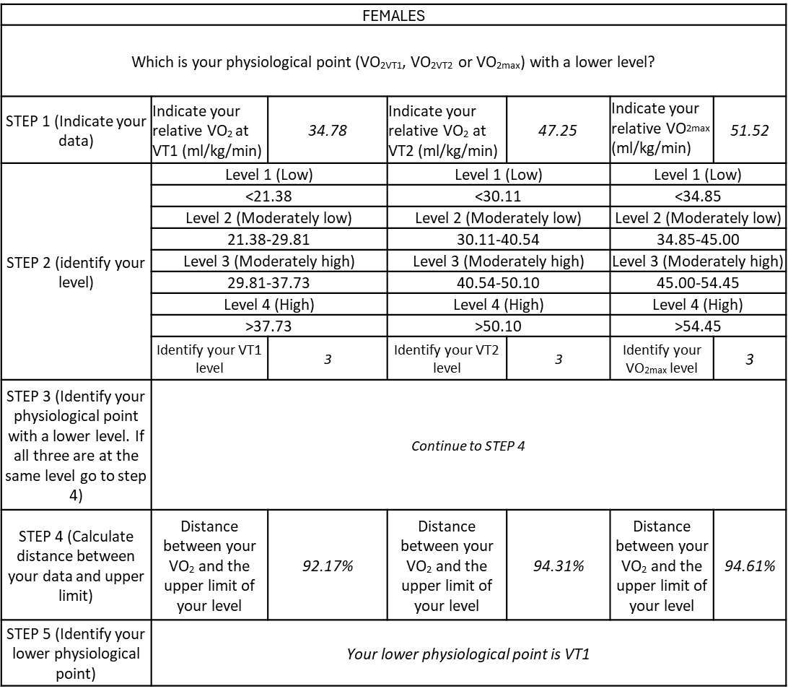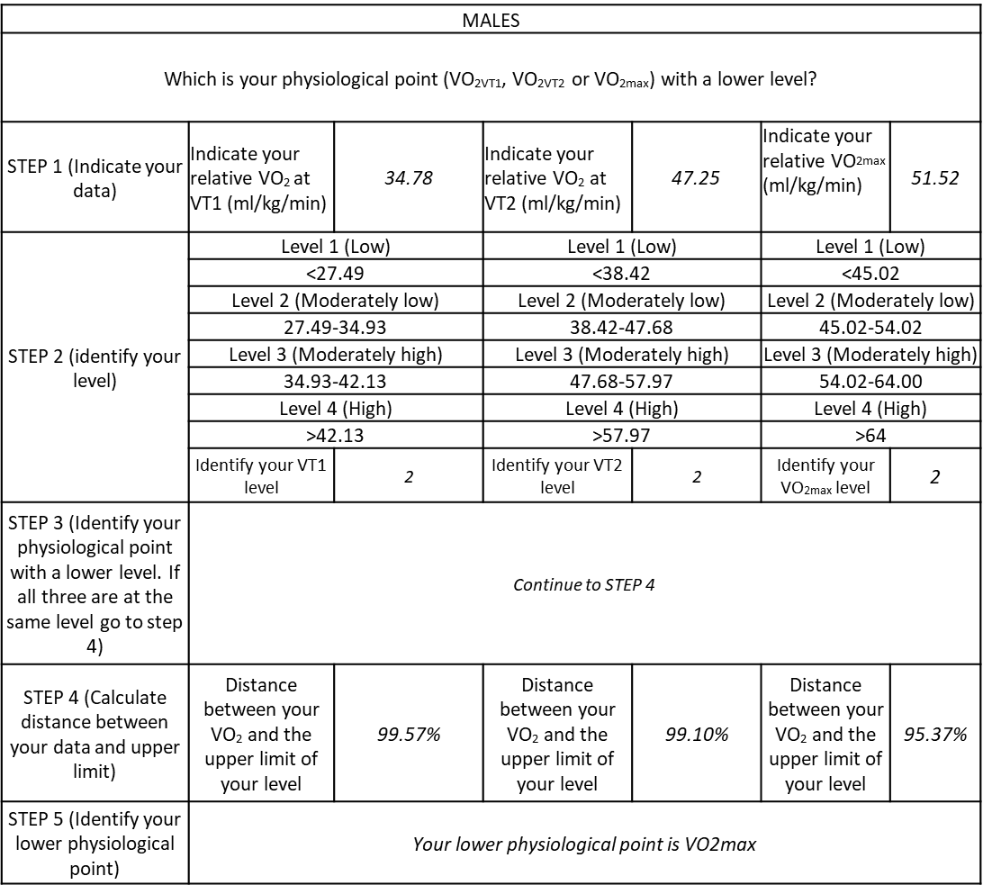
Figure S1. Practical tool to help to classify participant according to training status of the three main physiological points. In italics appears a real example of a participant.

