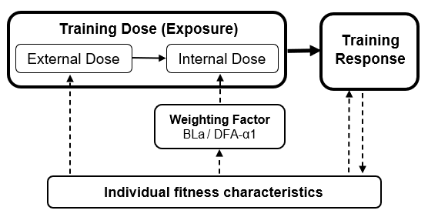
Supplementary Figure 1. Conceptual training dose-response relationship wherein weighting factors mediate the influence of individual fitness characteristics on the internal dose and thus the overall training exposure. Abbreviations: BLa, blood lactate; DFA-α1; detrended fluctuation analysis of heart rate variability.

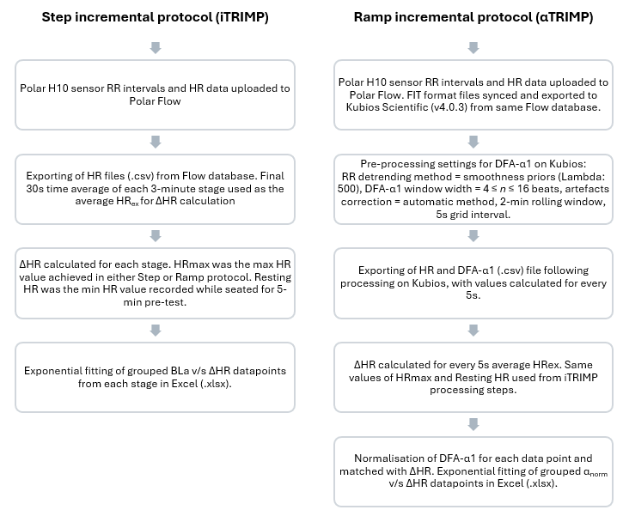
Supplementary Figure 2. Schematic representation of the pre- and post-processing steps for HR and RR intervals data during TRIMPs generation process. Abbreviations: BLa, blood lactate; DFA-α1; detrended fluctuation analysis of heart rate variability, ΔHR = fractional elevation in HR.
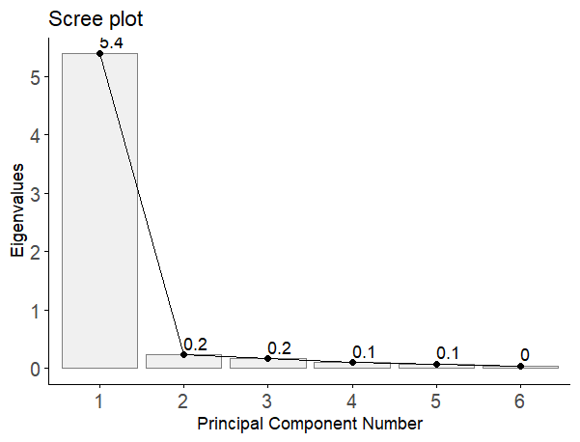
Supplementary Figure 2. Scree plot of all 6 principal components (PCs) based on cardiorespiratory fitness variables (vLT₁, vLT₂, vVT₁, vVT₂, V̇O_{2max} and vV̇O_{2max}) with their eigenvalues.

Supplementary Table 1. Specifications of principal component regression models to assess the relationship between cardiorespiratory fitness (PC1) and weighting factors of iTRIMP and αTRIMP (BLa and α_{norm}).
 | Predictors |  |  |  | Model Fit
Variable | Intercept | PC1 | (PC1)² |  | AIC | RMSE | R² | MAE | n
Weightings at standardised ΔHR of 0.5 and 0.75 and cardiorespiratory fitness (PC1) models
BLa (ΔHR = 0.5) | 1.24 | -0.16  [-0.23 to -0.08] | 0.01  [-0.01 to 0.03] |  | 46.18 | 0.41 (0.25) | 0.71 (0.31) | 0.34 (0.19) | 31
α_{norm} (ΔHR = 0.5) | 0.33 | -0.09  [-0.12 to -0.05] | 0.02  [0.01 to 0.03] |  | -5.18 | 0.18 (0.11) | 0.78 (0.24) | 0.15 (0.07) | 31
BLa (ΔHR = 0.75) | 2.28 | -0.26  [-0.36 to -0.16] | 0.04  [0.00 to 0.07] |  | 63.01 | 0.54 (0.31) | 0.77 (0.27) | 0.45 (0.27) | 31
α_{norm} (ΔHR = 0.75) | 0.81 | -0.43  [-0.64 to -0.23] | 0.10  [0.04 to 0.15] |  | 77.01 | 1.04 (0.73) | 0.67 (0.39) | 0.78 (0.44) | 31
Individual coefficients and cardiorespiratory fitness (PC1) models
BLa intercept (coefficient a) | 0.39 | -0.05 [-0.10, 0.00] | / |  | 14.17 | 0.23 (0.18) | 0.67 (0.38) | 0.19 (0.11) | 31
α_{norm} intercept (coefficient p) | 0.06 | 0.01 [0.00, 0.02] | / |  | -108.09 | 0.04 (0.01) | 0.52 (0.40) | 0.03 (0.01) | 31
BLa slope (coefficient b) | 2.75 | 0.12  [0.00 to 0.24] | / |  | 75.39 | 0.72 (0.24) | 0.65 (0.34) | 0.64 (0.21) | 31
α_{norm} slope (coefficient q) | 3.59 | -0.28  [-0.42 to -0.13] | / |  | 86.27 | 0.83 (0.41) | 0.61 (0.43) | 0.72 (0.35) | 31
BLa = blood lactate, α_{norm} = DFA-α1 (normalised), PC1 = principal component 1 (or CRF_{m}), ΔHR = fractional elevation in HR, AIC = Akaike information criterion, RMSE = root mean square error, MAE = mean absolute error.

