Supplementary material – Depiction of the lifting task


Fig 1 The subject moves the load downwards.

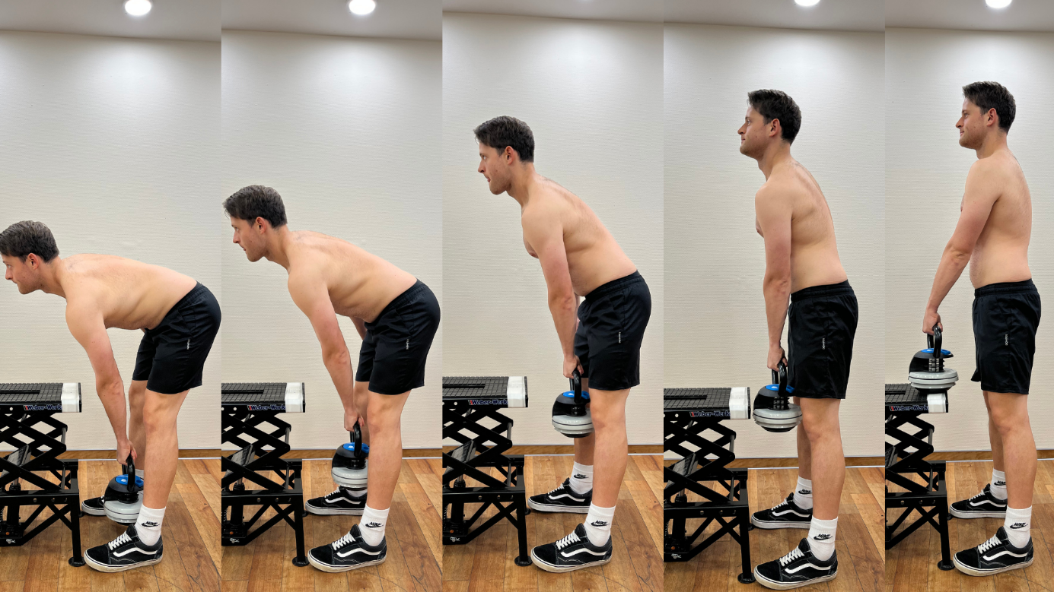
Fig 2 The subject moves the load upwards.

