Online Resource 1
Supplementary analyses
Exploratory model comparisons showed that adding sex did not improve model fit for LT1_{rel} in either the vLapeak model, F(1, 177) = 0.25, p = 0.618, or the vLamax_{blood} model, F(1, 177) = 0.11, p = 0.744. Likewise, sex × predictor interaction terms provided no additional explanatory value in the vLapeak model, F(3, 174) = 0.45, p = 0.721, or the vLamax_{blood} model, F(3, 174) = 0.45, p = 0.715. For LT2_{rel}, adding sex also did not improve the vLapeak model, F(1, 177) = 0.28, p = 0.600, or the vLamax_{blood} model, F(1, 177) = 0.36, p = 0.549. Sex × predictor interaction terms likewise did not improve model fit in the vLapeak model, F(3, 174) = 0.51, p = 0.676, or the vLamax_{blood} model, F(3, 174) = 0.40, p = 0.751. Standardised regression coefficients and 95% confidence intervals from the exploratory vLapeak models including sex are shown in Supplementary Figure S2. Corresponding bivariate associations for vLamax_{blood} are shown in Supplementary Figure S1. Additional sensitivity analyses using fixed lactate thresholds showed that vLapeak and vLamax_{blood} were negatively associated with body-mass-normalised power output at blood lactate concentrations of 2 and 4 mmol·L⁻¹. In contrast, neither vLapeak nor vLamax_{blood} was associated with Fat_{max} after accounting for relative V̇O_{2max} and gross efficiency. Full results are provided in Supplementary Table S1. Supplementary analyses using absolute LT1 and LT2 in watts showed a comparable pattern to the primary relative models. Higher vLapeak and vLamax_{blood} were associated with lower absolute LT1 and LT2, whereas absolute V̇O_{2max} and gross efficiency were positively associated with both outcomes. Full estimates are provided in Supplementary Table S2. Sensitivity analyses excluding gross efficiency showed lower explained variance for LT1_{rel} and LT2_{rel} than the corresponding primary models. Both vLapeak and vLamax_{blood} remained negatively associated with the outcomes after accounting for relative V̇O_{2max}. Full estimates are provided in Supplementary Table S3. In models using relative mean sprint power instead of vLapeak, relative mean sprint power was not significantly associated with LT1_{rel} or LT2_{rel}. Full estimates are provided in Supplementary Table S4.
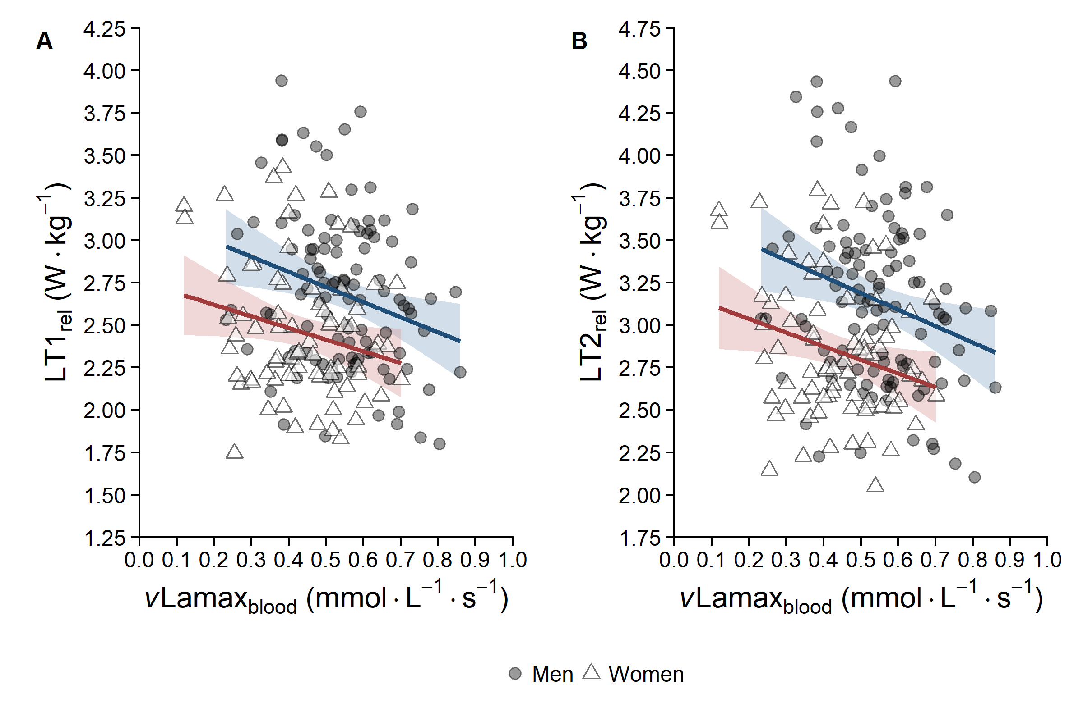Supplementary Fig. S1 Associations between vLamax_{blood} and body-mass-normalised lactate turnpoints in cyclists and triathletes. Panel A shows LT1_{rel} and Panel B shows LT2_{rel}. Symbols indicate individual participants stratified by sex, and lines represent sex-specific linear trends with 95% confidence intervals

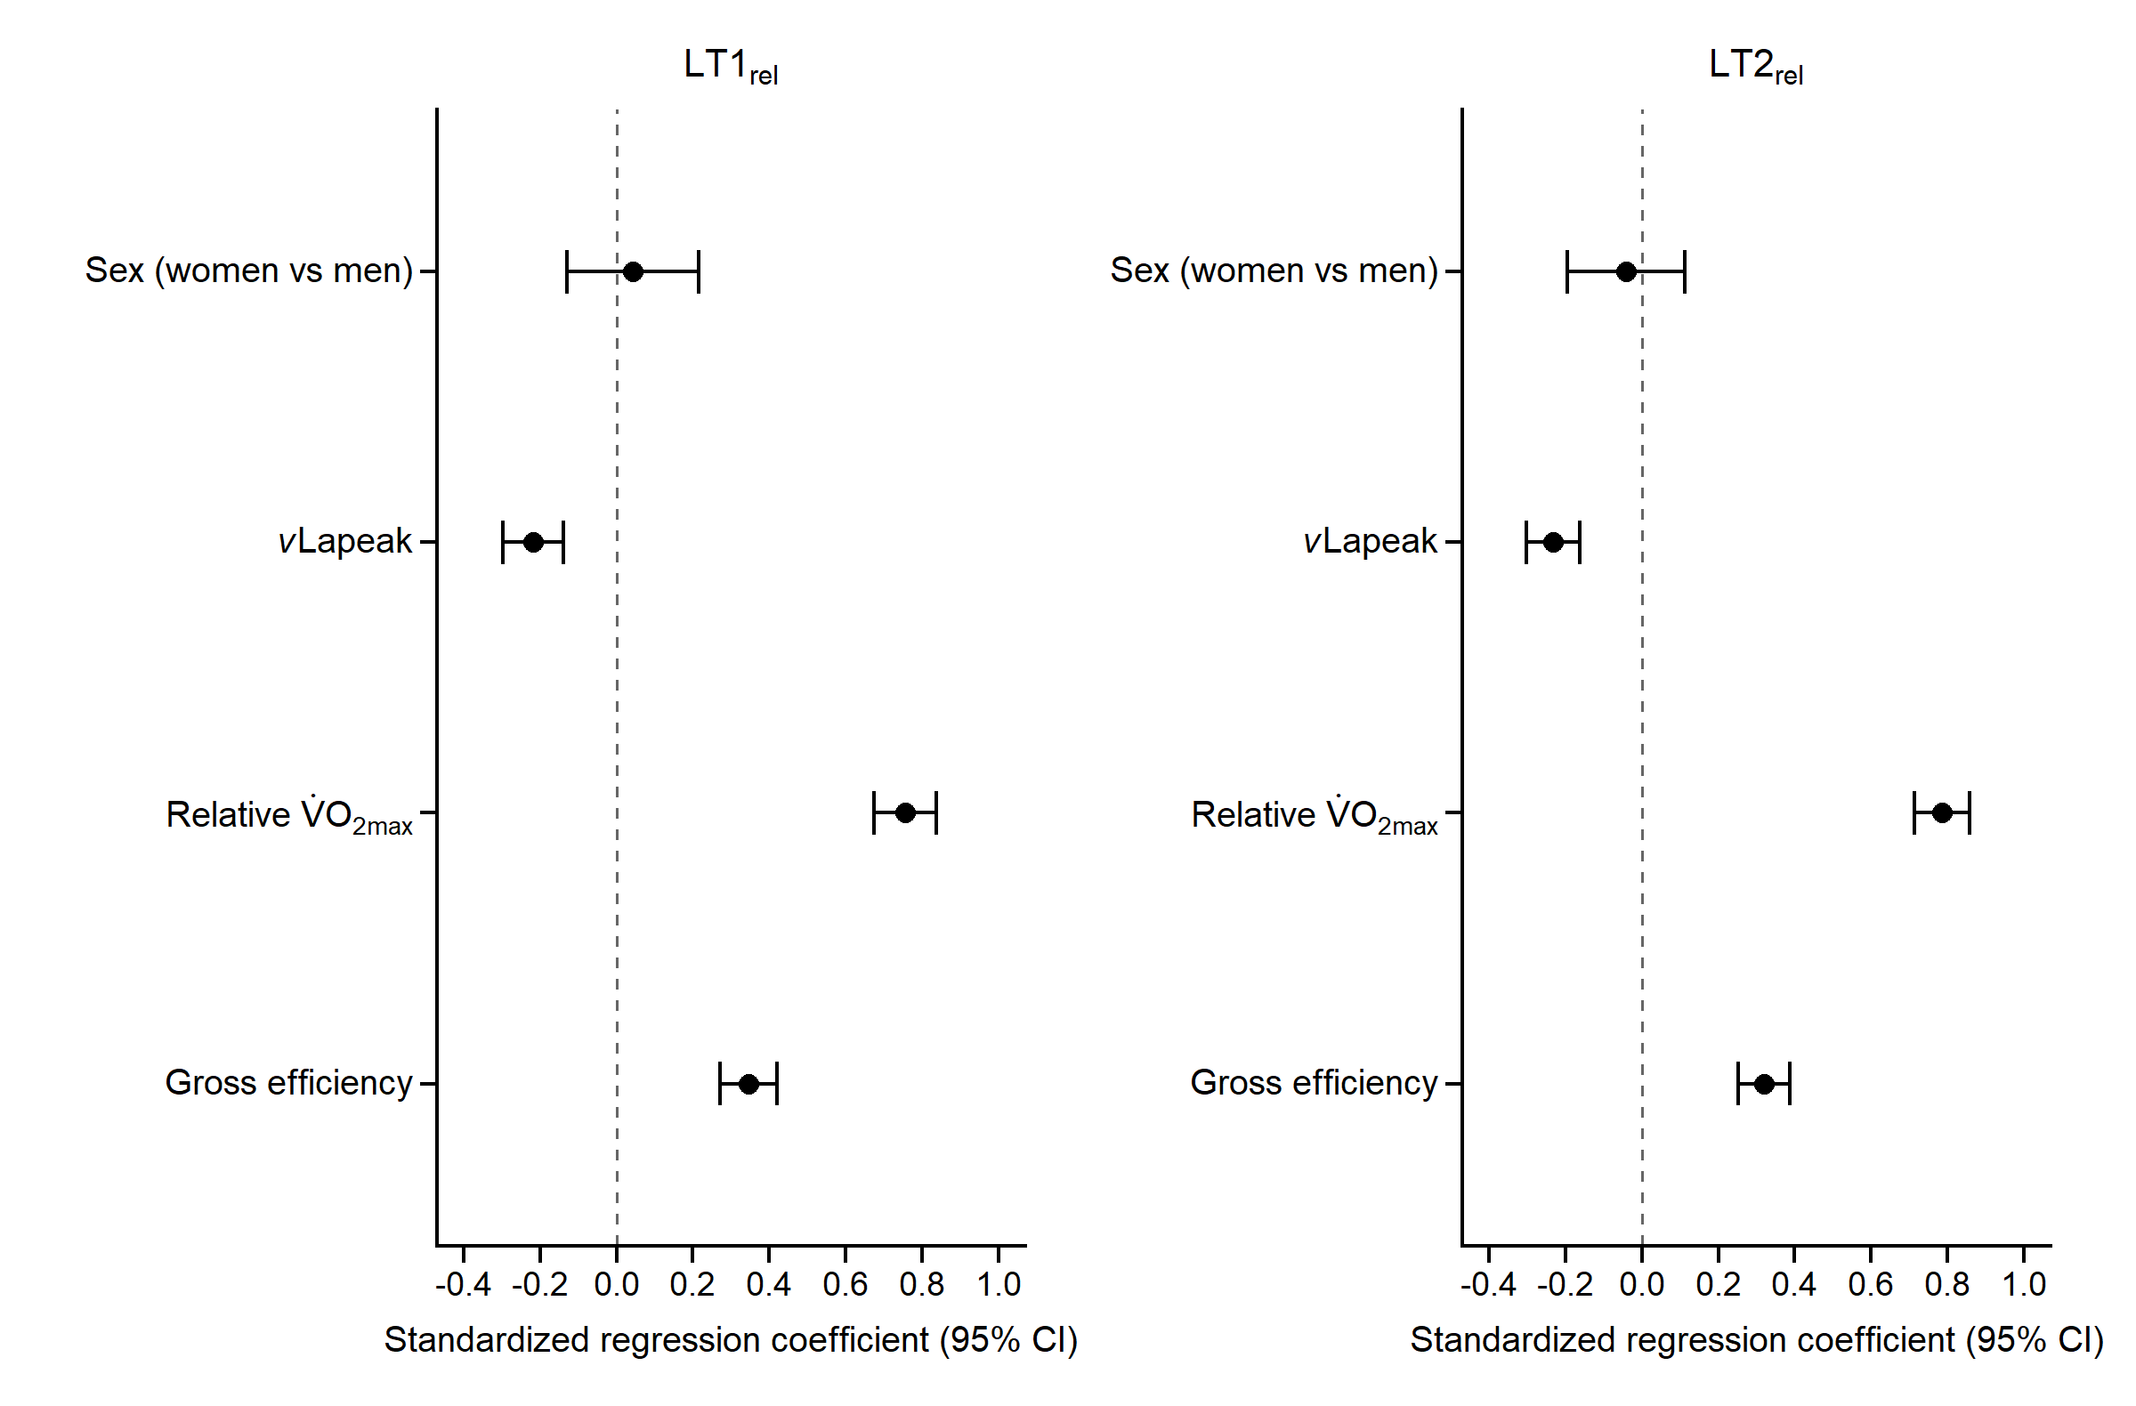
Supplementary Fig. S2 Standardised regression coefficients and 95% confidence intervals for the exploratory models including sex. Estimates are shown for LT1_{rel} and LT2_{rel} from models including gross efficiency, relative V̇O_{2max}, vLapeak, and sex. Sex was coded as women versus men. The dashed vertical line indicates the null value
Table S1. Linear regression models predicting additional body-mass-normalised intensity markers.
Outcome | Marker Model | n | Predictor | B (SE) | β | R² | Adjusted R²
2 mmol threshold | vLapeak | 182 | Gross efficiency | 0.10 (0.01)* | 0.341 | 0.63 | 0.63
2 mmol threshold | vLapeak | 182 | VO_{2max}, relative | 0.045 (0.003)* | 0.677 | 0.63 | 0.63
2 mmol threshold | vLapeak | 182 | vLapeak | -1.11 (0.23)* | -0.231 | 0.63 | 0.63
2 mmol threshold | vLamax_{blood} | 182 | Gross efficiency | 0.09 (0.01)* | 0.308 | 0.63 | 0.62
2 mmol threshold | vLamax_{blood} | 182 | VO_{2max}, relative | 0.045 (0.003)* | 0.672 | 0.63 | 0.62
2 mmol threshold | vLamax_{blood} | 182 | vLamax_{blood} | -0.91 (0.20)* | -0.216 | 0.63 | 0.62
4 mmol threshold | vLapeak | 112 | Gross efficiency | 0.10 (0.02)* | 0.331 | 0.56 | 0.55
4 mmol threshold | vLapeak | 112 | VO_{2max}, relative | 0.045 (0.005)* | 0.617 | 0.56 | 0.55
4 mmol threshold | vLapeak | 112 | vLapeak | -0.84 (0.34)* | -0.164 | 0.56 | 0.55
4 mmol threshold | vLamax_{blood} | 112 | Gross efficiency | 0.09 (0.02)* | 0.310 | 0.56 | 0.55
4 mmol threshold | vLamax_{blood} | 112 | VO_{2max}, relative | 0.046 (0.005)* | 0.624 | 0.56 | 0.55
4 mmol threshold | vLamax_{blood} | 112 | vLamax_{blood} | -0.85 (0.31)* | -0.177 | 0.56 | 0.55
Fat_{max} | vLapeak | 182 | Gross efficiency | 0.03 (0.01)* | 0.164 | 0.27 | 0.25
Fat_{max} | vLapeak | 182 | VO_{2max}, relative | 0.020 (0.003)* | 0.468 | 0.27 | 0.25
Fat_{max} | vLapeak | 182 | vLapeak | -0.09 (0.20) | -0.029 | 0.27 | 0.25
Fat_{max} | vLamax_{blood} | 182 | Gross efficiency | 0.03 (0.01)* | 0.161 | 0.27 | 0.25
Fat_{max} | vLamax_{blood} | 182 | VO_{2max}, relative | 0.020 (0.003)* | 0.466 | 0.27 | 0.25
Fat_{max} | vLamax_{blood} | 182 | vLamax_{blood} | -0.04 (0.17) | -0.016 | 0.27 | 0.25
Values are unstandardised regression coefficients (B), with standard errors in parentheses, and standardised regression coefficients (β). Standard errors refer to B. VO_{2max} = maximal oxygen uptake; vLapeak = peak lactate accumulation rate; vLamax_{blood} = maximal blood lactate accumulation rate; Fat_{max} = body-mass-normalised power output associated with maximal fat oxidation; R² = coefficient of determination. *p < 0.05.

Table S2. Linear regression models predicting absolute first and second lactate turnpoints.
Outcome | Predictor | B (SE) | β | R² | Adjusted R²
LT1 | Gross efficiency | 5.61 (0.68)* | 0.264 | 0.83 | 0.82
LT1 | VO_{2max}_abs | 0.043 (0.002)* | 0.851 | 0.83 | 0.82
LT1 | vLapeak | -54.44 (11.14)* | -0.160 | 0.83 | 0.82
LT2 | Gross efficiency | 5.74 (0.70)* | 0.238 | 0.86 | 0.85
LT2 | VO_{2max}_abs | 0.051 (0.002)* | 0.882 | 0.86 | 0.85
LT2 | vLapeak | -61.43 (11.36)* | -0.160 | 0.86 | 0.85
LT1 | Gross efficiency | 5.16 (0.69)* | 0.243 | 0.82 | 0.82
LT1 | VO_{2max}_abs | 0.043 (0.002)* | 0.851 | 0.82 | 0.82
LT1 | vLamax_{blood} | −46.96 (9.80)* | -0.157 | 0.82 | 0.82
LT2 | Gross efficiency | 5.26 (0.71)* | 0.218 | 0.86 | 0.85
LT2 | VO_{2max}_abs | 0.051 (0.002)* | 0.880 | 0.86 | 0.85
LT2 | vLamax_{blood} | −49.85 (10.09)* | -0.147 | 0.86 | 0.85
Values are unstandardised regression coefficients (B), with standard errors in parentheses, and standardised regression coefficients (β). Standard errors refer to B. LT1 = first lactate turnpoint; LT2 = second lactate turnpoint; VO_{2max}_abs = absolute maximal oxygen uptake; vLapeak = peak lactate accumulation rate; vLamax_{blood} = maximal blood lactate accumulation rate; R² = coefficient of determination. *p < 0.05.
Table S3. Linear regression models predicting body-mass-normalised lactate turnpoints without gross efficiency.
Outcome | Predictor | B (SE) | β | R² | Adjusted R²
LT1_{rel} | relative VO_{2max} | 0.041 (0.002)* | 0.804 | 0.64 | 0.63
LT1_{rel} | vLapeak | -0.71 (0.16)* | -0.199 | 0.64 | 0.63
LT2_{rel} | relative VO_{2max} | 0.048 (0.002)* | 0.846 | 0.70 | 0.70
LT2_{rel} | vLapeak | -0.81 (0.16)* | -0.202 | 0.70 | 0.70
LT1_{rel} | relative VO_{2max} | 0.041 (0.002)* | 0.806 | 0.65 | 0.65
LT1_{rel} | vLamax_{blood} | −0.737 (0.140)* | -0.234 | 0.65 | 0.65
LT2_{rel} | relative VO_{2max} | 0.048 (0.002)* | 0.845 | 0.71 | 0.71
LT2_{rel} | vLamax_{blood} | −0.784 (0.142)* | -0.224 | 0.71 | 0.71
Values are unstandardised regression coefficients (B), with standard errors in parentheses, and standardised regression coefficients (β). Standard errors refer to B. LT1_{rel} = body-mass-normalised first lactate turnpoint; LT2_{rel} = body-mass-normalised second lactate turnpoint; relative V̇O_{2max} = body-mass-normalised maximal oxygen uptake; vLapeak = peak lactate accumulation rate; vLamax_{blood} = maximal blood lactate accumulation rate; R² = coefficient of determination. The vLapeak and vLamax_{blood} models were estimated separately. *p < 0.05.

Analysis | Outcome | Group/model | n | Main predictor | B (SE) | β | R² | Adjusted R²
Mean power comparison | LT1_{rel} | Full sample | 182 | Rel mean power | -0.534 (0.828) | -0.033 | 0.692 | 0.686
Mean power comparison | LT2_{rel} | Full sample | 182 | Rel mean power | -0.498 (0.841) | -0.028 | 0.743 | 0.738
Table S4. Exploratory analyses using relative mean sprint power as an alternative sprint-related predictor.
Values are unstandardised regression coefficients (B), with standard errors in parentheses, and standardised regression coefficients (β). Standard errors refer to B. Mean-power comparison models included relative V̇O_{2max}, gross efficiency, and relative mean sprint power as predictors. LT1_{rel} = body-mass-normalised first lactate turnpoint; LT2_{rel} = body-mass-normalised second lactate turnpoint; relative mean sprint power = body-mass-normalised mean sprint power; R² = coefficient of determination. *p < 0.05.

Supplementary discussion of sensitivity and exploratory analyses
The supplementary analyses extended the primary findings across alternative outcome definitions and model specifications. Both vLapeak and vLamax_{blood} were negatively associated with body-mass-normalised power at fixed blood lactate concentrations of 2 and 4 mmol·L⁻¹. These findings indicate that the inverse associations were not limited to the specific turnpoint method used for the primary outcomes. In contrast, neither lactate accumulation marker was associated with Fat_{max} after accounting for relative V̇O_{2max} and gross efficiency. Within the present dataset, this divergence suggests that Fat_{max} and lactate-derived intensity markers reflected partly distinct aspects of the metabolic exercise response rather than interchangeable indicators of submaximal performance.
Comparable associations were also observed when LT1 and LT2 were expressed in absolute watts. The consistency between absolute and body-mass-normalised outcomes indicates that the main pattern was not solely attributable to the scaling of power output to body mass. In addition, both lactate accumulation markers remained negatively associated with LT1_{rel} and LT2_{rel} when gross efficiency was omitted from the models. However, the corresponding models explained less variance than the primary models, supporting the inclusion of gross efficiency when characterising interindividual differences in lactate turnpoint power.
The exploratory analyses including sex did not identify an additional contribution of sex or sex × predictor interactions after the physiological predictors had been considered. This does not exclude established sex-related differences in endurance physiology, including differences in substrate metabolism, oxygen transport, body composition, and fatigability (Besson et al., 2022; Hunter, 2014; Joyner, 2017). Rather, no clear evidence was found that the associations of relative V̇O_{2max}, gross efficiency, and the respective lactate accumulation marker with lactate turnpoint power differed between women and men in the present sample. This interpretation is broadly consistent with recent cycling data showing that V̇O_{2peak} and the cost of cycling account for a large proportion of LT2 power in both sexes (Fischer et al., 2025).
Overall, the sensitivity analyses support the robustness of the primary associations across different outcome definitions and reduced model specifications. At the same time, the absence of associations with Fat_{max} indicates that the explanatory relevance of vLapeak and vLamax_{blood} should not be generalised to all markers of submaximal metabolic intensity.

References
Besson, T., Macchi, R., Rossi, J., Morio, C. Y. M., Kunimasa, Y., Nicol, C., Vercruyssen, F., & Millet, G. Y. (2022). Sex Differences in Endurance Running. Sports Med, 52(6), 1235-1257. https://doi.org/10.1007/s40279-022-01651-w
Fischer, J., Havecker, F., Ji, S., Wahl, P., & Keller, S. (2025). Modeling lactate threshold in cycling-influence of sex, maximal oxygen uptake, and cost of cycling in young athletes. Eur J Appl Physiol, 125(8), 2145-2158. https://doi.org/10.1007/s00421-025-05744-y
Hunter, S. K. (2014). Sex differences in human fatigability: mechanisms and insight to physiological responses. Acta Physiol (Oxf), 210(4), 768-789. https://doi.org/10.1111/apha.12234
Joyner, M. J. (2017). Physiological limits to endurance exercise performance: influence of sex. J Physiol, 595(9), 2949-2954. https://doi.org/10.1113/JP272268

