Supplementary Materials

Blood-flow restriction versus high-intensity resistance exercise training in older men: A three-group randomized controlled trial

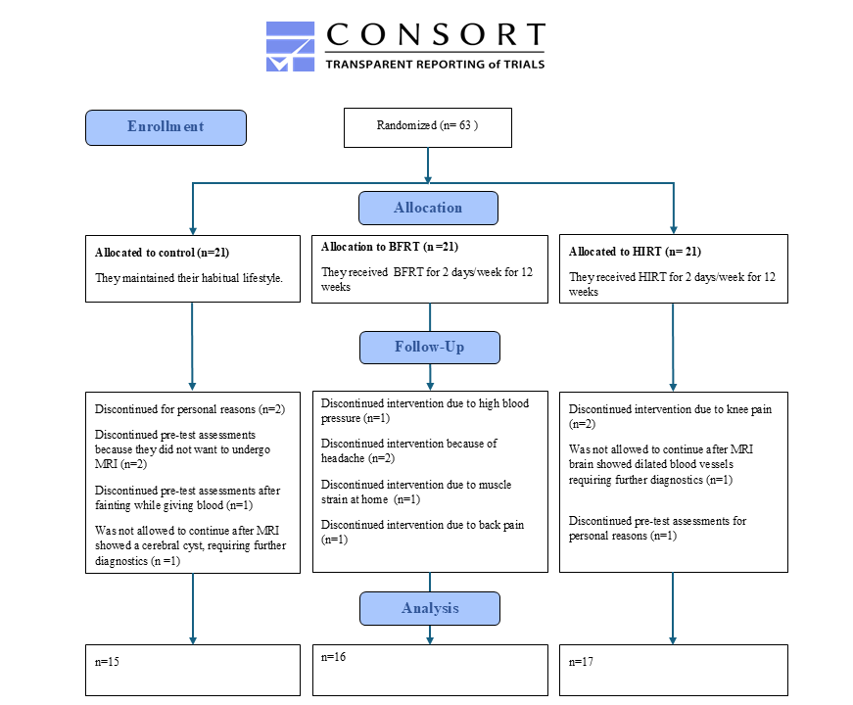

  - Supplemental Figure S1. CONSORT 2010 Flow Diagram

Supplemental Table S1. Overview of training protocols and intervention design
Panel A. Training protocols
Protocol | Intensity (% 1RM) | N° exercises | Rest Sets | Rest Exercises | Volume %
BFRT: 4x 12reps/exercise | 40% | 3 | 30” | 3’ | 57.6
RE: 4x 6reps/exercise | 80% | 3 | 2’ | 3’ | 57.6
EOE: 4x 4reps/exercise | 120% | 3 | 2’ | 3’ | 57.6
Panel B. Weekly intervention schedule
Week | Blood flow restriction training |  |  |  | High-intensity resistance training
 | 1st visit | 2nd visit | 3rd visit |  | 1st visit | 2nd visit | 3rd visit
-1 | 1RM |  |  |  | 1RM
00 | Blood+BFRT | Blood |  |  | Blood+EOE | Blood
01 | BFRT | BFRT |  |  | RE | RE
02 | BFRT | BFRT |  |  | RE | RE
03 | BFRT | BFRT |  | 1RM | RE | RE | 1RM
04 | BFRT | Blood+BFRT |  |  | EOE | Blood+RE
05 | BFRT | BFRT |  |  | RE | RE
06 | BFRT | BFRT |  |  | RE | RE
07 | BFRT | BFRT |  | 1RM | RE | RE | 1RM
08 | BFRT | Blood+BFRT |  |  | EOE | Blood+RE
09 | BFRT | BFRT |  |  | RE | RE
10 | BFRT | BFRT |  |  | RE | RE
11 | BFRT | BFRT |  |  | RE | RE
12 | BFRT | Blood |  | 1RM | EOE | Blood | 1RM
Blood biomarkers were monitored in the morning before the first exercise session of the program and in the morning 48 hours after intervention. In week 4 and 8, the next training session followed immediately after blood collection. 1RM tests were performed on non-training days later in the week and the weight was adjusted accordingly from the subsequent week. The last 1RM test was performed in the week of the last training session or the week after. Abbreviations: 1RM, one-repetition maximum test; BFRT, blood-flow restriction training; RE, traditional resistance exercise; EOE, eccentric-only exercise; Rest Exercises, rest between exercises; Rest Sets, rest between sets.

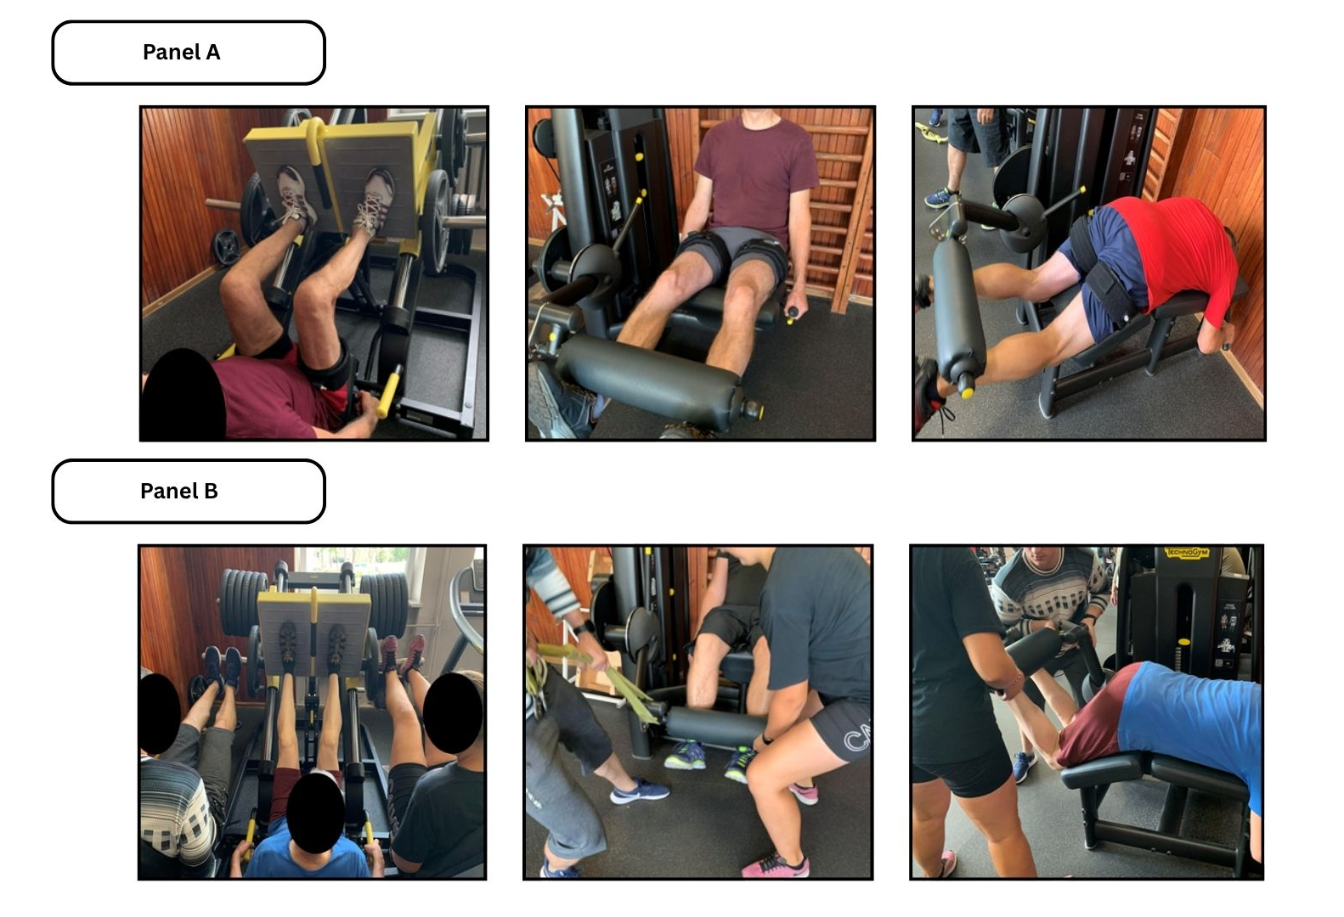
Supplemental Figure S2. Overview of exercises
Panel A shows pictures of the eccentric-only exercise (EOE) condition, where the concentric phase of the movement is supported by two coaches. During traditional resistance training (RE) the support of the coaches was absent, but the exercises remained the same. Panel B shows pictures of the blood-flow restriction training condition.
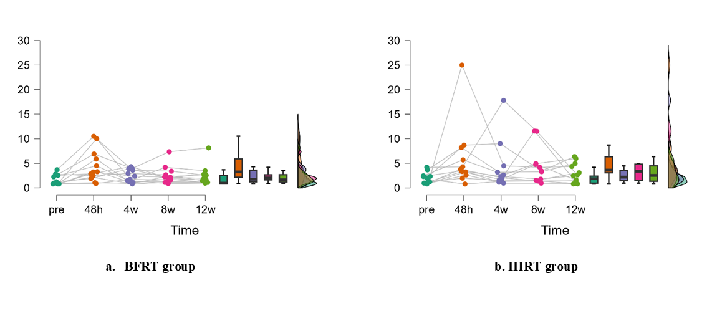
Supplemental Figure S3. Changes in creatine kinase (CK) levels over time in the BFRT and HIRT groups. Panel (a) shows CK levels in the BFRT group, and panel (b) shows CK levels in the HIRT group at baseline (pre), 48 hours, 4 weeks, 8 weeks, and 12 weeks. Individual data points are presented along with group distributions. Time p = 0.001*, Group p = 0.664, Time*Group interaction p = 0.033*.

Supplementary Table S2. Repeated measures ANOVA results
 |  |  |  |  |  | Time effect |  | Group effect |  | Interaction effect |  | Post-hoc group analysis
Variable | Group | Mean pre | SD pre | Mean post | SD post | p-value Time | pη² Time | p-value Group | pη² Group | p-value Time*Group | pη² Time*Group | 2x2 table
CK pre-CK 48h post first session | Total | 1.88 | 1.12 | 4.94 | 6.76 | 0.001* | 0.185 | 0.044* | 0.114 | 0.016* | 0.147 |  | BFRT | HIRT | CON
CK pre-CK 48h post first session | BFRT | 1.77 | 1.01 | 4.47 | 3.2 | 0.067 | 0.063 |  |  |  |  | BFRT
CK pre-CK 48h post first session | HIRT | 1.71 | 0.99 | 8.16 | 10.63 | <0.001* | 0.254 |  |  |  |  | HIRT | 0.209
CK pre-CK 48h post first session | CON | 2.19 | 1.36 | 2.09 | 1.24 | 0.944 | 0 |  |  |  |  | CON | 0.641 | 0.038*
CK pre- mean CK 48h after sessions at 4,8,12w | Total | 1.88 | 1.12 | 2.7 | 1.88 | 0.001* | 0.205 | 0.664 | 0.733 | 0.033* | 0.135 |  | BFRT | HIRT | CON
CK pre- mean CK 48h after sessions at 4,8,12w | BFRT | 1.77 | 1.01 | 2.47 | 1.65 | 0.056 | 0.076 |  |  |  |  | BFRT
CK pre- mean CK 48h after sessions at 4,8,12w | HIRT | 1.71 | 0.99 | 3.1 | 2.41 | <0.001* | 0.273 |  |  |  |  | HIRT | 0.661
CK pre- mean CK 48h after sessions at 4,8,12w | CON | 2.19 | 1.36 | 2.52 | 1.41 | 0.903 | 0 |  |  |  |  | CON | 0.801 | 0.982
Lactate pre-post first session | Total | 2.16 | 1.02 | 4.76 | 3.15 | <0.001* | 0.502 | <0.001* | 0.346 | <0.001* | 0.379 |  | BFRT | HIRT | CON
Lactate pre-post first session | BFRT | 2.22 | 1.06 | 7.08 | 2.81 | <0.001* | 0.585 |  |  |  |  | BFRT
Lactate pre-post first session | HIRT | 2.14 | 1.09 | 4.55 | 3.09 | <0.001* | 0.239 |  |  |  |  | HIRT | 0.015*
Lactate pre-post first session | CON | 2.1 | 0.95 | 2.27 | 0.82 | 0.781 | 0.001 |  |  |  |  | CON | <0.001* | 0.043*
1RM leg extension pre - after 12 weeks | Total | 71.57 | 16.74 | 85.9 | 18.85 | <0.001* | 0.534 | 0.107 | 0.097 | <0.001 | 0.368 |  | BFRT | HIRT | CON
1RM leg extension pre - after 12 weeks | BFRT | 72.34 | 14.25 | 84.54 | 16.69 | 0.001* | 0.227 |  |  |  |  | BFRT
1RM leg extension pre - after 12 weeks | HIRT | 71.02 | 18.99 | 98.28 | 15.6 | <0.001* | 0.594 |  |  |  |  | HIRT | 0.49
1RM leg extension pre - after 12 weeks | CON | 71.33 | 17.78 | 74.13 | 16.81 | 0.429 | 0.014 |  |  |  |  | CON | 0.557 | 0.088
1RM leg curl pre - after 12 weeks | Total | 44.43 | 11.07 | 51.3 | 9.1 | <0.001* | 0.391 | 0.504 | 0.03 | 0.002* | 0.247 |  | BFRT | HIRT | CON
1RM leg curl pre - after 12 weeks | BFRT | 42.21 | 9.51 | 52 | 7.15 | <0.001* | 0.316 |  |  |  |  | BFRT
1RM leg curl pre - after 12 weeks | HIRT | 44.71 | 10.08 | 55.07 | 7.71 | <0.001* | 0.355 |  |  |  |  | HIRT | 0.649
1RM leg curl pre - after 12 weeks | CON | 46.47 | 13.71 | 46.3 | 10.53 | 0.94 | 0 |  |  |  |  | CON | 0.973 | 0.517
1RM leg press pre - after 12 weeks | Total | 191.54 | 41.74 | 237.3 | 62.84 | <0.001* | 0.605 | 0.001* | 0.274 | <0.001* | 0.574 |  | BFRT | HIRT | CON
1RM leg press pre - after 12 weeks | BFRT | 170.74 | 33.31 | 238.89 | 52.61 | <0.001* | 0.55 |  |  |  |  | BFRT
1RM leg press pre - after 12 weeks | HIRT | 206.21 | 41.17 | 286.31 | 39.38 | <0.001* | 0.628 |  |  |  |  | HIRT | 0.013*
1RM leg press pre - after 12 weeks | CON | 198.07 | 43.95 | 183.33 | 49.81 | 0.132 | 0.051 |  |  |  |  | CON | 0.587 | 0.001*

