Supplementary Table S1. Physiological responses during 120 min experimental trials (n = 20)
Variables | Trial 1  (Mean ± SD) | Trial 2  (Mean ± SD) | p-value
Variables | Trial 1  (Mean ± SD) | Trial 2  (Mean ± SD) | Time | Trial | Interaction
Rectal temperature (℃) | 38.52 ± 0.38 | 38.40 ± 0.32 | < 0.001 | 0.844 | 0.158
Heart rate (bpm) | 146 ± 8 | 147 ± 4 | < 0.001 | 0.081 | 0.302
RPE (scale; 6-20) | 11 ± 1 | 10 ± 1 | < 0.001 | 0.632 | 0.624
RPE rating of perceived exertion

Supplementary Figure S1
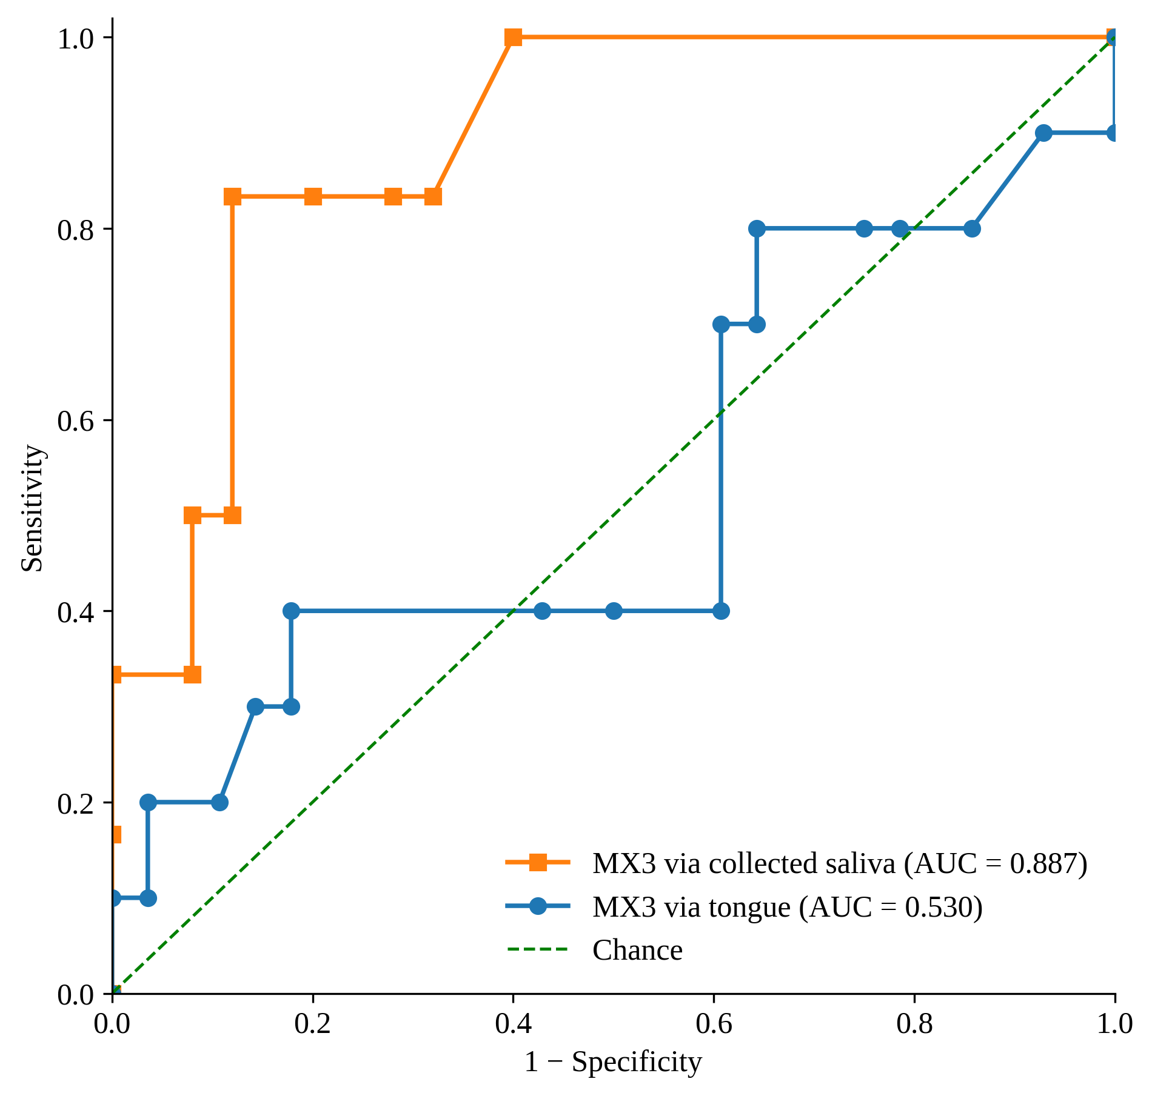
Supplementary Figure S1. Receiver operating characteristic (ROC) curves evaluating the ability of MX3-derived saliva osmolality obtained directly from the tongue and from collected saliva samples to identify ≥2% exercise-induced body mass loss following 120 min of exercise. The direct-tongue analysis included 38 observations from 19 participants (10 observations ≥2% BML), and the collected-saliva analysis included 31 observations from 17 participants (6 observations ≥2% BML). Participant-level cluster bootstrapping with 10,000 resamples was used to calculate 95% confidence intervals for the area under the curve (AUC) while accounting for repeated observations within participants. The analyses were exploratory because of the limited number of observations meeting the ≥2% BML criterion.

