Supplementary material

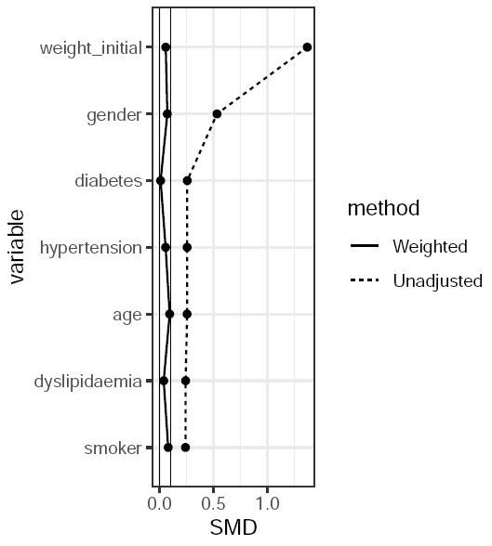

Fig. S1. Balance plot for weighted and unadjusted for all variables including initial weight, gender, dyslipidaemia, age, hypertension, diabetes and smoking. SMD = standardised mean difference.

