Supplement to:
Survival after combined resection and ablation is not inferior to that after resection alone, in patients with four or more colorectal liver metastases.

Authors & Affiliations
Iakovos Amygdalos MBBS PhD ^{1,2}, Lea Hitpass MD^{2,3}, Felix Schmidt¹, Gerrit Josephs¹, Jan Bednarsch MD^{1,2}, Marie-Luise Berres MD^{2,4}, Tom Lüdde MD^{2,5}, Steven W. M. Olde Damink MD PhD^{1,6}, Tom Florian Ulmer MD^{1,2}, Ulf P. Neumann MD^{1,2,6}, Philipp Bruners MD^{2,3}, and Sven Arke Lang MD^{1,2}

¹Department of General, Visceral and Transplantation Surgery, University Hospital RWTH Aachen, Aachen, Germany; ²Center for Integrated Oncology Aachen, Bonn, Cologne and Düsseldorf (CIO ABCD); ³Department of Diagnostic and Interventional Radiology, University Hospital RWTH Aachen, Aachen, Germany; ⁴Department of Internal Medicine III, University Hospital RWTH Aachen, Germany; ⁵Department of Gastroenterology, Hepatology and Infectious Diseases, University Hospital Düsseldorf, Germany; ⁶Department of Surgery, Maastricht University Medical Center, Maastricht, The Netherlands

Corresponding Author
Iakovos Amygdalos, MBBS BSc PhD
Department of General, Visceral and Transplantation Surgery;
University Hospital RWTH Aachen, Pauwelsstraße 30, 52074 Aachen, Germany
Tel: +49 (0) 241 80 37274; Fax: +49 (0) 241 80 82417
URL: www.ukaachen.de, e-mail: iamygdalos@ukaachen.de, Twitter: @iamygdalos

Supplementary Table 1. Demographic and oncological information of whole cohort, RESABL and RES groups, after propensity score matching.
 | All patients  (n=88) | RESABL  (n=44) | RES  (n=44) | p-value
Age | 62 (52-68) | 62 (53-68) | 62 (51-68) | 0.822
Sex (M) | 58 (66%) | 31 (71%) | 27 (61%) | 0.368
BMI | 26.0 (23.0-29.0) | 26.0 (24.0-29.0) | 25.0 (21.0-29.0) | 0.206
ASA score  I  II  III  IV | 1 (1%)  35 (40%)  50 (57%)  2 (2%) | 1 (2%)  13 (30%)  28 (64%)  2 (5%) | 0 (0%)  22 (50%)  22 (50%)  0 (0%) | 0.110
Primary tumor location  Coecum  Ascending Colon  Transverse Colon  Descending Colon  Sigmoid Colon  Rectum | 8 (9%)  16 (18%)  1 (1%)  4 (4%)  19 (22%)  40 (46%) | 4 (9%)  7 (16%)  1 (2%)  2 (5%)  11 (25%)  19 (43%) | 4 (9%)  9 (20%)  0 (0%)  2 (5%)  8 (18%)  21 (48%) | 0.873
Primary tumor diff. grade  G1  G2  G3 | 1 (1%)  60 (90%)  6 (9%) | 1 (3%)  29 (94%)  1 (3%) | 0 (0%)  31 (86%)  5 (14%) | 0.185
Primary tumor T-stage  T1  T2  T3  T4 | 3 (3%)  12 (14%)  55 (64%)  16 (19%) | 3 (7%)  5 (11%)  30 (68%)  6 (14%) | 0 (0%)  7 (17%)  25 (59%)  10 (24%) | 0.192
Primary tumor N-stage  N0  N1  N2 | 21 (25%)  34 (41%)  28 (34%) | 13 (30%)  16 (37%)  14 (33%) | 8 (20%)  18 (45%)  14 (35%) | 0.548
Synchronous metastases | 65 (74%) | 29 (66%) | 36 (82%) | 0.089
Number of metastases  4-6  7-9  ≥10 | 52 (59%)  26 (30%)  10 (11%) | 20 (45%)  18 (41%)  6 (14%) | 32 (73%)  8 (18%)  4 (9%) | 0.030
Location of metastases  Only right (Seg. V-VIII)  Only left (Seg I-IV)  Bilateral | 11 (12%)  0 (0%)  77 (88%) | 2 (4%)  0 (0%)  42 (96%) | 9 (20%)  0 (0%)  35 (80%) | 0.050
Diameter of largest metastasis (cm) | 2.6 (1.6-3.8) | 2.2 (1.7-3.1) | 3.0 (1.6-4.6) | 0.076
Extrahepatic metastases  None  Pulmonary  Skeletal  Other (incl. peritoneal)  Combined | 70 (80%)  9 (10%)  1 (1%)  7 (8%)  1 (1%) | 35 (80%)  4 (9%)  0 (0%)  4 (9%)  1 (2%) | 35 (80%)  5 (11%)  1 (2%)  3 (7%)  0 (0%) | 0.689
KRAS status (mutated) | 33 (49%) | 16 (46%) | 17 (53%) | 0.544
Preoperative serum CEA (µg/l) | 4.8 (2.6-30.4) | 4.1 (3.1-8.2) | 14.1 (1.9-99.0) | 0.163
Perioperative chemotherapy (yes)ª  Neoadjuvant  Adjuvant  Inductive  Additive | 21 (24%)  29 (33%)  47 (53%)  22 (25%) | 11 (25%)  20 (46%)  22 (50%)  9 (21%) | 10 (23%)  9 (21%)  25 (57%)  13 (30%) | 0.803  0.023  0.521  0.325
Portal vein embolization | 25 (28%) | 9 (21%) | 16 (36%) | 0.098
Major resections | 60 (68%) | 22 (50%) | 38 (86%) | <0.001
Multi-stage hepatectomy | 25 (28%) | 12 (27%) | 13 (30%) | 0.813
Liver R0 | 78 (89%) | 38 (86%) | 40 (91%) | 0.502
Primary tumor R0 | 78 (95%) | 41 (98%) | 37 (93%) | 0.347
Legend: Values given as median (1st quartile – 3rd quartile) or absolute and relative frequencies; Abbreviations used: RESABL, resection combined with ablation; RES, resection only; BMI, Body Mass Index; ASA, American Society of Anesthesiology score; KRAS, Kirsten rat sarcoma viral oncogene homolog; CEA, Carcinoembryonic antigen; ªChemotherapy regimens defined as: neoadjuvant before rectum resection, adjuvant after colon resection, inductive before liver resection, additive after liver resection. Overlapping percentages due to patients undergoing multiple regimens.

Supplementary Figure 1. OS and RFS according to ablation type
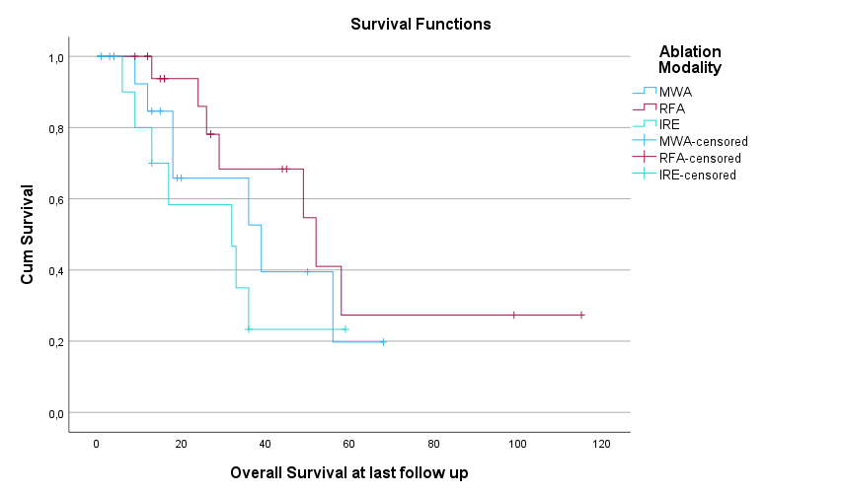
Median OS: RFA 52 months vs. MWA 39 months vs. IRE 32 months, p=0.248

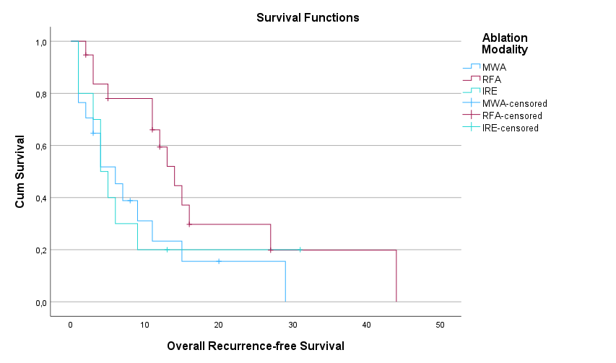
Median RFS: RFA 14 months vs. MWA 6 months vs. IRE 4 months, p=0.111

Supplementary Figure 2. Local-recurrence-free survival of whole cohort and according to ablation type

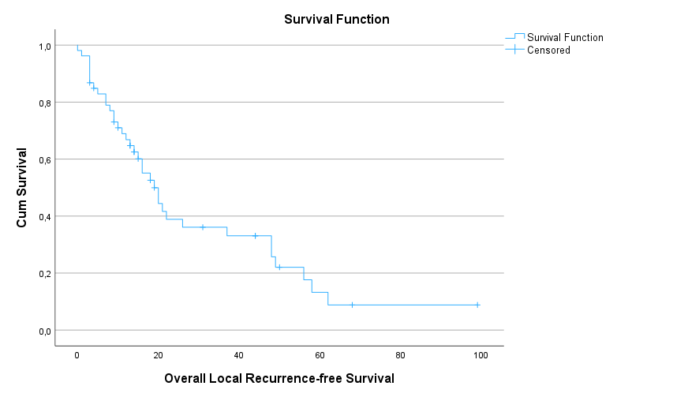
Median LRFS for whole cohort: 19 months

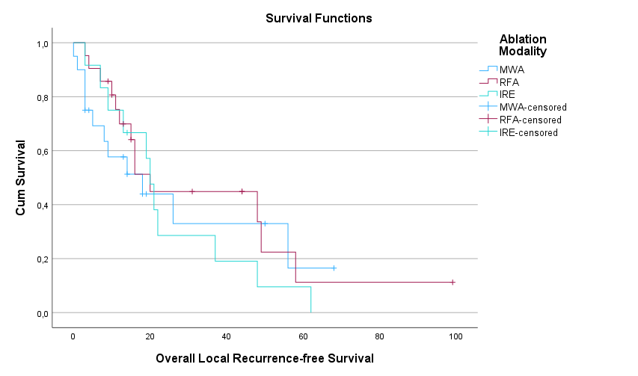
Median LRFS: RFA 20 months vs. MWA 18 months vs. IRE 20 months, p=0.664

Supplementary Figure 3. OS and RFS in one-sided vs. bilateral metastases
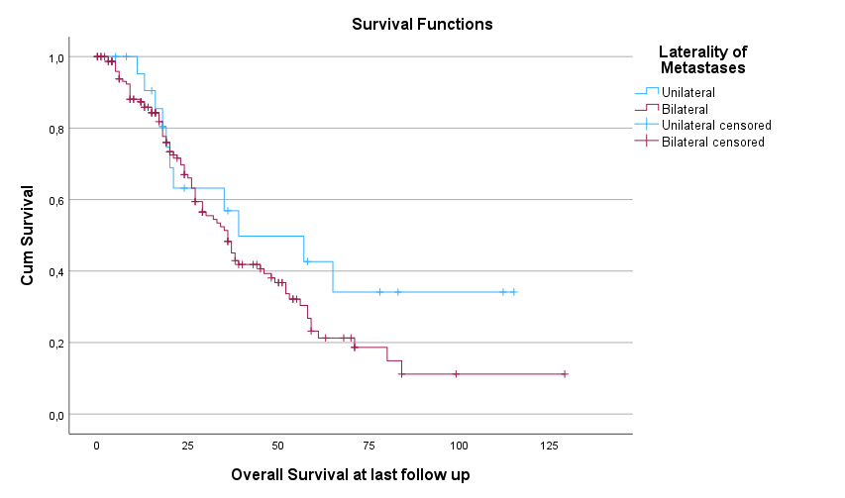
Median OS: One-sided 39 months vs. bilateral 36 months, p=0.209

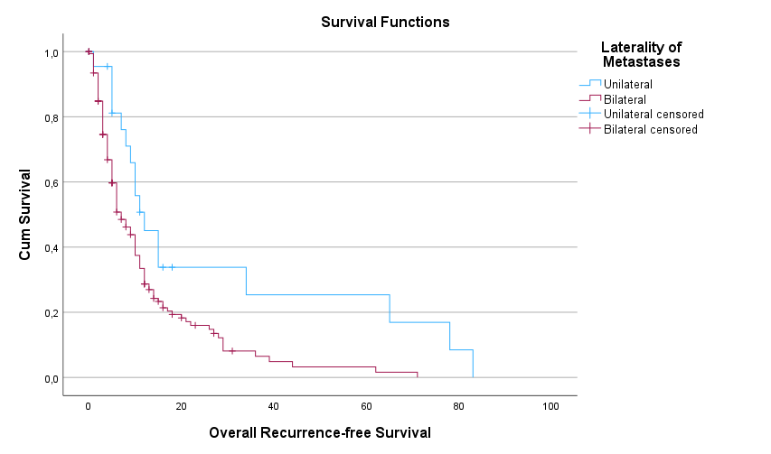

Median RFS: One-sided 12 months vs. bilateral 7 months, p=0.008

Supplementary Figure 4. OS and RFS of RESABL vs. RES in bilateral metastases only
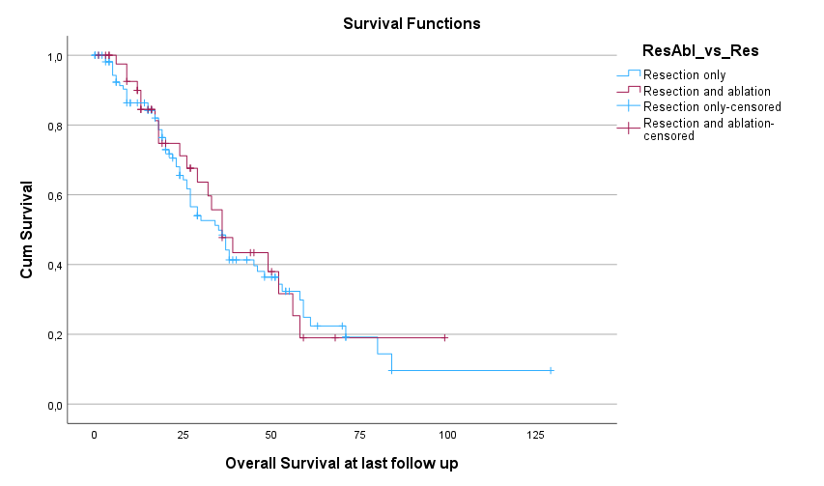
Median OS: RES 35 months vs. RESABL 36 months, p=0.780

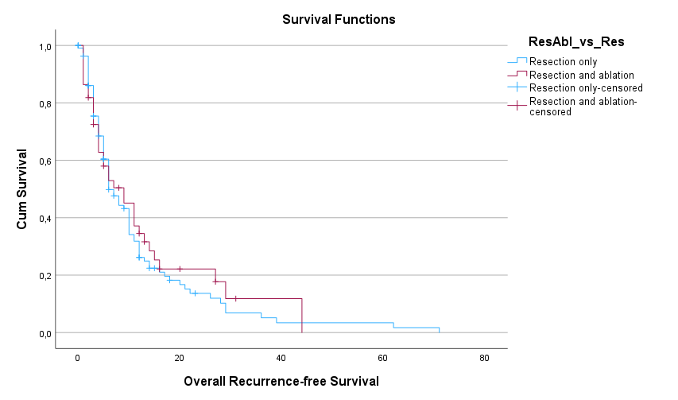
Median RFS: RES 6 months vs. RESABL 9 months, p=0.632

Supplementary Figure 5. OS and RFS of RESABL vs. RES after propensity score matching
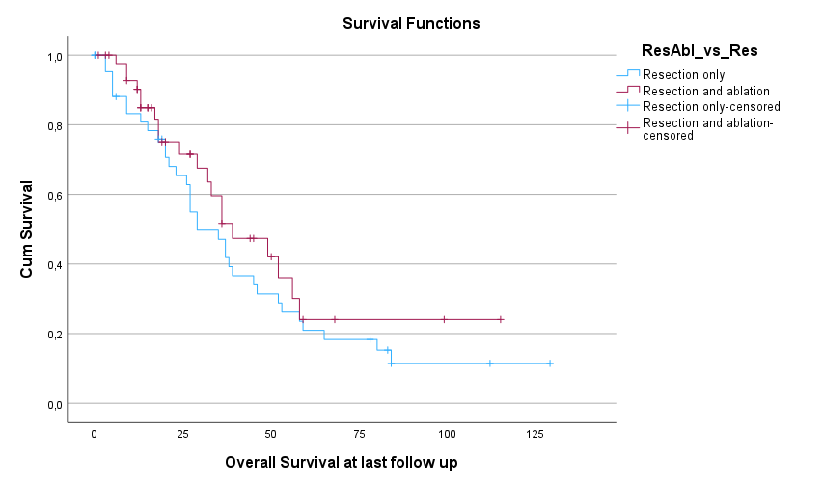
Median OS: RES 29 months vs. RESABL 39 months, p=0.292

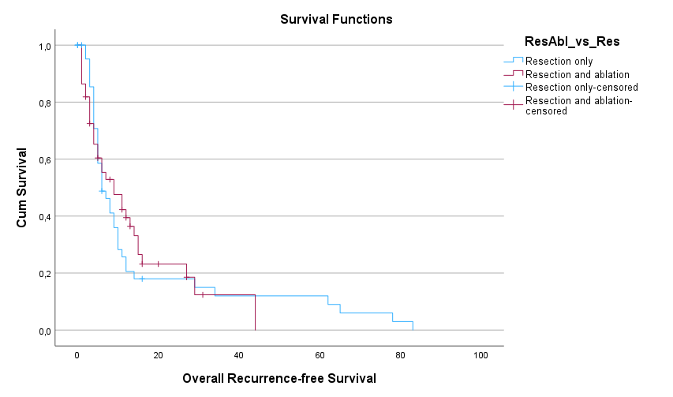
Median RFS: RES 6 months vs. RESABL 9 months, p=0.797

