Supplements

Total Supplements: 2 Figures

- Figure 1: PRISMA Flow diagram of study selection

- Figure 2: Risk of Bias Assessment – ROBINS-I and ROB2

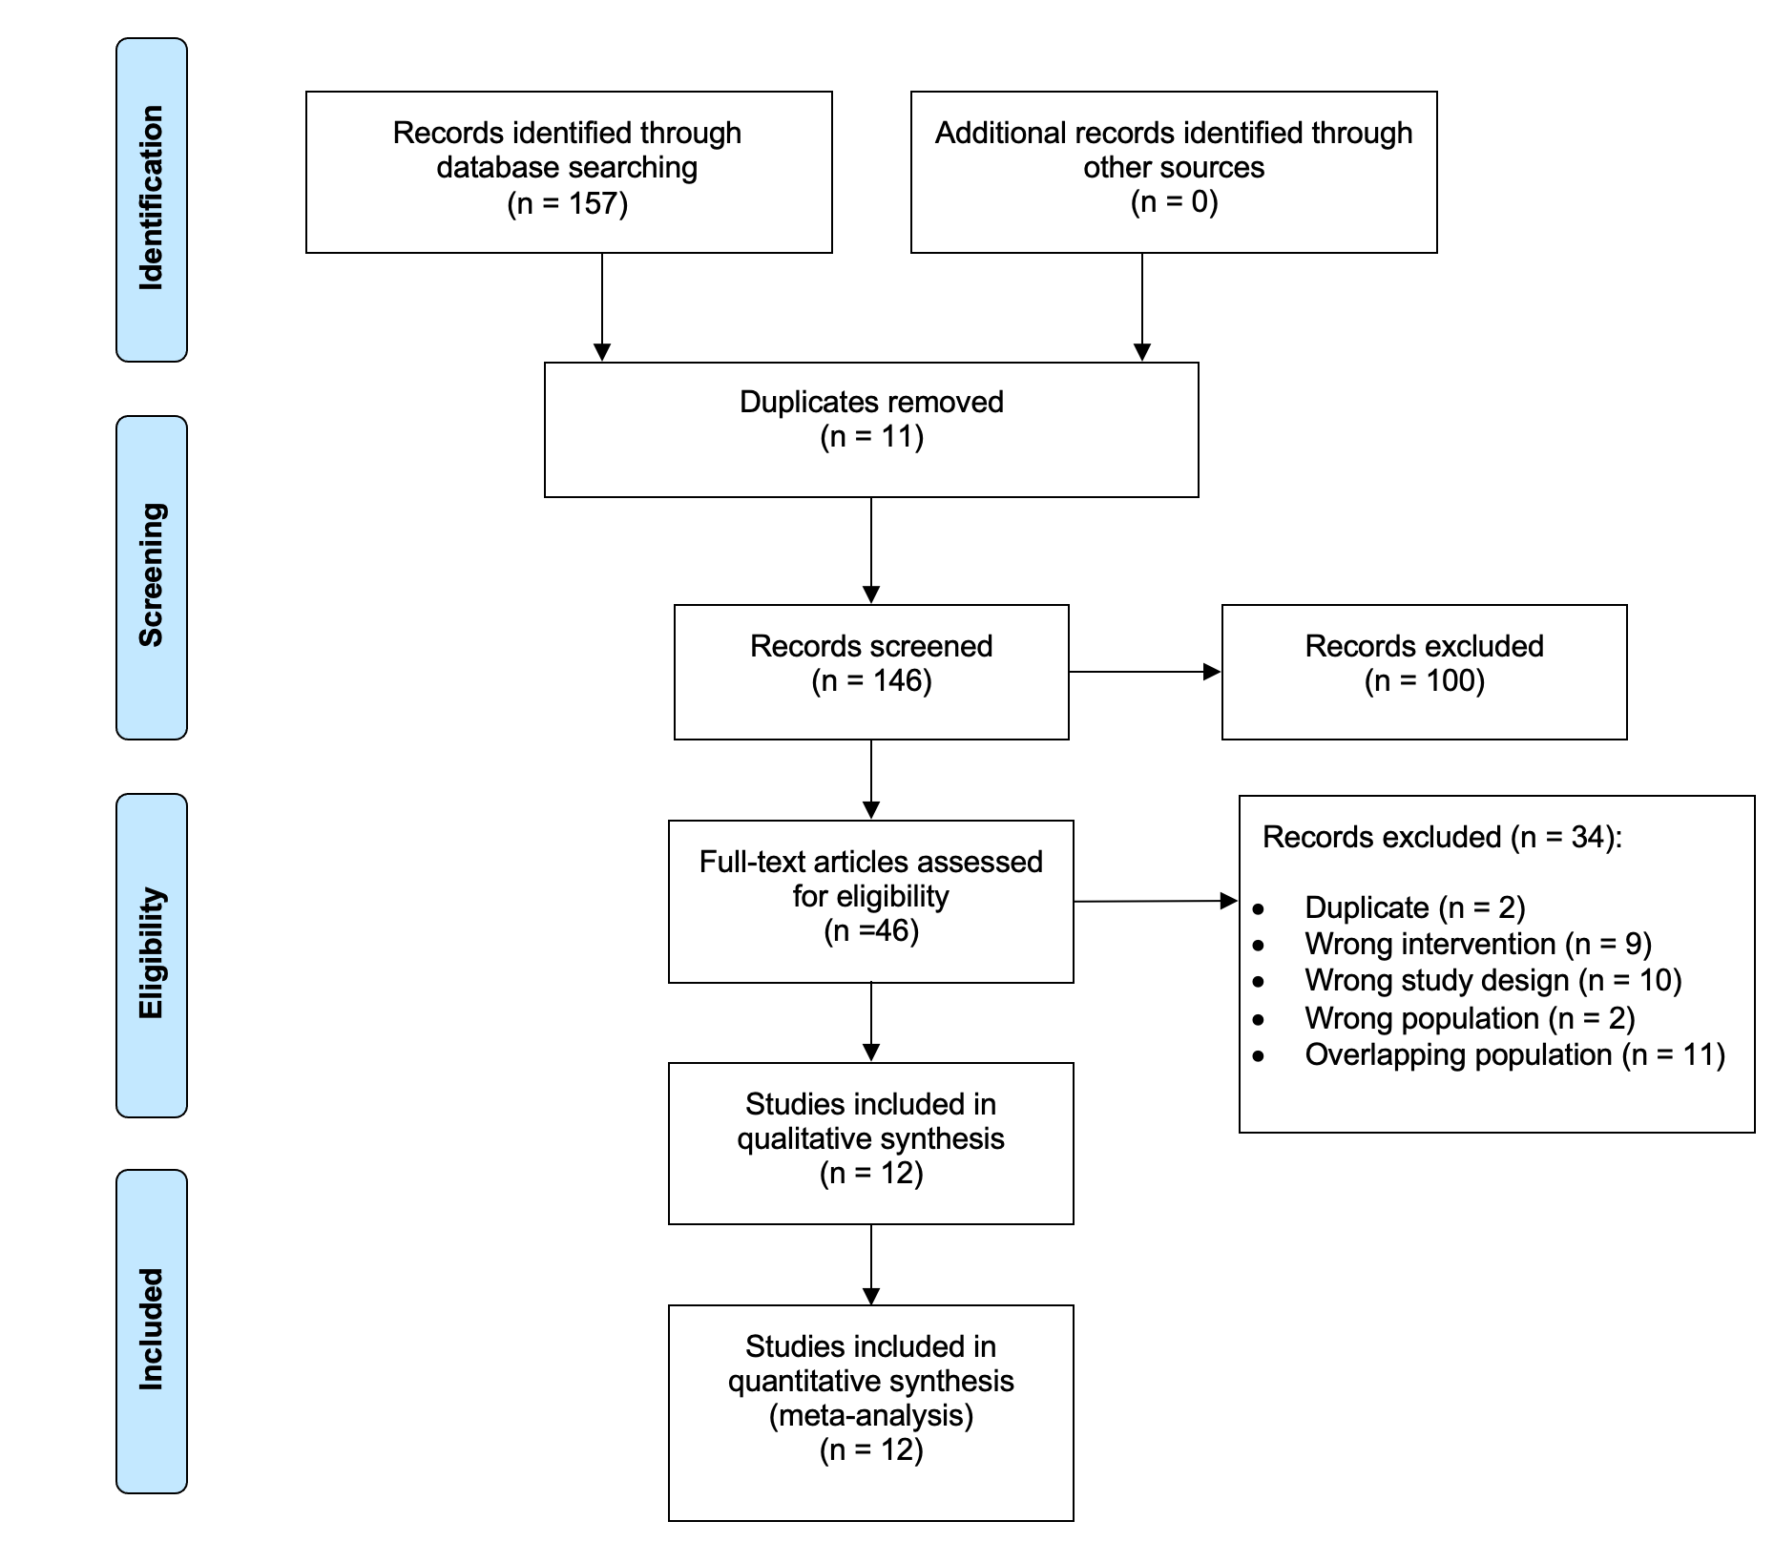
eFigure 1: PRISMA Flow diagram of study selection

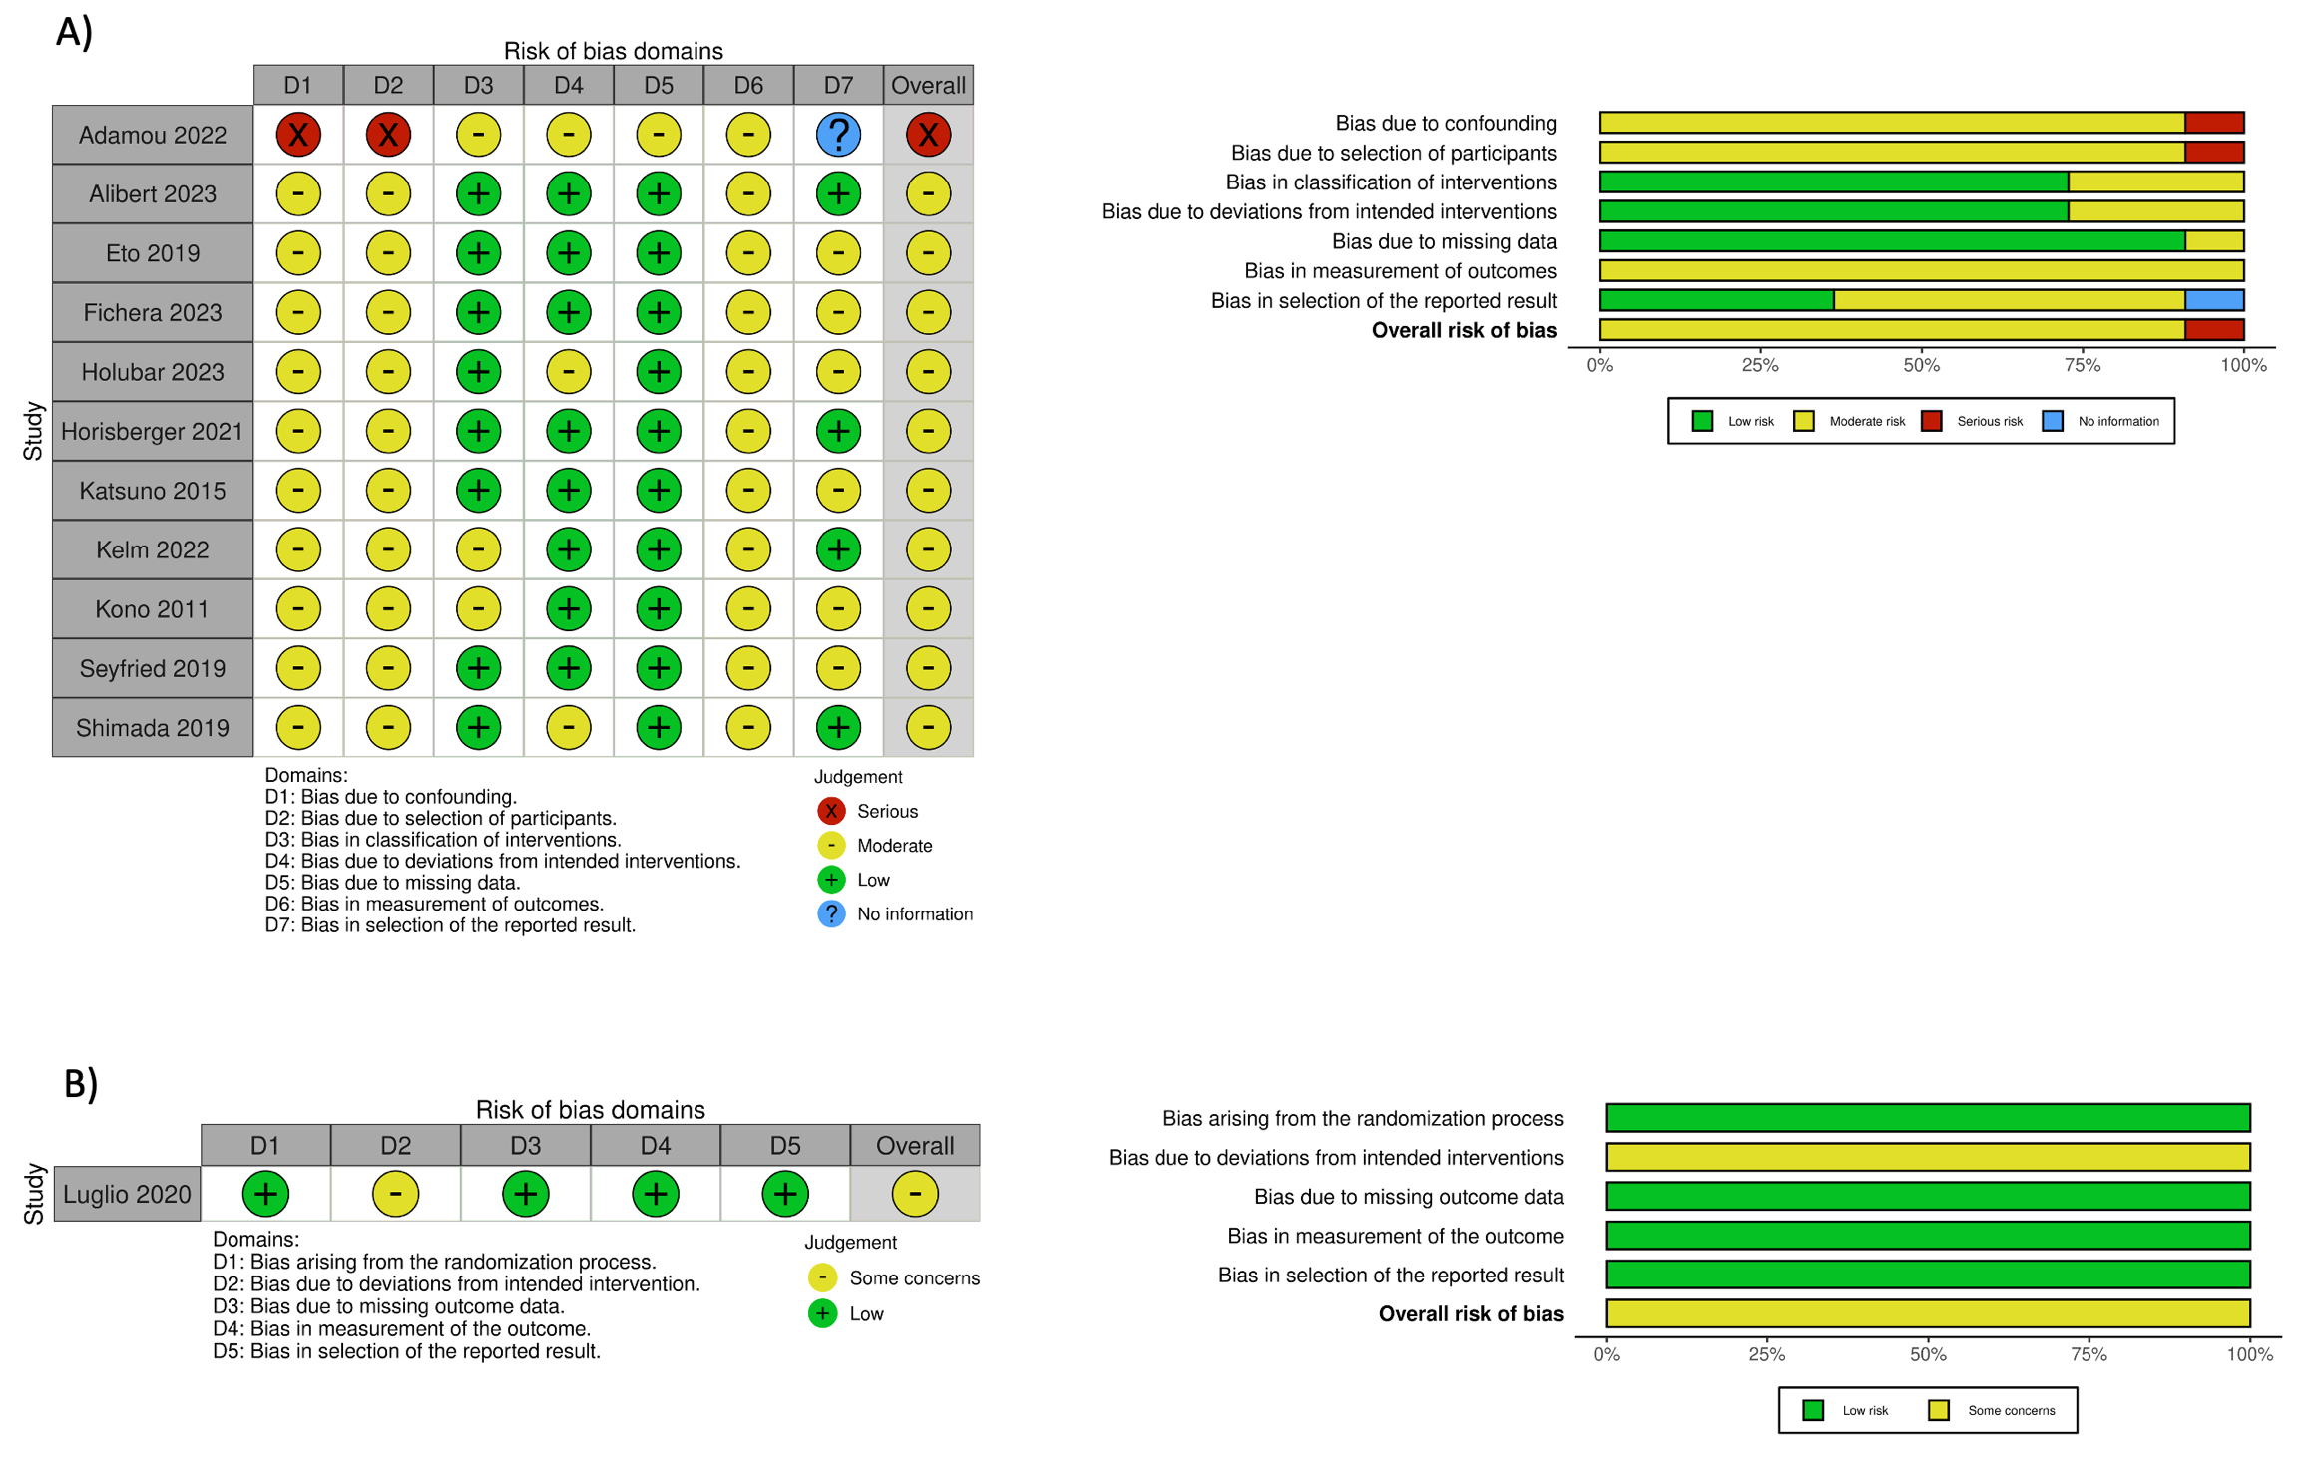
A) ROBINS-I assessment for non-randomized studies
B) ROB-2 assessment for randomized control trials
eFigure 2: Risk of Bias Assessment – ROBINS-I and ROB2

