Supplementary Figure 1. Flowchart of patient inclusion
Potential cases, including one control each (n=116)
Patients without peritoneal infection and patients not included as controls (n=610)
Case & control without consent (n=2)
Cases & controls for whom matching was not possible (n=10)
Case and/or control missing first postoperative sample (n=40)

Remaining for analysis (n=64; 32 cases + 32 controls)
Elective surgery with a primary anastomosis for non-dissseminated colorectal cancer at Umeå or Uppsala university hospitals during 2010-2015 (n=726)

Supplementary Figure 2. Kaplan-Meier curve for (A) overall survival and (B) cancer recurrence
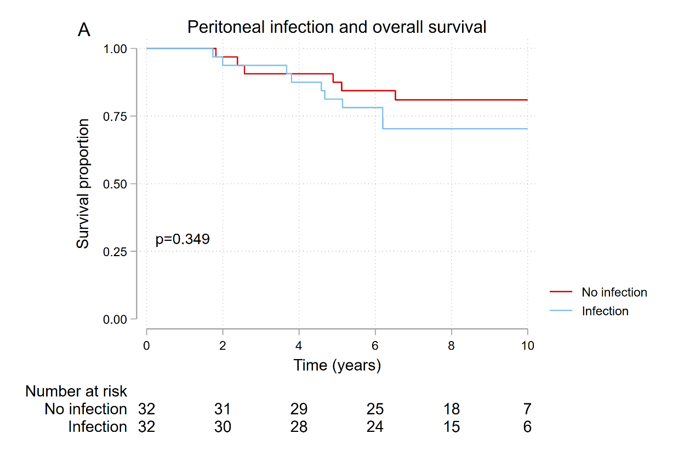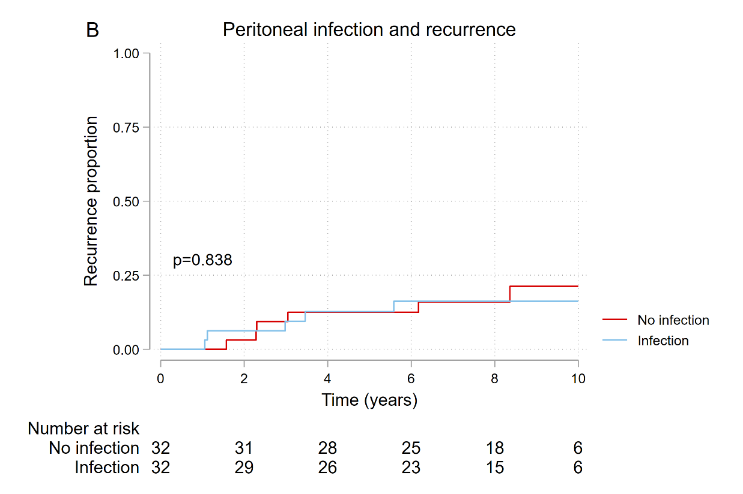
Kaplan-Meier curves for overall survival and cancer recurrence of 104 patients operated for colorectal cancer with a primary anastomosis during 2010-2015, with cases suffering peritoneal infection, contrasted to controls with a complication-free postoperative hospital stay.

Supplementary Figure 3. Functional enrichment analysis of downregulated proteins
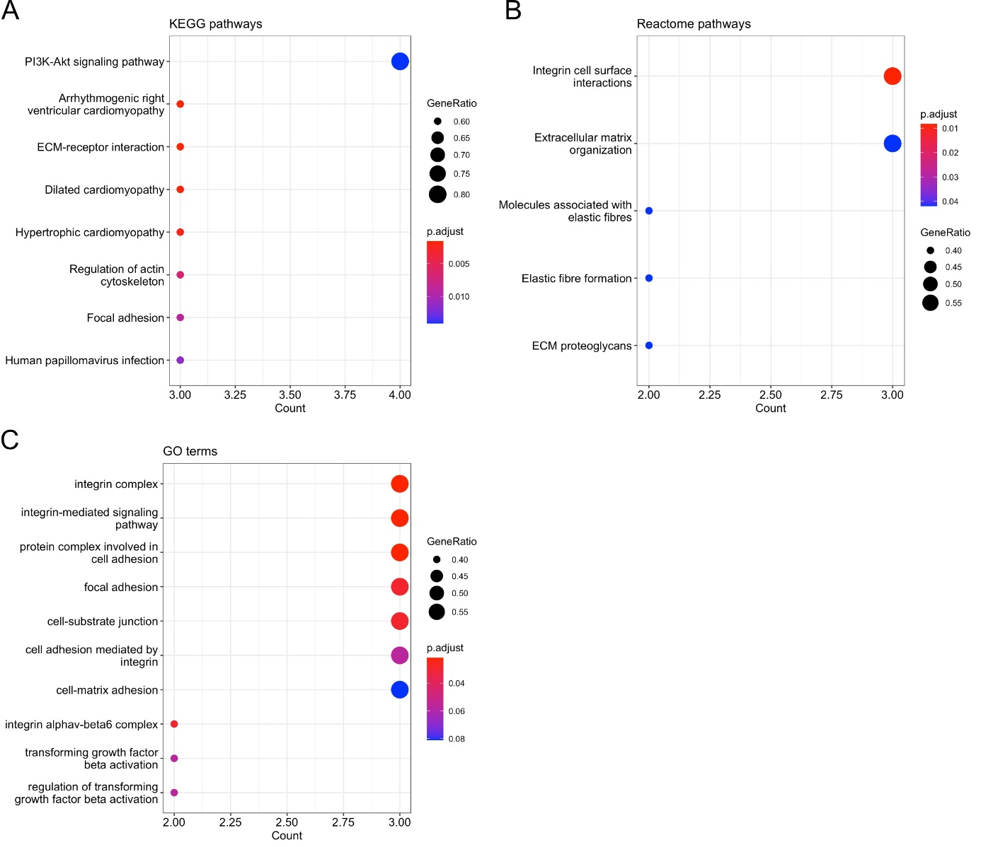
Significantly over-represented Kyoto encyclopedia of genes and genomes (KEGG) pathways (A), Reactome pathways (B), and gene ontology (GO) terms (C) that were identified. P-value adjusted for a false detection rate <0.1 using the Benjamini-Hochberg procedure. Count (x-axis) displays the number of differentially expressed proteins in each pathway. GeneRatio (circle-size) is the ratio of differentially expressed down-regulated proteins in the pathway, divided by the total amount of differentially expressed proteins that were down-regulated.

Supplementary Table 1. Complete Olink biomarker panels. The title of each panel is listed on the first row
Oncology II | Inflammation | Immune Response
5'-NT | 4E-BP1 | AREG*
ABL1 | ADA | ARNT
ADAM 8 | ARTN | BACH1
ADAM-TS 15 | AXIN1 | BIRC2
ANXA1 | Beta-NGF | BTN3A2
AREG* | CASP-8 | CCL11*
CAIX | CCL11* | CD28
CD160 | CCL19 | CD83
CD207 | CCL20 | CDSN
CD27 | CCL23 | CKAP4
CD48 | CCL25 | CLEC4A
CD70 | CCL28 | CLEC4C
CDKN1A | CCL3 | CLEC4D
CEACAM1 | CCL4 | CLEC4G
CEACAM5 | CD244 | CLEC6A
CPE | CD40 | CLEC7A
CRNN | CD5 | CNTNAP2
CTSV | CD6 | CXADR
CXCL13 | CD8A | CXCL12
CXL17 | CDCP1 | DAPP1
CYR61 | CSF-1 | DCBLD2
DLL1 | CST5 | DCTN1
EGF | CX3CL1 | DDX58
EPHA2 | CXCL1 | DFFA
ERBB2 | CXCL10 | DGKZ
ERBB3 | CXCL11 | DPP10
ERBB4 | CXCL5 | EDAR
ESM-1 | CXCL6 | EGLN1
FADD | CXCL9 | EIF4G1
FASLG | DNER | EIF5A
FCRLB | EN-RAGE | FAM3B
FGF-BP1 | FGF-19 | FCRL3
FR-alpha | FGF-21 | FCRL6
FR-gamma | FGF-23 | FGF2
FURIN | FGF-5 | FXYD5
Gal-1 | Flt3L | GALNT3
GPC1 | GDNF | GLB1
GPNMB | HGF* | HCLS1
GZMB | IFN-gamma | HEXIM1
GZMH | IL-1 alpha | HNMT
HGF* | IL10* | HSD11B1
hK11 | IL-10RA | ICA1
hK14 | IL-10RB | IFNLR1
hK8 | IL-12B | IL10*
ICOSLG | IL13 | IL12RB1
IFN-gamma-R1 | IL-15RA | IL5*
IGF1R | IL-17A | IL6**
IL6** | IL-17C | IRAK1
ITGAV | IL18 | IRAK4
ITGB5 | IL-18R1 | IRF9
KLK13 | IL2 | ITGA11
LY9 | IL-20 | ITGA6
LYN | IL-20RA | ITGB6
LYPD3 | IL-22 RA1 | ITM2A
MAD homolog 5 | IL-24 | JUN
MetAP 2 | IL-2RB | KLRD1
MIA | IL33 | KPNA1
MIC-A/B | IL4 | KRT19
MK | IL5* | LAG3
MSLN | IL6** | LAMP3
MUC-16 | IL7 | LILRB4
PODXL | IL8 | LY75
PPY | LAP TGF-beta-1 | MASP1
PVRL4 | LIF | MGMT
RET | LIF-R | MILR1
RSPO3 | MCP-1 | NCR1
S100A11 | MCP-2 | NF2
S100A4 | MCP-3 | NFATC3
SCAMP3 | MCP-4 | NTF4
SCF | MMP-1 | PADI2
SEZ6L | MMP-10 | PIK3AP1
SPARC | NRTN | PLXNA4
SYND1 | NT-3 | PPP1R9B
TCL1A | OPG | PRDX1
TFPI-2 | OSM | PRDX3
TGF-alpha* | PD-L1 | PRDX5
TGFR-2 | SCF | PRKCQ
TLR3 | SIRT2 | PSIP1
TNFRSF19 | SLAMF1 | PTH1R
TNFRSF4 | ST1A1 | SH2B3
TNFRSF6B | STAMPB | SH2D1A
TNFSF13 | TGF-alpha* | SIT1
TRAIL* | TNF | SPRY2
TXLNA | TNFB | SRPK2
VEGFA* | TNFRSF9 | STC1
VEGFR-2 | TNFSF14 | TANK
VEGFR-3 | TRAIL* | TPSAB1
VIM | TRANCE | TRAF2
WFDC2 | TSLP | TREM1
WIF-1 | TWEAK | TRIM21
WISP-1 | uPA | TRIM5
XPNPEP2 | VEGFA* | ZBTB16
* Biomarker represented in two panels
** Biomarker represented in three panels
Supplementary Table 2. Differentially expressed proteins at the first postoperative visit.
Panel name / Protein name | Adjusted* p-value | Median fold change | Mean fold change
Oncology 2 panel
5'-NT | 0.05 | 1.07 | 1.05
ADAM 8 | 0.05 | 1.06 | 1.06
ADAM-TS 15 | 0.01 | 1.12 | 1.21
CD160 | 0.05 | 1.03 | 1.07
CD27 | 0.01 | 1.02 | 1.04
CD48 | 0.05 | 1.01 | 1.03
CD70 | 0.02 | 1.14 | 1.11
CXCL13 | 0.01 | 1.08 | 1.07
DLL1 | 0.01 | 1.04 | 1.03
EPHA2 | 0.01 | 1.16 | 1.18
ERBB3 | 0.06 | 1.02 | 1.02
FCRLB | 0.09 | 1.15 | 1.22
FURIN | 0.09 | 1.04 | 1.06
Gal-1 | 0.08 | 1.03 | 1.02
GZMH | 0.03 | 1.20 | 1.22
HGF** | 0.02 | 1.04 | 1.06
IL6** | 0.02 | 1.50 | 1.39
ITGAV* | 0.06 | 0.88 | 0.92
LY9 | 0.01 | 1.08 | 1.08
MetAP 2 | 0.06 | 1.07 | 1.10
MK | 0.06 | 1.00 | 1.05
S100A11 | 0.06 | 1.04 | 1.06
SCF* | 0.01 | 0.95 | 0.93
SYND1 | 0.00 | 1.12 | 1.11
TGFR-2 | 0.06 | 1.02 | 1.03
TNFRSF4 | 0.05 | 1.07 | 1.10
TNFRSF6B | 0.02 | 1.10 | 1.12
TNFSF13 | 0.08 | 1.01 | 1.01
TXLNA | 0.06 | 1.25 | 1.17
VEGFR-3 | 0.01 | 1.04 | 1.04
VIM | 0.06 | 1.12 | 1.10
WFDC2 | 0.06 | 1.02 | 1.03
Panel name / Protein name | Adjusted* p-value | Median fold change | Mean fold change
Inflammation panel
CASP-8 | 0.09 | 1.06 | 1.12
CCL20 | 0.09 | 1.12 | 1.10
CDCP1 | 0.09 | 1.04 | 1.11
CXCL1 | 0.09 | 1.03 | 1.05
CXCL6 | 0.09 | 1.05 | 1.07
EN-RAGE | 0.09 | 1.18 | 1.17
FGF-21 | 0.09 | 1.33 | 1.29
FGF-23 | 0.09 | 1.14 | 1.26
GDNF | 0.09 | 1.01 | 1.10
HGF** | 0.09 | 1.04 | 1.06
IL-15RA | 0.10 | 1.04 | 1.10
IL6** | 0.09 | 1.43 | 1.24
IL7 | 0.09 | 1.08 | 1.11
IL8 | 0.09 | 1.08 | 1.08
SLAMF1 | 0.09 | 1.13 | 1.12
TNFRSF9 | 0.09 | 1.05 | 1.08
Panel name / Protein name | Adjusted* p-value | Median fold change | Mean fold change
Immune Response panel
BACH1 | 0.09 | 1.17 | 1.11
BTN3A2 | 0.03 | 1.05 | 1.08
CD83 | 0.03 | 1.06 | 1.06
CKAP4 | 0.00 | 1.09 | 1.09
CLEC4D | 0.05 | 1.16 | 1.12
CLEC4G | 0.03 | 1.08 | 1.08
DDX58 | 0.09 | 1.10 | 1.10
DFFA | 0.02 | 1.08 | 1.08
EIF4G1 | 0.03 | 1.21 | 1.16
FCRL6 | 0.03 | 1.10 | 1.12
GLB1* | 0.03 | 0.88 | 0.90
HEXIM1 | 0.01 | 1.08 | 1.10
IFNLR1 | 0.05 | 1.08 | 1.11
IL12RB1 | 0.01 | 1.09 | 1.11
IL6** | 0.02 | 1.22 | 1.20
IRF9 | 0.03 | 1.11 | 1.14
ITGA11* | 0.03 | 0.89 | 0.88
ITGB6* | 0.03 | 0.92 | 0.93
KLRD1 | 0.01 | 1.08 | 1.08
LAG3 | 0.08 | 1.05 | 1.07
LILRB4 | 0.02 | 1.14 | 1.11
MGMT | 0.05 | 1.24 | 1.23
MILR1 | 0.04 | 1.06 | 1.07
NCR1 | 0.03 | 1.09 | 1.10
SH2D1A | 0.05 | 1.07 | 1.15
SIT1 | 0.09 | 1.12 | 1.11
STC1 | 0.01 | 1.05 | 1.05
TREM1 | 0.05 | 1.41 | 1.39
TRIM21 | 0.03 | 1.12 | 1.20

Differentially expressed proteins for 104 patients operated for colorectal cancer with a primary anastomosis during 2010-2015 in Sweden, with cases suffering peritoneal infection and controls with a complication-free postoperative hospital stay.
* Down-regulated proteins
** Proteins overlapping between panels

Supplementary Table 3. List of proteins in each significant pathway, divided into sections according to database
Database and significantly over-represented pathways | Altered proteins in each pathway
Kyoto Encyclopedia of Genes and Genomes
PI3K-Akt signaling pathway | ITGAV, ITGB6, ITGA11, SCF
Arrythmogenic right ventricular cardiomyopathy | ITGAV, ITGB6, ITGA11
ECM-receptor interaction | ITGAV, ITGB6, ITGA11
Dilated cardiomyopathy | ITGAV, ITGB6, ITGA11
Hypertrophic cardiomyopathy | ITGAV, ITGB6, ITGA11
Regulation of actin cytoskeleton | ITGAV, ITGB6, ITGA11
Focal adhesion | ITGAV, ITGB6, ITGA11
Human papillomavirus infection | ITGAV, ITGB6, ITGA11
Reactome
Integrin cell surface interactions | ITGAV, ITGB6, ITGA11
Extracellular matrix organisation | ITGAV, ITGB6, ITGA11
Molecules associated with elastic fibres | ITGAV, ITGB6
Elastic fibre formation | ITGAV, ITGB6
ECM proteoglycans | ITGAV, ITGB6
Gene Ontology
Integrin complex | ITGAV, ITGB6, ITGA11
Integrin-mediated signaling pathway | ITGAV, ITGB6, ITGA11
Protein complex involved in cell adhesion | ITGAV, ITGB6, ITGA11
Focal adhesion | ITGAV, ITGB6, ITGA11
Cell-substrate junction | ITGAV, ITGB6, ITGA11
Cell adhesion mediated by integrin | ITGAV, ITGB6, ITGA11
Cell-matrix adhesion | ITGAV, ITGB6, ITGA11
Integrin alphaV-beta6 complex | ITGAV, ITGB6
Transforming growth factor beta activation | ITGAV, ITGB6
Regulation of transforming growth factor beta activation | ITGAV, ITGB6
* P-value adjusted for a false detection rate <0.1 using the Benjamini-Hochberg procedure.

