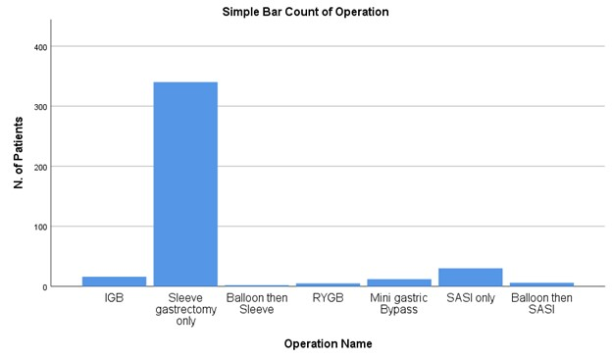
Figure S1: The frequency of bariatric surgery among participants from a single obesity control setting

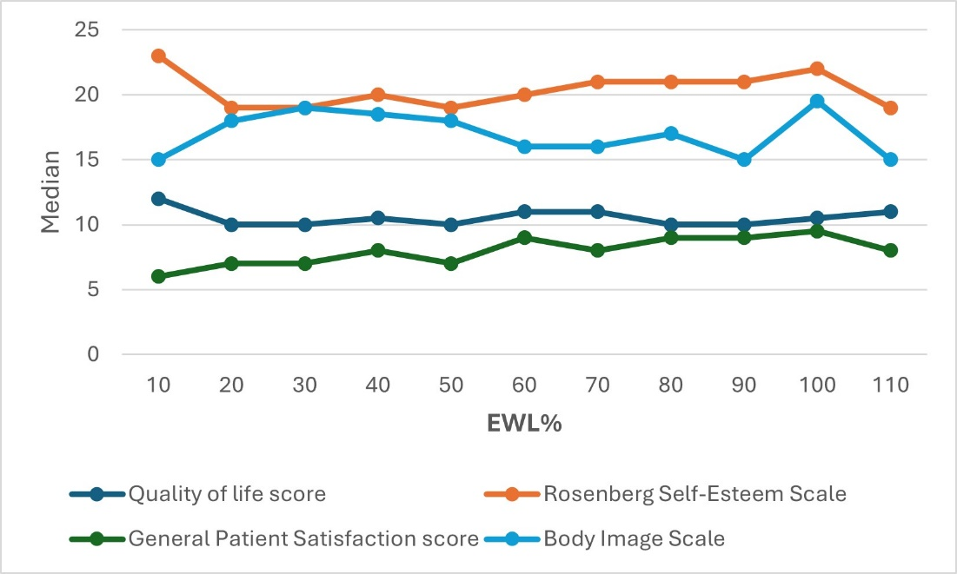
Figure S2: A line chart showing no correlation between the Excess Weight loss Percentage (EWL%) and the median psychological assessment scores.

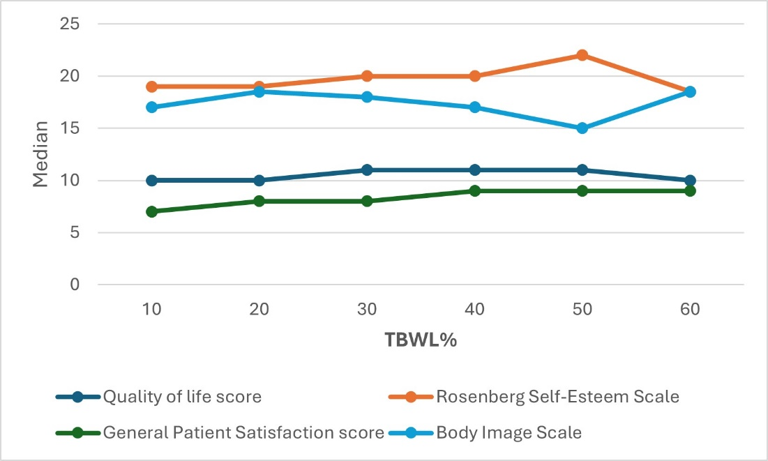
Figure S3: A line chart showing no correlation between the Total Body Weight loss Percentage (TBWL%) and the median psychological assessment scores.

