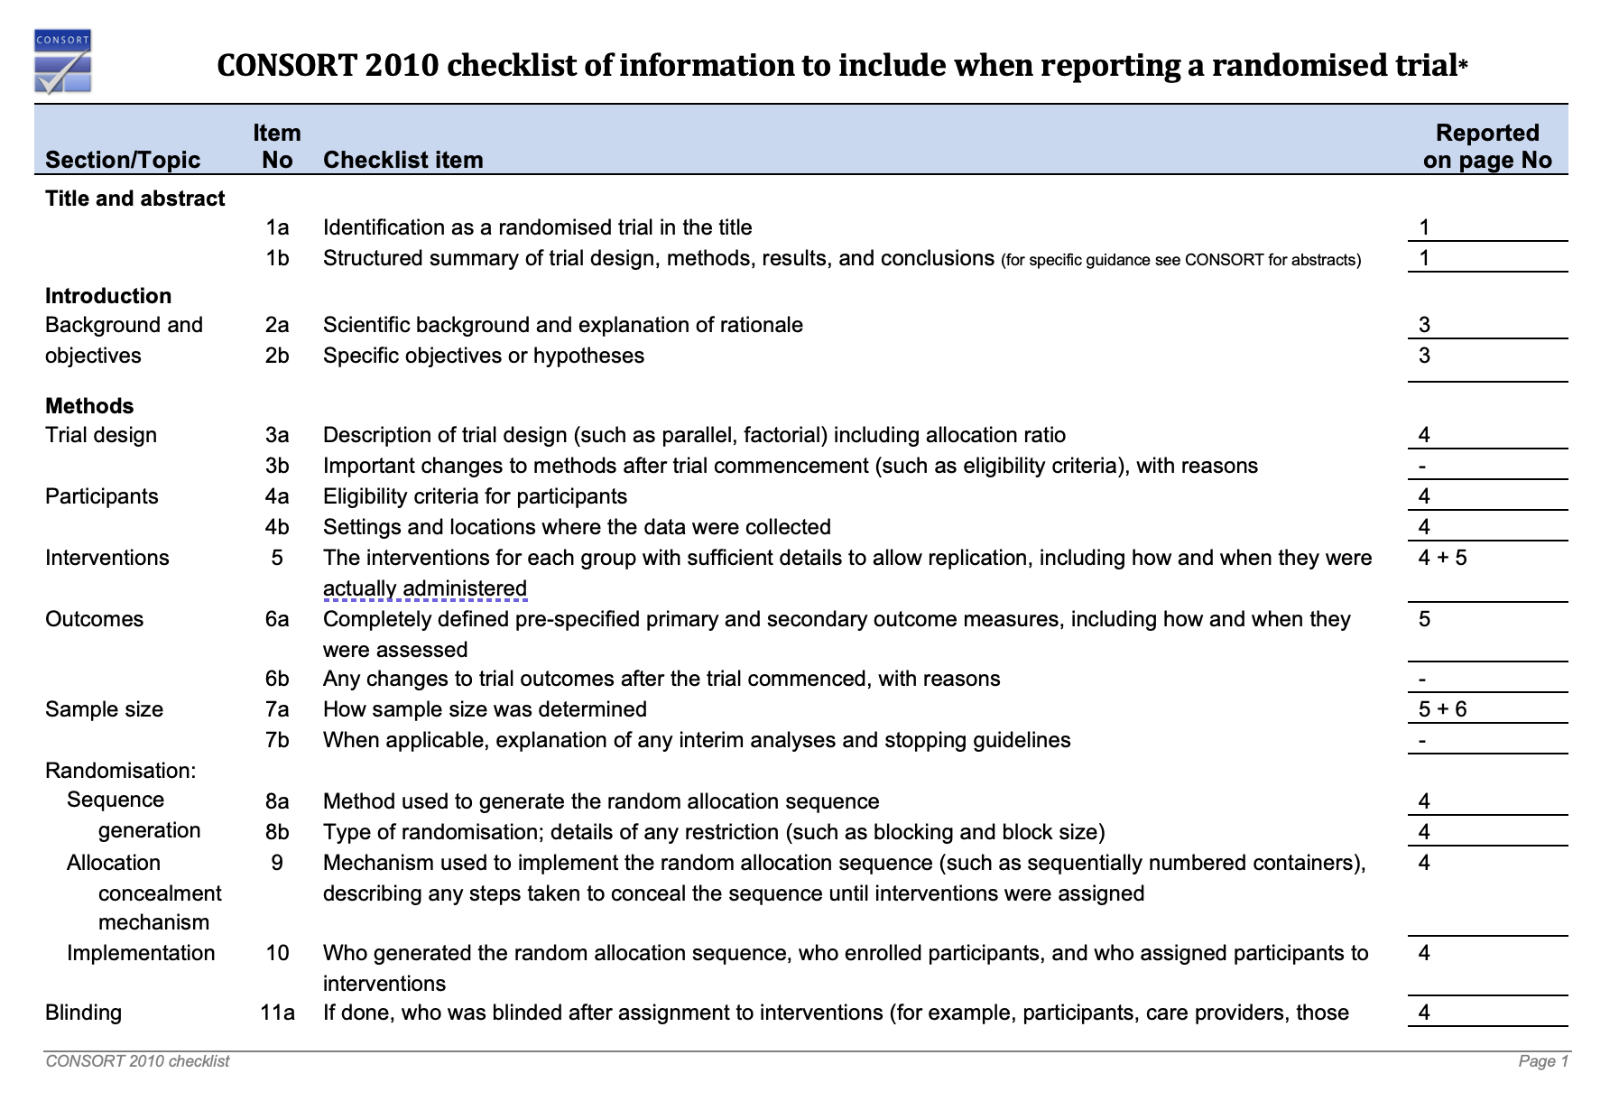
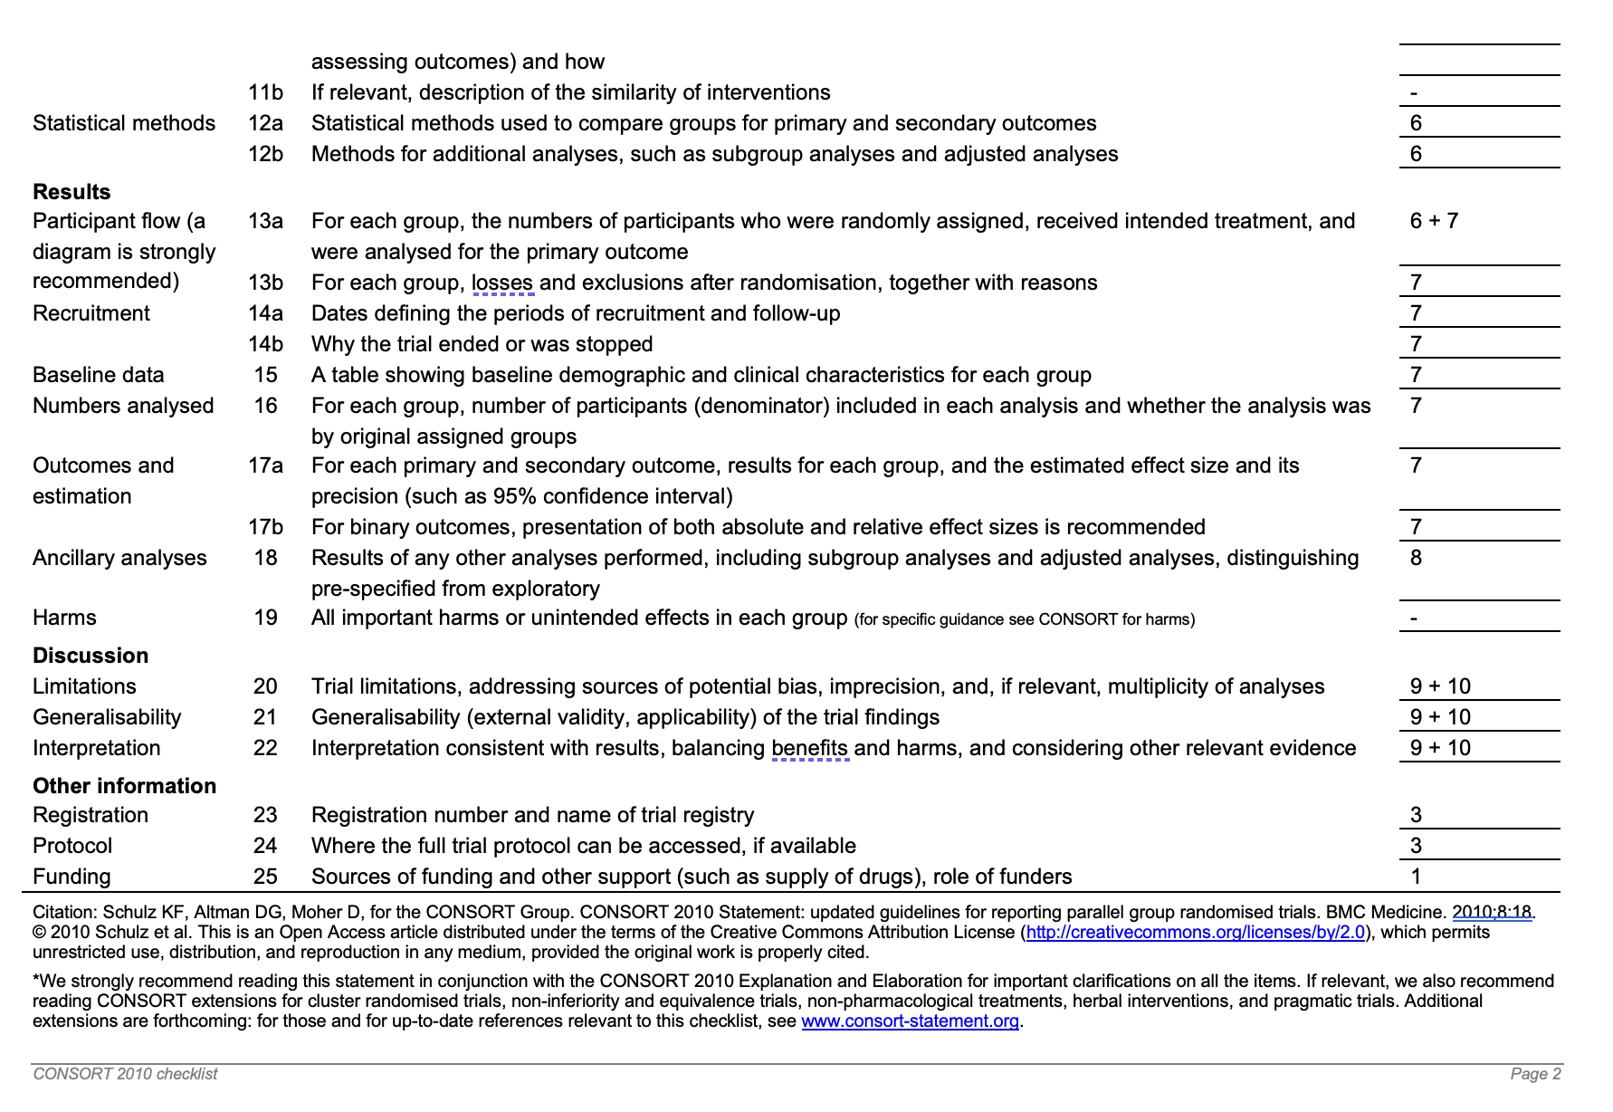
Additional references Figure 1 – Consort 2010 checklist when reporting randomized controlled trial
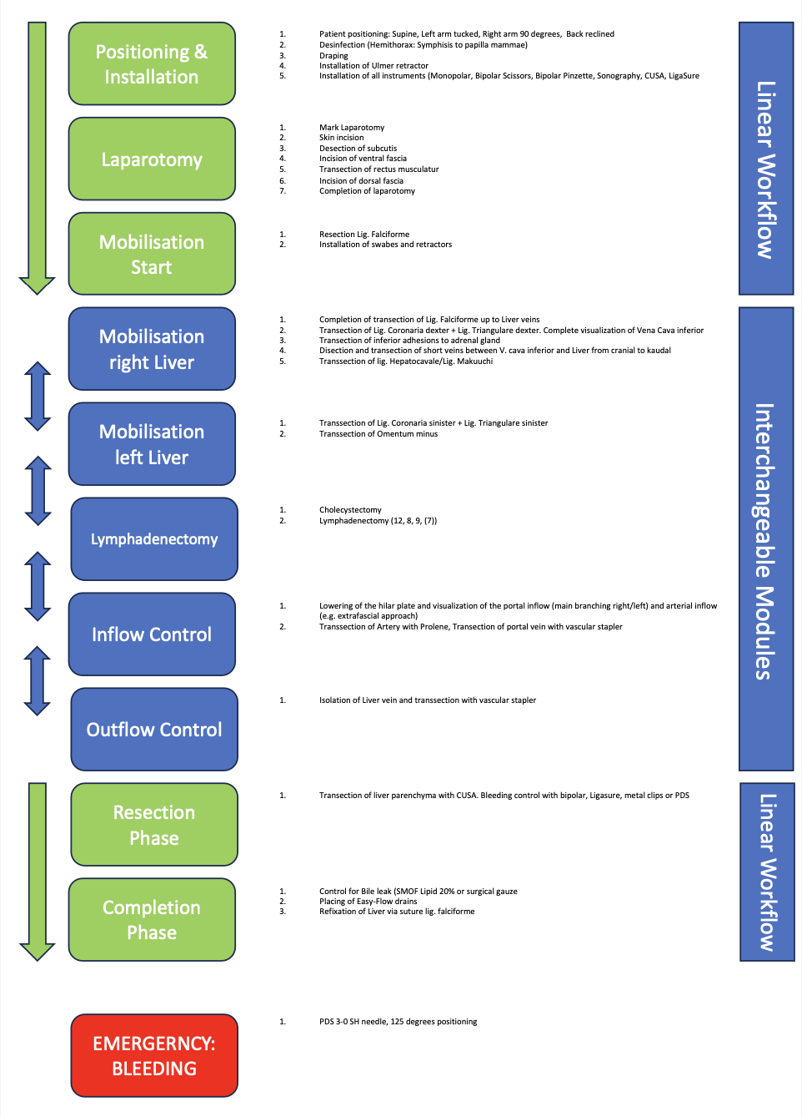
Additional references figure 2 – Initial Surgical Procedure Model

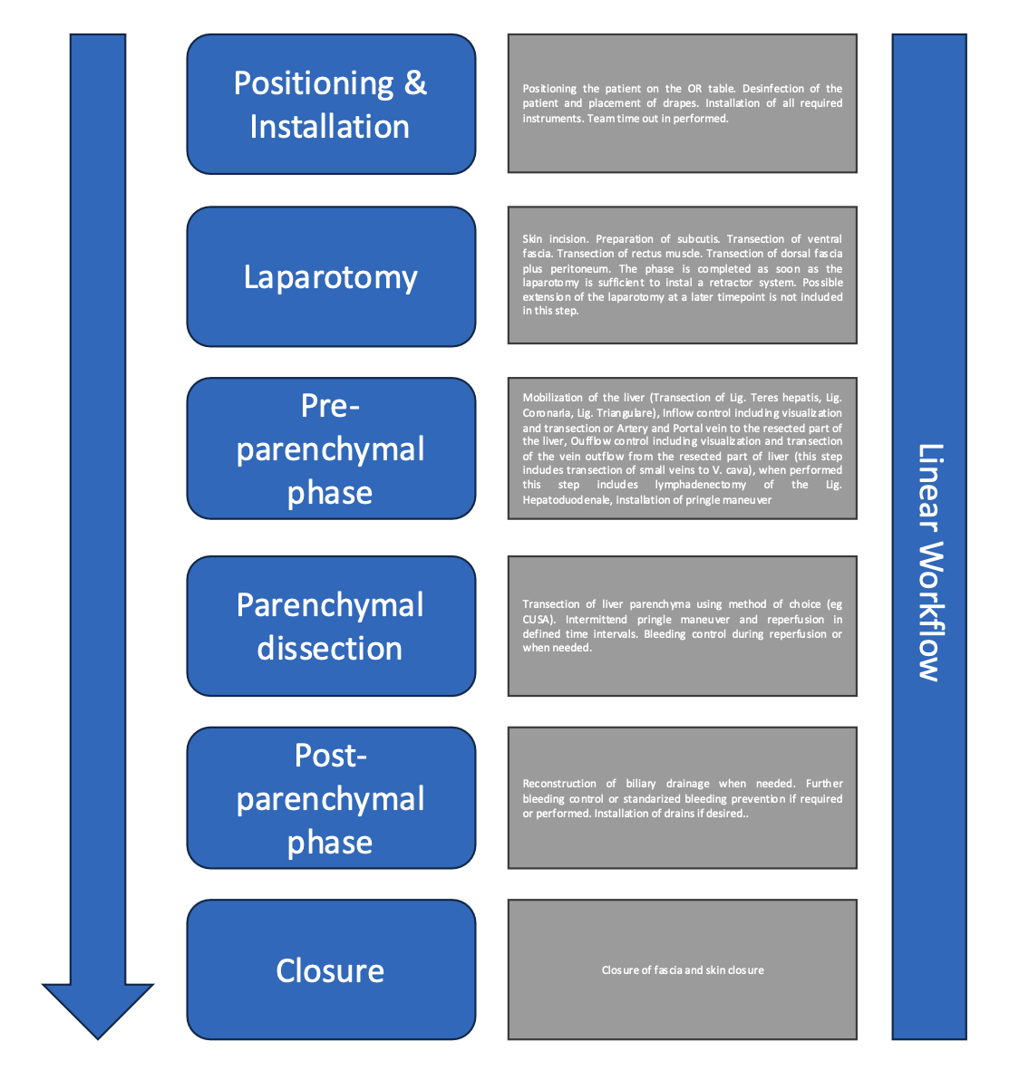
Additional references figure 3 – Final Surgical Procedure Model used after generalization of initial model
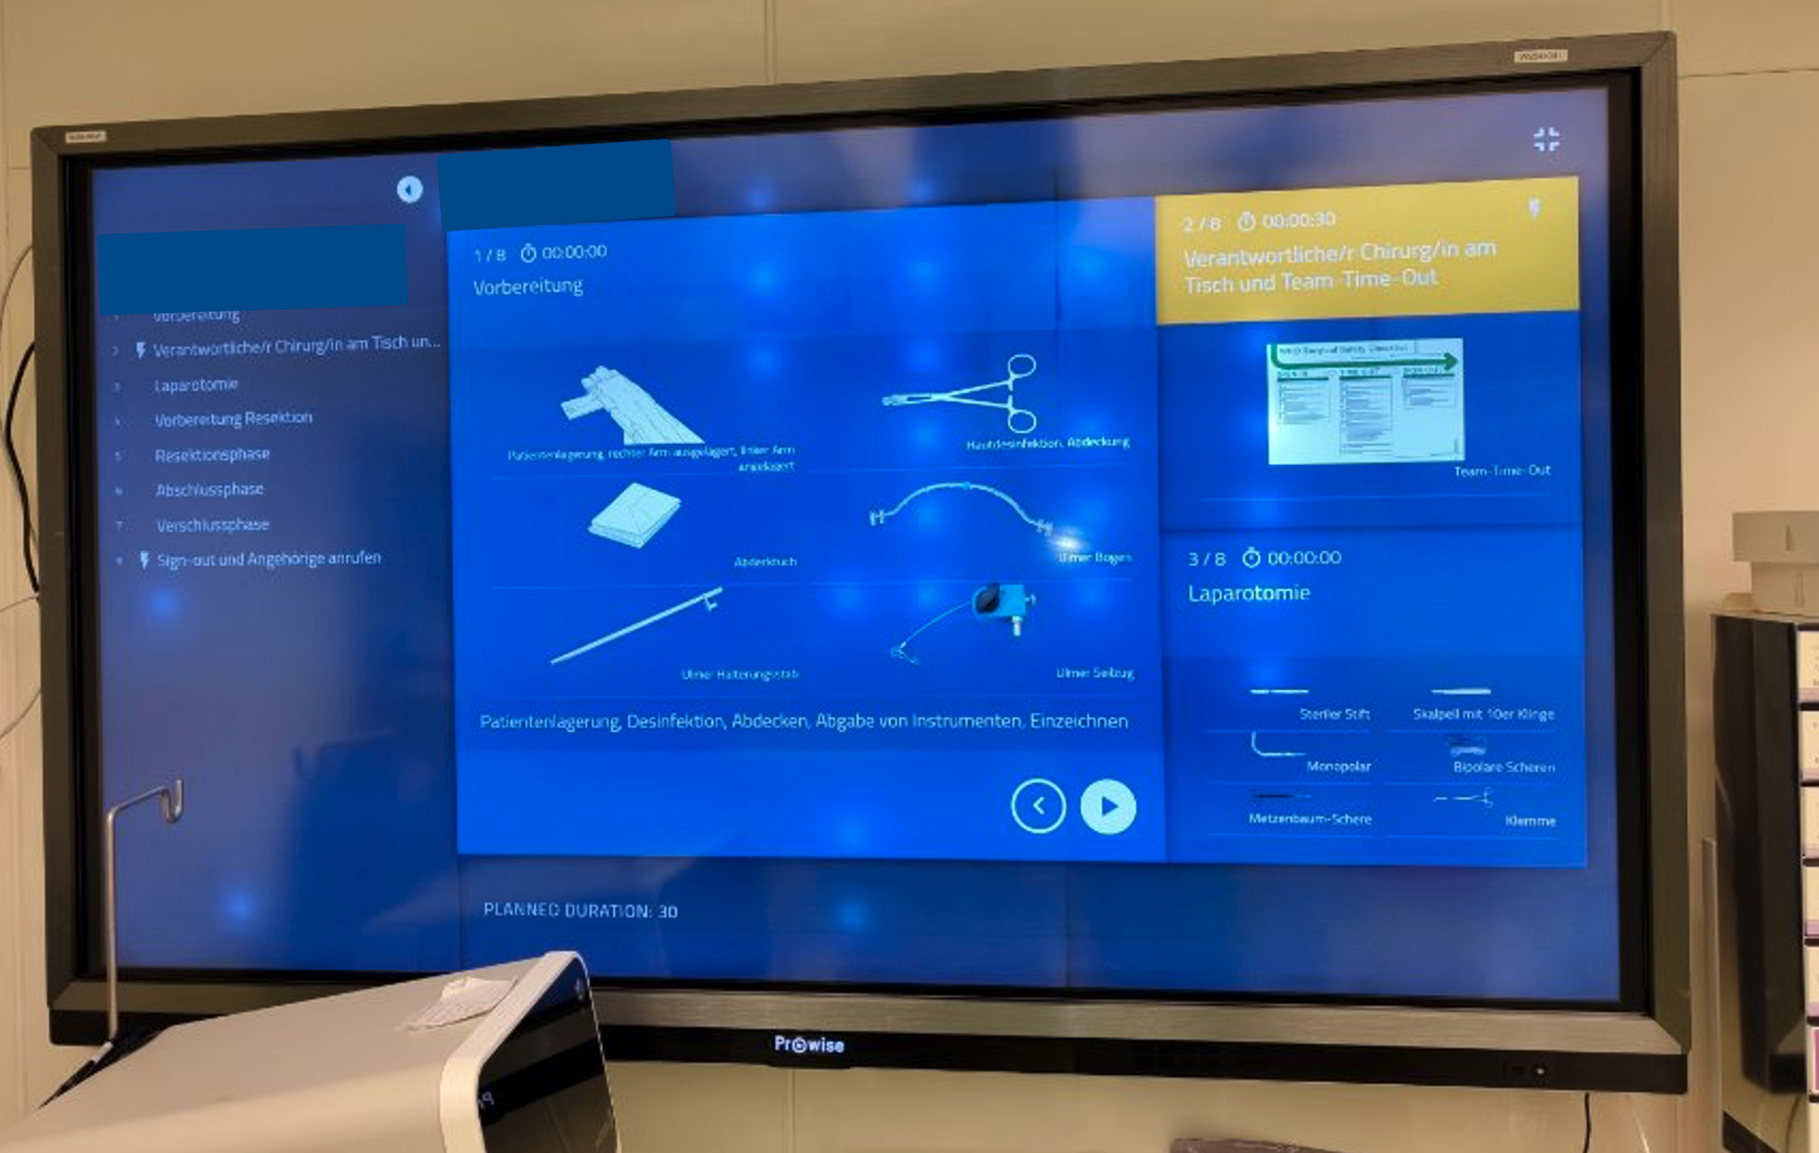
Additional references figure 4 – Display of SWMS in the OR

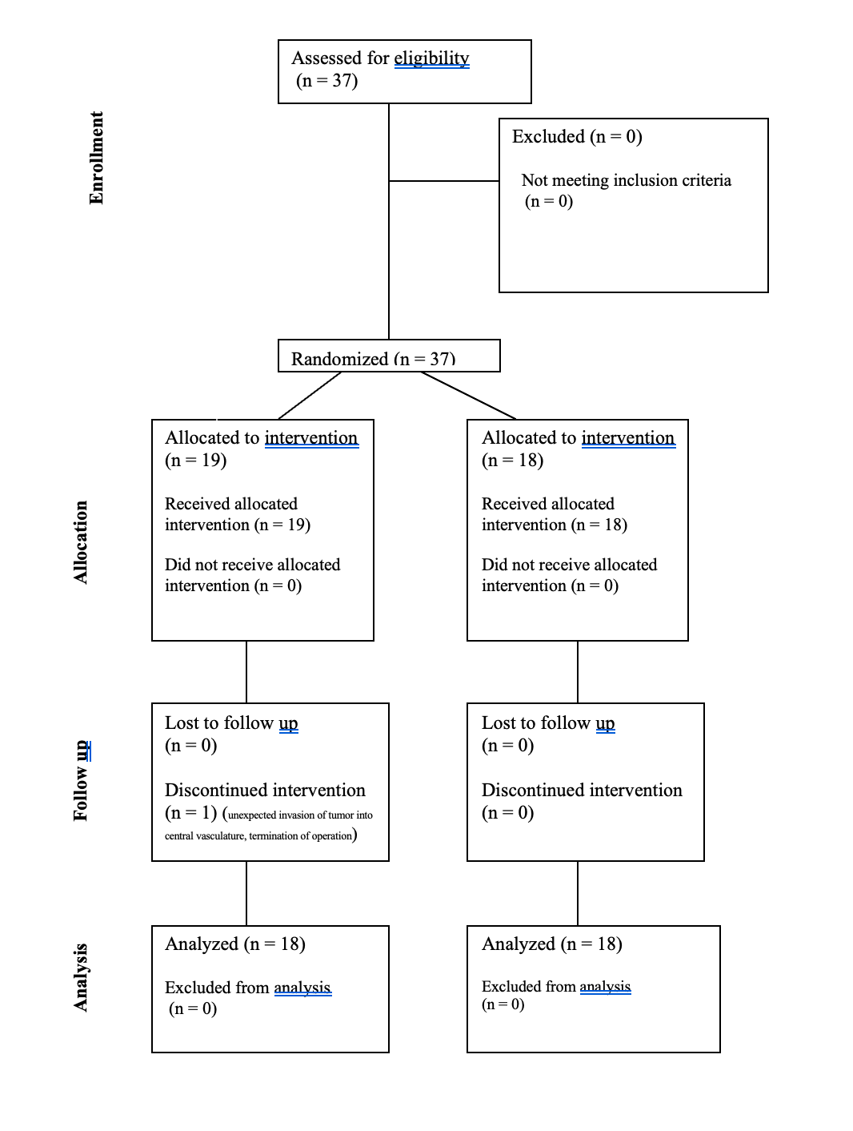Additional references figure 5 – Patient flow chart
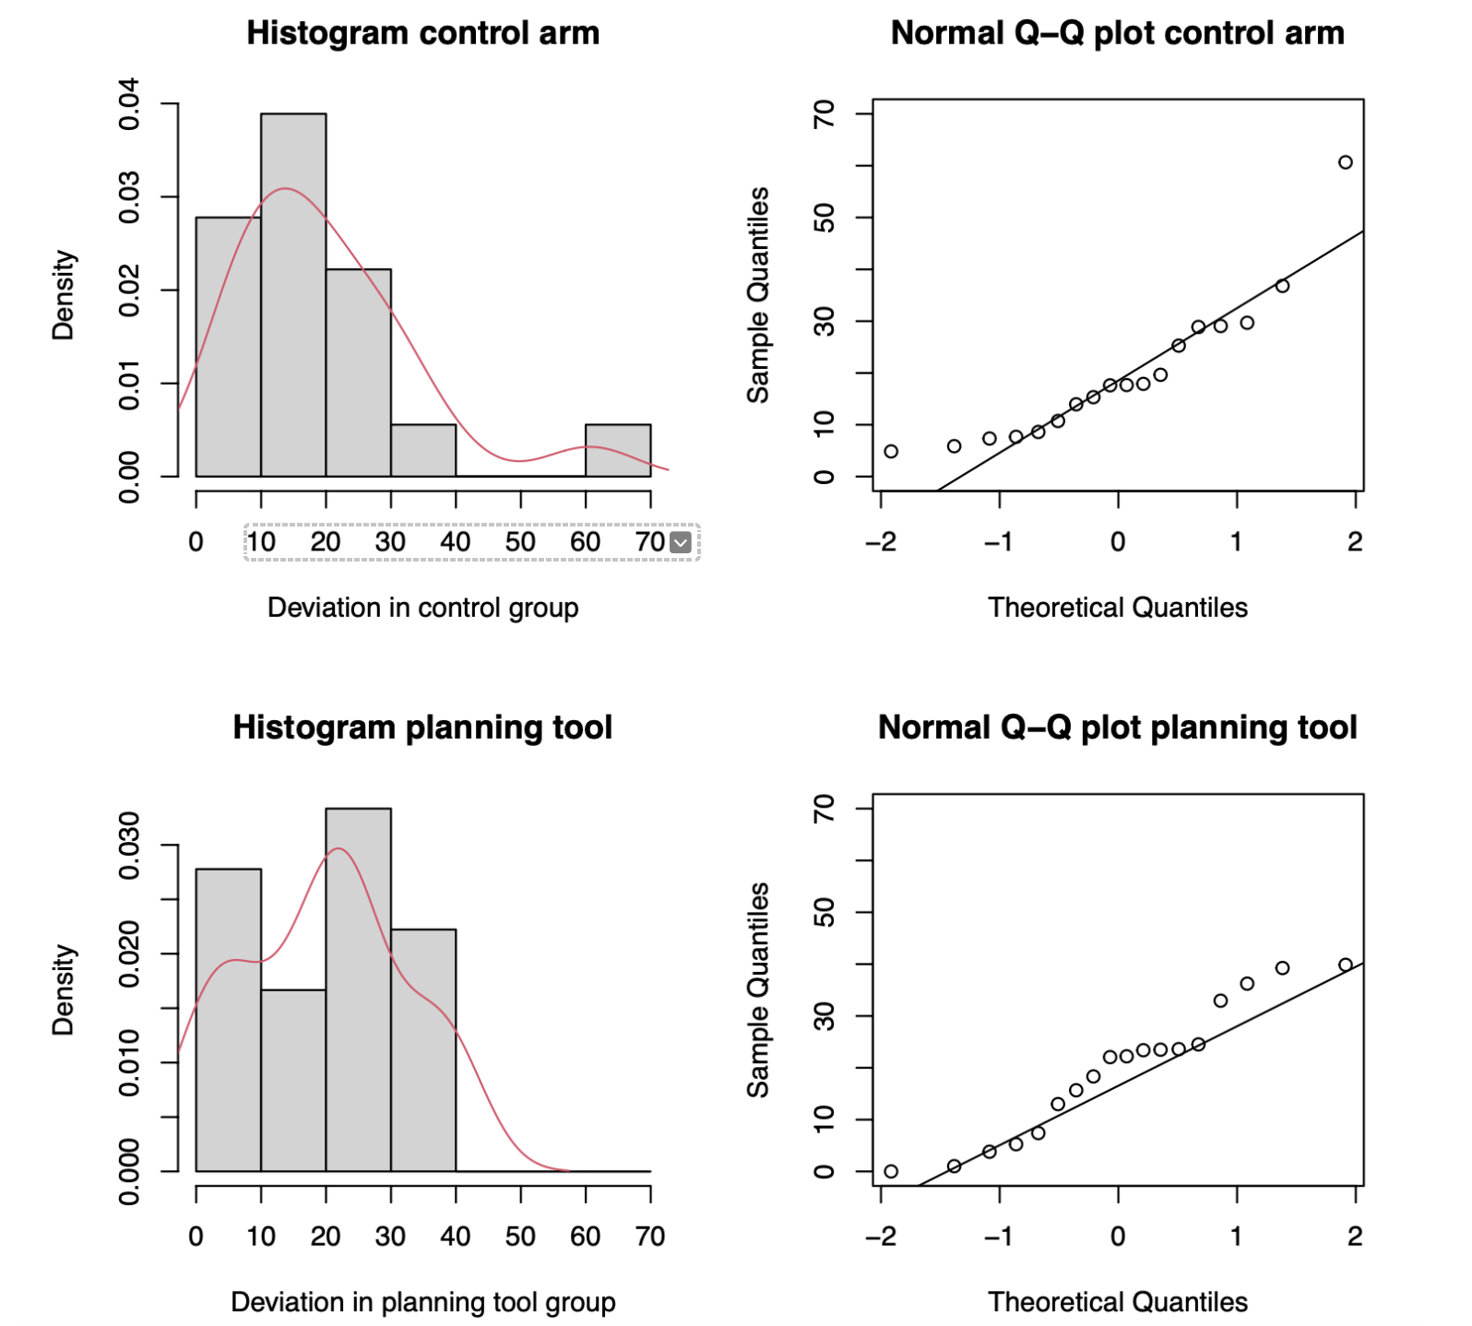
Additional references figure 6

