Supplementary Figures

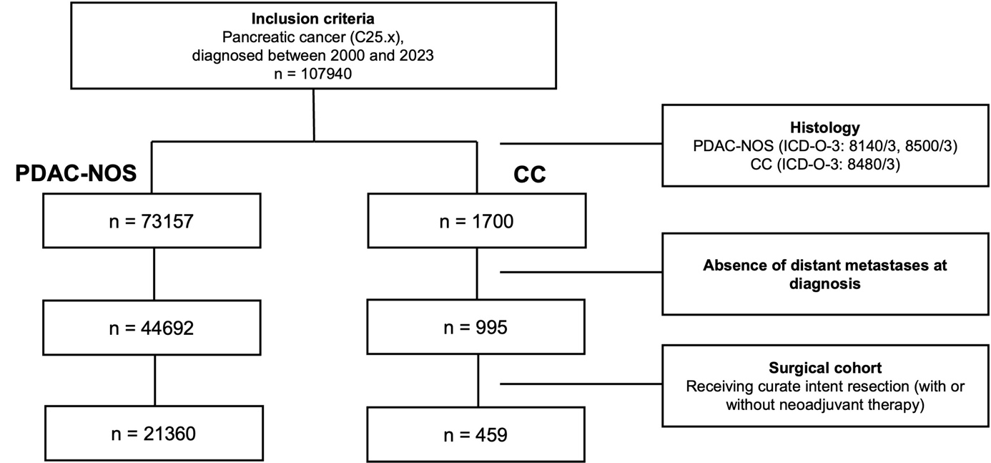

Suppl. Fig. 1: Consort diagram.

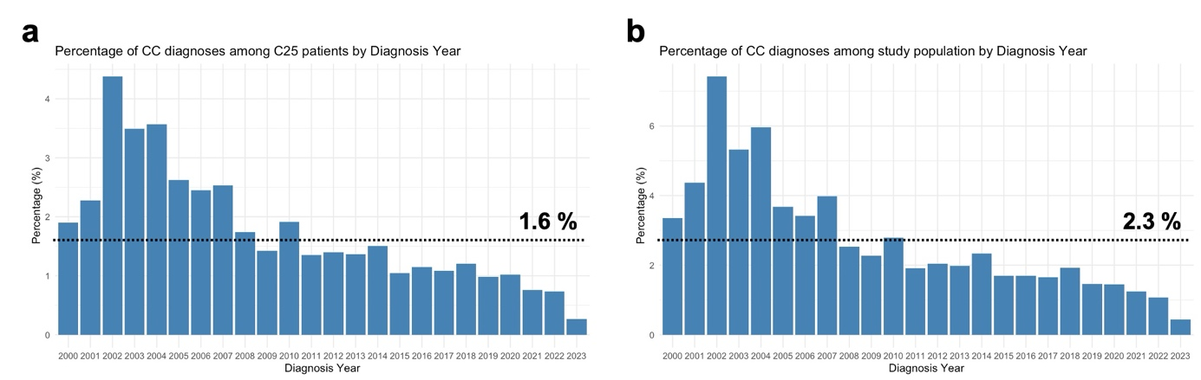
Suppl. Fig. 2: Percentage of CC diagnoses over the study period. Shown are the percentages of CC diagnoses over the study period from 2000 – 2023 among all patients with malignant tumors of the pancreas (ICD-10: C25; a) and the study population consisting of patients with PDAC-NOS or CC (b). The dotted line represents the overall percentage within the study period.

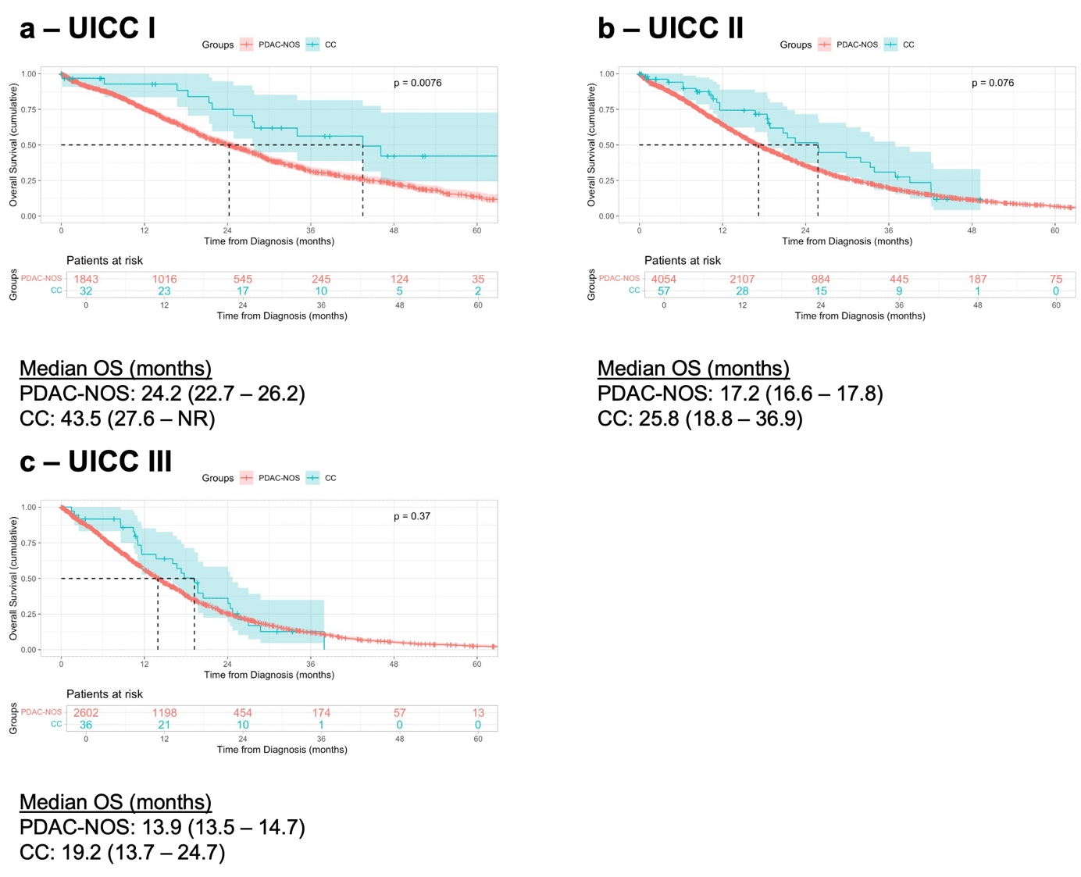

Suppl. Fig. 3: Survival analysis in Stage-matched cohorts. Kaplan-Meier curves showing the overall survival from diagnosis in months with 95% Confidence interval between resected PDAC-NOS or CC patients stratified according to UICC I (a), UICC II (b), and UICC III (c) stages. Only patients with 8th edition AJCC-staging were identified to ensure comparability. The displayed p-values were calculated using the Log-rank test.

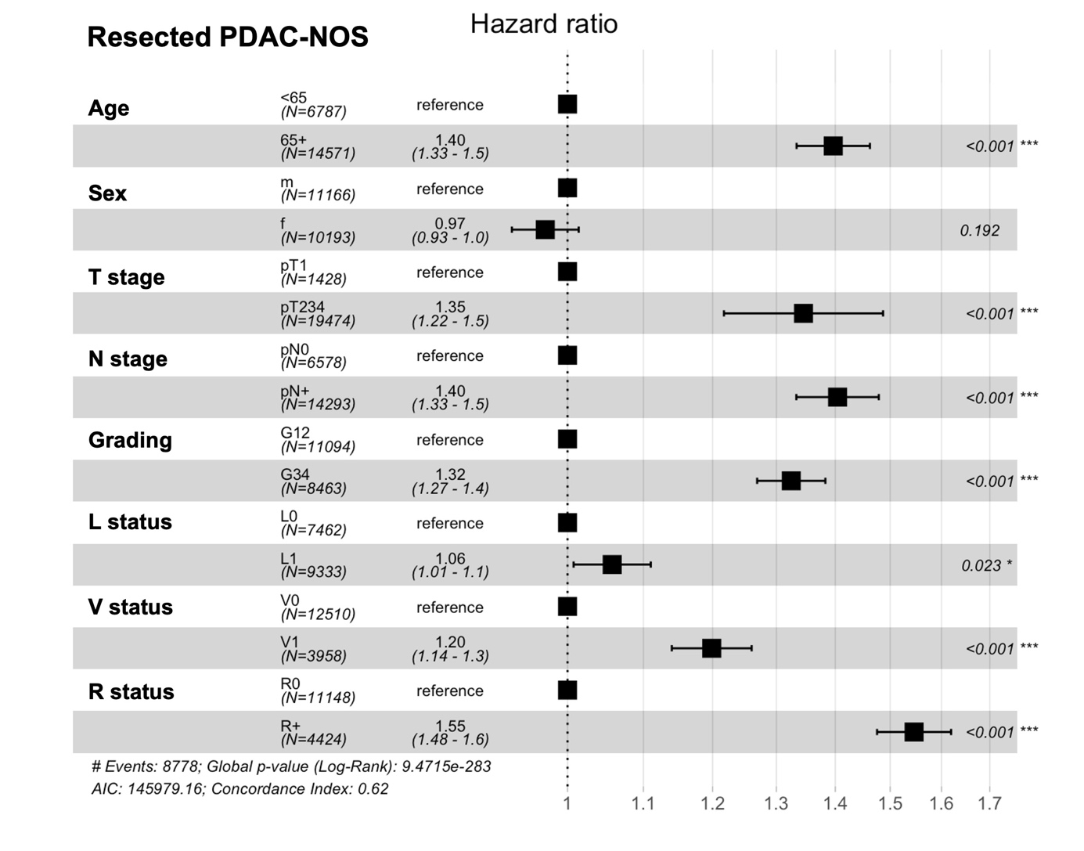
Suppl. Fig. 4: Multivariable Analysis of Prognostic Factors in resected PDAC-NOS patients. Multivariable cox-regression analysis of the overall survival of resected PDAC-NOS patients. Shown are the hazards ratios with the 95% Confidence Interval, as well as the p-values.

