Supplementary Table 1 Model development information
Information-2025.10.3 Sheet2(Model development information)
*NR: Not Report

Supplementary Table 2 PROBAST risk of bias of included studies
References  Sections |  | Benovic S et al, 2024 | Boppana SH et al, 2025 | Choi JY et al, 2023 | Fliegenschmidt J et al, 2022 | Kocar TD et al, 2025 | Li H et al, 2025 | Liu Y et al, 2023 | Lu Y et al, 2025 | Menzenbach J et al, 2022 | Oosterhoff JHF et al, 2021 | Oosterhoff JHF et al, 2022 | Song Y et al, 2024 | Song YX et al, 2023 | Yoshimura M rt al, 2024
Participants | 1.1 | + | + | + | + | + | + | + | + | + | + | + | + | + | +
Participants | 1.2 | + | + | + | + | + | + | + | + | + | + | + | + | + | +
Participants | Total | + | + | + | + | + | + | + | + | + | + | + | + | + | +
Predictors | 2.1 | + | + | + | + | + | + | + | + | + | + | + | + | + | +
Predictors | 2.2 | + | + | + | + | + | + | + | + | + | + | + | + | + | +
Predictors | 2.3 | + | + | + | + | + | + | + | + | + | + | + | + | + | +
Predictors | Total | + | + | + | + | + | + | + | + | + | + | + | + | + | +
Outcome | 3.1 | + | ? | - | + | + | + | + | + | + | + | + | + | + | -
Outcome | 3.2 | + | ? | + | + | + | + | + | + | + | + | + | + | + | +
Outcome | 3.3 | + | + | + | + | + | + | + | + | + | + | + | + | + | +
Outcome | 3.4 | + | + | + | + | + | + | + | + | + | + | + | + | + | +
Outcome | 3.5 | ? | ? | + | + | + | ? | + | ? | ? | ? | ? | ? | ? | +
Outcome | 3.6 | + | + | + | + | + | + | + | + | + | + | + | + | + | +
Outcome | Total | + | ? | - | + | + | + | + | + | + | + | + | + | + | +
Analysis | 4.1 | - | + | + | - | - | + | + | + | + | + | + | - | + | +
Analysis | 4.2 | + | + | + | + | + | + | + | + | + | + | + | + | + | +
Analysis | 4.3 | + | + | + | + | + | + | + | + | - | + | + | + | + | +
Analysis | 4.4 | + | ? | ? | - | + | + | - | + | - | + | + | ? | - | -
Analysis | 4.5 | + | + | + | + | + | + | + | + | - | + | ? | - | - | +
Analysis | 4.6 | + | + | + | + | + | + | + | + | + | + | + | + | + | +
Analysis | 4.7 | + | + | + | + | + | + | + | + | + | + | + | + | + | +
Analysis | 4.8 | + | + | + | ? | ? | - | + | + | + | + | ? | + | + | +
Analysis | 4.9 | + | - | + | ? | ? | + | + | + | + | + | ? | ? | + | +
Analysis | Total | + | + | + | - | - | + | + | + | - | + | + | - | - | -
Overall |  | + | ? | - | - | - | + | + | + | - | + | + | - | - | -
1.1: Were appropriate data sources used, e.g. cohort, RCT or nested case-control study data? 1.2: Were all inclusions and exclusions of participants appropriate? 2.1: Were predictors defined and assessed in a similar way for all participants? 2.2Were predictor assessment made without knowledge of outcome data? 2.3 Are all predictors available at the time the model is intended to be used? 3.1 was the outcome determined appropriately? 3.2 Was a pre-specified or standard outcome definition used? 3.3 Were predictors excluded from the outcome definition? 3.4 Was the outcome defined and determined in a similar way for all participants? 3.5 Was the outcome determine without knowledge of predictor information? 3.6 Was the time interval between predictor assessment and outcome? 4.1 Were there a reasonable number of participants with the outcome? 4.2 Were continuous and categorical predictors handled appropriately? 4.3 Were all enrolled participants included in the analysis? 4.4. Were participants with missing data handled appropriately? 4.5 Was selection of predictors based on univariable analysis avoided? 4.6 Were complexities in the data (e.g., censoring, competing risks, sampling of control participants) accounted for appropriately? 4.7 Were relevant model performance measures evaluated appropriately? 4.8 Were model overfitting and optimism in model performance accounted for? 4.9 Do predictors and their assigned weights in the final model correspond to the results from the reported multivariable analysis?
“+” indicated low RoB; “?”indicated unclear RoB; “-”indicated high RoB. RoB: risk of bias
Supplementary Figure 1 Forest plot of ensemble model
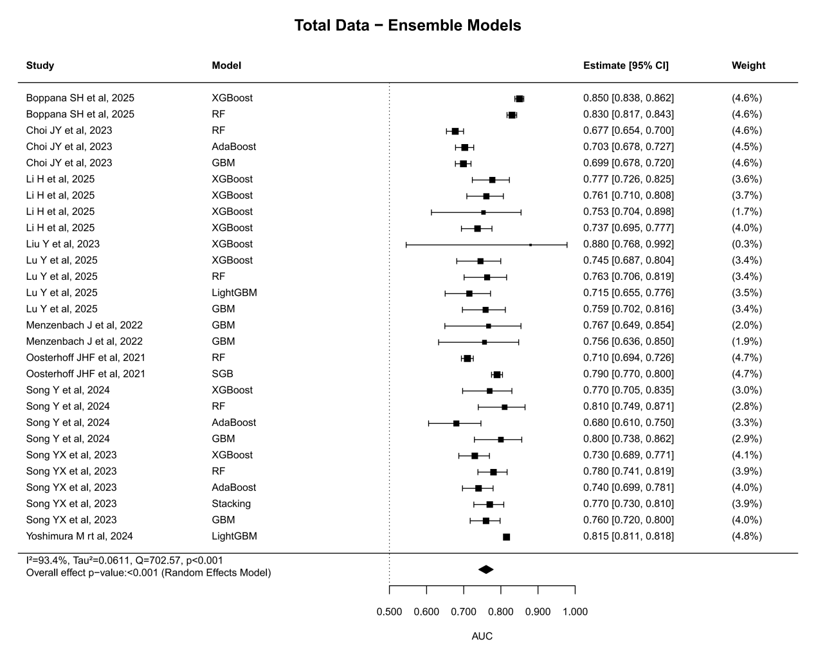

Supplementary Figure 2 Forest plot of single model
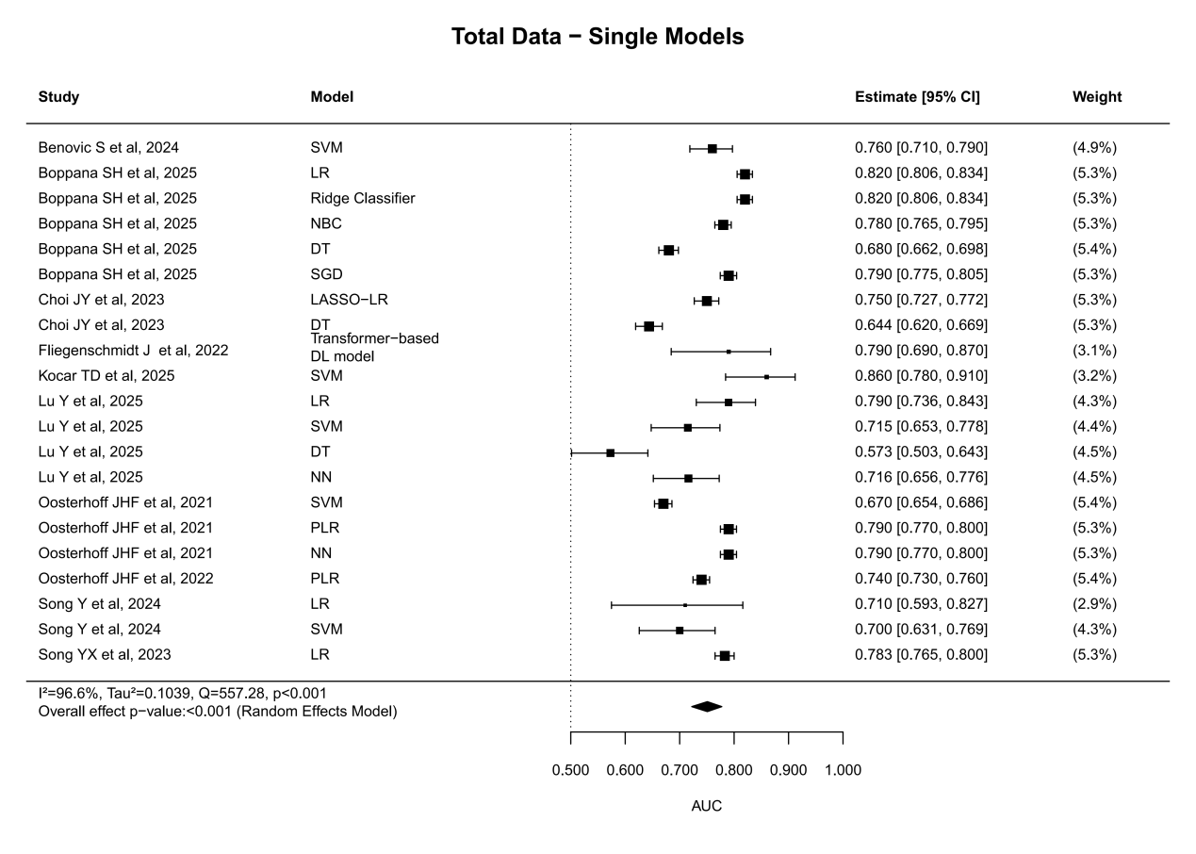

Supplementary Figure 3 Forest plot of internal validation
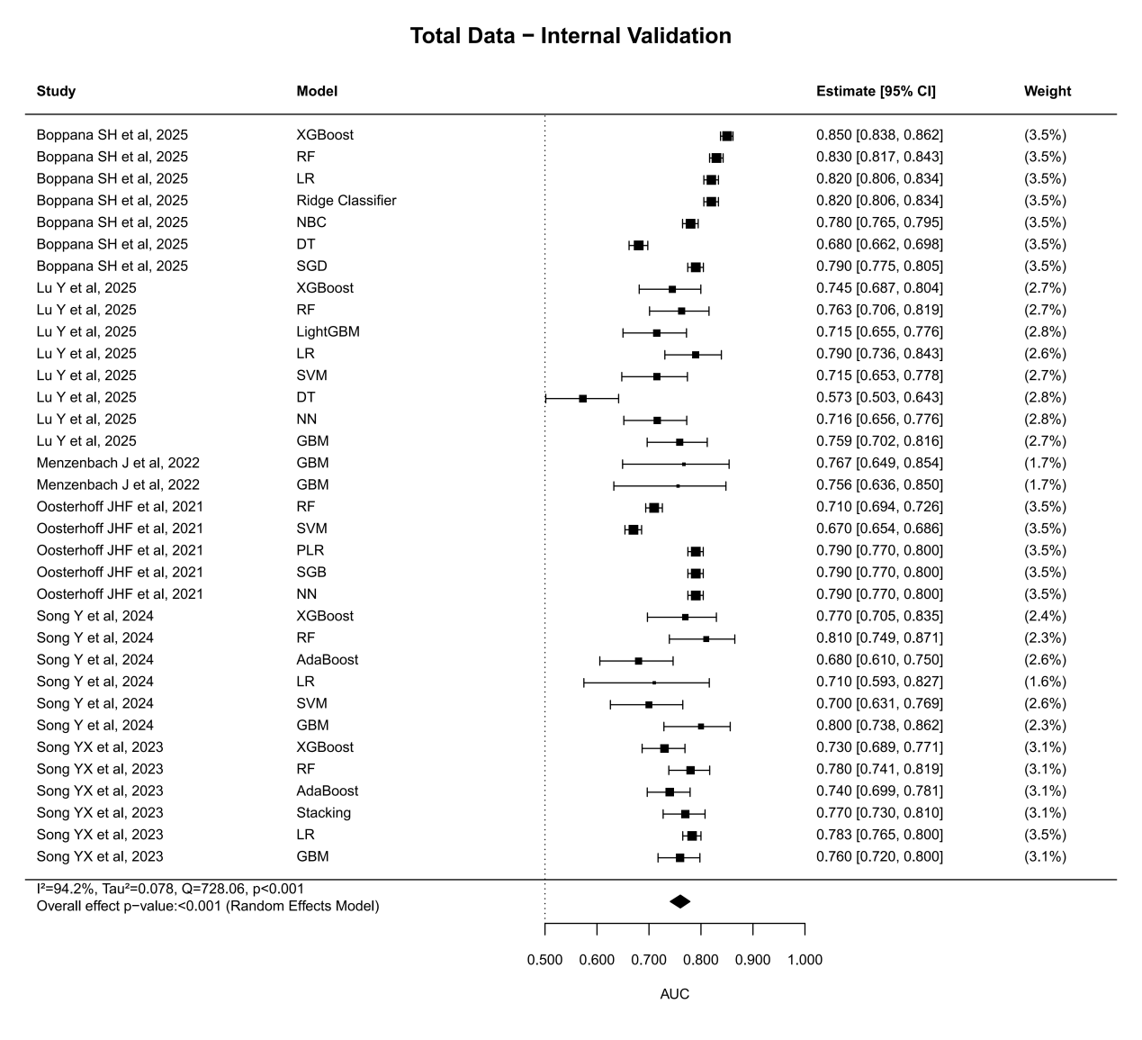

Supplementary Figure 4 Forest plot of external validation
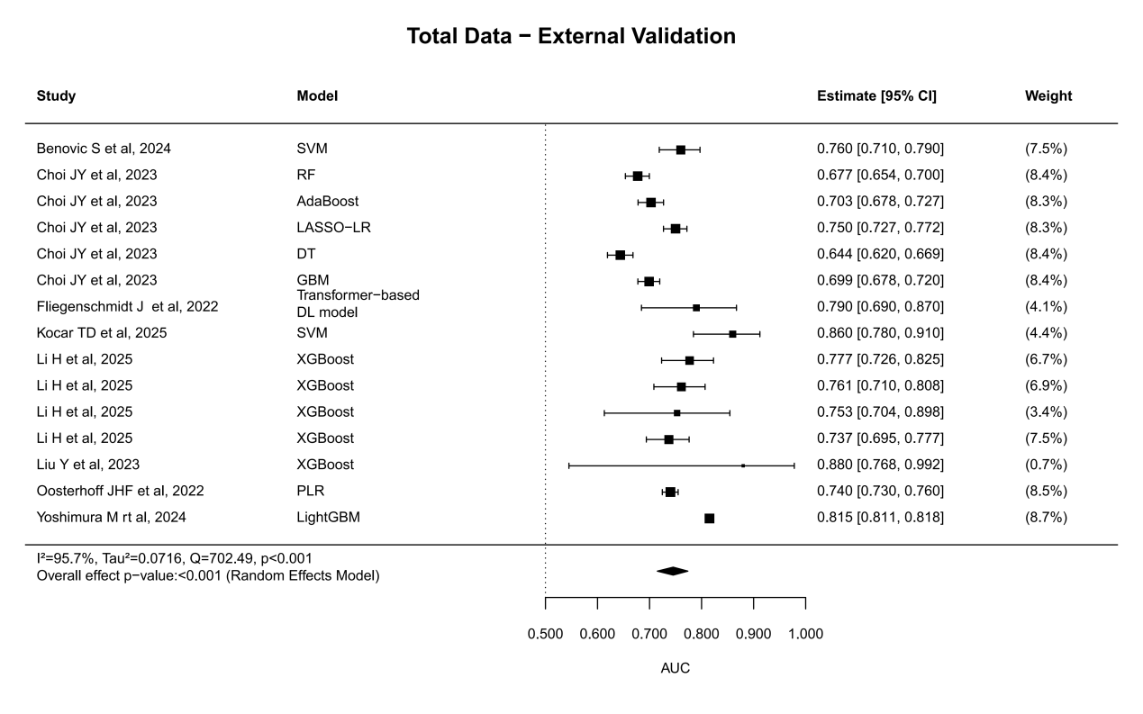

Supplementary Figure 5 Number of models for external validation
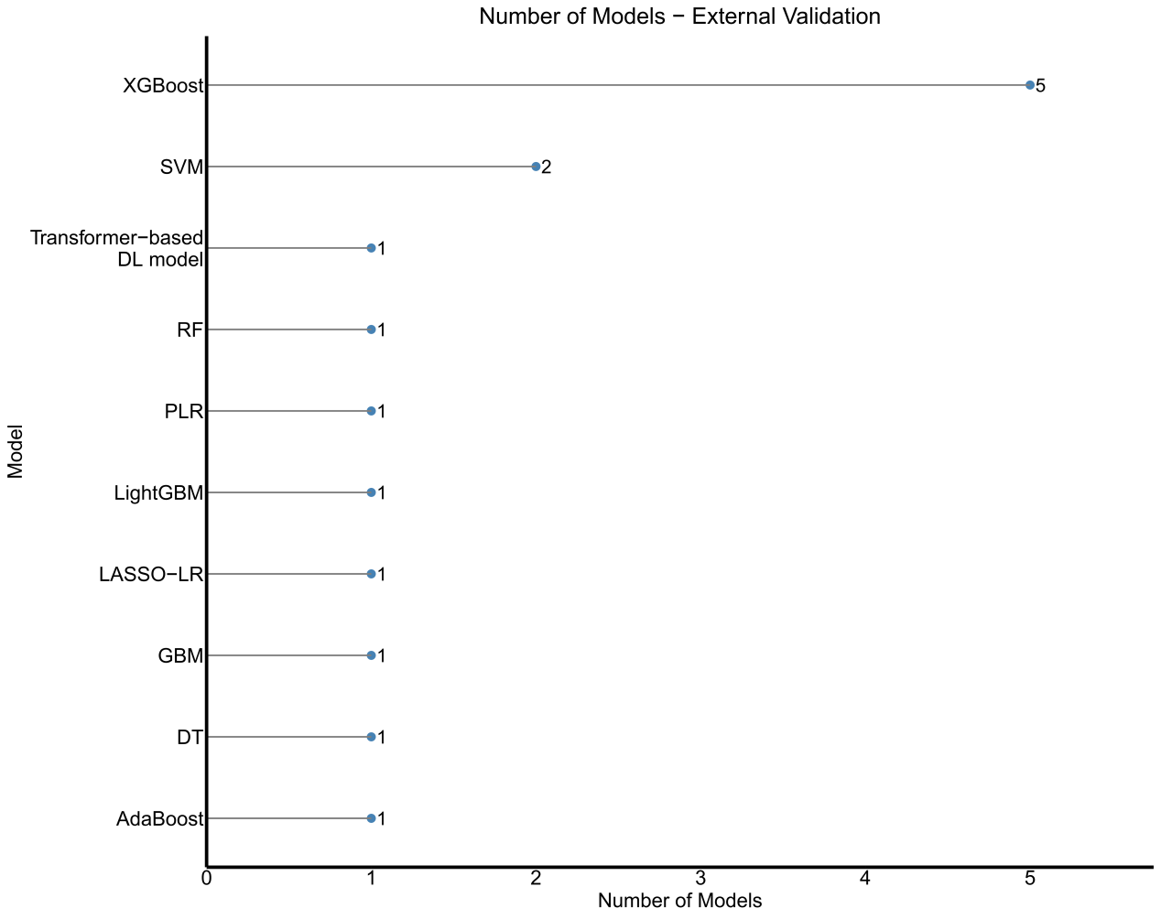

Supplementary Figure 6 AUC performance of external validation models
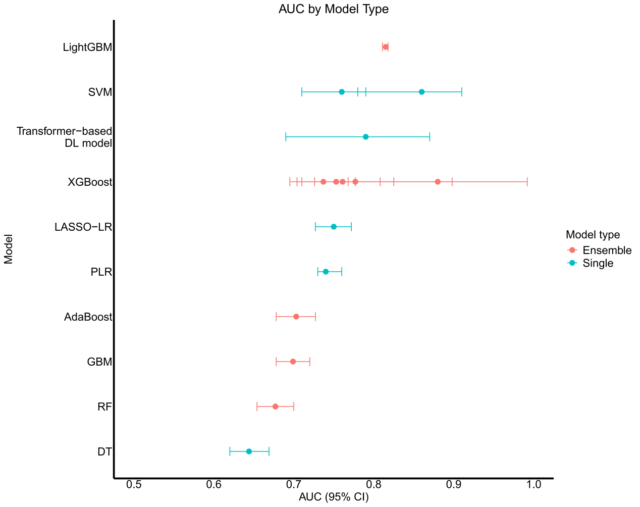

Supplementary Figure 7 Forest plot of ensemble model from external validation
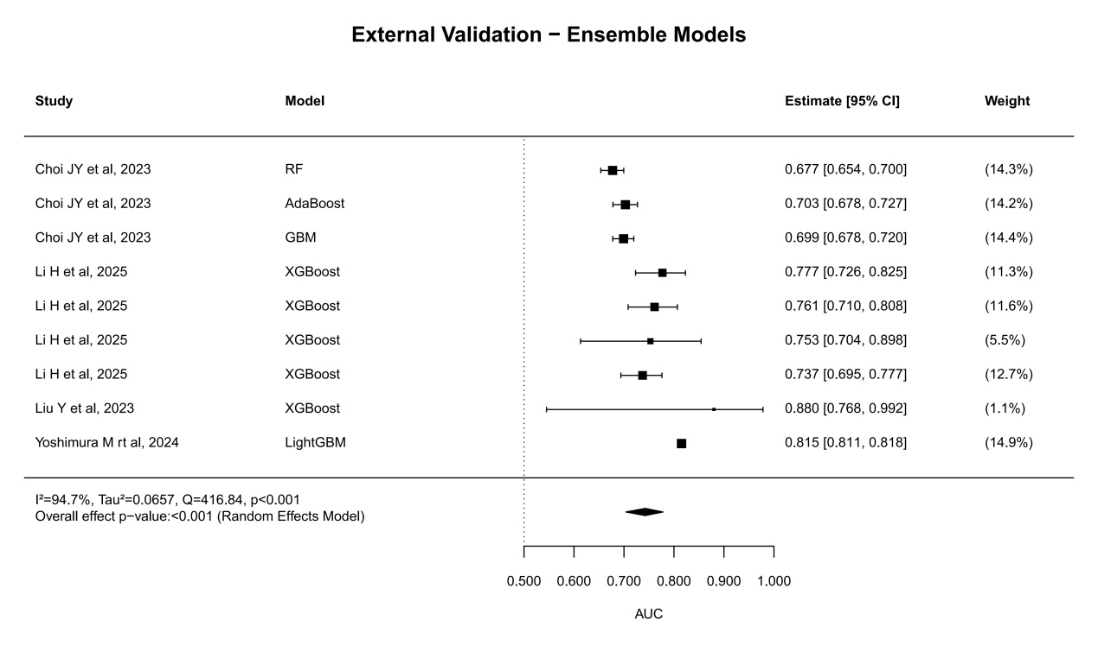

Supplementary Figure 8 Forest plot of single model from external validation
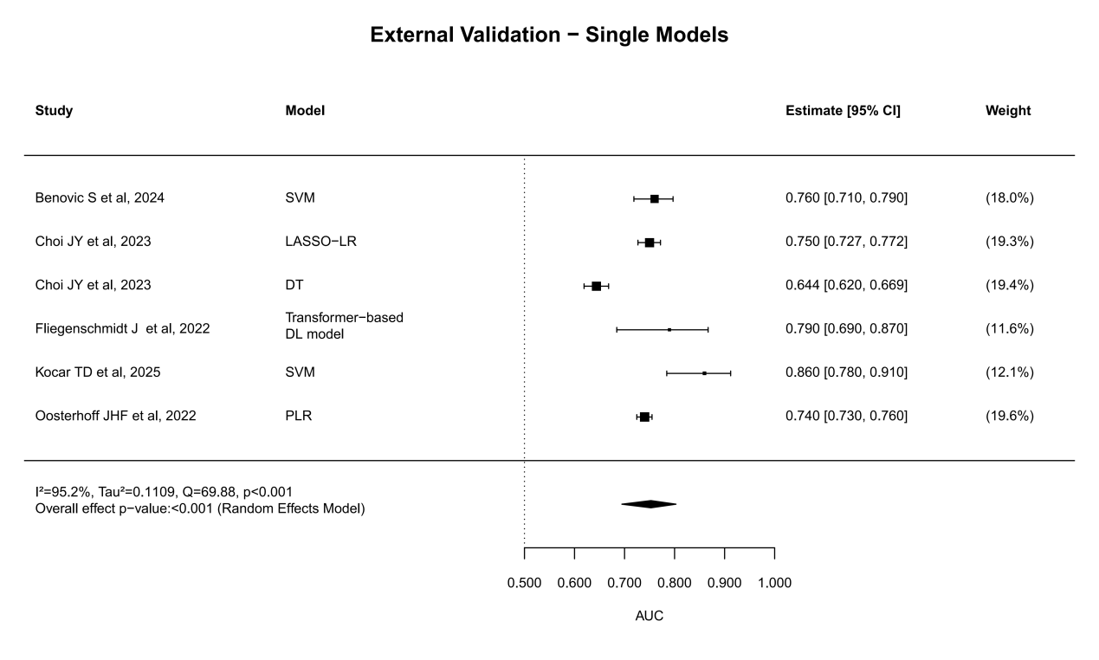
Supplementary Figure 9 Funnel plot for publication bias assessment for external validation
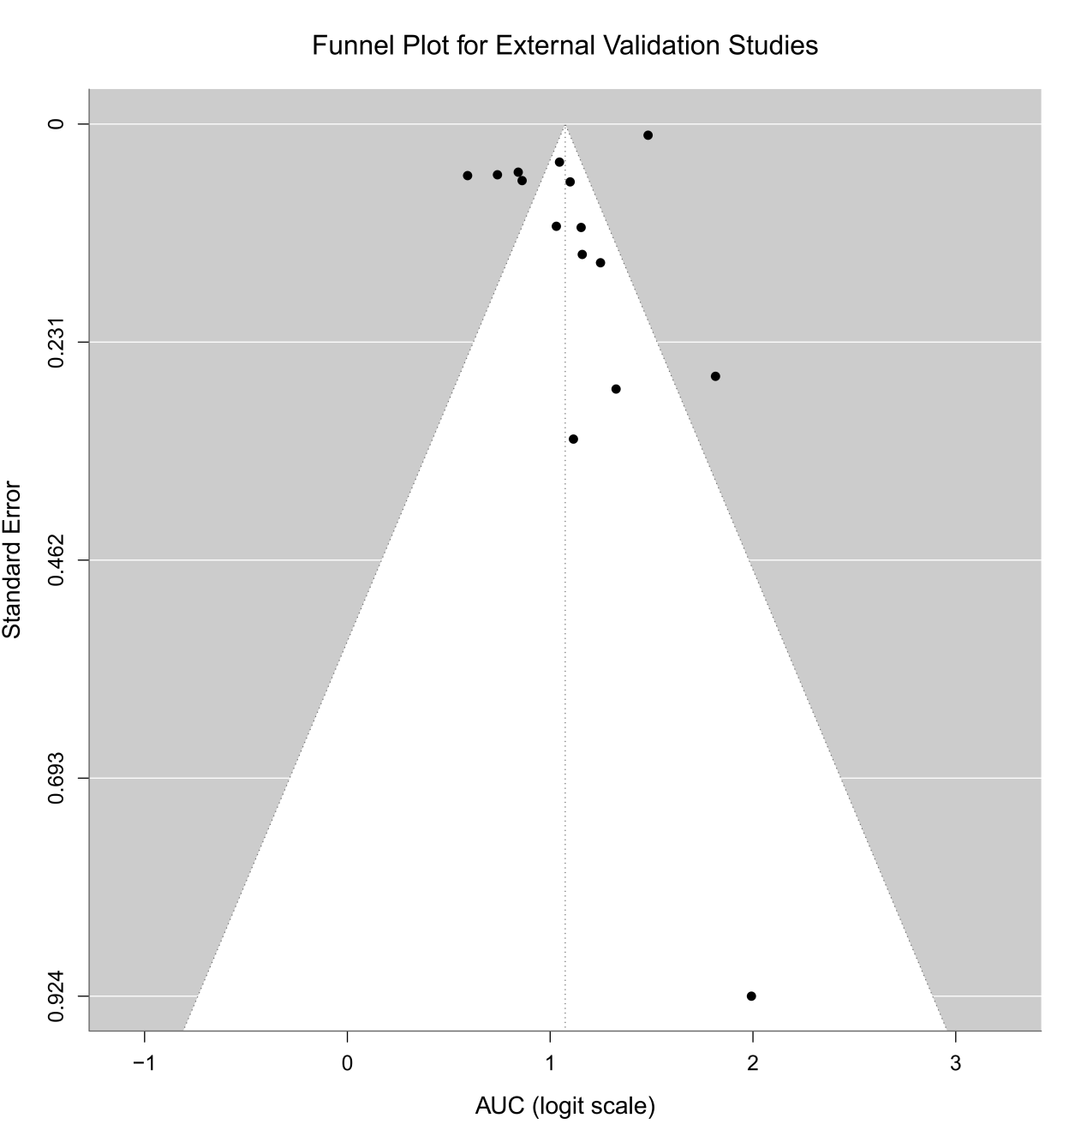

Supplementary Figure 10 Spearman's correlation between sample size and model performance for external validation
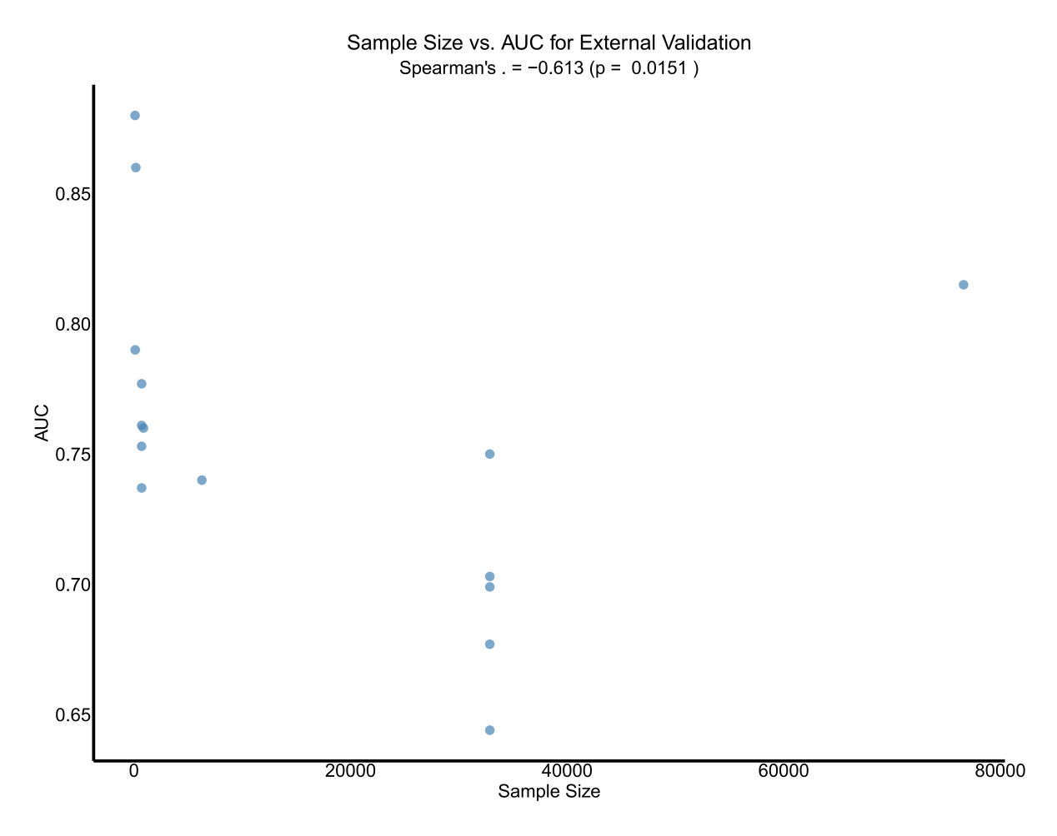

Supplementary Figure 11 Heterogeneity assessment and sensitivity analysis from external validation
